Venice Minerals and Mining
Inspection 4/22/10
Photo’s by Michael Storino & Debbie Anders

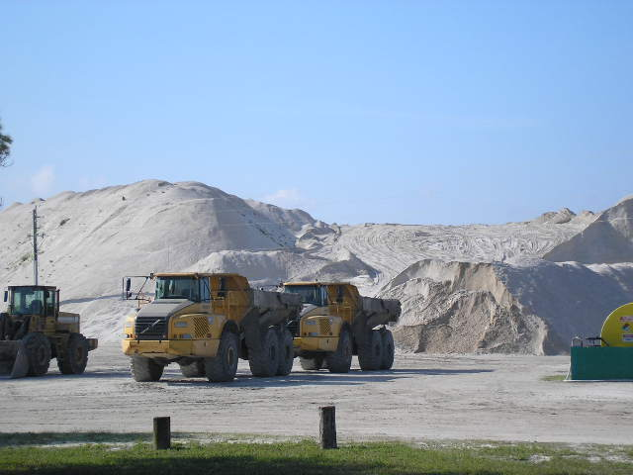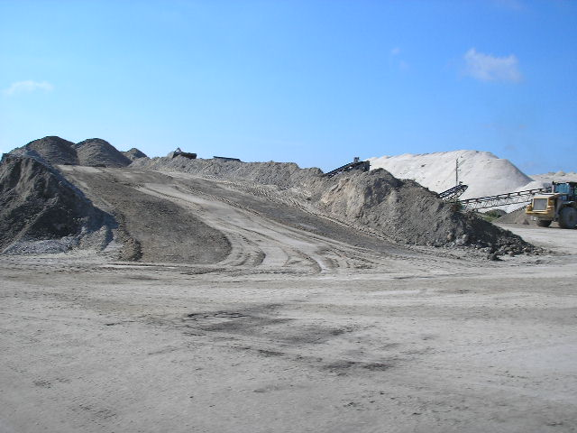
Figure 1 – stockpile ¼” product w/ access road Figure 2 - stockpile 3/8" product w/access road

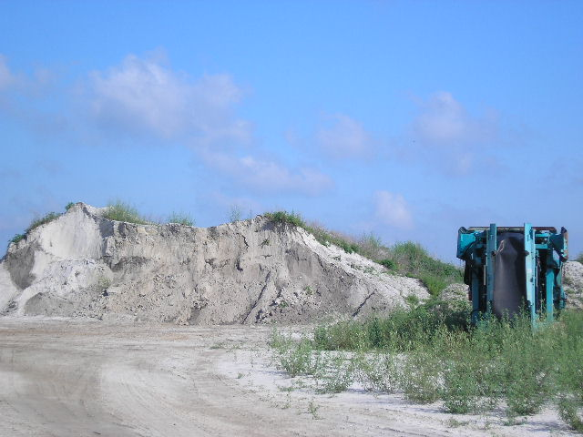
Figure 3 – Remains of soil stockpile, mostly used and not being replenished

