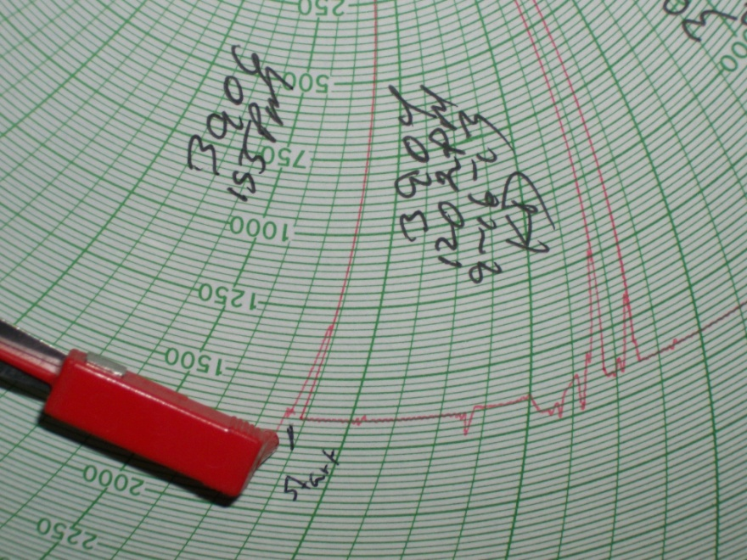  1. Chart recorder at beginning of VE test at 1:55 p.m. | 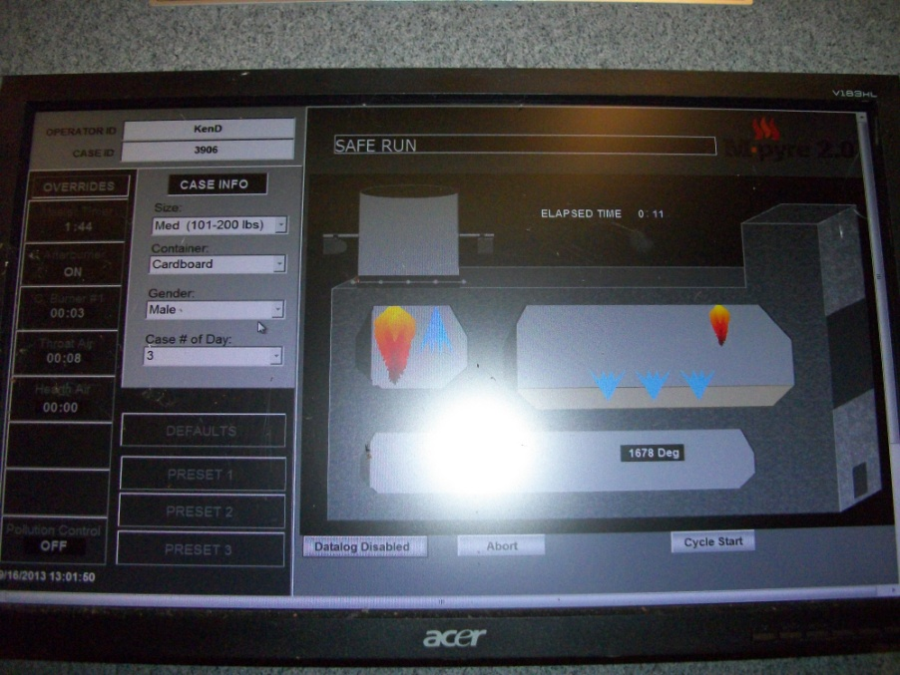  2. Crematory unit display at start of test.
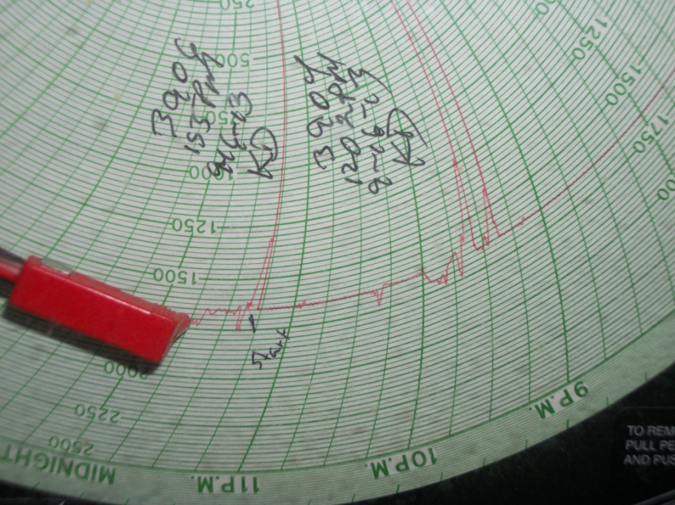  3. Chart recorder display approximately 40 minutes into VE test. | 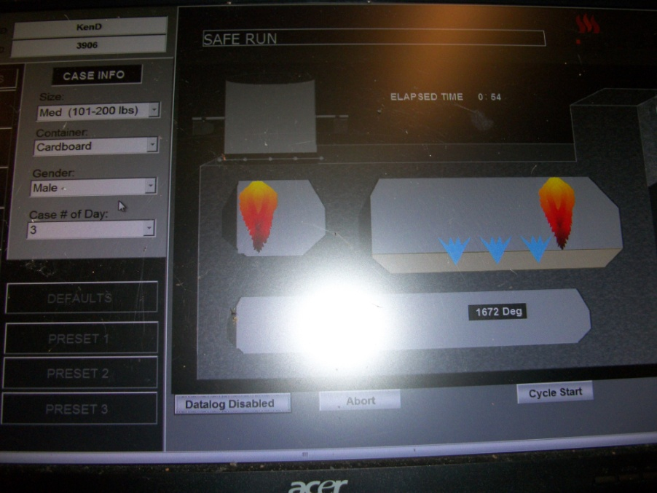  4.
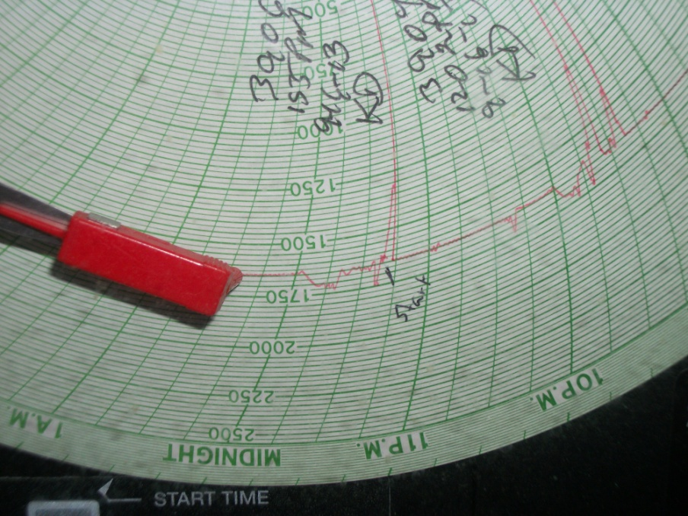  5. Chart recorder display at the end of the VE test. | 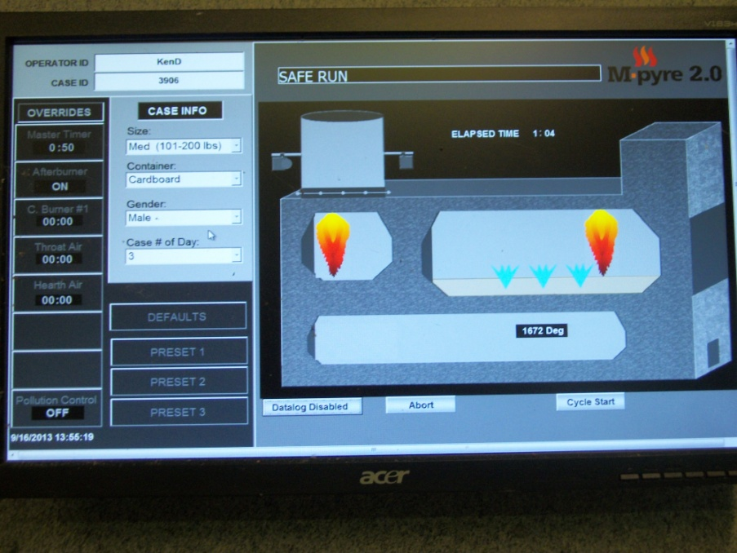  6. Crematory display at end of the VE test.
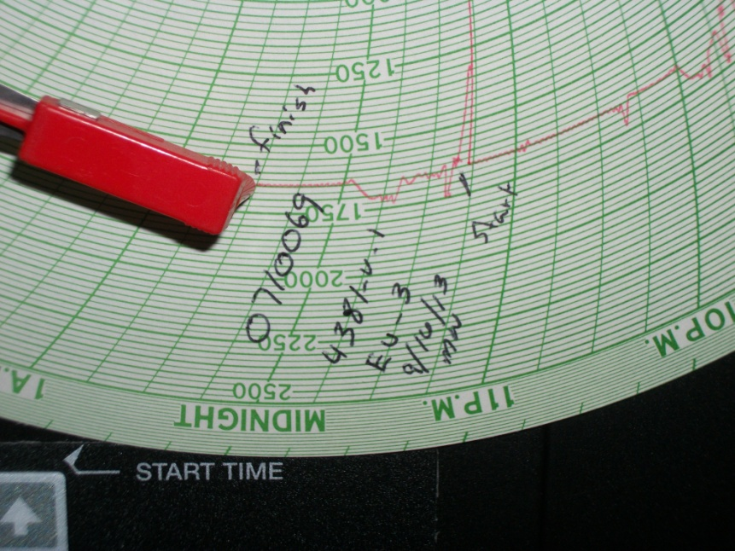
7. Chart recorder final annotation by consultant.

