CEMEX-Arcadia-DeSoto County
Facility Id# 0270004 Ins-2: 10/02/2008

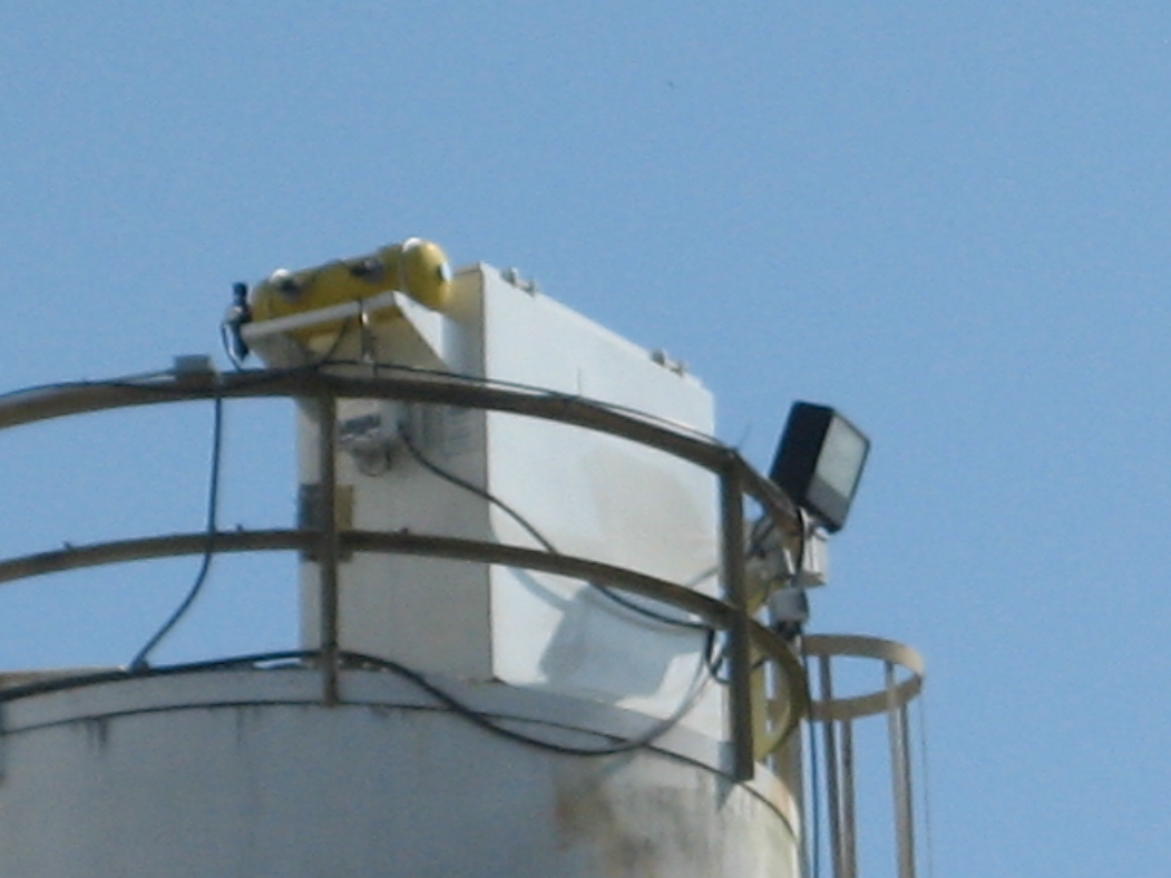
New CP C & W 305 Silo Top dust collector on Flyash Silo EU #1

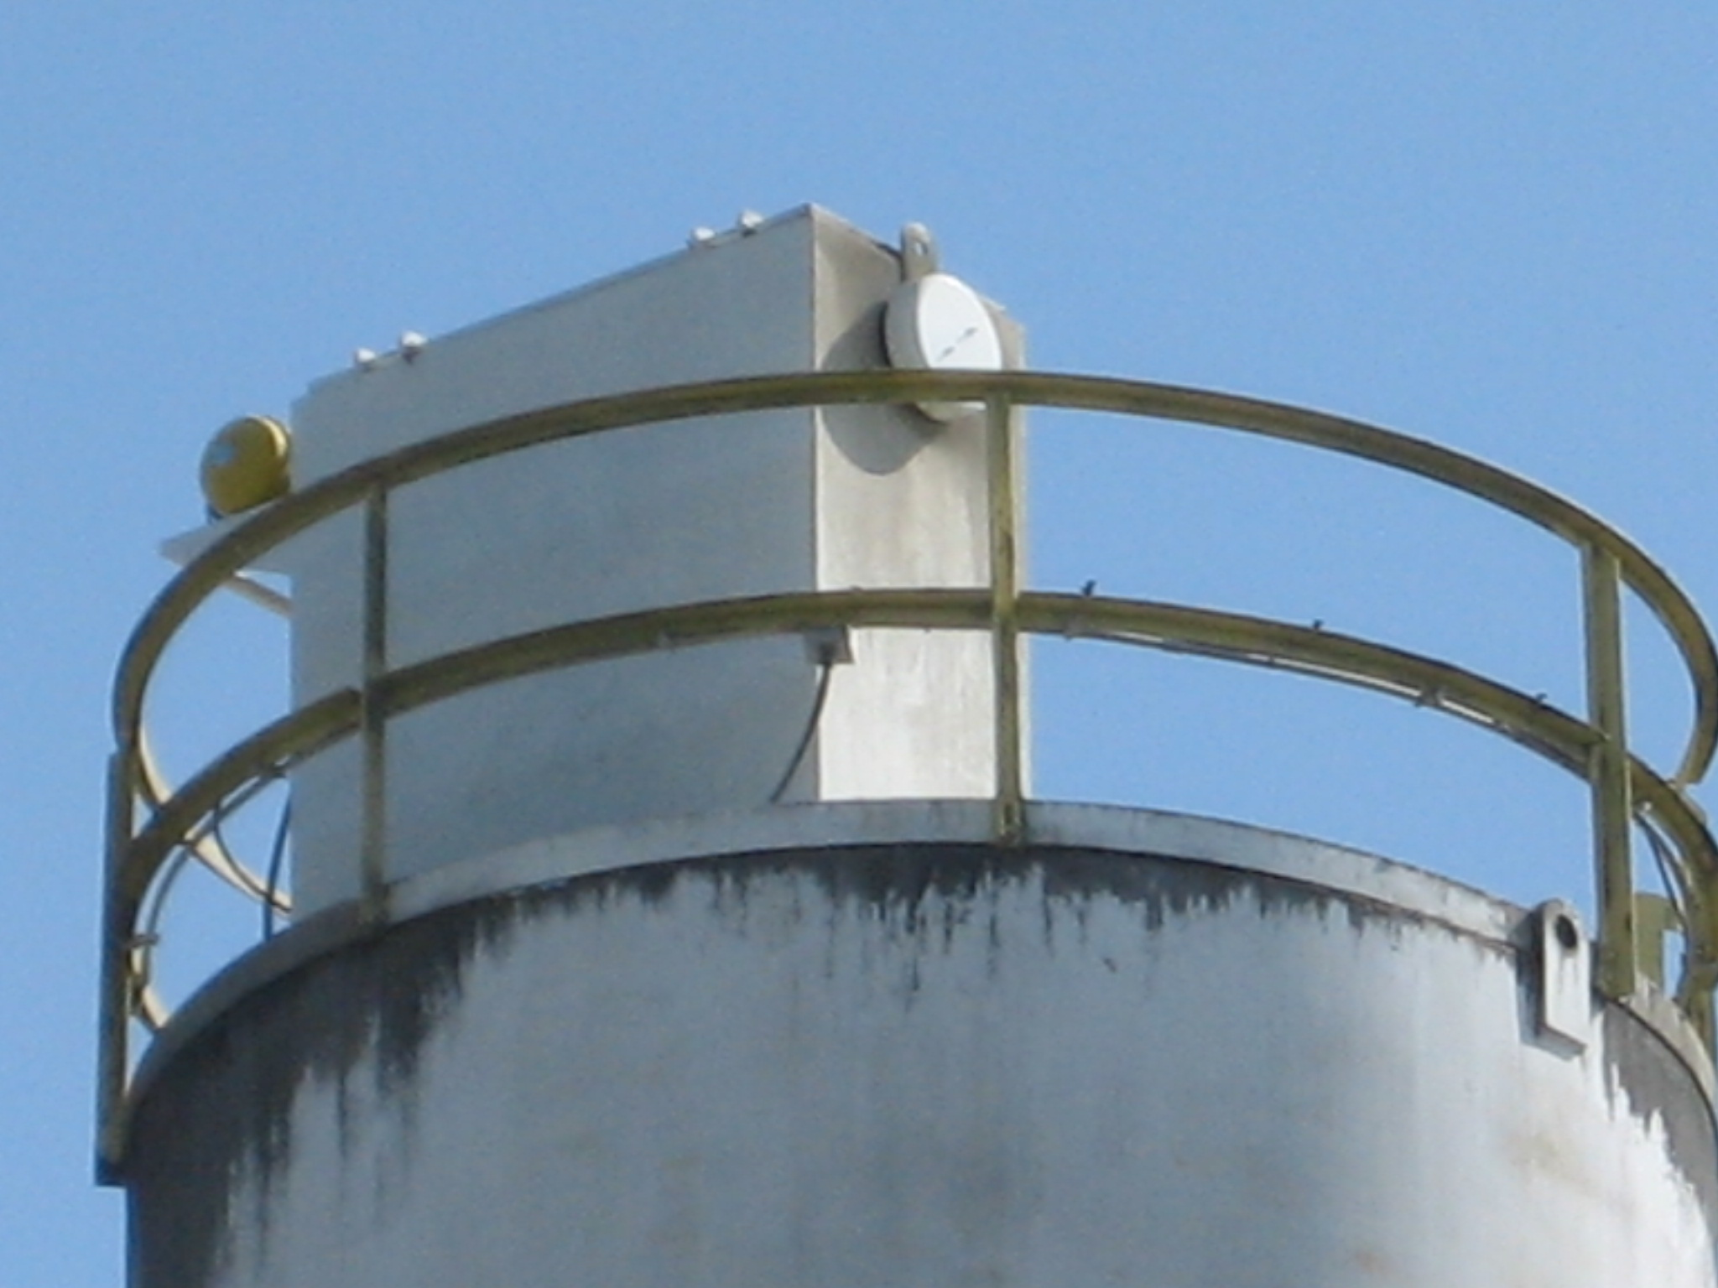
New CP C & W 305 Silo Top dust collector on Cement Silo EU #2

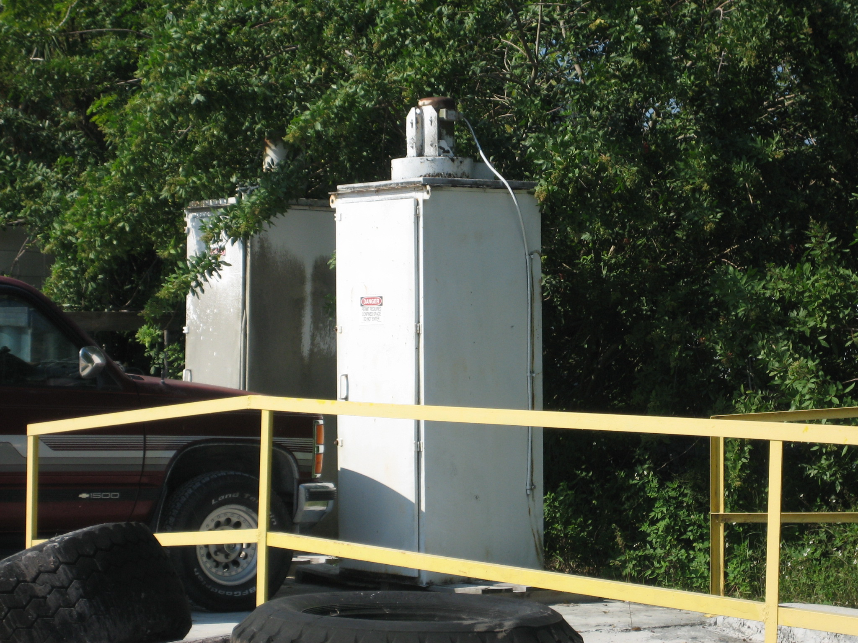
Old Griffith 36 LSB Silo top baghouses from EU#’s 1 and 2,
according to Mr. Nick Mascorro, plant manager.

