1030207 80787
FACILITY: TSE Industries Inc. |  |  |  |  |  |  |  |  |  |  |  |  |  |  |  |  |  |  |  | PERMIT ID: 508
 |  |  |  |  |  |  |  |  |  |  |  |  |  |  |  |  |  |  |  | DISTRICT: Southwest
ADDRESS: 5260 113th Avenue North |  |  |  |  |  |  |  |  |  |  |  |  |  |  |  |  |  |  |  | CONTACT PHONE:
Clearwater, FL |  |  |  |  |  |  |  |  |  |  |  |  |  |  |  |  |  |  |  | 727-573-7676
ARMS NO:  1030207 002 |  |  |  |  |  |  |  | PERMIT NO: |  |  |  |  |  |  |  |  |  |  |  | Expiration Date: 2/9/2016  Renewal Date: 12/11/2015
 |  |  |  |  |  |  |  | 1030207-011-AO
 |  |  |  |  |  |  |  |  |  |  |  |  |  |  |  |  |  |  |  | Test Due Date:
EMISSION UNIT DESCRIPTION : VOC and HAP Fugitive Emissions generated by the batch reactor system used to produce toluene-diisocyanate dimer, miscellaneous cleaning activities, quality control, and other associated activities

INSPECTION DATE: |  |  |  |  |  |  | ARMS INSPECTION TYPE: |  |  |  |  |  |  |  |  |  |  |  |  |  |  | COMPLIANCE STATUS:
 | June 29, 2012 |  |  |  |  |  |  |  |  | INS1 |  | ✓ | INS2 |  |  | INS3 |  |  | FUI |  |  |  | ✓ |  | IN |  |  | MNC |  |  |  |  |  | SNC
INSPECTION TYPE: |  |  |  | ✓ | Initial |  |  |  |  |  | Re-inspection |  |  |  |  |  | Complaint |  |  |  |  |  |  | Drive-by |  |  |  |  |  |  | Quarterly
✓ |  |  | A. General Review:
1. |  | Permit File Review |  |  |  |  |  |  |  |  |  |  |  |  |  |  |  |  |  |  |  |  |  |  |  |  |  |  |  | Yes |  |  |  |  | No
 |  | Comments: File reviewed
2. |  | Introduction and Entry |  |  |  |  |  |  |  |  |  |  |  |  |  |  |  |  |  |  |  |  |  |  |  |  |  |  |  | Yes |  |  |  |  | No
 |  | Comments: I met with the Richard Catalano, corporate counsel and Damean Thomas, technical supervisor
3. |  | Is the Responsible Official/Authorized Representative still: Robert Klingel? |  |  |  |  |  |  |  |  |  |  |  |  |  |  |  |  |  |  |  |  |  |  |  |  |  |  |  | Yes |  |  |  |  | No
Comments:
The Responsible Official/Authorized Representative’s e-mail is: Robert.Klingel@TSE-Industries.com
4. |  | Is the facility contact still: Radmila Petrovich? |  |  |  |  |  |  |  |  |  |  |  |  |  |  |  |  |  |  |  |  |  |  |  |  |  |  |  | Yes |  |  |  |  | No
Comments:
The facility contact’s e-mail is: Radmila.Petrovich l@tse-industries.com

IN | MNC | SNC |  |  | B. Specific Conditions:
✓  ✓  ✓  ✓  ✓  ✓  ✓  ✓  ✓  ✓  ✓  ✓  ✓  ✓ |  |  |  |  | General Conditions [62-4.160, F.A.C.]  8. If, for any reason, the permittee does not comply with or will be unable to comply with any condition or limitation specified in this permit, the permittee shall immediately provide the Department with the following information:  a. A description of and cause of noncompliance; and  b. The period of noncompliance, including dates and times; or, if not corrected, the anticipated time the noncompliance is expected to continue, and steps being taken to reduce, eliminate, and prevent recurrence of the noncompliance. The permittee shall be responsible for any and all damages which may result and may be subject to enforcement action by the Department for penalties or for revocation of this permit.  Comments: There were no issues of non compliance stated to have occurred and none evident to address at this time.  12. This permit or a copy thereof shall be kept at the work site of the permitted activity.  Comments: A copy of the permit was not kept at the worksite. Mrs. Petrovich maintains a copy of permit in her office personal computer.  Common Conditions [Rule 62-296.320(4)(c), F.A.C.]  Unless otherwise specified in the permit, the following conditions apply to all emissions units and activities at the facility.  Emissions and Controls  2. Circumvention: The permittee shall not circumvent the air pollution control equipment or allow the emission of air pollutants without this equipment operating properly. [Rule 62-210.650, F.A.C.]  Comments: There was no evidence of the control device being circumvented; the nitrogen blanket is in place to prevent toluene from being released. I observed the N2 rotameter float at 0.5 SCFM being maintained to prevent release of toluene.  6. VOC or OS Emissions: No person shall store, pump, handle, process, load, unload or use in any process or installation, volatile organic compounds (VOC) or organic solvents (OS) without applying known and existing vapor emission control devices or systems deemed necessary and ordered by the Department. [Rule 62-296.320(1), F.A.C.]  Comments: There were no observations of spills, leaks observed during the inspection. The containers were closed. There are pick up lines for the control of vapors coming from processes performed in the production lines where containers are filled from mixtures in the vats.  7. Objectionable Odor Prohibited: No person shall cause, suffer, allow or permit the discharge of air pollutants, which cause or contribute to an objectionable odor. An “objectionable odor” means any odor present in the outdoor atmosphere which by itself or in combination with other odors, is or may be harmful or injurious to human health or welfare, which unreasonably interferes with the comfortable use and enjoyment of life or property, or which creates a nuisance. [Rules 62-296.320(2) and 62-210.200(Definitions), F.A.C.]  Comments: An upwind/downwind survey of the facility was conducted. The observed parameters were:  Downwind odor level detected- none ; Wind direction - Northwesterly Upwind odor level detected-None.  The area where the toluene is stored had only very slight odor, was not detectable beyond the storage area.  9. Unconfined Particulate Emissions:  a. No person shall cause, let, permit, suffer or allow the emissions of unconfined particulate matter from any activity, including vehicular movement; transportation of materials; construction, alteration, demolition or wrecking; or industrially related activities such as loading, unloading, storing or handling; without taking reasonable precautions to prevent such emissions.  b. Any permit issued to a facility with emissions of unconfined particulate matter shall specify the reasonable precautions to be taken by that facility to control the emissions of unconfined particulate matter.  c. Reasonable precautions include the following:  (1) Paving and maintenance of roads, parking areas and yards.  (2) Application of water or chemicals to control emissions from such activities as demolition of buildings, grading roads, construction, and land clearing.  (3) Application of asphalt, water, oil, chemicals or other dust suppressants to unpaved roads, yards, open stock piles and similar activities.  (4) Removal of particulate matter from roads and other paved areas under the control of the owner or operator of the facility to prevent reentrainment, and from buildings or work areas to prevent particulate from becoming airborne.  (5) Landscaping or planting of vegetation.  (6) Use of hoods, fans, filters, and similar equipment to contain, capture and/or vent particulate matter.  (7) Confining abrasive blasting where possible.  (8) Enclosure or covering of conveyor systems.  Comments: 1.The facility is paved outside, there is no need for water application or other suppressants, and the grounds are completely landscaped. The facility utilizes hoods in lab areas and other work station areas where necessary to capture PM. There is not any abrasive blasting, in the manufacturing of the facilities products. There are no conveyor systems at this facility. The facility did not have unconfined particulate being emitted from activities performed inside the building at this time.  Permit Administrative Requirements  7. Volatile Organic Compounds (VOC) Emissions or Org- anic Solvents (0s)E missions : The permittee shall allow no person to store, pump, handle, process, load, unload or use in any process or installation, volatile organic compounds (VOC) or organic solvents (0s) without applying known and existing vapor emission control devices or systems deemed necessary and ordered by the Department as follows:  a. Maintain tightly fitting cover, lids, etc. on all containers when they are not being handled, tapped, etc.  b. Where possible and practical, procure/fabricate a tightly fitting cover for any open trough, basin, etc. of VOC so that it can be covered when not in use.  c. immediately attend to all spills/waste as appropriate. [Rule 62-296.320(1)(a), F.A.C.]  Comments: The facility maintains closed containers on products which are packaged in 55 gallon drums, 100 gallon totes and 5 gallon pails. There were no spills observed. The work areas are maintained with clean and open floors throughout the facility. The waste materials are stored in a separate area locked shelter in secondary containment on west side of building.  8 Annual Operating Report: On or before April 1 of each year, the permittee shall submit a completed DEP Form 62-210.900(5), "Annual Operating Report for Air Pollutant Emitting Facility" (AOR) for the preceding calendar year. The report may be submitted electronically in accordance with the instructions received with the AOR package sent by the Department, or a hardcopy may be sent to the Compliance Authority. [Rule 62-210.370(3), F.A.C.]  Comments: The annual operating report for calendar year 2011_ was submitted on 3/30/12 Completed review, fwd to SES on 5/10/12.  9 Operation Permit Renewal Application: A completed application for renewal of the operation permit shall be submitted to the Permitting Authority with a copy to PCDEM (Compliance Authority) no later than 60 days prior to the expiration date of the operation permit. [Rules 62-4.030, 62-4.050, 62-4.070(3), 62-4.090, 62-210.300(2), and 62-210.900, F.A.C.]  Comments: The permit expires on 2/9/2016 . An application is required to be submitted no later than 12/11/2015.  A. Common Conditions for EU Nos. 002 and 003  This section of the document include common conditions for the following emissions units:  A.2. VOC/HAP Emission Limitations: VOC and HAP emissions from EU Nos. 002 and 003 shall not exceed the following limits:  [Rule 62-210.200, F.A.C. - Definitions (PTE); and as requested by the permittee in applications  dated 03/09/2011 and 12/22/2011]  Comments: The point #2 consist of the Lab toluene, TDI, IPA, NMP, Mixed lab chemical, and Miscellaneous VOC/HAPs. The highest monthly usage was 0.198 tons for month January 2012. The cumulative VOC total was 1.97 tons, HAP Total was 0.230 tons. The cumulative totals were 4.36 tons VOC 3.265 tons HAPS for combination of 002 and 003 3\emissions. These totals are below the  ( Individual HAP) 9.5 Tons Total Hazardous Air Pollutants (Total HAPs) 23.5 Tons Volatile Organic Compounds (VOCs) 29.75 Tons, therefore the facility is in compliance of this conditions.  A.3. Recordkeeping: The permittee shall maintain adequate records to demonstrate compliance with the emission limitations in Specific Condition No. A.1. See Specific Condition Nos. 8.1. and C.3. for additional recordkeeping requirements [Rule 62-4.070(3), F.A.C]  Comments: Mrs. Petrovich maintains the records according to the permit conditions and keeps in her personal computer.  A.4. Record Completion and Retention: All daily records required by this permit shall be completed within ten (10) calendar days and all monthly records shall be completed by the 15th day of the following month All records required by this permit shall be maintained at the facility for at least three (3) years, and be made available to the Department or PCAQD upon request.  [Rules 62-4.160(14) and 62-4.070(3), F.A.C]  Comments: The records from 1999 to 2004 have been archived to disk. The rest of the records to date are maintained with Mrs. Petrovich. The annual records are maintained in her personal computer up through May 2012.  EMISSION UNIT ID 002 – VOC AND HAP FUGITIVE EMISSIONS  B.1. VOC / HAP Monthly Records: To demonstrate compliance with the VOC and HAP limitations of Specific Condition No. A.2., the permittee shall maintain a monthly VOC and HAP emissions log, which includes the following:  a. Facility name, Facility ID No. (1030207), Emission Unit No. (002);  b. Month and year of the record;  c. The usage of each solvent and other VOC/HAP-containing material;  d. The VOC and HAP content in each solvent and any other VOC/HAP-containing material;  e. The VOC, total HAP and each individual HAP emissions for the month (tons); and  f. The most recent consecutive 12-month total emissions of VOC, total HAP and each individual HAP (tons). [Rule 62-4.070(3), F.A.C.]  Comments: This condition pertaining to the records is for the monitoring of the toluene tanks under emission unit 003 and lab use. I could not observe the records; the facility contact was not in at this time, Mrs. Petrovich called from Canada while I was on site. She stated she would forward records to email when she can get to a location where she could send to our office. I received copies of records on 7/2/2012. (See attached copies)  B.2. Documentation - Appropriate records to support the estimation of VOC/HAP usage emission logs, including Material Safety Data Sheets (MSDS), EPA data sheets, mass-fraction analyses, purchase orders, tank soundings, and distillation-bottom analyses shall be maintained at the facility and be made available to the Department or the Pinellas County Department of Environmental Management upon request. Records verifying the non-VOC or non-HAP quality of other materials shall also be maintained.  [Rule 62-4.070(3), F.A.C.]  Comments: Mrs. Petrovich is maintaining approximately 3000 MSD sheets for the products produced and used for the facility.
  Pollutant | Allowable Emissions  (tons per any consecutive 12-month period)
  Volatile Organic Compounds (VOCs) | 29.75
  Total Hazardous Air Pollutants (Total HAPs) | 24.5
  Any Individual Hazardous Air Pollutant  (Individual HAP) | 9.9
✓ |  |  |  |  | Valid Permit [Rule 62-210.300]
✓ |  |  |  |  | Changes to Facility/emission unit [Rule 62-210.300]  Does the emission unit description above match what the facility is operating (Number of emission units or points, model number and serial number, etc.) Yes No  Comments:
✓ |  |  | C. Other:
Pollution Prevention Activities
- P2 Handouts Provided: P2 Brochure; P2 Manual; P2 Checklist
- Have any emissions reductions occurred Yes / No
Chemical Substitution; Equipment Changes; Process Changes
Chemical/Material Reuse; On-site Recycling; Other:
Comments: There have been no changes since the return to use of Toluene.

Closing Conference: I informed Mr. Thomas I would be in contact with Mrs. Petrovich if needed additional information or records.

Inspector(s): Shea Jackson, Pinellas County, Air Quality Division
Signature(s): Date: |  |  |  |  |  |  |  |  | Date: July 2, 2012
ACCESS? |  |  |  | ✓ |  | ARMS? | ✓

TSE Industries Inc.
5260 113th Avenue North, Clearwater

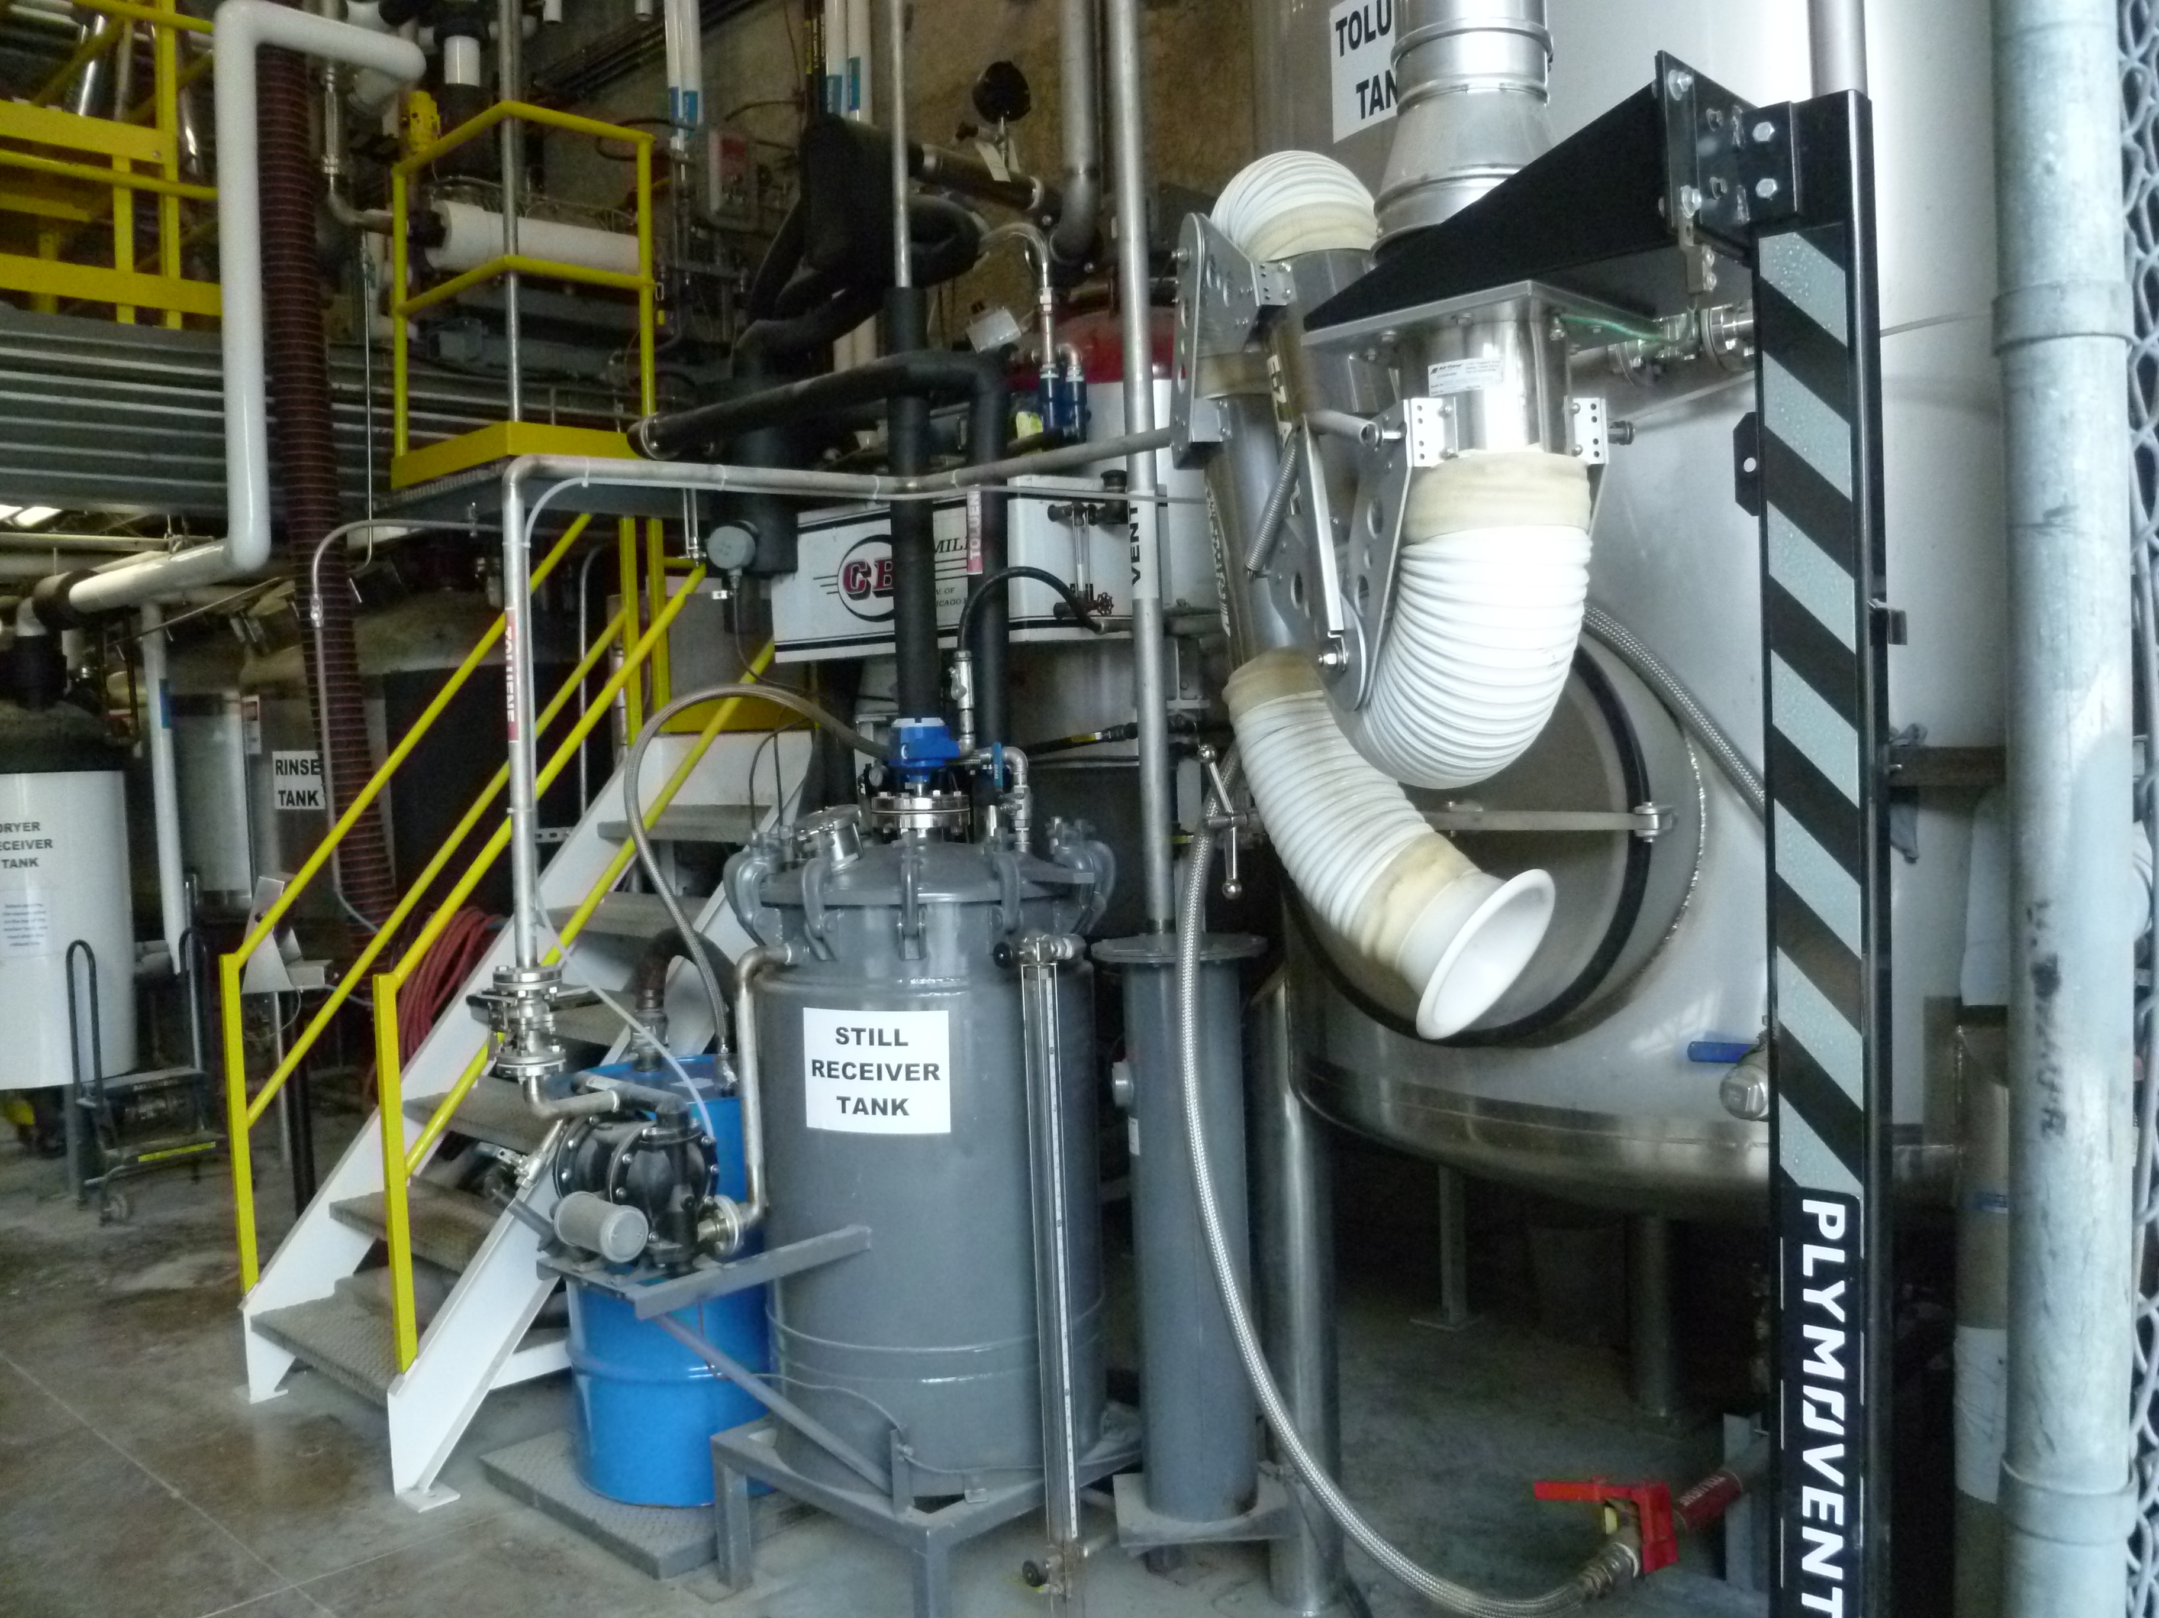

Project Id: 80787 Permit No: 1030207-011-AO Arms Number: 0207 002
Inspector: Shea Jackson Inspection Date / Time: 6/29/2012 / _______
Source (EU): VOC and HAP Fugitive Emissions generated by the batch reactor system used to produce toluene-diisocyanate dimer, miscellaneous cleaning activities, quality control, and other associated activities

Description: [This is the Toluene tank storage area and area of T9 dimer processing, located in the outside storage area of the main building. ]

TSE Industries Inc.
5260 113th Avenue North, Clearwater

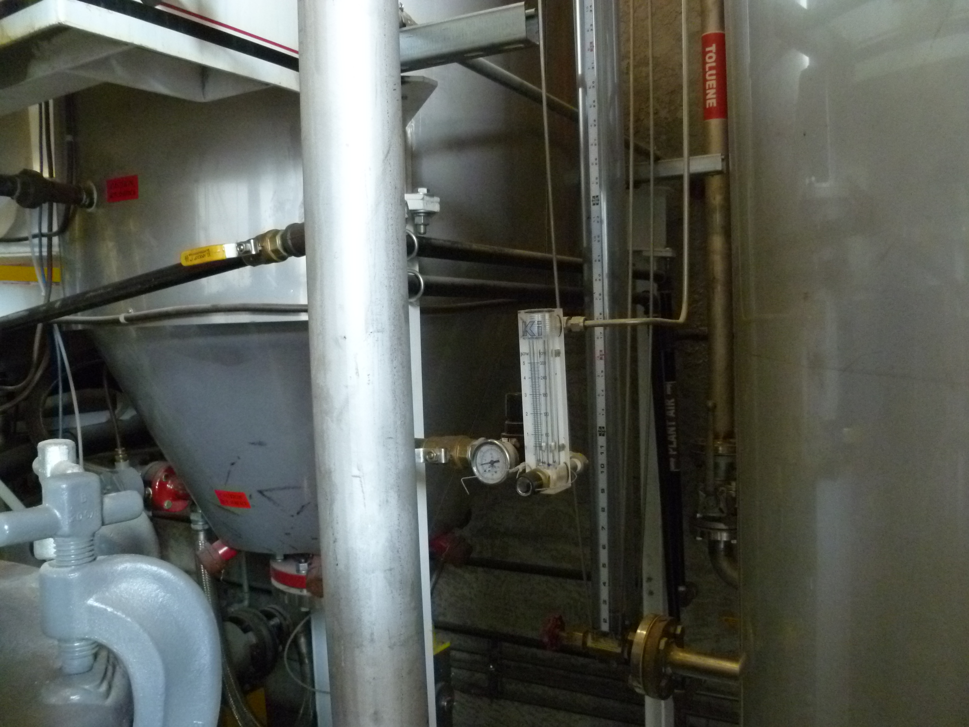

Project Id: 80787 Permit No: 1030207-011-AO Arms Number: 0207 002
Inspector: Shea Jackson Inspection Date / Time: 6/29/2012 / _______
Source (EU): VOC and HAP Fugitive Emissions generated by the batch reactor system used to produce toluene-diisocyanate dimer, miscellaneous cleaning activities, quality control, and other associated activities

Description: [The nitrogen flow meter is monitored to insure the nitrogen blanket is maintained to prevent

the release of toluene ]

TSE Industries Inc.
5260 113th Avenue North, Clearwater

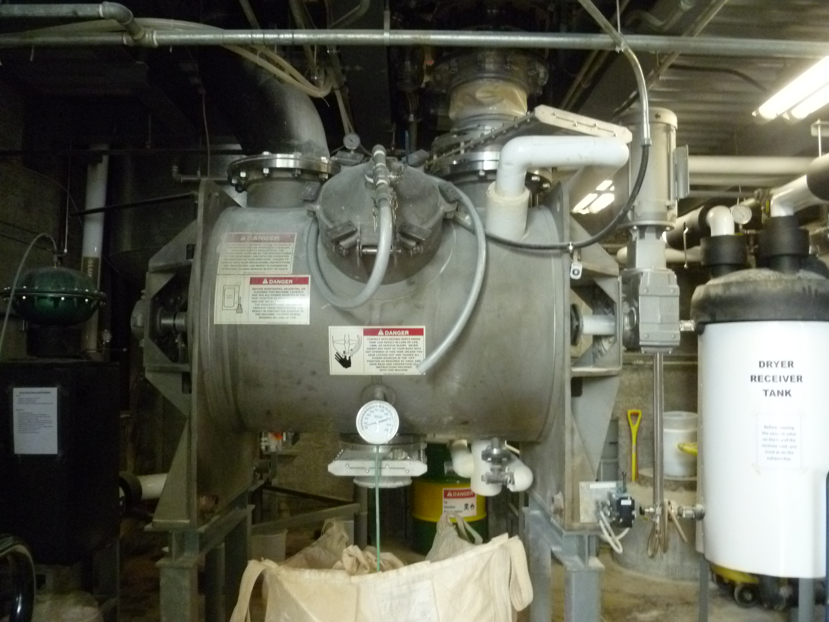

Project Id: 80787 Permit No: 1030207-011-AO Arms Number: 0207 002
Inspector: Shea Jackson Inspection Date / Time: 6/29/2012 / _______
Source (EU): VOC and HAP Fugitive Emissions generated by the batch reactor system used to produce toluene-diisocyanate dimer, miscellaneous cleaning activities, quality control, and other associated activities

Description: [This is the reactor vessel used to produce the T9 dimer ]

