1030094 75599
FACILITY: Intercit, Inc. |  |  |  |  |  |  |  |  |  |  |  |  |  |  |  |  |  |  |  | PERMIT ID: 2696
Firmenich |  |  |  |  |  |  |  |  |  |  |  |  |  |  |  |  |  |  |  | DISTRICT: Southwest
ADDRESS: 1585 South 10th Street |  |  |  |  |  |  |  |  |  |  |  |  |  |  |  |  |  |  |  | CONTACT PHONE:
Safety Harbor, FL |  |  |  |  |  |  |  |  |  |  |  |  |  |  |  |  |  |  |  | 727-725-1678
ARMS NO:  1030094 007 |  |  |  |  |  |  |  | PERMIT NO: |  |  |  |  |  |  |  |  |  |  |  | Expiration Date: 2/17/2011  Renewal Date: 12/19/2010
 |  |  |  |  |  |  |  | 1030094-018-AF
 |  |  |  |  |  |  |  |  |  |  |  |  |  |  |  |  |  |  |  | Test Due Date:
EMISSION UNIT DESCRIPTION : There are 31 non-NSPS tanks (14 storage tanks and 17 blend/process tanks) shown in Appendix E
CMS INSPECTION DATE: |  |  |  |  |  |  | ARMS INSPECTION TYPE: |  |  |  |  |  |  |  |  |  |  |  |  |  |  | COMPLIANCE STATUS:
 | February 16, 2011 |  |  |  |  |  |  |  |  | INS1 |  | ✓ | INS2 |  |  | INS3 |  |  | FUI |  |  |  | ✓ |  | IN |  |  | MNC |  |  |  |  | SNC
INSPECTION TYPE: |  |  |  | ✓ | Initial |  |  |  |  |  | Re-inspection |  |  |  |  |  | Complaint |  |  |  |  |  |  | Drive-by |  |  |  |  |  | Quarterly
✓ |  |  | A. General Review:
1. |  | Permit File Review |  |  |  |  |  |  |  |  |  |  |  |  |  |  |  |  |  |  |  |  |  |  |  |  |  |  | Yes |  |  |  |  | No
 |  | Comments: : File review for stack test inspection
2. |  | Introduction and Entry |  |  |  |  |  |  |  |  |  |  |  |  |  |  |  |  |  |  |  |  |  |  |  |  |  |  | Yes |  |  |  |  | No
 |  | Comments: I met on site with Tom Pearson, Tom John company consultant and Southern Environmental testing team Byron Nelson, and David Cassatt.
3. |  | Is the Responsible Official/Authorized Representative still: Patricia Sinnott? |  |  |  |  |  |  |  |  |  |  |  |  |  |  |  |  |  |  |  |  |  |  |  |  |  |  | Yes |  |  |  |  | No
Comments: She is still company president..
The Responsible Official/Authorized Representative’s e-mail is: patricia.sinnot@firmenich.com
4. |  | Is the facility contact still: Tom Pearson? |  |  |  |  |  |  |  |  |  |  |  |  |  |  |  |  |  |  |  |  |  |  |  |  |  |  | Yes |  |  |  |  | No
Comments: Mr. Pearson is the new facility contact as recorded in the access data base.
The facility contact’s e-mail is: tom.pearson@firmenich.com
IN | MNC | SNC | B. Specific Conditions:
✓  ✓  ✓  ✓  ✓  ✓  ✓  ✓  ✓  ✓  ✓  ✓  ✓ |  |  | Inspection note: This permit, effective on 2/9/10, revises FESOP No. 1030094-015-AF to incorporate the terms and conditions of Air Construction Permit No. 1030094-017-AC.  General Conditions [62-4.160, F.A.C.]  12. This permit or a copy thereof shall be kept at the work site of the permitted activity.  Comments: A copy of the permit was was not kept at the worksite. Mr. Pearson, keep file copies of all records in the main office at the east end of the property. Mr. Pearson stated they will not be removing any more tanks. They may be using the distilling tank for the IPA recycling on their own property under a new permit.  8. If, for any reason, the permittee does not comply with or will be unable to comply with any condition or limitation specified in this permit, the permittee shall immediately provide the Department with the following information:  - A description of and cause of noncompliance; and  - The period of noncompliance, including dates and times; or, if not corrected, the anticipated time the noncompliance is expected to continue, and steps being taken to reduce, eliminate, and prevent recurrence of the noncompliance. The permittee shall be responsible for any and all damages which may result and may be subject to enforcement action by the Department for penalties or for revocation of this permit.  Comments: The facility has not made any changes and there have not been any upset conditions or non compliance issues at this time. The facility has determined the facility will remain open for 2-3 more years at this location.  Common Conditions [Rule 62-296.320(4)(c), F.A.C.]  2. Circumvention: The permittee shall not circumvent the air pollution control equipment or allow the emission of air pollutants without this equipment operating properly. [Rule 62-210.650, F.A.C.]  Comments: There are no control devices on this emission unit to be circumvented.  6. VOC or OS Emissions: No person shall store, pump, handle, process, load, unload or use in any process or installation, volatile organic compounds (VOC) or organic solvents (OS) without applying known and existing vapor emission control devices or systems deemed necessary and ordered by the Department. [Rule 62-296.320(1), F.A.C.]  Comments: the facility is maintaining closed containers, no spills were observed in the work areas.  I noted the liquids to be contain in process lines and secondary containment areas.  7. Objectionable Odor Prohibited: No person shall cause, suffer, allow or permit the discharge of air pollutants, which cause or contribute to an objectionable odor. An “objectionable odor” means any odor present in the outdoor atmosphere which by itself or in combination with other odors, is or may be harmful or injurious to human health or welfare, which unreasonably interferes with the comfortable use and enjoyment of life or property, or which creates a nuisance. [Rules 62-296.320(2) and 62-210.200(Definitions), F.A.C.]  Comments: An upwind/downwind survey of the facility was conducted. The observed parameters were:  Downwind odor level detected- none ; Wind direction – northwesterly Upwind odor level detected-none There was a mild orange citrus scent detectable on the property during the durorome processing.  9. Unconfined Particulate Emissions:  - No person shall cause, let, permit, suffer or allow the emissions of unconfined particulate matter from any activity, including vehicular movement; transportation of materials; construction, alteration, demolition or wrecking; or industrially related activities such as loading, unloading, storing or handling; without taking reasonable precautions to prevent such emissions.  - Any permit issued to a facility with emissions of unconfined particulate matter shall specify the reasonable precautions to be taken by that facility to control the emissions of unconfined particulate matter.  - Reasonable precautions include the following:  - Paving and maintenance of roads, parking areas and yards.  - Application of water or chemicals to control emissions from such activities as demolition of buildings, grading roads, construction, and land clearing.  - Application of asphalt, water, oil, chemicals or other dust suppressants to unpaved roads, yards, open stock piles and similar activities.  - Removal of particulate matter from roads and other paved areas under the control of the owner or operator of the facility to prevent reentrainment, and from buildings or work areas to prevent particulate from becoming airborne.  - Landscaping or planting of vegetation.  - Use of hoods, fans, filters, and similar equipment to contain, capture and/or vent particulate matter.  - Confining abrasive blasting where possible.  - Enclosure or covering of conveyor systems.  Comments: The facility does not have any activities which generate unconfined particulate matter at this time. The items under c(1-5 and (7,8) are not applicable to this location. The use of hoods fans and filters are used inside the building to capture and remove particulate during the encapsulating process.  Administrative Requirements  7 Annual Operating Report: On or before April 1 of each year, the permittee shall submit a completed DEP Form 62-210.900(5), "Annual Operating Report for Air Pollutant Emitting Facility" (AOR) for the preceding calendar year. The report may be submitted electronically in accordance with the instructions received with the AOR package sent by the Department, or a hardcopy may be sent to the Compliance Authority. [Rule 62-210.370(3), F.A.C.]  Comments: The annual operating report for calendar year 2009 was submitted on last year as required and on time on 4/15/2010. The 2010 AOR was submitted according to the consultant Tom John.  8 Operation Permit Renewal Application: A completed application for renewal of the operation permit shall be submitted to the Permitting Authority with a copy to PCDEM (Compliance Authority) no later than 60 days prior to the expiration date of the operation permit.  [Rules 62-4.030, 62-4.050, 62-4.070(3), 62-4.090, 62-210.300(2), and 62-210.900, F.A.C.]  Comments: The permit expires on 2/17/11. An application is required to be submitted no later than 12/19/10. Tom John stated the permit applications was submitted and being reviewed by Dan Stubb. He stated there should be a copy with Gary Robbins for review. The ARMS data base showed that the permit was received 12/20/2010.  Performance Restrictions  A.2. VOC and HAP Multi-Unit Emission Limits: The Total VOC and Total HAP emissions from Emission Units 007 and 008 shall not exceed the following limits:  [Rule 62-210.200 (PTE); Construction Permit 1030094-017-AC]  Comments: The highest reported emissions were 0.45, & 0 .47 tons VOC, for EU 007 for the months of October & December 2010 respectively. The total VOCS was 2.64 tons for the /rolling 12-month period reviewed records for the months of January 20 through December 2010 . The total facility emissions rolling 12-month period were 004 = VOC 0.59 HAPS = 0.13, 007 VOC = 2.64,AND 008 VOC =0.38 AND HAP = 0.28 . TOTALS = VOC – 3.61 AND HAP =0.41. These totals do not exceed the above limitations.  A.3. Multi-Unit VOC and HAP Recordkeeping: In order to document compliance with the requirements of Specific Condition No. A.2., the permittee shall maintain the following records:  - Facility Name, Facility ID No. (10300094) Month and Year;  - The total quantity of VOCs emitted from emission units 007 and 008 for the month (in tons);  - The total quantity of HAPs emitted from emission units 007 and 008 for the month (in tons).  - The total quantity of VOCs emitted from emission units 007 and 008 for the most recent consecutive 12-month period (in tons);  - The total quantity of HAPs emitted from emission units 007 and 008 for the most recent consecutive 12-month period (in tons).  [Rule 62-4.070(3), F.A.C.]  Note: Multi-Unit VOC and HAP emissions shall include contributions from emission units 007 and 008.  Comments: The records for all units were obtained and meet with the above listed conditions A – E., for facility Name, Id number year, and total quantity of VOC and HAPS emitted from units 004 007 and 008.  A.4. Records Retention: All daily records required by this permit shall be completed within ten (10) calendar days and all monthly records shall be completed by the end of the following month. All records required by this permit shall be maintained at the facility for at least three years, unless otherwise noted, and be made available to the Department or the Pinellas County Department of Environmental Management (PCDEM) for inspection upon request. [Rules 62-4.160(14)(b) and 62 4.070(3), F.A.C.; Pinellas County Code Section 58-90]  Comments: The records for the daily operations are taken by operators of equipment and tank observations, then records are forwarded to the managers and monthly, yearly total are compiled and given to the consultant Tom John for calculations and input into spreadsheets and then returned to Tom Pearson for keeping in file in main front office, Environmental file 01 . The records are available back to 2005.  C.1. Tank Removal Notification: The permittee shall notify the Pinellas County Department of Environmental Management (PCDEM) with a copy to the Air Permitting Section of the Department’s Southwest District Office, in writing of the removal date for each process tank, P-18 and P-26. The written notification shall be postmarked within 5 days after such date.  [Rule 62-4.070(3), F.A.C.]  Comments: There have been no additional tank removals. The facility is considering staying on site for 2 – 3 more years.  C.2. Single-Unit VOC and HAP Emissions Recordkeeping: In order to document compliance with the VOC and HAP limitations of Specific Condition No. A.2., the permittee shall maintain the following monthly records:  - Facility Name, Facility ID No. (1030094), Emission Unit ID No. (007), and Month/Year.  - For each storage tank record the following:  - The storage tank ID number.  - The volume and composition of material delivered to each storage tank. Where “storage tank” refers to a tank that receives material directly from a tanker truck.  - The total volume (in gallons) of each material (i.e. ethanol, isopropanol, terpenes) delivered to the storage tanks for the month.  - HAP Emissions  - The HAP content for each raw material delivered.  - The total system HAP emissions (in pounds or tons) for the month. Where “system” refers to all storage tanks and blend/process tanks. This value shall be determined by multiplying the storage tank HAP emissions by a multiple of four.  - The total system HAP emissions (in pounds or tons) for the most recent consecutive 12-month period.  - VOC Emissions  - The total storage tank VOC emissions (in pounds or tons) for the month. Unless changes to the emission factors are required, emissions from all storage tanks (combined) shall be estimated using the following emission factors which were derived from working and breathing calculations:  - If changes to these emission factors are required, the permittee shall notify the Air Permitting Section of the Department’s Southwest District Office of any proposed changes and must receive written approval from the Department prior to implementing the changes.  - Note: The emission factors listed in the table above, corresponds to pure compound throughputs (100% ethanol, 100% Terpenes and 100% Isopropanol). Throughputs at concentrations other than 100% (i.e. 12% , 95%) must be adjusted to reflect only the pure compound portion of the mixture when calculating emission.  - The total system VOC emissions (in pounds or tons) for the month. Where “system” refers to all storage tanks and blend/process tanks. This value shall be determined by multiplying the storage tank VOC emissions by a multiple of four.  - The total system VOC emissions (in pounds or tons) for the most recent consecutive 12-month period.  Note: The storage tank emission factor and system multiplier were determined based on information provided in the permit application dated May 18, 2006 and additional information application received by the Department on October 2, 2006. [Rule 62-4.070(3), F.A.C.; Construction Permit 1030094-017-AC]  Note: Single-Unit VOC and HAP emissions shall include contributions only from emission unit 007.  Comments: The records for all units were obtained and meet with the above listed conditions A – D (1-5), for facility Name, Id number year, and total quantity of VOC and HAPS emitted from units 004, 007 and 008. The tanks are all labeled as required. The tanks and equipment are shared for the emission units.  The facility emissions have not exceeded the above limitations, The records after accumulation from these divisions are sent to Tom Johns , Inc. for entry into the spread sheets (See copies of operators daily logs and monthly summary sheets and emissions spreadsheet). The total through put for the month of December 2010 was 1,339,196 gallons.  Storage Tanks - vented emissions / evaporation losses during 2010 determined by breathing lbs/ gal throughput, and working lbs/ gal stored. The FIRE data is used with calculations for the terpene:ethanol mole weight and vapor losses. The VOC emissions 12 month rolling total was 1339.19 gals. The highest monthly total was June and October 2010 and December 2011 with .33 , 0.4, and 0.47 tons. The emissions are determined by the ethanol, Isopropyl Alcohol and Terpene losses from the tanks breathing/venting and working. (See record copies).
  Pollutant | Annual Emission Limits
  Pollutant | (Tons/any consecutive 12 month period)
  Total Volatile Organic Compounds (VOC) | 30.0
  Total Hazardous Air Pollutants (HAPS)  All HAPS must be VOCs | 2.0
  - Storage tank VOC Emission Factors
  - 3849 lbs of VOC / million gallons of pure ethanol throughput
  - 62 lbs of VOC / million gallons of pure terpenes throughput
  - 760 lbs of VOC / million gallons of pure isopropanol throughput
✓ |  |  | Valid Permit [Rule 62-210.300]
✓ |  |  | Changes to Facility/emission unit [Rule 62-210.300]  Does the emission unit description above match what the facility is operating (Number of emission units or points, model number and serial number, etc.) Yes No  Comments: there have been no changes to the emission units operation.

✓ |  | C. Other:
Pollution Prevention Activities
- P2 Handouts Provided: P2 Brochure; P2 Manual; P2 Checklist
- Have any emissions reductions occurred Yes / No
Chemical Substitution; Equipment Changes; Process Changes
Chemical/Material Reuse; On-site Recycling; Other:
Comments: The facility is reviewing the cost of processing their own IPA to recycle by distilling on site. This would reduce the facility cost of sending out the spent IPA and having to purchase IPA at higher cost

Closing Conference: I informed Mr. Pearson, that the facility appears to be in compliance at this time, and I will review the records and be in contact with him if there are any questions.

Inspector(s): Shea Jackson, Pinellas County, Air Quality Division
Signature(s): Date: |  |  |  |  |  |  | Date: February 22, 2011
 | ACCESS? |  | ü | ARMS? | ü

Intercit, Inc. Firmenich
1585 South 10th Street, Safety Harbor

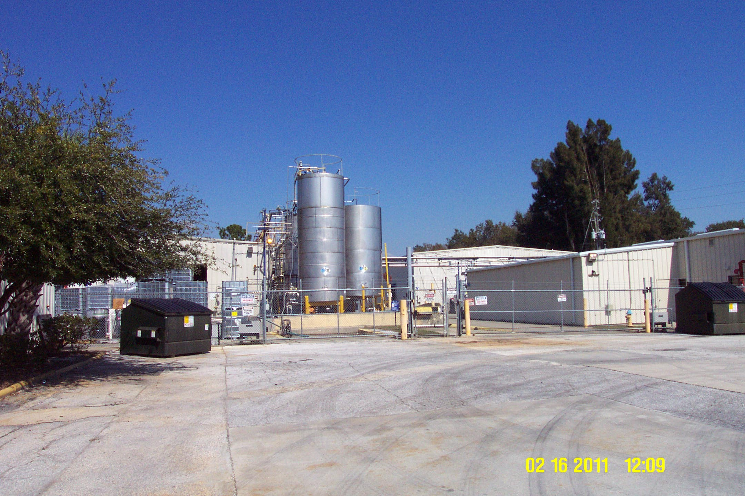

Project Id: 75599 Permit No: 1030094-018-AF Arms Number: 0094 007
Inspector: Shea Jackson Inspection Date : 2/16/2011
Source (EU): There are 31 non-NSPS tanks (14 storage tanks and 17 blend/process tanks) shown in Appendix E

Description: [This facility has a number of tanks used in the processing of Natural products. ]

Intercit, Inc. Firmenich
1585 South 10th Street, Safety Harbor

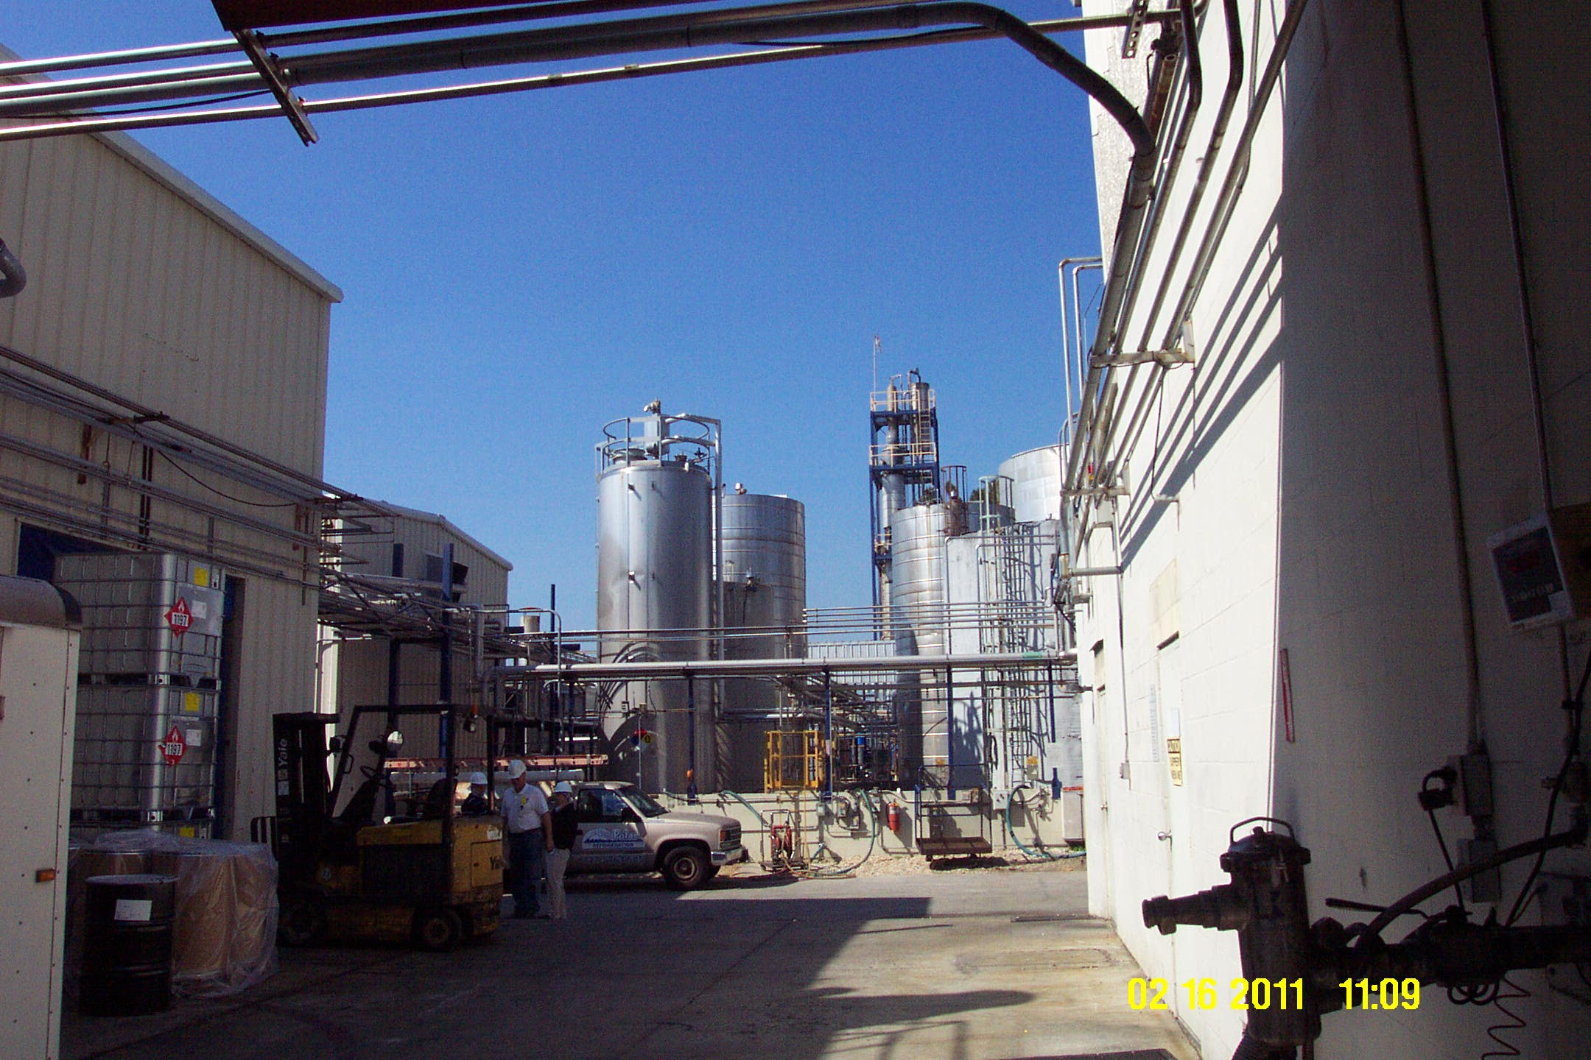

Project Id: 75599 Permit No: 1030094-018-AF Arms Number: 0094 007
Inspector: Shea Jackson Inspection Date: 2/16/2011
Source (EU): There are 31 non-NSPS tanks (14 storage tanks and 17 blend/process tanks) shown in Appendix E

Description: [This facility has a number of tanks used in the processing of Natural products. ]

]

AIRS ID  1030094 | OWNER  Intercit, Inc. |  | FACILITY NAME  Firmenich
TITLE V |  | SYNTHETIC MINOR | DATE OF THIS FCE
TITLE V MEGA-SITE* |  | OTHER | DATE OF LAST FCE
*Facility with a large number of complex emissions units. It is more reasonable to evaluate a Title V Mega-Site once every 3 years instead of once every 2 years.

Review of All Required Reports

PERIODIC REPORTS |  | COMMENTS
DONE N/A | Annual operating report
DONE N/A | Statement of compliance
DONE N/A | Annual
DONE N/A | Semi-annual
DONE N/A | Quarterly
DONE N/A | Other :
DONE N/A | Other :

CONTINUOUS EMISSION MONITOR REPORTS |  | COMMENTS
DONE N/A | Quarterly excess emissions
DONE N/A | Semi-annual
DONE N/A | RATA
DONE N/A | CGA
DONE N/A | Other :
DONE N/A | Other :

Assessment of Control Device and Process Operating Conditions

OFF-SITE ASSESSMENT |  | (Describe the off-site assessment in comments)
ON-SITE ASSESSMENT |  | (Document the on-site inspection below)
DATE OF INSPECTION | DATE OF INSPECTION REPORT |  | My office maintains the inspection report...
DATE OF INSPECTION |  |  | ...in the ARMS database through EASIIR. | ...with the paper or electronic compliance files | ...in another location (specify).
2/16/2011 |  |  |  |  | in access database
COMMENTS
2/16/2011 - Inspection and stack test observation of the flavor capsulating process. I met with the faciity contact Tom Pearson, and consultant Tom John with the southern environmental Testing team Byron Nelson. The process rate during testing was 1351.6 lbs/hour which is 90% for the maximum process capacity of the durorome processing . The total facility emissions rolling 12-month period were 004 = VOC 0.59 HAPS = 0.13, 007 VOC = 2.64,AND 008 VOC =0.38 AND HAP = 0.28 . TOTALS = VOC – 3.61 AND HAP =0.41. These totals do not exceed the permit limitations

Review of Tests and Records
TESTS, OBSERVATIONS AND RECORDS |  | COMMENTS
DONE N/A | Visible emission observation(s)
DONE N/A | Review of facility records and logs
DONE N/A | Assessment of process parameters (feed rates, process rates, raw material compositions, etc.)
DONE N/A | Assessment of control equipment performance parameters  (water flow rates, pressure drops, temperatures, ESP power levels, etc.)
DONE N/A | Stack test(s)
DONE N/A | Other :
DONE N/A | Other :

Compliance Monitoring (CM) Information
CM ELEMENT | My office maintains this information...
CM ELEMENT | ...electronically, in the ARMS database. | ...in the permit. | ...in the inspection report. | ...in another location (specify).
Facility information |  |  |  | in access database
Applicable requirements |  |  |  | in access database
Inventory of emission units |  |  |  | in access database
Enforcement history |  |  |  | in access database
Compliance activities |  |  |  | in access database
Findings and recommendations |  |  |  | in access database
COMMENTS

Other Comments

Prepared by: Shea Jackson Date: 2/25/2011 & 9/2/2011

Reviewed by: Date:

1. Complete the form as much as possible during for inspection; 2. The remainder of checklist, for activities in the FY, are filled in no later than 9/15; 3. Between 9/15 and 9/30, complete the FCE by closing out the FCS project in ARMS. The INSP > FCS record only accepts a completion date and a comment; it does not accept information on the lower portion of the form. If an FCS project already exists for the fiscal year in question, enter a completion date and comment in the existing record, do not create a duplicate FCS record

