1030012 84549
FACILITY: Duke Energy Florida, Inc. |  |  |  |  |  |  |  |  |  |  |  |  |  |  |  |  |  |  |  | PERMIT ID: 82
Higgins Plant |  |  |  |  |  |  |  |  |  |  |  |  |  |  |  |  |  |  |  | DISTRICT: Southwest
ADDRESS: 998 East Shore Drive |  |  |  |  |  |  |  |  |  |  |  |  |  |  |  |  |  |  |  | CONTACT PHONE:
Oldsmar, FL |  |  |  |  |  |  |  |  |  |  |  |  |  |  |  |  |  |  |  | 727-827-6161
ARMS NO:  1030012 007 |  |  |  |  |  |  |  | PERMIT NO: |  |  |  |  |  |  |  |  |  |  |  | Expiration Date: 12/31/2017  Renewal Date: 5/17/2017
 |  |  |  |  |  |  |  | 1030012-007-AV
 |  |  |  |  |  |  |  |  |  |  |  |  |  |  |  |  |  |  |  | Test Due Date:
EMISSION UNIT DESCRIPTION : Combustion Turbine Peaking Unit No. 4; Rated at 42.9 MW at 59 degrees F and 631 MMBtu Fired on New No. 2 Fuel Oil
CMS INSPECTION DATE: |  |  |  |  |  |  | ARMS INSPECTION TYPE: |  |  |  |  |  |  |  |  |  |  |  |  |  |  | COMPLIANCE STATUS:
 | June 24, 2013 |  |  |  |  |  |  |  |  | INS1 |  | ✓ | INS2 |  |  | INS3 |  |  | FUI |  |  |  | ✓ |  | IN |  |  | MNC |  |  |  |  | SNC
INSPECTION TYPE: |  |  |  | ✓ | Initial |  |  |  |  |  | Re-inspection |  |  |  |  |  | Complaint |  |  |  |  |  |  | Drive-by |  |  |  |  |  | Quarterly
✓ |  |  | A. General Review:
1. |  | Permit File Review |  |  |  |  |  |  |  |  |  |  |  |  |  |  |  |  |  |  |  |  |  |  |  |  |  |  | Yes |  |  |  |  | No
 |  | Comments: yes file reviewed
2. |  | Introduction and Entry |  |  |  |  |  |  |  |  |  |  |  |  |  |  |  |  |  |  |  |  |  |  |  |  |  |  | Yes |  |  |  |  | No
 |  | Comments: I met with Suzanne Hamilton, and Chris Bradley on site for facility inspection and records review
3. |  | Is the Responsible Official/Authorized Representative still: Reginald D Anderson? |  |  |  |  |  |  |  |  |  |  |  |  |  |  |  |  |  |  |  |  |  |  |  |  |  |  | Yes |  |  |  |  | No
Comments: yes
The Responsible Official/Authorized Representative’s e-mail is: Reginald.Anderson@pgnmail.com
4. |  | Is the facility contact still: Gus Schaefer? |  |  |  |  |  |  |  |  |  |  |  |  |  |  |  |  |  |  |  |  |  |  |  |  |  |  | Yes |  |  |  |  | No
Comments: no, retired, now Suzanne Hamilton
The facility contact’s e-mail is: Gustave.Schaefer@pgnmail.com?
IN | MNC | SNC | B. Specific Conditions:
ü  ü  ü  ü  ü  ü  ü  ü  ü  ü  ü  ü  ü  ü  ü  ü  ü  ü  ü |  |  | A.1. Permitted Capacity. The maximum allowable heat input rate for each combustion turbine peaking unit is as follows:  {Permitting note: The heat input limitations have been placed in each permit to identify the capacity of each unit for the purposes of confirming that emissions testing is conducted within 90 to 100 percent of the unit's rated capacity (or to limit future operation to 110 percent of the test load), to establish appropriate emission limits and to aid in determining future rule applicability. Regular record keeping is not required for heat input. Instead the owner or operator is expected to determine heat input whenever emission testing is required, to demonstrate at what percentage of the rated capacity that the unit was tested. Rule 62-297.310(5), F.A.C., included in the permit, requires measurement of the process variables for emission tests. Such heat input determination may be based on measurements of fuel consumption by various methods including but not limited to fuel flow metering or tank drop measurements, using the heat value of the fuel determined by the fuel vendor or the owner or operator, to calculate average hourly heat input during the test.} [Rules 62-4.160(2), 62-210.200(PTE), and, AO52-216420, AO52-216421, AO52-216422, and AO52-216423]  Comments: Reviewed the records of fuel usage for the peakers, Mr. Bradley submitted a record which showed the CTP 4 was operated at 472.8 MMbtu/ hour for 16 hours during the reviewed period of 1/1/2012 – 5/31/13, with a fuel oil sulfur content of 0.0205 % by weight. The emission unit also operated on natural gas for 23 hours at 549.4 MMbtu/ hour, with a sulfur content of .0006 lbs/MMbtu, which is <0.5 grains S/hcf. The emission unit is complying with the permit limitation. (see Higgins Peaking info request chart copies)  A.2. Emissions Unit Operating Rate Limitation After Testing. See the related testing provisions in Appendix TR, Facility-wide Testing Requirements. [Rule 62-297.310(2), F.A.C.]  TR2.Operating Rate During Testing. Testing of emissions shall be conducted with the emissions unit operating at permitted capacity. If it is impractical to test at permitted capacity, an emissions unit may be tested at less than the maximum permitted capacity; in this case, subsequent emissions unit operation is limited to 110 percent of the test rate until a new test is conducted. Once the unit is so limited, operation at higher capacities is allowed for no more than 15 consecutive days for the purpose of additional compliance testing to regain the authority to operate at the permitted capacity. Permitted capacity is defined as 90 to 100 percent of the maximum operation rate allowed by the permit. [Rule 62-297.310(2), F.A.C.]  Comments During the VE test, the peaker unit was tested at with 100% fuel oil, at 406.2 MMBtu/hour on 3/1/2012, which correlates to 67 % of the maximum heat input of 603mmBtu/hr at 76.2 F. During the NOx emissions test, the peaker unit was tested at with No# 2 fuel oil, at 440.6 MMBtu/hour on 5/7/2013, which correlates to 81 % of the maximum heat input of 608 MMBtu/hr at 73 F. (See CEM Report 20-3239-0204-001. The received test reports for 2013 for Methods 1, 3A,19 & 20 Test Report received 2/11/13 for Test completed CEM SRPT 206043-020304. The test were peformed on natural gas and fuel oil. This was to develop a nitrogen oxides emissions curve in accordance with Title 40 CFR 75 Appendix E. (See CEM report 20-5745-01). The heat input averages ranged from 229 -565 for Ngas, and 181.8- 451.6 for fuel oil.  , which correlates to ~30- 89 % of the maximum heat input permitted rate. These tests were below the 90- 100 % permitted capacity for demonstrating future operation at the maximum operation rate as allowed by permit. This result would require additional testing if emission unit was to needed to operate at higher capacities. This would likely only occur if emergency power generation was required after a storm or disaster event. (See test report)  A.3. Methods of Operation.  a. Fuels. The fuels that are allowed to be burned in these units are:  (1) New No. 2 fuel oil having a maximum sulfur content of 0.5% weight.  (2) Natural gas having a maximum sulfur content of 1 grain/100 dscf shall be fired in these turbines  - Fuel consumption rates. The heat inputs in Specific Condition A.1. are based on the following fuel consumption rates while firing new No. 2 fuel oil and natural gas. These rates may vary depending on the heating values of the fuels:  [Rule 62-213.410, F.A.C.; Applicant’s request in Title V permit renewal application received May 17, 2012; and, AO64-216420, AO64-216421, AO64-216422, and AO64-216423]  Comments: The GCV monthly average is the only part 75 (CEMS) gas data input. The rate remains the same for the entire month. The gas sulfur default to Part 75 and is 0.0006 lbs/mmbtu provided from the annual samples < 0.5 grains/100/mmcf. The CTP 4 was operated with fuel oil for 16 hours at 406.2 MMBtu/hr and 3,372 gals/hr and 80 bbls/ hour. The CTP 4 also operated for 23 hours on natural gas at 549.43 MMBtu/hr and 0.539 MMCF/hour. The emission unit is complying with the permit limitation.  A.5. Visible Emissions. Visible emissions from each turbine shall not be equal to or greater than 20% opacity. [Rule 62-296.320(4)(b)1., F.A.C.; and, AO64-216420, AO64-216421, AO64-216422, and AO64-216423]  Comments: There was no visible emissions, 0% opacity was observed from the stack vents, as during this inspection the peakers were not in operation.  A.6. Sulfur Content. The fuel oil sulfur content of the new No. 2 fuel oil shall not exceed 0.5% by weight, and the sulfur content of the natural gas shall not exceed 1 gr/100 dscf.  [Rule 62-213.440, F.A.C.; and, AO64-216420, AO64-216421, AO64-216422, and AO64-216423.]  Comments: The Fuel Oil used in EUs 007 (CTPs 4) had a Sulfur content of 0.0205%.  The Natural Gas used in EU007 (CTPs 4) had a Sulfur content of less than 0.0006 grains/100 dscf.  A.7. Excess Emissions Allowed. Excess emissions resulting from startup, shutdown or malfunction of any emissions unit shall be permitted provided that best operational practices to minimize emissions are adhered to and the duration of excess emissions shall be minimized but in no case exceed two hours in any 24 hour period unless specifically authorized by the Department for longer duration. [Rule 62-210.700(1), F.A.C.] Rule 62-210.700 (Excess Emissions), F.A.C. cannot vary any requirement of an NSPS, NESHAP or Acid Rain program provision.  Comments: The facility contacts, Suzanne Hamilton, and Chris Bradley stated there have been no excess emissions occurrences recorded, or to report for the past 12 month period.  A.8. Excess Emissions Prohibited. Excess emissions which are caused entirely or in part by poor maintenance, poor operation, or any other equipment or process failure which may reasonably be prevented during startup, shutdown or malfunction shall be prohibited. [Rule 62-210.700(4), F.A.C.] Monitoring of Operations  Comments: There have been no excess emissions in occurrence or recorded, or reported, the units are maintenance on monthly bases, and have operated less than 50 hours in the past 12 month period.  A.9. Fuel Analysis. The permittee shall demonstrate compliance with the sulfur content limit with a fuel analysis provided by the vendor or permittee upon each fuel delivery. See Specific Condition A.12. [Rule 62-213.440, F.A.C.; and, AO 64-216420, AO-216421, AO 64-216422, and AO 64-216423.]  Comments: The fuel analysis report from Tampa Electric Laboratory Services for the #2 fuel oil for the Higgins CT’s grab sample was collected on 2/4/13, shows the sulfur content 0.0205%. was within the permit limitations. (see copy attached)  A.10. Common Testing Requirements. Unless otherwise specified, tests shall be conducted in accordance with the requirements and procedures specified in Appendix TR, Facility-Wide Testing Requirements, of this permit. [Rule 62-297.310, F.A.C.]  Comments: the facility testing of the CTP 1-4 units was performed according to the required test methods as specified at the time of permit renewal.  A.11. Visible emissions. The test method for visible emissions shall be EPA Method 9, incorporated and adopted by reference in Rule 62-204.800, F.A.C., and referenced in Chapter 62-297, F.A.C. [Rules 62-204.800, 62-296.320 and 62-297.401, F.A.C.]  Comments: The method 9 test performance is every 5 years, as required during permit renewal time. The method 9 test were performed in March, 1 2012, unless the unit was operated less the 400 hours on fuel oil. Mr. Bradley sent email copy of results, stated they were submitted (i.e. received), by FDEP DARM in Tallahassee on May 17, 2012. Method 9 Performed 3/1/12 14.8% opacity passed.  A.12. Sulfur Content. The fuel sulfur content, percent by weight, provided by the vendor or permittee for each delivery of liquid fuels shall be evaluated using either ASTM D1552-90 or later editions, ASTM D2622-94, ASTM D4294-90, or both ASTM D4057-88 and ASTM D129-91, or the later editions. In addition, any ASTM method (or later editions) referenced in Rule 62-297-440(1) F.A.C., or in 40 CFR 60.335 (b) (10) is acceptable. [Rules 62-213.440 and 62-297.440, F.A.C.]  {Permitting Notes: the above methods are described in 40 CFR 60, Appendix a, and adopted by reference in Rule 62-204.800, F.A.C. No other methods may be used unless prior written approval is received from the Department}  Comments: The fuel analysis report from Tampa Electric Laboratory Services for the #2 fuel oil for the Higgins CT’s grab sample was collected on 2/4/13, and shows the sulfur content was analysis according to ASTM D 5433 method.  A.13. Visible Emissions Testing - Annual. During each federal fiscal year (October 1st to September 30th), each EU shall be tested to demonstrate compliance with the emissions standards for visible emissions. By this permit, annual emissions compliance testing for visible emissions is not required for these emissions units while burning:  a. Only gaseous fuels; or  b. Gaseous fuels in combination with any amount of liquid fuels for less than 400 hours per year; or  c. Only liquid fuels for less than 400 hours per year.  [Rules 62-297.310(7)(a)4. and 8., F.A.C.]  Comments: The facility annual Method 9 testing is typically waived based on operation with fuel oil usage was below 400 hours. The emission unit to this date has only operated _16 hours on fuel oil for 2013. Mr. Bradley stated the facility will send a request letter for waiver prior to September 30, 2013.  A.14. Compliance Tests Prior To Renewal. Compliance tests shall be performed for visible emissions prior to obtaining a renewed operation permit to demonstrate compliance with the emission limits in Specific Conditions A.10. Any combustion turbine that does not operate for more than 400 hours per year shall conduct a visible emissions compliance test once per each five-year period, coinciding with the term of its air operation permit. [Rules 62-210.300(2)(a) and 62-297.310(8), F.A.C.] {Permitting Note: Tests which are only required once during the term of a permit prior to obtaining a renewed permit should be performed roughly five years from the previous test.}  Comments: The last method 9 was performed on March 1, 2012, 306 days prior to expiration date of 12/31/12 and 80 days prior to the renewal date of 5/12/2012. Test was received , April 13, 2012 11:56 AM via email to BF, PCAQ SES. (See copy attached)  A.15. Compliance Test Notification. The owner or operator shall notify the Compliance Authority, at least 15 days prior to the date on which each formal compliance test is to begin, of the date, time, and place of each such test, and the test contact person who will be responsible for coordinating and having such test conducted for the owner or operator.  Comments: The notifications for NOX testing were received on 0ctober 5, 2012, 25 days prior to test date of October 30, 2012. The Method 9 notification was January 23, 2012 for February 7, 2012 test date, 15 days prior to test date.  A.16. Special Compliance Tests. When the Compliance Authority, after investigation, has good reason (such as complaints, increased visible emissions or questionable maintenance of control equipment) to believe that any applicable emission standard contained in a Department rule or in a permit issued pursuant to those rules is being violated, it may require the owner or operator of the emissions unit to conduct compliance tests which identify the nature and quantity of pollutant emissions from the emissions unit and to provide a report on the results of said tests to the Compliance Authority. Recordkeeping and Reporting Requirements  Comments: The record keeping and reporting requirements have been fulfilled for 2012. There have been no special test requirements requested by the department for this emission unit at this time for 2013. The facility will submit the semi- annual reports by 8/29/13  A.17. Other Reporting Requirements. See Appendix RR, Facility-Wide Reporting Requirements,  for additional reporting requirements. [Rule 62-213.440(1)(b), F.A.C.]  Comments: The facility is required to submit the semi- annual operating report, for TV – 1-4, FOR RULE 62-213.440(1)(B) 3 a which states permittee shall submit reports of required monitoring at least every six months. All deviations from permit requirements must be clearly identified in such reports. These reports received by PCAQ on 8/9/12, and 1/11/13 were signed by R.O. Reginald Anderson. The semiannual and compliance reports for 2012, stated no deviations occurred during the year, or the 6 month periods on any of the peakers, CTP1-4. The CTPs 1-4 are pre NSPS requirements and the quarterly reports are not applicable. There are no CEM requirements, just PEM reporting is required. (Copies in permit file).  A.18. Malfunction Reporting. In the case of excess emissions resulting from malfunctions as defined in Specific Conditions A.7. and A.8., each owner or operator shall notify the Department in accordance with Rule 62-4.130, F.A.C. A full written report on the malfunctions shall be submitted in a quarterly report, if requested by the Compliance Authority. [Rule 62-210.700(6), F.A.C.]  Comments: The facility contacts Ms. Hamilton, and Mr. Bradley stated there were no excess emissions, shutdowns or malfunctions that occurred during the reviewed period of 1/1/2012 – 6/30/2013.  A.19. Test Reports.  a. The owner or operator of an emissions unit for which a compliance test is required shall file a report with the Compliance Authority on the results of each such test.  b. The required test report shall be filed with the Compliance Authority as soon as practical but no later than 45 days after the last sampling run of each test is completed. [Rule 62-297.310(8), F.A.C.  Comments: The received test reports for 2012 by PCAQ SES Bill Froberg, and determined to be in compliance. Methods 3A,7E & 19 Test Report received 12/18/12 for Test completed 10/30 - 11/2/2012 RPT 205745-01 CEM Solutions. Method 9 Performed 3/1/12 14.8% opacity passed.  A.20. Temporary Use of Replacement Combustion Turbine (CT). Facility routine repair and overhaul of the modular CTs, temporary use of identical CT model replacement unit is authorized as follows:  a. The temporary replacement CT shall comply with the requirements of this permit.  b. No less than 7 days prior to installation, the permittee shall provide written notification (by letter, facsimile, or e-mail) to the Compliance Authority of the planned installation date of the temporary CT. Written notification shall include the following information:  (1) Identification of the CT being replaced (emission unit number and facility location).  (2) Identification of the temporary replacement CT including make and model.  (3) Date the temporary replacement CT will be brought onsite.  (4) Expected period of time the temporary replacement CT will remain in place.  c. Within 7 days of removal, the permittee shall provide written notification (by letter, facsimile, or e-mail) to the Compliance Authority of the date that the replacement CT was removed.  d. Within 7 days of re-installing the original CT, the permittee shall provide written notification (by letter, facsimile, or e-mail) to the Compliance Authority of the date installation was complete. {Permitting Note: A visible emissions test is not required for the temporary combustion turbine replacement.}  Comments: The facility routine maintenance has been typical startups and shutdowns, low hourly usage. The CT1 unit is back up in power outages or storms, and significant events. There has been no modification or changes to the equipment, and no replacement warranted of equipment
  Emissions Units | Maximum Heat Input  MMBtu/hour at 59°F | Fuel Type
  CTP 1 | 566 MMBtu/hour | No. 2 fuel oil, maximum sulfur content of 0.5% by weight, or  Natural gas, maximum sulfur content of 1 grain/100dscf
  CTP 2 | 566 MMBtu/hour
  CTP 3 | 631 MMBtu/hour
  CTP 4 | 631 MMBtu/hour
  Emissions Units | Maximum Hourly Rate
  Emissions Units | New No. 2 Fuel Oil | Natural Gas
  CTP 1 | 4,101 gals/hr (97.6 barrels/hour) | 0.55 million cubic feet (MMCF)/hr
  CTP 2 | 4,101 gals/hr (97.6 barrels/hour) | 0.55 million cubic feet (MMCF)/hr
  CTP 3 | 4,572 gals/hr (108.8 barrels/hour) | 0.613 MMCF/hr
  CTP 4 | 4,572 gals/hr (108.8 barrels/hour) | 0.613 MMCF/hr
✓ |  |  | Valid Permit [Rule 62-210.300]
✓ |  |  | Changes to Facility/emission unit [Rule 62-210.300]  Does the emission unit description above match what the facility is operating (Number of emission units or points, model number and serial number, etc.) Yes No  Comments: There have been no changes in the emission units are equipment used.

✓ |  | C. Other:
Pollution Prevention Activities
- P2 Handouts Provided: P2 Brochure; P2 Manual; P2 Checklist
- Have any emissions reductions occurred Yes / No
Chemical Substitution; Equipment Changes; Process Changes
Chemical/Material Reuse; On-site Recycling; Other:
Comments: There have been no changes, no process modifications no recycling. The reduction in operation of the
Turbine Peakers and Emissions at Higgins are attributed to the new CCTS at the Bartow and Weedon Island Plants being able to absorb the “peak” demand for power, which historically had relied on the Higgins as well as the Bayboro Turbine Peakers.

Closing Conference: I informed Ms. Hamilton and Mr. Bradley that the EUs appear to comply with applicable rules and permit conditions.

Inspector(s): Shea Jackson, Pinellas County, Air Quality Division
Signature(s): Date: |  |  |  |  |  |  | Date: July 11, 2013
 | ACCESS? |  |  | ARMS?

AIRS ID  1030012 | OWNER  Duke Energy Florida, Inc. |  | FACILITY NAME  Higgins Plant
TITLE V |  | SYNTHETIC MINOR | DATE OF THIS FCE
TITLE V MEGA-SITE* |  | OTHER | DATE OF LAST FCE
*Facility with a large number of complex emissions units. It is more reasonable to evaluate a Title V Mega-Site once every 3 years instead of once every 2 years.

Review of All Required Reports

PERIODIC REPORTS |  | COMMENTS
DONE N/A | Annual operating report | Received 3/22/12
DONE N/A | Statement of compliance | Received 2/15/13
DONE N/A | Annual
DONE N/A | Semi-annual | Received 2/6/2013
DONE N/A | Quarterly | Not required for NSPS sources
DONE N/A | Other :
DONE N/A | Other :

CONTINUOUS EMISSION MONITOR REPORTS |  | COMMENTS
DONE N/A | Quarterly excess emissions
DONE N/A | Semi-annual
DONE N/A | RATA
DONE N/A | CGA
DONE N/A | Other :
DONE N/A | Other :

Assessment of Control Device and Process Operating Conditions

OFF-SITE ASSESSMENT |  | (Describe the off-site assessment in comments)
ON-SITE ASSESSMENT |  | (Document the on-site inspection below)
DATE OF INSPECTION | DATE OF INSPECTION REPORT |  | My office maintains the inspection report...
DATE OF INSPECTION |  |  | ...in the ARMS database through EASIIR. | ...with the paper or electronic compliance files | ...in another location (specify).
6/24/13 | 7/3/13 |  |  |  | access
COMMENTS

Review of Tests and Records
TESTS, OBSERVATIONS AND RECORDS |  | COMMENTS
DONE N/A | Visible emission observation(s) | Method 9 Performed 3/1/12 15% opacity passed
DONE N/A | Review of facility records and logs | 6/24/12
DONE N/A | Assessment of process parameters (feed rates, process rates, raw material compositions, etc.)
DONE N/A | Assessment of control equipment performance parameters  (water flow rates, pressure drops, temperatures, ESP power levels, etc.)
DONE N/A | Stack test(s) | Methods 3A,7E & 19 Test Report received 12/18/12 for Test completed 10/30 - 11/2/2012 RPT 205745-01 CEM and method1,3A,19 & 20 on 1/8 11& 23/13 RPT 206043-020304 for NOx oxide curve
DONE N/A | Other :
DONE N/A | Other :

Compliance Monitoring (CM) Information
CM ELEMENT | My office maintains this information...
CM ELEMENT | ...electronically, in the ARMS database. | ...in the permit. | ...in the inspection report. | ...in another location (specify).
Facility information |  |  |  | access
Applicable requirements |  |  |  | access
Inventory of emission units |  |  |  | access
Enforcement history |  |  |  | access
Compliance activities |  |  |  | access
Findings and recommendations |  |  |  | access
COMMENTS

Other Comments

Prepared by: Shea Jackson Date:

Reviewed by: Date:

1. Complete the form as much as possible during for inspection; 2. The remainder of checklist, for activities in the FY, are filled in no later than 9/15; 3. Between 9/15 and 9/30, complete the FCE by closing out the FCS project in ARMS. The INSP > FCS record only accepts a completion date and a comment; it does not accept information on the lower portion of the form. If an FCS project already exists for the fiscal year in question, enter a completion date and comment in the existing record, do not create a duplicate FCS record.

Duke Energy Florida, Inc. Higgins Plant
998 East Shore Drive, Oldsmar

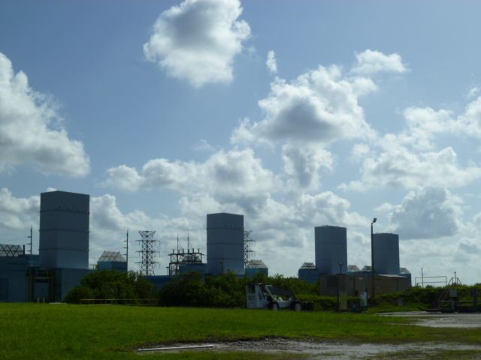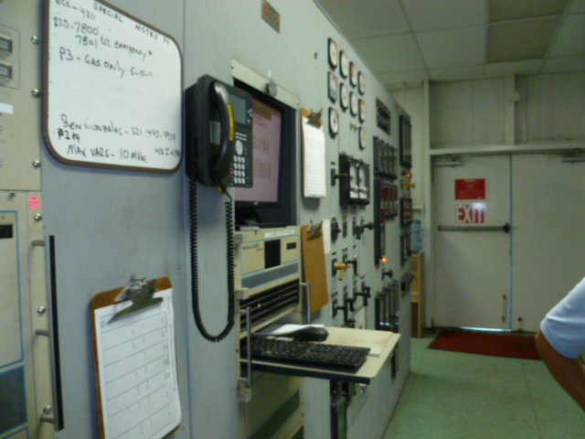

Project Id: 84549 Permit No: 1030012-007-AV Arms Number: 0012 007
Inspector: Shea Jackson Inspection Date / Time: 6/24/2013 / _______
Source (EU): Combustion Turbine Peaking Unit No. 4; Pratt & Witnew, rated at 42.9 MW at 59 degrees F and 631 MMBtu Fired on New No. 2 Fuel Oil
Description: [This is looking toward the northeast at the peakers 1-4. The operations time meter panel and monitoring system inside the peaker station]

Duke Energy Florida, Inc. Higgins Plant
998 East Shore Drive, Oldsmar

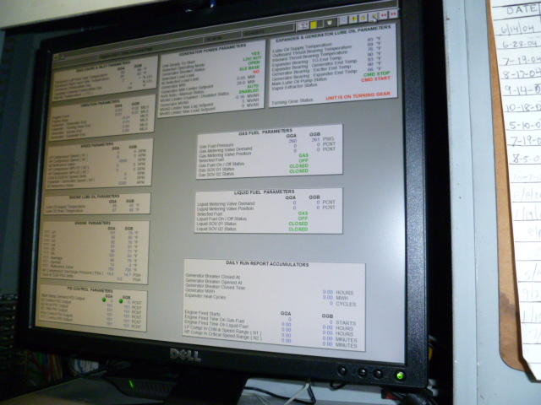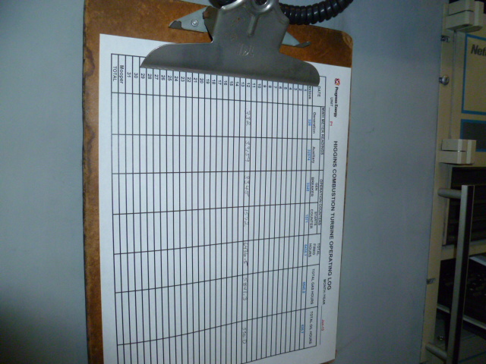

Project Id: 84549 Permit No: 1030012-007-AV Arms Number: 0012 007
Inspector: Shea Jackson Inspection Date / Time: 6/24/2013 / _______
Source (EU): Combustion Turbine Peaking Unit No. 4; Pratt & Witnew, rated at 42.9 MW at 59 degrees F and 631 MMBtu Fired on New No. 2 Fuel Oil
Description: [This is the chart for operator to record hours and fuel usage, and the monitor contains the operations information for the peakers.]

Duke Energy Florida, Inc. Higgins Plant
998 East Shore Drive, Oldsmar

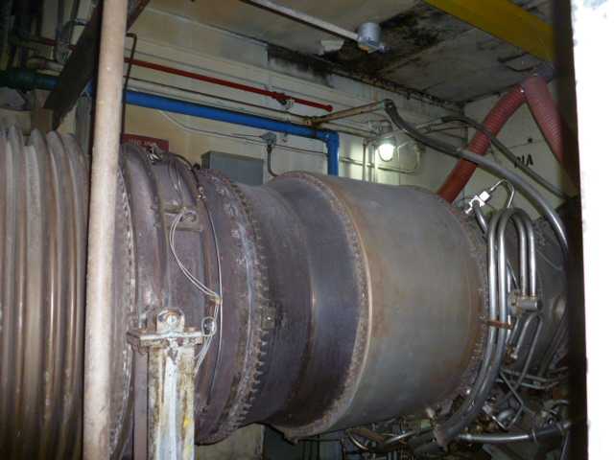

Project Id: 84549 Permit No: 1030012-007-AV Arms Number: 0012 007
Inspector: Shea Jackson Inspection Date / Time: 6/24/2013 / _______
Source (EU): Combustion Turbine Peaking Unit No. 4; Pratt & Witnew, rated at 42.9 MW at 59 degrees F and 631 MMBtu Fired on New No. 2 Fuel Oil
Description: [This is the turbine used to power the power generator for electric]



