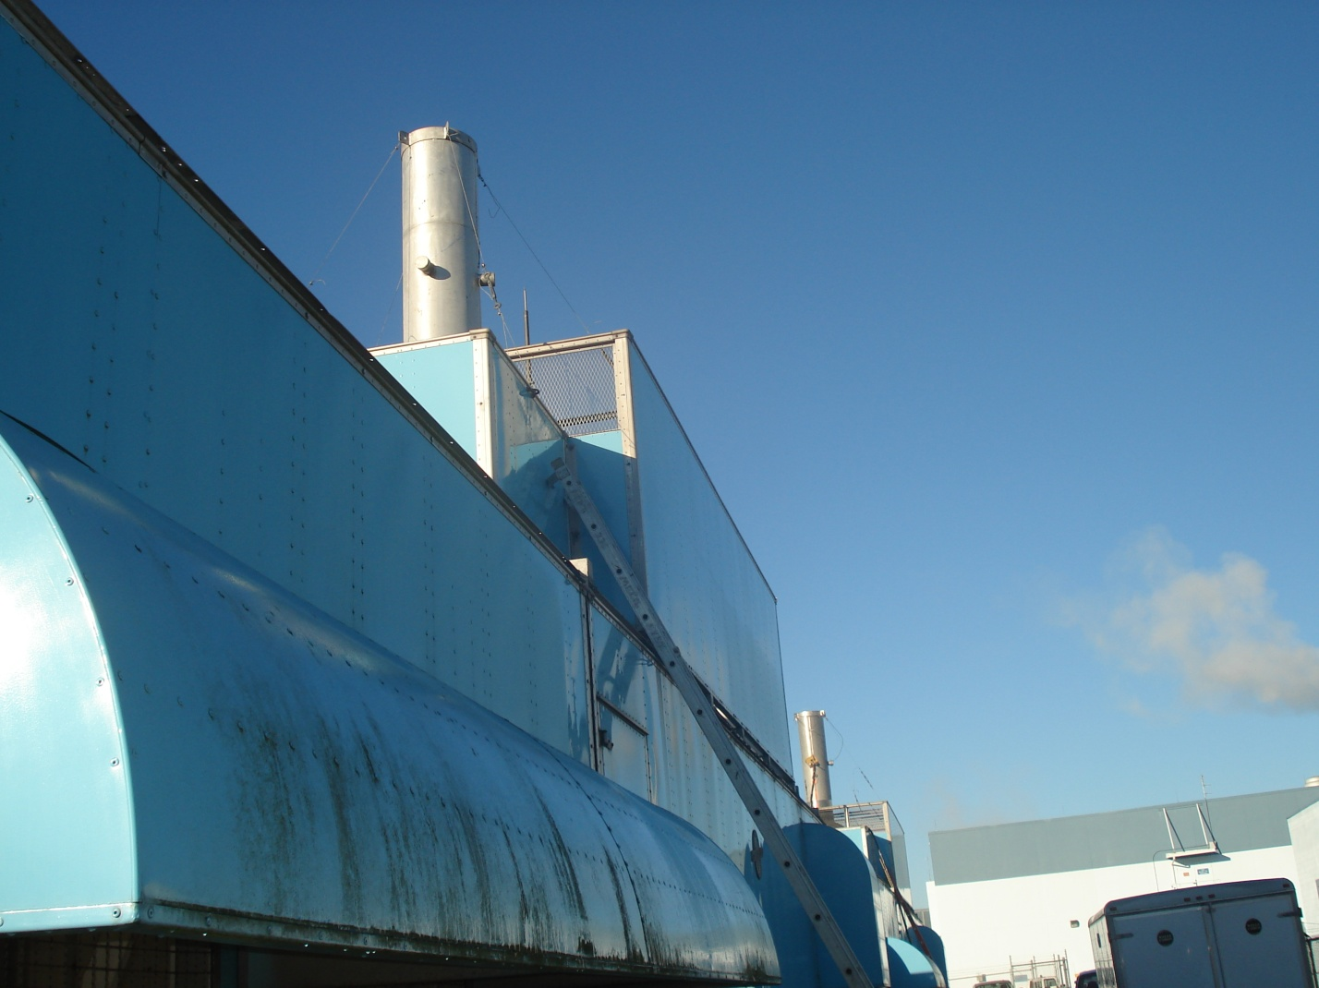
Walt Disney World, EPCOT Center Diesel Generators January 23, 2009. Stack test being conducted on unit 2. Unit 1 was tested yesterday. Taken by Garry Kuberski.
Unit 2 stack test arrangement.

