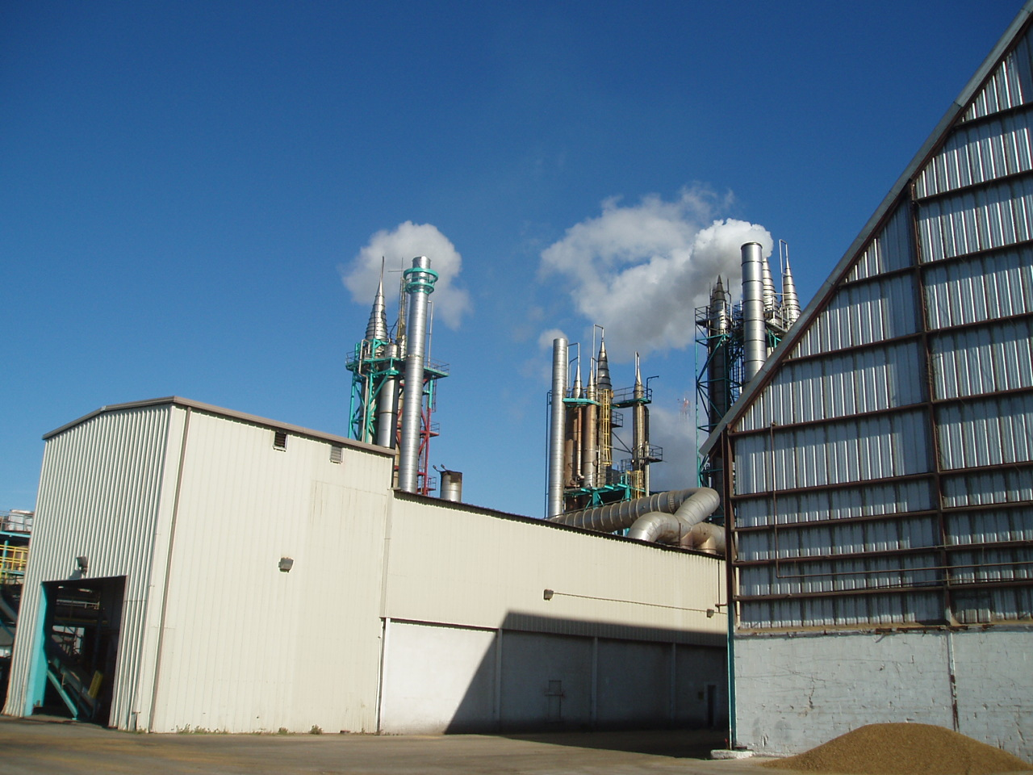

Observation Point

Distance and Direction Varied

Emission Point

Peel Dryer #2 (EU 005)