FACILITY ADDRESS:  801 McCloskey Blvd., Tampa, FL 33605-6715 |  |  |  |  |  |  | FACILITY PHONE:  813-247-3429
INSPECTION DATE:  7/25/2007 |  | TIME IN:  8:30 AM |  | TIME OUT:  12:30 AM |  | INSPECTION TYPE  FCE |  |  | STATUS:  IN
Permit No.  0570016-007-AV  0570016-009-AV | Expiration Date:  9/22/2005  2/1/2012 |  | Effective Date:  9/22/2000  2/1/2007 |  | Citizen Complaints:  None |  |  | Warning Notice:  None
SOURCE DESCRIPTION: This facility stores and handles petroleum products and petroleum product additives. The regulated emissions units (E.U.) at this facility include two loading racks with pollution control equipment, 17 storage tanks, and equipment leaks.
CONTACT(S): Mr. Terry W. Fluke, Terminal Manager
Correspondence File Review:
The review of the correspondence file revealed the following:
1. Seal inspection for Tank #1, #5, and #14 were done on 12/9/2006. (Notification date 11/9/2006).
2. Internal inspection for Tank #17 on 12/15/06 should notify EPC for return to service. (notification date 9/27/2006)
3. Replace secondary seal for Tank #18 within the month of February 2006. (notification date 2/6/2006)
I did not find the notification of return to service for Tank #17.
I went to the facility for the 2007 FCE inspection. Mr. Terry Fluke assisted me with record checking and field inspection. We went through the permit first since the new permit became effective in 2/1/2007. I also asked him about Tank #7. According to permit condition B.15. CITGO should give EPC 30 days notice before tank filling/refilling, or at least 7 days before if the date could not have known. Terry told me that the tank was filled in February 2007. He informed Hillsborough County EPC Tank Group. I gave him a verbal warning for failing to notify Air Management Division for the date of refilling.

The following records from 1/2006 to 7/2007 were reviewed:
Record Keeping Requirement | Description
Year 2005 RVP by Tank | 1, 5, 11, 12, 14, 15, 16, 17, 18, 19
Tank throughputs for 2005 | 1, 5, 11, 12, 14, 16, 15, 17, 18, 19
Loading Rack Throughput | Diesel / Gasoline
Annual Internal Tank Inspection | 17, 18, 19
Monthly Storage Tank Inspection Report | 1, 5, 11, 12, 14, 15, 16, 17, 18, 18, 19, WW1-WW2
Equipment Leak Detection Checklist | Daily
Equipment leak Detection & Repair Form
Annual Roof Gap Test | 1, 5, 14
Weekly Inspection Check | VCU
Gabner RVP Testing Results | On each ship unloading
Seal Inspection Report
Malfunction and Maintenance Record

After the pre-inspection meeting, we went to see the VCU temperature monitor which is located inside the office building. CITGO purchased a Thermo Electron SV100 Data Acquisition System to record temperature readings from the VCU thermocouple. The original recorder Westronics Smartview II system has been retained and kept operational as a backup. I saw the instantaneous temperature was 1134 F; numbers of gasoline loading arms in service were 4; and the 6-hr average was 1022 F. According to Terry, the assist gas will be turned on when the temperature drop to 750 F. When temperature drops to 710 F, the loading racks will shutdown. This monitor system runs 24-hr a day. If the system heated above 800 F, the audio alarm will go off to alert the facility for safety. The temperature data are backup once a month. CITGO also purchased an additional propane tank. Now they have two propane tanks on site as assist gas for VCU. Each tank can store 1000 gallons.

Temperature Monitoring System
We went to the VCU area and checked the vapor pressure from the loading rack to be 2 in W.C. The facility keeps a max. pressure at 15 in W.C. for safety. Exceeding this pressure, the facility would shutdown the loading racks.
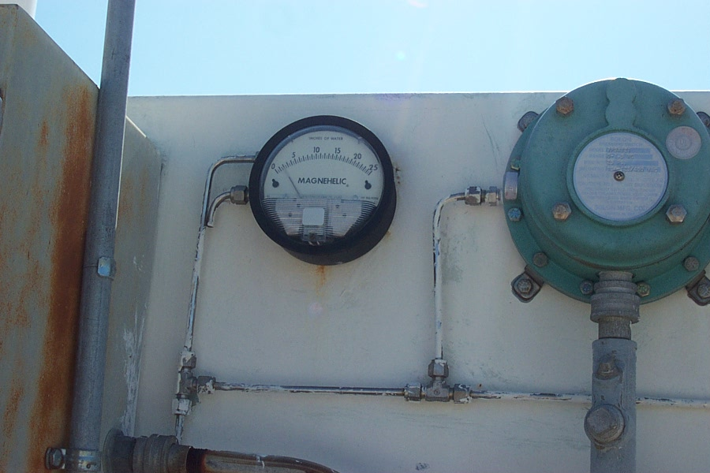
Pressure Gauge at VCU

We then went to the loading rack I checked the pressure at pumps for SPC. A.6. not to exceed 17.7 in W.C.
Rack | 1 | 2 | 3 | 4 | 5 | 6
In W.C. | 10 | 3 | 2 | 3.5 | 2 | 4

Apparently, all the pressure is under the permitted level. I also got to see inside of the storage tank 1. The facility is the process of replacing the bottom of the tank.
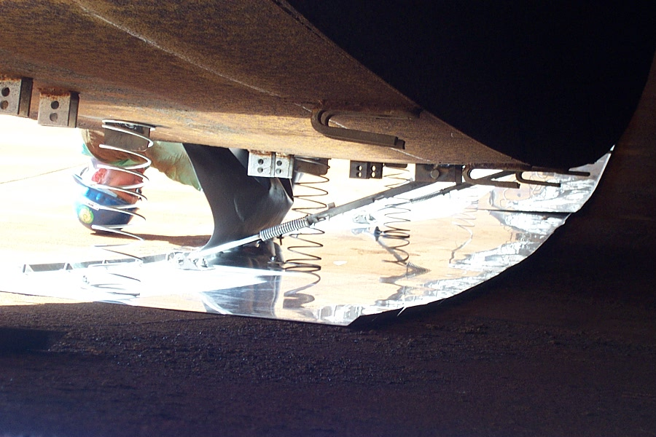
A flexible coated fabric (envelope) spans the annular space between the metal sheet and the floating roof.
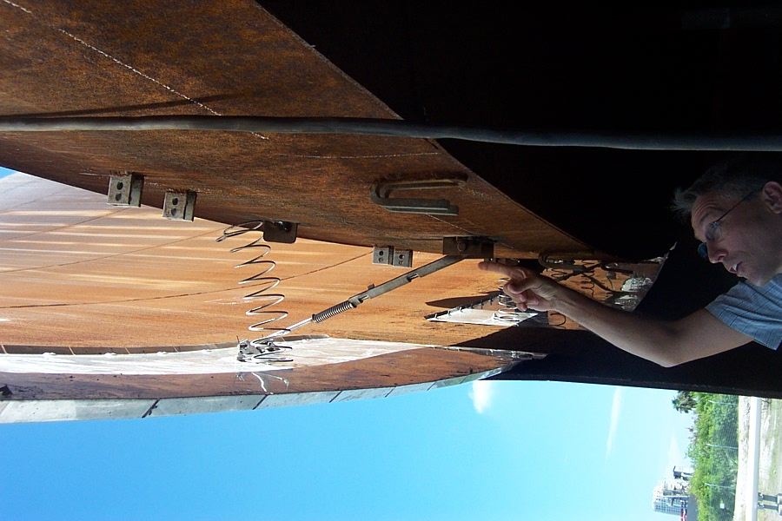
Spring to suspend the internal floating roof
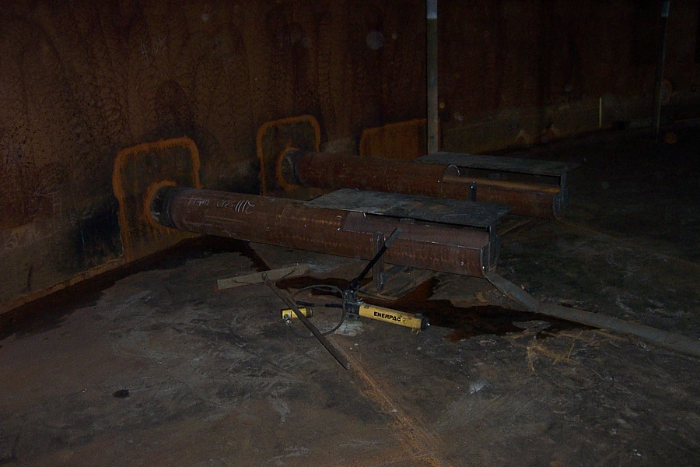
Inside dispensers of gasoline

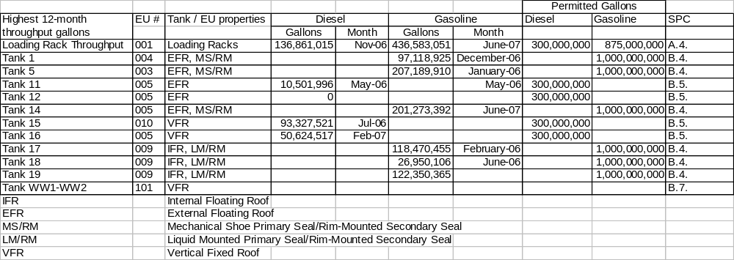
After the walk through, I reviewed all the records on site. There was no delay in repairing the leaks in the facility as shown in the Equipment Leak Detection & Repair Report. Tank 12 was out of the service since 2005 as shown in the Monthly Storage Tank Inspection Report. On 12/9/2006, the Annual Roof Seal Gap Test showed Tank 14 had 1.38 cm2/diameter in gap. The requirement is to be less than 212 cm2/diameter. Tank 17, 18, and 19 had inspection done on 3/29/2006 and 5/21/2007 for internal tank inspection. The facility is in compliance with all the record keeping requirements.
Permit Condition | Observation
6. The maximum allowable volatile organic compound (VOC) emissions for the facility shall not exceed 156.4 tons per twelve consecutive month period. [Construction Permit 0570016-008-AC, EPC Permit Determination Letters Dated December 1, 2005 and December 12, 2005 for Diesel Lubricity/Additive Storage Tanks] | According to the 2006 AOR, the facility emitted 77 tpy.
13. In order to provide reasonable assurance of compliance with all applicable regulations, the measures detailed in Appendix CP-1, Compliance Plan for Recordkeeping of Certification Tests for Each Gasoline Cargo Tank Loading at CITGO’s Tampa Terminal, shall be implemented according to the schedule provided.  [40 CFR 63.428(b), Rules 62-296.600(4), 62-204.800(11)(b)16. and 62-4.070(3), F.A.C. and Title V Air Operation Permit Renewal Application received March 28, 2005] | The facility is aware of CP-1.
A.6. (c). (6). Pursuant to the 40 CFR 60.505(e) (2), for the permittee that utilize a terminal automation system to prevent gasoline cargo tanks that do not have valid cargo tank vapor tightness documentation from loading (e.g., via a card lock-out system), a copy of the documentation shall be made available (e.g., via facsimile) for inspection by permitting authority representatives during the course of a site visit, or within a mutually agreeable time frame.  (i) The copy of each record shall be an exact duplicate image of the original paper record with certifying signatures.  (ii) The permitting authority is notified in writing that the Terminal using this alternative is in compliance with the 40 CFR 60.505(e)(2).  A.6.(f) The vapor collection and liquid loading equipment shall be designed and operated to prevent gauge pressure in the delivery tank from exceeding 4,500 pascals (450 mm of water) during product loading. This level is not to be exceeded when measured by the procedures specified in Specific Condition A.11.(d).  A.6.(g) No pressure-vacuum vent in the bulk gasoline terminal's vapor collection system shall begin to open at a system pressure less than 4,500 pascals (450 mm of water). [40 CFR 63.422 and 40 CFR 60.502] | I checked three tank trucks for their vapor tightness documents. They are all current. The facility also has its own check list for all the tank trucks. See attachment.  The facility is in compliance with A.6(f).  The facility does not have a pressure-vacuum vent. A.6.(g).
A.9. Excess emissions which are caused entirely or in part by poor maintenance, poor operation, or any other equipment or process failure which may reasonably be prevented during startup, shutdown, or malfunction shall be prohibited. No trucks shall be hooked up for filling once the equipment or process failure is recognized. Truck loading shall restart only after the problem is completely resolved. [Rule 62-210.700, F.A.C. and Construction Permit 0570016-008-AC] | The facility is aware of this permit condition.
A.11. Performance Test. The permittee shall conduct annual performance testing on the VCU as follows and submit a copy of the results within 45 days of completion of the test to the Environmental Protection Commission of Hillsborough County: | Last compliance test – 8/7/2006.
Continuous Monitoring Requirements  A.20. The permittee shall comply with the following requirements for the loading racks:  (a) The permittee shall install, calibrate, certify, operate, and maintain, according to the manufacturer's specifications, a continuous monitoring system (CMS) as follows:  (1) For the VCU, a continuous parameter monitoring system (CPMS) capable of measuring temperature shall be installed in the firebox or in the ductwork immediately downstream from the firebox in a position before any substantial heat exchange occurs.  (b) The permittee shall operate the vapor processing system in a manner not to go below the operating parameter value for the parameter described in paragraph (a)(1) of this Specific Condition, and established using the procedures in Specific Condition A.12. Operation of the vapor processing system in a manner going below the operating parameter value, as specified above, shall constitute a violation of the emission standard in Specific Condition A.5.  (c) Pursuant to the 40 CFR 63.427(a)(5), monitoring an alternative operating parameter or a parameter of a vapor processing system other than those listed above will be allowed upon demonstrating to the EPA's satisfaction that the alternative parameter demonstrates continuous compliance with the emission standard. [40 CFR 63.427(a) and (b)] | The facility is in compliance.
A.22. The permittee shall:  (a) Keep an up-to-date, readily accessible record of the continuous monitoring data required under Specific Condition A.20.(a). This record shall indicate the time intervals during which loadings of gasoline cargo tanks have occurred or, alternatively, shall record the operating parameter data only during such loadings. The date and time of day shall also be indicated at reasonable intervals on this record.  (b) Record and report simultaneously with the notification of compliance status required under 40 CFR 63.9(h):  (1) All data and calculations, engineering assessments, and manufacturer's recommendations used in determining the operating parameter value under Specific Condition A.12. [40 CFR 63.428(c)] | The facility keeps 6-hour temperature averages at every 30 second interval. I asked if they would consider reporting 6-hour averages for every hour.
A.27. Compliance with the emission limitations of Specific Condition A.4. shall be demonstrated through the use of a monthly recordkeeping system. The recordkeeping system shall contain the following information and be made available for inspection by the  Environmental Protection Commission of Hillsborough County for the most recent 5 year period:  (a) Month, Year  (b) Product(s) Loaded  (c) Maximum Product Vapor Pressure (psia)  (d) Product Throughput (gallons)  (e) Most recent twelve consecutive month of Product Throughput (gallons) [Rule 62-213.440(1)(b)2.b., F.A.C. and Construction Permit 0570016-008-AC] | The facility is in compliance.
A.26. Excess Emissions Report. The permittee shall submit an excess emissions report to the Environmental Protection Commission of Hillsborough County in accordance with 40 CFR 63.10(e), whether or not a CMS is installed at the facility. The following occurrences are excess emissions events under 40 CFR 63, Subpart R, and the following information shall be included in the excess emissions report as applicable:  (a) Each exceedance or failure to maintain, as appropriate, the monitored operating parameter value determined under Specific Condition A.12. The report shall include the monitoring data for the days on which exceedances or failures to maintain have occurred, and a description and timing of the steps taken to repair or perform maintenance on the vapor collection and processing systems or the CMS.  (b) Each instance of a nonvapor-tight gasoline cargo tank loading at the facility in which the permittee failed to take steps to assure that such cargo tank would not be reloaded at the facility before vapor tightness documentation for that cargo tank was obtained.  (c) Each reloading of a nonvapor-tight gasoline cargo tank at the facility before vapor tightness documentation for that cargo tank is obtained by the facility in accordance with Specific Condition A.6.(c)(5). [40 CFR 63.428(h)(1)-(3)] | The facility submitted the excess emissions report with SAM on 7/25/2007.
A.28. The VCU shall be maintained in good repair to perform adequately the function for which it was intended. Maintenance shall include, but is not limited to, bi-weekly inspections and replacement or repair of faulty equipment when necessary or as required by the manufacturer. Any maintenance/repair performed should be recorded. Records shall be maintained for the most recent 5 year period and made available for inspection upon request. [Rule 62-4.070(3), F.A.C.] | I checked the records from 1/2006 till present. The facility is doing weekly inspection.
A.30. The above emissions unit equipped with the VCU is subject to the 40 CFR 63, Subpart R. The continuous monitoring requirement has been addressed as follows. Operation of the vapor processing system in a manner going below the operating parameter value, as specified below, shall constitute a violation of the emission standard in Specific Condition A.5. [40 CFR 63.427(a) and (b)]  (a) The VCU temperature shall be maintained at a minimum 6-hour average temperature of 700.0 oF during the loading of gasoline into gasoline cargo tanks. Periods when gasoline loading is not occurring shall not contribute to the time period, nor to the temperature average. [40 CFR 63.425(b) and CITGO’s compliance tests conducted on 9/15/05, 8/6/06 and 8/7/26]  (b) A rolling 6-hour period shall be used to show compliance with the minimum temperature requirement. | The facility complied with this condition by setting target temperature at 710 F. Below 710 F, the loading rack will shutdown.  Below 750 F, assist gas will be turned on.
B.4. The maximum allowable VOC emissions from the Gasoline Group Tanks (Storage Tanks 1, 5, 14, 17, 18, and 19) shall not exceed 30.4 tons per twelve consecutive month period as restricted below:  (a) Maximum product throughput: 1,000,000,000 gallons per twelve consecutive month period  (b) Allowable product storage: gasoline, jet fuel and diesel fuel  (c) Maximum weighted average 12-month product Reid vapor pressure for gasoline stored: 11 psia  (d) All tanks shall be clearly identified by number  (e) Each tank shall be maintained to retain the structure, roof type, and color characteristics described in the application dated June 17, 1996, as amended. {Permitting Note: CITGO has historically used an RVP of 11.32 psi. The RVP limit of 11 is based only on two significant figures, and 11.32 psi is not considered to be a violation.} | The facility is in compliance.
B.5. The maximum allowable VOC emissions from the Diesel Group Tanks (Storage Tanks 11, 12, 15, and 16) shall not exceed 3.04 tons per twelve consecutive month period as restricted below:  (a) Maximum product throughput: 300,000,000 gallons per twelve consecutive month period  (b) Allowable product storage: diesel fuel  (c) Maximum average 12-month product vapor pressure: 0.0137 psia  (d) The mixing or blending of products is disallowed.  (e) All tanks shall be clearly identified by number.  (f) Each tank shall be maintained to retain the structure, roof type, and color characteristics described in the application dated June 17, 1996, as amended. [Construction Permit 0570016-008-AC] | The facility is in compliance.
B.7. The maximum allowable VOC emissions from the PCW Group Tanks (Storage Tanks WW1 andWW2) shall not exceed 5.46 tons per twelve consecutive month period as restricted below:  (a) Allowable product storage: petroleum contact water (PCW)  (b) Maximum weighted average 12-month product Reid vapor pressure: 11 psia  (c) All tanks shall be clearly identified by number.  (d) Each tank shall be maintained to retain the structure, roof type, and color characteristics described in the application dated June 17, 1996, as amended. [Construction Permit 0570016-008-AC, Title V Air Operation Permit Renewal Application received March 28, 2005] {Permitting Note: CITGO has historically used an RVP of 11.32 psi. The RVP limit of 11 is based only on two significant figures, and 11.32 psi is not considered to be a violation.} | The facility is in compliance.
B.8. The permittee shall maintain Storage Tanks 17, 18 and 19 with a fixed roof in combination with an internal floating roof meeting the following specifications:  (a) The internal floating roof shall rest or float on the liquid surface (but not necessarily in complete contact with it) inside a storage vessel that has a fixed roof. The internal floating roof shall be floating on the liquid surface  at all times, except during initial fill and during those intervals when the storage vessel is completely emptied or subsequently emptied and refilled. When the roof is resting on the leg supports, the process of filling, emptying, or refilling shall be continuous and shall be accomplished as rapidly as possible.  (b) Each internal floating roof shall be equipped with one of the following closure devices between the wall of the storage vessel and the edge of the internal floating roof:  (1) A foam- or liquid-filled seal mounted in contact with the liquid (liquid-mounted seal). A liquid-mounted seal means a foam- or liquid-filled seal mounted in contact with the liquid between the wall of the storage vessel and the floating roof continuously around the circumference of the tank.  (2) Two seals mounted one above the other so that each forms a continuous closure that completely covers the space between the wall of the storage vessel and the edge of the internal floating roof. The lower seal may be vapor-mounted, but both must be continuous.  (3) A mechanical shoe seal. A mechanical shoe seal is a metal sheet held vertically against the wall of the storage vessel by springs or weighted levers and is connected by braces to the floating roof. A flexible coated fabric (envelope) spans the annular space between the metal sheet and the floating roof.  (c) Each opening in a noncontact internal floating roof except for automatic bleeder vents (vacuum breaker vents) and the rim space vents is to provide a projection below the liquid surface.  (d) Each opening in the internal floating roof except for leg sleeves, automatic bleeder vents, rim space vents, column wells, ladder wells, sample wells, and stub drains is to be equipped with a cover or lid which is to be maintained in a closed position at all times (i.e., no visible gap) except when the device is in actual use. The cover or lid shall be equipped with a gasket. Covers on each access hatch and automatic gauge float well shall be bolted except when they are in use.  (e) Automatic bleeder vents shall be equipped with a gasket and are to be closed at all times when the roof is floating except when the roof is being floated off or is being landed on the roof leg supports.  (f) Rim space vents shall be equipped with a gasket and are to be set to open only when the internal floating roof is not floating or at the manufacturer's recommended setting.  (g) Each penetration of the internal floating roof for the purpose of sampling shall be a sample well. The sample well shall have a slit fabric cover that covers at least 90 percent of the opening.  (h) Each penetration of the internal floating roof that allows for passage of a column supporting the fixed roof shall have a flexible fabric sleeve seal or a gasketed sliding cover.  (i) Each penetration of the internal floating roof that allows for passage of a ladder shall have a gasketed sliding cover. [40 CFR 60.112b(a)(1) and 40 CFR 63.420(g)] | The facility does not have foam- or liquid-filled seals or automatic bleeder vents.  The facility is in compliance of conditions for the exiting devices on site.
B.9. The permittee shall maintain Storage Tanks 1 and 5 with an external floating roof. An external floating roof means a pontoon-type or double-deck type cover that rests on the liquid surface in a vessel with no fixed roof. Each external floating roof must meet the following specifications:  (a) Each external floating roof shall be equipped with a closure device between the wall of the storage vessel and the roof edge. The closure device is to consist of two seals, one above the other. The lower seal is referred to as the  primary seal, and the upper seal is referred to as the secondary seal.  (1) The primary seal shall be either a mechanical shoe seal or a liquid-mounted seal. Except as provided in Specific Condition B.15.(d), the seal shall completely cover the annular space between the edge of the floating roof and tank wall.  (2) The secondary seal shall completely cover the annular space between the external floating roof and the wall of the storage vessel in a continuous fashion except as allowed in Specific Condition B.15.(d).  (b) Except for automatic bleeder vents and rim space vents, each opening in a noncontact external floating roof shall provide a projection below the liquid surface. Except for automatic bleeder vents, rim space vents, roof drains, and leg sleeves, each opening in the roof is to be equipped with a gasketed cover, seal, or lid that is to be maintained in a closed position at all times (i.e., no visible gap) except when the device is in actual use. Automatic  bleeder vents are to be closed at all times when the roof is floating except when the roof is being floated off or is being landed on the roof leg supports. Rim vents are to be set to open when the roof is being floated off the roof legs supports or at the manufacturer's recommended setting. Automatic bleeder vents and rim space vents are to be gasketed. Each emergency roof drain is to be provided with a slotted membrane fabric cover that covers at least 90 percent of the area of the opening.  (c) The roof shall be floating on the liquid at all times (i.e., off the roof leg supports) except during initial fill until the roof is lifted off leg supports and when the tank is completely emptied and subsequently refilled. The process  of filling, emptying, or refilling when the roof is resting on the leg supports shall be continuous and shall be accomplished as rapidly as possible. [40 CFR 60.112b(a)(2) and 40 CFR 63.420(g)] | The facility does not have foam- or liquid-filled seals or automatic bleeder vents.  The facility is in compliance of conditions for the exiting devices on site
B.10. The permittee shall maintain Storage Tank 14 with an external floating roof. An external floating roof means a pontoon-type or double-deck type cover that rests on the liquid surface in a vessel with no fixed roof. Each external floating roof must meet the following specifications:  (a) Each external floating roof shall be equipped with a closure device between the wall of the storage vessel and the roof edge. The closure device is to consist of two seals, one above the other. The lower seal is referred to as the primary seal, and the upper seal is referred to as the secondary seal.  (1) The primary seal shall be either a mechanical shoe seal or a liquid-mounted seal. Except as provided in Specific Condition B.15.(d) the seal shall completely cover the annular space between the edge of the floating roof and tank wall.  (2) The secondary seal shall completely cover the annular space between the external floating roof and the wall of the storage vessel in a continuous fashion except as allowed in Specific Condition B.15.(d).  (b) The roof shall be floating on the liquid at all times (i.e., off the roof leg supports) except during initial fill until the roof is lifted off leg supports and when the tank is completely emptied and subsequently refilled. The process of filling, emptying, or refilling when the roof is resting on the leg supports shall be continuous and shall be accomplished as rapidly as possible. [40 CFR 63.423(a)] | The facility does not have foam- or liquid-filled seals or automatic bleeder vents.  The facility is in compliance of conditions for the exiting devices on site
B.11. For Storage Tanks 1, 5, and 14, the permittee shall comply with the following requirements:  (a) All openings in the external floating roof, except for automatic bleeder vents, rim space vents and leg sleeves, are:  (1) Equipped with covers, seals, or lids in the closed position except when the openings are in actual use; and,  (2) Equipped with projections in the tank which remain below the liquid surface at all times; and  (b) Automatic bleeder vents are closed at all times except when the roof is floating off or landing on the roof leg supports; and,  (c) Rim vents are set to open when the roof is being floated off the leg supports or at the manufacturer’s recommended setting; and,  (d) Emergency roof drains are provided with slotted membrane fabric covers or equivalent covers which cover at least 90 percent of the area of the opening. [Rule 62-296.516(2), F.A.C.] | The facility does not have foam- or liquid-filled seals or automatic bleeder vents.  The facility is in compliance of conditions for the exiting devices on site
B.13. All barge unloadings shall comply with the following terms and conditions:  (a) The permittee shall use good air pollution control practices to minimize emissions.  (b) During each barge unloading, the pipes, valves, fittings, and associated equipment shall be inspected for leaks. For purposes by this paragraph, detection methods incorporating sight, sound, or smell are acceptable. Each  detection of a leak shall be recorded and the source of the leak repaired within 7 calendar days after it is detected. Notify the Environmental Protection Commission of Hillsborough County within 24 hours of discovering each leak  (c) Ballasting of the marine vessel which results in the discharge of hydrocarbon vapors to the outside air is prohibited while operating inside the waters of Tampa Bay.  (d) All openings on the vessel which can be closed during product unloading and storage shall be closed to the extent practical. [Rules 62-296.320(1)(a) and 62-4.070(3), F.A.C.] | The facility does not do ballasting. At this time, no facility personnel is permitted to enter the barge for security reasons.
B.14. For Storage Tanks 17, 18, and 19 the permittee shall:  (a) Visually inspect the internal floating roof, the primary seal, and the secondary seal (if one is in service), prior to filling the storage vessel with VOL. If there are holes, tears, or other openings in the primary seal, the secondary seal, or the seal fabric or defects in the internal floating roof, or both, the permittee shall repair the items before filling the storage vessel.  (b) For Vessels equipped with a liquid-mounted or mechanical shoe primary seal, visually inspect the internal floating roof and the primary seal or the secondary seal (if one is in service) through manholes and roof hatches on the fixed roof at least once every 12 months after initial fill. If the internal floating roof is not resting on the surface of the VOL inside the storage vessel, or there is liquid accumulated on the roof, or the seal is detached, or there are holes or tears in the seal fabric, the permittee shall repair the items or empty and remove the storage vessel from service within 45 days. If a failure that is detected during inspections required in this paragraph cannot be repaired within 45 days and if the vessel cannot be emptied within 45 days, a 30-day extension may be requested from the Environmental Protection Commission of Hillsborough County in the inspection report required in Specific Condition B.18.(a)(3). Such a request for an extension must document that alternate  storage capacity is unavailable and specify a schedule of actions the company will take that will assure that the control equipment will be repaired or the vessel will be emptied as soon as possible.  (c) For vessels equipped with a double-seal system as specified in Specific Condition B.8.(b)(2).  (1) Visually inspect the vessel as specified in paragraph (d) of this Specific Condition at least every 5 years; or  (2) Visually inspect the vessel as specified in paragraph (b) of this Specific Condition.  (d) Visually inspect the internal floating roof, the primary seal, the secondary seal (if one is in service), gaskets, slotted membranes and sleeve seals (if any) each time the storage vessel is emptied and degassed. If the internal floating roof has defects, the primary seal has holes, tears, or other openings in the seal or the seal fabric, or the secondary seal has holes, tears, or other openings in the seal or the seal fabric, or the gaskets no longer close off the liquid surfaces from the atmosphere, or the slotted membrane has more than 10 percent open area, the permittee shall repair the items as necessary so that none of the conditions specified in this paragraph exist before refilling the storage vessel with VOL. In no event shall inspections conducted in accordance with this provision occur at intervals greater than 10 years in the case of vessels conducting the 12-month visual inspection as specified in paragraphs (b) and (c)(2) of this Specific Condition and at intervals no greater than 5 years in the case of vessels specified in paragraph (c)(1) of this Specific Condition.  (e) Notify the Environmental Protection Commission of Hillsborough County in writing at least 30 days prior to the filling or refilling of each storage vessel for which an inspection is required by paragraphs (a) and (d) of this Specific Condition to afford the Environmental Protection Commission of Hillsborough County the opportunity to have an observer present. If the inspection required by paragraph (d) of this Specific Condition is not planned and the permittee could not have known about the inspection 30 days in advance of refilling the tank, the permittee shall notify the Environmental Protection Commission of Hillsborough County at least 7 days prior to the refilling of the storage vessel. Notification shall be made by telephone immediately followed by written documentation demonstrating why the inspection was unplanned. Alternatively, this notification including the written documentation may be made in writing and sent by express mail so that it is received by the Environmental Protection Commission of Hillsborough County at least 7 days prior to the refilling. [40 CFR 60.113b(a) and 40 CFR 63.425(d)] | The facility does not have foam- or liquid-filled seals or automatic bleeder vents.  The facility is in compliance of conditions for the exiting devices on site  The facility performs inspection every year. No delay in repairs were shown in the records.  I gave the facility a verbal warning for not notifying of filling Tank #17.
B.15. For Storage Tanks 1, 5, and 14 the permittee shall:  (a) Determine the gap areas and maximum gap widths, between the primary seal and the wall of the storage vessel and between the secondary seal and the wall of the storage vessel according to the following frequency.  (1) Measurements of gaps between the tank wall and the primary seal (seal gaps) shall be performed during the hydrostatic testing of the vessel or within 60 days of the initial fill with VOL and at least once every 5 years thereafter.  (2) Measurements of gaps between the tank wall and the secondary seal shall be performed within 60 days of the initial fill with VOL and at least once per year thereafter.  (3) If any source ceases to store VOL for a period of 1 year or more, subsequent introduction of VOL into the vessel shall be considered an initial fill for the purposes of paragraphs (a)(1) and (a)(2) of this Specific Condition.  (b) Determine gap widths and areas in the primary and secondary seals individually by the following procedures:  (1) Measure seal gaps, if any, at one or more floating roof levels when the roof is floating off the roof leg supports.  (2) Measure seal gaps around the entire circumference of the tank in each place where a 0.32-cm diameter uniform probe passes freely (without forcing or binding against seal) between the seal and the wall of the storage vessel and measure the circumferential distance of each such location.  (3) The total surface area of each gap described in paragraph (b)(2) of this Specific Condition shall be determined by using probes of various widths to measure accurately the actual distance from the tank wall to the seal and multiplying each such width by its respective circumferential distance.  (c) Add the gap surface area of each gap location for the primary seal and the secondary seal individually and divide the sum for each seal by the nominal diameter of the tank and compare each ratio to the respective standards in paragraph (d) of this Specific Condition.  (d) Make necessary repairs or empty the storage vessel within 45 days of identification in any inspection for seals not meeting the requirements listed in (d)(1) and (2) of this Specific Condition:  (1) The accumulated area of gaps between the tank wall and the mechanical shoe or liquid-mounted primary seal shall not exceed 212 cm2 per meter of tank diameter, and the width of any portion of any gap shall not exceed 3.81 cm.  (i) One end of the mechanical shoe is to extend into the stored liquid, and the other end is to extend a minimum vertical distance of 61 cm above the stored liquid surface.  (ii) There are to be no holes, tears, or other openings in the shoe, seal fabric, or seal envelope.  (2) The secondary seal is to meet the following requirements:  (i) The secondary seal is to be installed above the primary seal so that it completely covers the space between the roof edge and the tank wall except as provided in paragraph (b)(3) of this Specific Condition.  (ii) The accumulated area of gaps between the tank wall and the secondary seal shall not exceed 21.2 cm2 per meter of tank diameter, and the width of any portion of any gap shall not exceed 1.27 cm.  (iii) There are to be no holes, tears, or other openings in the seal or seal fabric.  (3) If a failure that is detected during inspections required in paragraph (a) of this Specific Condition cannot be repaired within 45 days and if the vessel cannot be emptied within 45 days, a 30-day extension may be requested from the Environmental Protection Commission of Hillsborough County in the inspection report required in Specific Condition B.18.(b)(4). Such extension request must include a demonstration of unavailability of alternate storage capacity and a specification of a schedule that will assure that the control equipment will be repaired or the vessel will be emptied as soon as possible.  (e) Notify the Environmental Protection Commission of Hillsborough County 30 days in advance of any gap measurements required by paragraph (b)(1) of this section to afford the Environmental Protection Commission of Hillsborough County the opportunity to have an observer present.  (f) Visually inspect the external floating roof, the primary seal, secondary seal, and fittings each time the vessel is emptied and degassed.  (1) If the external floating roof has defects, the primary seal has holes, tears, or other openings in the seal or the seal fabric, or the secondary seal has holes, tears, or other openings in the seal or the seal fabric, the permittee shall repair the items as necessary so that none of the conditions specified in this paragraph exist before filling or refilling the storage vessel with VOL.  (2) For all the inspections required by paragraph (f) of this Specific Condition, the permittee shall notify the Environmental Protection Commission of Hillsborough County in writing at least 30 days prior to the filling or refilling of each storage vessel to afford the Environmental Protection Commission of Hillsborough County the opportunity to inspect the storage vessel prior to refilling. If the inspection required by paragraph (f) of this Specific Condition is not planned and the permittee could not have known about the inspection 30 days in advance of refilling the tank, the permittee shall notify the Environmental Protection Commission of Hillsborough County at least 7 days prior to the refilling of the storage vessel. Notification shall be made by telephone immediately followed by written documentation demonstrating why the inspection was unplanned. Alternatively, this notification including the written documentation may be made in writing and sent by express mail so that it is received by the 7 days prior to the refilling. [40 CFR 60.113b(b) and 40 CFR 63.425(d)] | The facility is in compliance.
B.16. For Storage Tanks 1, 5, 14, 17, 18, and 19, the permittee shall keep copies of all records required by this Specific Condition, except for the record required by paragraph (a) of this Specific Condition, for at least 5 years. The record required by paragraph (a) of this Specific Condition will be kept for the life of the source.  (a) The permitee shall keep readily accessible records showing the dimension of the storage vessel and an analysis showing the capacity of the storage vessel.  (b) Except as provided in paragraphs (e) of this Specific Condition, the permittee for each storage vessel storing a liquid with a maximum true vapor pressure greater than or equal to 3.5 kPa shall maintain a record of the VOL stored, the period of storage, and the maximum true vapor pressure of that VOL during the respective storage period.  (c) The permittee for each storage vessel storing a liquid with a maximum true vapor pressure that is normally less than 5.2 kPa shall notify the Environmental Protection Commission of Hillsborough County within 30 days  when the maximum true vapor pressure of the liquid exceeds the maximum true vapor pressure value.  (d) Available data on the storage temperature may be used to determine the maximum true vapor pressure as determined below.  (1) For vessels operated above or below ambient temperatures, the maximum true vapor pressure is calculated based upon the highest expected calendar-month average of the storage temperature. For vessels operated at ambient temperatures, the maximum true vapor pressure is calculated based upon the maximum local monthly average ambient temperature as reported by the National Weather Service.  (2) For crude oil or refined petroleum products the vapor pressure may be obtained by the following:  (i) Available data on the Reid vapor pressure and the maximum expected storage temperature based on the highest expected calendar-month average temperature of the stored product may be used to determine the maximum true vapor pressure from nomographs contained in API Bulletin 2517 (incorporated by reference-see 40 CFR 60.17), unless the Environmental Protection Commission of Hillsborough County specifically requests that the liquid be sampled, the actual storage temperature determined, and the Reid vapor pressure determined from the sample(s).  (ii) The true vapor pressure of each type of crude oil with a Reid vapor pressure less than 13.8 kPa or with physical properties that preclude determination by the recommended method is to  be determined from available data and recorded if the estimated  maximum true vapor pressure is greater than 3.5 kPa.  (3) For other liquids, the vapor pressure:  (i) May be obtained from standard reference texts, or  (ii) Determined by ASTM Method D2879-83 (incorporated by reference-see 40 CFR 60.17); or  (iii) Measured by an appropriate method approved by the Administrator; or  (iv) Calculated by an appropriate method approved by the Administrator.  (e) The permittee for each vessel storing a waste mixture of indeterminate or variable composition shall be subject to the following requirements.  (1) Prior to the initial filling of the vessel, the highest maximum true vapor pressure for the range of anticipated liquid compositions to be stored will be determined using the methods described in paragraph (d) of this Specific Condition. [40 CFR 60.116b and 40 CFR 63.427(c)] | The facility is in compliance. All the records are on site.
B.17. For Storage Tanks 15, WW1, and WW2, the permittee shall keep readily accessible records showing the dimension of the storage vessel and an analysis showing the capacity of the storage vessel. The records shall be kept for the life of the source. [40 CFR 60.116b and 40 CFR 60.110b(b)&(c)] | The facility is in compliance.
B.18. The permittee shall keep records and furnish reports as required by paragraphs (a) and (b) of this Specific Condition. The permittee shall keep copies of all reports and records required by this Specific Condition for at least 5 years.  (a) For Storage Tanks 17, 18, and 19, the permittee shall meet the following requirements.  (1) Reserved.  (2) Keep a record of each inspection performed as required by Specific Condition B.14.(a)-(d). Each record shall identify the storage vessel on which the inspection was performed and shall contain the date the vessel was inspected and the observed condition of each component of the control equipment (seals, internal floating roof, and fittings).  (3) If any of the conditions described in Specific Condition B.14. are detected during the 12-month visual inspection required by Specific Condition B.14.(b), a report shall be furnished to the Environmental Protection Commission of Hillsborough County within 30 days of the inspection. Each report shall identify the storage vessel, the nature of the defects, and the date the storage vessel was emptied or the nature of and date the repair was made.  (4) After each inspection required by Specific Condition B.14.(c) that finds holes or tears in the seal or seal fabric, or defects in the internal floating roof, or other control equipment defects listed in Specific Condition B.14.(c)(2), a report shall be furnished to the Environmental Protection Commission of Hillsborough County within 30 days of the inspection. The report shall identify the storage vessel and the reason it did not meet the specifications of Specific Condition B.8. or B.14.(c) and list each repair made.  (b) For Storage Tanks 1, 5, and 14, the permittee shall meet the following requirements.  (1) Reserved.  (2) Within 60 days of performing the seal gap measurements required by Specific Condition B.15.(a) furnish the Environmental Protection Commission of Hillsborough County with a report that contains:  (i) The date of measurement.  (ii) The raw data obtained in the measurement.  (iii) The calculations described in Specific Condition B.15.(b) and (c).  (3) Keep a record of each gap measurement performed as required by Specific Condition B.15. Each record shall identify the storage vessel in which the measurement was performed and shall contain:  (i) The date of measurement.  (ii) The raw data obtained in the measurement.  (iii) The calculations described in Specific Condition B.15.(b) and (c)  (4) After each seal gap measurement that detects gaps exceeding the limitations specified by Specific Condition B.15.(d), submit a report to the Environmental Protection Commission of Hillsborough County within 30 days of the inspection. The report will identify the vessel and contain the information specified in paragraph (b)(2) of this Specific Condition and the date the vessel was emptied or the repairs made and date of repair. [40 CFR 60.115b and 40 CFR 63.428(d)] | The facility is in compliance.  I reviewed the gap inspection reports on site.
B.21. The permittee shall promptly notify (by telephone) the Environmental Protection Commission of Hillsborough County of any abnormal event which occurs at the facility. Within thirty (30) days of the abnormal event, the permittee shall submit a written report detailing the following:  (a) Tank Identification Number  (b) The Abnormal Event  (c) Corrective Action Taken  For purposes of this condition, an abnormal event shall mean:  (a) Identification of any item out of compliance.  (b) The landing or floating off of a roof on its support legs.  (c) Any tank out of service for more than four (4) weeks.  [Rule 62-4.070(3), F.A.C.] | I told Terry that he need to submit future notifications to Air Management Division for such events.
C.5. Each detection of a liquid or vapor leak shall be recorded in the log book. When a leak is detected, an initial attempt at repair shall be made as soon as practicable, but no later than 5 calendar days after the leak is detected. Repair or replacement of leaking equipment shall be completed within 15 calendar days after detection of each leak, except as provided in Specific Condition C.6.  [40 CFR 63.424(c)] | The leak log did not have delay repairs entries.
C.6. Delay of repair of leaking equipment will be allowed upon a demonstration to the Environmental Protection Commission of Hillsborough County that repair within 15 days is not feasible. The permittee shall provide the reason(s) a delay is needed and the date by which each repair is expected to be completed.  [40 CFR 63.424(d)] | The leak log did not have delay repairs entries.
C.8. The permittee shall record the following information in the log book for each leak that is detected:  (a) The equipment type and identification number,  (b) The nature of the leak (i.e., vapor or liquid) and the method of detection (i.e., sight, sound, or smell),  (c) The date the leak was detected and the date of each attempt to repair the leak,  (d) Repair methods applied in each attempt to repair the leak,  (e) "Repair delayed" and the reason for the delay if the leak is not repaired within 15 calendar days after discovery of the leak,  (f) The expected date of successful repair of the leak if the leak is not repaired within 15 days, and  (g) The date of successful repair of the leak. [40 CFR 63.428(e)] | The facility is in compliance.
C.11. Excess Emissions Report. The permittee shall submit an excess emissions report to the Environmental Protection Commission of Hillsborough County in accordance with 40 CFR 63.10(e), whether or not a CMS is installed at the facility. The following occurrences are excess emissions events under 40 CFR 63, Subpart R, and the following information shall be included in the excess emissions report as applicable:  (a) For each occurrence of an equipment leak for which no repair attempt was made within 5 days or for which repair was not completed within 15 days after detection:  (1) The date on which the leak was detected,  (2) The date of each attempt to repair the leak,  (3) The reasons for the delay of repair, and  (4) The date of successful repair. [40 CFR 63.428(h)(4)] | The facility is in compliance.
CP-1 Allow A.21. TO BE IN COMPLIANCE TILL 2/3/2008 | The facility is working with State and trucking company to have a form that will include A.21. requirements.

