Miami-Dade South Dade WWTP Photos 2-26-2013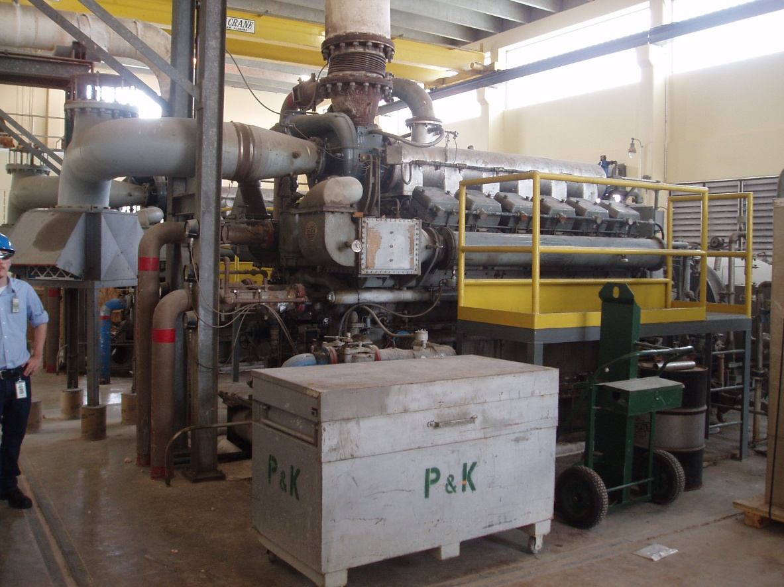
EU002, or 003 Cogenerator
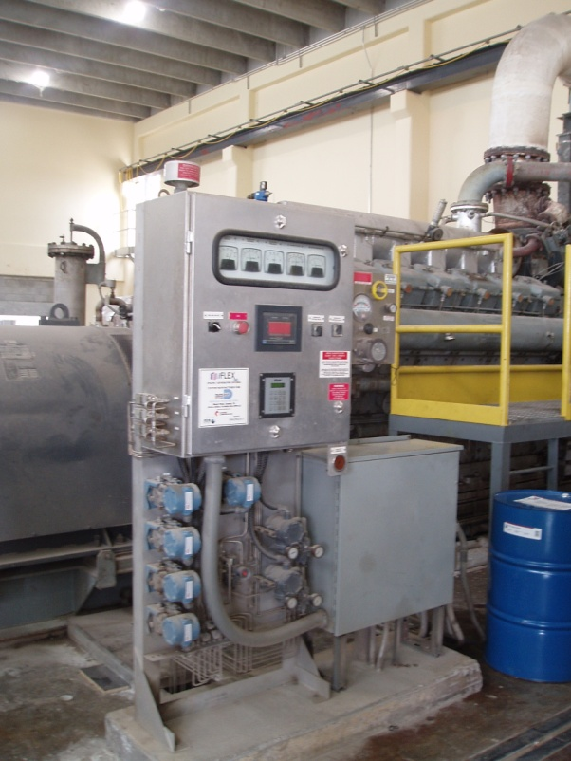
Cogenerator Control Panel
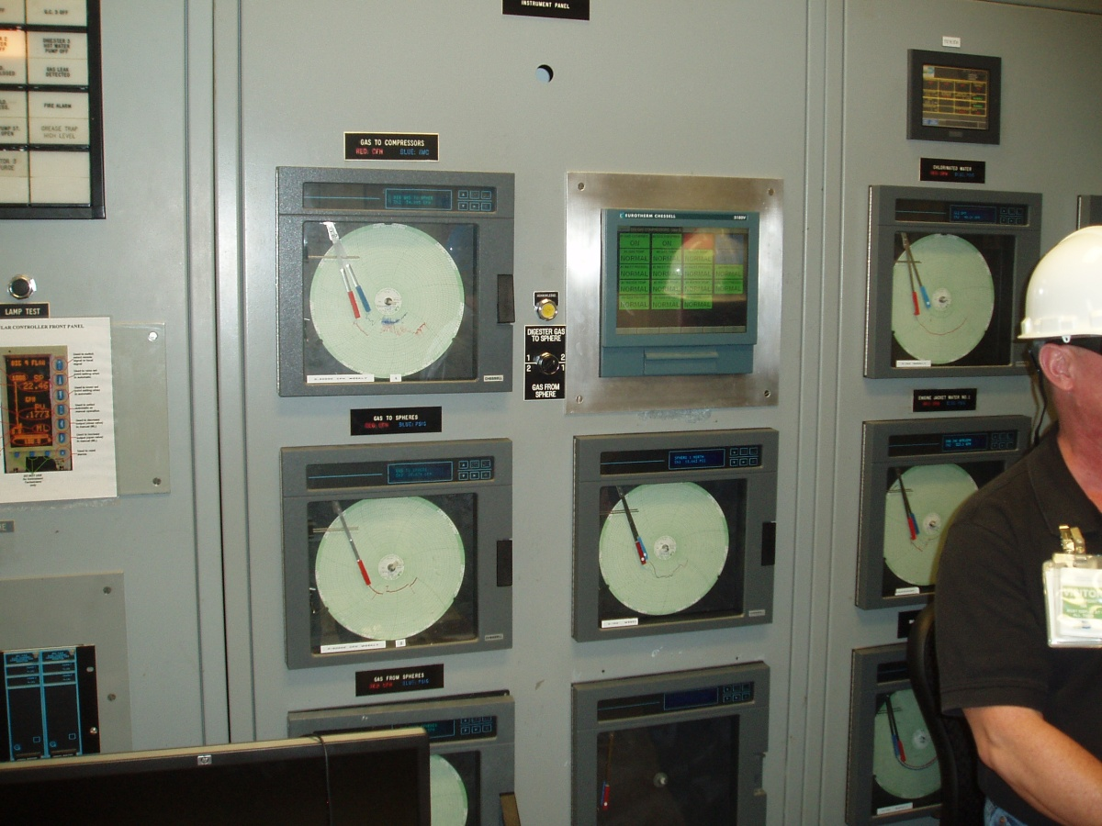
Cogenerator Control Room Monitors
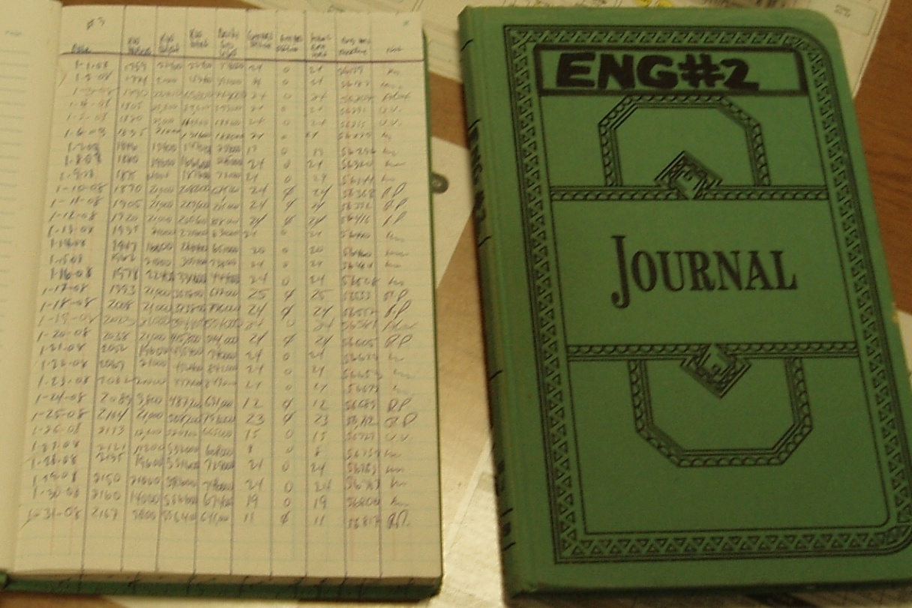
Cogenerator Daily Log Books
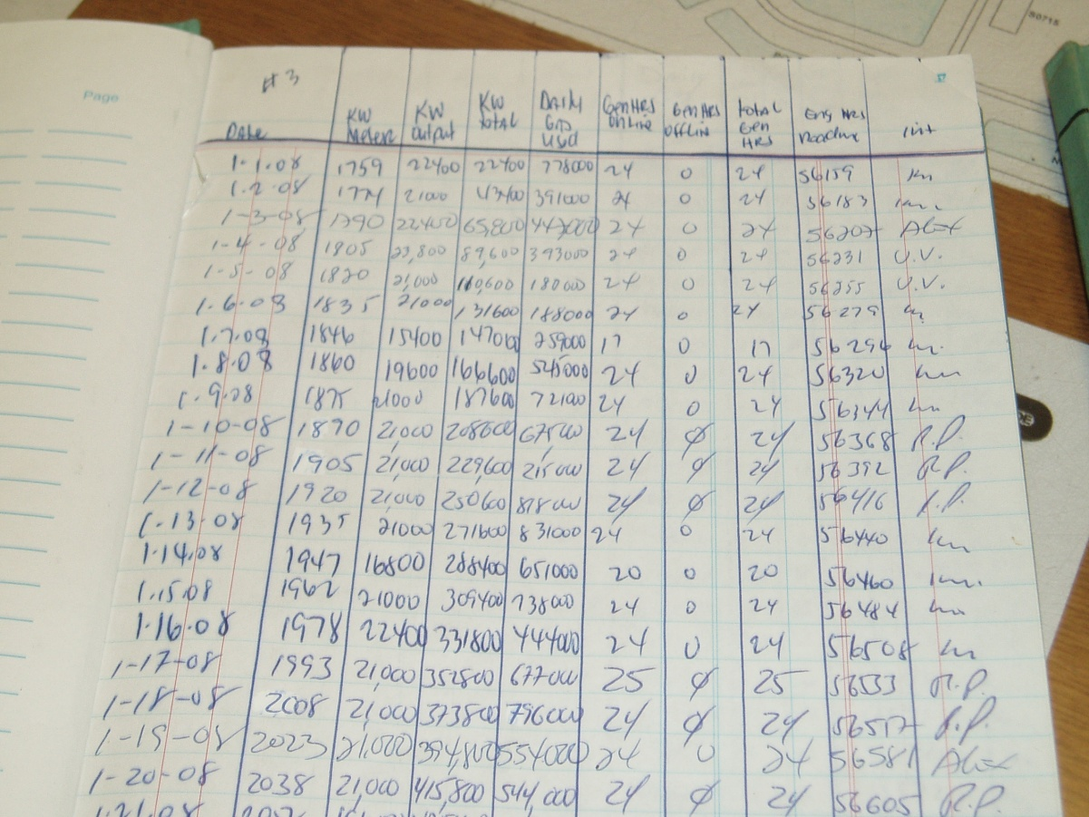
Cogenerator No 3 Daily Log Book Closeup
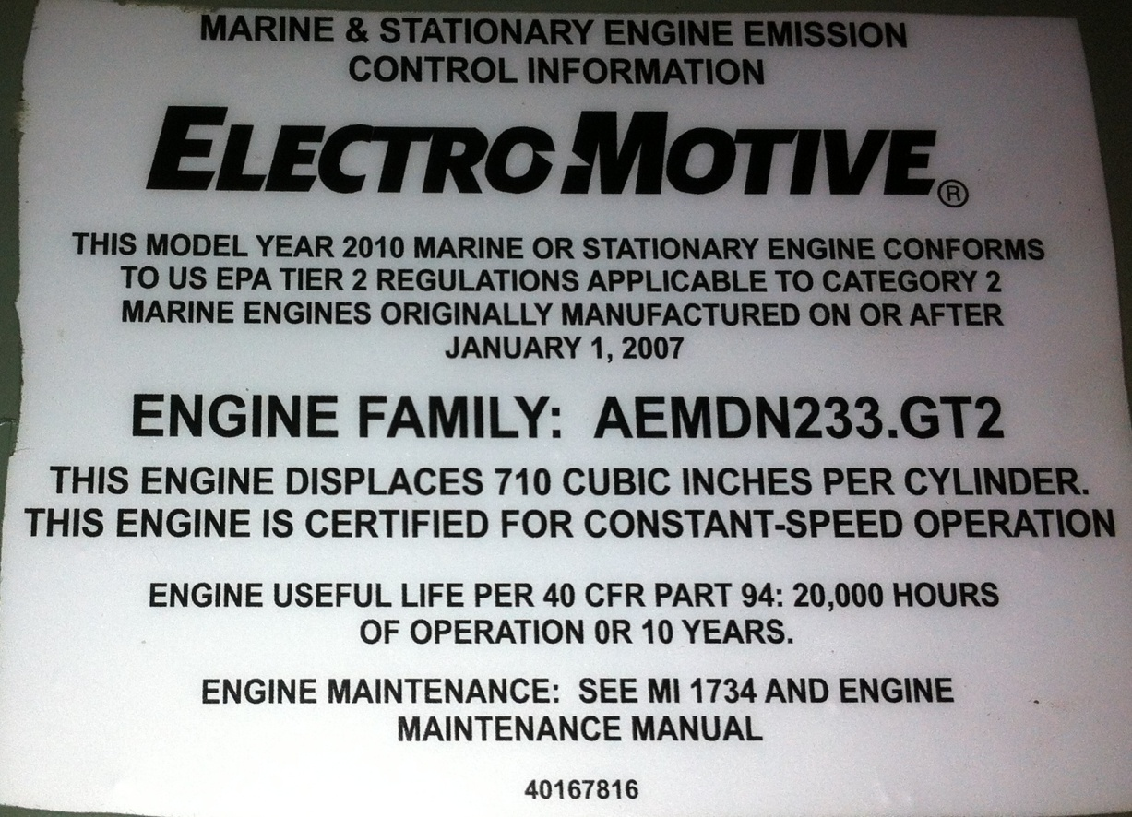
EU014 Emission Control Information
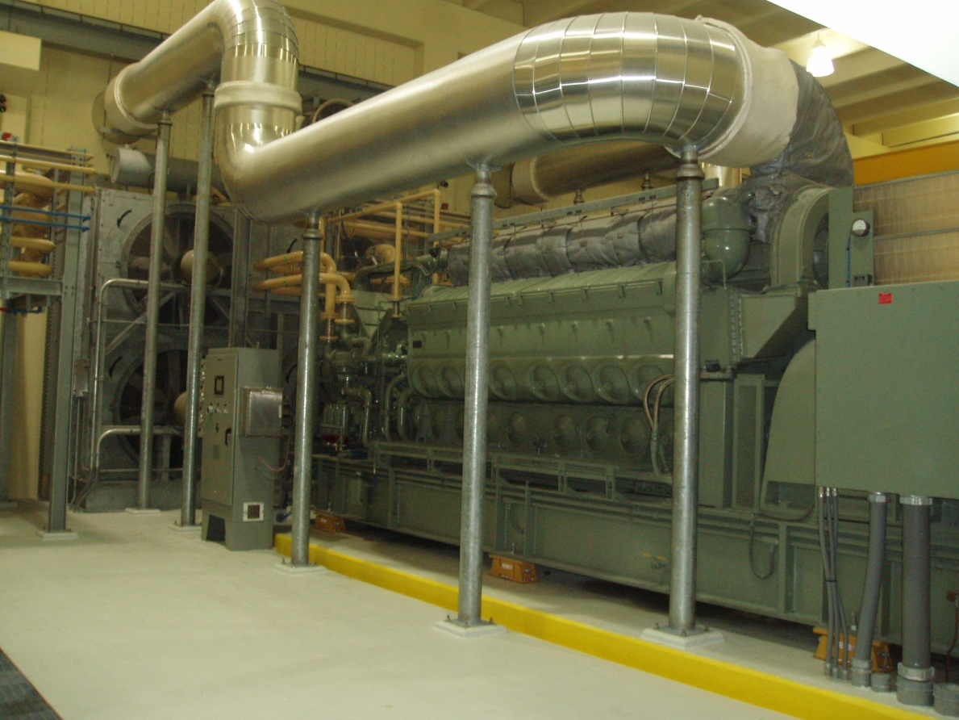
EU014 Generator
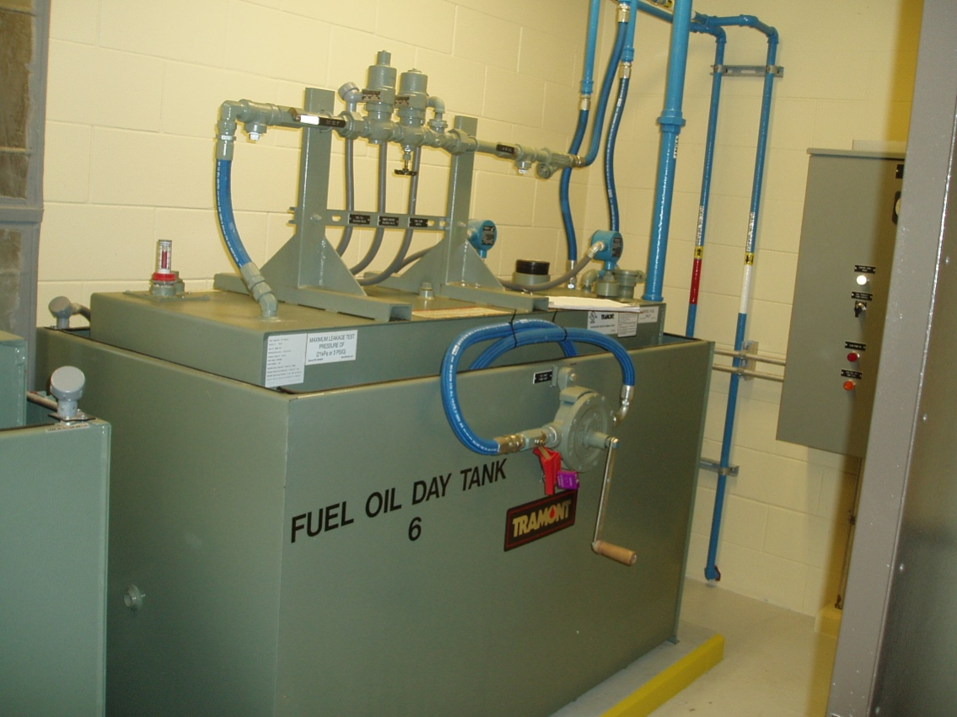
EU014 Generator Day Tank
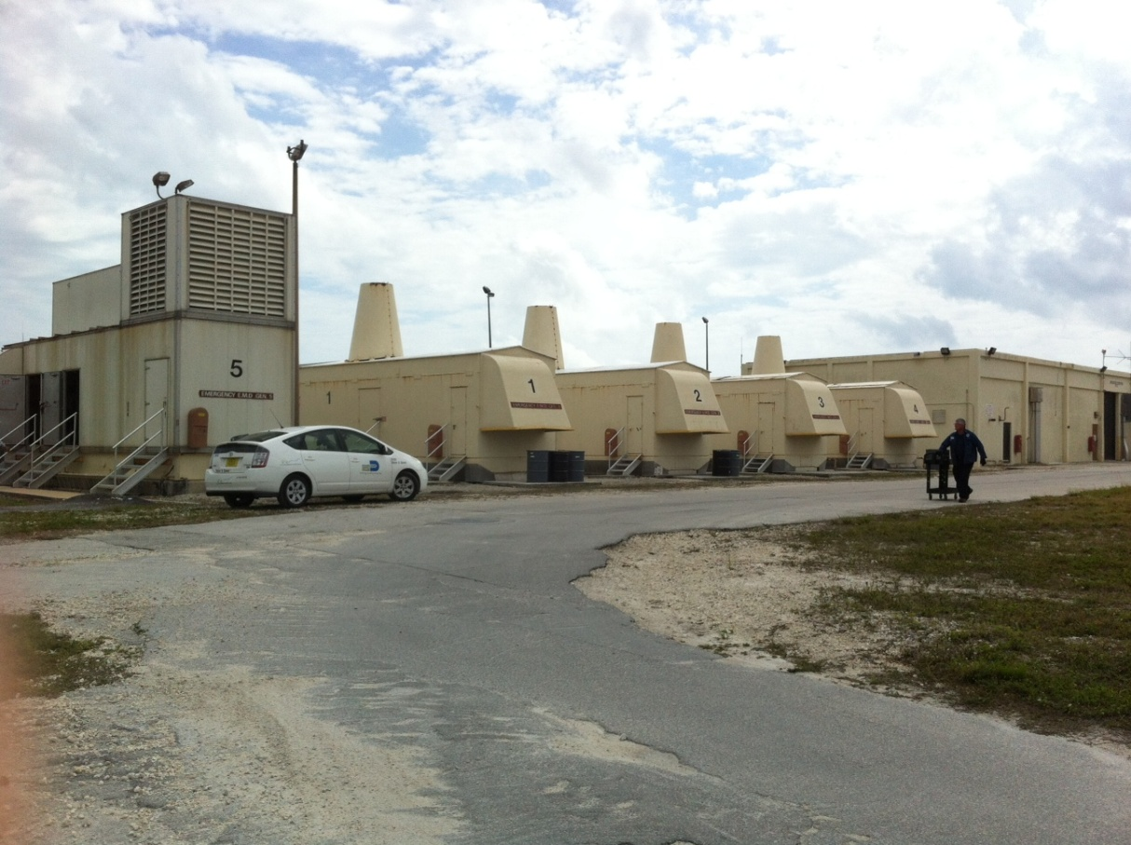
Diesel Generators 1 (EU006) through 5 (EU010)
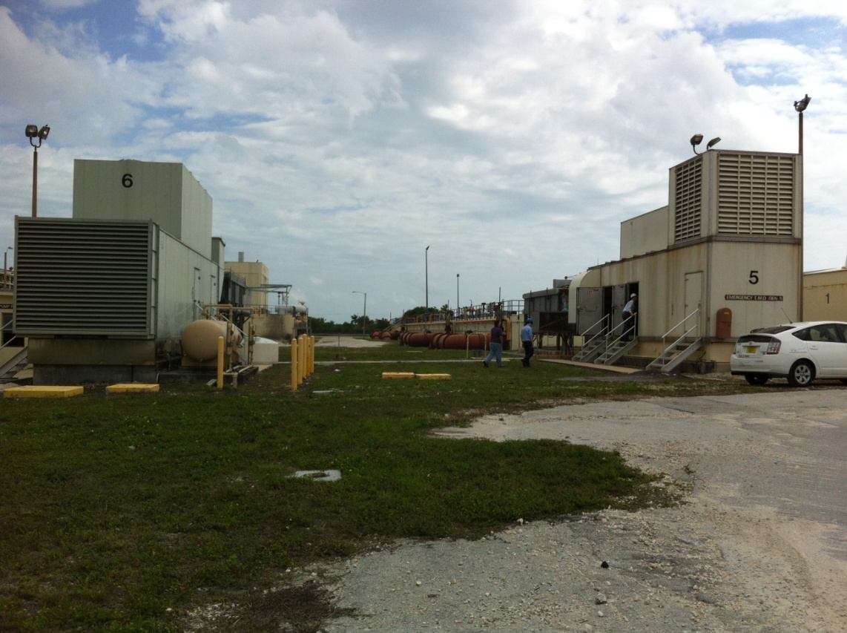
Diesel Generators 5 (EU010) and 6 (EU013)
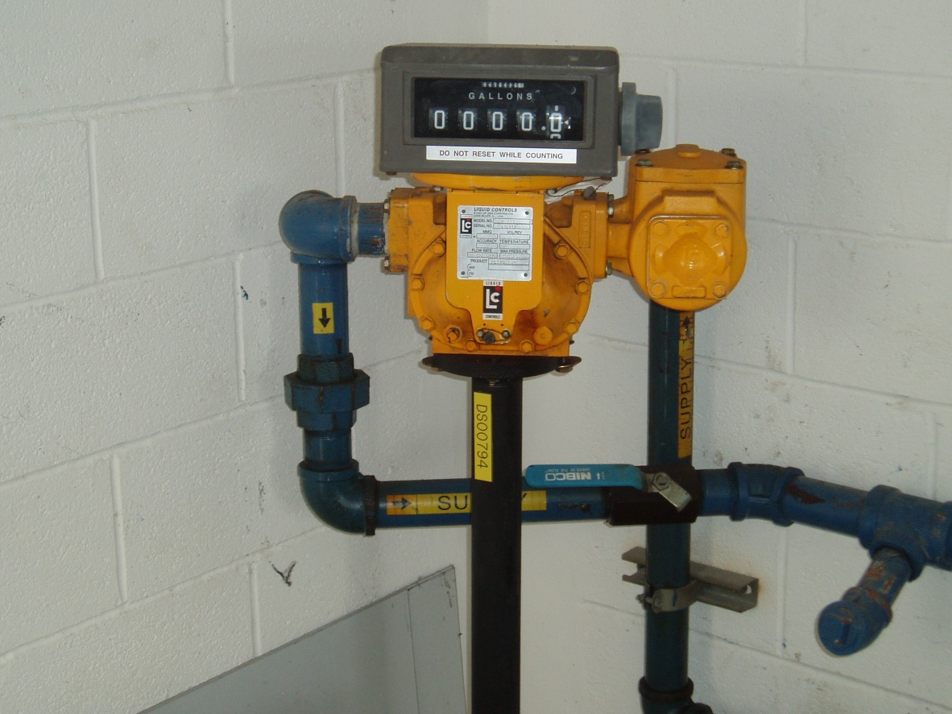
Diesel Generators 1-6 (EU006-010 and EU013) Fuel Meter
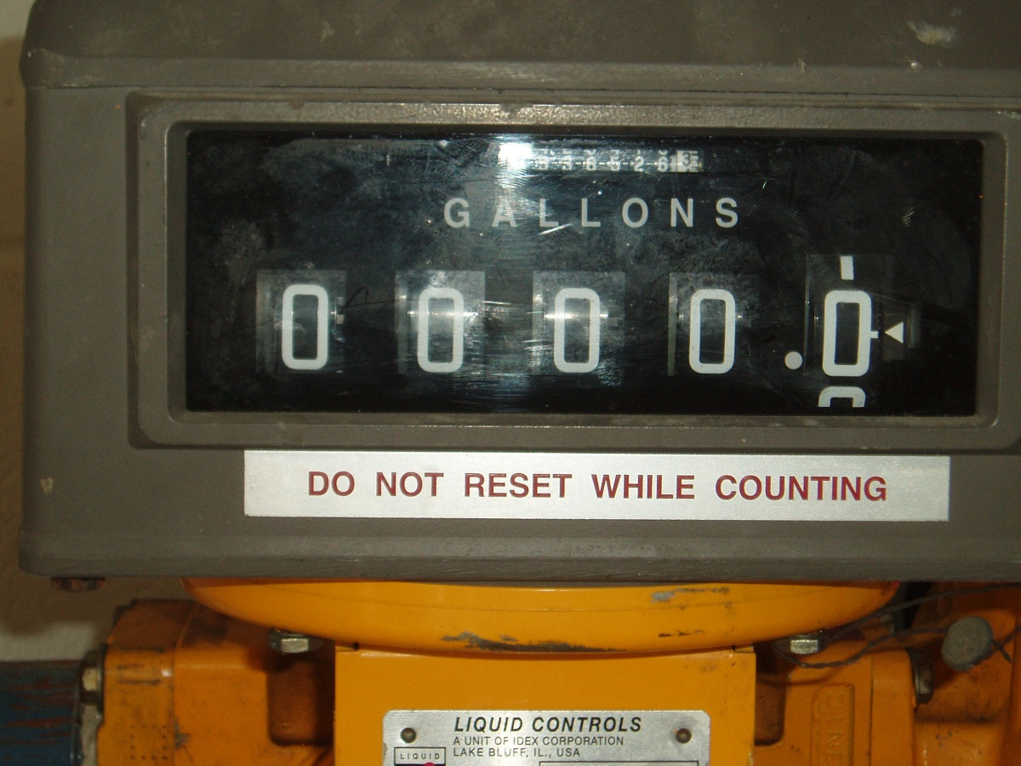
Diesel Generators 1-6 (EU006-010 and EU013) Fuel Meter Closeup

