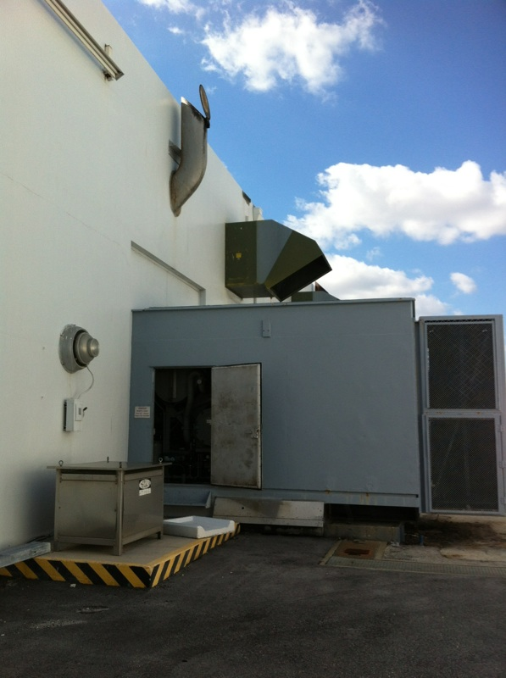
EU006 (Generator #1)
Stack
Back end of generator protrudes from building

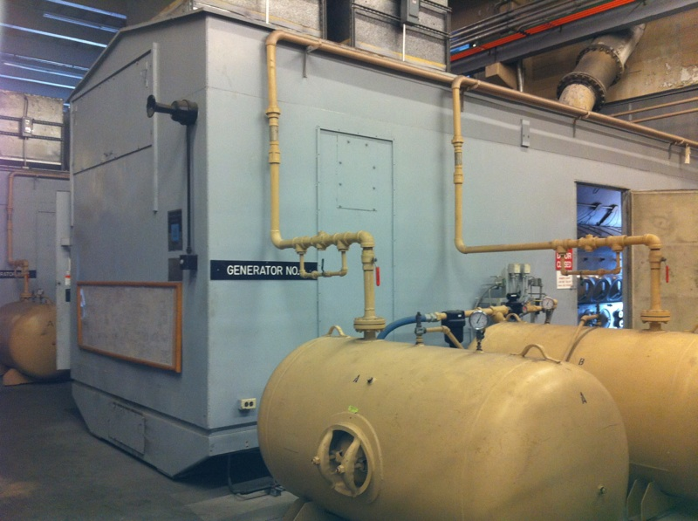
Inside View of Generator #1

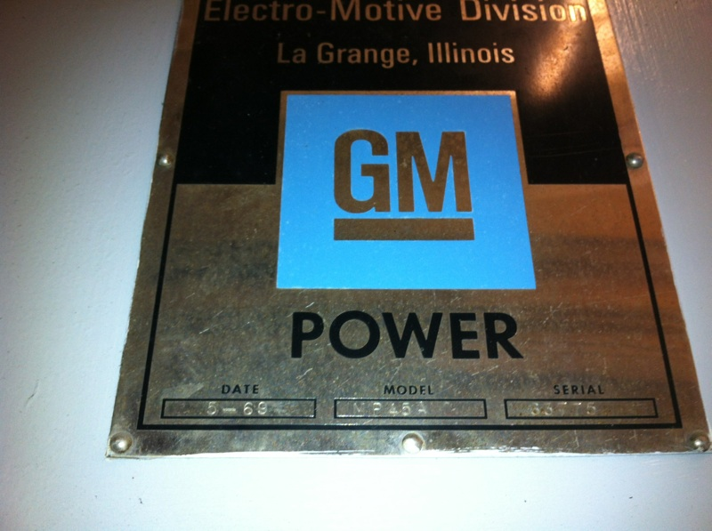
GM Power, Date 5-69, Model MP45A, Serial No. 63775

