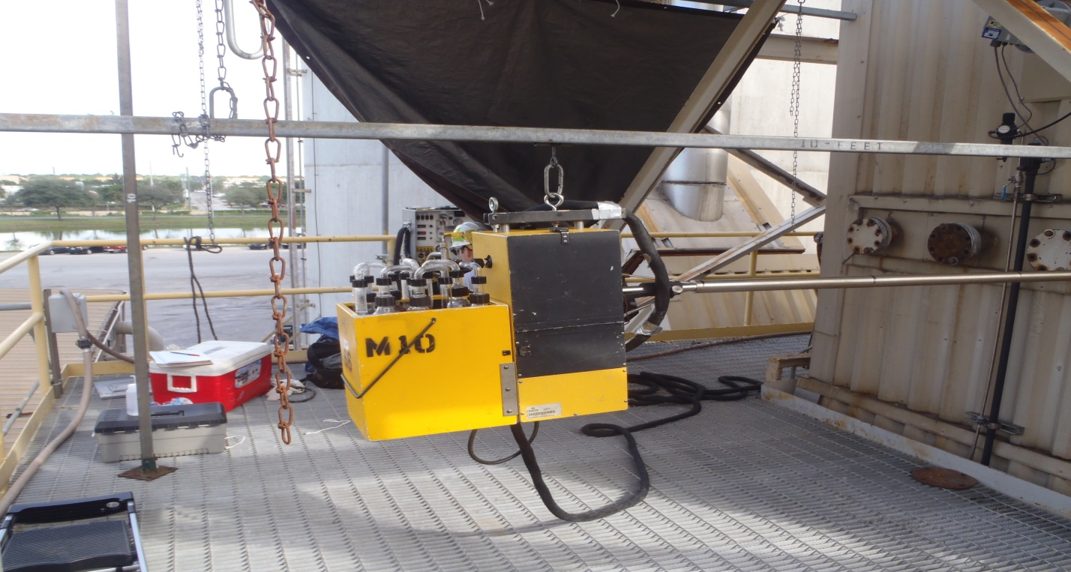Sample Probe/Impinger Assembly
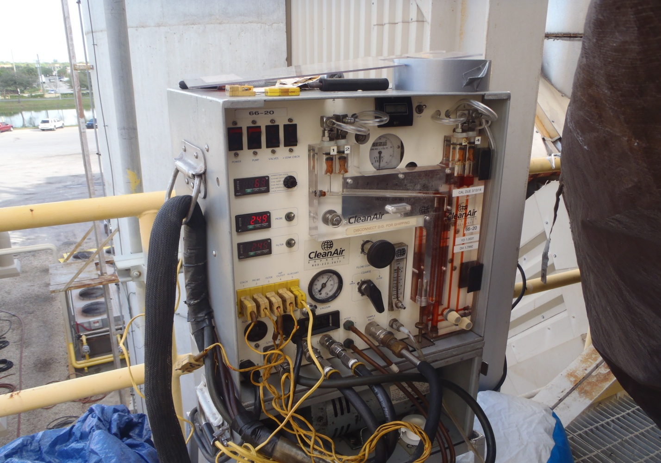
Isokinetic Control Console
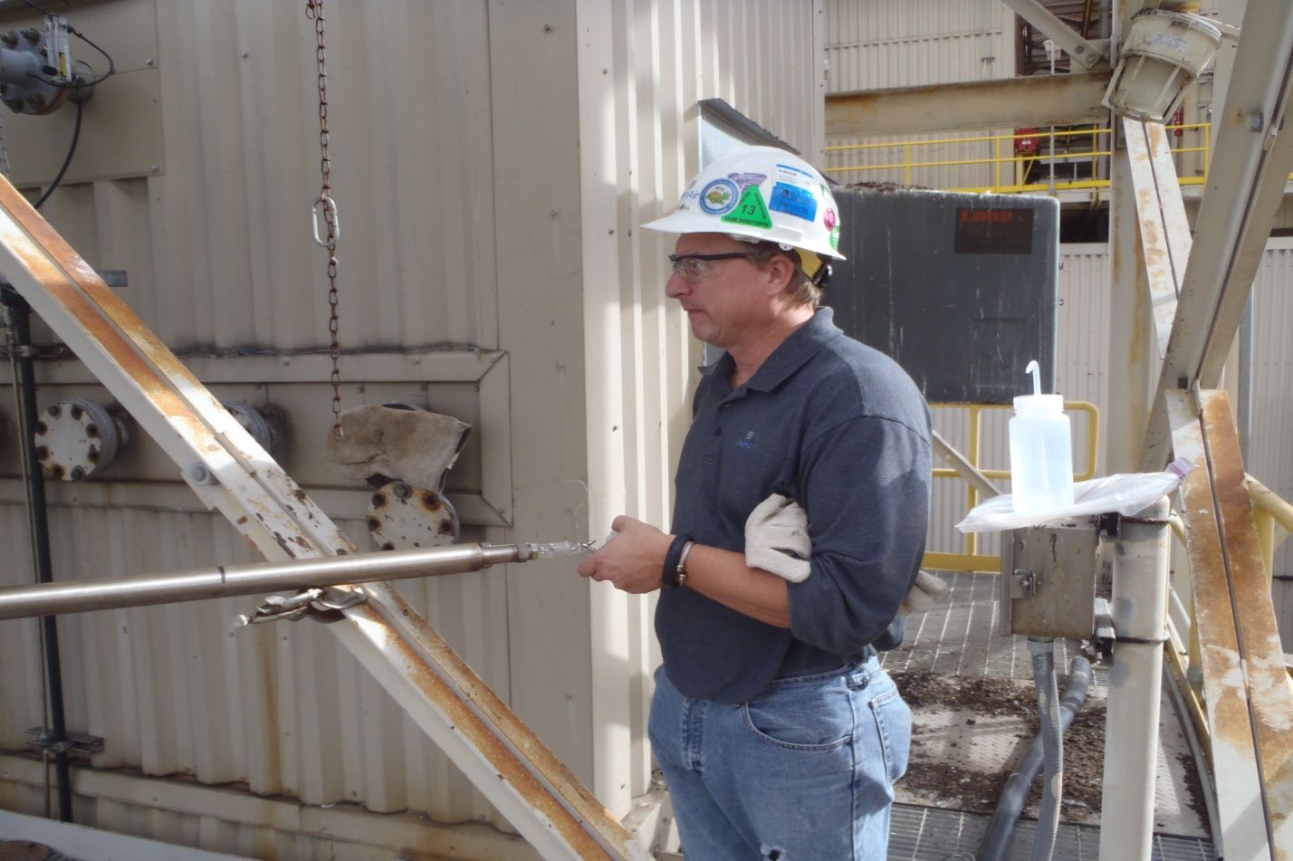
Leak Check after Run #2
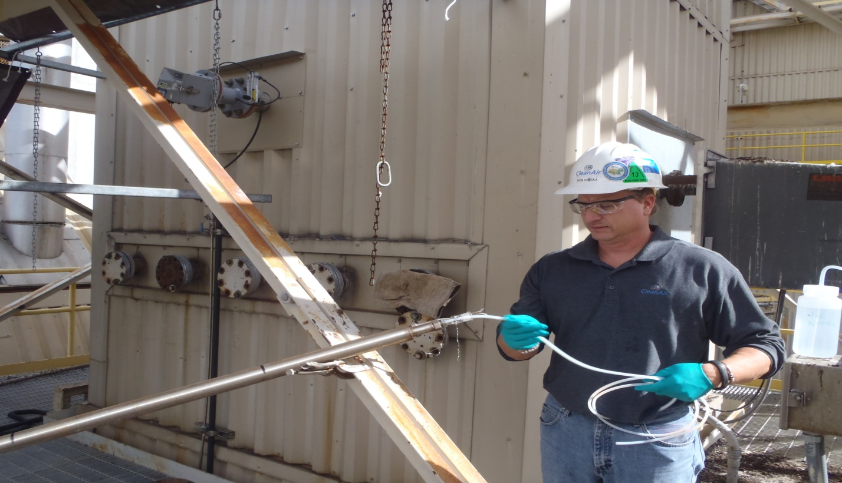
Cleaning Probe after Run #2
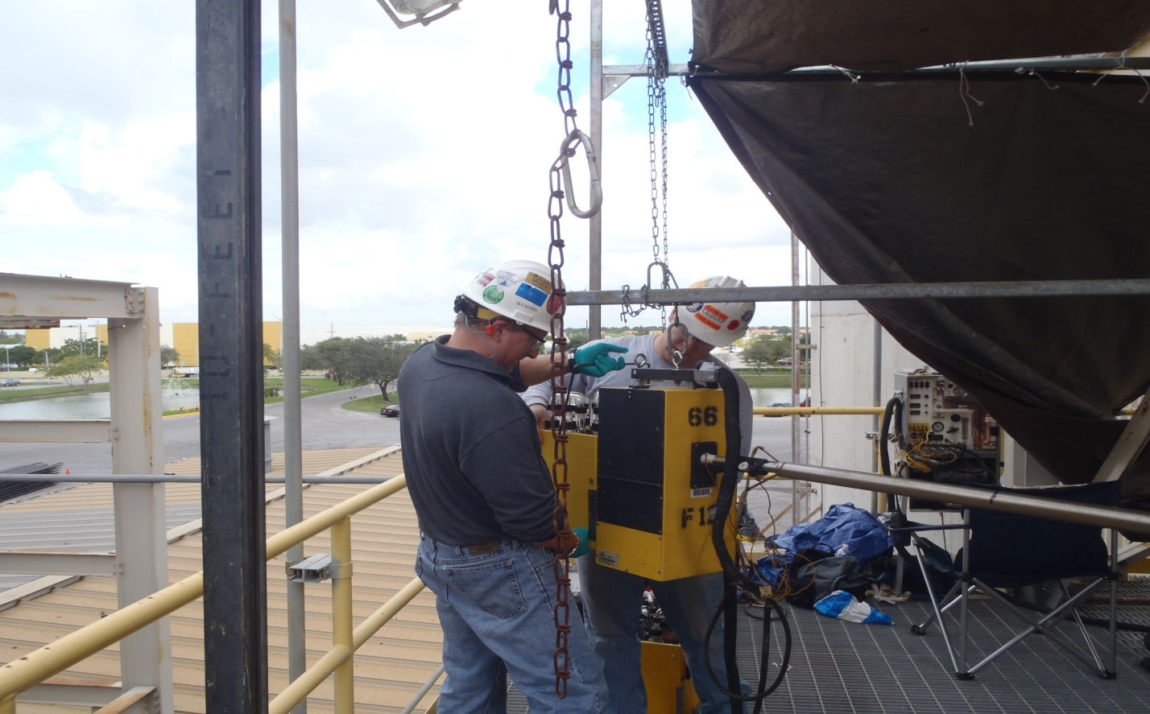
Setting up probe/impinger assembly for Run #3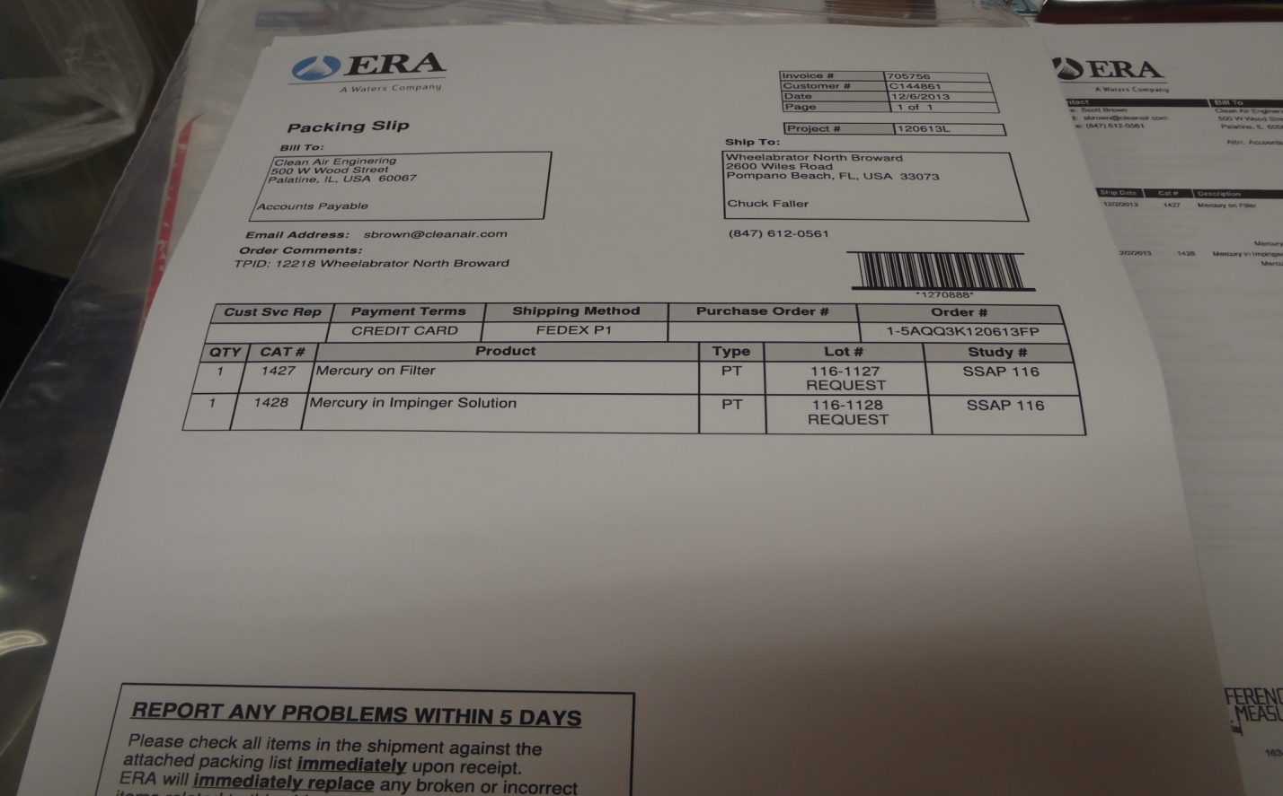
Audit Sample Packing Slip (sample IDs 1116-1127, 1116-1128)
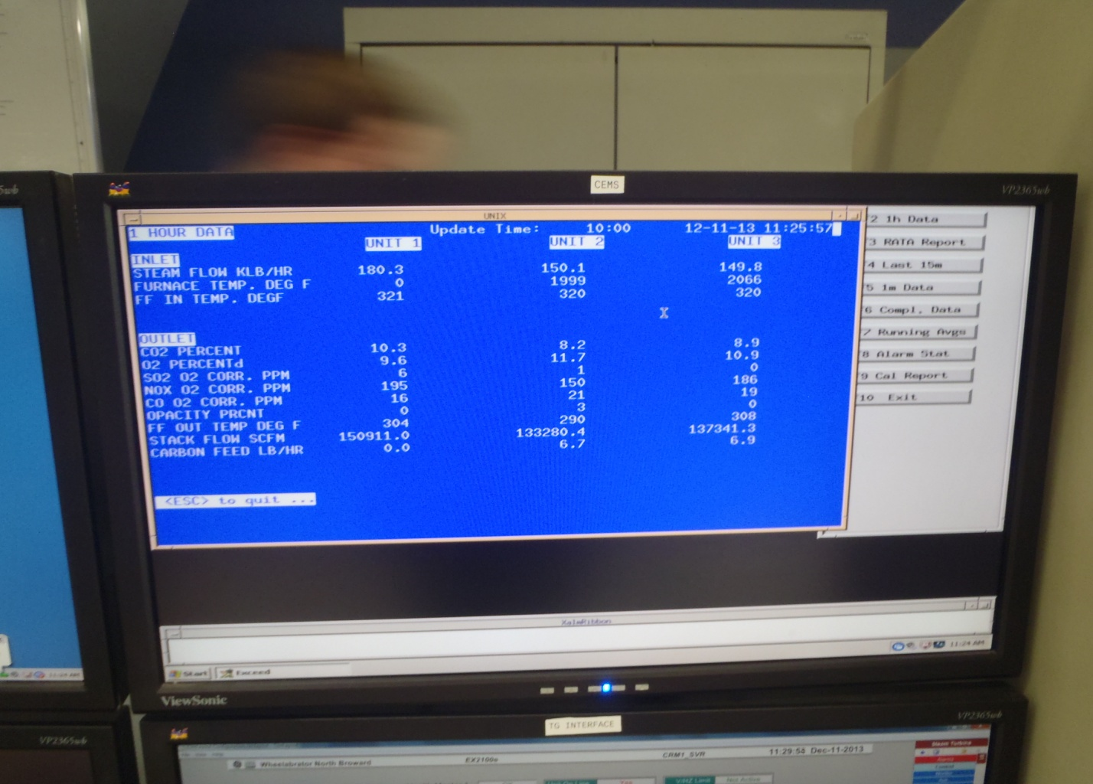 Control Room Monitor

