7770073 84783
FACILITY: APAC-Southeast, Inc |  |  |  |  |  |  |  |  |  |  |  |  |  |  |  |  |  |  |  | PERMIT ID: 2802
Clearwater Asphalt Plant |  |  |  |  |  |  |  |  |  |  |  |  |  |  |  |  |  |  |  | DISTRICT: Southwest
ADDRESS: 12955 40th Street North |  |  |  |  |  |  |  |  |  |  |  |  |  |  |  |  |  |  |  | CONTACT PHONE:
Clearwater, FL |  |  |  |  |  |  |  |  |  |  |  |  |  |  |  |  |  |  |  | 813-623-3622
ARMS NO:  7770073 002 |  |  |  |  |  |  |  | PERMIT NO: |  |  |  |  |  |  |  |  |  |  |  | Expiration Date: 4/15/2016  Renewal Date: 2/15/2016
 |  |  |  |  |  |  |  | 7770073-015-AO
 |  |  |  |  |  |  |  |  |  |  |  |  |  |  |  |  |  |  |  | Test Due Date:
EMISSION UNIT DESCRIPTION : Up to 250 Ton/Hr Portable Recycle Asphalt Pavement (RAP) Crushing System, including Screening and Conveying equipment subject to NSPS Subpart OOO

INSPECTION DATE: |  |  |  |  |  |  | ARMS INSPECTION TYPE: |  |  |  |  |  |  |  |  |  |  |  |  |  |  | COMPLIANCE STATUS:
 | August 12, 2013 |  |  |  |  |  |  |  |  | INS1 |  | ✓ | INS2 |  |  | INS3 |  |  | FUI |  |  |  |  |  | IN |  |  | MNC |  |  |  |  |  | SNC
INSPECTION TYPE: |  |  |  | ✓ | Initial |  |  |  |  |  | Re-inspection |  |  |  |  |  | Complaint |  |  |  |  |  |  | Drive-by |  |  |  |  |  |  | Quarterly
✓ |  |  | A. General Review:
1. |  | Permit File Review |  |  |  |  |  |  |  |  |  |  |  |  |  |  |  |  |  |  |  |  |  |  |  |  |  |  |  | Yes |  |  |  |  | No
 |  | Comments: yes
2. |  | Introduction and Entry |  |  |  |  |  |  |  |  |  |  |  |  |  |  |  |  |  |  |  |  |  |  |  |  |  |  |  | Yes |  |  |  |  | No
 |  | Comments: I met on site with operator Robert Grubbs, and rock crusher foreman Albert Wright of Bottorf Associates, Inc.
3. |  | Is the Responsible Official/Authorized Representative still: Mark S. Marine? |  |  |  |  |  |  |  |  |  |  |  |  |  |  |  |  |  |  |  |  |  |  |  |  |  |  |  | Yes |  |  |  |  | No
Comments: He continues to be the responsible official, at the corporate office for this facility
The Responsible Official/Authorized Representative’s e-mail is: msMarine@apac.com
4. |  | Is the facility contact still: Luther Ellis? |  |  |  |  |  |  |  |  |  |  |  |  |  |  |  |  |  |  |  |  |  |  |  |  |  |  |  | Yes |  |  |  |  | No
Comments: No retired, Darin Kubilis, plant superintendent for the facility and Robert Grubb will be the facility contact to remain on site.
The facility contact’s e-mail is: Darin.kubilis@apac.com

IN | MNC | SNC |  |  | B. Specific Conditions:
✓  ✓  ✓  ✓  ✓  ✓  ✓  ü  ü  ü  ü  ü  ü  ü  ü  ü  ü  ü  ü  ü  ü  ü  ü  ü  ü  ü  ü  ✓ |  |  |  |  | Inspection note: This operation permit became effective on 4/15/11. It authorizes the operation of a drum mix asphalt plant that allows a portable reclaimed asphalt pavement (RAP) crushing system to be brought onto the asphalt concrete plant’s site.  Exempt Emission Units/Activities  - A 335 HP diesel engine with a design heat input rate of 2.35 MMBtu/hour that powers both the portable RAP crushing system and the electrical generator for the crushing system. This engine is fired with new No.2 fuel oil. This engine was previously permitted as Emission Unit 003. [Rule 62-210.300(3)(a)36., F.A.C.]  - Three 200 ton capacity hot mix asphalt concrete storage silos.[Rule 62-210.300(3)(b)1., F.A.C.]  - A Gencor electric powered lump breaker is used to break up conglomerated pieces of RAP. [Rule 62-210.300(3)(b)1., F.A.C.]  - A Meeker-Patriot Model 9-FT-161-CMC hot asphalt oil heater rated at a maximum of 2.0 MMBTU/hr. The heater is fired with natural gas or new diesel fuel oil having a maximum sulfur content of 0.5% by weight. [Rule 62-210.300(3)(a)34., F.A.C.]  Comments: The lump breaker is exempt. It is operated in line with the plant or when the added reclaimed asphalt . This is not a asphalt crusher. (See Photo)  Permit Administrative Requirements  17. Asbestos Containing Materials – This facility shall not process Asbestos Containing Materials (ACM), whether regulated asbestos containing material (RACM), category I or category II, and whether friable or non-friable when received at the facility.  a. "Asbestos" means the asbestiform varieties of serpentinite (chrysotile), riebeckite (crocidolite), cummingtonite-grunerite, anthophyllite, and actinolite-tremolite and includes trade acronyms products such as amosite.  b. "Asbestos-containing materials", ACM, means any materials which contain more than one percent asbestos as determined by Polarized Light Microscopy. Based on a representative composite sample.  c. "Asbestos removal project" means renovation or demolition operation in a facility that involves the removal of a threshold amount of regulated asbestos-containing material.  d. "Category I Nonfriable Asbestos-Containing Material (ACM)" means asbestos-containing packings, gaskets, resilient floor covering, and asphalt roofing products containing more than 1 percent asbestos as determined using the method specified in Appendix A, Subpart F, 40 CFR Part 763, Section 1, Polarized Light Microscopy.  e. "Category II Non-friable ACM" means any material, excluding Category I Nonfriable ACM, containing more than 1 percent asbestos as determined using the methods specified in Appendix A, Subpart F, 40 CFR Part 763, Section 1, Polarized Light Microscopy, that, when dry, cannot be crumbled, pulverized, or reduced to powder by hand pressure.  [40 CFR 61, Subpart M; Chapter 62-257, F.A.C.; and Rules 62-730.300 and 62-701.520, F.A.C.]  Comments: The facility did not have or receive asbestos containing materials. The Facility stockpiles observed consisted of aggregates and RAP, no construction debris was on site.  B.1. Federal Regulatory Requirements -  a. If any affected piece(s) of equipment of the portable RAP crushing system used at this asphalt plant is not subject to the attached Title 40, Code of Federal Regulations (CFR), Part 60, Subpart OOO – Standards of Performance for Nonmetallic Mineral Processing Plants (see Appendix F.) and the attached general provisions of 40 CFR 60, Subpart A (see Appendix G.), where applicable, regarding Part B of Section 3 of this permit then only Specific Condition Nos. B.2., B.3., B.4., B.6., B.16., and B.18.a.- e. apply to the affected piece(s) of equipment.  b. If any affected piece(s) of equipment of the portable RAP crushing system used at this asphalt plant is subject to the attached Title 40, Code of Federal Regulations (CFR), Part 60, Subpart OOO – Standards of Performance for Nonmetallic Mineral Processing Plants (see Appendix F.) and the attached general provisions of 40 CFR 60, Subpart A (see Appendix G.), where applicable, then all of the following specific conditions apply to the affected piece(s) of equipment. [40 CFR 60, Subparts A and OOO; Construction Permit 7770073-013-AC]  Comments: There was no crushing unit observed on the site at time of stack testing inspection on 6/4/ 13 The Powerscreen of Florida, Inc, sent the facility notification for the crushing unit under permit 7775743 for located to the site on 7/24/13. The crusher did set up, but was not operating until 7/30/13.  SECTION 4. APPENDIX F. 40 CFR 60, Subpart OOO – Standards of Performance for Nonmetallic Mineral Processing Plants  § 60.672 Standard for particulate matter (PM).  (a) Affected facilities must meet the stack emission limits and compliance requirements in Table 2 of this subpart within 60 days after achieving the maximum production rate at which the affected facility will be operated, but not later than 180 days after initial startup as required under §60.8. The requirements in Table 2 of this subpart apply for affected facilities with capture systems used to capture and transport particulate matter to a control device.  (b) Affected facilities must meet the fugitive emission limits and compliance requirements in Table 3 of this subpart within 60 days after achieving the maximum production rate at which the affected facility will be operated, but not later than 180 days after initial startup as required under §60.11. The requirements in Table 3 of this subpart apply for fugitive emissions from affected facilities without capture systems and for fugitive emissions escaping capture systems.  (d) Truck dumping of nonmetallic minerals into any screening operation, feed hopper, or crusher is exempt from the requirements of this section.  (e) If any transfer point on a conveyor belt or any other affected facility is enclosed in a building, then each enclosed affected facility must comply with the emission limits in paragraphs (a) and (b) of this section, or the building enclosing the affected facility or facilities must comply with the following emission limits:  (1) Fugitive emissions from the building openings (except for vents as defined in §60.671) must not exceed 7 percent opacity; and  (2) Vents (as defined in §60.671) in the building must meet the applicable stack emission limits and compliance requirements in Table 2 of this subpart.  (f) Any baghouse that controls emissions from only an individual, enclosed storage bin is exempt from the applicable stack PM concentration limit (and associated performance testing) in Table 2 of this subpart but must meet the applicable stack opacity limit and compliance requirements in Table 2 of this subpart. This exemption from the stack PM concentration limit does not apply for multiple storage bins with combined stack emissions.  Comments: The stack test was performed on the baghouse for the asphalt plant within 30 days of start up on 6/4/3.  § 60.674 Monitoring of operations.  (b) The owner or operator of any affected facility for which construction, modification, or reconstruction commenced on or after April 22, 2008, that uses wet suppression to control emissions from the affected facility must perform monthly periodic inspections to check that water is flowing to discharge spray nozzles in the wet suppression system. The owner or operator must initiate corrective action within 24 hours and complete corrective action as expediently as practical if the owner or operator finds that water is not flowing properly during an inspection of the water spray nozzles. The owner or operator must record each inspection of the water spray nozzles, including the date of each inspection and any corrective actions taken, in the logbook required under §60.676(b).  (1) If an affected facility relies on water carryover from upstream water sprays to control fugitive emissions, then that affected facility is exempt from the 5-year repeat testing requirement specified in Table 3 of this subpart provided that the affected facility meets the criteria in paragraphs (b)(1)(i) and (ii) of this section:  (i) The owner or operator of the affected facility conducts periodic inspections of the upstream water spray(s) that are responsible for controlling fugitive emissions from the affected facility. These inspections are conducted according to paragraph (b) of this section and §60.676(b), and  (ii) The owner or operator of the affected facility designates which upstream water spray(s) will be periodically inspected at the time of the initial performance test required under §60.11 of this part and §60.675 of this subpart.  (2) If an affected facility that routinely uses wet suppression water sprays ceases operation of the water sprays or is using a control mechanism to reduce fugitive emissions other than water sprays during the monthly inspection (for example, water from recent rainfall), the logbook entry required under §60.676(b) must specify the control mechanism being used instead of the water sprays.  Comments: The APAC provides water for the crushing unit on site. There was a new water truck on site for the yard watering. I also observed the water suppression system working on the conveyor by pass of the escaloator conveyor to the asphalt storage silos. The hoses for crusher water suppression were attached to the crusher, and hoses were visible along the conveyors of the crusher, and at nozzles observed at the drop points from the crusher I.E. 1st belt below the crusher hopper of conveyor #1.  § 60.675 Test methods and procedures.  (a) In conducting the performance tests required in §60.8, the owner or operator shall use as reference methods and procedures the test methods in appendices A–1 through A–7 of this part or other methods and procedures as specified in this section, except as provided in §60.8(b). Acceptable alternative methods and procedures are given in paragraph (e) of this section.  (b) The owner or operator shall determine compliance with the PM standards in §60.672(a) as follows:  (2) Method 9 of Appendix A–4 of this part and the procedures in §60.11 shall be used to determine opacity.  (c)  (1) In determining compliance with the particulate matter standards in §60.672(b) or §60.672(e)(1), the owner or operator shall use Method 9 of Appendix A–4 of this part and the procedures in §60.11, with the following additions:  (i) The minimum distance between the observer and the emission source shall be 4.57 meters (15 feet).  (ii) The observer shall, when possible, select a position that minimizes interference from other fugitive emission sources ( e.g., road dust). The required observer position relative to the sun (Method 9 of Appendix A–4 of this part, Section 2.1) must be followed.  (iii) For affected facilities using wet dust suppression for particulate matter control, a visible mist is sometimes generated by the spray. The water mist must not be confused with particulate matter emissions and is not to be considered a visible emission. When a water mist of this nature is present, the observation of emissions is to be made at a point in the plume where the mist is no longer visible.  (3) When determining compliance with the fugitive emissions standard for any affected facility described under §60.672(b) or §60.672(e)(1) of this subpart, the duration of the Method 9 (40 CFR part 60, Appendix A–4) observations must be 30 minutes (five 6-minute averages). Compliance with the applicable fugitive emission limits in Table 3 of this subpart must be based on the average of the five 6-minute averages.  (e) The owner or operator may use the following as alternatives to the reference methods and procedures specified in this section:  (1) For the method and procedure of paragraph (c) of this section, if emissions from two or more facilities continuously interfere so that the opacity of fugitive emissions from an individual affected facility cannot be read, either of the following procedures may be used:  (i) Use for the combined emission stream the highest fugitive opacity standard applicable to any of the individual affected facilities contributing to the emissions stream.  (ii) Separate the emissions so that the opacity of emissions from each affected facility can be read.  (2) A single visible emission observer may conduct visible emission observations for up to three fugitive, stack, or vent emission points within a 15-second interval if the following conditions are met:  (i) No more than three emission points may be read concurrently.  (ii) All three emission points must be within a 70 degree viewing sector or angle in front of the observer such that the proper sun position can be maintained for all three points.  (iii) If an opacity reading for any one of the three emission points equals or exceeds the applicable standard, then the observer must stop taking readings for the other two points and continue reading just that single point.  Comments: The method 9 for the unit under 7775743 was performed for the annual requirement during 2012 at a different location off site. The opacity result was 0% on 3 emission points tested on 11/26/12. Diesel stack, Drop entrance to crusher and drop from Crusher to screen.  § 60.676 Reporting and recordkeeping.  (2) For a screening operation:  (i) The total surface area of the top screen of the existing screening operation being replaced and  (ii) The total surface area of the top screen of the replacement screening operation.  (3) For a conveyor belt:  (i) The width of the existing belt being replaced and  (ii) The width of the replacement conveyor belt.  (b)  (1) Owners or operators of affected facilities (as defined in §§60.670 and 60.671) for which construction, modification, or reconstruction commenced on or after April 22, 2008, must record each periodic inspection required under §60.674(b) or (c), including dates and any corrective actions taken, in a logbook (in written or electronic format). The owner or operator must keep the logbook onsite and make hard or electronic copies (whichever is requested) of the logbook available to the Administrator upon request.  (f) The owner or operator of any affected facility shall submit written reports of the results of all performance tests conducted to demonstrate compliance with the standards set forth in §60.672 of this subpart, including reports of opacity observations made using Method 9 (40 CFR part 60, Appendix A–4) to demonstrate compliance with §60.672(b), (e) and (f).  (k) Notifications and reports required under this subpart and under subpart A of this part to demonstrate compliance with this subpart need only to be sent to the EPA Region or the State which has been delegated authority according to §60.4(b).  Comments: The APAC facility began record keeping upon start up of the asphalt plant plant on 5/13/13. The plant had been shutdown in 2011. The crushing unit began operations 7/30/13. The powerscreen foreman was maintaining the daily records for the crusher noting the diesel fuel usage and tons of RAP produced, hours of operation. The crusher is equipped with a meter for recording the tons produced.  40 CFR PART 60, SUBPART A - GENERAL PROVISIONS  § 60.7 NOTIFICATION AND RECORD KEEPING.  (a) Any owner or operator subject to the provisions of this part shall furnish the Administrator written notification or, if acceptable to both the Administrator and the owner or operator of a source, electronic notification, as follows:  (3) A notification of the actual date of initial startup of an affected facility postmarked within 15 days after such date.  Comments: Notification of relocation and startup was received on 7/9/13, emission unit will be located on the site by 7/15/13. The facility superintendent was notified this was not proper notification time. So they delayed bring to the site until 7/24/13. This is 9 days notice prior to relocation. The facility was not able to perform visible emissions test as the unit was not on site 6/4/13 during stack test performed for EU 001. Facility was granted waiver based on difficulties associated with procuring a job of sufficient size with desired process rate for testing. Also note 7 days re notification is allowed re 60.8(5)d. under performance tests section. The crusher operation was not until 7/30/13.  § 60.8 PERFORMANCE TESTS.  (a) Except as specified in paragraphs (a)(1),(a)(2), (a)(3), and (a)(4) of this section, within 60 days after achieving the maximum production rate at which the affected facility will be operated, but not later than 180 days after initial startup of such facility, or at such other times specified by this part, and at such other times as may be required by the Administrator under section 114 of the Act, the owner or operator of such facility shall conduct performance test(s) and furnish the Administrator a written report of the results of such performance test(s).  (1) If a force majeure is about to occur, occurs, or has occurred for which the affected owner or operator intends to assert a claim of force majeure, the owner or operator shall notify the Administrator, in writing as soon as practicable following the date the owner or operator first knew, or through due diligence should have known that the event may cause or caused a delay in testing beyond the regulatory deadline, but the notification must occur before the performance test deadline unless the initial force majeure or a subsequent force majeure event delays the notice, and in such cases, the notification shall occur as soon as practicable.  (2) The owner or operator shall provide to the Administrator a written description of the force majeure event and a rationale for attributing the delay in testing beyond the regulatory deadline to the force majeure; describe the measures taken or to be taken to minimize the delay; and identify a date by which the owner or operator proposes to conduct the performance test. The performance test shall be conducted as soon as practicable after the force majeure occurs.  (3) The decision as to whether or not to grant an extension to the performance test deadline is solely within the discretion of the Administrator. The Administrator will notify the owner or operator in writing of approval or disapproval of the request for an extension as soon as practicable.  (4) Until an extension of the performance test deadline has been approved by the Administrator under paragraphs (a)(1), (2), and (3) of this section, the owner or operator of the affected facility remains strictly subject to the requirements of this part.  (b) Performance tests shall be conducted and data reduced in accordance with the test methods and procedures contained in each applicable subpart unless the Administrator (1) specifies or approves, in specific cases, the use of a reference method with minor changes in methodology, (2) approves the use of an equivalent method, (3) approves the use of an alternative method the results of which he has determined to be adequate for indicating whether a specific source is in compliance, (4) waives the requirement for performance tests because the owner or operator of a source has demonstrated by other means to the Administrator's satisfaction that the affected facility is in compliance with the standard, or (5) approves shorter sampling times and smaller sample volumes when necessitated by process variables or other factors. Nothing in this paragraph shall be construed to abrogate the Administrator's authority to require testing under section 114 of the Act.  (c) Performance tests shall be conducted under such conditions as the Administrator shall specify to the plant operator based on representative performance of the affected facility. The owner or operator shall make available to the Administrator such records as may be necessary to determine the conditions of the performance tests. Operations during periods of startup, shutdown, and malfunction shall not constitute representative conditions for the purpose of a performance test nor shall emissions in excess of the level of the applicable emission limit during periods of startup, shutdown, and malfunction be considered a violation of the applicable emission limit unless otherwise specified in the applicable standard.  (d) The owner or operator of an affected facility shall provide the Administrator at least 7 days prior notice of any performance test, except as specified under other subparts, to afford the Administrator the opportunity to have an observer present. If after 30 days notice for an initially scheduled performance test, there is a delay (due to operational problems, etc.) in conducting the scheduled performance test, the owner or operator of an affected facility shall notify the Administrator (or delegated State or local agency) as soon as possible of any delay in the original test date, either by providing at least 7 days prior notice of the rescheduled date of the performance test, or by arranging a rescheduled date with the Administrator (or delegated State or local agency) by mutual agreement.  (e) The owner or operator of an affected facility shall provide, or cause to be provided, performance  Comments: There was not any compliance issues observed or reported, the plant has been in temporary shutdown since June 2011. The oil heater was started on 5/8/13. The asphalt plant operation started 5/13/13. The crusher was brought to site on 7/24/13 was not in operation during stack testing.  § 60.11 COMPLIANCE WITH STANDARDS AND MAINTENANCE REQUIREMENTS.  (b) Compliance with opacity standards in this part shall be determined by conducting observations in accordance with Method 9 in appendix A of this part, any alternative method that is approved by the Administrator, or as provided in paragraph (e)(5) of this section. For purposes of determining initial compliance, the minimum total time of observations shall be 3 hours 30 minutes(30 5 6-minute averages) for the performance test or other set of observations (meaning those fugitive-type emission sources subject only to an opacity standard).  (c) The opacity standards set forth in this part shall apply at all times except during periods of startup, shutdown, malfunction, and as otherwise provided in the applicable standard.  (d) At all times, including periods of startup, shutdown, and malfunction, owners and operators shall, to the extent practicable, maintain and operate any affected facility including associated air pollution control equipment in a manner consistent with good air pollution control practice for minimizing emissions. Determination of whether acceptable operating and maintenance procedures are being used will be based on information available to the Administrator which may include, but is not limited to, monitoring results, opacity observations, review of operating and maintenance procedures, and inspection of the source.  (e)  (1) For the purpose of demonstrating initial compliance, opacity observations shall be conducted concurrently with the initial performance test required in §60.8 unless one of the following conditions apply. If no performance test under §60.8 is required, then opacity observations shall be conducted within 60 days after achieving the maximum production rate at which the affected facility will be operated but no later than 180 days after initial startup of the facility. If visibility or other conditions prevent the opacity observations from being conducted concurrently with the initial performance test required under §60.8, the source owner or operator shall reschedule the opacity observations as soon after the initial performance test as possible, but not later than 30 days thereafter, and shall advise the Administrator of the rescheduled date. In these cases, the 30-day prior notification to the Administrator required in §60.7(a)(6) shall be waived. The rescheduled opacity observations shall be conducted (to the extent possible) under the same operating conditions that existed during the initial performance test conducted under §60.8. The visible emissions observer shall determine whether visibility or other conditions prevent the opacity observations from being made concurrently with the initial performance test in accordance with procedures contained in Method 9 of appendix B of this part. Opacity readings of portions of plumes which contain condensed, uncombined water vapor shall not be used for purposes of determing compliance with opacity standards. The owner or operator of an affected facility shall make available, upon request by the Administrator, such records as may be necessary to determine the conditions under which the visual observations were made and shall provide evidence indicating proof of current visible observer emission certification. Except as provided in paragraph (e)(5) of this section, the results of continuous monitoring by transmissometer which indicate that the opacity at the time visual observations were made was not in excess of the standard are probative but not conclusive evidence of the actual opacity of an emission, provided that the source shall meet the burden of proving that the instrument used meets (at the time of the alleged violation) Performance Specification 1 in appendix B of this part, has been properly maintained and (at the time of the alleged violation) that the resulting data have not been altered in any way.  (2) Except as provided in paragraph (e)(3) of this section, the owner or operator of an affected facility to which an opacity standard in this part applies shall conduct opacity observations in accordance with paragraph (b) of this section, shall record the opacity of emissions, and shall report to the Administrator the opacity results along with the results of the initial performance test required under §60.8. The inability of an owner or operator to secure a visible emissions observer shall not be considered a reason for not conducting the opacity observations concurrent with the initial performance test.  (3) The owner or operator of an affected facility to which an opacity standard in this part applies may request the Administrator to determine and to record the opacity of emissions from the affected facility during the initial performance test and at such times as may be required. The owner or operator of the affected facility shall report the opacity results. Any request to the Administrator to determine and to record the opacity of emissions from an affected facility shall be included in the notification required in §60.7(a)(6). If, for some reason, the Administrator cannot determine and record the opacity of emissions from the affected facility during the performance test, then the provisions of paragraph (e)(1) of this section shall apply.  (g) For the purpose of submitting compliance certifications or establishing whether or not a person has violated or is in violation of any standard in this part, nothing in this part shall preclude the use, including the exclusive use, of any credible evidence or information, relevant to whether a source would have been in compliance with applicable requirements if the appropriate performance or compliance test or procedure had been performed.  Comments: the method 9 compliance test was performed off site, at a different location 2012 for 30 minutes. . (See attached test records)  § 60.12 CIRCUMVENTION.  No owner or operator subject to the provisions of this part shall build, erect, install, or use any article, machine, equipment or process, the use of which conceals an emission which would otherwise constitute a violation of an applicable standard. Such concealment includes, but is not limited to, the use of gaseous diluents to achieve compliance with an opacity standard or with a standard which is based on the concentration of a pollutant in the gases discharged to the atmosphere. [39 FR 9314, Mar. 8, 1974]  Comments: The facility has not circumvented the air pollution control device the asphalt plant baghouse was observed to be in operation during inspection.  § 60.14 MODIFICATION.  (a) Except as provided under paragraphs (e) and (f) of this section, any physical or operational change to an existing facility which results in an increase in the emission rate to the atmosphere of any pollutant to which a standard applies shall be considered a modification within the meaning of section 111 of the Act. Upon modification, an existing facility shall become an affected facility for each pollutant to which a standard applies and for which there is an increase in the emission rate to the atmosphere.  (b) Emission rate shall be expressed as kg/hr of any pollutant discharged into the atmosphere for which a standard is applicable. The Administrator shall use the following to determine emission rate:  (1) Emission factors as specified in the latest issue of ―Compilation of Air Pollutant Emission Factors, EPA Publication No. AP–42, or other emission factors determined by the Administrator to be superior to AP–42 emission factors, in cases where utilization of emission factors demonstrates that the emission level resulting from the physical or operational change will either clearly increase or clearly not increase.  (2) Material balances, continuous monitor data, or manual emission tests in cases where utilization of emission factors as referenced in paragraph (b)(1) of this section does not demonstrate to the Administrator's satisfaction whether the emission level resulting from the physical or operational change will either clearly increase or clearly not increase, or where an owner or operator demonstrates to the Administrator's satisfaction that there are reasonable grounds to dispute the result obtained by the Administrator utilizing emission factors as referenced in paragraph (b)(1) of this section. When the emission rate is based on results from manual emission tests or continuous monitoring systems, the procedures specified in appendix C of this part shall be used to determine whether an increase in emission rate has occurred. Tests shall be conducted under such conditions as the Administrator shall specify to the owner or operator based on representative performance of the facility. At least three valid test runs must be conducted before and at least three after the physical or operational change. All operating parameters which may affect emissions must be held constant to the maximum feasible degree for all test runs.  (c) The addition of an affected facility to a stationary source as an expansion to that source or as a replacement for an existing facility shall not by itself bring within the applicability of this part any other facility within that source.  (e) The following shall not, by themselves, be considered modifications under this part:  (1) Maintenance, repair, and replacement which the Administrator determines to be routine for a source category, subject to the provisions of paragraph (c) of this section and §60.15.  (2) An increase in production rate of an existing facility, if that increase can be accomplished without a capital expenditure on that facility.  (3) An increase in the hours of operation.  (4) Use of an alternative fuel or raw material if, prior to the date any standard under this part becomes applicable to that source type, as provided by §60.1, the existing facility was designed to accommodate that alternative use. A facility shall be considered to be designed to accommodate an alternative fuel or raw material if that use could be accomplished under the facility's construction specifications as amended prior to the change. Conversion to coal required for energy considerations, as specified in section 111(a)(8) of the Act, shall not be considered a modification.  (5) The addition or use of any system or device whose primary function is the reduction of air pollutants, except when an emission control system is removed or is replaced by a system which the Administrator determines to be less environmentally beneficial.  (6) The relocation or change in ownership of an existing facility.  (f) Special provisions set forth under an applicable subpart of this part shall supersede any conflicting provisions of this section.  (g) Within 180 days of the completion of any physical or operational change subject to the control measures specified in paragraph (a) of this section, compliance with all applicable standards must be achieved.  Comments: There has been no additional emission points added to the crusher system. It was observed to match the configuration of points outlined by the permit.  § 60.15 RECONSTRUCTION.  (a) An existing facility, upon reconstruction, becomes an affected facility, irrespective of any change in emission rate.  (b) ―Reconstruction means the replacement of components of an existing facility to such an extent that:  (1) The fixed capital cost of the new components exceeds 50 percent of the fixed capital cost that would be required to construct a comparable entirely new facility, and  (2) It is technologically and economically feasible to meet the applicable standards set forth in this part.  Comments: There was no reconstruction or replacement of emission units observed of the asphalt plant or rock crushing operations or equipment.  B.2. Florida Air Permit Requirement - Every portable RAP crushing system operated at this facility shall have a valid Florida Air General Permit or a non-Title V relocatable air permit.  [Construction Permit 7770073-013-AC]  Comments: The crusher on site is permitted under 7775743 /crusher unit TESAB serial number RK 1012T. (See photo)  B.3. Permitted Capacity - This emission unit is limited to the following operating parameters:  *Only one RAP crushing system is authorized to operate with this asphalt plant at any one time.  [Rules 62-210.200 (“Potential to Emit”) and 62-297.310(2), F.A.C.; Construction Permit 7770073-013-AC]  Comments: The emission unit has only been in operation for 2 weeks, The total tons of RAP produced per day averages around 1200 tons. (See facility records)  B.4. Maximum Emission Points - The crushing system located with the asphalt concrete plant shall not have more emission points and specific pieces of equipment than shown in the Table below. (See Appendix K for a flow diagram of the RAP Crushing System).  [Rule 62-210.200 (“Potential to Emit”), F.A.C.; Construction Permit 7770073-013-AC]  Comments: Mr. Wright pointed out the emission point of the crusher, and they met the above described points and coordinated with the named 11 emissions points as listed above. (See photos)  B.5. Visible Emissions (VE) Limitations - Each emission point associated with this emission unit shall comply with the following maximum visible emission limitations:  * Rule 62-296.320(4)(b), F.A.C. ** 40 CFR 60.672(b)  ¹ For crushers and affected pieces of equipment (e.g., screens) that commenced construction, modification or reconstruction after 8/31/1983, but before 4/22/2008.  ² For crushers and affected pieces of equipment (e.g., screens) that commenced construction, modification or reconstruction on or after 4/22/2008.  Permitting Note: Emission Point Nos. 1 and 11 do not require regular scheduled VE compliance testing, since the applicable visible emission limitation is a facility-wide limitation and there is no applicable allowable mass emission limitation. Emission Point Nos. 4 & 5 are at the same location and require only one VE test.  [Rules 62-210.200 (“Potential to Emit”) and 62-296.320(4)(b), F.A.C.; 40 CFR 60.672(b) and (c); Construction Permit 7770073-013-AC]  Comments: There were no visible emissions observed. The crusher was not in operation. The unit was broke down at this time. The crushing jaw mechanism was worn and being replaced.  B.6. Unconfined Emissions of Particulate Matter - Unconfined emissions shall be controlled by using a water suppression system with spray bars located wherever unconfined emissions occur at the feeder, the entrance and exit of the crusher, screen, and the conveyor drop points. [Rule 62-296.320(4)(c), F.A.C.]  Comments: The facility yard had been watered. There had been recent rains, there were no unconfined emissions observed from site activities.  B.7. Visible Emissions Test Requirements - In order to determine compliance with the visible emission limitations of Specific Condition No. B.5. for each crushing system that is brought on-site, the permittee shall maintain on site either documentation of the most recent* annual visible emissions test that complies with the crushing system’s General Permit or non-Title V relocatable air permit requirements prior to locating at this site (see Specific Condition B.8.) or shall test on-site according to Specific Condition Nos. B.9. - B.11., below. [Construction Permit 7770073-013-AC]  Comments: the emission unit had been tested off site for 11/26/2012. (see copy of test attachment)  B.8. Off-Site Test Requirements - An off-site test may be accepted by the Department provided the required documentation listed in Specific Condition No. B.14., below can be provided with the test report required in Specific Condition No. B.15., below. In addition, the crushing system must have been tested while operating with the same or more emission points and equipment that will be operating while on-site. If an off-site visible emissions test is used to demonstrate compliance with Specific Condition No. B.5., the crusher shall not be operated at rates greater than 110% of the actual processing rate measured during that test. [Construction Permit 7770073-013-AC]  Comments: the emission unit had been tested off site for 11/26/2012. (see copy of test attachment)  B.9. On-Site Test Requirements – If adequate documentation as required by Specific Condition No. B.8. is not available, the permittee shall test Emission Point Nos. 2 through 10 (as applicable) for visible emissions as soon as possible but no later than 30 days of placing the crushing system into operation after the effective date of this permit. Once tested, the crushing system may not operate in a configuration that has more pieces of equipment and/or emission points than were operating during the test unless a new compliance test is conducted with the greater number of pieces of equipment and/or emission points. In no case shall the pieces of equipment and/or emission points exceed those in Specific Condition No. B.4. The crusher shall not be operated at a rate greater than 110% of the actual processing rate measured during the most recent visible emission test. If the crusher remains on-site, the crushing system shall be tested for visible emissions annually during each federal fiscal year (October 1 – September 30) the crushing system is on-site.  [Rule 62-297.310(7)(a), F.A.C.; Construction Permit 7770073-013-AC]  Comments: the emission unit had been tested off site for 11/26/2012. (see copy of test attachment)  B.10. Visible Emission Testing Requirements - On-site visible emission testing shall be conducted in accordance with the applicable requirements specified in Appendix D (Common Testing Requirements) of this permit and shall also comply with the following:  a. The minimum distance between the observer and the emission source shall be 15 feet.  b. The observer shall, when possible, select a position that minimizes interference from other fugitive emission sources (e.g., road dust). The required observer position relative to the sun (Method 9, Section 2.1) must be followed.  c. The duration of the Method 9 observations must be 30 minutes (five 6-minute averages). Compliance with Specific Condition B.5., must be based on the average of the five 6-minute averages.  d. As an alternative to the Method 9 requirement to conduct visible emission observations of only one emission point at a time, a single visible emission observer may conduct visible emission observations for up to three fugitive, stack, or vent emission points within a 15-second interval if the following conditions are met:  (1) No more than three emission points may be read concurrently.  (2) All three emission points must be within a 70 degree viewing sector or angle in front of the observer such that the proper sun position can be maintained for all three points.  (3) If an opacity reading for any one of the three emission points equals or exceeds the applicable standard, then the observer must stop taking readings for the other two points and continue reading just that single point.  [Rules 62-297.310(4), and 62-297.401, F.A.C.; 40 CFR 60.675 (c) and (e)(2)]  Comments: The standard method 9 test for the unit in operation on site, had been performed in accordance with the method requirements.  B.11. Test Method(s) - Required tests shall be performed in accordance with the following reference method(s).  The above method(s) are described in Appendix A of 40 CFR 60 and are adopted by reference in Rule 62-204.800, F.A.C. No other method(s) may be used unless prior written approval is received from the Department. [Rules 62-204.800 and 62-297.401, F.A.C.; 40 CFR 60, Appendix A-4]  Comments: the test methods were performed as required.  s  b.12. Monitoring Requirements - If any affected piece(s) of equipment of the RAP Crushing System (i.e., crusher, screen or conveyor belt) was constructed, modified, or began reconstruction on or after April 22, 2008, a monthly inspection must be performed to check that water is flowing to discharge spray nozzles of the wet suppression system. The owner or operator must initiate corrective action within 24 hours and complete corrective action as expediently as practical if water is not flowing properly during the inspection. [40 CFR 60, 60.674(b)]  Comments: The water suppression system was ready and had been in operation prior to breakdown of crusher.  B.13. On-Site Test Notification - The permittee shall notify the Compliance Authority in writing at least 15 days prior to any required on-site tests. The notification must include the following information: the date, time, and location of each test; the name and telephone number of the facility’s contact person who will be responsible for coordinating the test; and the name, company, and the telephone number of the person conducting the test. [Rules 62-4.070(3) and 62-297.310(7)(a)9., F.A.C.]  Comments: Notification of relocation and startup was received on 7/9/13, emission unit for location on the site by 7/15/13, but not operational until testing performed on 7/22/13. This is 14 days notice for test performance. The facility was not able to perform visible emissions test as the unit was not on site 6/4/13 during stack test performed for EU 001. Facility was granted waiver based on difficulties associated with procuring a job of sufficient size with desired process rate for testing. Also note 7 days re notification is allowed re 60.8(5)d. under performance tests section.  B.14. On-Site Test Report Requirements - The permittee shall prepare and submit to the Compliance Authority reports for all required tests in accordance with the requirement specified in Appendix D (Common Testing Requirements) of this permit. The test report must include the following:  a. owner name;  b. General or non-Title V Air Permit number (e.g., 7771234-XXX-AX);  c. manufacturer’s maximum rated capacity for any material (i.e. the rated TPH capacity of the material with the highest processing rate);  d. date each affected piece of equipment of the crushing system commenced construction, modification or reconstruction;  e. type of material processed;  f. actual material handling rate during the test period (tons/hour);  g. configuration of the crushing system during the test to include specific pieces of equipment, emission points and/or a process flow diagram; and  h. a copy of the monthly log as required by Specific Condition No. B.16. for the month the test was conducted.  [Rule 62-297.310(8), F.A.C.; Construction Permit 7770073-013-AC]  Comments: This is non applicable at this time, no on site test performed for crusher  B.15. Off-Site RAP Crushing System Test Reports - When demonstrating compliance with Specific Condition No. B.5. with an off-site visible emissions test, the permittee shall submit a copy of the most recent VE test report for each crushing system operated on site at the same time the test report for the drum mix asphalt plant (EU 001) is submitted (see Specific Condition No. A.13.). The test reports must include the information specified in Specific Condition No. B.14.a.-g. above.  [Construction Permit 7770073-013-AC]  Comments: The copy of the test was requested after notification received did not contain test. (See attached)  B.16. Operation Records - In order to document compliance with Specific Condition No. B.3., the permittee shall record the following while the crushing system is on-site:  Daily:  a. facility name, facility ID No., emission unit ID No., crushing system owner’s name, Florida General or non-Title V Air Permit No., and any other identification information so each crushing system can be clearly distinguished from another crushing system;  b. hours of operation;  c. total RAP throughput (tons);  d. daily average throughput rate based on b. and c. above (tons/hour);  Monthly:  e. facility name, facility ID No., and emission unit ID No.;  f. total RAP throughput (tons);  g. most recent consecutive 12-month rolling total RAP throughput (tons/consecutive 12-month period);  h. quantity of No. 2 fuel oil burned; and  i. most recent consecutive 12-month rolling total of fuel oil consumed.  Daily records shall be completed within 5 business days and monthly records shall be completed by the end of the following month. [Construction Permit 7770073-013-AC]  Comments: The APAC facility maintains the records as permit conditions require.a-i (See attachment)  B.17. Monitoring Records - If any affected piece(s) of equipment of the RAP Crushing System was constructed, modified, or began reconstruction on or after April 22, 2008, the owner or operator must record each inspection of the water spray nozzles, including the date of each inspection and any corrective actions taken. (see also Specific Condition No. B.12.) [40 CFR 60, 60.674(b)]  Comments: This is not applicable the facility has been shutdown since 2011, and there has been no modification to crusher.  B.18. General Recordkeeping Requirements - The permittee shall keep records for each RAP crushing system operated on site as follows:  a. owner name;  b. General or non-Title V Air Permit number(s) (e.g., 7771234-xxx-AX) and permit effective date(s);  c. dates on site;  d. manufacturer’s maximum rated capacity for any material (i.e. the rated TPH capacity of the material with the highest processing rate);  e. operating configuration while on-site to include specific pieces of equipment, emission points, and/or a process flow diagram; and  f. date of most recent visible emissions test and a copy of the test report.  [Construction Permit 7770073-013-AC]  Comments: The APAC facility maintains the records as permit conditions require.a-f  (See attachment)
  EU ID No. | Brief Description | Maximum throughput of uncrushed RAP at this facility  (tons/any consecutive 12-month period)
  002 | RAP Crushing System* | 125,000
  Emission Point No. | Brief Description
  1 | Drop to Loading Hopper
  2 | Loading Hopper to Crusher
  3 | Crusher to Conveyor 1
  4 | Conveyor 1 to Screen
  5 | Screen
  6 | Screen to Conveyor 4
  7 | Conveyor 4 to Stacking Conveyor
  8 | Screen to Oversized Conveyor 2
  9 | Oversized Conveyor 2 to Oversized Conveyor 3
  10 | Oversized Conveyor 3 to Loading Hopper
  11 | Stacking Conveyor to Stockpile
  Emission Point No. | Brief Description | Max.VE Limit  (% Opacity)¹ | Max.VE Limit  (% Opacity)²
  1 | Drop to Loading Hopper | <20* | <20*
  2 | Loading Hopper to Crusher | 15** | 12**
  3 | Crusher to Conveyor 1 | 15** | 12**
  4 | Conveyor 1 to Screen | 10** | 7**
  5 | Screen | 10** | 7**
  6 | Screen to Conveyor 4 | 10** | 7**
  7 | Conveyor 4 to Stacking Conveyor | 10** | 7**
  8 | Screen to Oversized Conveyor 2 | 10** | 7**
  9 | Oversized Conveyor 2 to Oversized Conveyor 3 | 10** | 7**
  10 | Oversized Conveyor 3 to Hopper | 10** | 7**
  11 | Stacking Conveyor to Stockpile | <20* | <20*
  Method(s) | Description of Method and Comments
  9 | Visual Determination of the Opacity of Emissions from Stationary Sources
✓ |  |  |  |  | Valid Permit [Rule 62-210.300]
✓ |  |  |  |  | Changes to Facility/emission unit [Rule 62-210.300]  Does the emission unit description above match what the facility is operating (Number of emission units or points, model number and serial number, etc.) Yes No  Comments: No changes
✓ |  |  | C. Other:
Pollution Prevention Activities
- P2 Handouts Provided: P2 Brochure; P2 Manual; P2 Checklist
- Have any emissions reductions occurred Yes / No
Chemical Substitution; Equipment Changes; Process Changes
Chemical/Material Reuse; On-site Recycling; Other:
Comments: Asphalt

Closing Conference: I informed Mr. Grubbs the corrections to the water truck and by water suppression app to

Inspector(s): Shea Jackson, Pinellas County, Air Quality Division
Signature(s): Date: |  |  |  |  |  |  |  |  | Date: August 27, 2013
ACCESS? |  |  |  | ✓ |  | ARMS? | ✓

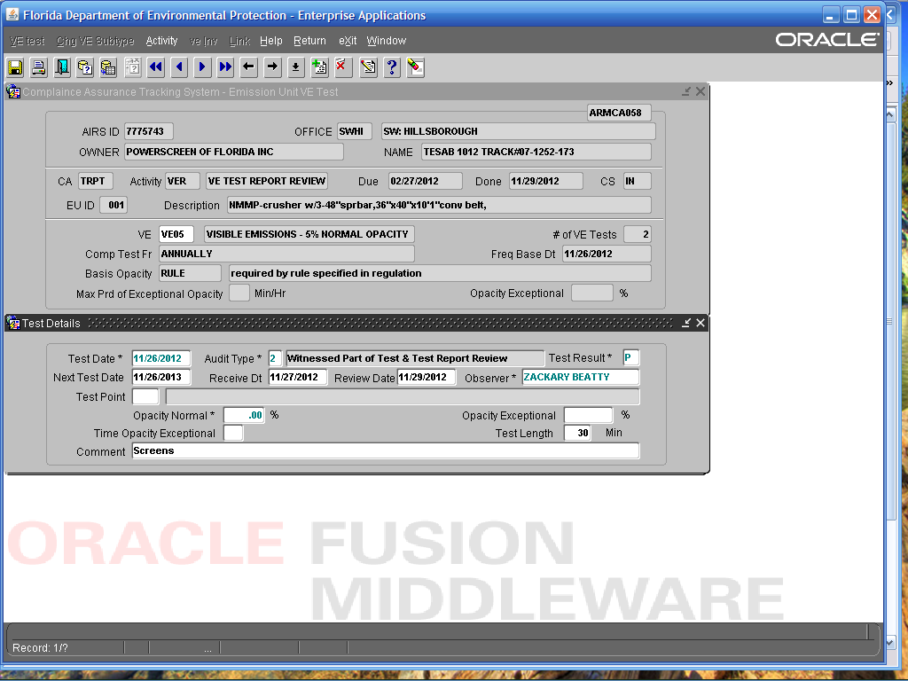

APAC-Southeast, Inc Clearwater Asphalt Plant
12955 40th Street North, Clearwater

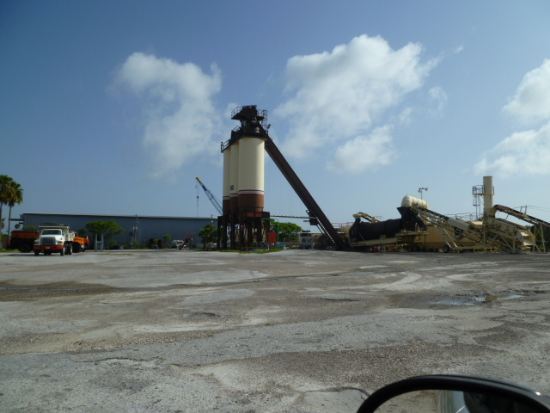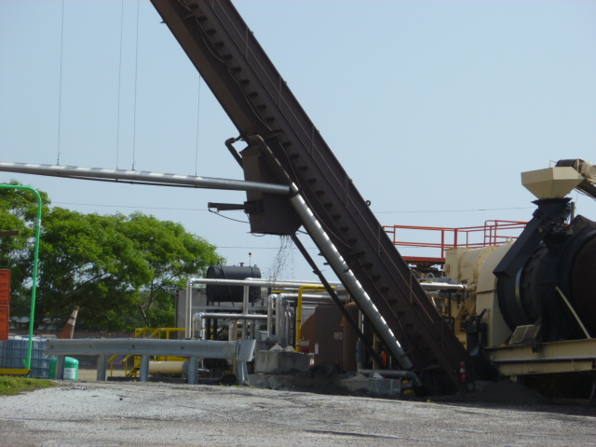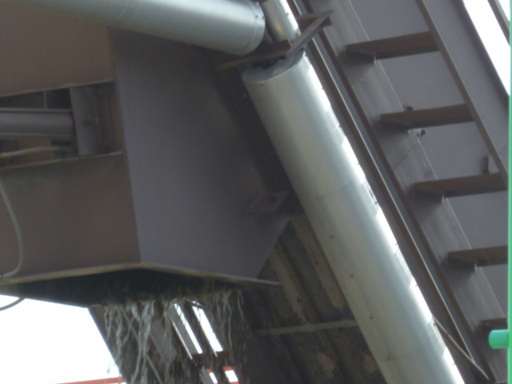

Project Id: 84783 Permit No: 7770073-015-AO Arms Number: 0073 002
Inspector: Shea Jackson Inspection Date / Time: 8/12/2013 / _______
Source (EU): Up to 250 Ton/Hr Portable Recycle Asphalt Pavement (RAP) Crushing System, including Screening and Conveying equipment subject to NSPS Subpart OOO

Description: [The aggregate by pass exit on the conveyor had a water suppression system installed and observed to be in operation. Water was turned on by operator]

.

APAC-Southeast, Inc Clearwater Asphalt Plant
12955 40th Street North, Clearwater

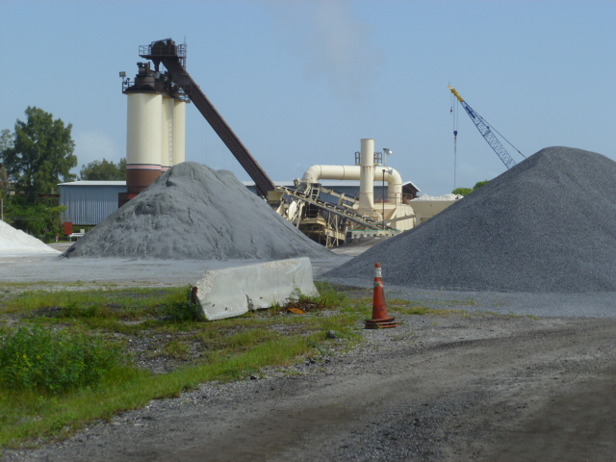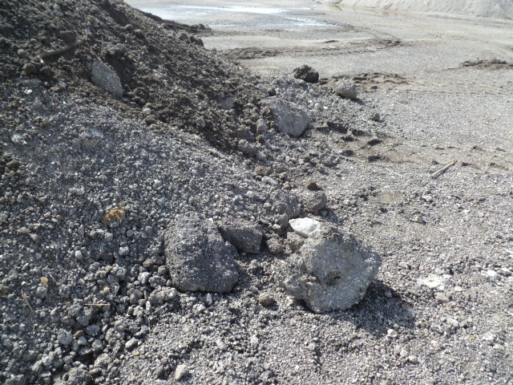

Project Id: 84783 Permit No: 7770073-015-AO Arms Number: 0073 002
Inspector: Shea Jackson Inspection Date / Time: 8/12/2013 / _______
Source (EU): Up to 250 Ton/Hr Portable Recycle Asphalt Pavement (RAP) Crushing System, including Screening and Conveying equipment subject to NSPS Subpart OOO

Description: [Observation of detached plum, no emission only steam. The RAP on site contains lumps]

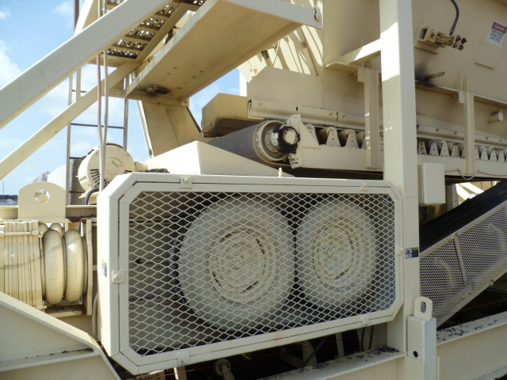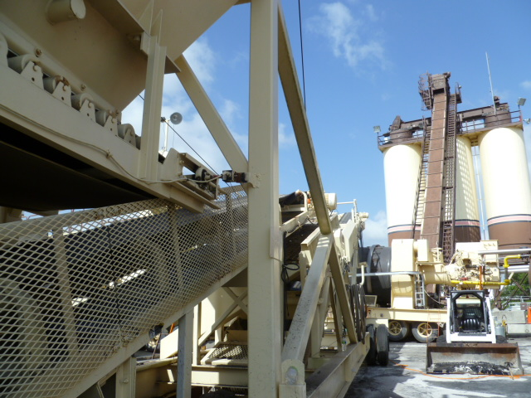

Description: [The lump crusher consisted of a roller system that presses the lumps into smaller pieces and is fed back into the asphalt plant drum]

APAC-Southeast, Inc Clearwater Asphalt Plant
12955 40th Street North, Clearwater

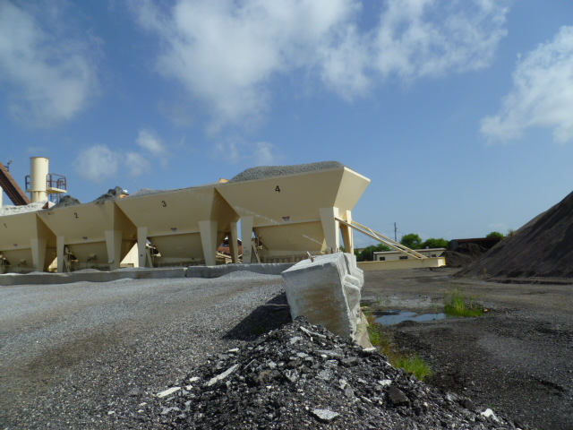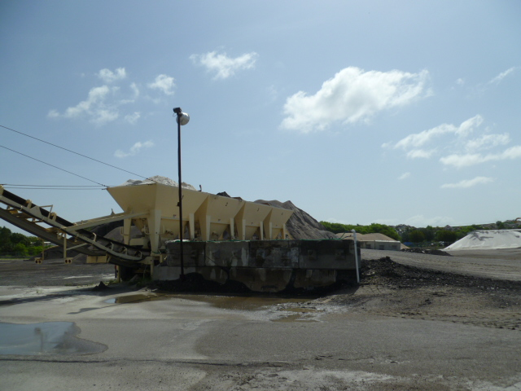

Description: [Sprinklers added to the ramp for the aggregate bin, which operate when plant in operation]

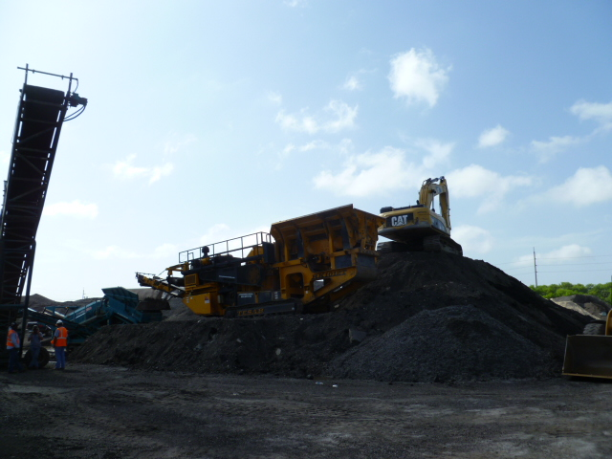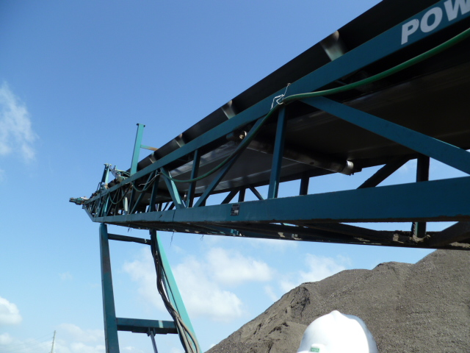

Project Id: 84783 Permit No: 7770073-015-AO Arms Number: 0073 002
Inspector: Shea Jackson Inspection Date / Time: 8/12/2013 / _______
Source (EU): Up to 250 Ton/Hr Portable Recycle Asphalt Pavement (RAP) Crushing System, including Screening and Conveying equipment subject to NSPS Subpart OOO

Description: [Power screen crusher system was broken down at time. Observation of hoses and nozzles on crusser for water suppression system]

APAC-Southeast, Inc Clearwater Asphalt Plant
12955 40th Street North, Clearwater
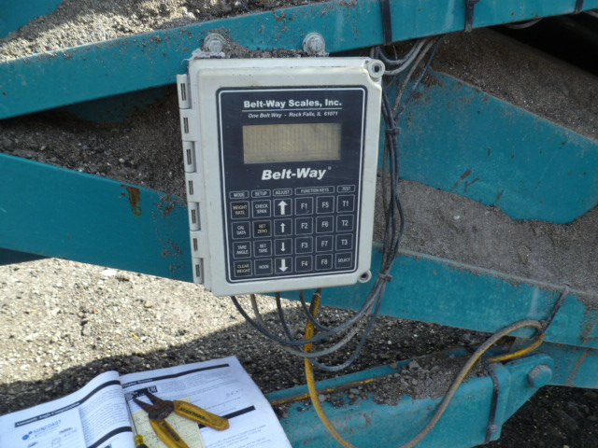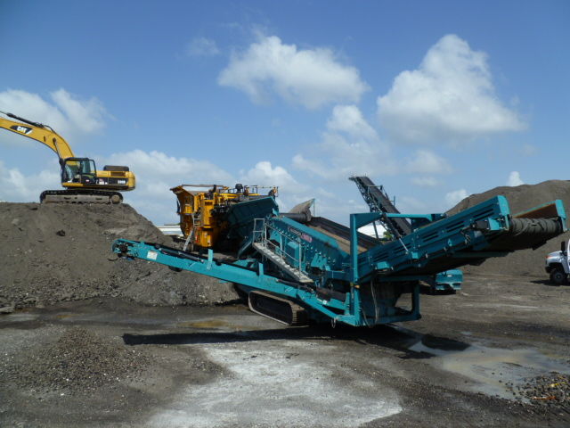

Project Id: 84783 Permit No: 7770073-015-AO Arms Number: 0073 002
Inspector: Shea Jackson Inspection Date / Time: 8/12/2013 / _______
Source (EU): Up to 250 Ton/Hr Portable Recycle Asphalt Pavement (RAP) Crushing System, including Screening and Conveying equipment subject to NSPS Subpart OOO

Description: [Meter for measurement of tons of aggregate crushed per hour.]

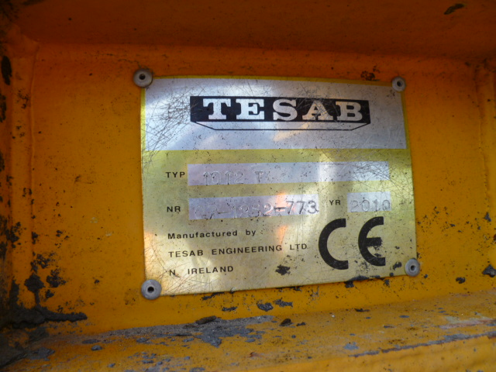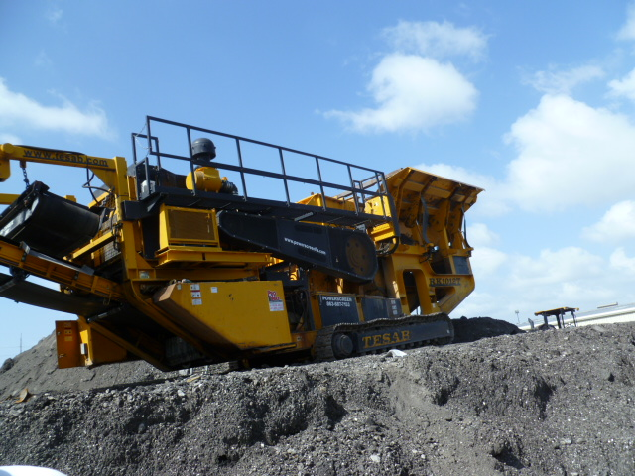
Project Id: 84783 Permit No: 7770073-015-AO Arms Number: 0073 002
Inspector: Shea Jackson Inspection Date / Time: 8/12/2013 / _______
Source (EU): Up to 250 Ton/Hr Portable Recycle Asphalt Pavement (RAP) Crushing System, including Screening and Conveying equipment subject to NSPS Subpart OOO

Description: [the crusher and the serial number for identification of the emission unit]

