7770073 80641
FACILITY: APAC-Southeast, Inc |  |  |  |  |  |  |  |  |  |  |  |  |  |  |  |  |  |  |  | PERMIT ID: 2801
Clearwater Asphalt Plant |  |  |  |  |  |  |  |  |  |  |  |  |  |  |  |  |  |  |  | DISTRICT: Southwest
ADDRESS: 12955 40th Street North |  |  |  |  |  |  |  |  |  |  |  |  |  |  |  |  |  |  |  | CONTACT PHONE:
Clearwater, FL |  |  |  |  |  |  |  |  |  |  |  |  |  |  |  |  |  |  |  | 813-623-3622
ARMS NO:  7770073 001 |  |  |  |  |  |  |  | PERMIT NO: |  |  |  |  |  |  |  |  |  |  |  | Expiration Date: 4/15/2016  Renewal Date: 2/15/2016
 |  |  |  |  |  |  |  | 7770073-015-AO
 |  |  |  |  |  |  |  |  |  |  |  |  |  |  |  |  |  |  |  | Test Due Date:
EMISSION UNIT DESCRIPTION : A Gencor Model 300 Ultraplant portable drum-mix asphalt plant with a capacity of 300 TPH using an associated Gencor Model 620-Primary collector followed by a Gencor-Bituma Model 620-P baghouse, that has 792 bags with a total cloth area.
CMS INSPECTION DATE: |  |  |  |  |  |  | ARMS INSPECTION TYPE: |  |  |  |  |  |  |  |  |  |  |  |  |  |  | COMPLIANCE STATUS:
 | July 12, 2012 |  |  |  |  |  |  |  |  | INS1 |  | ✓ | INS2 |  |  | INS3 |  |  | FUI |  |  |  | ✓ |  | IN |  |  | MNC |  |  |  |  | SNC
INSPECTION TYPE: |  |  |  | ✓ | Initial |  |  |  |  |  | Re-inspection |  |  |  |  |  | Complaint |  |  |  |  |  |  | Drive-by |  |  |  |  |  | Quarterly
✓ |  |  | A. General Review:
1. |  | Permit File Review |  |  |  |  |  |  |  |  |  |  |  |  |  |  |  |  |  |  |  |  |  |  |  |  |  |  | Yes |  |  |  |  | No
 |  | Comments: reviewed
2. |  | Introduction and Entry |  |  |  |  |  |  |  |  |  |  |  |  |  |  |  |  |  |  |  |  |  |  |  |  |  |  | Yes |  |  |  |  | No
 |  | Comments: The facility has ceased operations. The gates were locked.
3. |  | Is the Responsible Official/Authorized Representative still: Mark S. Marine? |  |  |  |  |  |  |  |  |  |  |  |  |  |  |  |  |  |  |  |  |  |  |  |  |  |  | Yes |  |  |  |  | No
 |  | Comments: There were no employees on site. I contacted the corporation office, Mark Marine was not available. I spoke to Todd Pfeifer. The Responsible Official/Authorized Representative’s e-mail is: Mark.Marine@apac.com
4. |  | Is the facility contact still: Luther Ellis? |  |  |  |  |  |  |  |  |  |  |  |  |  |  |  |  |  |  |  |  |  |  |  |  |  |  | Yes |  |  |  |  | No
The facility contact’s e-mail is Luther.Ellis@apac.com?
Comments: Email to Mr. Ellis return stating out of office no anticipated return. I called the corporation office and spoke to Todd Phferrer todd.pfeiffer@oldcastlematerials.com . He stated, Mr. Ellis had retired. I informed the main office they will need to submit who the future facility contact will be.

IN | MNC | SNC | B. Specific Conditions:
✓  ✓  ✓  ✓  ✓  ✓  ✓  ✓  ✓  ✓  ✓  ✓  ✓  ✓  ✓  ✓  ✓  ✓  ✓  ✓  ✓  ✓  ✓  ✓  ✓  ✓  ✓  ✓  ✓  ✓  ✓  ✓  ✓  ✓  ✓ |  |  | Inspection note: This operation permit became effective on 4/15/11. It authorizes the operation of a drum mix asphalt plant that allows a portable reclaimed asphalt pavement (RAP) crushing system to be brought  onto the asphalt concrete plant’s site.  Exempt Units:  - Under Title 40, Code of Federal Regulations (CFR), Part 60, Subpart IIII – Standards of Performance for Stationary Compression Ignition Combustion Engines, as long as the permittee operates and maintains the engine according to the manufacturer’s written instructions or procedures over the entire life of the engine and the manufacturer keeps its certification, the engine is not required by the federal rule to demonstrate compliance with emission limits. This engine was previously permitted as Emission Unit 003.  - Three 200 ton capacity hot mix asphalt concrete storage silos.  - [Rule 62-210.300(3)(b)1., F.A.C.]  - A Gencor electric powered lump breaker is used to break up conglomerated pieces of RAP.  [Rule 62-210.300(3)(b)1., F.A.C.]  General Conditions [62-4.160, F.A.C.]  8. If, for any reason, the permittee does not comply with or will be unable to comply with any condition or limitation specified in this permit, the permittee shall immediately provide the Department with the following information:  a. A description of and cause of noncompliance; and  b. The period of noncompliance, including dates and times; or, if not corrected, the anticipated time the noncompliance is expected to continue, and steps being taken to reduce, eliminate, and prevent recurrence of the noncompliance. The permittee shall be responsible for any and all damages which may result and may be subject to enforcement action by the Department for penalties or for revocation of this permit.  Comments: The APAC Pinellas Plant and all crushing operations are idle. The asphalt production plant has not operated since June of 2011 and a portable RAP crushing unit has not operated at the facility since March 16, 2010. The last crushing unit operated at the facility was owned and operated by Crush-It, Inc. (7775279-001), crushing unit #3.  12. This permit or a copy thereof shall be kept at the work site of the permitted activity.  Comments: A copy of the permit was was not kept at the worksite. Non applicable, the plant site was closed and locked down; There were no employees at this location during inspection.  Common Conditions [Rule 62-296.320(4)(c), F.A.C.]  Unless otherwise specified in the permit, the following conditions apply to all emissions units and activities at the facility.  Emissions and Controls  2. Circumvention: The permittee shall not circumvent the air pollution control equipment or allow the emission of air pollutants without this equipment operating properly. [Rule 62-210.650, F.A.C.]  Comments: No evidence of circumvention. Non -applicable at this time, non operational, the facility temporarily shutdown June 2011.  6. VOC or OS Emissions: No person shall store, pump, handle, process, load, unload or use in any process or installation, volatile organic compounds (VOC) or organic solvents (OS) without applying known and existing vapor emission control devices or systems deemed necessary and ordered by the Department. [Rule 62-296.320(1), F.A.C.]  Comments: Non -applicable at this time asphalt plant production in temporarily shutdown June 2011.  7. Objectionable Odor Prohibited: No person shall cause, suffer, allow or permit the discharge of air pollutants, which cause or contribute to an objectionable odor. An “objectionable odor” means any odor present in the outdoor atmosphere which by itself or in combination with other odors, is or may be harmful or injurious to human health or welfare, which unreasonably interferes with the comfortable use and enjoyment of life or property, or which creates a nuisance. [Rules 62-296.320(2) and 62-210.200(Definitions), F.A.C.]  Comments: An upwind/downwind survey of the facility was conducted. The observed parameters were:  Downwind odor level detected- no odors; Wind direction – Southeasterly Upwind odor level detected-  Non -applicable at this time asphalt plant in temporary shutdown.  9. Unconfined Particulate Emissions:  a. No person shall cause, let, permit, suffer or allow the emissions of unconfined particulate matter from any activity, including vehicular movement; transportation of materials; construction, alteration, demolition or wrecking; or industrially related activities such as loading, unloading, storing or handling; without taking reasonable precautions to prevent such emissions.  b. Any permit issued to a facility with emissions of unconfined particulate matter shall specify the reasonable precautions to be taken by that facility to control the emissions of unconfined particulate matter.  c. Reasonable precautions include the following:  (1) Paving and maintenance of roads, parking areas and yards.  (2) Application of water or chemicals to control emissions from such activities as demolition of buildings, grading roads, construction, and land clearing.  (3) Application of asphalt, water, oil, chemicals or other dust suppressants to unpaved roads, yards, open stock piles and similar activities.  (4) Removal of particulate matter from roads and other paved areas under the control of the owner or operator of the facility to prevent reentrainment, and from buildings or work areas to prevent particulate from becoming airborne.  (5) Landscaping or planting of vegetation.  (6) Use of hoods, fans, filters, and similar equipment to contain, capture and/or vent particulate matter.  (7) Confining abrasive blasting where possible.  (8) Enclosure or covering of conveyor systems.  Comments: Non -applicable at this time asphalt plant in temporary shutdown. No Yard activities observed.  Permit Administrative Requirements  8. Relocation to a Previously Authorized County - At least thirty (30) days prior to relocating the facility to a site in a county previously authorized (see Appendix J) the permittee shall notify the Air Compliance Section of the appropriate District Office(s) or Local Air Program Office(s) having jurisdiction over the current site and the relocation site (see Appendix H or I). The notification shall be on DEP Form 62-210.900(6), F.A.C. – Facility Relocation Notification. A permit amendment and amendment fee are not required. The form may only be used if the facility is currently authorized by this permit to locate in the county to which it intends to operate. This facility can only operate in Pinellas County where the public notice for Construction Permit 7770073-013-AC was published. [Rules 62-210.370(4) and 62-210.900(6), F.A.C.]  Comments: Non -applicable at this time asphalt plant in temporary shutdown. No relocation notifications received, since performance of stack testing in December 10, 2010 for the fiscal year of 2011.  9. Relocation to a Proposed New (Unauthorized) County - If the facility is not currently authorized to locate in the county to which it intends to relocate, a permit application [DEP Form 62-210.900(3)] with the appropriate fee must be submitted to apply for authorization to locate to that county. The application (w/fee) shall be submitted to the Air Permitting Section of the appropriate District Office or Local Air Program Office having permitting jurisdiction over the relocation site for processing as a modification to the existing operation permit under Rule 62-4.080, F.A.C. (see Appendix H or I) [Rules 62-4.080, 62-210.300(1), and 62-210.900, F.A.C.]  Comments: Non -applicable at this time asphalt plant in temporary shutdown.  10. Collocation Requirement - This facility shall not collocate with, or relocate to, any Title V source; nor shall it create a Title V source in combination with any other collocated facilities, emissions units, or pollutant-emitting activities, including any such facility, emissions unit, or activity that is otherwise exempt from permitting. [Rule 62-210.300(3)(c)2.j., F.A.C.]  Comments: Non -applicable at this time asphalt plant in temporary shutdown.  12. Facility-Wide Fuel Usage - Facility-wide fuel oil consumption, including exempt sources, shall not exceed 1.2 million gallons in any consecutive 12-month period. [Rule 62-210.200 (“Potential to Emit”), F.A.C.; Construction Permit 7770073-013-AC]  Comments: Non -applicable at this time asphalt plant in temporary shutdown. Previous years records show the facility did not exceed this limitation. The 12 month consecutive total record for February 2011 showed 87,437.20 gallons for the combined fuel usage.  13. Facility-Wide Fuel Usage Records - In order to demonstrate compliance with Specific Condition No. 12, the permittee shall monthly record the type of fuel oil (i.e., new No. 2 fuel oil, BFO-1 bio fuel and on-specification reclaimed fuel oil) and quantity, in gallons, of each type of fuel oil used at the facility. The permittee shall monthly calculate and record the most recent consecutive 12-month period total amount of fuel oil in gallons for each fuel oil type and the total (combined from all sources, which includes exempt emission activities that burn fuel oil) amount of fuel oil in gallons. The permittee shall monthly calculate and record the amount of natural gas burned for AOR reporting purposes. [Rule 62-210.300(3)(c)2.g., F.A.C.; Construction Permit 7770073-013-AC]  Comments: Non -applicable at this time asphalt plant in temporary shutdown. Previous years records show the facility did not exceed this limitation. The last 12 month consecutive total record for 2011 showed August 2011 total as 67,471.20 gallons for the combined fuel usage.  14. Fuel Oil Sulfur Content Limitation - The sulfur content for all fuel oils, including BFO-1 bio fuel, shall not exceed 0.5% by weight. [Construction Permit 7770073-013-AC]  Comments: Non -applicable at this time asphalt plant in temporary shutdown. Previous years records show the facility did not exceed this limitation. The 12 month consecutive total record for February 2011 showed 87,437.20 gallons for the combined fuel usage.  15. Fuel Sulfur Content Record - In order to document continuing compliance with the sulfur content limitation in Specific Condition No. 14., in % by weight of the fuel oil, the permittee shall keep records on either vendor provided as-shipped analysis or on analysis of as-received samples taken at the plant. The analysis shall be determined by appropriate ASTM methods. [Rule 62-210.300(3)(c)2.c. F.A.C.; Construction Permit 7770073-013-AC]  Comments: Non -applicable at this time asphalt plant in temporary shutdown.  16. Reclaimed Fuel Oil Specifications – The permittee shall not burn off-specification reclaimed fuel oil. For each delivery of on-specification reclaimed fuel oil, the vendor shall provide an analysis documenting the fuel oil meets the following requirements of 40 CFR 761.20(e)(2) and (3) and 40 CFR 279.11:  [Rules 62-4.070(3) and 62-710.210, F.A.C.; Construction Permit 7770073-013-AC]  Comments: Non -applicable at this time asphalt plant in temporary shutdown.  17. Asbestos Containing Materials – This facility shall not process Asbestos Containing Materials (ACM), whether regulated asbestos containing material (RACM), category I or category II, and whether friable or non-friable when received at the facility.  a. "Asbestos" means the asbestiform varieties of serpentinite (chrysotile), riebeckite (crocidolite), cummingtonite-grunerite, anthophyllite, and actinolite-tremolite and includes trade acronyms products such as amosite.  b. "Asbestos-containing materials", ACM, means any materials which contain more than one percent asbestos as determined by Polarized Light Microscopy. Based on a representative composite sample.  c. "Asbestos removal project" means renovation or demolition operation in a facility that involves the removal of a threshold amount of regulated asbestos-containing material.  d. "Category I Nonfriable Asbestos-Containing Material (ACM)" means asbestos-containing packings, gaskets, resilient floor covering, and asphalt roofing products containing more than 1 percent asbestos as determined using the method specified in Appendix A, Subpart F, 40 CFR Part 763, Section 1, Polarized Light Microscopy.  e. "Category II Non-friable ACM" means any material, excluding Category I Nonfriable ACM, containing more than 1 percent asbestos as determined using the methods specified in Appendix A, Subpart F, 40 CFR Part 763, Section 1, Polarized Light Microscopy, that, when dry, cannot be crumbled, pulverized, or reduced to powder by hand pressure. [40 CFR 61, Subpart M; Chapter 62-257, F.A.C.; and Rules 62-730.300 and 62-701.520, F.A.C.]  Comments: Non -applicable at this time asphalt plant in temporary shutdown, not receiving materials or processing to make asphalt..  18. Unconfined Particulate Emissions:  a. No person shall cause, let, permit, suffer or allow the emissions of unconfined particulate matter from any activity, including vehicular movement; transportation of materials; construction, alteration, demolition or wrecking; or industrially related activities such as loading, unloading, storing or handling; without taking reasonable precautions to prevent such emissions.  b. Any permit issued to a facility with emissions of unconfined particulate matter shall specify the reasonable precautions to be taken by that facility to control the emissions of unconfined particulate matter.  c. Reasonable precautions include the following:  (1) Paving and maintenance of roads, parking areas and yards.  (2) Application of water or chemicals to control emissions from such activities as demolition of buildings, grading roads, construction, and land clearing.  (3) Application of asphalt, water, oil, chemicals or other dust suppressants to unpaved roads, yards, open stock piles and similar activities.  (4) Removal of particulate matter from roads and other paved areas under the control of the owner or operator of the facility to prevent reentrainment, and from buildings or work areas to prevent particulate from becoming airborne.  (5) Landscaping or planting of vegetation.  (6) Use of hoods, fans, filters, and similar equipment to contain, capture and/or vent particulate matter.  (7) Confining abrasive blasting where possible.  (8) Enclosure or covering of conveyor systems.  Comments: Non -applicable at this time asphalt plant in temporary shutdown. No activity on site.  19. Records Retention – All records shall be recorded in a permanent form suitable for inspection upon request by the Department and/or the approved local program which has permitting/compliance jurisdiction and shall be kept at the facility for a minimum of the most recent five (5) year period.  [Rule 62-210.300(3)(c)2.g., F.A.C.; Construction Permit 7770073-013-AC]  Comments: Records were received related to operations at the plant 2010 – June 2011. (See copies attached)  20. Annual Operating Report - On or before April 1 of each year, the permittee shall submit a completed DEP Form 62-210.900(5), "Annual Operating Report for Air Pollutant Emitting Facility" (AOR) for the preceding calendar year. The report may be submitted electronically in accordance with the instructions received with the AOR package sent by the Department, or a hardcopy may be sent to the Compliance Authority. The sulfur dioxide emissions from using fuel oil when producing asphalt product shall be determined using the US EPA’s document AP-42, Table 1.3-1 and a reduction of 50% of the fuel bound sulfur, up to a maximum (as SO₂) of 0.1 lb of sulfur dioxide for each ton of asphalt product produced. Note: one pound of sulfur produces two pounds of SO₂ [Rules 62-210.300(3)(c)2. and 62-210.370(3), F.A.C.; Construction Permit Amendment 7770073-014-AC]  Comments: The annual operating report for calendar year 2011 was submitted 1/12/12and reviewed by WF on 3/21/12.  21 Operation Permit Renewal Application: A completed application for renewal of the operation permit shall be submitted to the Permitting Authority with a copy to PCDEM (Compliance Authority) no later than 60 days prior to the expiration date of the operation permit.  [Rules 62-4.030, 62-4.050, 62-4.070(3), 62-4.090, 62-210.300(2), and 62-210.900, F.A.C.]  Comments: The permit expires on 4/15/16. An application is required to be submitted no later than 2/15/16. : Non -applicable at this time  A.1. Federal Regulatory Requirements - This emission unit is subject to the requirements of the attached 40 CFR 60, Subpart I – Standards of Performance for Hot Mix Asphalt Facilities (see Appendix E.) and the attached general provisions of 40 CFR 60, Subpart A (see Appendix G.), where applicable, which are adopted by reference in Rule 62-204.800(8), F.A.C.  [Rule 62-204.800(8), F.A.C.; 40 CFR 60, Subparts A and I]  APPENDIX E 40 CFR 60, Subpart I – Standards of Performance for Hot Mix Asphalt Facilities  § 60.92 Standard for particulate matter.  (a) On and after the date on which the performance test required to be conducted by § 60.8 is completed, no owner or operator subject to the provisions of this subpart shall discharge or cause the discharge into the atmosphere from any affected facility any gases which:  (1) Contain particulate matter in excess of 90 mg/dscm (0.04 gr/dscf).  (2) Exhibit 20 percent opacity, or greater.  [39 FR 9314, Mar. 8, 1974, as amended at 40 FR 46259, Oct. 6, 1975]  Comments: Non -applicable at this time asphalt plant in temporary shutdown. The stack test performed December 10, 2010,result was .00329 gr/dscf was below 0.04 gr/dscf test passed as audited by JAR.  § 60.93 Test methods and procedures.  (a) In conducting the performance tests required in § 60.8, the owner or operator shall use as reference  methods and procedures the test methods in appendix A of this part or other methods and procedures as specified in this section, except as provided in § 60.8(b).  (b) The owner or operator shall determine compliance with the particulate matter standards in  § 60.92 as follows:  (1) Method 5 shall be used to determine the particulate matter concentration. The sampling  time and sample volume for each run shall be at least 60 minutes and 0.90 dscm (31.8 dscf).  (2) Method 9 and the procedures in § 60.11 shall be used to determine opacity.  [54 FR 6667, Feb. 14, 1989]  Comments: The December 2010 test was performed using the applicable methods 5 & 9. Non -applicable at this time asphalt plant in temporary shutdown. They do not anticipate the site operating in the 2012 FFY. Therefore, a stack test will most likely not be completed or submitted. At this time we cannot project if business will justify operations in the 2013 FFY at this time.  A.2. Permitted Capacity - This emission unit is limited to the following operating parameters:  [Rules 62-210.200 (“Potential to Emit”) and 62-210.300(3)(c)2.a., F.A.C.; Construction Permit 7770073-013-AC]  Comments: Non -applicable at this time asphalt plant in temporary shutdown.  A.3. Authorized Fuel - The following fuels are allowed:  a. 100% natural gas;  b. new No. 2 fuel oil;  c. on-specification reclaimed fuel oil; and  d. Parsons BFO-1 bio fuel.  [Rule 62-210.200 (“Potential to Emit”), F.A.C.; Construction Permit application 7770073-013-AC]  Comments: Previous operations used stated facility used #5 on spec fuel oil. Non -applicable at this time asphalt plant in temporary shutdown.  A.4. Visible Emission (VE) Limitation - Visible emissions associated with the asphalt concrete plant shall be less than 20% opacity, except when operating within a particulate matter maintenance area. More stringent visible emissions standards apply in air quality maintenance areas for particulate matter. When subject to both limits, the more stringent limit shall take precedence. [40 CFR 60 Subpart I, 60.92(a)(2) and adopted by reference in Rules 62-204.800(8), F.A.C. and 62-210.300(3)(c)2.f., F.A.C.]  Comments: Non -applicable at this time asphalt plant in temporary shutdown. Last test result was ss%  A.5. Particulate Matter (PM) Limitation - Particulate emissions, associated with the asphalt concrete plant, shall not exceed 0.04 grains per dry standard cubic foot averaged over a three (3) hour period.  (Permitting Note: Based on a design airflow rate of 28,000 dscfm and 8760 hours/year of operation, the equivalent PM emissions are 9.6 lbs./hour and 42.05 tons/year)  [40 CFR 60 Subpart I, 60.92(a)(1) and adopted by reference in Rule 62-204.800(8)(b) F.A.C.; Rule 62-210.300(3)(c)2.d., F.A.C.]  Comments: Non -applicable at this time asphalt plant in temporary shutdown. Last test result was and stack test result was ss/ss/ss  A.6. Visible Emission (VE) Testing - In order to document compliance with Specific Condition No. A.4., the permittee shall test for visible emissions from the asphalt concrete plant’s baghouse annually during each federal fiscal year (October 1 – September 30). [Rules 62-210.300(3)(c)2.i. and 62-297.310(7)(a), F.A.C.]  Comments: I contacted the main office and spoke to Todd Pfiffer in regards to testing. They cannot predict the work load for the possible performance of testing. They will be requesting an extension to testing requirement, based on testing as soon as operations start up.  A.7. Particulate Matter (PM) Testing - In order to document compliance with Specific Condition No. A.5., the permittee shall test for particulate matter emissions from the baghouse of the asphalt concrete plant annually during each federal fiscal year (October 1 – September 30).  [Rules 62-210.300(3)(c)2.i. and 62-297.310(7)(a), F.A.C.]  Comments: I contacted the main office and spoke to Todd Pfiffer in regards to testing. They cannot predict the work load for the possible performance of testing. They will be requesting an extension to testing requirement, based on testing as soon as operations start up.  A.8. Test Requirements - Tests shall be conducted in accordance with the applicable requirements specified in Appendix D (Common Testing Requirements) of this permit. [Rule 62-297.310(7)(a)9., F.A.C.]  Comments: I contacted the main office and spoke to Todd Phfeiffer in regards to testing. They cannot predict the work load for the possible performance of testing. They will be requesting an extension to testing requirement, based on testing as soon as operations start up.  A.9. Additional Emissions Testing Requirements - Testing requirements for the asphalt concrete plant include the following:  a. A compliance test submitted when the dryer is fired with a natural gas will automatically constitute an amended permit to allow the dryer to be only fired with natural gas and up to a total of 400 hours of firing new No. 2 fuel oil, BFO-1 bio fuel, or on-specification reclaimed fuel oil prior to triggering a requirement for additional compliance testing. Within 30 days of exceeding the 400th hour of firing the dryer with new No. 2 fuel oil, BFO-1 bio fuel or on-specification reclaimed fuel oil, new compliance tests shall be conducted when the dryer is fired with the worst fuel oil that was used during the 400-hour period. The fuel is ranked as follows from the worst to the best:  - on-specification reclaimed fuel oil (worst)  - BFO-1 bio fuel  - new No. 2 fuel oil (best)  b. A compliance test submitted when the dryer is fired with a new No. 2 fuel oil will automatically constitute an amended permit to allow the dryer to be only fired with natural gas or new No. 2 fuel oil, and up to a total of 400 hours of firing BFO-1 bio fuel and on-specification reclaimed fuel oil prior to triggering a requirement for additional compliance testing. Within 30 days of exceeding the 400th hour of firing the dryer with BFO-1 bio fuel or on-specification reclaimed fuel oil, new compliance tests shall be conducted when the dryer is fired with the worst fuel oil that was used during the 400-hour period.  c. The requirement to conduct additional testing, based on firing the dryer with the worst type of fuel oil, shall continue to progress as shown above from the best ranked fuel oil through the use of the worst fuel oil, which is on-specification reclaimed fuel oil. Therefore, a compliance test submitted when the dryer is fired with on-specification reclaimed fuel oil will automatically constitute an amended permit to allow the dryer to be fired with natural gas, new No. 2 fuel oil, BFO-1 bio fuel or on-specification reclaimed fuel oil without triggering additional compliance testing.  d. A compliance test submitted when processing RAP shall limit the plant to processing only RAP. If the plant is so limited, within thirty (30) days upon processing virgin materials (conventional hot mix asphalt), a new compliance test shall be conducted using only virgin materials.  e. A compliance test submitted when processing only virgin materials shall also allow the plant to process RAP. [Rule 62-297.310(7), F.A.C.; Construction Permit 7770073-013-AC]  Comments: This facility does not have additional test requirements at this time. I contacted the main office and spoke to Todd Pfiffer in regards to testing. They cannot predict the work load for the possible performance of testing, because not sure if there will be demand in 2012 or 2013. They will be drafting a letter to request an extension to testing requirement, based on testing as soon as operations start up.  A.10. Test Method(s) - Required tests shall be performed in accordance with the following reference method(s).  The above method(s) are described in Appendix A of 40 CFR 60 and are adopted by reference in Rule 62-204.800, F.A.C. No other method(s) may be used unless prior written approval is received from the Department. [Rules 62-204.800, 62-210.300(3)(c)2.i., and 62-297.401, F.A.C.; Appendix A of 40 CFR 60]  Comments: The test methods listed above were performed for the 2011 fiscal year test performed on December 10, 2011.  A.11. Test Notification - The permittee shall notify the Compliance Authority In writing at least 15 days prior to any tests. The notification must include the following information the date, time, and location of each test; the name and telephone number of the facility’s contact person who will be responsible for coordinating the test; and the name, company, and the telephone number of the person conducting the test. Permitting Note: The notification should also include the relevant emission unit ID No(s)., test method(s) to be used, and pollutants to be tested. [Rules 62-4.070(3) and 62-297.310(7)(a)9., F.A.C.]  Comments: The facility sent notification within the proper time line prior to the December 10, 2010 test performance. The 2012 test will not be performed.  A.12. Notification of Initial Operation on Bio Fuel - The permittee shall notify the Permitting and Compliance Authorities in writing of the date of commencing operation of the asphalt concrete plant while burning BFO-1 bio fuel, no later than five (5) business days after that date.  [Rule 62-4.070, F.A.C.; Construction Permit 7770073-013-AC]  Comments: This not applicable, the facility is not in operation.  A.13. Test Reports - The permittee shall prepare and submit reports to the Compliance Authority for all  required tests in accordance with the requirements specified in Appendix D (Common Testing Requirements) of this permit. Include the following for the test period in the test report submittal*:  a. facility name, facility ID and Emission Unit number;  b. date;  c. production rate of hot mix asphalt concrete in tons/hour including a statement that indicates whether conventional/virgin asphalt concrete or RAP was produced;  d. type and usage rate (cubic feet, gallons) of fuel burned;  e. a copy of the most recent fuel oil analysis to document the sulfur content of the fuel oil used (if applicable);  f. on-specification reclaimed fuel oil analysis to document compliance with the on-specification reclaimed fuel oil limits (if applicable);  g. a copy of the log for the day the test was conducted and the monthly log for the month the test was conducted as required by Specific Condition No. A.14.; and  h. pressure drop across the baghouse (in inches of water); and  i. a visible emission test report for each RAP crushing system that used an off-site VE test to comply with Specific Condition No. B.8., since the previous asphalt plant emissions test (see Specific Condition No. B.15.).  *Failure to submit this information may invalidate the test.  [Rule 62-297.310(8), F.A.C.; Construction Permit 7770073-013-AC]  Comments: The December 10, 2012 test was received on January 25, 2011. This was within 45 days of test performance and was acceptable. No test performance scheduled for 2012.  A.14. Operation Records - In order to document continuing compliance with Specific Condition No. A.2., the owner shall maintain the following records:  Daily:  a. facility name, facility ID No., emission unit ID No., and description (i.e., APAC Southeast, Inc., 7770073, EU 001, drum mix asphalt plant);  b. date;  c. total asphalt concrete production, in tons;  d. hours of operation;  e. tons/hr. daily average production rate of asphalt concrete;  f. pressure drop across the baghouse during normal operations, in inches of water;  g. If the most recent compliance test was conducted when the dryer was not fired with on-specification fuel oil, adequate records shall be maintained in order to determine when additional testing is required. The records shall include at a minimum, listing of each fuel type, hours of firing each fuel type, and a cumulative total of the hours of firing the fuel(s) until the 400th hour triggering a new compliance emission test is determined (see Specific Condition A.9.).  Monthly:  h. facility name, facility ID No., emission unit ID No., and description (i.e., APAC Southeast, Inc., 7770073, EU 001, drum mix asphalt plant);  i. total tons of asphalt concrete produced for the month (tons);  j. most recent consecutive 12-month period total tons of asphalt concrete produced (tons/consecutive 12-month period);  k. total hours of operation;  l. most recent consecutive 12-month period total hours of operation;  m. type and quantity (gallons) of fuel oil burned;  n. the most recent consecutive 12-month total for each fuel oil type used, in gallons;  o. most recent consecutive 12-month combined total for all fuel oil types used, in gallons; and  p. quantity (cubic feet) of natural gas burned (for AOR reporting).  Daily records shall be completed within 3 business days and monthly records shall be completed by the end of the next month. [Rule 62-210.300(3)(c)2.g., F.A.C.; Construction Permit 7770073-013-AC]  Comments: This information was submitted with the 12/10/10 test performance. No test is scheduled for 2012.  A.15. Operation and Maintenance Plan - When air pollution control devices and collection systems are operated in Pinellas County, the permittee shall maintain and implement the Operation and Maintenance (O&M) Plan for the Gencor-Bituma Model 620-P baghouse, submitted with the response received on December 24, 2009, to the Department’s request for additional information (see Appendix L) or as revised with the prior approval from the PCAQD. The O&M Plan documentation shall be retained at the facility and made available to the Department and PCAQD upon request. At a minimum, the O&M plan shall include:  a. The operating parameters of the pollution control device.  b. Time table for the routine maintenance of the pollution control device as specified by the manufacturer.  c. Time table of routine daily, weekly, bi-weekly, or monthly observations and inspections of the pollution control device.  d. A list of the type and quantity of the required spare parts for the pollution control device which are stored on the premises.  e. A maintenance log which will indicate, as a minimum:  1. When maintenance and observations were performed.  2. What maintenance and observations were performed.  3. Who performed said maintenance and observations.  4. Acceptable parameter ranges for each operational check.  [Construction Permit 7770073-013-AC; Pinellas County Code, Section 58-12]  Comments: The facility operations shutdown June 2011, and no maintenance is being performed at this time.
  Constituent/Property | Allowable Level
  Arsenic | 5 ppm maximum
  Cadmium | 2 ppm maximum
  Chromium | 10 ppm maximum
  Lead | 100 ppm maximum
  Total Halogens | Shall not exceed 1000 ppm
  Flash Point | 100 degrees F minimum
  PCB’s | Shall be less than 2 ppm
  EU ID No. | Brief Description | Daily Average Maximum Production Rate of Hot Mix Asphalt Concrete (tons/hour) | Maximum Production of Hot Mix Asphalt Concrete  (tons/any consecutive 12-month period)
  001 | Drum Mix Asphalt Plant | 300 | 500,000
  Method(s) | Description of Method and Comments
  1-4 | Traverse Points, Velocity and Flow Rate, Gas Analysis, and Moisture Content
  5 or 5A | Determination of Particulate Matter Emissions from Stationary Sources
  9 | Visual Determination of the Opacity of Emissions from Stationary Sources
✓ |  |  | Valid Permit [Rule 62-210.300]
✓ |  |  | Changes to Facility/emission unit [Rule 62-210.300]  Does the emission unit description above match what the facility is operating (Number of emission units or points, model number and serial number, etc.) Yes No  Comments: Non applicable not operational, plant closed. Did not enter property.

 |  | C. Other:
Pollution Prevention Activities
- P2 Handouts Provided: P2 Brochure; P2 Manual; P2 Checklist
- Have any emissions reductions occurred Yes / No Shutdown
Chemical Substitution; Equipment Changes; Process Changes
Chemical/Material Reuse; On-site Recycling; Other:
Comments: Non - applicable the plant is not operational.

Closing Conference: I spoke to Todd Phfeiffer at the corporation office. The plant is shutdown, no test to be performed in 2012 and operations not predicted to start in 2013. The facility contact has stated they will submit documentation regarding status, temporary shutdown, and request to waive test performance until operations startup.
Inspector(s): Shea Jackson, Pinellas County, Air Quality Division
Signature(s): Date: |  |  |  |  |  |  | Date: August 1, 2012
 | ACCESS? |  | ✓ | ARMS? | ✓

APAC-Southeast, Inc Clearwater Asphalt Plant
12955 40th Street North, Clearwater
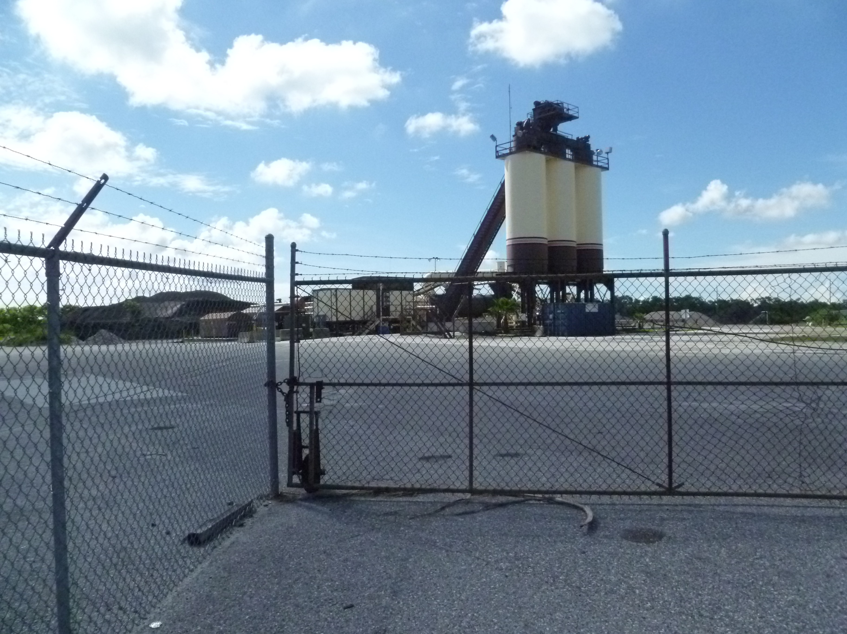

Project Id: 80641 Permit No: 7770073-015-AO Arms Number: 0073 001
Inspector: Shea Jackson Inspection Date / Time: 7/12/2012 / _______
Source (EU): A Gencor Model 300 Ultraplant portable drum-mix asphalt plant with a capacity of 300 TPH using an associated Gencor Model 620-Primary collector followed by a Gencor-Bituma Model 620-P baghouse, that has 792 bags with a total cloth area.

Description: [This is the North west gate of the facility. The gate is locked, no activity or personnel on site

The facility has ceased operations June 2011.]

APAC-Southeast, Inc Clearwater Asphalt Plant
12955 40th Street North, Clearwater
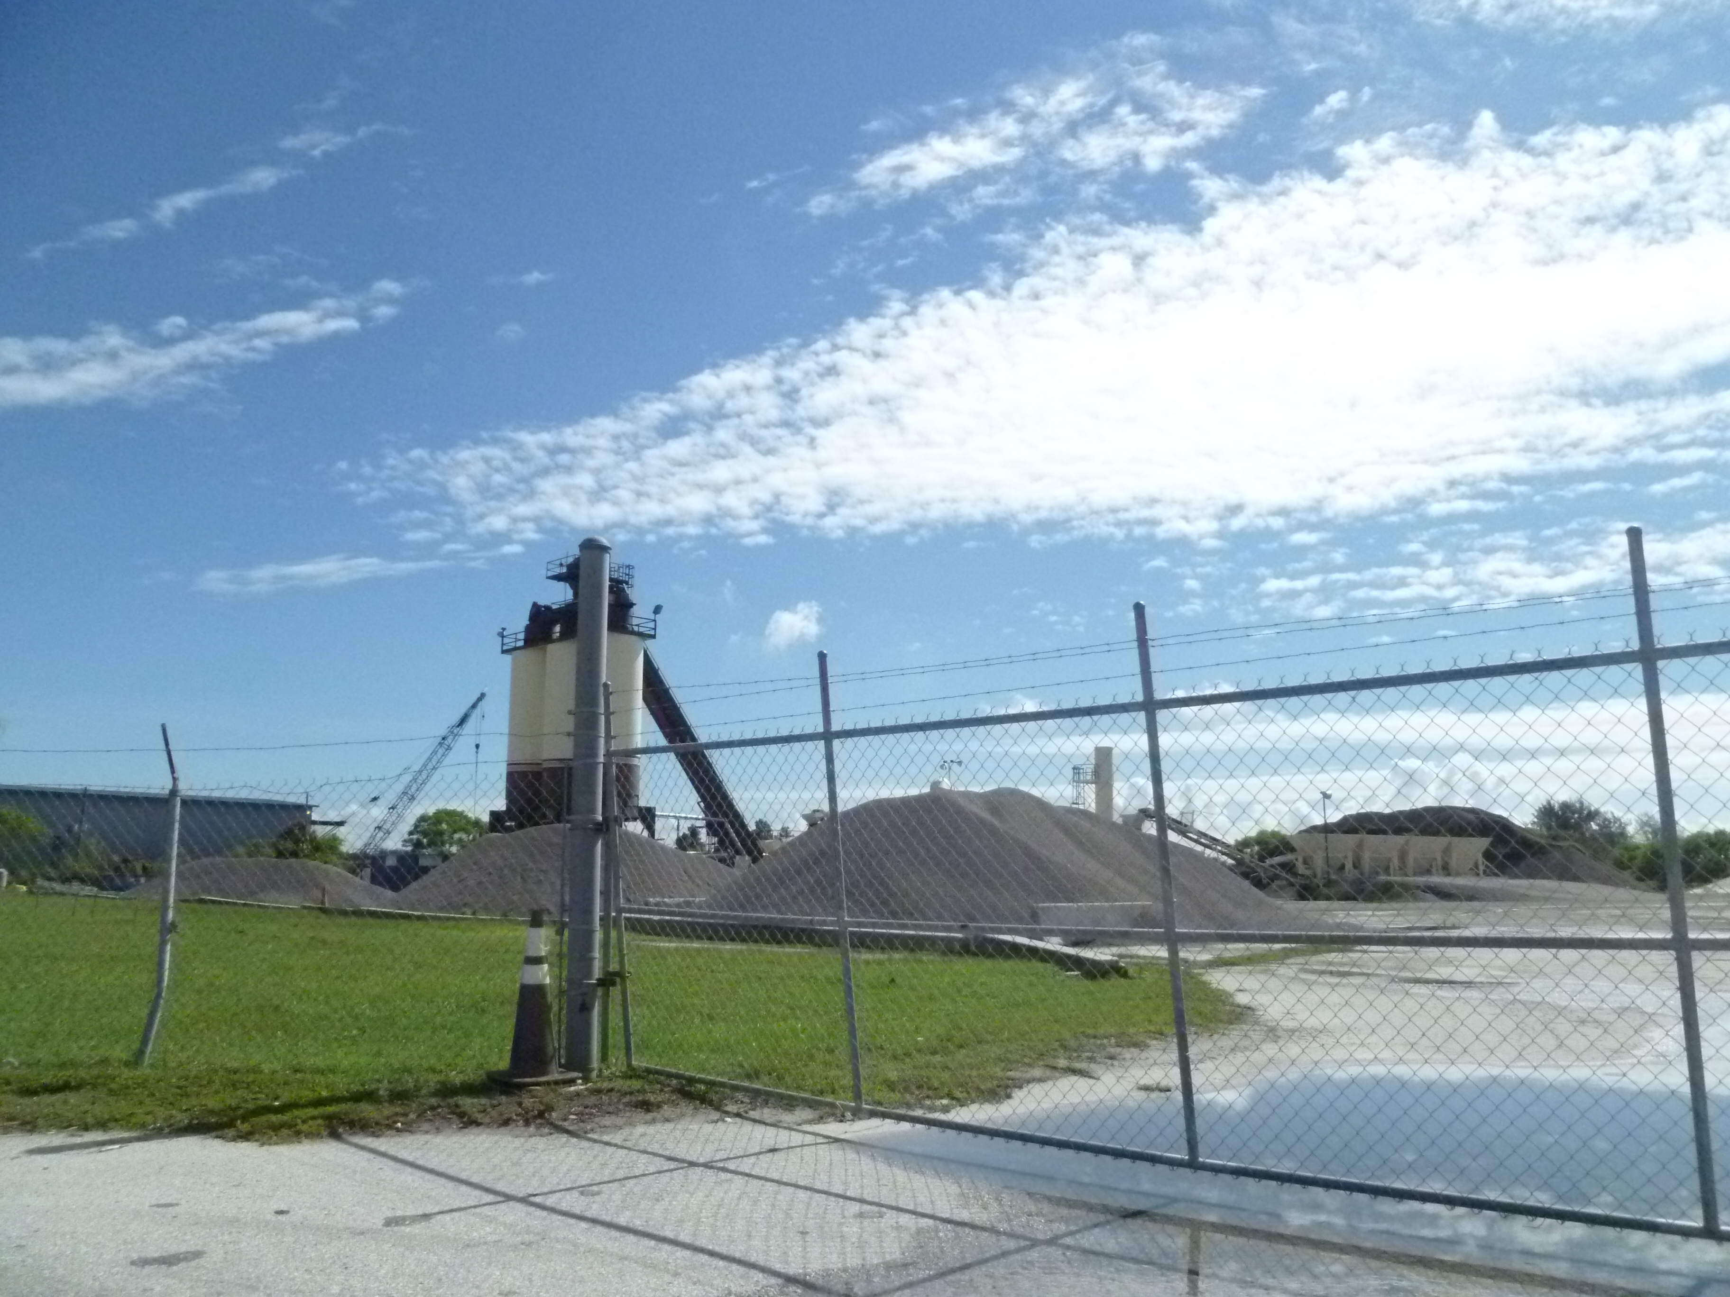

Project Id: 80641 Permit No: 7770073-015-AO Arms Number: 0073 001
Inspector: Shea Jackson Inspection Date / Time: 7/12/2012
Source (EU): A Gencor Model 300 Ultraplant portable drum-mix asphalt plant with a capacity of 300 TPH using an associated Gencor Model 620-Primary collector followed by a Gencor-Bituma Model 620-P baghouse, that has 792 bags with a total cloth area.

Description: [This is the South west gate of the facility. The gate is locked, no activity or personnel on site

The facility ceased operations June 2011.]

AIRS ID  7770073 | OWNER  APAC-Southeast, Inc |  | FACILITY NAME  Clearwater Asphalt Plant
TITLE V |  | SYNTHETIC MINOR | DATE OF THIS FCE  8/1/2012
TITLE V MEGA-SITE* |  | OTHER | DATE OF LAST FCE
*Facility with a large number of complex emissions units. It is more reasonable to evaluate a Title V Mega-Site once every 3 years instead of once every 2 years.

Review of All Required Reports

PERIODIC REPORTS |  | COMMENTS
DONE N/A | Annual operating report | 3/12/2012
DONE N/A | Statement of compliance
DONE N/A | Annual
DONE N/A | Semi-annual
DONE N/A | Quarterly
DONE N/A | Other :
DONE N/A | Other :

CONTINUOUS EMISSION MONITOR REPORTS |  | COMMENTS
DONE N/A | Quarterly excess emissions
DONE N/A | Semi-annual
DONE N/A | RATA
DONE N/A | CGA
DONE N/A | Other :
DONE N/A | Other :

Assessment of Control Device and Process Operating Conditions

OFF-SITE ASSESSMENT |  | (Describe the off-site assessment in comments)
ON-SITE ASSESSMENT |  | (Document the on-site inspection below)
DATE OF INSPECTION | DATE OF INSPECTION REPORT |  | My office maintains the inspection report...
DATE OF INSPECTION |  |  | ...in the ARMS database through EASIIR. | ...with the paper or electronic compliance files | ...in another location (specify).
7/12/12 | 7/31/12 |  |  |  | access database
COMMENTS

Review of Tests and Records
TESTS, OBSERVATIONS AND RECORDS |  | COMMENTS
DONE N/A | Visible emission observation(s) | 12/10/10 for fiscal 2011 year, no test for 2012
DONE N/A | Review of facility records and logs | Plant not in operation
DONE N/A | Assessment of process parameters (feed rates, process rates, raw material compositions, etc.) | Plant not in operation
DONE N/A | Assessment of control equipment performance parameters  (water flow rates, pressure drops, temperatures, ESP power levels, etc.) | Plant not in operation
DONE N/A | Stack test(s) | Not performed for fiscal year
DONE N/A | Other :
DONE N/A | Other :

Compliance Monitoring (CM) Information
CM ELEMENT | My office maintains this information...
CM ELEMENT | ...electronically, in the ARMS database. | ...in the permit. | ...in the inspection report. | ...in another location (specify).
Facility information
Applicable requirements
Inventory of emission units
Enforcement history
Compliance activities
Findings and recommendations
COMMENTS
The facility is in temporary shutdown since 6/2011 and does not know if will operate in 2013. Stack test will not be performed for fiscal year 2012

Other Comments

Prepared by: Shea Jackson Date:

Reviewed by: Date:

1. Complete the form as much as possible during for inspection; 2. The remainder of checklist, for activities in the FY, are filled in no later than 9/15; 3. Between 9/15 and 9/30, complete the FCE by closing out the FCS project in ARMS. The INSP > FCS record only accepts a completion date and a comment; it does not accept information on the lower portion of the form. If an FCS project already exists for the fiscal year in question, enter a completion date and comment in the existing record, do not create a duplicate FCS record.

