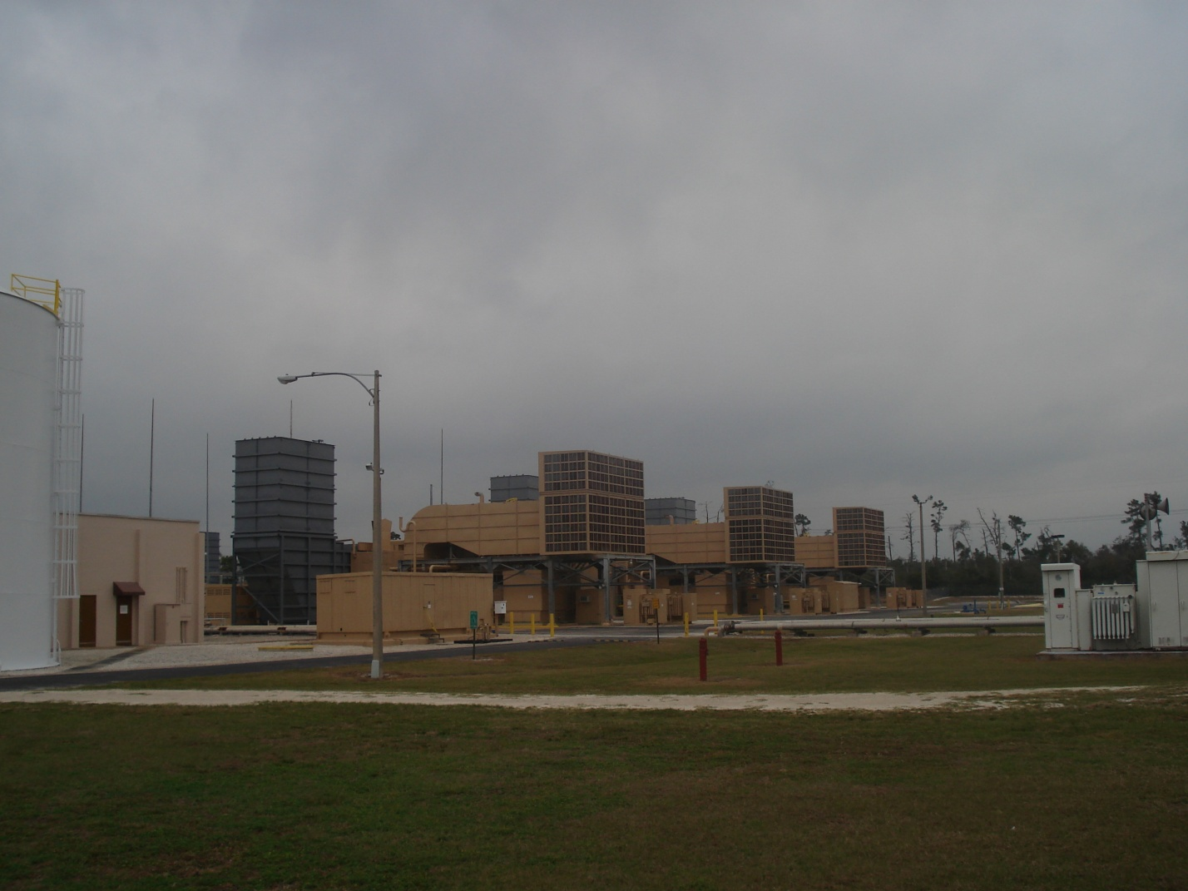
February 19, 2009. Progress Energy Debary. Pre NSPS combustion turbines. Grey rectangular stacks are units are Progress Energy units P2, P4, and P6 or DEP emission units 005, 009, and 013. The consultant, C.E.M. SOLUTIONS, took VE readings on EU 5, 9, and 13 from this location. The tan and black checkered, rectangular devices that appear to be about the same size as the stacks are the air intake for the combustion turbine.
Photo taken by G. Kuberski

