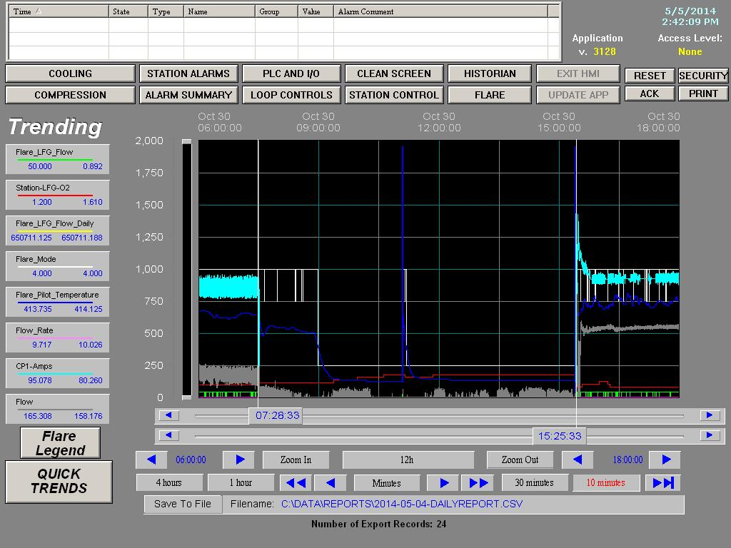
St. Lucie County Landfill – Flare Downtime Chart 1/8/2014

St Lucie County Landfill – Flare Downtime Chart 10/30/2014
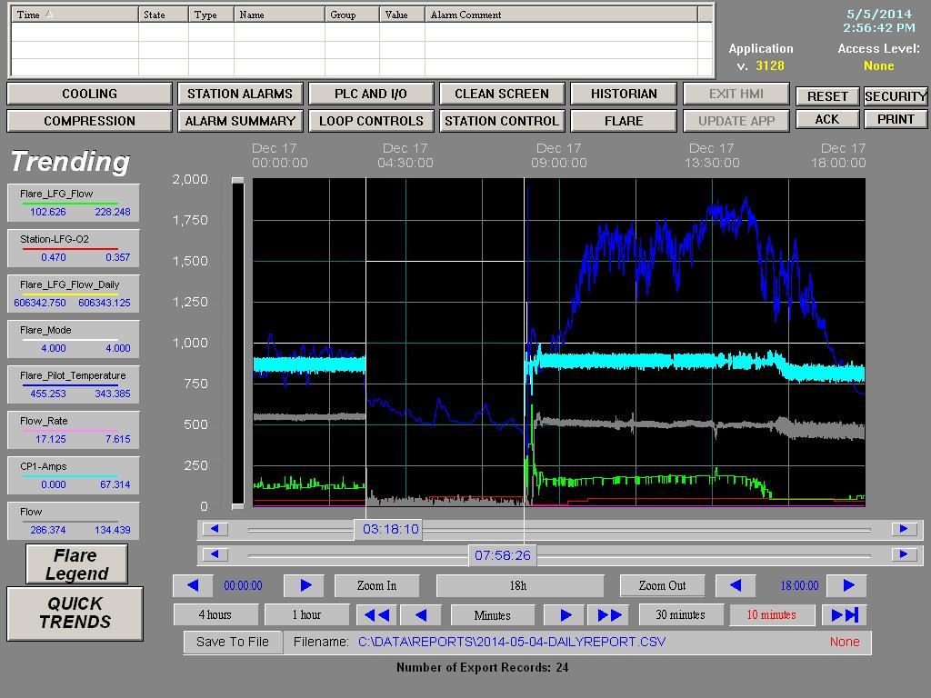
St. Lucie County Landfill – Flare Downtime Chart 12/17/2012
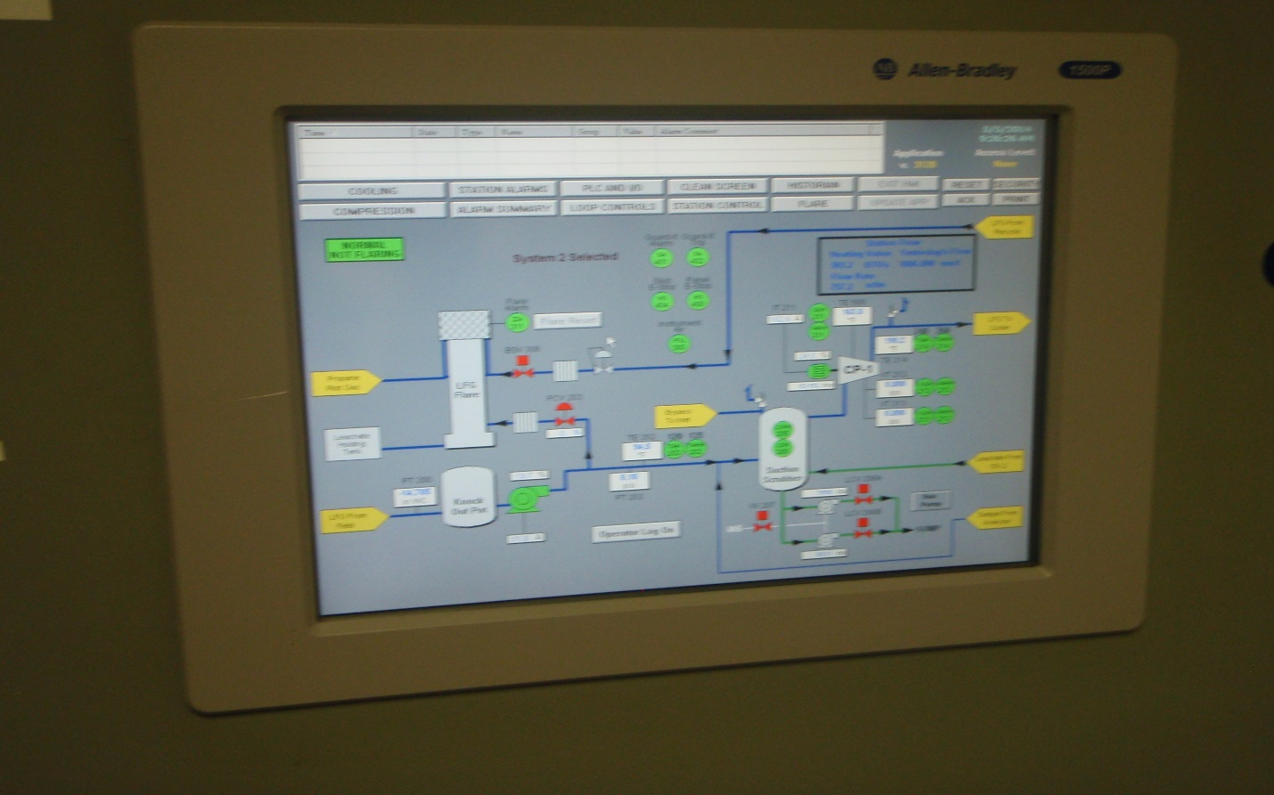
St. Lucie County Landfill Flare Display 5/5/2014

