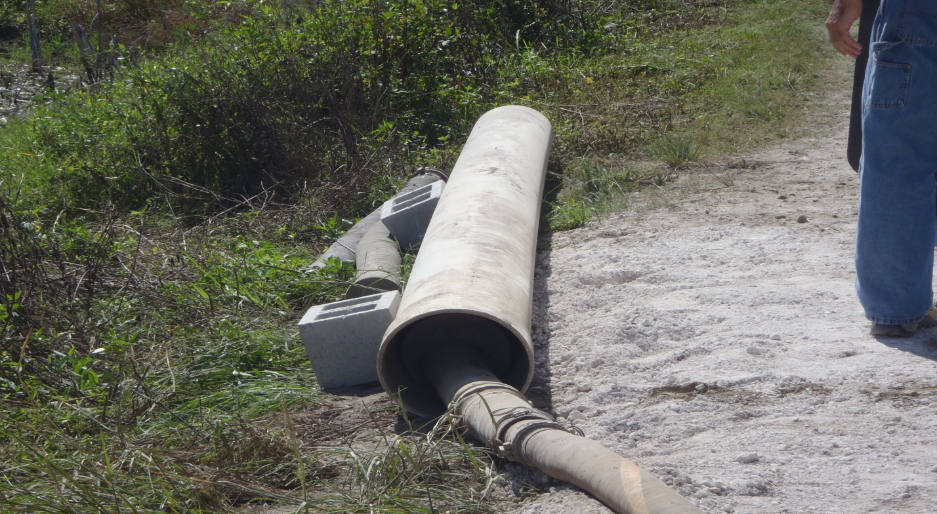
EU 007 Transloader Air Pollution Control being bypassed into bag inside PVC pipe on ground
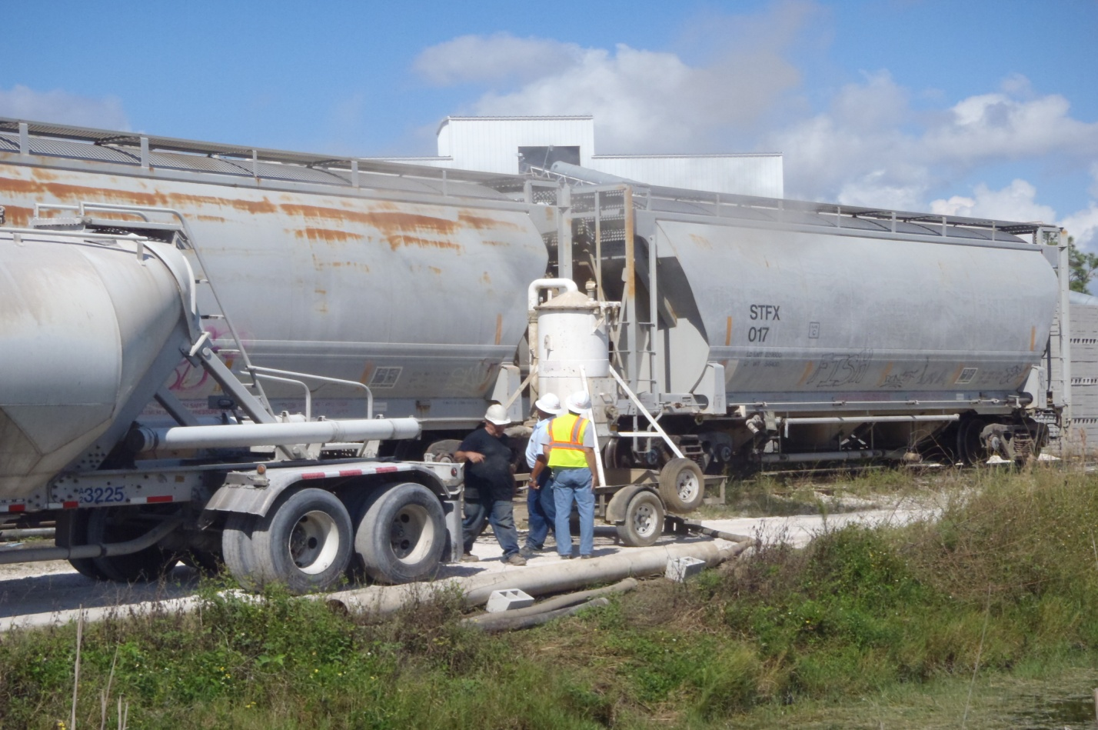
EU 007 Air Pollution Control Device

