1030543 88770
FACILITY: Melitta USA, Inc. |  |  |  |  |  |  |  |  |  |  |  |  |  |  |  |  |  |  |  | PERMIT ID: 3491
 |  |  |  |  |  |  |  |  |  |  |  |  |  |  |  |  |  |  |  | DISTRICT: Southwest
ADDRESS: 13925 58th Street North |  |  |  |  |  |  |  |  |  |  |  |  |  |  |  |  |  |  |  | CONTACT PHONE:
Clearwater, FL |  |  |  |  |  |  |  |  |  |  |  |  |  |  |  |  |  |  |  | 727-524-4852
ARMS NO:  1030543 001 |  |  |  |  |  |  |  | PERMIT NO: |  |  |  |  |  |  |  |  |  |  |  | Expiration Date: 2/26/18  Renewal Date: 12/28/17
 |  |  |  |  |  |  |  | 1030543-005-AO
 |  |  |  |  |  |  |  |  |  |  |  |  |  |  |  |  |  |  |  | Test Due Date:
EMISSION UNIT DESCRIPTION : Coffee Filter manufacturer using ethyl alcohol and methanol solvents. Emissions from filters are controlled by ventilation system that pulls from the entry point and runs underground to the exempt FARR Gold Series, Model GS36, cartridge dust collector
CMS INSPECTION DATE: |  |  |  |  |  |  | ARMS INSPECTION TYPE: |  |  |  |  |  |  |  |  |  |  |  |  |  |  | COMPLIANCE STATUS:
 | July 28, 2014 |  |  |  |  |  |  |  |  | INS1 |  | ✓ | INS2 |  |  | INS3 |  |  | FUI |  |  |  | ✓ |  | IN |  |  | MNC |  |  |  |  | SNC
INSPECTION TYPE: |  |  |  | ✓ | Initial |  |  |  |  |  | Re-inspection |  |  |  |  |  | Complaint |  |  |  |  |  |  | Drive-by |  |  |  |  |  | Quarterly
✓ |  |  | A. General Review:
1. |  | Permit File Review |  |  |  |  |  |  |  |  |  |  |  |  |  |  |  |  |  |  |  |  |  |  |  |  |  |  | Yes |  |  |  |  | No
 |  | Comments: yes
2. |  | Introduction and Entry |  |  |  |  |  |  |  |  |  |  |  |  |  |  |  |  |  |  |  |  |  |  |  |  |  |  | Yes |  |  |  |  | No
 |  | Comments: yes, met with Mr. Ken Donavon and Mike Crook.
3. |  | Is the Responsible Official/Authorized Representative still: Ken Donavon? |  |  |  |  |  |  |  |  |  |  |  |  |  |  |  |  |  |  |  |  |  |  |  |  |  |  | Yes |  |  |  |  | No
Comments: Ken Donavon is the authorized representative and facility contact
The Responsible Official/Authorized Representative’s e-mail is: Ken.donavon@melitta.com
4. |  | Is the facility contact still: Ken Donovan? |  |  |  |  |  |  |  |  |  |  |  |  |  |  |  |  |  |  |  |  |  |  |  |  |  |  | Yes |  |  |  |  | No
Comments: Yes, he is the facility contact.
The facility contact’s e-mail is: ken.donovan@melitta.com?
IN | MNC | SNC | B. Specific Conditions:
✓  ✓  ✓  ✓  ✓  ✓  ✓  ✓  ✓  ✓  ✓ |  |  | Inspection note: This initial operating permit became effective on 2/26/13  General Conditions [62-4.160, F.A.C.]  12. This permit or a copy thereof shall be kept at the work site of the permitted activity.  Comments: A copy of the permit was was not kept at the worksite. Mr. Donavan had a copy in his file cabinet.  8. If, for any reason, the permittee does not comply with or will be unable to comply with any condition or limitation specified in this permit, the permittee shall immediately provide the Department with the following information:  a. A description of and cause of noncompliance; and  b. The period of noncompliance, including dates and times; or, if not corrected, the anticipated time the noncompliance is expected to continue, and steps being taken to reduce, eliminate, and prevent recurrence of the noncompliance. The permittee shall be responsible for any and all damages which may result and may be subject to enforcement action by the Department for penalties or for revocation of this permit.  Comments: The facility has not reported any non compliance issues to this date. There are no control devices associated with the filter presses operation. I observed the nine filter presses. There were four in operation at the time of inspection. There were two carton packaging machines in operation but they do not use the ethanol. Typically the maximum is the operation of 6 filter machines at one time.  Common Conditions [Rule 62-296.320(4)(c), F.A.C.]  Unless otherwise specified in the permit, the following conditions apply to all emissions units and activities at the facility.  Emissions and Controls  2. Circumvention: The permittee shall not circumvent the air pollution control equipment or allow the emission of air pollutants without this equipment operating properly. [Rule 62-210.650, F.A.C.]  Comments: There is not at control device associated with the ethanol usage. The permittee has the air pollution control devices for the filter paper collection system a FARR Gold Series, Model GS36, cartridge dust collector attach by pick up points to the filter presses. I observed was in operation during inspection.  6. VOC or OS Emissions: No person shall store, pump, handle, process, load, unload or use in any process or installation, volatile organic compounds (VOC) or organic solvents (OS) without applying known and existing vapor emission control devices or systems deemed necessary and ordered by the Department. [Rule 62-296.320(1), F.A.C.]  Comments: The ethanol is contained in closed drums, in locked flame proof lockers. (See photos) The ethanol is pumped into a dispenser which fills each filter press vessel. This is a closed container which gravity feeds the ethanol to the nozzles over the filter paper. The spray is used to eliminate static charge for maintaining press operation. The nozzle spray area is covered and injects onto paper surfaces as needed. There were no spills or open containers observed during inspection of facility.  9. Unconfined Particulate Emissions:  a. No person shall cause, let, permit, suffer or allow the emissions of unconfined particulate matter from any activity, including vehicular movement; transportation of materials; construction, alteration, demolition or wrecking; or industrially related activities such as loading, unloading, storing or handling; without taking reasonable precautions to prevent such emissions.  b. Any permit issued to a facility with emissions of unconfined particulate matter shall specify the reasonable precautions to be taken by that facility to control the emissions of unconfined particulate matter.  c. Reasonable precautions include the following:  (1) Paving and maintenance of roads, parking areas and yards.  (2) Application of water or chemicals to control emissions from such activities as demolition of buildings, grading roads, construction, and land clearing.  (3) Application of asphalt, water, oil, chemicals or other dust suppressants to unpaved roads, yards, open stock piles and similar activities.  (4) Removal of particulate matter from roads and other paved areas under the control of the owner or operator of the facility to prevent reentrainment, and from buildings or work areas to prevent particulate from becoming airborne.  (5) Landscaping or planting of vegetation.  (6) Use of hoods, fans, filters, and similar equipment to contain, capture and/or vent particulate matter.  (7) Confining abrasive blasting where possible.  (8) Enclosure or covering of conveyor systems.  Comments:  (1) the surrounding building area is paved.  (2) No water control is needed for this facility.  (3) There is no need for suppressants, any debris or  (4) particulate for this facility, outside of building operations.  (5) There is landscaping.  (6) The filter paper which is cut in the filter press machine is controlled by the pickup points for each filter press inside the building..  (7) The paper is taken to a separate room captured with cyclone vacuum bag system.  (8) The paper is bundled into bales, which are loaded into trucks at dock and shipped to be recycled into diapers and into reusable paper rolls for filters.  The areas inside and outside of building were observed to be clean swept, and no unconfined emissions were occurring during operations. The facility is complying with this condition.  Administrative Requirements  7 Annual Operating Report: On or before April 1 of each year, the permittee shall submit a completed DEP Form 62-210.900(5), "Annual Operating Report for Air Pollutant Emitting Facility" (AOR) for the preceding calendar year. The report may be submitted electronically in accordance with the instructions received with the AOR package sent by the Department, or a hardcopy may be sent to the Compliance Authority. [Rule 62-210.370(3), F.A.C.]  Comments: The annual operating report for calendar year 2013 was submitted on 3/31/2014.  8. Operation Permit Renewal Application - A completed application for renewal of the operation permit shall be submitted to the Permitting Authority with a copy to the Pinellas County Air Quality Division (Compliance Authority) no later than 60 days prior to the expiration date of this operation permit  [Rules 62-4.030, 62-4.050, 62-4.070(3), 62-4.090, 62-210.300(2), and 62-210.900, F.A.C.]  Comments: Non- applicable at this time, renewal not due until 12/28/17.  FACILITY WIDE  10. Objectionable Odor Prohibited - No person shall cause, suffer, allow or permit the discharge of air pollutants, which cause or contribute to an objectionable odor. An “objectionable odor” means any odor present in the outdoor atmosphere which by itself or in combination with other odors, is or may be harmful or injurious to human health or welfare, which unreasonably interferes with the comfortable use and enjoyment of life or property, or which creates a nuisance. [Rules 62-296.320(2) and 62-210.200(Definitions), F.A.C. and Pinellas County Code, Section 58-178]  Comments: There were no objectionable odors detected outside the building. There were no solvent odors. The only odors detected during the interior building inspection, was a mild odor from the filter paper around filter press equipment, and the locked chemical storage lockers. There were four filter presses in operation at this time.  11. Documentation - Supporting documentation (e.g., MSD sheets, “As Supplied” sheets, “As Applied” sheets, purchase orders, inventory records, production records, etc.) for the records required by Specific Condition Nos. A.2. and B.2. which include sufficient information to determine VOC and HAP emissions, shall also be kept. At the permittee’s option, “quantity received” may be reported to satisfy the requirement of “quantity used”. [Rule 62-4.070(3), F.A.C.]  Comments: the Ethanol usage for the filters is the same, they are purchasing from company Brenntag MID South, Ind Co. The MSD sheets are maintained in yellow binders located in hall across from Mr. Donovan office, beside the manufacturing area. I obtain, a copy of the current product. The SDA 3A 200 proof Ethanol copy for me from the binders in this location. The MSD sheet states the chemical product components to be Ethanol 95% and Methanol 4.7%. The VOC content is 6.67 lbs per gallons, last year after change from manufacturer. The HAP content is .313 lbs/gal.  12. Records Retention - The monthly logs required by Specific Condition Nos. A. 2. and B.2. shall be completed by the end of the following month. These records shall be maintained at the facility for at least 3 years and made available to the Department and the Pinellas County Air Quality Division upon request. [Rule 62-4.070(3), F.A.C.]  Comments: The facility records began with permitting January 2010 and have been maintained up to date of end of July 2014. (See attached)  This section of the permit addresses the following emissions unit.  A.1. VOC and HAP Emission Limitations - Emissions of volatile organic compounds (VOCs) and hazardous air pollutants (HAPs), as defined in Rule 62-210.200, F.A.C., shall not exceed the following:  Permitting Note - These emission limits are based on an annual usage of 15,000 gallons of the solvent SDA 3A 200 Proof with a VOC content of 100% and a HAP content of 4.7%. Other solvents with similar VOC and HAP content may be used. [Rule 62-210.200, F.A.C. (“Potential to Emit”); Construction Permit No. 1030543-001-AC]  Comments: The facility is limiting emissions by controlling the monthly usage of the (ethanol/methanol). I reviewed the monthly usage for during this inspection for the period of June 2013 – July 2014. The typical month solvent usage was 880 to 1155 gallons. There were a couple of months no solvent was purchased. This facilities usage is very consistent, and no changes to production levels. HAP emission levels are 0.00 , and 290.40 to 381.15lbs/month. VOC emission levels are 0.00 , and 5869.60 to 7,703.85 lbs/month. The facility 12 month consecutive record emission totals showed the highest process rate to be the month of January 2014 with totals of 43.69 tons VOC, and 1.88 tons HAP. The highest solvent usage was November 2013 with 10,505 gallons. The 12 month consecutive total was 12,265 gallons.  This is below the emissions limitations of the permit table and the facility is complying with the permit limitations condition at this time.  A.2. VOC and HAP Recordkeeping - In order to document compliance with the VOC and HAP emission limits in Specific Condition No. A.2., the permittee shall maintain monthly records. The records shall contain, at a minimum, the following:  a. facility name, facility ID No., emission unit ID No., and description (i.e., Melitta USA, Inc., 1030543, EU 001, Coffee Filter Manufacturing);  b. total quantity (gallons) and VOC and HAP content (lbs/gallon) of all VOC and HAP containing materials used during the month;  c. calculated monthly total VOC and HAP emissions, in pounds or tons per month (based on b. above); and  d. cumulative total of all VOC and HAP emissions for the most recent consecutive 12 month period (tons per consecutive 12 month period).  [Rule 62-4.070(3), F.A.C.; Construction Permit No. 1030543-001-AC]  Comments: The facility is maintaining the records according to (a-d). (See record copies attached)
  Pollutant | Emission Limits  (tons/consecutive 12 month period)
  Volatile Organic Compounds | 49.3
  Total Hazardous Air Pollutants | 2.5
✓ |  |  | Valid Permit [Rule 62-210.300]
✓ |  |  | Changes to Facility/emission unit [Rule 62-210.300]  Does the emission unit description above match what the facility is operating (Number of emission units or points, model number and serial number, etc.) Yes No  Comments: there has been a changes to the facility operations, part of the flexographic printer equipment EU 002 was observed to be in the filter line, but the inks vessel, and printing mechanisms for its operation were placed in warehouse storage. Mr. Donavan stated they company has decided not to invest in use of the ink placement on filters.

✓ |  | C. Other:
Pollution Prevention Activities
- P2 Handouts Provided: P2 Brochure; P2 Manual; P2 Checklist
- Have any emissions reductions occurred Yes / No
Chemical Substitution; Equipment Changes; Process Changes
Chemical/Material Reuse; On-site Recycling; Other:
Comments: The facility returns the white filter scraps to their filter manufacturing facility where combined and made into rolls for filter press machines. The brown filter is sent to a manufacturer who uses for pet bedding. They also recycle miscellaneous office items IE. bulbs, glass, aluminum, and plastic wrap.

Closing Conference: I informed Mr. Donavan the facility appears to be in compliance at this time.

Inspector(s): Shea Jackson, Pinellas County, Air Quality Division
Signature(s): Date: |  |  |  |  |  |  | Date: July 31, 2014
 | ACCESS? |  | ✓ | ARMS? | ✓

AIRS ID  1030543 | OWNER  Melitta USA, Inc. |  | FACILITY NAME
TITLE V |  | SYNTHETIC MINOR | DATE OF THIS FCE  9/15/14
TITLE V MEGA-SITE* |  | OTHER | DATE OF LAST FCE  9/15/12
*Facility with a large number of complex emissions units. It is more reasonable to evaluate a Title V Mega-Site once every 3 years instead of once every 2 years.

Review of All Required Reports

PERIODIC REPORTS |  | COMMENTS
DONE N/A | Annual operating report
DONE N/A | Statement of compliance
DONE N/A | Annual
DONE N/A | Semi-annual
DONE N/A | Quarterly
DONE N/A | Other :
DONE N/A | Other :

CONTINUOUS EMISSION MONITOR REPORTS |  | COMMENTS
DONE N/A | Quarterly excess emissions
DONE N/A | Semi-annual
DONE N/A | RATA
DONE N/A | CGA
DONE N/A | Other :
DONE N/A | Other :

Assessment of Control Device and Process Operating Conditions

OFF-SITE ASSESSMENT |  | (Describe the off-site assessment in comments)
ON-SITE ASSESSMENT |  | (Document the on-site inspection below)
DATE OF INSPECTION | DATE OF INSPECTION REPORT |  | My office maintains the inspection report...
DATE OF INSPECTION |  |  | ...in the ARMS database through EASIIR. | ...with the paper or electronic compliance files | ...in another location (specify).
7/28/14 | 7/31/14 |  |  |  | access data base
COMMENTS

Review of Tests and Records
TESTS, OBSERVATIONS AND RECORDS |  | COMMENTS
DONE N/A | Visible emission observation(s)
DONE N/A | Review of facility records and logs
DONE N/A | Assessment of process parameters (feed rates, process rates, raw material compositions, etc.)
DONE N/A | Assessment of control equipment performance parameters  (water flow rates, pressure drops, temperatures, ESP power levels, etc.)
DONE N/A | Stack test(s)
DONE N/A | Other :
DONE N/A | Other :

Compliance Monitoring (CM) Information
CM ELEMENT | My office maintains this information...
CM ELEMENT | ...electronically, in the ARMS database. | ...in the permit. | ...in the inspection report. | ...in another location (specify).
Facility information |  |  |  | Access database
Applicable requirements |  |  |  | Access database
Inventory of emission units |  |  |  | Access database
Enforcement history |  |  |  | Access database
Compliance activities |  |  |  | Access database
Findings and recommendations |  |  |  | Access database
COMMENTS

Other Comments

Prepared by: Shea Jackson Date: 9/15/14

Reviewed by: Date:

1. Complete the form as much as possible during for inspection; 2. The remainder of checklist, for activities in the FY, are filled in no later than 9/15; 3. Between 9/15 and 9/30, complete the FCE by closing out the FCS project in ARMS. The INSP > FCS record only accepts a completion date and a comment; it does not accept information on the lower portion of the form. If an FCS project already exists for the fiscal year in question, enter a completion date and comment in the existing record, do not create a duplicate FCS record.

Melitta USA, Inc.
13925 58th Street North, Clearwater
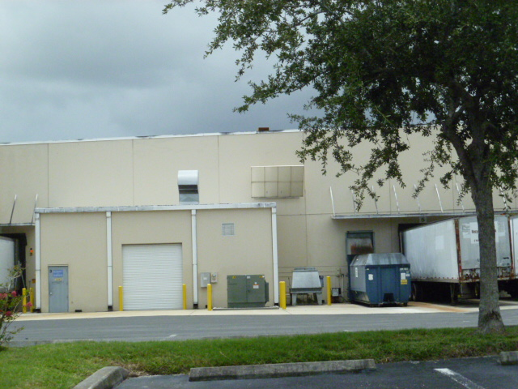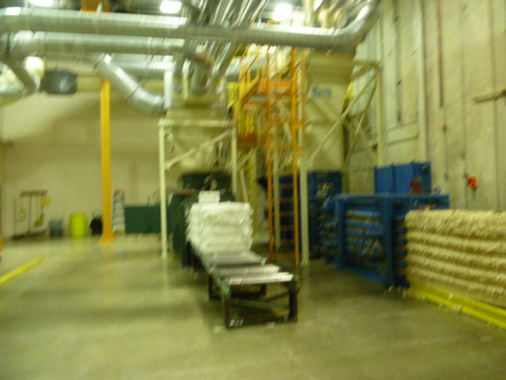
Project Id: 88770 Permit No: 1030543-005-AO Arms Number: 0543 001
Inspector: Shea Jackson Inspection Date / Time: 7/28/14 / _______
Source (EU): Coffee Filter manufacturer using ethyl alcohol and methanol solvents. Emissions from filters are controlled by ventilation system that pulls from the entry point and runs underground to the exempt FARR Gold Series, Model GS36, cartridge dust collector

Description: [The intake air vent for the filter scrap papers baling machine and inside baghouse control system]
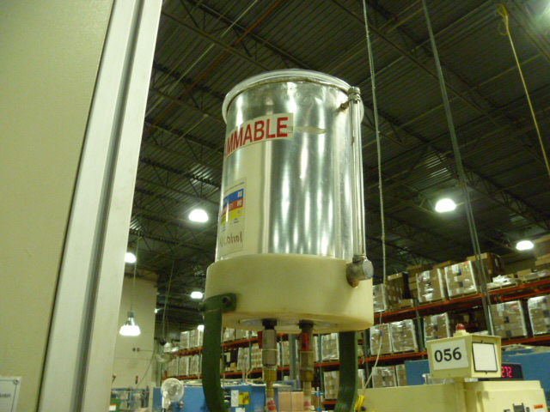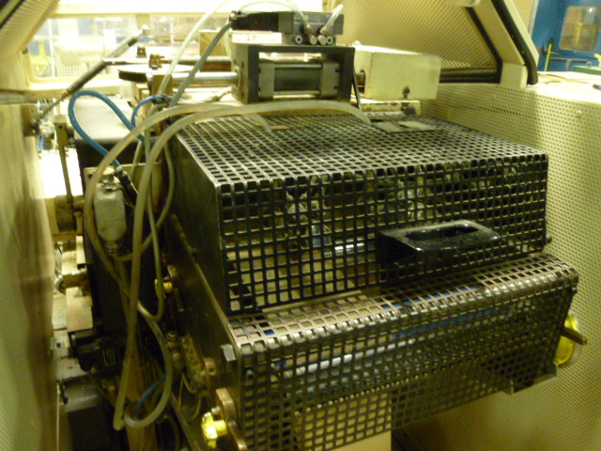

Description: [The filter press ethanol vessel gravity dispenses to the nozzles lined up over the filter paper roll going into the press. ]

Melitta USA, Inc.
13925 58th Street North, Clearwater

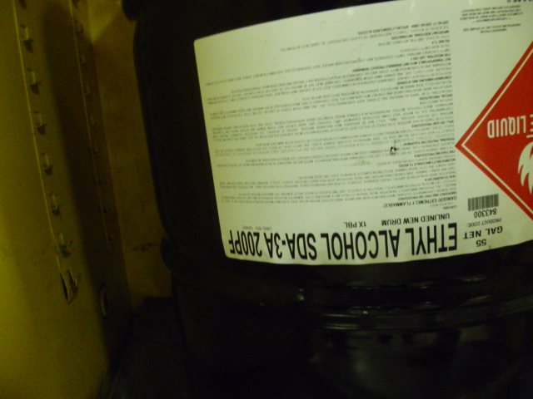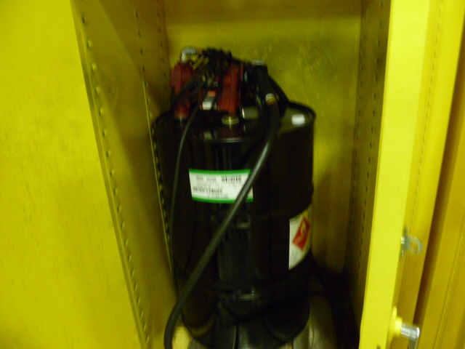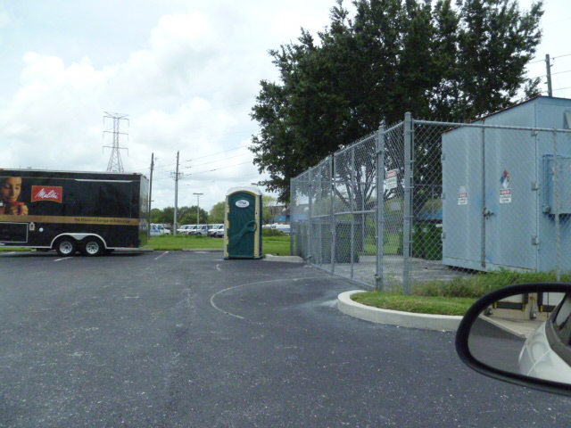

Project Id: 88770 Permit No: 1030543-005-AO Arms Number: 0543 001
Inspector: Shea Jackson Inspection Date / Time: 7/28/14 / _______
Source (EU): Coffee Filter manufacturer using ethyl alcohol and methanol solvents. Emissions from filters are controlled by ventilation system that pulls from the entry point and runs underground to the exempt FARR Gold Series, Model GS36, cartridge dust collector

Description: [Ethanol alcohol is stored inside flame proof cabinets until drawn for putting in press vessels, when finished with drum are stored in outside fenced area for pick up ]

