1030518 80833
FACILITY: Lantmannen Unibake USA, Inc. |  |  |  |  |  |  |  |  |  |  |  |  |  |  |  |  |  |  |  | PERMIT ID: 2852
EuroBake |  |  |  |  |  |  |  |  |  |  |  |  |  |  |  |  |  |  |  | DISTRICT: Southwest
ADDRESS: 1927 4th Avenue South |  |  |  |  |  |  |  |  |  |  |  |  |  |  |  |  |  |  |  | CONTACT PHONE:
St. Petersburg, FL |  |  |  |  |  |  |  |  |  |  |  |  |  |  |  |  |  |  |  | 727-823-1113
ARMS NO:  1030518 001 |  |  |  |  |  |  |  | PERMIT NO: |  |  |  |  |  |  |  |  |  |  |  | Expiration Date: 2/28/2013  Renewal Date: 12/30/2012
 |  |  |  |  |  |  |  | 1030518-006-AF
 |  |  |  |  |  |  |  |  |  |  |  |  |  |  |  |  |  |  |  | Test Due Date:
EMISSION UNIT DESCRIPTION : Baking Line #1 (Mecatherm Line) a continuous non-stop baking line. Bread production of 1.1023 tons/hour and 9,656 tons/year. Heat input-1.270 MMBtu/hour. VOCs generated from fermentation.

INSPECTION DATE: |  |  |  |  |  |  | ARMS INSPECTION TYPE: |  |  |  |  |  |  |  |  |  |  |  |  |  |  | COMPLIANCE STATUS:
 | September 6, 2012 |  |  |  |  |  |  |  |  | INS1 |  | ✓ | INS2 |  |  | INS3 |  |  | FUI |  |  |  | ✓ |  | IN |  |  | MNC |  |  |  |  |  | SNC
INSPECTION TYPE: |  |  |  | ✓ | Initial |  |  |  |  |  | Re-inspection |  |  |  |  |  | Complaint |  |  |  |  |  |  | Drive-by |  |  |  |  |  |  | Quarterly
✓ |  |  | A. General Review:
1. |  | Permit File Review |  |  |  |  |  |  |  |  |  |  |  |  |  |  |  |  |  |  |  |  |  |  |  |  |  |  |  | Yes |  |  |  |  | No
 |  | Comments: yes,
2. |  | Introduction and Entry |  |  |  |  |  |  |  |  |  |  |  |  |  |  |  |  |  |  |  |  |  |  |  |  |  |  |  | Yes |  |  |  |  | No
 |  | Comments: yes, met with Mr. Leibensperger the authorized representative
3. |  | Is the Responsible Official/Authorized Representative still: David Leibensperger? |  |  |  |  |  |  |  |  |  |  |  |  |  |  |  |  |  |  |  |  |  |  |  |  |  |  |  | Yes |  |  |  |  | No
Comments: yes
The Responsible Official/Authorized Representative’s e-mail is: david.leibensperger@lantmannen.com
4. |  | Is the facility contact still: David Leibensperger? |  |  |  |  |  |  |  |  |  |  |  |  |  |  |  |  |  |  |  |  |  |  |  |  |  |  |  | Yes |  |  |  |  | No
Comments: yes
The facility contact’s e-mail is: david.leibensperger@lantmannen.com

IN | MNC | SNC |  |  | B. Specific Conditions:
✓  ü  ü  ü  ü  ü  ü  ü  ü  ü  ü  ü |  |  |  |  | Permitting Note: This permit became effective on11/17/2008. This permit incorporate changes from 1030518-003-AC.  This permit or a copy thereof shall be kept at the work site of the permitted activity.  [62-4.160 F.A.C. - General Condition 12.]  Comments: The facility did did not have a copy of the permit on-site.  Mr. Leibensperger keeps the permit in his office.  4. General Visible Emission Limitation - No person shall cause, let, permit, suffer or allow to be discharged into the atmosphere the emissions of air pollutants from any activity, the density of which is equal to or greater than that designated as Number 1 on the Ringelmann Chart (20 percent opacity). The facility may add control type devices or work practices to reduce visible emissions below the facility wide opacity limit while baking the seeded breads that contain cheese ingredients.  [Rules 62-296.320(4)(b)1. & 4., F.A.C.]  Comments: There were no visible emissions observed during survey of outside of building as looking at the flour silos, not loading at time of inspection,. The ovens were in operation. There were no emissions observed from the stack vents. The facility uses parchment paper on pans instead of mineral oil to prevent visible emissions. (see photos)  5. Objectionable Odor - No person shall cause, suffer, allow or permit the discharge of air pollutants which cause or contribute to an objectionable odor. An objectionable odor is any odor present in the outdoor atmosphere that by itself or in combination with other odors is or may be harmful or injurious to human health or welfare, which unreasonably interferes with the comfortable use and enjoyment of life or property, or which creates a nuisance. [Rules 62-296.320(2) and 62-210.200, Definitions-(Objectionable Odors), F.A.C., Pinellas County Code Subsection 58-178]  Comments: There were no objectionable odors detected off the property. There was mild bread baking odor around and in the building.  6. Circumvention - No person shall circumvent any air pollution control device, or allow the emission of air pollutants without the applicable air pollution control device operating properly.  [Rule 62-210.650, F.A.C.]  Comments: there are no pollution control devices for the oven emissions units of this facility, and no circumvention evident.  7. Unconfined Particulate Matter - All reasonable precautions shall be taken to prevent and control generation of unconfined emissions of particulate matter in accordance with the provisions in Rule 62-296.320(4)(c)., F.A.C. These provisions are applicable to any source, including but not limited to, vehicular movement, transportation of materials, construction, alteration, demolition or wrecking, or industrial related activities such as loading, unloading, storing and handling. Reasonable precautions include the following:  - Removal of particulate matter from roads and other paved areas under the control of the owner or operator of the facility to prevent reentrainment, and from buildings or work areas to prevent particulate from becoming airborne.  - Landscaping or planting of vegetation.  - Use of hoods, fans, filters, and similar equipment to contain, capture and/or vent particulate matter.  - Confining abrasive blasting where possible.  [Rule 62-296.320(4)(c), F.A.C. and Construction Permit No. 1030518-003-AC]  Comments: This facility does not typically have operations which generate unconfined emissions outside of the building. There was a remodel of the front of the building; most of construction activity was inside building. A check later with the Asbestos section verified they had notified and taken proper steps for construction activities. There is no particulate matter activities associated with the roads; the landscaping is still in place. There is use of hoods inside for the collection of emissions from the ovens inside the building from the ovens. There is no abrasive blasting performed at this bread making facility.  8. Excess Emissions  - Startup/Shutdown/Malfunction – Excess emissions resulting from startup, shutdown, or malfunction shall be permitted providing (1) Best operational practices to minimize emissions are adhered to and (2) The duration of excess emissions shall be minimized but in no case exceed two (2) hours in any 24 hour period unless specifically authorized by the Department for a longer duration.  - Poor Maintenance/Operation, Equipment/Process Failure – Excess emissions which are caused entirely or in part by poor maintenance, poor operation, or any other equipment or process failure which may reasonably be prevented during startup, shutdown, or malfunction shall be prohibited.  - Excess Emissions Recordkeeping – The permittee shall maintain records of the occurrence and duration of any startup, shutdown, or malfunction in the operation of this facility which results in excess emissions; any malfunction of the air pollution control equipment; and any periods during which a continuous monitoring system or monitoring device is inoperative. Records shall be maintained at the facility and be available to the Department and/or PCDEM for inspection upon request. [Rules 62-4.070(3) and 62-210.700, F.A.C.]  Comments: There were not any excess emissions observed or reported, no shutdown. The facility is clean and well maintenance no malfunctions or upset conditions were stated to have occurred.  9. Special Compliance Test – If the Department and/or Pinellas County Department of Environmental Management (PCDEM), after investigation, have good reason (such as complaints, increased visible emissions or questionable maintenance of control equipment) to believe that any applicable emission standard contained in a Department rule or in a permit issued pursuant to those rules is being violated, it shall require the owner or operator of the emissions unit to conduct compliance tests which identify the nature and quantity of pollutant emissions from the emissions unit and to provide a report on the results of said tests to the Department and the PCDEM. [Rule 62-297.310(7)(b), F.A.C.]  Comments: There are no special compliance test requirements for this facility. The dept had not received any citizen complaints related to activities performed at this source.  10. Annual Operating Report (AOR) Requirement - On or before April 1 of each year, submit to the Air Compliance Section of the Department's Southwest District Office and the PCDEM (unless otherwise directed by the Department), an Annual Operating Report [DEP Form No. 62-210.900(5)] for the preceding calendar year. Note, the annual operating report for calendar year 2008 shall be submitted by May 1, 2009. The report may be submitted electronically in accordance with the instructions received with the AOR package sent by the Department, or a hardcopy may be submitted.  [Rule 62-210.370(3), F.A.C.]  Comments: The facility submitted the 2011 AOR on 3/21/12 and completed review 5/22/12.  11. Records Retention – All monthly records shall be completed by the end of the following month. All records required by this permit shall be maintained at the facility for at least three years, unless otherwise noted, and be made available to the Department and/or PCDEM for inspection upon request.  [Rule 62-4.160(14)(b), F.A.C.]  Comments: The monthly records for the ovens are maintained by Mr. Leibensperger as required in this permit condition. He monitors and keeps record through the production of the daily bread batches. There are tons of bread produced in vats and go through the conveyor lines into the ovens , flash frozen and packaged for shipment. The information is transferred to the spread sheet and reviewed by consultant Marvin Scott to maintain accuracy (See Record copies)  Operation Permit Renewal  12. Permit Renewal Application – A completed application to renew this operation permit shall be submitted to the Air Permitting Section of the Department’s Southwest District Office with a copy sent to the PCDEM no later than 60 days prior to the expiration date of this permit. To properly apply for an operation permit renewal, the applicant shall submit the following:  - The appropriate operation permit application form (see current version of Rule 62-210.900, F.A.C. and /or FDEP Division of Air Resource management website at: http://www.dep.state.fl.us/air/);  - The appropriate operation permit application fee (see Rule 62-4.050(4)(a), F.A.C.);  - Copies of the records specified in Specific Condition No. 14 for the most recent 2 months of operation. [Rules 62-4.070(3), 62-4.090, 62-210.300(2) and 62-210.900 F.A.C.]  Comments: I informed Mr. Leibensperger that permit renewal date is 12/30/12 and permit expires 2/28/2013.  EMISSION UNIT ID 001, 002, 005  13. Emissions Limits – VOC emissions from emission units 001, 002, and 005 shall not exceed the following limit:  [Rule 62-210.200, F.A.C. – Definitions (PTE) and Permit 1030518-001-AF and Construction Permit 1030518-003-AC]  Comments: The records reviewed from August 2011 through August 2012. The highest production month for EU 001 Mecatherm was December 2011 at 595.76 tons of bread baked and 1.19.tons VOC emission per month. The 12 month consecutive total for VOC emissions was 13.51 tons. The unit was below the 19.3 tons limitation of the permit and in compliance. The permit limitations were calculated for the facility while operating at full capacity continuously 24/7 with all emissions units 001, 005 and 006. This means all ovens would have to be operating continuously to exceed permit limitations. The only emission unit continuously operated is EU 001.  14. Monthly Recordkeeping – The permittee shall maintain appropriate records to document compliance with the VOC emission limits of Specific Condition No. 13. The records shall include, but are not limited to, the following:  - Facility Name, Facility Number (1030518), Emission Unit Numbers (001, 002, 005), Month, Year;  - For each emission unit (001, 002, 005);  - The total quantity of bread produced (in tons) for the month;  - The calculated quantity of VOCs emitted (in pounds or tons) for the month as follows;  *VOC Emission Factor = 4 pounds of VOCs / ton of baked bread  - The sum of VOCs emitted (in tons) for the most recent consecutive 12-month period.  [Rule 62-4.070(3), F.A.C.]  Permitting Note: The VOC emission factor was determined based upon use of the equation below (ref: EPA document number 453/R-02-017, Alternative Control Technology Document for Bakery Oven Emissions, 12/92) and the worst case parameters supplied by the applicant in the revised permit application dated 4/23/2007.  VOC Emission Factor = 0.95Y_{i} + 0.195t_{i} – 0.51S – 0.86t_{s} + 1.90  Where:  VOC E.F. = pounds VOC per ton of baked bread  Y_{i} = initial baker’s percent of yeast to the nearest tenth of a percent  t_{i} = total yeast action time in hours to the nearest tenth of an hour  S = final (spike) baker’s percent of yeast to the nearest tenth of a percent  t_{s} = spiking time in hours to the nearest tenth of an hour  Comments: The monthly records for the ovens are maintained by Mr. Leibensperger as required in this permit condition. He monitors and keeps record through the production of the daily bread batches. There are tons of bread produced in batches as mixed in vats and go through the conveyor lines into the ovens, flash frozen and packaged for shipment. The information is transferred to the spread sheet and reviewed by consultant Marvin Scott to maintain accuracy (See Record copies)
  E.U. ID No. | Annual VOC Emissions  (Any consecutive 12-month period)
  001 | 19.3 tons
  002 | 15.5 tons
  005 | 38.6 tons
  VOC Emissions Equation
  VOCs emitted = Tons of bread produced x VOC Emission Factor*
ü |  |  |  |  | Valid Permit [Rule 62-210.300]
ü |  |  |  |  | Changes to Facility/emission unit [Rule 62-210.300]  Does the emission unit description above match what the facility is operating (Number of emission units or points, model number and serial number, etc.) Yes No  Comments: there have been no changes to the facility emission units.
✓ |  |  | C. Other:
Pollution Prevention Activities
- P2 Handouts Provided: P2 Brochure; P2 Manual; P2 Checklist
- Have any emissions reductions occurred Yes / No
Chemical Substitution; Equipment Changes; Process Changes
Chemical/Material Reuse; On-site Recycling; Other:
Comments: The facility recycles cardboard and waste dough goes to animal farm.

Closing Conference: I informed Mr. Leibensperger the facility appears to be in compliance pending review of records.
Inspector(s): Shea Jackson, Pinellas County, Air Quality Division
Signature(s): Date: |  |  |  |  |  |  |  |  | Date: September 19, 2012
ACCESS? |  |  |  | ✓ |  | ARMS? | ✓

Lantmannen Unibake USA, Inc. EuroBake
1927 4th Avenue South, St. Petersburg

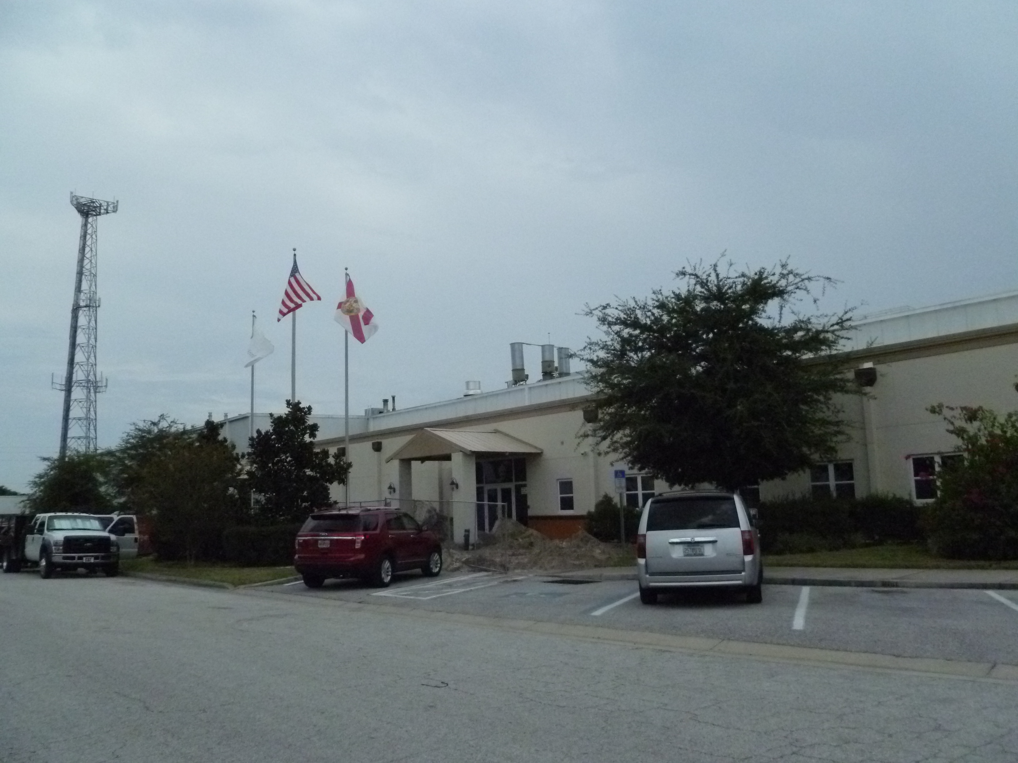

Project Id: 80833 Permit No: 1030518-006-AF Arms Number: 0518 001
Inspector: Shea Jackson Inspection Date / Time: 9/6/2012 / _______
Source (EU): Baking Line #1 (Mecatherm Line) a continuous non-stop baking line. Bread production of 1.1023 tons/hour and 9,656 tons/year. Heat input-1.270 MMBtu/hour. VOCs generated from fermentation.

Description: [Looking to the North West the oven stacks as located on the roof to the right side of flag pole southernmost stack for EU 001. There were no visible emissions from stacks. ]

