1030502 84792
FACILITY: Marine Industrial Paint Company, Inc. |  |  |  |  |  |  |  |  |  |  |  |  |  |  |  |  |  |  |  | PERMIT ID: 1140
 |  |  |  |  |  |  |  |  |  |  |  |  |  |  |  |  |  |  |  | DISTRICT: Southwest
ADDRESS: 4590 60th Avenue North |  |  |  |  |  |  |  |  |  |  |  |  |  |  |  |  |  |  |  | CONTACT PHONE:
St. Petersburg, FL |  |  |  |  |  |  |  |  |  |  |  |  |  |  |  |  |  |  |  | 727-527-3382
ARMS NO:  1030502 001 |  |  |  |  |  |  |  | PERMIT NO: |  |  |  |  |  |  |  |  |  |  |  | Expiration Date: 2/3/2014  Renewal Date: 12/5/2013
 |  |  |  |  |  |  |  | 1030502-003-AO
 |  |  |  |  |  |  |  |  |  |  |  |  |  |  |  |  |  |  |  | Test Due Date:
EMISSION UNIT DESCRIPTION : Mixes and distributes paint used for specialty concrete coatings.

INSPECTION DATE: |  |  |  |  |  |  | ARMS INSPECTION TYPE: |  |  |  |  |  |  |  |  |  |  |  |  |  |  | COMPLIANCE STATUS:
 | July 30, 2013 |  |  |  |  |  |  |  |  | INS1 |  | ✓ | INS2 |  |  | INS3 |  |  | FUI |  |  |  | ✓ |  | IN |  |  | MNC |  |  |  |  |  | SNC
INSPECTION TYPE: |  |  |  | ✓ | Initial |  |  |  |  |  | Re-inspection |  |  |  |  |  | Complaint |  |  |  |  |  |  | Drive-by |  |  |  |  |  |  | Quarterly
✓ |  |  | A. General Review:
1. |  | Permit File Review |  |  |  |  |  |  |  |  |  |  |  |  |  |  |  |  |  |  |  |  |  |  |  |  |  |  |  | Yes |  |  |  |  | No
 |  | Comments: I met on site with employees on site
2. |  | Introduction and Entry |  |  |  |  |  |  |  |  |  |  |  |  |  |  |  |  |  |  |  |  |  |  |  |  |  |  |  | Yes |  |  |  |  | No
 |  | Comments: I spoke with Mr. Cook. Mr. Deininger and his son, Carson Deininger were not on site at time of inspection.
3. |  | Is the Responsible Official/Authorized Representative still: Greg Deininger? |  |  |  |  |  |  |  |  |  |  |  |  |  |  |  |  |  |  |  |  |  |  |  |  |  |  |  | Yes |  |  |  |  | No
Comments: yes
The Responsible Official/Authorized Representative’s e-mail is: gregd@tuf-top.com
4. |  | Is the facility contact still: Carson Deininger? |  |  |  |  |  |  |  |  |  |  |  |  |  |  |  |  |  |  |  |  |  |  |  |  |  |  |  | Yes |  |  |  |  | No
Comments: yes
The facility contact’s e-mail is: stevec@tuf-top.com

IN | MNC | SNC |  |  | B. Specific Conditions:
✓  ✓  ✓  ✓  ✓  ✓  ✓  ✓  ✓  ✓  ✓  ✓  ✓  ✓ |  |  |  |  | Inspection note: this permit became effective on 2/3/09 and replaces 1030502-002-AO and is for continued operation of a paint manufacturing and blending facility which manufactures both water based and solvent based paints. On the basis of the emission limitations included in this permit, this facility’s allowable emissions are below the major source emission criteria that would require a Title V Major Source operation permit. This facility is therefore considered as a synthetic non-Title V source.  This permit or a copy thereof shall be kept at the work site of the permitted activity.  [62-4.160 F.A.C. - General Condition 12.]  Comments: The facility did did not have a copy of the permit on-site.  4. Emission Limits. In order to establish the facility as a non-Title V minor source of VOC and HAP emissions, the following emission limits shall not be exceeded:  [Rule 62-210.200(Potential To Emit), F.A.C.; Construction Permit 1030502-001-AC]  Comments: The employees were not familiar with retrieval of the records from their employers personal computer. They were out of town on vacation. I informed them I would need to review records as soon as they returned next week. The records were email on August 5,2013 from Mr. Carson Deininger. The facility is continuing to manufacture more water base paints. They estimate 75% of their products are water base. After review of the records showed the May 2013 reported emissions were 0.286 tons VOC, and 0.100 tons individual HAP (Xylene), and 0.101 total HAP. The record period reviewed was months Jan 2013 – July 2013. The highest consecutive 12 month total was 2.605 tons VOC and 0.888 tons HAP for May2013. These totals did not exceed the permit limitation in table above. The facility is below a ton of HAP for the 12 month period. They are operating at a low level of VOC HAP emissions and actual emissions are exempt according to the rule requirements. (see record copies)  5. Fugitive Organic Solvents, and Volatile Organic Compounds. The permittee shall not store, pump, handle, process, load, unload, or use in any process or installation, OS, or VOCs without applying known and existing vapor emission control devices or systems deemed necessary and ordered by the Department. The permittee shall comply with the following:  - All equipment, pipes, hoses, lids, fittings, etc., shall be operated/maintained in such a manner as to minimize leaks, fugitive emissions and spills of solvent materials.  - All VOC/OS from washings (equipment clean-up) shall be directed into containers that prevent evaporation into the atmosphere.  - When they are not in use and where possible, tightly cover all open troughs, basins, baths, tanks, etc. which contain VOC's and/or OS's.  - Prevent excessive air turbulence across exposed VOC's and/or OS’s.  - Immediately confine and clean up VOC and/or OS spills and make sure wastes are placed in closed containers for reuse, recycling or proper disposal.  [Rule 62-296.320(1), FAC]  Comments: The facility has paint mixtures in closed containers. The mixers have covers to reduce VOC /OS emissions and turbulence exposure.  - The mixer lids were observed in place, except for the one in operation as ingredients were being added to the mixer. No observations of spills or any fittings with leaks.  - When the equipment is washed it is performed in a sealed tank.  - The outside bulk storage tanks closed containers were observed at the south side of the building in a secondary containment area. The bulk tanks are empty at this time; they are looking to remove because most supplies are received in totes and drums.  - The paint mixers are covered to prevent air turbulence during mixing operations. The mixer tops were in place at time of inspection (See photo).  - Any rags used when using toluene or xylene were disposed of in closed containers.  6. Modification. Unless otherwise exempt by rule, the permittee shall not initiate any construction, reconstruction, or modification at the facility and shall not install/modify any pollution control device at the facility without obtaining prior authorization from the Department. Modification is defined as: Any physical change or changes in the method of operations or addition to a facility that would result in an increase in the actual emissions of any air pollutant subject to air regulations, including any not previously emitted, from any emission unit or facility. Equipment and components of Emission Unit No. 001 may be replaced if the actions do not trigger a construction or modification. A construction permit will be required if there is a physical or operation change that causes actual emissions of VOC or HAP to increase, or if there are changes that would be considered a new emission unit. Within 30 days of adding or deleting equipment to or from Emission Unit No. 001, a new equipment list shall be submitted in writing to the Air Compliance section of the Department’s Southwest District and the Pinellas County Department of Environmental Management (PCDEM). The notice shall include the date that each piece of equipment was added and/or deleted. [Rules 62-210.200 - Definition of “Modification” and 62-210.300(1)(a), F.A.C.]  Comments: There were not any modifications observed to the equipment at this facility. The facility manufacture paints; the facility mixes pigments, solvents and various other ingredients. The paints are packaged into individual gallon containers for resale.  7. Equipment Identification. All tanks and mixers shall be labeled for identification purposes.  [Rules 62-4.070(3), F.A.C.; Construction Permit 1030502-001-AC]  Comments: The facility has 6 mixers. There are various size vats used to mix according to the batch size needed. The bulk tanks have been labeled as a condition of his permit. The bulk tanks were empty at this time. (See Photos)  8. General Pollutant Emission Limiting Standard: Visible Emissions. Except for emissions units that are subject to a particulate matter or opacity limit set forth or established by rule, no person shall cause, let, permit, suffer or allow to be discharged into the atmosphere the emissions of air pollutants from any activity, the density of which is equal to or greater than that designated as Number 1 on the Ringelmann Chart (20 percent opacity). EPA Method 9 is the method of compliance pursuant to Rule 62-297.401, F.A.C. [Rules 62-296.320(4)(b)1, 62-296.320(4)(b)4 and 62-297.401, F.A.C.]  Comments: No visible emissions observe during this inspection. Visible emissions when adding the pigment into the liquids forthe mixing process could occur, but is located inside the building, there are no stacks or emission points outside the structure. The employees were running 3 mixers for different batches of paint. The covers were on the mixers to prevent unconfined emissions and evaporation of VOCs. (See photos)  9. General Pollutant Emission Limiting Standards: Objectionable Odor. No person shall cause, suffer, allow or permit the discharge of air pollutants, which cause or contribute to an objectionable odor. An objectionable odor is any odor present in the outdoor atmosphere, which by itself or in combination with other odors, is or may be harmful or injurious to human health or welfare, which unreasonably interferes with the comfortable use and enjoyment of life or property, or which creates a nuisance.  [Rules 62-210.200 (Definition “Objectionable Odor”) and 62-296.320(2), F.A.C.; Pinellas County Code, Section 58-178]  Comments: An upwind/downwind survey of the facility was conducted. The observed parameters were:  Downwind odor level detected-None; 0 -no odors detected during survey of facility. Wind direction – westerly Upwind odor level detected- None 0  10. General Pollutant Emission Limiting Standards: Unconfined Particulates - All reasonable precautions shall be taken to prevent and control generation of unconfined emissions of particulate matter in accordance with the provisions in Rule 62-296.320, F.A.C. These provisions are applicable to any source, including but not limited to, vehicular movement, transportation of materials, construction, alteration, demolition or wrecking, or industrial related activities such as loading, unloading, storing and handling. Reasonable precautions shall include, but are not being limited to, the handling of pigments and specific additives in a manner such that fugitive emissions of particulate matter are kept to a minimum. [Rules 62-4.070(3) and 62-296.320(4)(c), F.A.C.; Construction Permit 1030502-001-AC]  Comments: I did not observe the facility operations to be generating any unconfined emissions with their work activities. The floor of the work area was swept. There were no spills on floors. The mixing vats in operation were covered. There is no construction demolition transportation, activities at this time which would cause emissions from this facility.  11. Excess Emissions. Excess emissions resulting from startup, shutdown, or malfunction shall be permitted providing (1) Best operational practices to minimize emissions are adhered to and (2) The duration of excess emissions shall be minimized but in no case exceed two hours in any 24 hour period unless specifically authorized by the Department for a longer duration. Excess emissions which are caused entirely or in part by poor maintenance, poor operation, or any other equipment or process failure which may be reasonably prevented during startup, shutdown, or malfunction shall be prohibited.  [Rule 62-210.700(4), F.A.C.]  Comments: No excess emissions were associated with this facility at this time. There are no control devices that would require shutdown procedure. The facility minimizes emissions by following good work practices to cover containers, etc, and continue to reduce VOC HAP content in paints they manufacture.  12. Special Compliance Tests. When the Department, after investigation, has good reason (such as complaints, increased visible emissions, or questionable maintenance of control equipment) to believe that any applicable emission standard contained in a Department rule or in a permit issued pursuant to those rules is being violated, it may require the owner or operator of the emissions unit to conduct compliance tests which identify the nature and quantity of pollutant emissions from the emission unit and to provide a report on the results of said tests to the Department. [Rule 62-297.310(7)(b), F.A.C.]  Comments: There is no compliance tests necessary at this time, there is no evidence of any emission standard having been exceeded during the compliance year for this facility.  12. Recordkeeping. To document continuing compliance with the limits of Specific Condition No. 4, the permittee shall maintain, at a minimum, the following records:  - Monthly Records:  - Facility Name, Facility Number (1030502), Emission Unit Number (001), Month and Year.  - The amount of each VOC and/or HAP containing material (by identification number) used in gallons and/or pounds (all records shall be in the same units);  - The VOC and/or HAP content (percent by weight if usage recorded in pounds or lbs/gallon if usage recorded in gallons) of coatings and solvents used;  - Calculate the total quantity of VOC, individual HAP and total HAP emissions for the month (in tons) for each raw material. VOC emission and HAP emission (which are also VOC's) shall be calculated based on the amount of material processed and the following emission factor unless otherwise directed by the Department:  - Emission Factor = 30 pounds of emissions per ton of VOC/HAP processed  - Calculate the total quantity of VOC, individual HAP and total HAP emissions for the most recent consecutive 12-month period (in tons).  - Daily Records: If the total VOC, individual HAP or total HAP emissions for the most recent consecutive 12 month period exceeds 80% of the limit specified in Specific Condition No. 4 (e.g., 7.60 tons individual HAP), the permittee shall implement daily recordkeeping. The daily records shall be kept as described in Specific Condition 12.A. above and shall be added to the previous 11 monthly totals to demonstrate the facility is remaining below the permitted threshold. Daily recordkeeping shall remain in effect until the VOC and/or HAP emissions are less than 80% of the limit for the most recent consecutive 12 month period.  Supporting documentation (e.g., MSDS sheets, “As Supplied” sheets, “As Applied” sheets, purchase orders, inventory records, production records, etc.) which shall include sufficient information to determine VOC, HAP emissions, shall also be kept. At the permittee’s option, “quantity purchased” may be reported to satisfy the requirement of “quantity used”, provided no materials are used which are not purchased. [Rule 62-4.070(3), F.A.C.; Pinellas County Code, Section 58-90/94, Construction Permit 1030502-001-AC]  Comments: The records had been reviewed up to December 2012 during the AOR review, and the rest of the records reviewed were for the months of Jan 2013 – July 2013. The facility maintains the record by keeping in Mr. Deininger’s personal computer. The monthly totals for the 12 month consecutive totals are maintained according to the permit conditions to determine VOC and HAP emissions are within the permit limitations. I was not able to review records at the time of inspection. Both Greg and Carson. Deininger were not in. I requested records for review when they returns next week. I received and review the records he emailed to our A.Q. Division office. He apologized later that the employees did not know where he kept the hard copy binder of records.  13. Records Retention. Daily Records (if required) shall be completed within five (5) calendar days. Monthly records shall be completed within 10 days of the end of month. All records required by this permit shall be maintained at the facility for at least three years, unless otherwise noted, and be made available to the Department for inspection upon request. [Rules 62-4.070(3) and 62-4.160(14)(b), F.A.C.]  Comments: The facility keeps daily records of the paints as manufacture, and the facility has records on-site back to 2003. (See attached and permits file copies).  14. Annual Operating Report. On or before April 1 of each year, the permittee shall submit a completed DEP Form 62-210.900(5), "Annual Operating Report for Air Pollutant Emitting Facility" (AOR) for the preceding calendar year. Note, the annual operating report for calendar year 2008 shall be submitted by May 1, 2009. The report may be submitted electronically in accordance with the instructions received with the AOR package sent by the Department, or a hardcopy may be sent to the Air Compliance section of the Department’s Southwest District and to the PCDEM.  [Rule 62-210.370(3), F.A.C.]  Comments: The 2012 AOR submitted on 3/26/13, and was reviewed by Shea Jackson. The facility was deemed to be in compliance with emissions limits.  15. Operation Permit Renewal Application. A completed application to renew this operation permit shall be submitted to the Air Permitting Section of the Department’s Southwest District Office and a copy to the PCDEM no later than 60 days prior to the expiration date of this operation permit. [Rules 62-4.070(3), 62-4.090, 62-210.300(2) and 62-210.900 F.A.C.]  Comments: The permit renewal date is 12/5/2013. I informed the facility the permit does expire 2/3 2014. I left my business card with reminder to facility contact and responsible official the renewal date was close and permit application had to be submitted prior to December 5, 2013.
  Pollutant | Annual Emissions  (Tons Per Any Consecutive 12-month period)
  Total Volatile Organic Compounds (VOC) | 24.0
  Individual Hazardous Air Pollutants (HAP) | 9.5
  Total Hazardous Air Pollutants (HAP) | 24.0
✓ |  |  |  |  | Valid Permit [Rule 62-210.300]
✓ |  |  |  |  | Changes to Facility/emission unit [Rule 62-210.300]  Does the emission unit description above match what the facility is operating (Number of emission units or points, model number and serial number, etc.) Yes No  Comments: no changes
✓ |  |  | C. Other:
Pollution Prevention Activities
- P2 Handouts Provided: P2 Brochure; P2 Manual; P2 Checklist
- Have any emissions reductions occurred Yes / No
Chemical Substitution; Equipment Changes; Process Changes
Chemical/Material Reuse; On-site Recycling; Other:
Comments: The facility continues to manufacture more water base products to reduce the VOC content and HAPS in their paint products. They claim to have 75% of the products they manufacture as water base.

Closing Conference: I advised the facility that the permit expiration date is close to be aware renewal is required by 12/5/2013, and the facility compliance status was pending receipt and review of records.

Inspector(s): Shea Jackson, Pinellas County, Air Quality Division
Signature(s): Date: |  |  |  |  |  |  |  |  | Date: August 5, 2013
ACCESS? |  |  |  | ü |  | ARMS? | ü

Marine Industrial Paint Company, Inc.
4590 60th Avenue North, St. Petersburg

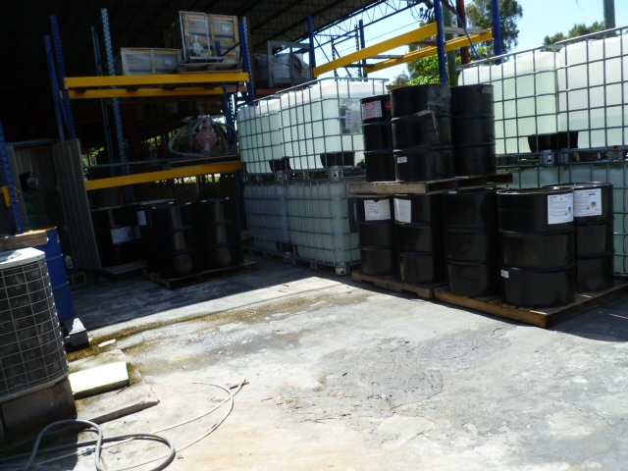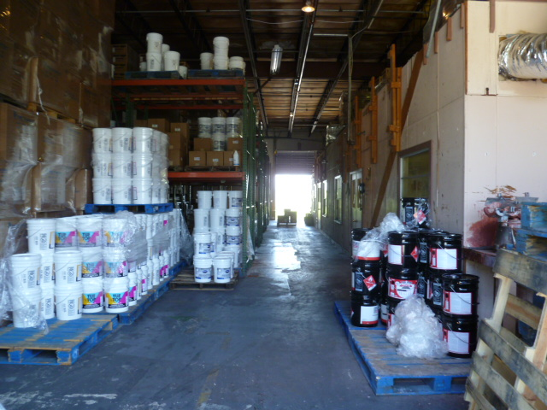

Project Id: 84792 Permit No: 1030502-003-AO Arms Number: 0502 001
Inspector: Shea Jackson Inspection Date / Time: 7/30/2013 / _______
Source (EU): Mixes and distributes paint used for specialty concrete coatings.

Description: [containers outside storage , and inside paint storage already batch]

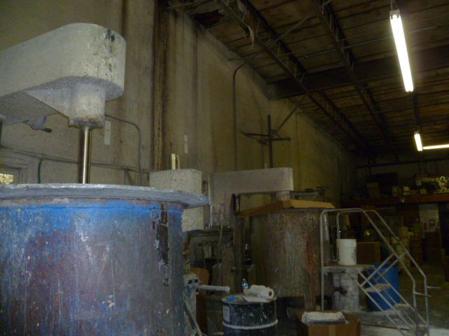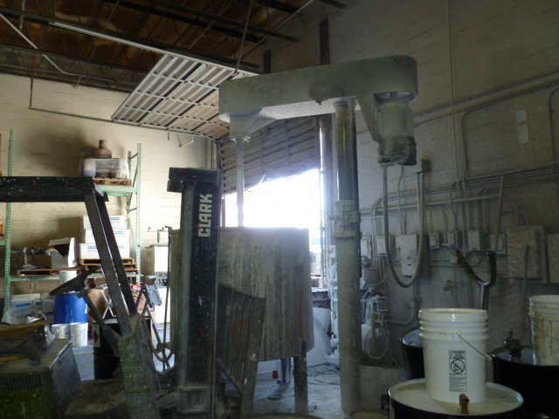
Project Id: 84792 Permit No: 1030502-003-AO Arms Number: 0502 001
Inspector: Shea Jackson Inspection Date / Time: 7/30/2013 / _______
Source (EU): Mixes and distributes paint used for specialty concrete coatings.

Description: [Mixers batching paint operation , covers in place, and repackaging into containers.]

Marine Industrial Paint Company, Inc.
4590 60th Avenue North, St. Petersburg

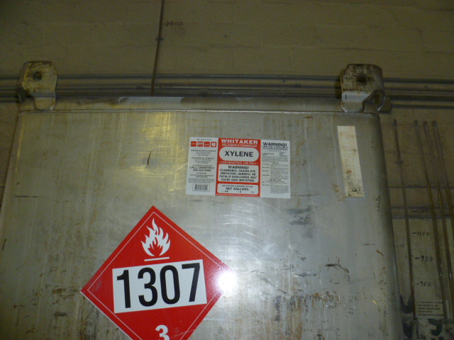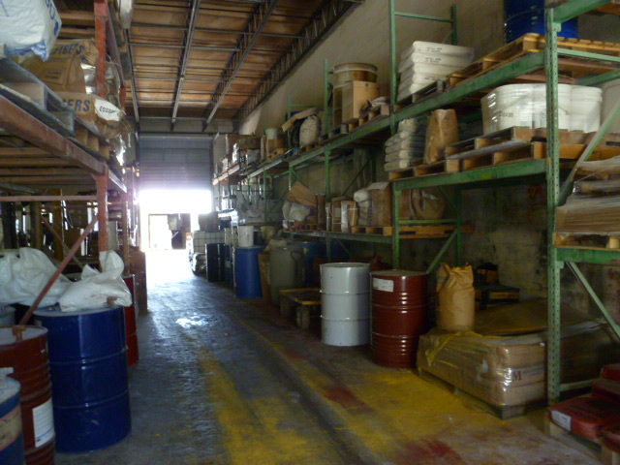
Project Id: 84792 Permit No: 1030502-003-AO Arms Number: 0502 001
Inspector: Shea Jackson Inspection Date / Time: 7/30/2013 / _______
Source (EU): Mixes and distributes paint used for specialty concrete coatings.

Description: [Xylene one of the HAPS used in manufacturing the paint coatings, and other solvents, and pigments in storage area used for paint mixtures.]

