1030500 84795
FACILITY: Precision Litho Service, Inc. |  |  |  |  |  |  |  |  |  |  |  |  |  |  |  |  |  |  |  | PERMIT ID: 2533
 |  |  |  |  |  |  |  |  |  |  |  |  |  |  |  |  |  |  |  | DISTRICT: Southwest
ADDRESS: 4250 118th Avenue North |  |  |  |  |  |  |  |  |  |  |  |  |  |  |  |  |  |  |  | CONTACT PHONE:
Clearwater, FL |  |  |  |  |  |  |  |  |  |  |  |  |  |  |  |  |  |  |  | 727-573-1763
ARMS NO:  1030500 001 |  |  |  |  |  |  |  | PERMIT NO: |  |  |  |  |  |  |  |  |  |  |  | Expiration Date: 1/7/2015  Renewal Date: 11/8/2014
 |  |  |  |  |  |  |  | 1030500-003-AO
 |  |  |  |  |  |  |  |  |  |  |  |  |  |  |  |  |  |  |  | Test Due Date: 9/3/2015
EMISSION UNIT DESCRIPTION : Lithographic Press Operation: 4 Komori and 1 Heidelberg sheet fed presses; 2 Didde MVP web presses; Harris M-110 heatset press, two drying ovens and a TEC Systems Diablo No. 1250 S Thermal Incinerator.

INSPECTION DATE: |  |  |  |  |  |  | ARMS INSPECTION TYPE: |  |  |  |  |  |  |  |  |  |  |  |  |  |  | COMPLIANCE STATUS:
 | July 23, 2013 |  |  |  |  |  |  |  |  | INS1 |  | ✓ | INS2 |  |  | INS3 |  |  | FUI |  |  |  | ✓ |  | IN |  |  | MNC |  |  |  |  |  | SNC
INSPECTION TYPE: |  |  |  | ✓ | Initial |  |  |  |  |  | Re-inspection |  |  |  |  |  | Complaint |  |  |  |  |  |  | Drive-by |  |  |  |  |  |  | Quarterly
✓ |  |  | A. General Review:
1. |  | Permit File Review |  |  |  |  |  |  |  |  |  |  |  |  |  |  |  |  |  |  |  |  |  |  |  |  |  |  |  | Yes |  |  |  |  | No
 |  | Comments: yes
2. |  | Introduction and Entry |  |  |  |  |  |  |  |  |  |  |  |  |  |  |  |  |  |  |  |  |  |  |  |  |  |  |  | Yes |  |  |  |  | No
 |  | Comments: yes, I met with Terry Olsen
3. |  | Is the Responsible Official/Authorized Representative still: John A. Blair? |  |  |  |  |  |  |  |  |  |  |  |  |  |  |  |  |  |  |  |  |  |  |  |  |  |  |  | Yes |  |  |  |  | No
Comments: yes, he continues to be the responsible
The Responsible Official/Authorized Representative’s e-mail is: John@plsprint.com
4. |  | Is the facility contact still: Terry Olsen? |  |  |  |  |  |  |  |  |  |  |  |  |  |  |  |  |  |  |  |  |  |  |  |  |  |  |  | Yes |  |  |  |  | No
Comments: yes,
The facility contact’s e-mail is: terry@plsprint.com

IN | MNC | SNC |  |  | B. Specific Conditions:
ü  ü  ü  ü  ü  ü  ü  ü  ü  ü  ü  ü  ü  ü  ü  ü |  |  |  |  | This permit or a copy thereof shall be kept at the work site of the permitted activity.  [62-4.160 F.A.C. - General Condition 12.]  Comments: The facility did did not have a copy of the permit on-site.  7. Annual Operating Report: On or before April 1 of each year, the permittee shall submit a completed DEP Form 62-210.900(5), "Annual Operating Report for Air Pollutant Emitting Facility" (AOR) for the preceding calendar year. The report may be submitted electronically in accordance with the instructions received with the AOR package sent by the Department, or a hardcopy may be sent to the Compliance Authority. [Rule 62-210.370(3), F.A.C.]  Comments: The AOR for calendar year _2012______ was submitted on __ 2/7/2013_______  8. Operation Permit Renewal Application: A completed application for renewal of the operation permit shall be submitted to the Permitting Authority with a copy to the Pinellas County Department of Environmental Management, Air Quality Division (Compliance Authority) no later than 60 days prior to the expiration date of the operation permit. [Rules 62-4.030, 62-4.050, 62-4.070(3), 62-4.090, 62-210.300(2), and 62-210.900, F.A.C.]  Comments: The permit expires on 1/7/15. An application is required to be submitted no later than 11/8/14.  A.2. VOC and HAP Emissions Limits: The following emission limits on volatile organic compounds (VOCs) and Hazardous Air pollutants (HAPs), as defined in Rule 62-210.200, F.A.C., shall apply:  [Rule 62-210.200(PTE), F.A.C. and Construction Permit 1030500-001-AC]  Comments: The record period reviewed was months. May 2012 through June 2013. The highest consecutive 12 month total was for January 2013 at 6.04 tons VOC and 1.342 tons HAP. This complies with the emissions limitations of the above table.  A.3. Visible Emissions (VE) from Heat Set Press Thermal Oxidizer: No visible emissions (5% opacity) are allowed from the heat set press thermal oxidizer except that visible emissions not exceeding 20% opacity are allowed for up to three minutes in any one-hour period.  [Construction Permit 1030500-001-AC]  Comments: There were no visible emissions observed from the stack for the Thermal oxidizer. It was in operation at the time observation off the property. There was visible heat wave coming from the stack vent, and during the inspection observed again. (See photo)  A.4. General Pollutant Emission Limiting Standards. Objectionable Odor Prohibited: No person shall cause, suffer, allow or permit the discharge of air pollutants which cause or contribute to an objectionable odor. An objectionable odor is any odor present in the outdoor atmosphere which by itself or in combination with other odors, is or may be harmful or injurious to human health or welfare, which unreasonably interferes with the comfortable use and enjoyment of life or property, or which creates a nuisance.  [Rules 62-296.320(2), and 62-296.401(1)(b), F.A.C. & Pinellas County Code, Section 58-178]  Comments: An upwind/downwind survey of the facility was conducted. The observed parameters were:  Downwind odor level detected- none 0 ; Wind direction – westerly Upwind odor level detected- none.  A.5. General Pollutant Emission Limiting Standards. Volatile Organic Compounds (VOC) Emissions or Organic Solvents (OS) Emissions: The permittee shall allow no person to store, pump, handle, process, load, unload or use in any process or installation, VOCs or organic solvents (OS) without applying known and existing vapor-emission control devices or systems deemed necessary and ordered by the Department.  A. All equipment, pipes, hoses, lids, fittings, etc., shall be operated/maintained in such a manner as to minimize leaks, fugitive emissions and spills of solvent materials.  B. All VOC/OS from washings (equipment clean up) shall be directed into containers that prevent evaporation into the atmosphere.  C. Tightly cover or close all VOC/OS containers when they are not in use.  D. Prevent excessive air turbulence across exposed VOC/OS.  E. Immediately confine and clean up VOC/OS spills and make sure wastes are placed in closed containers for reuse, recycling or proper disposal.  [Rule 62-296.320(1)(a), F.A.C.; Construction Permit 1030500-001-AC]  Comments: During the facility tour with Mr. Olsen I observed the conditions of VOC And OS solvent usage.  A. The printers, equipment and surrounding work areas were maintained, no leaks, spills or fugitive emissions were detected. B. The washings and ink mixers were in closed containers. C. The other products in use at printer work stations were capped or covered. D. There were no open solutions being exposed to air turbulence. The products not used were being recycled or properly disposed. The facility was in compliance with A – E  A.6. VE Compliance Tests: In order to demonstrate compliance with Specific Condition No. A.3., the heat set press thermal oxidizer exhaust stack shall be tested for visible emissions (VE) between 150 and 90 days prior to the expiration date of the operation permit. [Rule 62-297.310(7)(a)1 & 3, F.A.C.]  Comments: This is not applicable at this time the renewal date is 11/8/14, and more the 365 days prior to expiration date  A.7. Special Compliance Tests: When the Department or PCDEM, after investigation, has good reason (such as complaints, increased visible emissions, or questionable maintenance of control equipment) to believe that any applicable emission standard contained in a Department rule or in a permit issued pursuant to those rules is being violated, it may require the owner or operator of the emissions unit to conduct compliance tests which identify the nature and quantity of pollutant emissions from the emissions unit and to provide a report on the results of said tests to the Department and/or the PCDEM. [Rule 62-297.310(7)(b), F.A.C.]  Comments: There are no special tests required at this time. The A.Q Division has not received any citizen complaints, or observed increased emissions, which would indicate a need for additional testing.  A.8. Test Requirements: Tests shall be conducted in accordance with the applicable requirements specified in Appendix D (Common Testing Requirements) of this permit. [Rule 62-297.310, F.A.C.]  Comments: The facility’s last test was performed on 7/17/2009 for the permit renewal, resulted in 0% opacity operating at 615 sheet feed/minute with RTO temperature of 1079 F. The next visible emissions test is not due for performance until 11/8/2014.  A.9. Test Method: Required tests shall be performed in accordance with the following reference method.  The above method is described in Appendix A of 40 CFR 60 and is adopted by reference in Rule 62-204.800, F.A.C. No other method(s) may be used unless prior written approval is received from the Department. [Rules 62-204.800 and 62-297.100, F.A.C.; and Appendix A of 40 CFR 60]  Comments: The last 60 minute Method 9 Visible Emissions test the facility performed was on 7/17/2009 for the five year permit renewal. The RTO unit was operated at 1079⁰F and 615 sheet feed/ minute and oven temperatures were 290 and 270^{O} F. The opacity result at the time was 0% opacity.  A.10. Test Notification: The permittee shall notify the Compliance Authority in writing at least 15 days prior to any required tests. The notification must include the following information: the date, time, and location of each test; the name and telephone number of the facility’s contact person who will be responsible for coordinating the test; and the name, company, and the telephone number of the person conducting the test.  Comments: There is not a test or notification due for 2013. The notification would be submitted prior to permit renewal date 11/8/2014.  A.11. Test Reports: The permittee shall prepare and submit reports for all required tests in accordance with the requirements specified in Appendix D (Common Testing Requirements) of this permit. In addition to, the report shall provide the following information from the test period:  A. Thermal oxidizer temperature as required in Specific Condition No. A.13.  B. Utilization rates and VOC content of the inks and solvents used during the tests, in gallons per hour.  C. The calculated VOC loading rate to the thermal oxidizer, in pounds per hour.  Failure to submit this data or the actual operating conditions may invalidate the test.  [Rules 62-4.070(3) and 62-297.310(8), F.A.C.]  Comments: A. The thermal oxidizer temperature is recorded by the operator daily for date, time, temperature and operator initial as required by SPC # 13. (See Test Report 7/17/2010 record file)  B. When the test was performed showed the utilization rate for the inks and solvents in regard to the VOC content during the test as Ecotherm Black, cyan, magenta, and yellow ink 33 -37% VOC contents, 100 lbs of ink and 35.06 lbs of emissions for test with 3 gallons(25.47lbs) of solvents and 7.3 lbs VOC emissions .  C. The calculated VOC loading rate to the thermal oxidizer for the test result was 42.36 lbs/hour  A.12. VOC and HAP Records: The permittee shall maintain monthly records for the facility to document compliance with Specific Condition No. A.2. Records shall be completed by the 15th day of the next month. The records shall include, but are not limited to, the following:  A. Facility Name, Emission Unit ID No. (1030500; EU 001) and Description;  B. Month, Year of record;  C. List, by name or identification number, each ink, solvent, coating, thinner, or other VOC/HAP containing material used in association with the printing and manufacturing operations during the month and the usage (amount used minus amount collected for disposal or recycle) of each, in gallons.  D. List the VOC content and HAP content (lbs/gal) for each material listed in C.  E. Calculate the VOC and HAP emissions, using the following general equation:  F. Summarize the VOC, and total HAP emissions for the most recent month.  G. Summarize the VOC, and total HAP emissions for the most recent consecutive 12-month period.  Records of all calculations and supporting documentation ("As Supplied", "As Applied" sheets, MSDS Sheets, EPA data sheets, purchase orders, etc.) shall be kept for each ink, solvent, coating, thinner, or other VOC/HAP containing material used in association with the printing and manufacturing operations that includes sufficient information to determine VOC and HAP emissions.  At the permittee’s option, “purchases” may be used where “usage” is specified. If this option is utilized, no material may be used which is not purchased. The records shall be maintained at the facility for three (3) years and made available to the Department and the PCDEM upon request.  (Permitting Note: The heat set press thermal oxidizer’s destruction efficiency shall not be used in recordkeeping to reduce emissions from the heat set press to show compliance with the emission limits of this permit.) [Construction Permit 1030500-001-AC]  Comments: The record pages in the spreadsheet contain the information required for A and B at the top of the sheet. C., D. And E. is on spreadsheet as a list maintained as “ Hazardous Air Pollutant Summary” with each product named , product number and with lbs/gal HAP/VOC ad HAP/VOC % listed and amount of material used with emissions lbs per month . F. Total of VOC/HAP emission monthly. G. The month total is on Hazardous Air Pollutant Materials Usage. Mr. Olsen maintains his records from the purchases orders, as all products coming into the facility are assumed to be used. Mr. Olsen maintains the MSD sheets in environmental binders in his office, and in the employee work areas. (See photo) The products the facility uses are not altered without prior approval due to the specific requirements for the quality of their printed products as specified by their customers. The clients for their products have remained the same consistent purchases on annual bases. The daily work is based mainly regular clients. The records are maintained in Mr. Olsen’s personal computer in his office. (See Record copies).  A.13. Thermal Oxidizer Operation Records: In order to document periods of use of the heat set press thermal oxidizer for information purposes, the permittee shall operate and maintain a device that displays the temperature of the heat set press thermal oxidizer. At least once per day of operation of the heat set web press, the permittee shall record these temperatures. The records shall include the date and time of the measurements and the person responsible for performing the measurements. The records shall also indicate any replacements/additions that occur.  [Rule 62-4.070(3), F.A.C.]  Comments: I observed the temperature monitoring panel and digital display, was functioning. The operators record each day, time, temperatures for the 1st, and 2nd ovens and the Thermal oxidizer temperature with the operators initial and employee number, which is maintained at the Harris Printer work station. The weekly maintenance record for repairs and corrections are maintained at this station. The record is filled out once during the day by the operators, when the unit is operated. I obtained a copy of the daily temperature for the Drying Ovens and Thermal Oxidizer, (See copies)  A.14. Operation and Maintenance (O & M) Plan for VE and Odor Control: For air pollution control devices and collection systems, the permittee shall maintain and implement an O & M Plan to include a schedule for the maintenance and inspection of each control device, collection systems, and auxiliary equipment. Records of inspections, maintenance, and performance data of control devices and auxiliary equipment shall be retained by the emissions unit for a minimum of two (2) years and shall be made available to the Compliance Authority upon request. The performance parameters shall include operating rates and efficiencies. Such parameters and records shall include, at a minimum, that shown below.  a. Performance Parameters:  - The operating parameters of the pollution control device.  - Time table for the routine maintenance of the pollution control device as specified by the manufacturer.  - Time table of routine periodic observations of the pollution control device sufficient to ensure proper operation.  - A list of the type and quantity of the required spare parts for the pollution control device which are stored on the premises.  b. Operation and Maintenance Log: A record log which will indicate, at a minimum:  - When maintenance and observations were performed;  - What maintenance and observations were performed;  - Who performed said maintenance and observations; and  - Acceptable parameter ranges for each operational check.  [Pinellas County Code, Section 58-128; Rule 62-210.650, F.A.C.; Construction Permit 1030500- 001-AC]  Comments: The daily maintenance record is maintained by printer operator Mr. Brian Trane. He performs the checks and the maintains records according to the for the O & M maintenance plan. The record logs were reviewed for May 2012 through June 2013. The record binder is located adjacent to the presses. The records are available back to 2007. The O & M notes a minimum temperature of 700⁰F as a requirement in recordkeeping for odor control. The records showed temperature had been maintained in range of 945 -1009. for the O & M maintenance. (See copies)
  Pollutant | Emission Limits  (tons/any consecutive 12 month period)
  Total Volatile Organic Compounds (VOC) | 38.0
  Total Hazardous Air Pollutants (HAP) | 8.0
  DEP Method | Description of Method and Comments
  9 | Visual Determination of the Opacity of Emissions from Stationary Sources  - Shall be a minimum of 60 minutes in duration
  Emissions = Usage (gal) x VOC or HAP Content (lbs/gal)
✓ |  |  |  |  | Valid Permit [Rule 62-210.300]
✓ |  |  |  |  | Changes to Facility/emission unit [Rule 62-210.300]  Does the emission unit description above match what the facility is operating (Number of emission units or points, model number and serial number, etc.) Yes No  Comments: There have been no changes to printers operations at the facility. The facility has new plate burners, are exempt units.
✓ |  |  | C. Other:
Pollution Prevention Activities
- P2 Handouts Provided: P2 Brochure; P2 Manual; P2 Checklist
- Have any emissions reductions occurred Yes / No
Chemical Substitution; Equipment Changes; Process Changes
Chemical/Material Reuse; On-site Recycling; Other:
Comments: The facility continues to use vegetable inks, reduction of HAPS, use of recycled paper from American companies, reduction of energy use by obtaining a plate making machine. They recycle waste paper.

Closing Conference: I informed Mr. Olsen , the facility appeared to be in compliance at this time.

Inspector(s): Shea Jackson, Pinellas County, Air Quality Division
Signature(s): Date: |  |  |  |  |  |  |  |  | Date: July 29, 2013
ACCESS? |  |  |  | ü |  | ARMS? | ü

Precision Litho Service, Inc.
4250 118th Avenue North, Clearwater

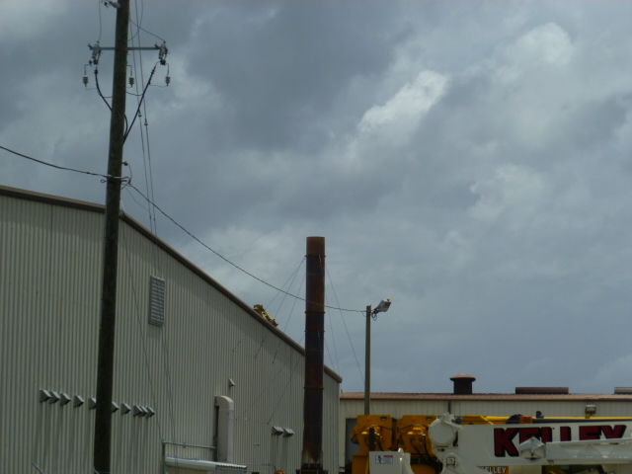

Project Id: 84795 Permit No: 1030500-003-AO Arms Number: 0500 001
Inspector: Shea Jackson Inspection Date / Time: 7/3/13 / _______
Source (EU): Lithographic Press Operation: 4 Komori and 1 Heidelberg sheet fed presses; 2 Didde MVP web presses; Harris M-110 heatset press, two drying ovens and a TEC Systems Diablo No. 1250 S Thermal Incinerator.

Description: [This is looking at the RTO stack from the southwest side of property. There were no visible emissions, observed prior to entering the facility.

Precision Litho Service, Inc.
4250 118th Avenue North, Clearwater
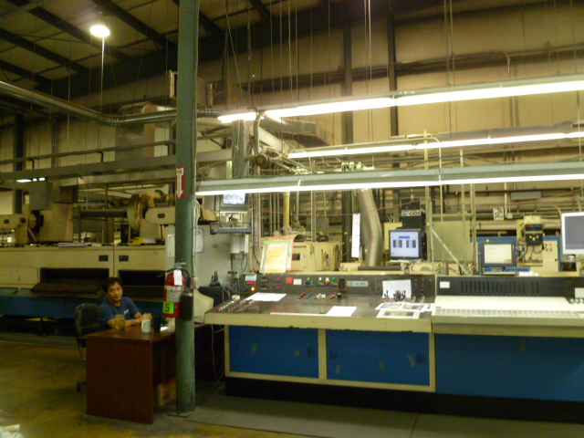

Project Id: 84795 Permit No: 1030500-003-AO Arms Number: 0500 001
Inspector: Shea Jackson Inspection Date / Time: 7/3/13 / _______
Source (EU): Lithographic Press Operation: 4 Komori and 1 Heidelberg sheet fed presses; 2 Didde MVP web presses; Harris M-110 heatset press, two drying ovens and a TEC Systems Diablo No. 1250 S Thermal Incinerator.

Description: [The drying ovens Harris printer and the operators station and control panel for RTO outside this area. ]

Precision Litho Service, Inc.
4250 118th Avenue North, Clearwater

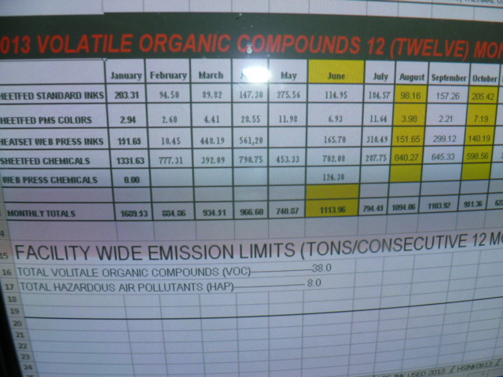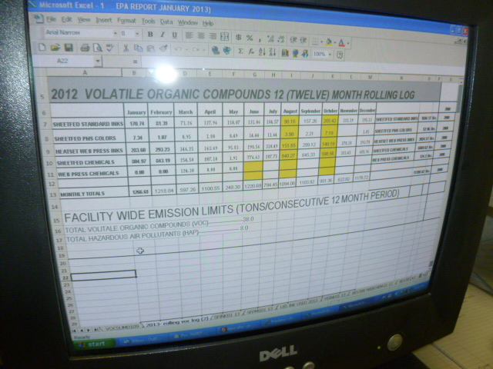

Project Id: 84795 Permit No: 1030500-003-AO Arms Number: 0500 001
Inspector: Shea Jackson Inspection Date / Time: 7/3/13 / _______
Source (EU): Lithographic Press Operation: 4 Komori and 1 Heidelberg sheet fed presses; 2 Didde MVP web presses; Harris M-110 heatset press, two drying ovens and a TEC Systems Diablo No. 1250 S Thermal Incinerator.

Description: [The daily record logs maintained by Mr. Olsen in his personal computer.]

Precision Litho Service, Inc.
4250 118th Avenue North, Clearwater

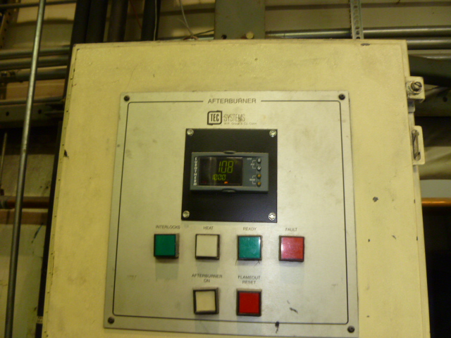

Project Id: 84795 Permit No: 1030500-003-AO 7/3/13 / _______
Source (EU): Lithographic Press Operation: 4 Komori and 1 Heidelberg sheet fed presses; 2 Didde MVP web presses; Harris M-110 heatset press, two drying ovens and a TEC Systems Diablo No. 1250 S Thermal Incinerator.

Description: [The continuous temperature monitoring panel for observations taken for the RTO and recorded]

