1030430 88672
FACILITY: Spa Manufacture, Inc. |  |  |  |  |  |  |  |  |  |  |  |  |  |  |  |  |  |  |  | PERMIT ID: 981
 |  |  |  |  |  |  |  |  |  |  |  |  |  |  |  |  |  |  |  | DISTRICT: Southwest
ADDRESS: 6060 Ulmerton Road |  |  |  |  |  |  |  |  |  |  |  |  |  |  |  |  |  |  |  | CONTACT PHONE:
Clearwater, FL |  |  |  |  |  |  |  |  |  |  |  |  |  |  |  |  |  |  |  | 727-530-9493
ARMS NO:  1030430 001 |  |  |  |  |  |  |  | PERMIT NO: |  |  |  |  |  |  |  |  |  |  |  | Expiration Date: 6/28/15  Renewal Date: 4/29/15
 |  |  |  |  |  |  |  | 1030430-004-AF
 |  |  |  |  |  |  |  |  |  |  |  |  |  |  |  |  |  |  |  | Test Due Date:
EMISSION UNIT DESCRIPTION : Fiberglass reinforced acrylic spa manufacturing facility. The manufacturing process includes vacuum molding of acrylic sheets, lamination, trimming, component assembly, and product storage

INSPECTION DATE: |  |  |  |  |  |  | ARMS INSPECTION TYPE: |  |  |  |  |  |  |  |  |  |  |  |  |  |  | COMPLIANCE STATUS:
 | June 10, 2014 |  |  |  |  |  |  |  |  | INS1 |  | ✓ | INS2 |  |  | INS3 |  |  | FUI |  |  |  | ✓ |  | IN |  |  | MNC |  |  |  |  |  | SNC
INSPECTION TYPE: |  |  |  | ✓ | Initial |  |  |  |  |  | Re-inspection |  |  |  |  |  | Complaint |  |  |  |  |  |  | Drive-by |  |  |  |  |  |  | Quarterly
✓ |  |  | A. General Review:
1. |  | Permit File Review |  |  |  |  |  |  |  |  |  |  |  |  |  |  |  |  |  |  |  |  |  |  |  |  |  |  |  | Yes |  |  |  |  | No
 |  | Comments: yes
2. |  | Introduction and Entry |  |  |  |  |  |  |  |  |  |  |  |  |  |  |  |  |  |  |  |  |  |  |  |  |  |  |  | Yes |  |  |  |  | No
 |  | Comments: yes, I met site with Mr. John Stevenson and Mrs. Cindi Magray
3. |  | Is the Responsible Official/Authorized Representative still: Cindi Magray? |  |  |  |  |  |  |  |  |  |  |  |  |  |  |  |  |  |  |  |  |  |  |  |  |  |  |  | Yes |  |  |  |  | No
Comments: no change
The Responsible Official/Authorized Representative’s e-mail is: info@spamanufacturers.com
4. |  | Is the facility contact still: Cindi Magray? |  |  |  |  |  |  |  |  |  |  |  |  |  |  |  |  |  |  |  |  |  |  |  |  |  |  |  | Yes |  |  |  |  | No
Comments: no change
The facility contact’s e-mail is: info@spamanufacturers.com

IN | MNC | SNC |  |  | B. Specific Conditions:
✓  ✓  ✓  ✓  ✓  ✓  ✓  ✓  ✓  ✓  ✓  ✓  ✓  ✓  ✓ |  |  |  |  | General Conditions [62-4.160, F.A.C.]  12. This permit or a copy thereof shall be kept at the work site of the permitted activity.  Comments: A copy of the permit was was not kept at the worksite.  8. If, for any reason, the permittee does not comply with or will be unable to comply with any condition or limitation specified in this permit, the permittee shall immediately provide the Department with the following information:  a. A description of and cause of noncompliance; and  b. The period of noncompliance, including dates and times; or, if not corrected, the anticipated time the noncompliance is expected to continue, and steps being taken to reduce, eliminate, and prevent recurrence of the noncompliance. The permittee shall be responsible for any and all damages which may result and may be subject to enforcement action by the Department for penalties or for revocation of this permit.  Comments: The facility has not reported any violations or non compliance issues and none were observed during the review of records and tour of facility.  Common Conditions [Rule 62-296.320(4)(c), F.A.C.]  Unless otherwise specified in the permit, the following conditions apply to all emissions units and activities at the facility.  Emissions and Controls  2. Circumvention: The permittee shall not circumvent the air pollution control equipment or allow the emission of air pollutants without this equipment operating properly. [Rule 62-210.650, F.A.C.]  Comments: This facility is polyester lamination process; there is not a specified control device to circumvent. The facility does have exhaust system with stack, which was in operation and filter in place.  6. VOC or OS Emissions: No person shall store, pump, handle, process, load, unload or use in any process or installation, volatile organic compounds (VOC) or organic solvents (OS) without applying known and existing vapor emission control devices or systems deemed necessary and ordered by the Department. [Rule 62-296.320(1), F.A.C.]  Comments: The facility did not have any open containers at this time. The employees were in process of lamination with magnum chopper guns. (See photo)  7. Objectionable Odor Prohibited: No person shall cause, suffer, allow or permit the discharge of air pollutants, which cause or contribute to an objectionable odor. An “objectionable odor” means any odor present in the outdoor atmosphere which by itself or in combination with other odors, is or may be harmful or injurious to human health or welfare, which unreasonably interferes with the comfortable use and enjoyment of life or property, or which creates a nuisance. [Rules 62-296.320(2) and 62-210.200(Definitions), F.A.C.]  Comments: An upwind/downwind survey of the facility was conducted. The observed parameters were:  Downwind odor level detected- 0 ; Wind direction – southwesterly Upwind odor level detected- No odors were detected off the property. There was moderate level of styrene odor in the lamination building area.  9. Unconfined Particulate Emissions:  a. No person shall cause, let, permit, suffer or allow the emissions of unconfined particulate matter from any activity, including vehicular movement; transportation of materials; construction, alteration, demolition or wrecking; or industrially related activities such as loading, unloading, storing or handling; without taking reasonable precautions to prevent such emissions.  b. Any permit issued to a facility with emissions of unconfined particulate matter shall specify the reasonable precautions to be taken by that facility to control the emissions of unconfined particulate matter.  c. Reasonable precautions include the following:  (1) Paving and maintenance of roads, parking areas and yards.  (2) Application of water or chemicals to control emissions from such activities as demolition of buildings, grading roads, construction, and land clearing.  (3) Application of asphalt, water, oil, chemicals or other dust suppressants to unpaved roads, yards, open stock piles and similar activities.  (4) Removal of particulate matter from roads and other paved areas under the control of the owner or operator of the facility to prevent reentrainment, and from buildings or work areas to prevent particulate from becoming airborne.  (5) Landscaping or planting of vegetation.  (6) Use of hoods, fans, filters, and similar equipment to contain, capture and/or vent particulate matter.  (7) Confining abrasive blasting where possible.  (8) Enclosure or covering of conveyor systems.  Comments: There was no activities, processes on spa tubs I.E. trimming or grinding work. There were no unconfined emissions at the time of inspection.  Administrative Requirements  7 Annual Operating Report: On or before April 1 of each year, the permittee shall submit a completed DEP Form 62-210.900(5), "Annual Operating Report for Air Pollutant Emitting Facility" (AOR) for the preceding calendar year. The report may be submitted electronically in accordance with the instructions received with the AOR package sent by the Department, or a hardcopy may be sent to the Compliance Authority. [Rule 62-210.370(3), F.A.C.]  Comments: The annual operating report for calendar year _2013__ was submitted on ___1/9/2014__.  8 Operation Permit Renewal Application: A completed application for renewal of the operation permit shall be submitted to the Permitting Authority with a copy to PCDEM (Compliance Authority) no later than 60 days prior to the expiration date of the operation permit.  [Rules 62-4.030, 62-4.050, 62-4.070(3), 62-4.090, 62-210.300(2), and 62-210.900, F.A.C.]  Comments: The permit expires on 6/28/15. An application is required to be submitted no later than 4/29/15. I informed Mrs. MaGray that the renewal date will be coming up next year for the permit. She made note of it to get in touch with Tom John her consultant.  A.2. Emission Limitations: Emissions from the facility shall comply with the following:  - Styrene* - Styrene emissions shall not exceed 9.4 tons in any 12 consecutive-month period.  - Hazardous Air Pollutants (HAP) - The total combined emissions of all HAPs, as defined in Rule 62-210.200, F.A.C. and including styrene, shall not exceed 24.0 tons in any 12 consecutive-month period.  - Volatile Organic Compound (VOC) – The total combined emissions of all VOCs shall not exceed 24.0 tons in any 12 consecutive-month period.  *Permitting/Title V Applicability Note: The limitations on styrene, total HAPs, and VOC will ensure that emissions from this facility will not exceed the Title V permitting thresholds (e.g. synthetic non-Title V minor).  [Rules 62-4.070(3) and 62-210.200 (PTE), F.A.C.; FESOP 1030430-002-AF]  Comments: The highest emission rate reviewed over the previous 12 month period was in May 2014 the 12 consecutive month total tons 5.22 styrene, 5.42 HAP and 6.39 VOC. These amounts do not exceed the emission limitations of this permit. ( See record copies)  A.3. VOC/Organic Solvents (OS) Emissions: The permittee shall allow no person to store, pump, handle, process, load, unload or use in any process or installation, volatile organic compounds (VOC) or organic solvents (OS) without applying known and existing vapor emission control devices or systems deemed necessary and ordered by the Department. The facility shall comply with the following:  - All equipment, pipes, hoses, lids, fittings, etc., shall be operated and maintained in such a manner as to minimize leaks, fugitive emissions and spills of VOC/OS materials.  - All VOC/OS washings (equipment clean-up) shall be directed into containers that prevent evaporation into the atmosphere.  - Tightly cover or close all VOC/OS containers when they are not in use.  - Prevent excessive air turbulence across exposed VOC/OS.  - Immediately confine and clean up VOC/OS spills and make sure wastes are placed in closed containers for reuse, recycling or proper disposal.  [Rules 62-4.070(3) and 62-296.320(1), F.A.C.; FESOP 1030430-002-AF]  Comments: The facility moved the solvents and flammable proof lockers to the inside because the locker had rusted out from being stored outside the building. The containers were covered containers. The solvent is recycled. The facility typically uses only acetone for their processes, usage for 714 lbs for May 2014. 12 month consecutive total was 6783 lbs.  A.4. Objectionable Odor: The permittee shall not cause, suffer, allow or permit the discharge of air pollutants which cause or contribute to an objectionable odor. An objectionable odor is any odor present in the outdoor atmosphere which by itself or in combination with other odors, is or may be harmful or injurious to human health or welfare, which unreasonably interferes with the comfortable use and enjoyment of life or property, or which creates a nuisance. If the Department or the Pinellas County Department of Environmental Management (PCDEM) receives a valid odor complaint, the Department reserves the right to require that odor control measures/work practices be implemented. These measures or practices may, for example, be requiring that building doors and windows will be closed when conducting any hand or spray lay-up application in order to ensure the emissions are captured and discharged with adequate dispersion. [Rules 62-296.320(2), and 62-210.200 (Objectionable Odors), F.A.C.; Pinellas County Code, Sec. 58-178]  Comments: There was styrene odor present in the laminations area during the spray layup with the resin Magnum chopper gun. This odor was detectable inside the building in close proximity to the spa tubs. The odors were no detected outside of the buildings.  A.5. Reasonable Precautions: All reasonable precautions shall be taken to prevent and control generation of unconfined emissions of particulate matter in accordance with the provisions in Rule 62-296.320(4)(c), F.A.C. These provisions are applicable to any source, including but not limited to industrial related activities such as loading, unloading, storing and handling of materials. Unconfined particulate emissions generated from activities such as cutting, sanding, trimming, shaping, and grinding shall be controlled by using good housekeeping and work practices which may include but not be limited to use of tarps, continued use of filters on exhaust fans, regular sweeping, and/or the use of “shop-vac” type vacuum collectors or a central vacuum dust collection system.  [Rule 62-296.320(4)(c)1, F.A.C.; FESOP 1030430-002-AF]  Comments: The facility uses reasonable precautions for particulate emissions during the trimming, grinding process of spas tubs , they perform in an area center of facility that is shielded by shed. The perform sweeping of facility daily to reduce dust debris collection on floors. (See photo)  A.6. Fugitive Emissions Opacity Standards: In order to provide reasonable assurance that adequate measures are being taken to control fugitive emissions, visible emissions from this facility should not exceed 5% opacity. Visible emissions in excess of this level will not be considered as a violation in and of itself, but shall be an indication that additional control measures beyond those in place may be necessary and serve as justification to the Department to require additional controls or work practices.  [Rule 62-4.070(3), F.A.C.; FESOP 1030430-002-AF]  Comments: There were no visible emissions from lamination exhaust stack, its operation for ventilation and reduction of odors at ground level. There was no overspray noted at vent exit. No visible emissions were observe at the stack vent. The fan intake side has a filter cloth cover to that was collecting the chopped fiber cloth debris that becomes airborne during the lamination process. The fan was on and filter appeared to have Moderate accumulation.  A.7. Emission Calculations: In order to document compliance with Specific Condition No. A.2., the permittee shall calculate emissions based on the following methodology:  Species Emission = Material Usage x Species Concentration* x Emission Factor*  * Styrene and Methyl Methacrylate (MMA) emission factors shall be determined in accordance with Appendix E. Attachment No. 1-Unified Emission Factors (UEF) for Open Molding of Composites table dated July 23, 2001.  Styrene and MMA emissions shall each be determined using the following equation:  lb/ton  2000  EF  Ms  (tons)  Emissions  ×  =  where:  Ms = amount of styrene or MMA containing material used (in tons)  EF = emission factor (lb/ton) for styrene monomer content or MMA content  [Rules 62-4.070(3) and 62-210.200(PTE), F.A.C.]  Comments: I reviewed the records from June 2013 through May 2014. The Tom John environmental consultant maintains the facility records. The records meet the above specific condition requirements. The records showed the resin Aropol 65305 t25, styrene content is 40%, and the resin is more economical to use, but the facility has to use the also use resin Aropol 50448 for the first skin coat to produce quality spa tub styrene content is 36.14%,. The facility ceased using the foam insulation for the spa tubs 4 years ago, I observed the area to be clean and not be in use. (See records and MSD sheet copies placed in file)  A.8. Monthly Records: A monthly Styrene/VOC/HAP recordkeeping log shall be established and maintained to document compliance with Specific Condition No. A.2. At a minimum, the log shall identify and quantify each material used in the operations at this facility that contains Styrene, VOCs and/or HAPs. The permittee shall record and calculate, at a minimum, the following:  - Facility Name, Emission Unit ID No. (1030430; EU 001) and Description.  - Month, Year of record.  - Material Usage – Record the quantity of each material (resin, coating, solvent, chemical, etc.) used at the facility that contains Styrene, HAPs, and/or VOCs.  - Concentrations – Record for each material used at the facility (identified in item C):  - Record the wt% of each Individual HAP in the material (including Styrene).  - Record the wt% of VOC in the material.  - Emission Factors – Record the appropriate emission factor(s), and method(s) of application (i.e., Mechanical Atomized, Mechanical Non-Atomized) used to determine Styrene, HAP and/or VOC emissions.  Monthly Emissions:  Individual HAPs – Calculate and record each Individual HAP emission (including Styrene) for the month in either lbs or tons.  HAPs - Calculate and record the total HAP emissions (including Styrene) for the month in either lbs or tons.  VOCs - Calculate and record the total VOC emissions (including Styrene) for the month in either lbs or tons.  - Rolling 12-Month Emissions:  - Individual HAPs - Calculate and record each Individual HAP emission (including Styrene) for the most recent consecutive 12-month period in either lbs or tons.  - HAPs - Calculate and record the total HAP emissions (including Styrene) for the most recent consecutive 12-month period in either lbs or tons.  - VOCs - Calculate and record the total VOC emissions (including Styrene) for the most recent consecutive 12-month period in either lbs or tons.  Supporting documentation (example calculations, MSD sheets, purchase orders, U. S. EPA "VOC DATA SHEETS”, etc.) shall be kept for each material used which includes sufficient information to determine Styrene, VOC, and HAP emissions. The monthly logs shall be completed by the fifth operating day of the next month. These records shall be retained on file at the facility for at least three years and shall be made available to the Department upon request.  Daily logs shall be kept for VOC and Styrene emissions if any of the emissions are equal to or exceed 90% of their associated allowable emission limit. Daily logs shall be kept for individual and total HAP emissions, if the total HAP emissions exceed 10 TPY for any consecutive 12-month period. [Rule 62-4.070(3), F.A.C.]  Comments: The facility resins, and their Styrene content had increased from the previous product used according to the material safety data sheets.
✓ |  |  |  |  | Valid Permit [Rule 62-210.300]
✓ |  |  |  |  | Changes to Facility/emission unit [Rule 62-210.300]  Does the emission unit description above match what the facility is operating (Number of emission units or points, model number and serial number, etc.) Yes No  Comments: There have been no changes at this facility. No specific emission unit.
✓ |  |  | C. Other:
Pollution Prevention Activities
- P2 Handouts Provided: P2 Brochure; P2 Manual; P2 Checklist
- Have any emissions reductions occurred Yes / No
Chemical Substitution; Equipment Changes; Process Changes
Chemical/Material Reuse; On-site Recycling; Other:
Comments: The facility resins, and their Styrene content for one product had increased to the material safety data sheets.

Closing Conference:
I informed facility responsible official Ms. McGray that I had not found any non compliance issues at the time of inspection.

Inspector(s): Shea Jackson, Pinellas County, Air Quality Division
Signature(s): Date: |  |  |  |  |  |  |  |  | Date: June 16, 2014
ACCESS? |  |  |  | ✓ |  | ARMS? | ✓

Spa Manufacture, Inc.
6060 Ulmerton Road, Clearwater

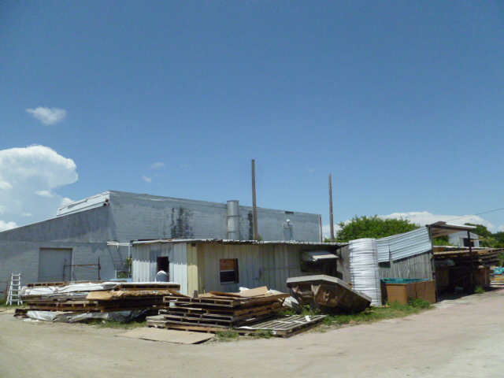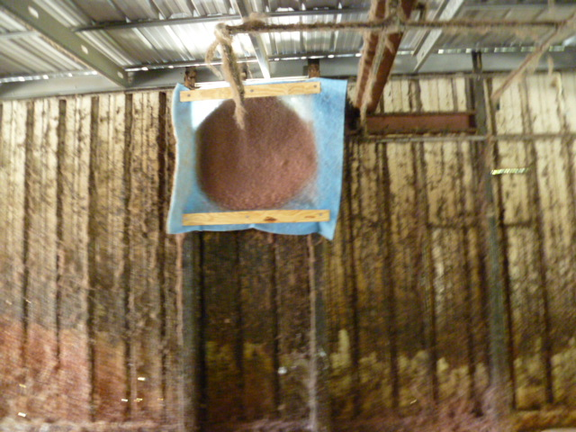

Project Id: 88672 Permit No: 1030430-004-AF Arms Number: 0430 001
Inspector: Shea Jackson Inspection Date / Time: 6/10/14 / _______
Source (EU): Fiberglass reinforced acrylic spa manufacturing facility. The manufacturing process includes vacuum molding of acrylic sheets, lamination, trimming, component assembly, and product storage

Description: [The lamination building and stack no visible emissions, the filter is in place to prevent clogging of fan and prevent emissions]

Spa Manufacture, Inc.
6060 Ulmerton Road, Clearwater

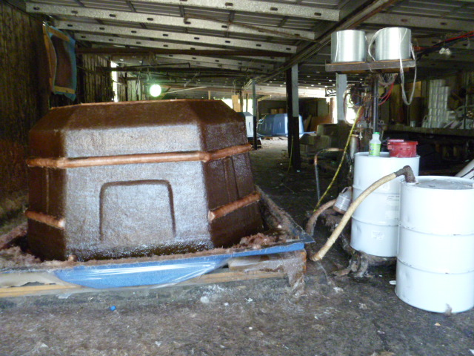

Project Id: 88672 Permit No: 1030430-004-AF Arms Number: 0430 001
Inspector: Shea Jackson Inspection Date / Time: 6/10/14 / _______
Source (EU): Fiberglass reinforced acrylic spa manufacturing facility. The manufacturing process includes vacuum molding of acrylic sheets, lamination, trimming, component assembly, and product storage

Description: [The lamination area with large swim spa in process, Magnum Chopper gun and resin in use]

Spa Manufacture, Inc.
6060 Ulmerton Road, Clearwater

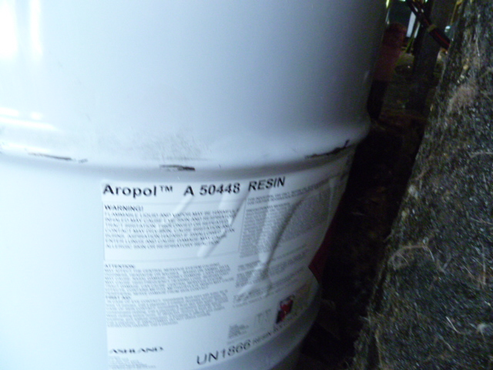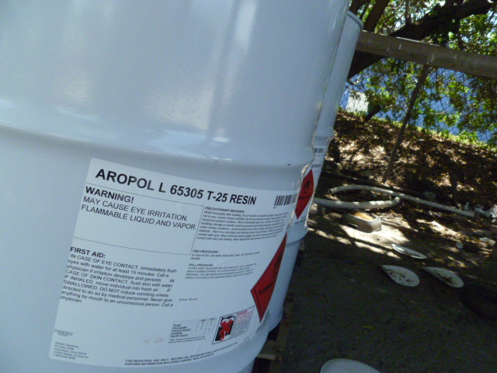

Project Id: 88672 Permit No: 1030430-004-AF Arms Number: 0430 001
Inspector: Shea Jackson Inspection Date / Time: 6/11/14 / _______
Source (EU): Fiberglass reinforced acrylic spa manufacturing facility. The manufacturing process includes vacuum molding of acrylic sheets, lamination, trimming, component assembly, and product storage

Description: [The two main resins in use Aropol 65305 and 50448 and also recorded in record keeping information]

