1030264 88748
FACILITY: Better Business Forms, Inc. |  |  |  |  |  |  |  |  |  |  |  |  |  |  |  |  |  |  |  | PERMIT ID: 393
Clondalkin Group |  |  |  |  |  |  |  |  |  |  |  |  |  |  |  |  |  |  |  | DISTRICT: Southwest
ADDRESS: 10950 Belcher Road |  |  |  |  |  |  |  |  |  |  |  |  |  |  |  |  |  |  |  | CONTACT PHONE:
Largo, FL |  |  |  |  |  |  |  |  |  |  |  |  |  |  |  |  |  |  |  | 727-545-8703
ARMS NO:  1030264 001 |  |  |  |  |  |  |  | PERMIT NO: |  |  |  |  |  |  |  |  |  |  |  | Expiration Date: 3/11/14  Renewal Date: 1/10/14
 |  |  |  |  |  |  |  | 1030264-006-AO & 1030264-007-AC
 |  |  |  |  |  |  |  |  |  |  |  |  |  |  |  |  |  |  |  | Test Due Date:
EMISSION UNIT DESCRIPTION : 24 Printing Presses (12 flexographic presses, 11 lithographic presses, and one (1) silk screening press)
CMS INSPECTION DATE: |  |  |  |  |  |  | ARMS INSPECTION TYPE: |  |  |  |  |  |  |  |  |  |  |  |  |  |  | COMPLIANCE STATUS:
 | January 23, 2014 |  |  |  |  |  |  |  |  | INS1 |  | ✓ | INS2 |  |  | INS3 |  |  | FUI |  |  |  | ✓ |  | IN |  |  | MNC |  |  |  |  | SNC
INSPECTION TYPE: |  |  |  | ✓ | Initial |  |  |  |  |  | Re-inspection |  |  |  |  |  | Complaint |  |  |  |  |  |  | Drive-by |  |  |  |  |  | Quarterly
✓ |  |  | A. General Review:
1. |  | Permit File Review |  |  |  |  |  |  |  |  |  |  |  |  |  |  |  |  |  |  |  |  |  |  |  |  |  |  | Yes |  |  |  |  | No
 |  | Comments: Yes
2. |  | Introduction and Entry |  |  |  |  |  |  |  |  |  |  |  |  |  |  |  |  |  |  |  |  |  |  |  |  |  |  | Yes |  |  |  |  | No
 |  | Comments: I met with Tony Dilly for facility tour and review of records
3. |  | Is the Responsible Official/Authorized Representative still: Michael Barrett? |  |  |  |  |  |  |  |  |  |  |  |  |  |  |  |  |  |  |  |  |  |  |  |  |  |  | Yes |  |  |  |  | No
Comments: Yes, he was not in at this time
The Responsible Official/Authorized Representative’s e-mail is: mbarrett@clondalkingroup.com
4. |  | Is the facility contact still: Tony Dilley? |  |  |  |  |  |  |  |  |  |  |  |  |  |  |  |  |  |  |  |  |  |  |  |  |  |  | Yes |  |  |  |  | No
Comments: Yes
The facility contact’s e-mail is: tdilley@clondalkingroup.com?
IN | MNC | SNC | B. Specific Conditions:
✓  ✓  ✓  ✓  ✓  ✓  ✓  ✓  ✓  ✓  ✓  ✓  ✓  ✓  ü  ü  ü  ü  ü  ü |  |  | Inspection Note: There are two current permits (1030264-006-AO and 1030264-007-AC) for this facility. 130264-007-AC is to add a KBA Karat74 four-color offset lithographic printing press that uses soy-based, air cured inks and to remove four of the six flexographic presses that use water based inks  SECTION 4. APPENDIX B - General Conditions [62-4.160, F.A.C.]  8. If, for any reason, the permittee does not comply with or will be unable to comply with any condition or limitation specified in this permit, the permittee shall immediately provide the Department with the following information:  a. A description of and cause of noncompliance; and  b. The period of noncompliance, including dates and times; or, if not corrected, the anticipated time the noncompliance is expected to continue, and steps being taken to reduce, eliminate, and prevent recurrence of the noncompliance. The permittee shall be responsible for any and all damages which may result and may be subject to enforcement action by the Department for penalties or for revocation of this permit.  Comments: The facility appears to be complying with the permit and in process of permit modification for the installation of new printers. #1 is a Flexographic printer which is being rented until the facility determines if operation is what they will be purchasing permanently, #2 is a Lithographic printer Karat Carton. The facility removed printers 17, 19 and 23. The new operation permit issued 2/6/14 states facility authorized to operate 21 printers1030264-008-AO, Nine Lithographic web press UV-cured; Two Flexographic press water-based; Four Flexographic press UV-cured; Two Flexographic press w/ one UV station water based; One Lithographic sheet fed press UV-cured; One Lithographic web press; One Silkscreen press.  12. This permit or a copy thereof shall be kept at the work site of the permitted activity.  Comments: A copy of the permit was was not kept at the worksite. Copy observed with the records binders, reviewed with Mr. Dilley.  SECTION 4. APPENDIX C - Common Conditions [Rule 62-296.320(4)(c), F.A.C.]  Unless otherwise specified in the permit, the following conditions apply to all emissions units and activities at the facility.  Emissions and Controls  2. Circumvention: The permittee shall not circumvent the air pollution control equipment or allow the emission of air pollutants without this equipment operating properly. [Rule 62-210.650, F.A.C.]  Comments: There was no evidence of circumvention this facility does not have a control device. All printers are contained inside building and do not vent to the outside roof.  6. VOC or OS Emissions: No person shall store, pump, handle, process, load, unload or use in any process or installation, volatile organic compounds (VOC) or organic solvents (OS) without applying known and existing vapor emission control devices or systems deemed necessary and ordered by the Department. [Rule 62-296.320(1), F.A.C.]  Comments: No observation of use of VOC or OS solvents without containment. The facility work spaces are clean and organized, and the containers and wash tanks were observed to be closed. There were no spills observed on the floors during the tour of the facility. The chemical storage area drums are stored on pallets with secondary containment receptacles under the drums.  9. Unconfined Particulate Emissions:  a. No person shall cause, let, permit, suffer or allow the emissions of unconfined particulate matter from any activity, including vehicular movement; transportation of materials; construction, alteration, demolition or wrecking; or industrially related activities such as loading, unloading, storing or handling; without taking reasonable precautions to prevent such emissions.  b. Any permit issued to a facility with emissions of unconfined particulate matter shall specify the reasonable precautions to be taken by that facility to control the emissions of unconfined particulate matter.  c. Reasonable precautions include the following:  (1) Paving and maintenance of roads, parking areas and yards.  (2) Application of water or chemicals to control emissions from such activities as demolition of buildings, grading roads, construction, and land clearing.  (3) Application of asphalt, water, oil, chemicals or other dust suppressants to unpaved roads, yards, open stock piles and similar activities.  (4) Removal of particulate matter from roads and other paved areas under the control of the owner or operator of the facility to prevent reentrainment, and from buildings or work areas to prevent particulate from becoming airborne.  (5) Landscaping or planting of vegetation.  (6) Use of hoods, fans, filters, and similar equipment to contain, capture and/or vent particulate matter.  (7) Confining abrasive blasting where possible.  (8) Enclosure or covering of conveyor systems.  Comments: There are no activities generating unconfined emissions with in this facility. The areas surrounding the building are paved and maintained. The use of hoods and filters is common for the press areas. There is no blasting or conveyor system at this facility. The floors were clean swept.  4. Emission Limits: In order to establish the facility as a non-Title V, synthetic minor source of VOC and HAP emissions, the following emission limits apply:  [Rule 62-210.200 (Definition “Potential to Emit”), F.A.C.; Construction Permit 1030264-003-AC] per 1030264-006-AO  Comments: Reviewed records for the months of January 2013 through December 2013. (See record copies) The highest reported monthly emissions for VOC was 1.43 tons for February 2013 and 14.4 tons for the consecutive 12 months period with the highest lb/hour as 4.27 lbs VOC . (See record copies)  The highest individual HAP was Ethylene glycol 0.54 tons, and .88 tons HAP for the /12-month period for the month of February 2013. The highest reported monthly emissions for HAP was 0.088 tons and the total for February 2013 per consecutive 12 months period was 0.393 tons. The emissions totals reviewed in the records showed the facility had not exceeded the permit limitations. (See record copies_)  5. Modification: Unless otherwise exempt by rule, the permittee shall not initiate any construction, reconstruction, or modification at the facility and shall not install/modify any pollution control device at the facility without obtaining prior authorization from the Air Permitting Section of the Department’s Southwest District Office and the Pinellas County Department of Environmental Management (PCDEM). Modification is defined as any physical change or changes in the method of operations or addition to a facility that would result in an increase in the actual emissions of any air pollutant subject to air regulations, including any not previously emitted, from any emission unit or facility.  [Rules 62-210.200 (Definition “Modification”) and 62-210.300(1)(a), F.A.C.] per 1030264-006-AO  Comments: The facility applied for a construction permit to allow for making changes in types of printers and number of printers the facility will be using for their operations.  A.3. Notification of Operation Commencement - The permittee shall notify the Compliance Authority in writing of the date of commencing operation of the new KBA Karat74 offset printing press after completing the modifications authorized by this permit, no later than fifteen (15) days after that date. Commencing operation means setting into operation of any emissions unit for any purpose. [Rules 62-4.070, and 62-210.200, F.A.C., (“Commence Operation”)] per 1030264-007-AC  Comments: I observed the KBA Karat 74 printing press. (see Photo) This unit according to Mr. Dilley was placed site approximately 6 months ago. He stated it was in testing mode at this time. It appeared to be operational. I asked Mr. Dilley if the facility sent notification of start up in July 2013. He stated he thought they had, and the operation permit was in process with FDEP. I reviewed the FDEP ARM data base entries and confirmed the permitting status was up to date. I spoke with Nancy Knight FDEP; she stated they had not received commencement of operation notification. I sent email to Mr. Barrett requesting copy of his notification. He sent notification, which stated commenced operation of the Karat 74 on 2/12/ 2014. The operation permit had been issued as of 2/6/2014, which served as notification of the commencement of operation of the new emission unit. This was within 15 days of setting the emissions unit into operation.  A.4. Plant Malfunction - If the permittee is temporarily unable to comply with any of the conditions of the permit due to breakdown of equipment or destruction by hazard of fire, wind or by other cause, the permittee shall immediately notify the Pinellas County Air Quality Division. Notification shall include pertinent information as to the cause of the problem, and what steps are being taken to correct the problem and to prevent its recurrence, and where applicable, the owner's intent toward reconstruction of destroyed facilities. Such notification does not release the permittee from any liability for failure to comply with Department rules. For purposes of notification to the Pinellas County Air Quality Division, “immediately” shall mean the same day, if during a workday (i.e., 8:00 a.m. - 5:00 p.m.), or the first business day after the incident, excluding weekends and holidays. [Rules 62-4.070(3) and 62-4.130, F.A.C.] per 1030264-007-AC  Comments: Mr. Dilley stated the facility has been operating routinely with no compliance issues or malfunctions to report at this time.  6. General Standards - Objectionable Odor: No person shall cause, suffer, allow, or permit the discharge of air pollutants from this plant which cause or contribute to an objectionable odor. An objectionable odor is any odor present in the outdoor atmosphere which by itself or in combination with other odors, is or may be harmful or injurious to human health or welfare, which unreasonably interferes with the comfortable use and enjoyment of life or property, or which creates a nuisance.  [Rules 62-210.200 (Definition “Objectionable Odor”) and 62-296.320(2), F.A.C.; Pinellas County Code, Section 58-178] per 1030264-006-AO  Comments: An upwind/downwind survey of the facility was conducted. The observed parameters were:  Downwind odor level detected- None; Wind direction –Northerly Upwind odor level detected  -No Odors detected outside of the building.  7. General Pollutant Emission Limiting Standards – Organic Solvent or Volatile Organic Compound Emissions: The permittee shall allow no person to store, pump, handle, process, load, unload or use in any process or installation, OSs or VOCs without applying known and existing vapor emission control devices or systems deemed necessary and ordered by the Department or PCDEM.  - All equipment, pipes, hoses, lids, fittings, etc., shall be operated/maintained in such a manner as to minimize leaks, fugitive emissions and spills of solvent materials. This includes returning all OS and VOC-containing fluids into closed containers during periods of time when the equipment is not operating;  - All OS/VOC from washings (e.g. equipment clean-up) shall be directed into containers that prevent evaporation into the atmosphere;  - Tightly cover or close all containers of OS or VOC-containing materials when they are not in use;  - Prevent excessive air turbulence across exposed OS and VOC-containing materials; and  - Immediately confine and clean up OS or VOC spills and make sure wastes are placed in closed containers for reuse, recycling or proper disposal.  [Rules 62-4.070(3) and 62-296.320(1)(a), F.A.C.] per 1030264-006-AO  Comments: The facility work spaces were clean and organized, and the containers and wash tanks were observed as closed during presses operations. There were no spills observed on the floors during the tour of the facility. The chemical storage area drums are stored on pallets with secondary containment receptacles under the drums.  8. General Particulate Emission Limiting Standards - General Visible Emissions Standard: Except for emissions units that are subject to a particulate matter or opacity limit set forth or established by rule and reflected by conditions in this permit, no person shall cause, let, permit, suffer or allow to be discharged into the atmosphere the emissions of air pollutants from any activity, the density of which is equal to or greater than that designated as Number 1 on the Ringelmann Chart (20 percent opacity). EPA Method 9 is the method of compliance pursuant to Chapter 62-297, F.A.C.  [Rules 62-296.320(4)(b)1. and 4., F.A.C.] per 1030264-006-AO  Comments: The facility does not have any emission units with stacks or sources that emit a visible plume. There is a cyclone and paper baler on the north end of building, but no emissions were coming from this unit.  9. Excess Emissions: Excess Emissions which are caused entirely or in part by poor maintenance, poor operation, or any other equipment or process failure which may reasonably be prevented during startup, shutdown, or malfunction shall be prohibited. [Rule 62-210.700(4), F.A.C.] per 1030264-006-AO  Comments: The facility does not have any excess emissions to report at this time, no maintenance issues or equipment failure.  A.5. VOC and HAP Recordkeeping - The permittee shall keep monthly logs to document compliance with the VOC and HAP limitations of Specific Condition No. A.2. The permittee shall record and calculate, at a minimum, the following:  a. facility name, Facility ID No., Emission Unit ID No., source description, date (month, day, and year), and operator initials for each measurement;  b. name or identification number of each ink, coating, solvent, or other HAP/VOC containing material used during the month and the amount of each material used, in gallons;  c. HAP (individual and total) content and VOC content, in pounds per gallon for each material listed in A.5.b., above;  d. facility-wide HAP (individual and total) and VOC emissions for the most recent month, in tons per month; and  e. facility-wide HAP (individual and total) and VOC emissions for the most recent consecutive 12-month period, in tons per consecutive 12-month period.  Supporting documentation (“As Supplied” and “As Applied” sheets, Material Safety Data Sheets (MSDS), purchase orders, USEPA "VOC Data Sheets”, etc.) shall be kept for each ink, coating, solvent and other material used in the printing operations which includes sufficient information to determine HAP and VOC emissions.  VOC content of materials may also be determined by using EPA Method 24 or 24A contained in 40 CFR 60, Appendix A, and adopted by reference in Rule 62-297, F.A.C. New materials, or the same material supplied by a different manufacturer, shall be tested for VOC content using EPA Method 24, 24A, or the above-mentioned certification prior to use.  Should the permittee wish to claim credit for solvent disposed of as hazardous waste, the HAP and VOC content of the waste must also be determined. Documentation of solvents consumed, such as during cleanup, may use a mass balance method to determine usage (amount used minus amount collected for disposal or recycle.  Monthly records shall be completed by the tenth day of the following month. All records shall be retained on file at the facility for at least three (3) years and shall be made available to the Department and the Pinellas County Air Quality Division upon request.  [Rules 62-4.160(14)(b) and 62-4.070(3), F.A.C.; Pinellas County Code, Section 58-90] per 1030264-007-AC  Comments: Reviewed records for the months of - January 2013 - December 2013. A. The records were all headed with facility and permit ID, and emission unit, and dates.  B. The name and identification number for each product is listed for the ink, solvent and other products materials used during the month and the VOC and HAP percentage with the gallons used, and VOC lbs emitted. (See individual VOC tracking and for HAP the same ( See individual HAP tracking sheets)  C. There is separate logs for the recording of the Individual VOC/HAP content for each product. The VOC lbs/gal is listed in the VOC tracking  D. The log for the 12 month running VOC and HAP list the hours of operation, with Lbs of VOC for the lbs/hour of VOC during each month..  E. The record called monthly HAP or Monthly VOC tons emitted, shows the emissions per each individual pollutant and E  F. The VOC and monthly HAP Tons Emitted show 12 month totals.  (see copies)  11. Plant Malfunction: If the permittee is temporarily unable to comply with any of the conditions of the permit due to breakdown of equipment or destruction by hazard of fire, wind or by other cause, the permittee shall immediately notify the PCDEM. Notification shall include pertinent information as to the cause of the problem, and what steps are being taken to correct the problem and to prevent its recurrence, and where applicable, the owner's intent toward reconstruction of destroyed facilities. Such notification does not release the permittee from any liability for failure to comply with Department rules. For purposes of notification to the PCDEM, “immediately” shall mean the same day, if during a workday (i.e. 8:00 a.m. - 5:00 p.m.), or the first business day after the incident, excluding weekends and holidays.  [Rules 62-4.070(3) and 62-4.130, F.A.C.] per 1030264-006-AO  Comments: Mr. Dilley stated they had not had any malfunctions or upsets conditions to report. I did not observe any plant-operation problems during the inspection.  12. Record Retention: The records required by Specific Condition No. 11 shall be maintained on-site or electronically available on-site for a minimum of the most recent three (3) year period and made available to the Department and the PCDEM, upon request.  [Rule 62-4.070(3), F.A.C.; Pinellas County Code, Section 58-90]  Comments: The facility records were observed back to 2011in binders. The records are maintained in binders in Mr. Barrett’s office back to 2010, and the rest are archived. Mr. Dilley made available records and copies for inspection.  13. Annual Operating Report: The permittee shall submit to the PCDEM Air Quality Division each calendar year on or April 1 of each year an Annual Operating Report (AOR) [DEP Form No. 62-210.900(5)] for the preceding calendar year. Note, the annual operating report for calendar year 2008 shall be submitted by May 1, 2009. The report may be submitted electronically in accordance with the instructions received with the AOR package sent by the Department, or a hardcopy may be submitted. [Rule 62-210.370(3)(a)2., F.A.C.] per 1030264-006-AO  Comments: The annual operating report for calendar year 2012_ was submitted on _ 2/13/13_.  14. Special Compliance Testing: When the Department or the PCDEM, after investigation, has good reason (e.g. complaints) to believe that any applicable emission standard contained in a Department rule or in a permit issued pursuant to those rules is being violated, it may require the owner or operator of the emissions unit to conduct compliance tests which identify the nature and quantity of pollutant emissions from the emissions unit and to provide a report on the results of said tests to the Air Compliance Section of the Department’s Southwest District Office and the PCDEM. [Rule 62-297.310(7)(b), F.A.C.] per 1030264-006-AO  Comments: There are no special compliance testing requirements for this facility at this time.  15. Permit Renewal: A completed application to renew this operating permit shall be submitted to the Air Program of the Southwest District Office of the Department and the PCDEM no later than 60 days prior to the expiration date of this permit. [Rules 62-4.030, 62-4.050, 62-4.070(3), 62-4.090, 62-210.300(2), and 62-210.900, F.A.C.] per 1030264-006-AO  Comments: The permit expires on 3/11/14. An application is required to be submitted no later than 1/10/14. Permit was issued 2/6/14.  8. Application for Non-Title V Air Operation Permit - This permit authorizes construction and modification of the permitted emissions units and initial operation to determine compliance with Department rules. A Non-Title V air operation permit is required for continued operation of the permitted emissions unit. The permittee shall apply for a Non-Title V air operation permit at least 90 days prior to expiration of this permit, but no later than 180 days after commencing operation or commencing operation as modified. Commencing operation means setting into operation of any emissions unit for any purpose. [Rules 62-4.030, 62-4.050, and 62-4.220, F.A.C.] per 1030264-007-AC  Comments: The ARMS system shows the facility submitted the application for operations permit on 1/10/14 and was issued 2/6/14 for 1030264 008AO.
  Pollutant | Facility-Wide Emission Limits
  Pollutant | [tons per any consecutive  12-month period] | [pounds per hour,  monthly average]
  Total Volatile Organic Compounds (VOC) | 49.0 | 11.2
  Any Individual Hazardous Air Pollutant (HAP) | 9.0 | N/A
  Total Hazardous Air Pollutants (HAP) | 18.0 | N/A
ü |  |  | Valid Permit [Rule 62-210.300]
ü |  |  | Changes to Facility/emission unit [Rule 62-210.300]  Does the emission unit description above match what the facility is operating (Number of emission units or points, model number and serial number, etc.) Yes No  Comments: N/A

✓ |  | C. Other:
Pollution Prevention Activities
- P2 Handouts Provided: P2 Brochure; P2 Manual; P2 Checklist
- Have any emissions reductions occurred Yes / No Removal of Presses
Chemical Substitution; Equipment Changes; Process Changes
Chemical/Material Reuse; On-site Recycling; Other: Paper recycling
Comments: The facility is removing some presses and replacements may reduce emissions. They are also reducing the various different of ink and solvent products in use.

Closing Conference: I informed Mr. Dilley it appeared there were no non compliance issues at this time. I asked him to send me a copy of the notification form for the Karat 74.

Inspector(s): Shea Jackson, Pinellas County, Air Quality Division
Signature(s): Date: |  |  |  |  |  |  | Date: February 24, 2014
 | ACCESS? |  | ü | ARMS? | ü

AIRS ID  1030264 | OWNER  Better Business Forms, Inc. |  | FACILITY NAME  Clondalkin Group
TITLE V |  | SYNTHETIC MINOR | DATE OF THIS FCE  9/15/14
TITLE V MEGA-SITE* |  | OTHER | DATE OF LAST FCE  9/15/12
*Facility with a large number of complex emissions units. It is more reasonable to evaluate a Title V Mega-Site once every 3 years instead of once every 2 years.

Review of All Required Reports

PERIODIC REPORTS |  | COMMENTS
DONE N/A | Annual operating report | 2012 submitted on 2/13/13 and 2/11/14
DONE N/A | Statement of compliance
DONE N/A | Annual
DONE N/A | Semi-annual
DONE N/A | Quarterly
DONE N/A | Other :
DONE N/A | Other :

CONTINUOUS EMISSION MONITOR REPORTS |  | COMMENTS
DONE N/A | Quarterly excess emissions
DONE N/A | Semi-annual
DONE N/A | RATA
DONE N/A | CGA
DONE N/A | Other :
DONE N/A | Other :

Assessment of Control Device and Process Operating Conditions

OFF-SITE ASSESSMENT |  | (Describe the off-site assessment in comments)
ON-SITE ASSESSMENT |  | (Document the on-site inspection below)
DATE OF INSPECTION | DATE OF INSPECTION REPORT |  | My office maintains the inspection report...
DATE OF INSPECTION |  |  | ...in the ARMS database through EASIIR. | ...with the paper or electronic compliance files | ...in another location (specify).
1/23/14 | 2/24/14 |  |  |  | in access data base
COMMENTS

Review of Tests and Records
TESTS, OBSERVATIONS AND RECORDS |  | COMMENTS
DONE N/A | Visible emission observation(s)
DONE N/A | Review of facility records and logs
DONE N/A | Assessment of process parameters (feed rates, process rates, raw material compositions, etc.)
DONE N/A | Assessment of control equipment performance parameters  (water flow rates, pressure drops, temperatures, ESP power levels, etc.)
DONE N/A | Stack test(s)
DONE N/A | Other :
DONE N/A | Other :

Compliance Monitoring (CM) Information
CM ELEMENT | My office maintains this information...
CM ELEMENT | ...electronically, in the ARMS database. | ...in the permit. | ...in the inspection report. | ...in another location (specify).
Facility information |  |  |  | access data base
Applicable requirements |  |  |  | access data base
Inventory of emission units |  |  |  | access data base
Enforcement history |  |  |  | access data base
Compliance activities |  |  |  | access data base
Findings and recommendations |  |  |  | access data base
COMMENTS

Other Comments

Reviewed by: Date: 9/15/14

1. Complete the form as much as possible during for inspection; 2. The remainder of checklist, for activities in the FY, are filled in no later than 9/15; 3. Between 9/15 and 9/30, complete the FCE by closing out the FCS project in ARMS. The INSP > FCS record only accepts a completion date and a comment; it does not accept information on the lower portion of the form. If an FCS project already exists for the fiscal year in question, enter a completion date and comment in the existing record, do not create a duplicate FCS record.

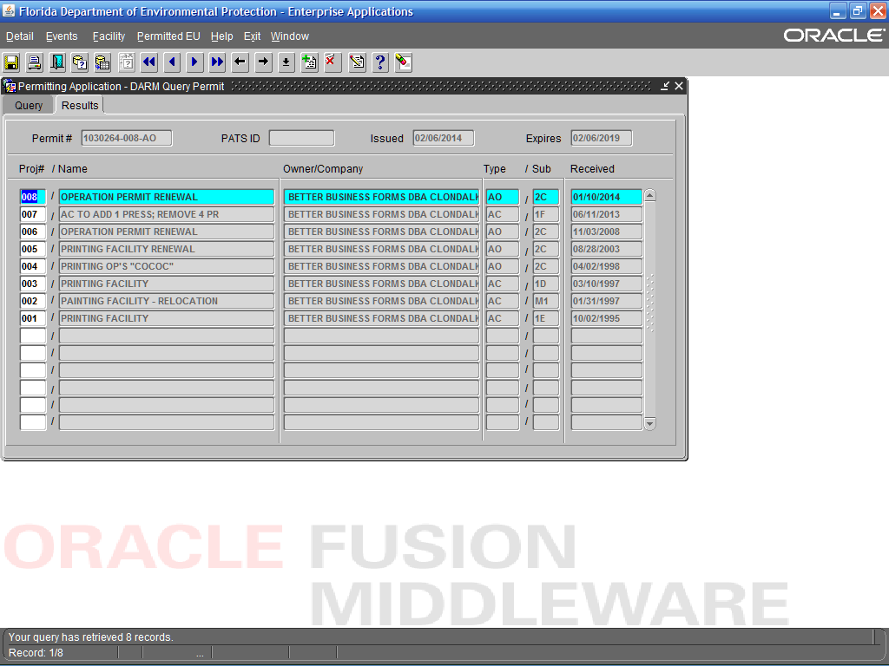
Permit renewal status

Better Business Forms, Inc. Clondalkin Group
10950 Belcher Road, Largo

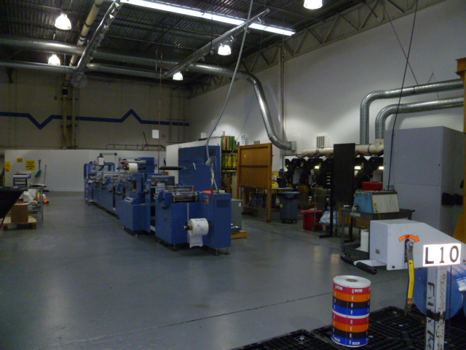

Project Id: 88748 Permit No: 1030264-008-AO Arms Number: 0264 001
Inspector: Shea Jackson Inspection Date / Time: 1/23/14 / _______
Source (EU): 21 printing presses

Description: [This was a additional permitted printe which was rented press in use after the removal or original press that occupied this area.]

Better Business Forms, Inc. Clondalkin Group
10950 Belcher Road, Largo

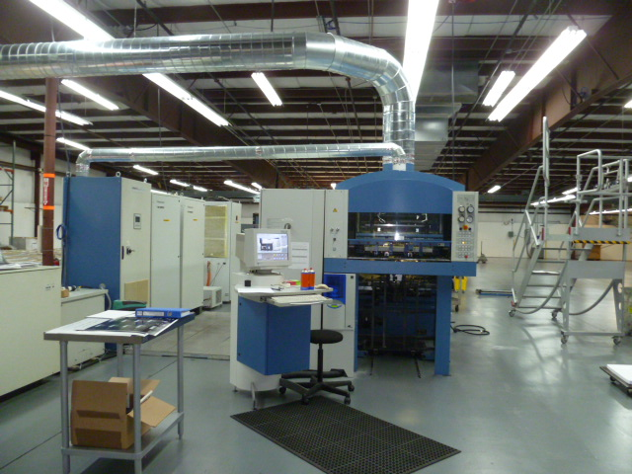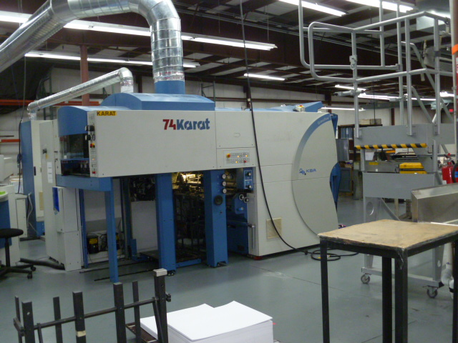

Project Id: 88748 Permit No: 1030264-008-AO Arms Number: 0264 001
Inspector: Shea Jackson Inspection Date / Time: 1/23/14 / _______
Source (EU): 21 printing presses

Description: [This is the new 74 Karat lithographic printer which had been installed in July 2013, stated to be in testing mode]

Better Business Forms, Inc. Clondalkin Group
10950 Belcher Road, Largo

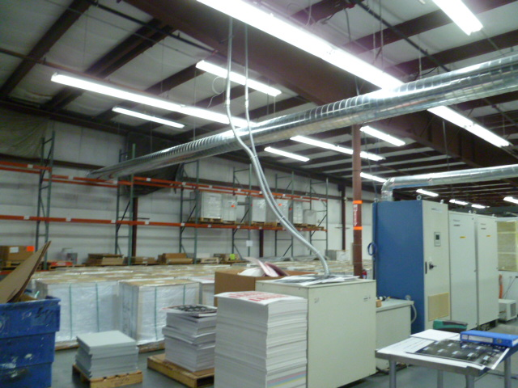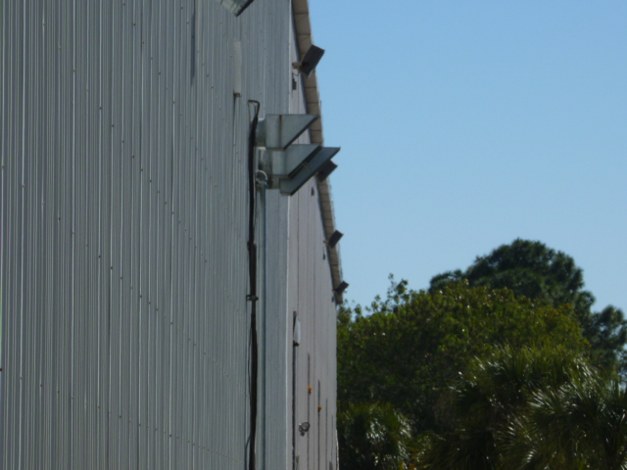

Project Id: 88748 Permit No: 1030264-008-AO Arms Number: 0264 001
Inspector: Shea Jackson Inspection Date / Time: 1/23/14 / _______
Source (EU): 21 printing presses

Description: The 74 Karat vents to the west side of the building
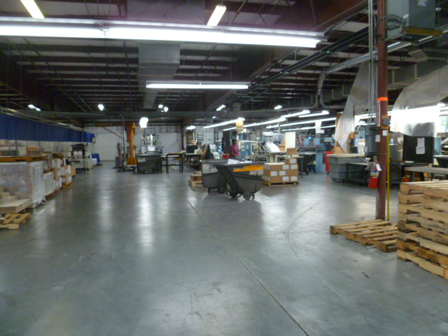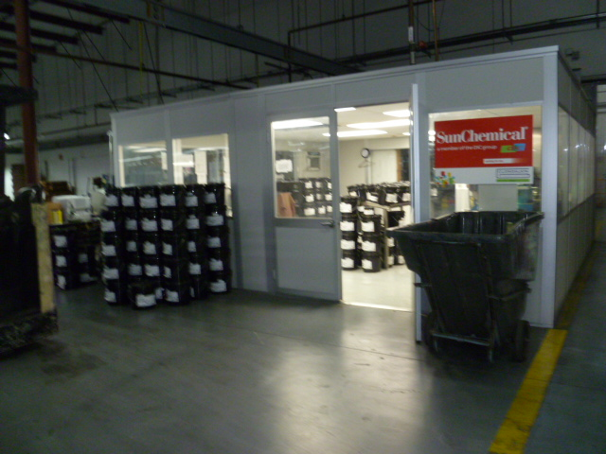
Project Id: 88748 Permit No: 1030264-008-AO Arms Number: 0264 001
Inspector: Shea Jackson Inspection Date / Time: 1/23/14 / _______
Source (EU): 21 printing presses

Description: [The facility keeps floors clear, and no spills. Storage of inks and lids closed.]

Better Business Forms, Inc. Clondalkin Group
10950 Belcher Road, Largo



Project Id: 88748 Permit No: 1030264-008-AO Arms Number: 0264 001
Inspector: Shea Jackson Inspection Date / Time: 1/23/14 / _______
Source (EU): 21 printing presses

Description: [Review of the records]

