1030190 84785
FACILITY: Big C Steel, Inc. |  |  |  |  |  |  |  |  |  |  |  |  |  |  |  |  |  |  |  | PERMIT ID: 25
 |  |  |  |  |  |  |  |  |  |  |  |  |  |  |  |  |  |  |  | DISTRICT: Southwest
ADDRESS: 13095 49th Street North |  |  |  |  |  |  |  |  |  |  |  |  |  |  |  |  |  |  |  | CONTACT PHONE:
Clearwater, FL |  |  |  |  |  |  |  |  |  |  |  |  |  |  |  |  |  |  |  | 727-573-2442
ARMS NO:  1030190 001 |  |  |  |  |  |  |  | PERMIT NO: |  |  |  |  |  |  |  |  |  |  |  | Expiration Date: 4/6/2016  Renewal Date: 2/6/2016
 |  |  |  |  |  |  |  | 1030190-005-AO
 |  |  |  |  |  |  |  |  |  |  |  |  |  |  |  |  |  |  |  | Test Due Date:
EMISSION UNIT DESCRIPTION : RACT VOCSpray Paint Area for Coating of Structural Steel Products

INSPECTION DATE: |  |  |  |  |  |  | ARMS INSPECTION TYPE: |  |  |  |  |  |  |  |  |  |  |  |  |  |  | COMPLIANCE STATUS:
 | July 23, 2013 |  |  |  |  |  |  |  |  | INS1 |  |  | INS2 |  |  | INS3 |  |  | FUI |  |  |  | ✓ |  | IN |  |  | MNC |  |  |  |  |  | SNC
INSPECTION TYPE: |  |  |  | ✓ | Initial |  |  |  |  |  | Re-inspection |  |  |  |  |  | Complaint |  |  |  |  |  |  | Drive-by |  |  |  |  |  |  | Quarterly
✓ |  |  | A. General Review:
1. |  | Permit File Review |  |  |  |  |  |  |  |  |  |  |  |  |  |  |  |  |  |  |  |  |  |  |  |  |  |  |  | Yes |  |  |  |  | No
 |  | Comments: yes
2. |  | Introduction and Entry |  |  |  |  |  |  |  |  |  |  |  |  |  |  |  |  |  |  |  |  |  |  |  |  |  |  |  | Yes |  |  |  |  | No
 |  | Comments: I met on site with Mr. David Cox, Nena Marris, and Sam McKlinene
3. |  | Is the Responsible Official/Authorized Representative still: David S. Cox? |  |  |  |  |  |  |  |  |  |  |  |  |  |  |  |  |  |  |  |  |  |  |  |  |  |  |  | Yes |  |  |  |  | No
Comments: Yes, was on site during inspection
The Responsible Official/Authorized Representative’s e-mail is: bigcdavid@yahoo.com
4. |  | Is the facility contact still: David S. Cox? |  |  |  |  |  |  |  |  |  |  |  |  |  |  |  |  |  |  |  |  |  |  |  |  |  |  |  | Yes |  |  |  |  | No
Comments: yes
The facility contact’s e-mail is: bigcdavid@yahoo.com

IN | MNC | SNC |  |  | B. Specific Conditions:
✓  ✓  ✓  ✓  ✓  ✓  ✓  ✓  ✓  ✓  ✓  ✓  ✓  ✓  ✓ |  |  |  |  | Inspection note: This renewal permit became effective on 4/6/11 and replaces 1030190-004-AO  General Conditions [62-4.160, F.A.C.]  8. If, for any reason, the permittee does not comply with or will be unable to comply with any condition or limitation specified in this permit, the permittee shall immediately provide the Department with the following information:  a. A description of and cause of noncompliance; and  b. The period of noncompliance, including dates and times; or, if not corrected, the anticipated time the noncompliance is expected to continue, and steps being taken to reduce, eliminate, and prevent recurrence of the noncompliance. The permittee shall be responsible for any and all damages which may result and may be subject to enforcement action by the Department for penalties or for revocation of this permit.  Comments: there was no non compliance issues discovered or disclosed by the facility during this inspection.  12. This permit or a copy there of shall be kept at the work site of the permitted activity.  Comments: A copy of the permit was was not kept at the worksite. I observed the copy of permit in binder and maintained in the front office by Nena Marris.  Common Conditions [Rule 62-296.320(4)(c), F.A.C.]  Unless otherwise specified in the permit, the following conditions apply to all emissions units and activities at the facility.  2. Circumvention: The permittee shall not circumvent the air pollution control equipment or allow the emission of air pollutants without this equipment operating properly. [Rule 62-210.650, F.A.C.]  Comments: there was no evidence of circumvention discovered or disclosed by the facility during this inspection.  6. VOC or OS Emissions: No person shall store, pump, handle, process, load, unload or use in any process or installation, volatile organic compounds (VOC) or organic solvents (OS) without applying known and existing vapor emission control devices or systems deemed necessary and ordered by the Department. [Rule 62-296.320(1), F.A.C.]  Comments: The facility has one building area used for all spraying of product. This is a gravel partial enclosed part of the 4th building. The paint containers were closed. The spray wand was being maintained in a closed container. There were no spills observed in any of the other four facility buildings which are used for metal fabrication, welding, cutting etc, assembly and storage prior to shipment.  7. Objectionable Odor Prohibited: No person shall cause, suffer, allow or permit the discharge of air pollutants, which cause or contribute to an objectionable odor. An “objectionable odor” means any odor present in the outdoor atmosphere which by itself or in combination with other odors, is or may be harmful or injurious to human health or welfare, which unreasonably interferes with the comfortable use and enjoyment of life or property, or which creates a nuisance. [Rules 62-296.320(2) and 62-210.200(Definitions), F.A.C.]  Comments: An upwind/downwind survey of the facility was conducted. The observed parameters were:  Downwind odor level detected- none; Wind direction – Westerly Upwind odor level detected-  No odors were detected at the time of inspection off property or on site during inspection. There was no spraying at this time.  9. Unconfined Particulate Emissions:  a. No person shall cause, let, permit, suffer or allow the emissions of unconfined particulate matter from any activity, including vehicular movement; transportation of materials; construction, alteration, demolition or wrecking; or industrially related activities such as loading, unloading, storing or handling; without taking reasonable precautions to prevent such emissions.  b. Any permit issued to a facility with emissions of unconfined particulate matter shall specify the reasonable precautions to be taken by that facility to control the emissions of unconfined particulate matter.  c. Reasonable precautions include the following:  (1) Paving and maintenance of roads, parking areas and yards.  (2) Application of water or chemicals to control emissions from such activities as demolition of buildings, grading roads, construction, and land clearing.  (3) Application of asphalt, water, oil, chemicals or other dust suppressants to unpaved roads, yards, open stock piles and similar activities.  (4) Removal of particulate matter from roads and other paved areas under the control of the owner or operator of the facility to prevent reentrainment, and from buildings or work areas to prevent particulate from becoming airborne.  (5) Landscaping or planting of vegetation.  (6) Use of hoods, fans, filters, and similar equipment to contain, capture and/or vent particulate matter.  (7) Confining abrasive blasting where possible.  (8) Enclosure or covering of conveyor systems.  Comments:  1. The areas around the building are paved or gravel surfaces.  2. There are no construction or demolition activities associated with this facility.  3. The do not have stockpiles or sprinkler systems, no heavy traffic patterns or need for sweep of outdoor areas. Work activities are maintained inside the buildings.  4. There is industrial area, not a significant amount of green space.  5. Processing of metals for spray are maintained inside the structures, cutting grinding, welding are shielded with Screens. The facility sprays I beam inside a 3 sided building to control spray paint particulate.  6. There are no conveyor systems associated with this facility. (See photos)  Permit Administrative Requirements  7. General Standards: Objectionable Odor - No person shall cause, suffer, allow or permit the discharge of air pollutants, which cause or contribute to an objectionable odor. An objectionable odor is any odor present in the outdoor atmosphere, which by itself or in combination with other odors, is or may be harmful or injurious to human health or welfare, which unreasonably interferes with the comfortable use and enjoyment of life or property, or which creates a nuisance. If the Department and/or Pinellas County Air Quality Division (PCAQD) receives a valid odor complaint, the Department and/or PCAQD reserves the right to require that odor control measures/work practices be implemented. [Rules 62-4.070(3), 62-210.200 (“Objectionable Odor”) and 62-296.320(2), F.A.C.; Pinellas County Code, Section 58-178]  Comments: There were no odors detected off the property when observing the spray panting building at this time. There was a mild paint odor present inside the spray room.  8. Annual Operating Report - The permittee shall submit to the Air Quality Division of Pinellas County each calendar year on or before April 1, a completed DEP Form 62-210.900(5), "Annual Operating Report for Air Pollutant Emitting Facility" (AOR) for the preceding calendar year. The report may also be submitted electronically in accordance with the instructions received with the AOR package sent by the Department. In addition to the requirements of Rule 62-296.500(2)(c), F.A.C. (VOC RACT – Reporting), the annual report shall also include a proof of compliance with the VOC RACT limitations (see Specific Condition No. A.4.). This proof of compliance shall consist of a statement of the VOC content in pounds of VOC per gallon of coating, excluding water, delivered to the coating applicator, for each coating used in the year being reported. [Rules 62-210.370(3), and 62-296.500(2)(c), F.A.C.]  Comments: The facility submitted the 2012 AOR on, 2/16/13 and review completed 4/8/13 and approved.  9 Operation Permit Renewal Application: A completed application for renewal of the operation permit shall be submitted to the Permitting Authority with a copy to PCDEM (Compliance Authority) no later than 60 days prior to the expiration date of the operation permit. [Rules 62-4.030, 62-4.050, 62-4.070(3), 62-4.090, 62-210.300(2), and 62-210.900, F.A.C.]  Comments: The renewal of permit date is 2/6/16, the facility does not need to renew permit at this time.  A.1. Permitted Capacity - In order to assure compliance with the emission limitations of Specific Condition No. A.4., total facility coating usage shall not exceed the following limits:  a. 325 gallons per month; and  b. 3900 gallons per any 12 consecutive month period. [Rule 62-210.200 (“Potential to Emit”) F.A.C.; Construction Permit AC52-169995]  Comments: The records from June 2012 – June 2013 were reviewed. The highest month of paint usage was May 2013 at 88 gallons of coating, and 751.5 gallons for the 12 month consecutive month total. These amounts do not exceed the permit limitations. (See records attached)  A.2. Hours of Operation - This facility is allowed to operate a maximum of 2,600 hours per year. [Rule 62-210.200 (“Potential to Emit”) F.A.C.; Construction Permit AC52-169995]  Comments: The highest hours of operation was 2418 hours for the 12 month consecutive total during the month of July 2012. This does not exceed the 2600 hours per year allowed.  A.3. Volatile Organic Compound Emissions and/or Organic Solvent Emissions - The permittee shall allow no person to store, pump, handle, process, load, unload or use in any process or installation, volatile organic compounds (VOC) or organic solvents (OS) without applying known and existing vapor emission control devices or systems deemed necessary and ordered by the Department. The following procedures shall be utilized to minimize pollutant emissions:  a. All equipment, pipes, hoses, lids, fittings, etc., shall be operated/maintained in such a manner as to minimize leaks, fugitive emissions and spills of solvent materials.  b. All VOC/OS from washings (equipment clean-up) shall be directed into containers prevent evaporation into the atmosphere.  c. Tightly cover or close all VOC and/or solvent containing vessels, drums, totes, etc., when they are not in use.  d. Immediately confine and clean up VOC spills, and make sure wastes are placed in closed containers for reuse, recycling or proper disposal.  [Rule 62-296.320(1)(a) F.A.C.]  Comments: There were no open containers, drums were sealed, no leaks, no loose fittings were observed on equipment, during the facility tour of the 4 production buildings ( Building 1, cutting and welding, building #2 coating metal, #3 , assembly and welding, and #4 Spray painting section . There were no uncovered containers, There were no spills on floors. The spray wand is maintained in a closed container. (See photo)  A.4. VOC RACT Emission Limitation – The following emission limitations apply:  a. No owner or operator of a coating line for miscellaneous metal parts and products shall cause, allow, or permit the discharge into the atmosphere of any volatile organic compounds in excess of 3.5 pounds per gallon of coating, excluding water, delivered to a coating applicator in a coating application system; and  b. All volatile organic compound emissions from solvent washings shall be considered in the emission limitations in Specific Condition No. A.4.a., above unless the solvent is directed into containers that prevent evaporation into the atmosphere.  [Rules 62-296.513(2)(a)2. and (2)(c), F.A.C. (Reasonably Available Control Technology (RACT) – Volatile Organic Compounds: Surface Coating of Miscellaneous Metal Parts and Products)]  Comments: The facility coating which is only coating used to prime metal structures is Delta Laboratories, Inc. Red Shopcoat primer. #34R001022. The VOC emitted is 3.48 lbs / gal. This is acceptable level under the above limitation. This has been the same coating used at the facility for since began operations. The VOC content varies slightly for batches, but not considered an exceedance. The facility does not use any other solvents or coatings for preparing the metal. They use fuel oil to clean up if needed. (See coating msd sheet attached).  A.5. VOC Emission Limitations – This emissions unit shall comply with the following VOC emission limitations:  [Rule 62-210.200 (“Potential to Emit”) F.A.C.; Construction Permit AC52-169995]  (Title V Applicability Note: Since all HAPs that are emitted are VOCs, the above VOC emission limitations also ensures that HAP emissions will be below the Title V major source level of 10 tons per  Comments: The records reviewed from June 2012 – June 2013 for VOC emissions. The highest Month usage was during June 2013 - Surface Cleaning is 0.0 lbs, painting 224 lbs, Equipment cleanup 0.0 = 224 lbs of VOC/month. The VOC 12 month cumulative total was 2628.5 lbs for 1.314 tons for Facility.  These totals did not exceed the VOC emissions limitations of the above listed table. (See records copy)  A.6. VOC Records – In order to document compliance with Specific Condition Nos. A.1. – A.2. and A.4. – A.5., and in accordance with Rule 62-296.500(2)(b), F.A.C. (VOC RACT – Recordkeeping), the permittee shall maintain records for all VOC containing materials (coatings, paint, solvents, etc.) which shall contain at a minimum the following:  DAILY  a. facility name, ID No. (1030190), Emission Unit No. (001);  b. date and description of operation (i.e., Surface Cleaning, Painting, or Equipment Cleanup);  c. the Rule number applicable to the operation for which the records are being maintained (i.e., Rule 62-296.513, F.A.C. - Surface Coating of Miscellaneous Metal Parts and Products);  d. application method and substrate type (i.e., spray painting on metal);  e. amount (gallons) and type (name and description) of coatings and solvent used at each point of application, including exempt compounds;  f. pounds of VOC per gallon of each coating, excluding water, as applied;  g. amount of each solvent used (all uses) and the solvent VOC content, including exempt compounds;  MONTHLY  h. facility name, ID No. (1030190), Emission Unit No. (001);  i. the total number of hours operated per month (operation consists of periods when surface coating or equipment cleanup is being conducted);  j. the total number of hours operated for the most recent 12 consecutive months;  k. the total quantity of coating used per month (gallons);  l. the total quantity of coatings used for the most recent 12 consecutive months (gallons);  m. the calculated monthly VOC emissions in pounds for each operation (i.e., Surface Cleaning, Painting, or Equipment Cleanup) based upon coating and solvent usage and their respective VOC contents; and  n. the calculated most recent 12 consecutive month total for VOC emissions in tons for each operation (i.e., Surface Cleaning, Painting, or Equipment Cleanup) and the total for the facility.  Supporting documentation (MSD sheets, purchase orders, etc.) shall be kept for each coating, which includes sufficient information to determine VOC emissions. All daily records shall be completed within three (3) business days and all monthly records shall be completed by the end of the following month. The logs shall be retained on file at the facility for at least two years, and be made available to the Department and Pinellas County Air Quality Division for inspection upon request. [Rules 62-4.070(3) and 62-296.500(2)(b), F.A.C.; Pinellas County Code Section 58-90]  Comments: The operators have individual record logs; they record usage in for at the spray area work station. This information is given to Nena Marris, she records information from the daily records into the monthly and annual records. The records observed meet with the above requirements for (a-n) (See attached copies). Reviewed 1 year of records and observed the facility is maintaining the annual records on site back to 2010 in binder, the previous years are archived to their files.
  Operation | Maximum Emission Limits  (lbs VOC/ month) | Maximum Emission Limits  (tons VOC/consecutive 12 month period)
  Surface Cleaning | 0.0 | 0.0
  Painting | 1137.5 | 6.83
  Equipment Cleanup | 7.04 | 0.04
  Facility Total | 1144.54 | 6.87
✓ |  |  |  |  | Valid Permit [Rule 62-210.300]
✓ |  |  |  |  | Changes to Facility/emission unit [Rule 62-210.300]  Does the emission unit description above match what the facility is operating (Number of emission units or points, model number and serial number, etc.) Yes No  Comments: no changes to facility etc
✓ |  |  | C. Other:
Pollution Prevention Activities
- P2 Handouts Provided: P2 Brochure; P2 Manual; P2 Checklist
- Have any emissions reductions occurred Yes / No changes
Chemical Substitution; Equipment Changes; Process Changes
Chemical/Material Reuse; On-site Recycling; Other: metals are sent to Trademark salvage.
Comments: The facility operation has not changed paints and VOC content is the same.

Closing Conference: I informed Mr. Cox the facility records and site appear to be operating in compliance at this time.

Inspector(s): Shea Jackson, Pinellas County, Air Quality Division
Signature(s): Date: |  |  |  |  |  |  |  |  | Date: July 25, 2013
ACCESS? |  |  |  | ✓ |  | ARMS? | ✓

Big C Steel, Inc.
13095 49th Street North, Clearwater

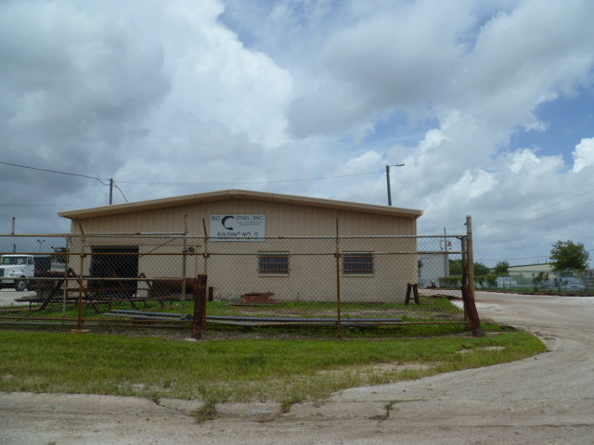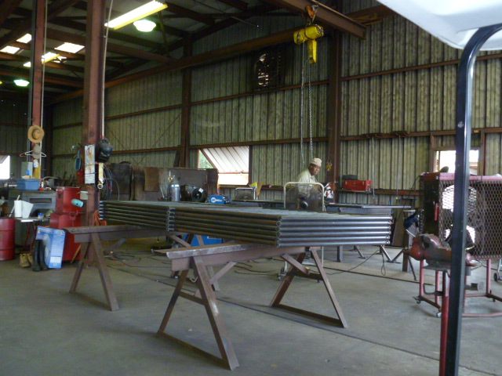
Project Id: 84785 Permit No: 1030190-005-AO Arms Number: 0190 001
Inspector: Shea Jackson Inspection Date / Time: 7/23/13 / _______
Source (EU): RACT VOCSpray Paint Area for Coating of Structural Steel Products

Description: [This building is used for the receipt of metals and cutting prior to the welding operations and

spray painting areas.]

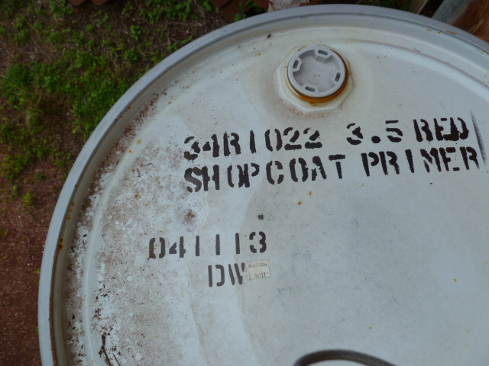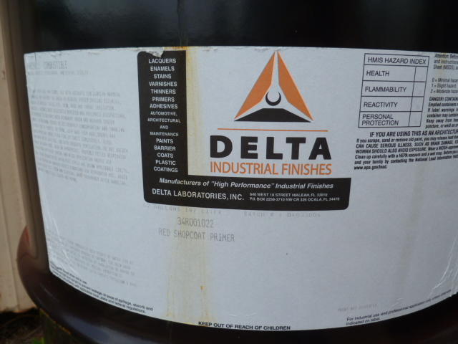
Project Id: 84785 Permit No: 1030190-005-AO Arms Number: 0190 001
Inspector: Shea Jackson Inspection Date / Time: 7/23/13 / _______
Source (EU): RACT VOCSpray Paint Area for Coating of Structural Steel Products
Description: [This is the only paint used on site. Delta 34R1022]

Big C Steel, Inc.
13095 49th Street North, Clearwater
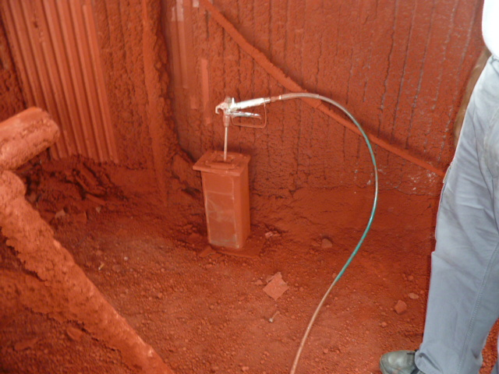

Project Id: 84785 Permit No: 1030190-005-AO Arms Number: 0190 001
Inspector: Shea Jackson Inspection Date / Time: 7/23/13 / _______
Source (EU): RACT VOCSpray Paint Area for Coating of Structural Steel Products
Description: [The employees keep the spray wand in closed container ]

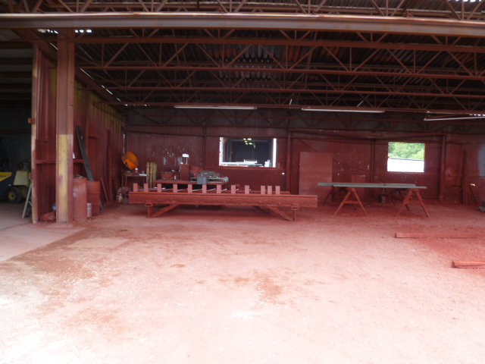
Project Id: 84785 Permit No: 1030190-005-AO Arms Number: 0190 001
Inspector: Shea Jackson Inspection Date / Time: 7/23/13 / _______
Source (EU): RACT VOCSpray Paint Area for Coating of Structural Steel Products

Description: [This area is partially enclosed for the spray painting of metal frame work, with primer

coating]

