1030154 88183
FACILITY: Thomas Sign & Awning Co., Inc. |  |  |  |  |  |  |  |  |  |  |  |  |  |  |  |  |  |  |  | PERMIT ID: 192
 |  |  |  |  |  |  |  |  |  |  |  |  |  |  |  |  |  |  |  | DISTRICT: Southwest
ADDRESS: 4590 118th Ave. North |  |  |  |  |  |  |  |  |  |  |  |  |  |  |  |  |  |  |  | CONTACT PHONE:
Clearwater, FL |  |  |  |  |  |  |  |  |  |  |  |  |  |  |  |  |  |  |  | 727-252-7777
ARMS NO:  1030154 001 |  |  |  |  |  |  |  | PERMIT NO: |  |  |  |  |  |  |  |  |  |  |  | Expiration Date: 1/10/2017  Renewal Date: 11/11/2016
 |  |  |  |  |  |  |  | 1030154-004-AO
 |  |  |  |  |  |  |  |  |  |  |  |  |  |  |  |  |  |  |  | Test Due Date:
EMISSION UNIT DESCRIPTION : Three paint spray booths: Booth 1- Binks, Model TFC-16-1 & Booth 2- Binks, Model FEC-10-7; and Booth 3 - Black Crowe Manufacturing; and a brush painting area for the coating of metal and plastic sign parts and metal sign posts.

INSPECTION DATE: |  |  |  |  |  |  | ARMS INSPECTION TYPE: |  |  |  |  |  |  |  |  |  |  |  |  |  |  | COMPLIANCE STATUS:
 | November 14, 2013 |  |  |  |  |  |  |  |  | INS1 |  | ✓ | INS2 |  |  | INS3 |  |  | FUI |  |  |  | ✓ |  | IN |  |  | MNC |  |  |  |  |  | SNC
INSPECTION TYPE: |  |  |  | ✓ | Initial |  |  |  |  |  | Re-inspection |  |  |  |  |  | Complaint |  |  |  |  |  |  | Drive-by |  |  |  |  |  |  | Quarterly
✓ |  |  | A. General Review:
1. |  | Permit File Review |  |  |  |  |  |  |  |  |  |  |  |  |  |  |  |  |  |  |  |  |  |  |  |  |  |  |  | Yes |  |  |  |  | No
 |  | Comments: Yes
2. |  | Introduction and Entry |  |  |  |  |  |  |  |  |  |  |  |  |  |  |  |  |  |  |  |  |  |  |  |  |  |  |  | Yes |  |  |  |  | No
 |  | Comments: I toured the facility and reviewed records with facility contact Buddy Moribito.
3. |  | Is the Responsible Official/Authorized Representative still: Priscilla G. Thomas? |  |  |  |  |  |  |  |  |  |  |  |  |  |  |  |  |  |  |  |  |  |  |  |  |  |  |  | Yes |  |  |  |  | No
Comments: Yes,
The Responsible Official/Authorized Representative’s e-mail is: pris.thomas@thomassign.com
4. |  | Is the facility contact still: Charles B. Copp? |  |  |  |  |  |  |  |  |  |  |  |  |  |  |  |  |  |  |  |  |  |  |  |  |  |  |  | Yes |  |  |  |  | No
Comments: Yes, was out of town at time of inspection. I met with Buddy Moraibito. Buddy.Morabito@thomasSign..com
The facility contact’s e-mail is: charlie.copp@thomassign.com

IN | MNC | SNC |  |  | B. Specific Conditions:
✓  ✓  ✓  ✓  ✓  ✓  ✓  ✓  ✓  ✓  ✓  ✓  ✓  ✓  ✓ |  |  |  |  | General Conditions [62-4.160, F.A.C.]  8. If, for any reason, the permittee does not comply with or will be unable to comply with any condition or limitation specified in this permit, the permittee shall immediately provide the Department with the following information:  a. A description of and cause of noncompliance; and  b. The period of noncompliance, including dates and times; or, if not corrected, the anticipated time the noncompliance is expected to continue, and steps being taken to reduce, eliminate, and prevent recurrence of the noncompliance. The permittee shall be responsible for any and all damages which may result and may be subject to enforcement action by the Department for penalties or for revocation of this permit.  Comments: The facility stated they did not have any non compliance periods or issues to report. I did not find any compliance issues during tour of the facility or review of records.  12. This permit or a copy thereof shall be kept at the work site of the permitted activity.  Comments: A copy of the permit was was not kept at the worksite. Mr. Morabito showed the current permit copy he maintains on his personal computer in his office.  Common Conditions [Rule 62-296.320(4)(c), F.A.C.]  Unless otherwise specified in the permit, the following conditions apply to all emissions units and activities at the facility.  Emissions and Controls  2. Circumvention: The permittee shall not circumvent the air pollution control equipment or allow the emission of air pollutants without this equipment operating properly. [Rule 62-210.650, F.A.C.]  Comments: The facility does not have a control device to circumvent, and at this time do not have any excess emissions to report. The filters for the three spray booths were observed to be in place for spray paintng operations. Mr. Morabito stated they change weekly. He stated it would be unwise to not use filters, as the accumulation of paint in stack is fire hazard and the accumulation can gum up the fans and baffles and cause decreased efficiency. (See photos).  6. VOC or OS Emissions: No person shall store, pump, handle, process, load, unload or use in any process or installation, volatile organic compounds (VOC) or organic solvents (OS) without applying known and existing vapor emission control devices or systems deemed necessary and ordered by the Department. [Rule 62-296.320(1), F.A.C.]  Comments: The facility installed a new enclosed mixing room. They have the solvents in reclaim drum, and the containers observed in storage were closed.  9. Unconfined Particulate Emissions:  a. No person shall cause, let, permit, suffer or allow the emissions of unconfined particulate matter from any activity, including vehicular movement; transportation of materials; construction, alteration, demolition or wrecking; or industrially related activities such as loading, unloading, storing or handling; without taking reasonable precautions to prevent such emissions.  b. Any permit issued to a facility with emissions of unconfined particulate matter shall specify the reasonable precautions to be taken by that facility to control the emissions of unconfined particulate matter.  c. Reasonable precautions include the following:  (1) Paving and maintenance of roads, parking areas and yards.  (2) Application of water or chemicals to control emissions from such activities as demolition of buildings, grading roads, construction, and land clearing.  (3) Application of asphalt, water, oil, chemicals or other dust suppressants to unpaved roads, yards, open stock piles and similar activities.  (4) Removal of particulate matter from roads and other paved areas under the control of the owner or operator of the facility to prevent reentrainment, and from buildings or work areas to prevent particulate from becoming airborne.  (5) Landscaping or planting of vegetation.  (6) Use of hoods, fans, filters, and similar equipment to contain, capture and/or vent particulate matter.  (7) Confining abrasive blasting where possible.  (8) Enclosure or covering of conveyor systems.  Comments: : (1) The facility parking lots and roads are paved, no activity of generating unconfined emissions observed.  (2) there were no activities such as demolition or construction associated with the operations of this facility.  (3) There was no accumulated particulate matter on surfaces which required the application of water or suppressants.  (4) No particulate needing removal.  (5) The building was landscaped on the north side of parking lot. .  (6) There was capture systems associated with the three spray booths.  (7)There was not any abrasive blasting activities at time of inspection. I observed the sandblasting area on the east side of building. Mr. Morabito stated they use the area only when low wind conditions and not when the wind from south direction. The area was enclosed with wood wall and trailer. I informed them a tarp could be used over the top to further reduce unconfined PM during sand blasting activities.  (8) There is no conveyor systems associated with this facilities operations.  Permit Administrative Requirements  7 Annual Operating Report: On or before April 1 of each year, the permittee shall submit a completed DEP Form 62-210.900(5), "Annual Operating Report for Air Pollutant Emitting Facility" (AOR) for the preceding calendar year. The report may be submitted electronically in accordance with the instructions received with the AOR package sent by the Department, or a hardcopy may be sent to the Compliance Authority. [Rule 62-210.370(3), F.A.C.]  Comments: The annual operating report for calendar year 2012 was submitted on _ 3/29/13___.  I informed Mr. Morabito, he must submit the annual operating report by April 1, 2014. He stated he was aware was due at that time.  8. Operation Permit Renewal Application - A completed application for renewal of the operation permit shall be submitted to the Permitting Authority with a copy to the Pinellas County Air Quality Division (Compliance Authority) no later than 60 days prior to the expiration date of the operation permit. To properly apply for an operation permit, the applicant shall submit the following: Rules 62-4.030, 62-4.050, and 62-4.220, F.A.C.] &  8. Application for Non-Title V Air Operation Permit: This permit authorizes modification of the permitted emissions unit and initial operation to determine compliance with Department rules. A Non-Title V air operation permit is required for continued operation of the permitted emissions unit. The permittee shall apply for a Non-Title V air operation permit at least 90 days prior to expiration of this permit, but no later than 180 days after the new paint booth (Paint Spray Booth No. 3) commences operation. Commencing operation means setting into operation of any emissions unit for any purpose. (Note: operation permit application for the activities addressed in construction permit 1030154-001-AC (Paint Spray Booth Nos. 1 and 2, and the brush painting area) is required no earlier than 90 days and no later than 120 days after issuance of the construction permit, which was July 2, 2012. Therefore, this operation permit application is due to be submitted between September 30, 2012 and October 30, 2012.) [Rules 62-4.030, 62-4.050, 62-4.070(3), 62-4.090, 62-210.300(2), and 62-210.900, F.A.C.] per 1030154-002-AC  Comments: The Air Operations permit 1030154-004-AO was issued on 7/25/13 and no further action is required until time of renewal date 11/11/2016.  9. Objectionable Odor Prohibited: The permittee shall not cause, suffer, allow, or permit the discharge of air pollutants, which cause or contribute to an objectionable odor. An "Objectionable Odor" is defined as any odor present in the outdoor atmosphere, which by itself or in combination with other odors, is or may be harmful or injurious to human health or welfare, which unreasonably interferes with the comfortable use and enjoyment of life or property, or which creates a nuisance. [Rules 62-210.200 (Objectionable Odor) and 62-296.320(2), F.A.C.; Pinellas County Code, Section 58-178]  Comments: During observations of facility off site, before entering the building, during an upwind downwind odor survey, there were no objectionable odors detected off the property. The paint odors were mainly detectable inside booths, and mixing room.  A.2. Paint Spray Booth Overspray Filters: The permittee shall not circumvent the paint spray booth air pollution control equipment (fiber filters) or allow the emissions of air pollutants without this equipment operating properly. In order to provide reasonable assurance the overspray control systems are adequately controlling emissions of uncontrolled particulate matter from the spray booths, visible emissions from the paint spray booth exhausts should not exceed 5% opacity. Exceedance of the 5% limit shall not be considered a violation in and of itself, but an indication that additional control precautions and/or practices (filter maintenance or replacement) may be necessary. [Rules 62-4.070(3), and 62-210.650, F.A.C]  Comments: During the off site observations of the spray booth stacks, there were no visible emissions or paint overspray on stacks or observed coming from the stacks. (see photo) During the tour inside the facility the three spray booth filters were observed to be in place with no gaps to allow paint overspray to bypass filters. There was a moderate accumulation on filter pads (see photos). Mr. Morabito stated the filters are changed weekly dependent of booth usage. He stated they generate 6 drums of filters that are disposed of monthly to hazardous waste .  A.3. VOC RACT Emission Limiting Standards: In accordance with Rule 62-296.513, F.A.C. (VOC RACT – Surface Coating of Miscellaneous Metal Parts and Products), the permittee shall comply with the following (only applies to the surface coating of metal parts and products):  a. VOC emissions shall not exceed 3.5 pounds per gallon of coating (excluding water), delivered to a coating applicator in a coating application system that is air dried or forced warm air dried at temperatures up to 194 degrees Fahrenheit;  b. VOC emissions shall not exceed 4.3 pounds per gallon of coating (excluding water), delivered to a coating applicator that applies clear coatings;  c. All VOC emissions from solvent washings shall be considered in the emission limitations in items a. and b. above, unless the solvent is directed into containers that prevent evaporation into the atmosphere.  d. Compliance may be demonstrated on a 24-hour weighted average basis for a single emissions unit point with a single emission limit. [Rules 62-296.500(5), 62-296.513(2)(a) and 62-296.513(2)(c), F.A.C.]  Comments:  a. 3.5 VOC applies to color products; after review of records listing products used by the facility it was found they use a paint applied to metal substrates with VOC contents ranging from 2.3 to 3.5as applied.  b. 4.3 applies to clear coating products. There were no clear coatings exceeding this limitation found at this time.  c. The facility contains solvents in Saftey Kleen gun cleaner. The solvents used are returned to a waste drum.  d. The facility surface coating operations is being expressed in units of pounds VOC/gallon of solids as applied rather than pounds VOC/gallon of coating (less water and exempt solvents)  The facility now uses an computer application called Grip Guard, furnished by their paint vendor AZKO NOBLE. The spread sheet allows them to put in their coating formulation being used , amounts, weights, and it calculates the VOC content, if it goes over 3.5 the results cell turns red. They contact the vendor who supplies them with alternative coatings so they can obtain their desired color coating for sign and not exceed the 3.5VOC limitation.  A.4. VOC/HAP Emissions Limits: Emissions from this emissions unit shall not exceed the following:  [Rules 62-4.070(3) and 62-210.200(PTE), F.A.C.]  {Permitting Note: The limits were requested in air construction permit application received on 04/27/12.}  Comments: The facility operations started recording the emissions when the permit became effective 7/2/12. The rolling 12 month totals have gradually climbed over the year and the highest total is for September 2013 with VOC 3.30 tons, and HAPS 2.02 tons. The facility is in compliance with permit limitations.  A.5. Daily RACT Records for Metal Surface Coating Operations: In order to document compliance with the VOC emission limitations of Specific Condition No. A.3., the permittee shall maintain, at a minimum, the following daily records:  a. Facility name, facility ID No., emissions unit ID No., and description (i.e., Thomas Sign & Awning Company, 1030154, EU 001, Surface Coating Operations);  b. Date;  c. The applicable rule (e.g., Rule 62-296.513(2)(a)2., F.A.C.);  d. The application method and substrate type (i.e., metal);  e. The amount and type of coatings (including catalyst and reducer for multicomponent coatings) and/or solvent, including exempt compounds;  f. The VOC content as applied in each coating and/or solvent;  g. The amount of surface preparation, clean-up, wash-up of solvent (including exempt compounds) used and the VOC content of each. [Rules 62-4.070(3) and 62-296-500(2)(b), F.A.C.]  Comments: The operators record their usage on their paint forms, and the daily usage is input into the automated soft ware system from paint contractor. AZKO NOBLE, by another employee, and then this information is reviewed by Mr. Morabito who download s collected information into emissions records.  A.6. VOC/HAP Monthly Records: In order to document compliance with the VOC and HAP emissions limitations of Specific Condition No. A.4., the permittee shall maintain monthly records. These records may be based on the beginning and ending inventories, deliveries, shipments, etc. At the option of the permittee, “purchases” may be used instead of “usage” in determining VOC/HAP emissions, provided that no materials are used which are not purchased. The monthly records shall include, but not be limited to, the following information:  a. Facility name, facility ID No., emissions unit ID No., and description (i.e., Thomas Sign & Awning Company, 1030154, EU 001, Surface Coating Operations);  b. Month, year, and method used for records (usage or purchase);  VOC Monthly Records  c. The quantity (gallons) and VOC content (pounds per gallon) of each VOC-containing material (surface coatings and solvents) used for the month;  d. The calculated monthly total VOC emissions, in tons;  e. A cumulative total of the VOC emissions for the most recent consecutive 12-month period, in tons;  HAP Monthly Records  f. The quantity (gallons) and HAP content (pounds per gallon) of each HAP-containing material (surface coatings and solvents) used for the month;  g. The calculated monthly HAP emissions for total HAPs, in tons.  h. A cumulative total of the HAP emissions for total HAPs for the most recent consecutive 12-month period, in tons.  [Rule 62-4.070(3), F.A.C.]  [Rule 62-4.070(3), F.A.C.]  Comments: .Mr. Morabito furnished copies of the records at the time of inspection.  A.7. Documentation: Supporting documentation (e.g., MSDS sheets, "As Supplied" sheets, "As Applied" sheets, purchase orders, inventory records, production records, etc.) for the records required by Specific Condition Nos. A.5. and A.6., which shall include sufficient information to determine VOC and HAP emissions, shall also be kept. These records may be maintained in either a hardcopy or electronic format. [Rule 62-4.070(3), F.A.C.]  Comments: Mr. Morabito maintains hard copy binders of the MSDS sheets. He also showed the current copies in his personal computer. (See photo)  A.8. Records Retention: The records shall be maintained at the facility for at least 3 years and made available to the Permitting and Compliance Authorities upon request. Daily records shall be completed within 10 business days and monthly records shall be completed by the end of the following month. These records may be maintained in either a hardcopy or electronic format.  [Rules 62-4.070(3) and 62-4.160, F.A.C.]  Comments: The facility started maintaining records with the effective date of the permit as of July 2, 2012. The monthly record were up to date, and current for September 2013 (See records attached).
  Pollutant | Emissions Limit (tons per any consecutive 12-month period)
  VOC (Volatile Organic Compounds) | 22.8
  Total HAPs (Hazardous Air Pollutants) | 8.6
✓ |  |  |  |  | Valid Permit [Rule 62-210.300]
✓ |  |  |  |  | Changes to Facility/emission unit [Rule 62-210.300]  Does the emission unit description above match what the facility is operating (Number of emission units or points, model number and serial number, etc.) Yes No  Comments:
✓ |  |  | C. Other:
Pollution Prevention Activities
- P2 Handouts Provided: P2 Brochure; P2 Manual; P2 Checklist
- Have any emissions reductions occurred Yes / No
Chemical Substitution; Equipment Changes; Process Changes
Chemical/Material Reuse; On-site Recycling; Other:
Comments: No changes.
Closing Conference: I informed Mr. Morabito, the facility appears to be operating in compliance with the permit conditions, and much better recordkeeping and improvements from previous year.

Inspector(s): Shea Jackson, Pinellas County, Air Quality Division
Signature(s): Date: |  |  |  |  |  |  |  |  | Date: November 15, 2013
ACCESS? |  |  |  | ✓ |  | ARMS? | ✓

Thomas Sign & Awning Co., Inc.
4590 118th Ave. North, Clearwater

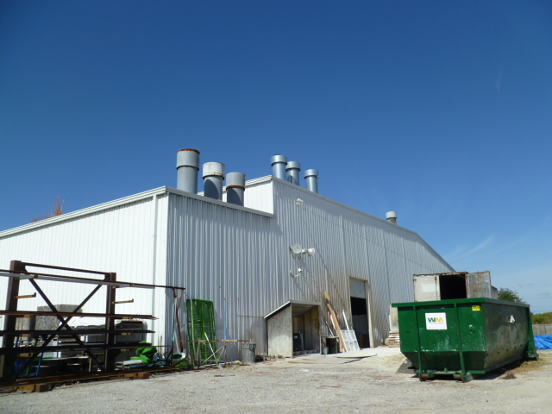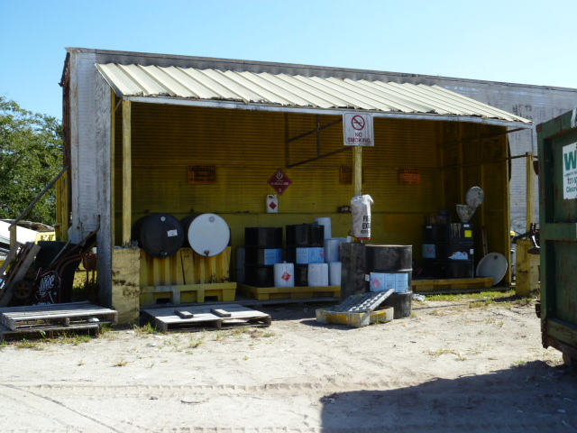

Project Id: 88183 Permit No: 1030154-004-AO Arms Number: 0154 001
Inspector: Shea Jackson Inspection Date / Time: 11/14/2013 / _______
Source (EU): Three paint spray booths: Booth 1- Binks, Model TFC-16-1 & Booth 2- Binks, Model FEC-10-7; and Booth 3 - Black Crowe Manufacturing; and a brush painting area for the coating of metal and plastic sign parts and metal sign posts.

Description: [Stacks of Spray Booths observed on the south east corner of facility building. No visible emissions or overspray observed on stacks. The used paints, and spent solvents were in secondary containment storage in outside shed]

Thomas Sign & Awning Co., Inc.
4590 118th Ave. North, Clearwater

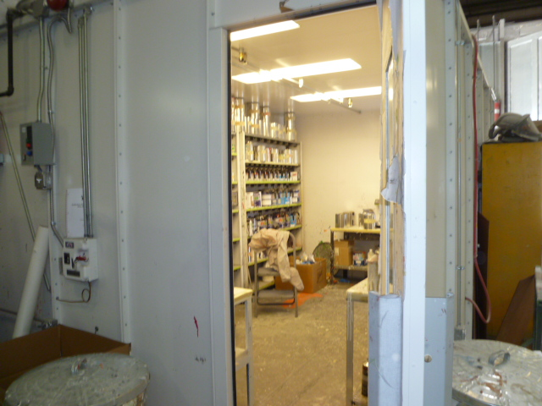

Project Id: 88183 Permit No: 1030154-004-AO Arms Number: 0154 001
Inspector: Shea Jackson Inspection Date / Time: 11/14/2013 / _______
Source (EU): Three paint spray booths: Booth 1- Binks, Model TFC-16-1 & Booth 2- Binks, Model FEC-10-7; and Booth 3 - Black Crowe Manufacturing; and a brush painting area for the coating of metal and plastic sign parts and metal sign posts.

Description: [the facility install a new paint room for mixing paints, fire marshall requested due to safety issues]

Thomas Sign & Awning Co., Inc.
4590 118th Ave. North, Clearwater

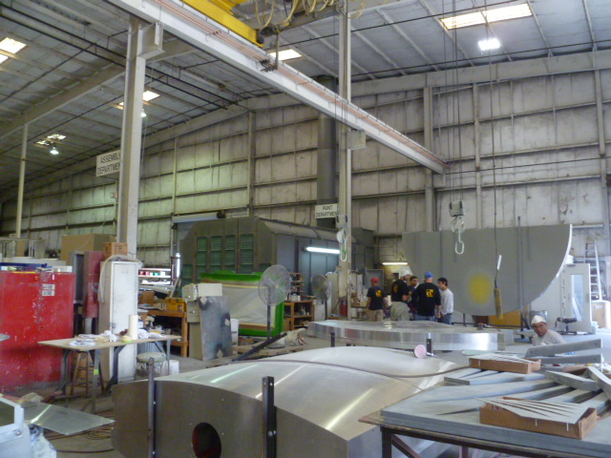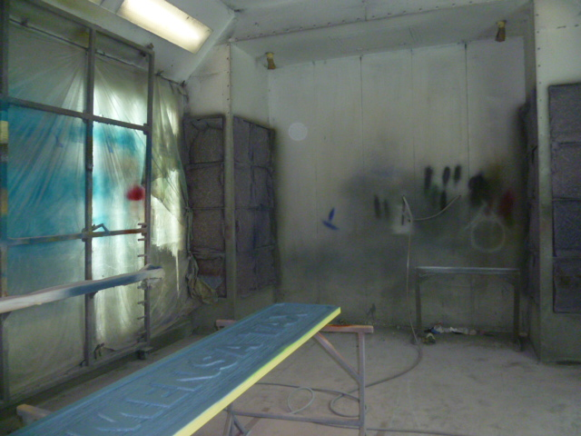

Project Id: 88183 Permit No: 1030154-004-AO Arms Number: 0154 001
Inspector: Shea Jackson Inspection Date / Time: 11/14/2013 / _______
Source (EU): Three paint spray booths: Booth 1- Binks, Model TFC-16-1 & Booth 2- Binks, Model FEC-10-7; and Booth 3 - Black Crowe Manufacturing; and a brush painting area for the coating of metal and plastic sign parts and metal sign posts.

Description: [Binks Booth outside and inside filters in place]

Thomas Sign & Awning Co., Inc.
4590 118th Ave. North, Clearwater

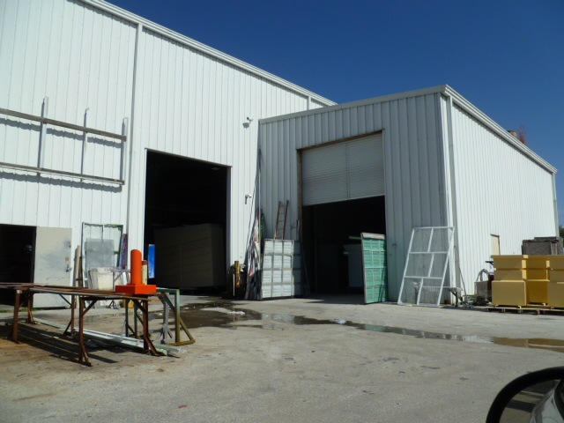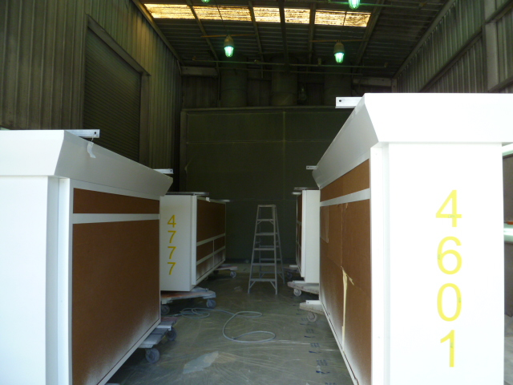

Project Id: 88183 Permit No: 1030154-004-AO Arms Number: 0154 001
Inspector: Shea Jackson Inspection Date / Time: 11/14/2013 / _______
Source (EU): Three paint spray booths: Booth 1- Binks, Model TFC-16-1 & Booth 2- Binks, Model FEC-10-7; and Booth 3 - Black Crowe Manufacturing; and a brush painting area for the coating of metal and plastic sign parts and metal sign posts.

Description: [Binks Model FEC Spray paint Booth outside Booth view and inside booth view, filters in place. ]

Thomas Sign & Awning Co., Inc.
4590 118th Ave. North, Clearwater

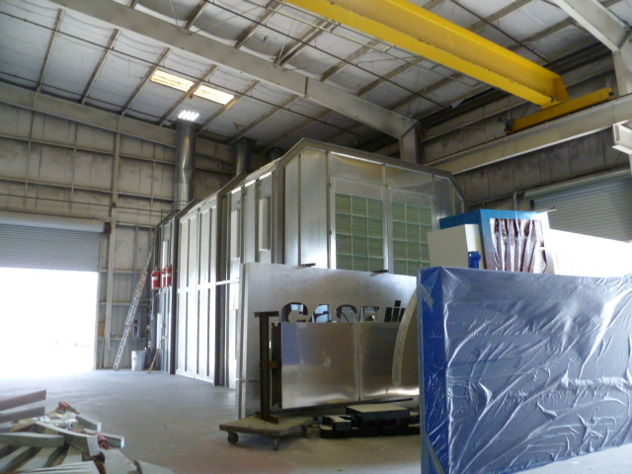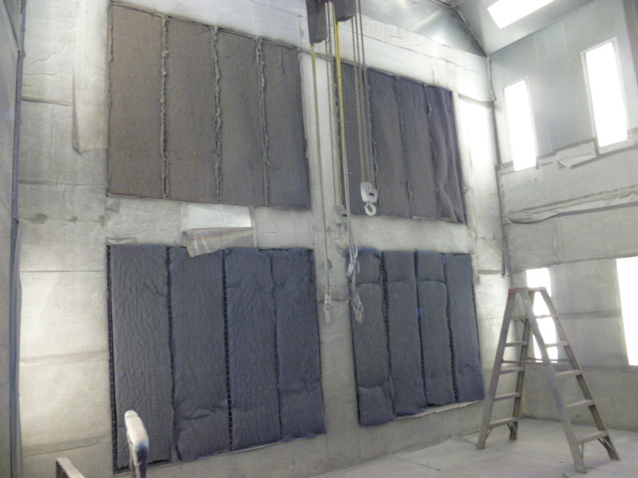

Project Id: 88183 Permit No: 1030154-004-AO Arms Number: 0154 001
Inspector: Shea Jackson Inspection Date / Time: 11/14/2013 / _______
Source (EU): Three paint spray booths: Booth 1- Binks, Model TFC-16-1 & Booth 2- Binks, Model FEC-10-7; and Booth 3 - Black Crowe Manufacturing; and a brush painting area for the coating of metal and plastic sign parts and metal sign posts.

Description: [Spray paint Booth # 3 Black Crowe Mfg Spray paint filters in place

Thomas Sign & Awning Co., Inc.
4590 118th Ave. North, Clearwater

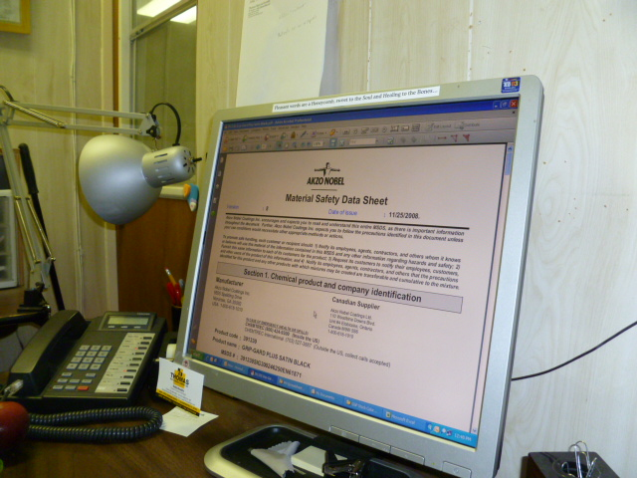

Project Id: 88183 Permit No: 1030154-004-AO Arms Number: 0154 001
Inspector: Shea Jackson Inspection Date / Time: 11/14/2013 / _______
Source (EU): Three paint spray booths: Booth 1- Binks, Model TFC-16-1 & Booth 2- Binks, Model FEC-10-7; and Booth 3 - Black Crowe Manufacturing; and a brush painting area for the coating of metal and plastic sign parts and metal sign posts.

Description: [MSD sheets in personal computer system, and Grip Guard calculations spread sheet from vendor used for VOC calculation to maintain 3.5 VOC contents] ]

