1030153 80613
FACILITY: HOWCO Environmental Services, Inc. |  |  |  |  |  |  |  |  |  |  |  |  |  |  |  |  |  |  |  | PERMIT ID: 2245
 |  |  |  |  |  |  |  |  |  |  |  |  |  |  |  |  |  |  |  | DISTRICT: Southwest
ADDRESS: 843 43rd Street South |  |  |  |  |  |  |  |  |  |  |  |  |  |  |  |  |  |  |  | CONTACT PHONE:
St. Petersburg, FL |  |  |  |  |  |  |  |  |  |  |  |  |  |  |  |  |  |  |  | 727-437-4059
ARMS NO:  1030153 004 |  |  |  |  |  |  |  | PERMIT NO: |  |  |  |  |  |  |  |  |  |  |  | Expiration Date: 3/10/2016  Renewal Date: 1/10/2016
 |  |  |  |  |  |  |  | 1030153-012-AO
 |  |  |  |  |  |  |  |  |  |  |  |  |  |  |  |  |  |  |  | Test Due Date: 5/30/2000
EMISSION UNIT DESCRIPTION : Air Stripper No. 2 - Environmental Products, Inc. Shallow Tray Model No. 3631
CMS INSPECTION DATE: |  |  |  |  |  |  | ARMS INSPECTION TYPE: |  |  |  |  |  |  |  |  |  |  |  |  |  |  | COMPLIANCE STATUS:
 | April 10, 2012 |  |  |  |  |  |  |  |  | INS1 |  | ü | INS2 |  |  | INS3 |  |  | FUI |  |  |  | ü |  | IN |  |  | MNC |  |  |  |  | SNC
INSPECTION TYPE: |  |  |  | ü | Initial |  |  |  |  |  | Re-inspection |  |  |  |  |  | Complaint |  |  |  |  |  |  | Drive-by |  |  |  |  |  | Quarterly
✓ |  |  | A. General Review:
1. |  | Permit File Review |  |  |  |  |  |  |  |  |  |  |  |  |  |  |  |  |  |  |  |  |  |  |  |  |  |  | Yes |  |  |  |  | No
 |  | Comments:
2. |  | Introduction and Entry |  |  |  |  |  |  |  |  |  |  |  |  |  |  |  |  |  |  |  |  |  |  |  |  |  |  | Yes |  |  |  |  | No
 |  | Comments: I reviewed the records with Mr. Richard Dillen and gave me a tour of the facility.
3. |  | Is the Responsible Official/Authorized Representative still: Tim Hagan? |  |  |  |  |  |  |  |  |  |  |  |  |  |  |  |  |  |  |  |  |  |  |  |  |  |  | Yes |  |  |  |  | No
Comments: yes, but he is not located at the emission work site, operates from another office.
The Responsible Official/Authorized Representative’s e-mail is:
4. |  | Is the facility contact still: Richard Dillen? |  |  |  |  |  |  |  |  |  |  |  |  |  |  |  |  |  |  |  |  |  |  |  |  |  |  | Yes |  |  |  |  | No
Comments:
The facility contact’s e-mail is: rdillen@howcousa.com
IN | MNC | SNC | B. Specific Conditions:
✓  ✓  ✓  ✓  ✓  ✓  ✓  ✓  ✓  ✓  ✓  ✓  ✓ |  |  | Permitting note: This is a renewal permit that became effective on 3/11/11  A.2. Water Throughput Rate - The water throughput rate to Air Stripper No. 1 and Air Stripper No. 2 shall not exceed 28.0 gpm and 90.0 gpm, respectively. [Rule 62-296.320(1), F.A.C.; Construction Permit 1030153-010-AC]  Comments: The plant was not in operation at this time. The facility is modifying the oil heater to allow the use of natural gas or fuel oil operation. They receive a permit amendment under 1030153-03AC on 4/9/2012. I observed the work being performed on oil heater and the removal of a storage tank. I asked Mr. Dillen how often the check the strippers as records are not recorded daily. Mr. Dillen stated the gallons per minute for the Strippers are checked every time the water is processed, records state no flow when gpm not recorded. Mr. Dillen checks the flow rate the gallons thru the system are divided by hours of processing, and minutes for flow rate that is recorded into the records.  A.3. Air Flow Rates - The minimum airflow for each Air Stripper shall be 1,200 acfm.  [Rule 62-4.070(3), F.A.C.; Construction Permit 1030153-010-AC]  Comments: The air flow rate is recorded on the continuous monitor. There is a continuous monitor panel recording the acfm.  A.4. Operation Mode - The air strippers are allowed to operate simultaneously.  [Rule 62-4.070(3), F.A.C.; Construction Permit 1030153-010-AC]  Comments: The strippers were not in operation at this time. The plant is temporarily shut down during this time. The heater which heats the water and oil for separation process was being converted from fuel oil to natural gas operation.  A.5. Mist Control Mechanism - To ensure that there is no mist carry-over impacting the surrounding area, each air stripper shall have adequately sized de-mister pads in the air stripper tower.  [Rule 62-4.070(3), F.A.C.; Construction Permit 1030153-010-AC]  Comments: The mister pads are inside the stripper structure. The pads are cleaned annually prior to testing.  A.6. VOC/OS Emission Limitations – VOC/OS emissions shall not exceed the following:  Permitting Note: Organic solvent emissions are included in the total emission limitations, since the EPA Methods used to analyze the waste water, as required by Specific Condition No. A.10., do not separate VOCs from the OSs that are not considered VOCs.  [Rule 62-210.200 (“Potential to Emit”), F.A.C.; Construction Permit 1030153-010-AC]  Comments: The monthly Batch VOC/OS report records reviewed demonstrated that the VOC permit limitations could not likely be achieved in a 12 month consecutive total. The records show that stripper No. 1 was 12.72 lbs, and Stripper no. 2 was 198lbs. These are typical monthly emissions totals.  A.7. Stripper Air Flow Testing Requirements - The stack airflow of each air stripper shall be tested annually within 60 days prior to or on the date of May 30. [Rules 62-4.070(3) and 62-297.310(7)(a)1, F.A.C.; Construction Permit 1030153-010-AC]  Comments: I asked Mr. Dillen, when they would be performing the next annual test, he stated it is scheduled for April 19, 2012. He stated the consultant for Ken Givens for Air testing and Consulting had sent test notification to Tammy Allen’s attention. He sent copy to our office.  (see copy attached). The test was rescheduled for April 25, 2012.  A.8. Test Requirements - Tests shall be conducted in accordance with the applicable requirements specified in Appendix D (Common Testing Requirements) of this permit.  [Rule 62-297.310, F.A.C.]  Comments: The consultant will perform method 1 & 2 for Air Flow rate on the Strippers.  A.9. Test Methods - Required tests shall be performed in accordance with the following reference methods.  The above method(s) are described in Appendix A of 40 CFR 60 and are adopted by reference in Rule 62-204.800, F.A.C. No other method(s) may be used unless prior written approval is received from the Department. [Rules 62-204.800 and 62-297.100, F.A.C.; and Appendix A of 40 CFR 60]  Comments: The test notification stated the above Methods will be tested on April 19, 2012. Changed to April 25, 2012  A.10. VOC/OS Concentration in Wastewater Test Methods - In order to demonstrate compliance with Specific Condition No. A.6., the batch waste water throughput shall be analyzed monthly using the appropriate EPA Method such as 601, 602, 625, etc. (see 40 CFR 136.3, Table 1C) prior to entering each air stripper (influent), and after exiting (treatment) each air stripper (effluent). The results of the effluent analysis for Air Stripper No. 2 cannot be used as the analysis results for the influent to Air Stripper No. 1. [Rule 62-4.070(3), F.A.C.; Construction Permit 1030153-010-AC]  Comments: I reviewed the records for the wastewater throughput which is sent to be analyzed monthly by Pace Analytical lab. I reviewed the labs field copies. Mr. Hagan stated that for example when the influent is measured as brought into system for Benzene at 40 ppm prior to the air stripper, and then it is measured to be 20ppm at the effluent point exiting the stripper. The evaporated emission through the stripper out to atmosphere would be 20 ppm of Benzene.  A.11. Water Flow Rate Monitoring - The permittee shall comply with the following:  a. The water flow rate in gallons per minute (gpm) to Air Stripper No. 1 shall be continuously monitored and recorded on monitor’s circular chart. The monitor’s recordings shall be obtained from the measurements on the upstream side for Air Stripper No. 1 and the downstream side of the holding tank.  b. The water flow rate in gallons per minute (gpm) to Air Stripper No. 2 shall be determined from each batch by manually recording the amount of water in gallons and the total time in minutes of transferring the batch of water. [Rule 62-4.070(3), F.A.C.; Construction Permit 1030153-010-AC]  Comments: a. the continuous monitor was not in operation at this time, had been shutdown, chart showed trace line, where had been in operation prior to shut down of the operations.  b. Mr. Dillion performs the measurements for the water flow rate to the stripper.  A.12. Test Reports - The permittee shall prepare and submit reports for all required tests in accordance with the requirements specified in Appendix D (Common Testing Requirements) of this permit. [Rule 62-297.310(8), F.A.C.]  Comments: The facility will submit the reports for the test after completion within 45 days.  A.13. Additional Test Report Requirements - Air Stripper test reports shall be submitted within 45 days of testing to the Compliance Authority and include the following:  a. The associated pressure drop (delta P in inches of water).  b. For Air Stripper No. 1 - A copy of the recorder's circular chart, which measures the wastewater flow rate for each day testing occurs.  c. A copy of the monthly records required by Specific Condition No. A.14. for the month the tests were conducted.  [Rules 62-4.070(3), 62-297.310(8), F.A.C.; Construction Permit 1030153-010-AC]  Comments: The continuous monitoring chart for the day of testing should be sent with the test report, as well as circular chart for flow rate, and monthly records for month test performed.  A.14. Operating and VOC/OS Emission Records: In order to document compliance with the requirements of Specific Condition Nos. A.2., A.6., A.10., and A.11., the permittee shall keep records (Batch VOC/OS Report) which contain the following information:  DAILY  a. Facility Name, Facility ID No., Emission Unit ID No., Emission Unit Description, and Date (month/day/year).  b. The start and end operating times, and total operating hours for each air stripper.  c. The gallons/day of water through each air stripper. Gallons/hour of water through Air Stripper No. 1 shall be documented by the circular chart of the continuous monitor's recorder.  d. The pressure drop (in inches of H₂O) across each of the air strippers.  MONTHLY  e. Facility Name, Facility ID No., Emission Unit ID No., Emission Unit Description, and Date (month/year).  f. A monthly total (hours/month) and a cumulative consecutive 12-month period total (hours/consecutive 12-month period) of air stripper operating hours for each air stripper.  g. The concentration levels of each pollutant in the influent and effluent based on laboratory gas chromatograph results.  h. The monthly (pounds/month) and consecutive 12-month period total (tons/most recent consecutive 12-month period) of VOC/OS emissions for each air stripper.  i. A combined (Air Stripper No. 1 + Air Stripper No. 2) consecutive 12-month total of VOC/OS emissions (tons/most recent consecutive 12-month period).  Other supporting documentation, such as quantitative analysis of the contaminated water, and gas chromatograph results (as presented in the laboratory reports) which gives the concentration levels of each pollutant in the influent and effluent, shall also be retained and made available at the facility. [Rule 62-4.070(3), F.A.C.; Construction Permit 1030153-010-AC]  Comments: The records reviewed called Batch VOC/OS reports are shown on two sheets. The records were in compliance with the above stated guidelines a-i. (See obtained record copies )
  Pollutant | Air Stripper No. 1 (tons per any consecutive 12 month period) | Air Stripper No.2  (tons per any consecutive 12 month period) | Total from both Air Strippers combined (tons per any consecutive 12 month period)
  Volatile Organic Compounds (VOCs)/Organic Solvents (OS) | 1.0 | 5.0 | 6.0
  Method(s) | Description of Method and Comments
  1 and 2 | Traverse Points and Velocity and Flow Rate
✓ |  |  | Valid Permit [Rule 62-210.300]
✓ |  |  | Changes to Facility/emission unit [Rule 62-210.300]  Does the emission unit description above match what the facility is operating (Number of emission units or points, model number and serial number, etc.) Yes No  Comments:

✓ |  | C. Other:
Pollution Prevention Activities
- P2 Handouts Provided: P2 Brochure; P2 Manual; P2 Checklist
- Have any emissions reductions occurred Yes / No
Chemical Substitution; Equipment Changes; Process Changes
Chemical/Material Reuse; On-site Recycling; Other:
Comments: The facility recycles 3000 gallons of oil, from used car oil containers and filters. The metal containers and filters are sent to a foundry in Jacksonville. The antifreeze collected is sent to Fort Meyer.

Closing Conference: : The facility appears to be in compliance. The conversion to natural gas may also help address the citizen complaints regarding nuisance odors.

Inspector(s): Shea Jackson, Pinellas County, Air Quality Division
Signature(s): Date: |  |  |  |  |  |  | Date: April 17, 2012
 | ACCESS? |  |  | ARMS?

AIRS ID  1030153 | OWNER  HOWCO Environmental Services, Inc. |  | FACILITY NAME
TITLE V |  | SYNTHETIC MINOR | DATE OF THIS FCE
TITLE V MEGA-SITE* |  | OTHER | DATE OF LAST FCE
*Facility with a large number of complex emissions units. It is more reasonable to evaluate a Title V Mega-Site once every 3 years instead of once every 2 years.

Review of All Required Reports

PERIODIC REPORTS |  | COMMENTS
DONE N/A | Annual operating report | Report was received 3/30/12
DONE N/A | Statement of compliance
DONE N/A | Annual
DONE N/A | Semi-annual
DONE N/A | Quarterly
DONE N/A | Other :
DONE N/A | Other :

CONTINUOUS EMISSION MONITOR REPORTS |  | COMMENTS
DONE N/A | Quarterly excess emissions
DONE N/A | Semi-annual
DONE N/A | RATA
DONE N/A | CGA
DONE N/A | Other :
DONE N/A | Other :

Assessment of Control Device and Process Operating Conditions

OFF-SITE ASSESSMENT |  | (Describe the off-site assessment in comments)
ON-SITE ASSESSMENT |  | (Document the on-site inspection below)
DATE OF INSPECTION | DATE OF INSPECTION REPORT |  | My office maintains the inspection report...
DATE OF INSPECTION |  |  | ...in the ARMS database through EASIIR. | ...with the paper or electronic compliance files | ...in another location (specify).
4/10/2012 | 4/17/12 |  |  |  | Access database
COMMENTS

Review of Tests and Records
TESTS, OBSERVATIONS AND RECORDS |  | COMMENTS
DONE N/A | Visible emission observation(s) | Oil heater was not in operations at time of inspection
DONE N/A | Review of facility records and logs | Reviewed records on site
DONE N/A | Assessment of process parameters (feed rates, process rates, raw material compositions, etc.) | Reviewed records on site
DONE N/A | Assessment of control equipment performance parameters  (water flow rates, pressure drops, temperatures, ESP power levels, etc.) | Reviewed records on site and observed control and panels were operational and had recorded the temperatures prior to emission unit shutdown.
DONE N/A | Stack test(s) | 4/25/2012 test is scheduled for performance
DONE N/A | Other :
DONE N/A | Other :

Compliance Monitoring (CM) Information
CM ELEMENT | My office maintains this information...
CM ELEMENT | ...electronically, in the ARMS database. | ...in the permit. | ...in the inspection report. | ...in another location (specify).
Facility information |  |  |  | in access data base
Applicable requirements |  |  |  | in access data base
Inventory of emission units |  |  |  | in access data base
Enforcement history |  |  |  | in access data base
Compliance activities |  |  |  | in access data base
Findings and recommendations |  |  |  | in access data base
COMMENTS

Other Comments

Prepared by: Shea Jackson Date: 4/17/2012

Reviewed by: Date:

1. Complete the form as much as possible during for inspection; 2. The remainder of checklist, for activities in the FY, are filled in no later than 9/15; 3. Between 9/15 and 9/30, complete the FCE by closing out the FCS project in ARMS. The INSP > FCS record only accepts a completion date and a comment; it does not accept information on the lower portion of the form. If an FCS project already exists for the fiscal year in question, enter a completion date and comment in the existing record, do not create a duplicate FCS record.

HOWCO Environmental Services, Inc.
843 43rd Street South, St. Petersburg

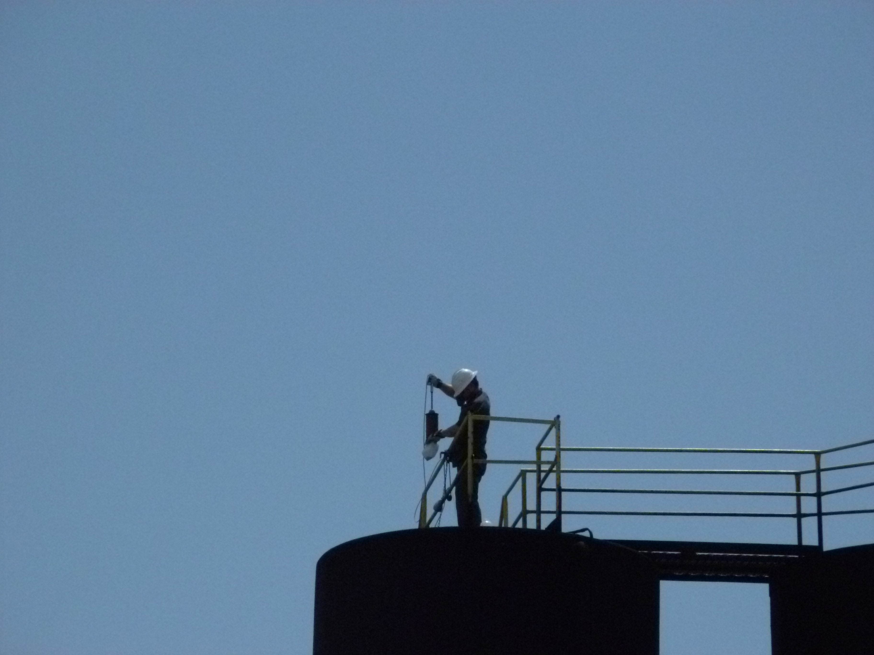

Project Id: 80613 Permit No: 1030153-012-AO Arms Number: 0153 004
Inspector: Shea Jackson Inspection Date / Time: 4/10/2012
Source (EU): Air Stripper No. 2 - Environmental Products, Inc. Shallow Tray Model No. 3631

Description: [Employee collecting a sample from the storage tank water treatment side of plant]

HOWCO Environmental Services, Inc.
843 43rd Street South, St. Petersburg

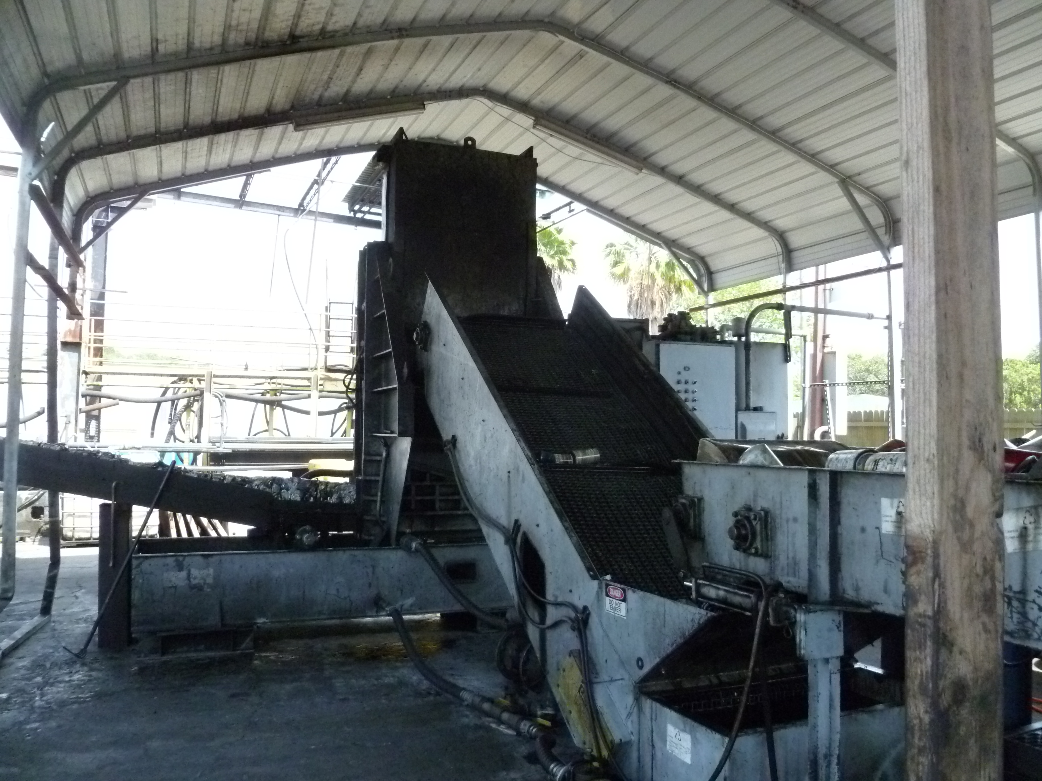

Project Id: 80613 Permit No: 1030153-012-AO Arms Number: 0153 004
Inspector: Shea Jackson Inspection Date / Time: 4/10/2012
Source (EU): Air Stripper No. 2 - Environmental Products, Inc. Shallow Tray Model No. 3631

Description: [This is the car oil filter recycling unit. The car filters are crushed, the oil is reclaimed and

metal blocks are sent to scrap metal ]

HOWCO Environmental Services, Inc.
843 43rd Street South, St. Petersburg

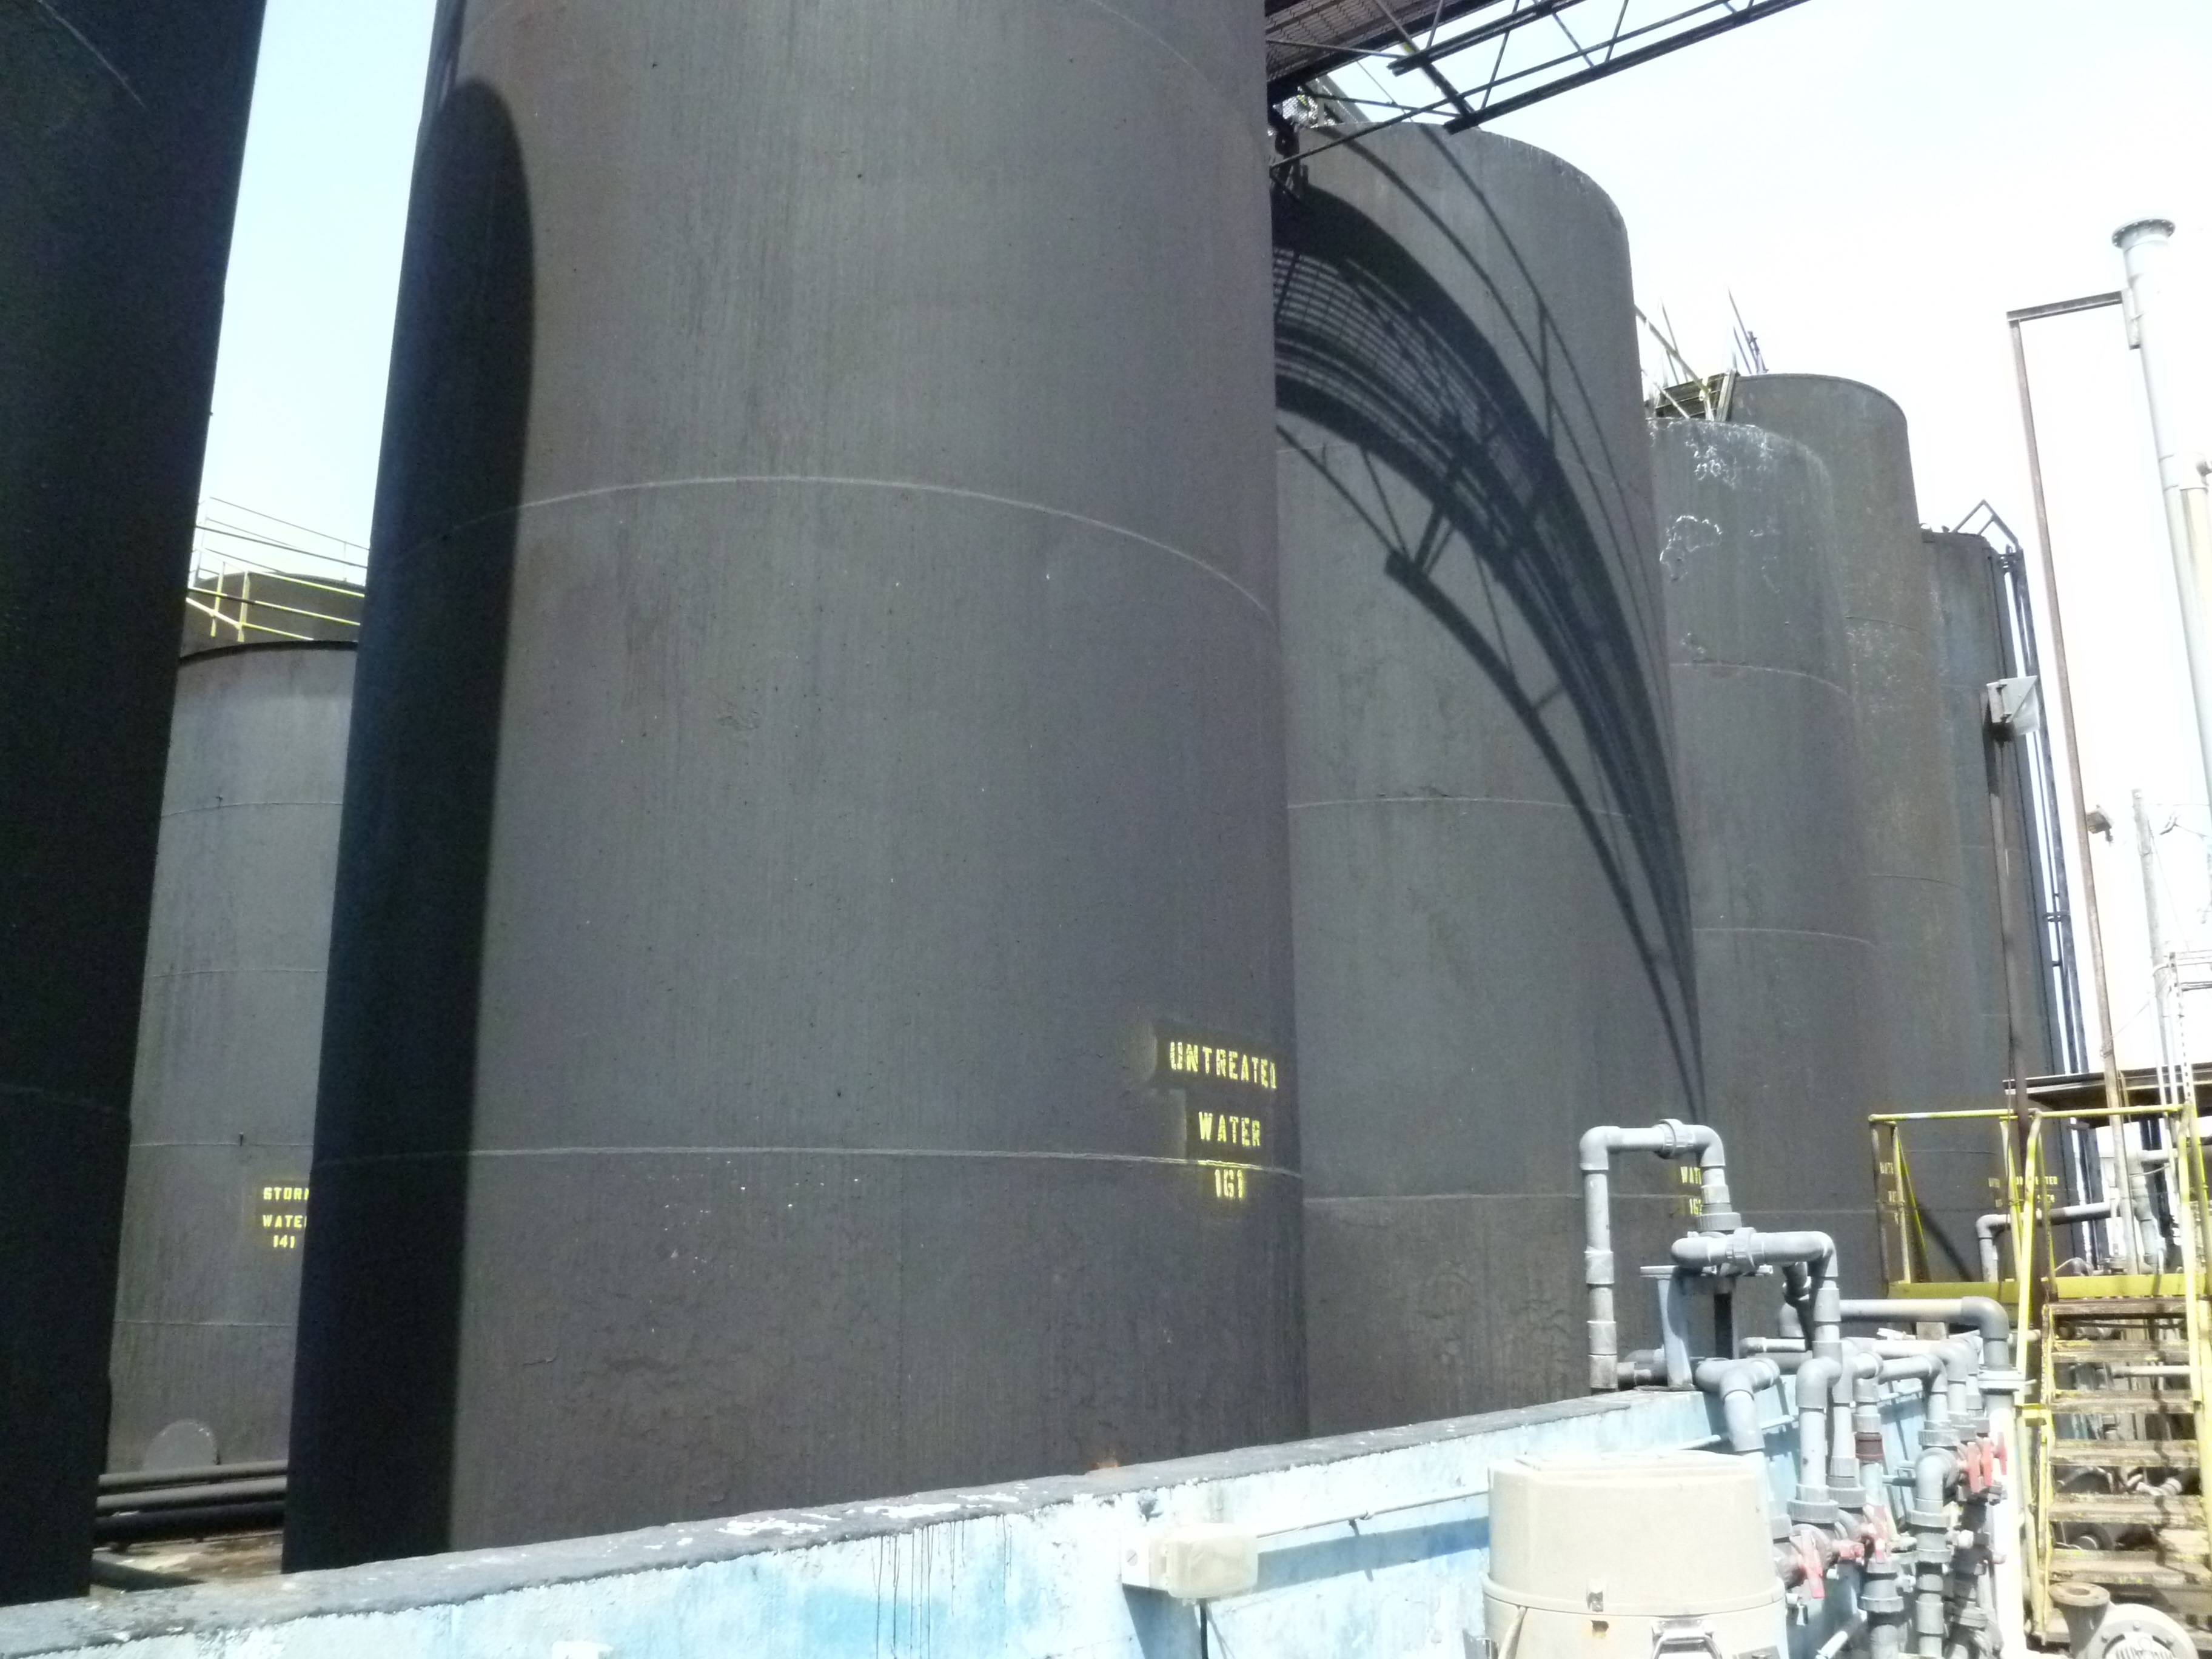

Project Id: 80613 Permit No: 1030153-012-AO Arms Number: 0153 004
Inspector: Shea Jackson Inspection Date / Time: 4/10/2012 / _______
Source (EU): Air Stripper No. 2 - Environmental Products, Inc. Shallow Tray Model No. 3631

Description: [This the tank farm containment area for the oil side of plant. ]

