1030118 75614
FACILITY: Schneller, LLC |  |  |  |  |  |  |  |  |  |  |  |  |  |  |  |  |  |  |  | PERMIT ID: 976
 |  |  |  |  |  |  |  |  |  |  |  |  |  |  |  |  |  |  |  | DISTRICT: Southwest
ADDRESS: 6200 49th St. No. |  |  |  |  |  |  |  |  |  |  |  |  |  |  |  |  |  |  |  | CONTACT PHONE:
Pinellas Park, FL |  |  |  |  |  |  |  |  |  |  |  |  |  |  |  |  |  |  |  | 727-521-2393
ARMS NO:  1030118 006 |  |  |  |  |  |  |  | PERMIT NO: |  |  |  |  |  |  |  |  |  |  |  | Expiration Date: 3/4/2017  Renewal Date: 7/22/2016
 |  |  |  |  |  |  |  | 1030118-011-AV
 |  |  |  |  |  |  |  |  |  |  |  |  |  |  |  |  |  |  |  | Test Due Date:
EMISSION UNIT DESCRIPTION : MEK Parts Cleaning Operations: MEK and a kerosene parts washer parts cleaning stations are located at the screen printing area, color mixing area. The tanks are approximated 8 gal. in capacity with self closing lids
CMS INSPECTION DATE: |  |  |  |  |  |  | ARMS INSPECTION TYPE: |  |  |  |  |  |  |  |  |  |  |  |  |  |  | COMPLIANCE STATUS:
 | November 29, 2012 |  |  |  |  |  |  |  |  | INS1 |  |  | INS2 | ü |  | INS3 |  |  | FUI |  |  |  | ü |  | IN |  |  | MNC |  |  |  |  | SNC
INSPECTION TYPE: |  |  |  | ü | Initial |  |  |  |  |  | Re-inspection |  |  |  |  |  | Complaint |  |  |  |  |  |  | Drive-by |  |  |  |  |  | Quarterly
ü |  |  | A. General Review:
1. |  | Permit File Review |  |  |  |  |  |  |  |  |  |  |  |  |  |  |  |  |  |  |  |  |  |  |  |  |  |  | Yes |  |  |  |  | No
 |  | Comments: The facility requested surrender of permit for closing facility in Pinellas County.
2. |  | Introduction and Entry |  |  |  |  |  |  |  |  |  |  |  |  |  |  |  |  |  |  |  |  |  |  |  |  |  |  | Yes |  |  |  |  | No
 |  | Comments: Tammy Allen and I met with Eric Custis on site
3. |  | Is the Responsible Official/Authorized Representative still: Eric Custis? |  |  |  |  |  |  |  |  |  |  |  |  |  |  |  |  |  |  |  |  |  |  |  |  |  |  | Yes |  |  |  |  | No
Comments: Yes, until closure complete 12/30/2012
The Responsible Official/Authorized Representative’s e-mail is: ecustis@schneller.com
4. |  | Is the facility contact still:? |  |  |  |  |  |  |  |  |  |  |  |  |  |  |  |  |  |  |  |  |  |  |  |  |  |  | Yes |  |  |  |  | No
Comments: Yes, but after closure if other items need further attention contact Bruce Wilson, VP of Operations
6019 Power Mill road, Kent Ohio 44240
The facility contact’s e-mail is: bwilson@schneller.com
IN | MNC | SNC | B. Specific Conditions:
ü  ü  ü  ü  ü  ü  ü  ü  ü |  |  | Annual Operating Report for Air Pollutant Emitting Facility.  (a) The Annual Operating Report for Air Pollutant Emitting Facility (DEP Form No. 62-210.900(5)) shall be completed each year.  (b) The annual operating report shall be submitted to the appropriate Department of Environmental Protection (DEP) division, district or DEP-approved local air pollution control program office by March 1 of the following year.  (c) Beginning with 2007 annual emissions, emissions shall be computed in accordance with the provisions of Rule 62-210.370(2), F.A.C., for purposes of the annual operating report.  [APPENDIX TV-6, TITLE V CONDITION 24(3)]  Comments: The facility submitted the 2011 AOR on 3/1/12. The reports for 2012 were requested within 60 days after the closing down of operations. Mr. Curtis stated all reports are being prepared by their consultant Cory Houchin and he would be submitting 1st week of December.  2. General Pollutant Emission Limiting Standards: Objectionable Odor Prohibited - No person shall cause, suffer, allow or permit the discharge of air pollutants which cause or contribute to an objectionable odor. An objectionable odor is any odor present in the outdoor atmosphere which by itself or in combination with other odors, is or may be harmful or injurious to human health or welfare, which unreasonably interferes with the comfortable use and enjoyment of life or property, or which creates a nuisance. [Rules 62-210.200, and 62-296.320(2), F.A.C.; Pinellas County Code, Section 58-178]  Comments: There were no odors inside or outside of the production buildings or on the Schneller property.  3. General Particulate Emission Limiting Standards: General Visible Emissions Standard - Except for emissions units that are subject to a particulate matter or opacity limit set forth or established by rule and reflected by conditions in this permit, no person shall cause, let, permit, suffer or allow to be discharged into the atmosphere the emissions of air pollutants from any activity, the density of which is equal to or greater than that designated as Number 1 on the Ringelmann Chart (20 percent opacity). EPA Method 9 is the method of compliance pursuant to Chapter 62-297, F.A.C.  [Rules 62-296.320(4)(b)1 & 62-296.320(4)(b)4, F.A.C.]  Comments: This facility was not a source of particulate emissions. The property around the building is paved. There was no accumulated debris or unconfined emissions from the remaining activities at the facility as they continue to remove equipment and materials. There were no fugitive dust emissions observed at this time  4. Prevention of Accidental Releases (Section 112(r) of CAA)-  a. The permittee shall submit its Risk Management Plan (RMP) to the Chemical Emergency Preparedness and Prevention Office (CEPPO) RMP Reporting Center when, and if, such requirement becomes applicable.  b. The permittee shall submit to the permitting authority Title V certification forms or a compliance schedule in accordance with Rule 62-213.440(2), F.A.C.  [40 CFR 68]  Comments: The facility submitted the RMP with its permit renewal. , Section 112(r) of the CAA does not apply to this facility since it does not use any of the pollutants listed in 40 CFR 68.130 in relation to any of the regulated Emission Units.  5. Insignificant Emissions Units and/or Activities - Appendix I-1, List of Insignificant Emissions Units and/or Activities, is a part of this permit. [Rules 62-213.440(1), 62-213.430(6), and 62-4.040(1)(b), F.A.C.]  6. Unregulated Emissions Units and/or Activities - Appendix U-1, List of Unregulated Emissions Units and/or Activities, is a part of this permit. [Rule 62-213.440(1), F.A.C.]  Comments: The list of Insignificant and Unregulated Emission Units and/or activities remains the same. Most of the insignificant emissions units have been removed, from the facility only the MEK storage, and Plastic wrapping and heat sealing activities, and Box marking and taping activities.  7. General Pollutant Emission Limiting Standards. Volatile Organic Compounds (VOC) Emissions or Organic Solvents (OS) Emissions. The permittee shall allow no person to store, pump, handle, process, load, unload or use in any process or installation, volatile organic compounds (VOC) or organic solvents (OS) without applying known and existing vapor emission control devices or systems deemed necessary and ordered by the Department.  (a) Ensure all lids, caps, covers on cans and other containers are properly fitted and maintained such that vapor emissions are minimized.  (b) Repair all leaks in piping, process equipment, and storage containers immediately and/or removing solvents to secure containers until repairs can be effected.  (c) All VOCs from solvent washing (equipment cleanup) shall be directed into containers that prevent evaporation into the atmosphere.  (d) For each parts cleaner, comply with each of the following requirements:  1. Equip the cleaner with a cover. The cover shall be so designed that it can be easily operated with one hand.  2. Equip the cleaner with a facility for draining cleaned parts. The drainage facility shall be constructed internally so that parts are enclosed under the cover while draining if the solvent volatility is greater than 0.6 pounds per square inch (31 millimeters of mercury or 4.1 kilopascals) measured at 100 degrees Fahrenheit (38 degrees Celsius), except that the drainage facility may be external for the applications where an internal type cannot fit into the cleaning system.  3. Provided a permanent, conspicuous label summarizing the operating requirements.  4. Store waste solvent only in covered containers.  5. Close the cover whenever parts are not being handled in the cleaner.  6. Drain the cleaned parts for at least 15 seconds or until dripping ceases.  7. If used, supply a solvent spray that is a solid fluid stream (not a fine, atomized, or shower-type spray) at a pressure which does not cause excessive splashing. [Rule 62-296.320(1)(a), F.A.C., previous Title V permit 1030118-010-AV]  (Permitting Note: The volatility of MEK is greater than 0.6 pounds per square inch measured at 100 degrees Fahrenheit. The volatility of kerosene is less than 0.6 pounds per square inch measured at 100 degrees Fahrenheit).  Comments: During the tour and observations of the facility, we observed the facility’s remaining containers were closed, and removed to storage for disposal and shipment to sister facility. There were no observations of leaks from removed equipment. Containers were labeled.  9. Statement of Compliance – The annual statement of compliance pursuant to Rule 62-213.440(3)(a)2., F.A.C. shall be submitted to this office, the EPA, and the Air Program of the Pinellas County Department of Environmental Management (PCDEM), within 60 days after the end of the calendar year using DEP Form No. 62-213.900(7), F.A.C. [Rules 62-4.070(3), 62-213.440(3), and 62-213.900(7), F.A.C.]  Comments: The 2011 ASOC was received (stamped at AQD) as received on 2/6/2012. The 2012 final ASOC will be submitted by the consultant Cory Houchin the first part of December 2012.  D.1. VOC Emissions Limitations - In order to qualify for an exemption from Rule 62-296.511, F.A.C., Reasonably Available Control Technology (RACT), Solvent Metal Cleaning, VOC emissions from the parts cleaning operations shall not exceed 2.7 tons per any consecutive 12-month period.  [Rule 62-296.500(3)(a), F.A.C.]  Comments: The highest VOC Emissions for this EU were 1.54 tons in the last 12 consecutive running cumulative totals. The usage of the solvent had ceased at the end of 10/2012. The facility was in compliance of their emissions limitation for this emission unit.  D.2. Monthly Records - Records shall be kept of usage of all VOC containing materials to document compliance with the limitations of condition No. D.1. The records shall include, but not be limited to, the following:  (a) facility name, month, and year;  (b) quantity of each VOC solvent used for parts cleaning;  (c) quantity of VOC solvent removed for disposal; and  (d) calculated VOC emissions for the month (lbs) and for the most recent consecutive 12-month period (tons).  Records of all calculations used to determine VOC emissions, and supporting documentation (MSD sheets, EPA data sheets, purchase orders, etc.) shall be kept for each solvent which includes sufficient information to determine VOC emissions. Daily records shall be completed within five business days and monthly records shall be completed by the end of the following month. The above records shall be maintained for five years and made available to the Department and the Air Program of the PCDEM upon request. [Rules 62-213.440(1)(b)2.b., 62-4.070(3), F.A.C.; Pinellas Co. Code, Section 58-90]  Comments: The facility was in compliance with the record-keeping requirements in (a) thru (c). The facility used MEK up to 10/19/12. The MEK bulk tank had been drained and was scheduled for removal. (See attached copy submitted.
ü |  |  | Valid Permit [Rule 62-210.300]
ü |  |  | Changes to Facility/emission unit [Rule 62-210.300]  Does the emission unit description above match what the facility is operating Yes No  Non applicable facility shutting down and removing emission units.

ü |  | C. Other:
Pollution Prevention Activities
- P2 Handouts Provided: P2 Brochure; P2 Manual; P2 Checklist
- Have any emissions reductions occurred Yes / No
Chemical Substitution; Equipment Changes; Process Changes
Chemical/Material Reuse; On-site Recycling; Other:
Comments: .non applicable operations ceased and facility shutting down.
Closing Conference: I informed Mr. Custis we will need to review the reports and records with the close out. I informed him that if I need additional information I will contact him or Bruce Wilson, VP of operations in Ohio.

Inspector(s): Shea Jackson , Pinellas County, Air Quality Division
Signature(s): Date: |  |  |  |  |  |  | Date: December 2012
 | ACCESS? |  | ü | ARMS? | ü

/tmp/lo/0000.doc

Schneller, LLC Florida Plant
6200 49th St. No., Pinellas Park

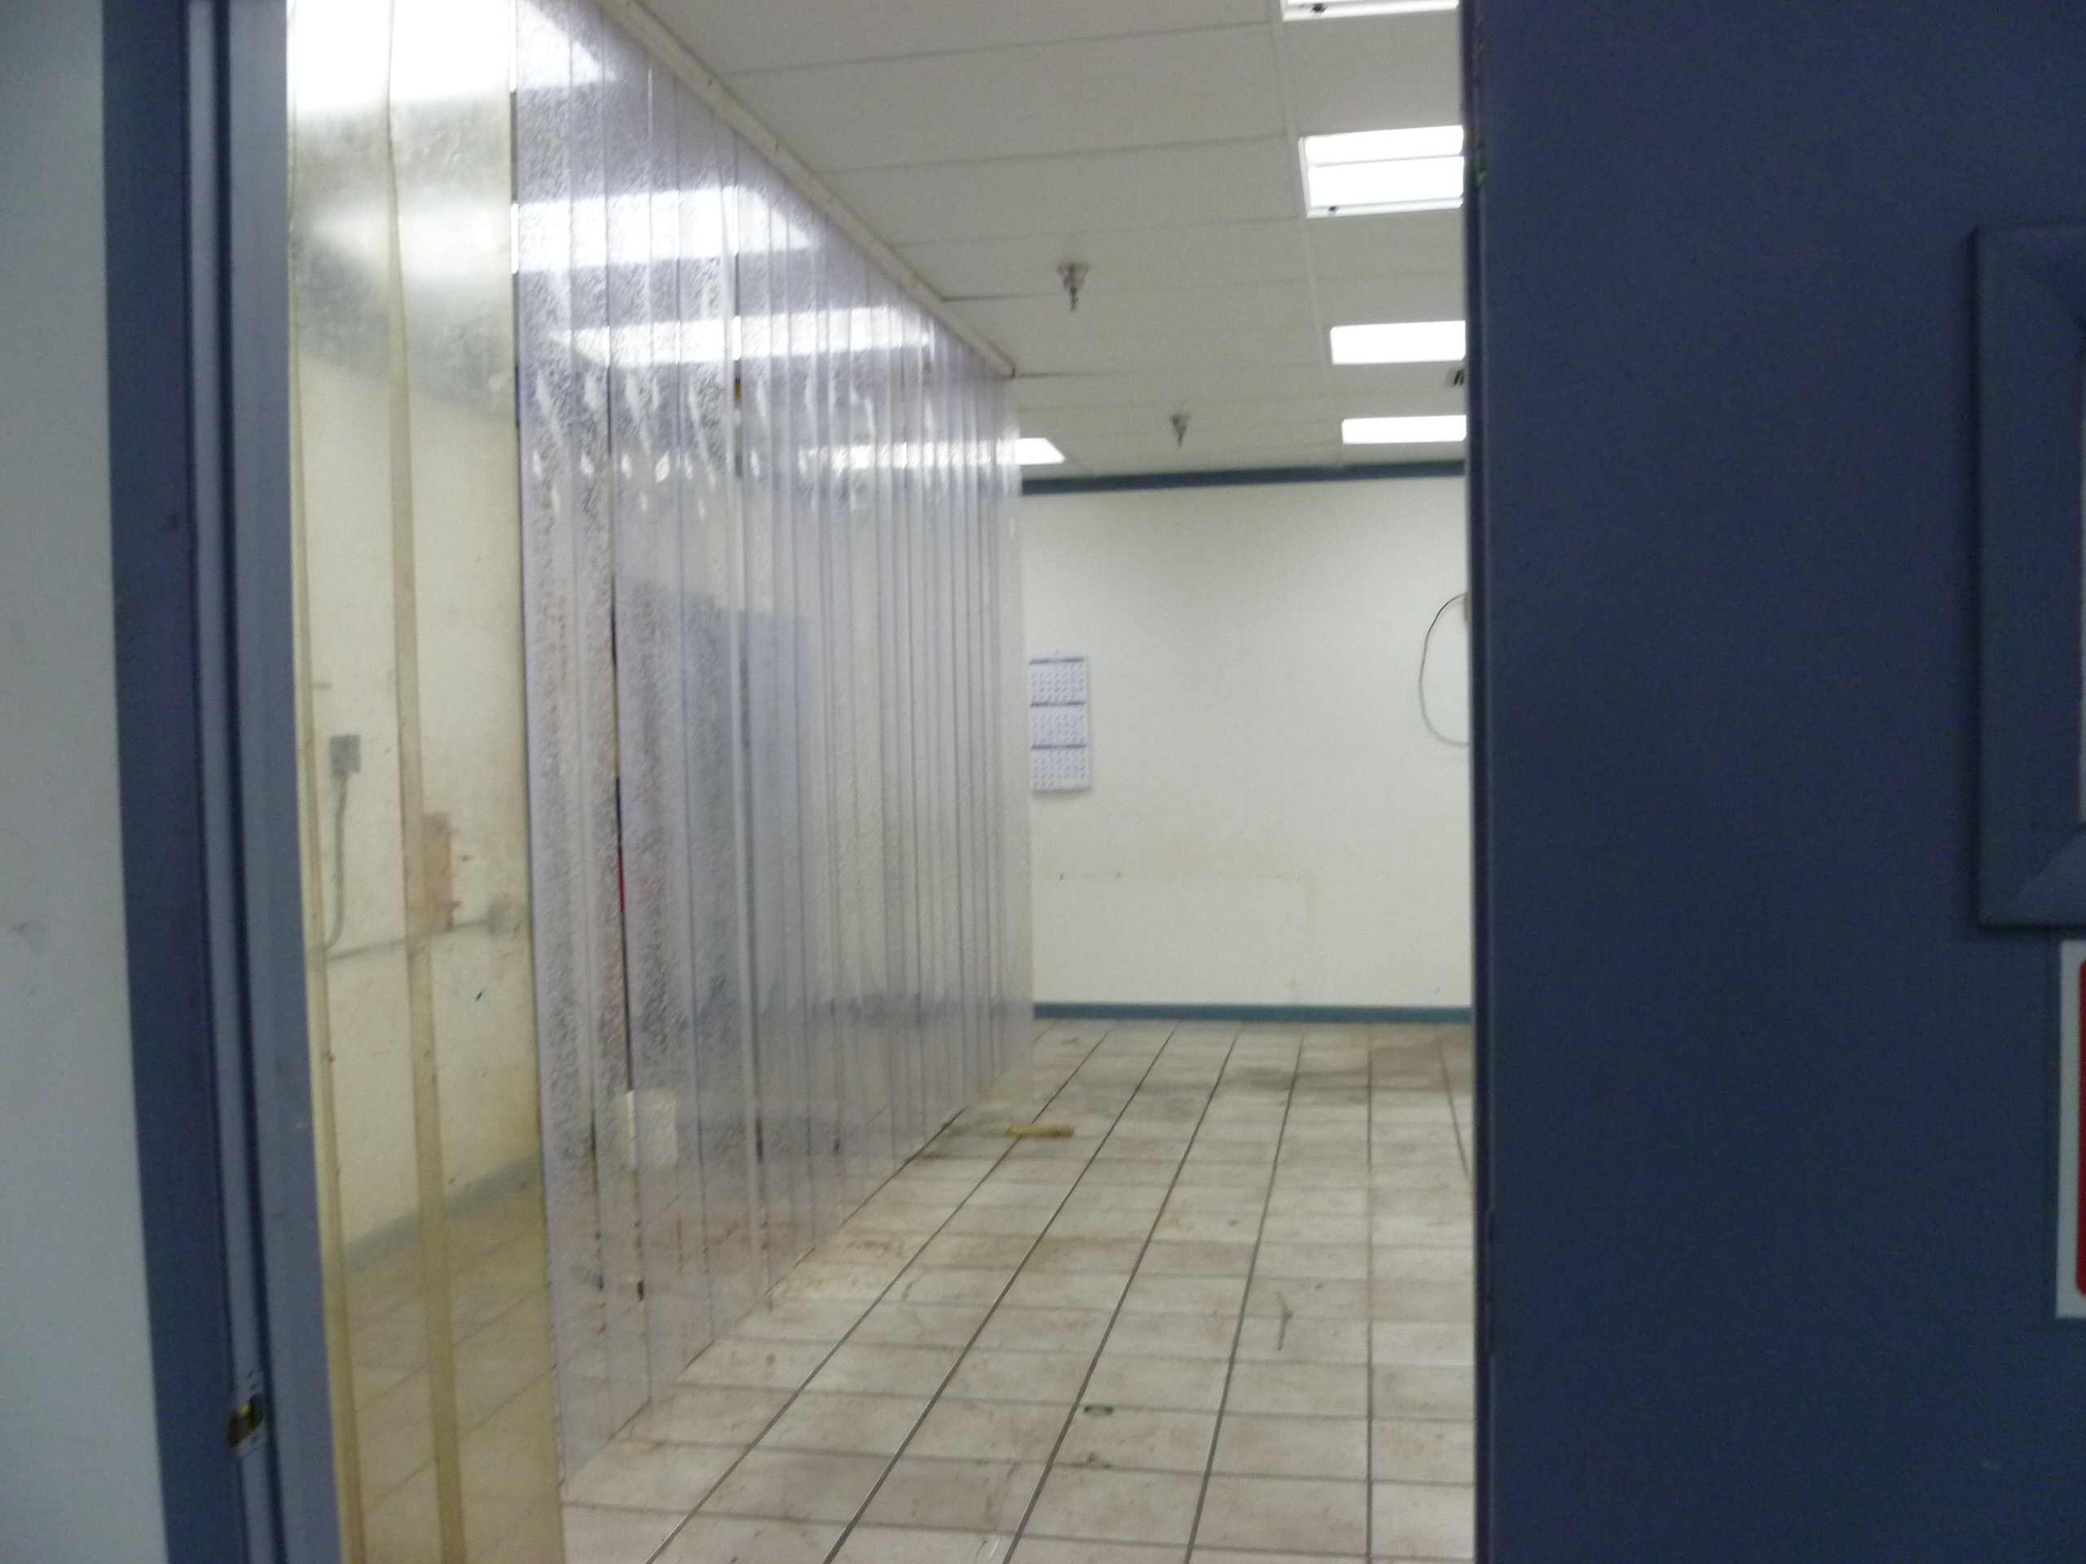

Project Id: 84543 Permit No: 1030118-014-AV Arms Number: 0118 006
2Inspector: Shea Jackson Inspection Date / Time: 11/29/2012 / _______
Source (EU): MEK Parts Cleaning Operations: MEK and a kerosene parts washer parts cleaning stations are located at the screen printing area, color mixing area. The tanks are approximated 8 gal. in capacity with self closing lids
Description: [Facility has been removing furnishing, equipment and process materials from the buildings,

this was previously the screen printing operations area.]

Schneller, LLC Florida Plant
6200 49th St. No., Pinellas Park

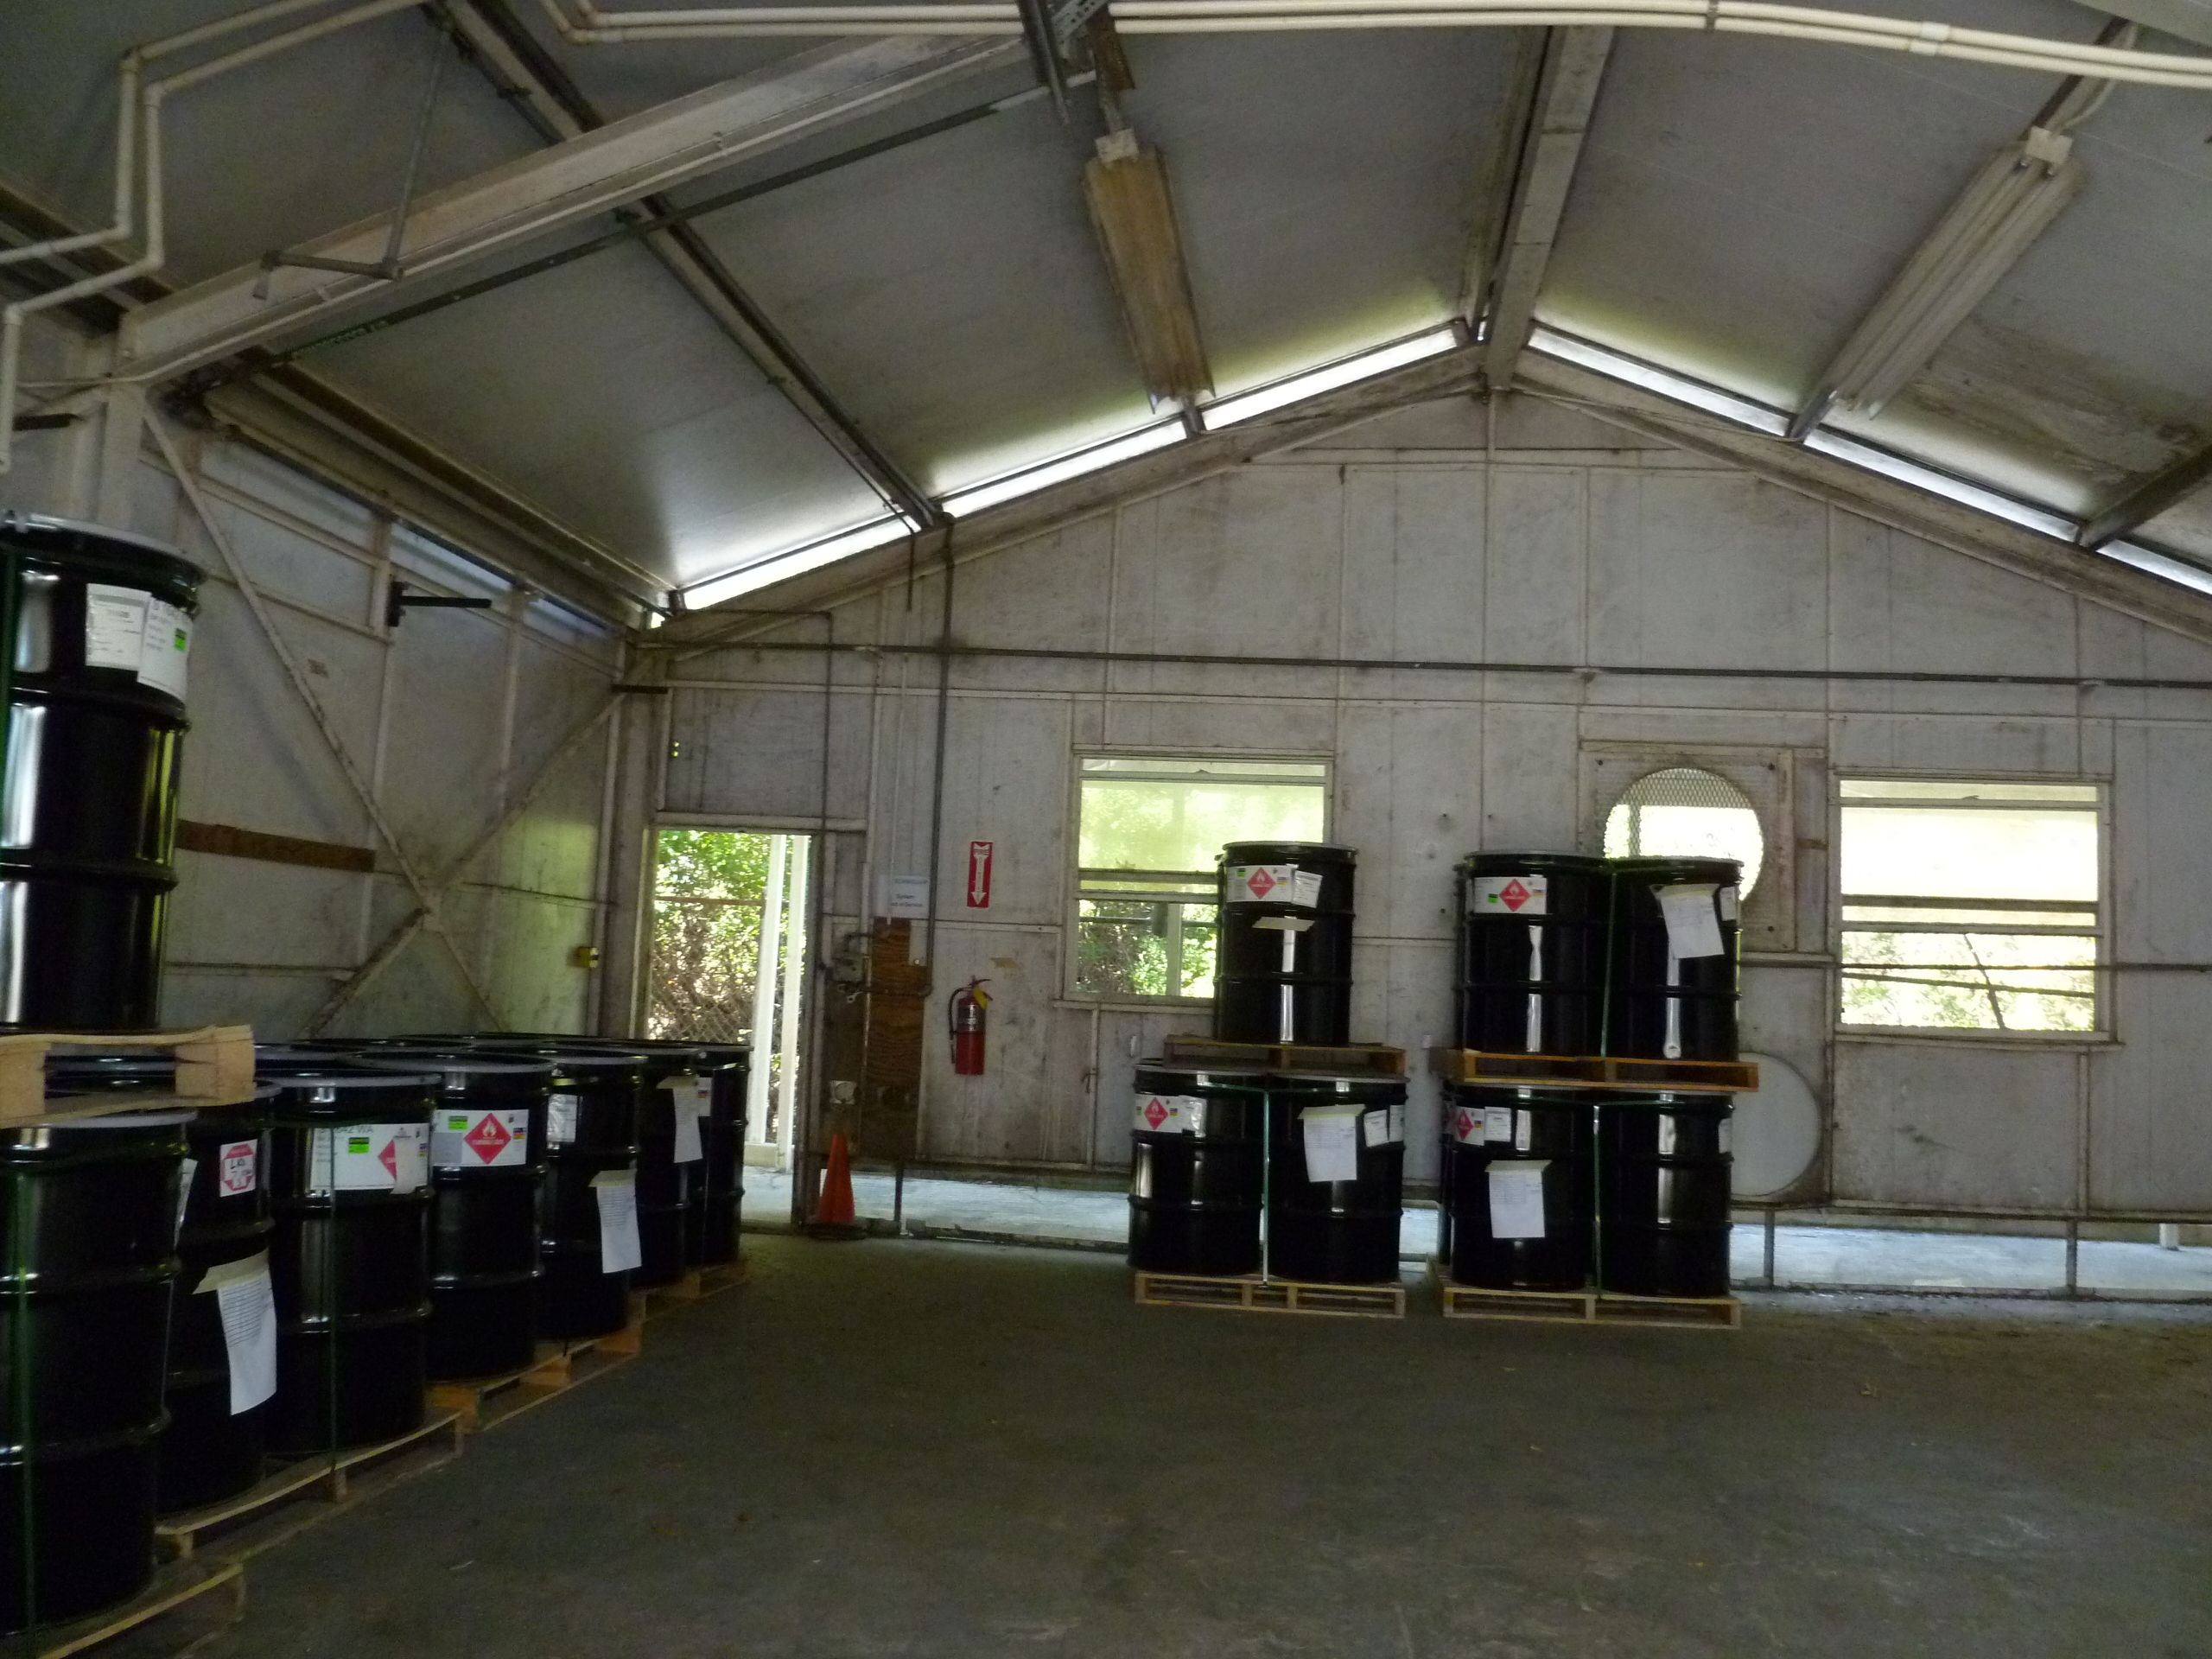

Project Id: 84543 Permit No: 1030118-014-AV Arms Number: 0118 006
Inspector: Shea Jackson Inspection Date / Time: 11/29/2012 / _______
Source (EU): MEK Parts Cleaning Operations: MEK and a kerosene parts washer parts cleaning stations are located at the screen printing area, color mixing area. The tanks are approximated 8 gal. in capacity with self closing lids
Description: [Facility has been removing process materials MEK solvent and materials from the buildings for disposal and shipment to sister facility in Ohio.]

AIRS ID  1030118 | OWNER  Schneller, LLC |  | FACILITY NAME  Florida Plant
TITLE V |  | SYNTHETIC MINOR | DATE OF THIS FCE  12/15/12
TITLE V MEGA-SITE* |  | OTHER | DATE OF LAST FCE
*Facility with a large number of complex emissions units. It is more reasonable to evaluate a Title V Mega-Site once every 3 years instead of once every 2 years.

Review of All Required Reports

PERIODIC REPORTS |  | COMMENTS
DONE N/A | Annual operating report | Facility submit within 60 days of shutdown ?
DONE N/A | Statement of compliance | Facility submit within 60 days of shutdown ?
DONE N/A | Annual
DONE N/A | Semi-annual | Subpart JJJJ, CAM within 60 days of shutdown ?
DONE N/A | Quarterly
DONE N/A | Other :
DONE N/A | Other :

CONTINUOUS EMISSION MONITOR REPORTS |  | COMMENTS
DONE N/A | Quarterly excess emissions
DONE N/A | Semi-annual
DONE N/A | RATA
DONE N/A | CGA
DONE N/A | Other :
DONE N/A | Other :

Assessment of Control Device and Process Operating Conditions

OFF-SITE ASSESSMENT |  | (Describe the off-site assessment in comments)
ON-SITE ASSESSMENT |  | (Document the on-site inspection below)
DATE OF INSPECTION | DATE OF INSPECTION REPORT |  | My office maintains the inspection report...
DATE OF INSPECTION |  |  | ...in the ARMS database through EASIIR. | ...with the paper or electronic compliance files | ...in another location (specify).
11/29/12 | 11/30/12 |  |  |  | access database
COMMENTS

Review of Tests and Records
TESTS, OBSERVATIONS AND RECORDS |  | COMMENTS
DONE N/A | Visible emission observation(s) | Emission unit not in operation
DONE N/A | Review of facility records and logs | Records submitted with reports
DONE N/A | Assessment of process parameters (feed rates, process rates, raw material compositions, etc.) | Emission units not in operation
DONE N/A | Assessment of control equipment performance parameters  (water flow rates, pressure drops, temperatures, ESP power levels, etc.) | Not in operation
DONE N/A | Stack test(s)
DONE N/A | Other :
DONE N/A | Other :

Compliance Monitoring (CM) Information
CM ELEMENT | My office maintains this information...
CM ELEMENT | ...electronically, in the ARMS database. | ...in the permit. | ...in the inspection report. | ...in another location (specify).
Facility information |  |  |  | access database
Applicable requirements |  |  |  | access database
Inventory of emission units |  |  |  | access database
Enforcement history |  |  |  | access database
Compliance activities |  |  |  | access database
Findings and recommendations |  |  |  | access database
COMMENTS

Other Comments

Prepared by: Shea Jackson Date: 12/15/12

Reviewed by: Date:

1. Complete the form as much as possible during for inspection; 2. The remainder of checklist, for activities in the FY, are filled in no later than 9/15; 3. Between 9/15 and 9/30, complete the FCE by closing out the FCS project in ARMS. The INSP > FCS record only accepts a completion date and a comment; it does not accept information on the lower portion of the form. If an FCS project already exists for the fiscal year in question, enter a completion date and comment in the existing record, do not create a duplicate FCS record.

