1030091 88175
FACILITY: Morton Plant Mease Healthcare |  |  |  |  |  |  |  |  |  |  |  |  |  |  |  |  |  |  |  | PERMIT ID: 323
 |  |  |  |  |  |  |  |  |  |  |  |  |  |  |  |  |  |  |  | DISTRICT: Southwest
ADDRESS: 1233 South Fort Harrison |  |  |  |  |  |  |  |  |  |  |  |  |  |  |  |  |  |  |  | CONTACT PHONE:
Clearwater, FL |  |  |  |  |  |  |  |  |  |  |  |  |  |  |  |  |  |  |  | 727-462-7097
ARMS NO:  1030091 007 |  |  |  |  |  |  |  | PERMIT NO: |  |  |  |  |  |  |  |  |  |  |  | Expiration Date: 1/18/2018  Renewal Date: 11/19/2017
 |  |  |  |  |  |  |  | 1030091-013-AO
 |  |  |  |  |  |  |  |  |  |  |  |  |  |  |  |  |  |  |  | Test Due Date:
EMISSION UNIT DESCRIPTION : 933 BHP engine (7.11 MMBtu/Hr) to drive a 1225 ton Natural Gas Chiller

INSPECTION DATE: |  |  |  |  |  |  | ARMS INSPECTION TYPE: |  |  |  |  |  |  |  |  |  |  |  |  |  |  | COMPLIANCE STATUS:
 | November 5, 2013 |  |  |  |  |  |  |  |  | INS1 |  | ✓ | INS2 |  |  | INS3 |  |  | FUI |  |  |  | ✓ |  | IN |  |  | MNC |  |  |  |  |  | SNC
INSPECTION TYPE: |  |  |  | ✓ | Initial |  |  |  |  |  | Re-inspection |  |  |  |  |  | Complaint |  |  |  |  |  |  | Drive-by |  |  |  |  |  |  | Quarterly
✓ |  |  | A. General Review:
1. |  | Permit File Review |  |  |  |  |  |  |  |  |  |  |  |  |  |  |  |  |  |  |  |  |  |  |  |  |  |  |  | Yes |  |  |  |  | No
 |  | Comments: yes
2. |  | Introduction and Entry |  |  |  |  |  |  |  |  |  |  |  |  |  |  |  |  |  |  |  |  |  |  |  |  |  |  |  | Yes |  |  |  |  | No
 |  | Comments: yes : I met with Bob Weber engineer, Mr. Reader had left for the day.
3. |  | Is the Responsible Official/Authorized Representative still: Anthony Reader? |  |  |  |  |  |  |  |  |  |  |  |  |  |  |  |  |  |  |  |  |  |  |  |  |  |  |  | Yes |  |  |  |  | No
Comments: yes
The Responsible Official/Authorized Representative’s e-mail is: anthony.reader@baycare.org
4. |  | Is the facility contact still: Anthony Reader? |  |  |  |  |  |  |  |  |  |  |  |  |  |  |  |  |  |  |  |  |  |  |  |  |  |  |  | Yes |  |  |  |  | No
Comments: yes
The facility contact’s e-mail is: anthony.reader@baycare.org

IN | MNC | SNC |  |  | B. Specific Conditions:
✓  ✓  ✓  ✓  ✓  ✓  ✓ |  |  |  |  | Inspection Note: This permit establishes fuel usage limitations on the facility’s existing boilers and chiller engine to ensure the facility’s potential emissions are below the Title V threshold  This permit or a copy thereof shall be kept at the work site of the permitted activity.  [General Condition 12.]  Comments: The facility had a permit copy posted on bulletin board in Engineer control room available for reference for the plant operators.  3. General Standards – Objectionable Odor: The permittee shall not cause, suffer, allow, or permit the discharge of air pollutants from this facility which cause or contribute to an objectionable odor. Objectionable odor is defined as any odor present in the outdoor atmosphere which by itself or in combination with other odors, is or may be harmful or injurious to human health or welfare, which unreasonably interferes with the comfortable use and enjoyment of life or property, or which creates a nuisance. [Rule 62-296.320(2), F.A.C.; Rule 62-210.200, F.A.C. – Definition of Objectionable Odor; and Pinellas County Code, Section 58-178]  Comments: There were no odors detected off the property.  5. General Visible Emissions Standard: Except for emissions units that are subject to a particulate matter or opacity limit set forth or established by rule and reflected by conditions in this permit, no person shall cause, let, permit, suffer or allow to be discharged into the atmosphere the emissions of air pollutants from any activity, the density of which is equal to or greater than 20 percent opacity. EPA Method 9 is the method of compliance pursuant to Chapter 62-297, F.A.C. [Rules 62-296.320(4)(b)1. & 4., F.A.C.]  Comments: There were no visible emissions observed the coming from the stacks of the boilers, chiller, generator or any other source at the facility,  6. Test Notification: The permittee shall notify the Air Quality Division of the Pinellas County Department of Environmental Management (PCDEM) at least 15 days prior to the date on which each formal compliance test is to begin of the date, time, and place of each such test, and the test contact person who will be responsible for coordinating and having such test conducted.  [Rule 62-297.310(7)(a)9., F.A.C.]  Comments: The facility filed notification for testing on 7/17/12 for the 2012 VE test Method 9 performed on 8/2/12  7. Annual Operating Report (AOR): The permittee shall submit to the Air Quality Division of the PCDEM each calendar year on or before March 1, completed DER Form 62-210.900(5), "Annual Operating Report for Air Pollutant Emitting Facility," for the preceding calendar year. The report may be submitted electronically in accordance with the instructions received with the AOR package sent by the Department, or a hardcopy may be submitted. [Rule 62-210.370(3)(a)2., F.A.C.]  Comments: The 2012 annual report was received by PCAQ on 4/9/13 and reviewed as acceptable by Bill Froberg.  8. Operation Permit Renewal Application: At least two applications to renew this operating permit shall be submitted to the Air Program of the Southwest District Office of the Department, with an additional copy also sent to the Air Quality Division of the PCDEM no later than 60 days prior to the expiration date of the operation permit… [Rules 62-210.300(2), 62-210.900 and 62-4.070(3), F.A.C.]  Comments: This is not applicable at this time the renewal date is 11/19/2017 and the permit does not expire until 1/18/2018  B.3. Operation and Fuel Usage Records - In order to document compliance with the requirements of Specific Condition No. B1,. the permittee shall maintain a monthly record of natural gas used by the chiller engine. The records shall include the following:  - facility ID (1030091), Emission Unit ID No. (EU No. 007), and description;  - month and year;  - monthly total quantity of natural gas burned by the chiller engine in MMCF;  - monthly operating hours of the chiller engine;  - monthly average chiller engine heat input rate in MMBtu/hr, calculated from c. and d. above; and  - consecutive 12-month rolling total quantity of natural gas burned by the chiller engine in MMCF.  [Rule 62-4.070(3), F.A.C.; Construction Permit 1030091-012-AC]  Comments: The records meet all of the conditions listed under B3 for (a-f.)  (See 2012-2013 attached copy of records).
✓ |  |  |  |  | Valid Permit [Rule 62-210.300]
✓ |  |  |  |  | Changes to Facility/emission unit [Rule 62-210.300]  Does the emission unit description above match what the facility is operating (Number of emission units or points, model number and serial number, etc.) Yes No  Comments: no changes
✓ |  |  | C. Other:
Pollution Prevention Activities
- P2 Handouts Provided: P2 Brochure; P2 Manual; P2 Checklist
- Have any emissions reductions occurred Yes / No
Chemical Substitution; Equipment Changes; Process Changes
Chemical/Material Reuse; On-site Recycling; Other:
Comments: No changes

Closing Conference: I informed Mr. Weber , the facility appears to be in compliance. I suggested the facility could send in an administrative correction letter if they need to add addition of his name as facility contact. I told him if they need to send in a change for the facility responsible official they would need to file an amendment to the permit.

Inspector(s): Shea Jackson, Pinellas County, Air Quality Division
Signature(s): Date: |  |  |  |  |  |  |  |  | Date: November 7, 2013
ACCESS? |  |  |  | ✓ |  | ARMS? | ✓

Morton Plant Mease Healthcare
1233 South Fort Harrison, Clearwater

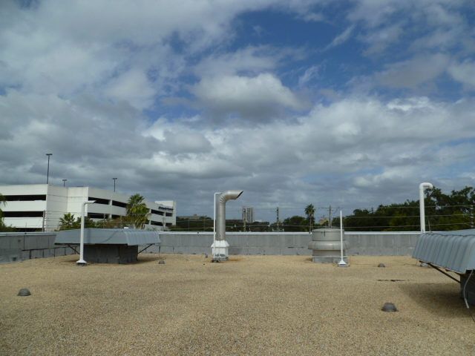

Project Id: 88175 Permit No: 1030091-013-AO Arms Number: 0091 007
Inspector: Shea Jackson Inspection Date / Time: 11/5/2013 / _______
Source (EU): 933 BHP engine (7.11 MMBtu/Hr) to drive a 1225 ton Natural Gas Chiller

Description: [The chiller stack, no emissions was not in operation at this time.

Morton Plant Mease Healthcare
1233 South Fort Harrison, Clearwater

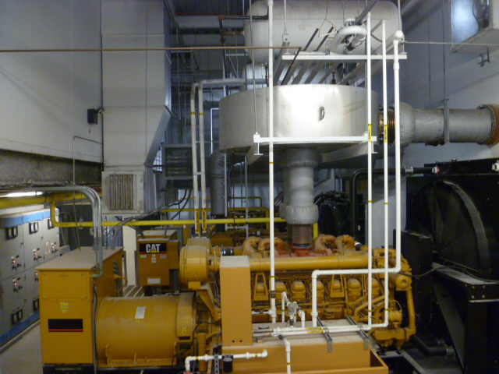

Project Id: 88175 Permit No: 1030091-013-AO Arms Number: 0091 007
Inspector: Shea Jackson Inspection Date / Time: 11/5/2013 / _______
Source (EU): 933 BHP engine (7.11 MMBtu/Hr) to drive a 1225 ton Natural Gas Chiller
Description: [The facility chillers, the gas chiller is located in back on the north wall]

