1030060 88669
FACILITY: Largo Wastewater Reclamation Facility |  |  |  |  |  |  |  |  |  |  |  |  |  |  |  |  |  |  |  | PERMIT ID: 30
Largo Wastewater Reclamation Facility |  |  |  |  |  |  |  |  |  |  |  |  |  |  |  |  |  |  |  | DISTRICT: Southwest
ADDRESS: 5100 150th Avenue North |  |  |  |  |  |  |  |  |  |  |  |  |  |  |  |  |  |  |  | CONTACT PHONE:
Clearwater, FL |  |  |  |  |  |  |  |  |  |  |  |  |  |  |  |  |  |  |  | 727-518-3080
ARMS NO:  1030060 001 |  |  |  |  |  |  |  | PERMIT NO: |  |  |  |  |  |  |  |  |  |  |  | Expiration Date: 11/12/14  Renewal Date: 9/13/14
 |  |  |  |  |  |  |  | 1030060-008-AF
 |  |  |  |  |  |  |  |  |  |  |  |  |  |  |  |  |  |  |  | Test Due Date: 3/13/19
EMISSION UNIT DESCRIPTION : Two Sewage Sludge Drying Trains: Emissions are controlled by a Settling Chamber, Fisher-Klosterman, Inc. Model MS-520 Cyclonic Separator, Venturi Scrubber, Huntington Energy System, Inc., Model 65 Regenerative Thermal Oxidizer AC allows new scrub/cyclone

INSPECTION DATE: |  |  |  |  |  |  | ARMS INSPECTION TYPE: |  |  |  |  |  |  |  |  |  |  |  |  |  |  | COMPLIANCE STATUS:
 | July 2, 2014 |  |  |  |  |  |  |  |  | INS1 |  | ✓ | INS2 |  |  | INS3 |  |  | FUI |  |  |  | ✓ |  | IN |  |  | MNC |  |  |  |  |  | SNC
INSPECTION TYPE: |  |  |  | ✓ | Initial |  |  |  |  |  | Re-inspection |  |  |  |  |  | Complaint |  |  |  |  |  |  | Drive-by |  |  |  |  |  |  | Quarterly
✓ |  |  | A. General Review:
1. |  | Permit File Review |  |  |  |  |  |  |  |  |  |  |  |  |  |  |  |  |  |  |  |  |  |  |  |  |  |  |  | Yes |  |  |  |  | No
 |  | Comments: yes review for stack test
2. |  | Introduction and Entry |  |  |  |  |  |  |  |  |  |  |  |  |  |  |  |  |  |  |  |  |  |  |  |  |  |  |  | Yes |  |  |  |  | No
 |  | Comments: I met on site with Richard Mushaben, and Test Team Member Ryan Nelson
3. |  | Is the Responsible Official/Authorized Representative still: Gary R. Glascock? |  |  |  |  |  |  |  |  |  |  |  |  |  |  |  |  |  |  |  |  |  |  |  |  |  |  |  | Yes |  |  |  |  | No
Comments: Yes, no change
The Responsible Official/Authorized Representative’s e-mail is: gjonesgl@largo.com
4. |  | Is the facility contact still: Richard Mushaben? |  |  |  |  |  |  |  |  |  |  |  |  |  |  |  |  |  |  |  |  |  |  |  |  |  |  |  | Yes |  |  |  |  | No
Comments: Yes, no change
The facility contact’s e-mail is: rmushabe@largo.com

IN | MNC | SNC |  |  | B. Specific Conditions:
Inspection Note: This permit revises Construction Permit 1030060-005-AC and replaces Title V Air Operation Permit 1030060-007-AV. The changes made to Permits 1030060-005-AC and 1030060-007-AV for EU 001 include the following:
- The facility designation is changed from Title V to synthetic non-Title V. The facility was previously designated as a Title V source solely because it was (and still is) subject to the requirements of a NESHAP regulation, i.e., 40 CFR 61, Subpart E, National Emission Standard for Mercury. However Florida Statutes, Section 403.0872(1)(e), was changed a few years ago. A facility is no longer subject to Title V permitting solely because it is subject to a NESHAP regulation.
- Requirements associated with the Compliance Assurance Monitoring (CAM) Plan are removed because these requirements apply to Title V facilities only.
- PM emissions limitations for EU Nos. 001, 005 and 006 are removed because these emissions limits were based on PM RACT requirements in Rules 62-296.711 and 62-296.712, F.A.C. However, these emissions units were permitted after May 30, 1988, therefore are not subject to the PM RACT requirements. The once every five year PM stack testing requirements for EU No. 001 is also removed.
- Visible emissions limitations for EU Nos. 001, 005 and 006 remain the same (i.e., not to exceed 5%), but the rule basis is changed from Rule 62-296.712(2), F.A.C., to Rules 62-4.070(3) and 62-210.650, F.A.C., i.e., to provide reasonable assurance of proper operation and maintenance of control devices.
- Details of the required Operation and Maintenance (O&M) Plans are removed from the permit, similar to other facilities in Pinellas County that are required to have an O&M Plan. The permittee will work directly with Pinellas County outside the permit.
- ASTM Method D1391-78, one of the two odor testing methods allowed by the permit, is removed from the permit since this method was withdrawn in 1986.
- VOC emissions limitations and the associated once every five year VOC stack testing requirements are removed from the permit. The VOC emissions limitations were not based on a rule requirement but due to odor complaints many years ago. With the RTO in operation, low VOC emissions demonstrated during compliance tests and good compliance history in recent years, it is reasonable to eliminate the VOC emissions limitations and the associated VOC testing requirements.
- EU No. 003 (Pelletizer Building with Odor Control System No. 1) is removed from the permit. The facility has not used the odor control scrubbers since 1998 due to lack of odor complaints.

General Conditions [62-4.160, F.A.C.]
8. If, for any reason, the permittee does not comply with or will be unable to comply with any condition or limitation specified in this permit, the permittee shall immediately provide the Department with the following information:
a. A description of and cause of noncompliance; and
b. The period of noncompliance, including dates and times; or, if not corrected, the anticipated time the noncompliance is expected to continue, and steps being taken to reduce, eliminate, and prevent recurrence of the noncompliance. The permittee shall be responsible for any and all damages which may result and may be subject to enforcement action by the Department for penalties or for revocation of this permit.

Comments: The facility did not report any non compliance issues at or prior to the time of inspection. There were no non compliance issues observed during inspection.

12. This permit or a copy thereof shall be kept at the work site of the permitted activity.

Comments: A copy of the permit was was not kept at the worksite. The permit copies are available in the shop office of Mr. Mushaben.

Common Conditions [Rule 62-296.320(4)(c), F.A.C.]
Unless otherwise specified in the permit, the following conditions apply to all emissions units and activities at the facility.
Emissions and Controls
2. Circumvention: The permittee shall not circumvent the air pollution control equipment or allow the emission of air pollutants without this equipment operating properly. [Rule 62-210.650, F.A.C.]

Comments: There was no evidence of the facility attempting to circumvent the air pollution control system. The Settling Chamber, Fisher-Klosterman, Inc. Model MS-520 Cyclonic Separator, Venturi Scrubber, Huntington Energy System, Inc., Model 65 Regenerative Thermal Oxidizer. The control devices and monitoring systems were observed to be in operation and functioning correctly during the facility tour.

6. VOC or OS Emissions: No person shall store, pump, handle, process, load, unload or use in any process or installation, volatile organic compounds (VOC) or organic solvents (OS) without applying known and existing vapor emission control devices or systems deemed necessary and ordered by the Department. [Rule 62-296.320(1), F.A.C.]

Comments: There were no spills, or open containers observed, or use of any solvents, noted to be part of this facilities processing of sludge materials from the dry train to the silo loading. Mr. Mushaben stated they have no solvent usage for the facility operations to report.

7. Objectionable Odor Prohibited: No person shall cause, suffer, allow or permit the discharge of air pollutants, which cause or contribute to an objectionable odor. An “objectionable odor” means any odor present in the outdoor atmosphere, which by itself or in combination with other odors, is or may be harmful or injurious to human health or welfare, which unreasonably interferes with the comfortable use and enjoyment of life or property, or which creates a nuisance. [Rules 62-296.320(2) and 62-210.200(Definitions), F.A.C.]

Comments: An upwind/downwind survey of the facility was conducted. The observed parameters were:
Downwind odor level detected- none - 0; Wind direction - southwest Upwind odor level detected-

9. Unconfined Particulate Emissions:
a. No person shall cause, let, permit, suffer or allow the emissions of unconfined particulate matter from any activity, including vehicular movement; transportation of materials; construction, alteration, demolition or wrecking; or industrially related activities such as loading, unloading, storing or handling; without taking reasonable precautions to prevent such emissions.
b. Any permit issued to a facility with emissions of unconfined particulate matter shall specify the reasonable precautions to be taken by that facility to control the emissions of unconfined particulate matter.
c. Reasonable precautions include the following:
(1) Paving and maintenance of roads, parking areas and yards.
(2) Application of water or chemicals to control emissions from such activities as demolition of buildings, grading roads, construction, and land clearing.
(3) Application of asphalt, water, oil, chemicals or other dust suppressants to unpaved roads, yards, open stock piles and similar activities.
(4) Removal of particulate matter from roads and other paved areas under the control of the owner or operator of the facility to prevent reentrainment, and from buildings or work areas to prevent particulate from becoming airborne.
(5) Landscaping or planting of vegetation.
(6) Use of hoods, fans, filters, and similar equipment to contain, capture and/or vent particulate matter.
(7) Confining abrasive blasting where possible.
(8) Enclosure or covering of conveyor systems.

Comments: The facility operations does not perform abrasive or unconfined materials generating activities that would be generating unconfined particulate. The areas around the buildings are pavement were observed to be swept cleaned, no emissions observe during inspection tour inside or outside of buildings.

Permit Administrative Requirements
7 Annual Operating Report: On or before April 1 of each year, the permittee shall submit a completed DEP Form 62-210.900(5), "Annual Operating Report for Air Pollutant Emitting Facility" (AOR) for the preceding calendar year. The report may be submitted electronically in accordance with the instructions received with the AOR package sent by the Department, or a hardcopy may be sent to the Compliance Authority. [Rule 62-210.370(3), F.A.C.]

Comments: The annual operating report for calendar year _2013___ was submitted on 3/29/14.

8 Operation Permit Renewal Application: A completed application for renewal of the operation permit shall be submitted to the Permitting Authority with a copy to PCDEM (Compliance Authority) no later than 60 days prior to the expiration date of the operation permit. [Rules 62-4.030, 62-4.050, 62-4.070(3), 62-4.090, 62-210.300(2), and 62-210.900, F.A.C.]

Comments: The renewal date of this permit is 9/13/2014 and the permit doe expire until 11/12/2014. I informed Mr Mushaben the renewal date was when the permit application had to be in. He stated he was working on submitting himself. The facility was doing additional PM testing on cyclones, but he was not sure if they would be included in the permit renewal.

Facility-wide Specific Conditions
- General Pollutant Emission Limiting Standards - Objectionable Odor: No person shall cause, suffer, allow, or permit the discharge of air pollutants, which cause or contribute to an objectionable odor. An "Objectionable Odor" is defined as any odor present in the outdoor atmosphere, which by itself or in combination with other odors, is or may be harmful or injurious to human health or welfare, which unreasonably interferes with the comfortable use and enjoyment of life or property, or which creates a nuisance. [Rules 62-210.200 and 62-296.320(2), F.A.C.; Pinellas County Code, Section 58-178]

Comments: There were no objectionable odors detected beyond the property boundaries. There were mild odors detectable around the pelletizer building on the property.

A.1. Federal Regulatory Requirements: This emission unit is subject to 40 CFR 61, Subpart E – National Emission Standard for Mercury and 40 CFR 61, Subpart A – National Emission Standards for Hazardous Air Pollutants, General Provisions; adopted and incorporated by reference in Rule 62-204.800(10), F.A.C., and attached to this permit.
40 CFR 61, Subpart E Applicable Provision References
§ 61.50 Applicability.
§ 61.51 Definitions.
§ 61.52 Emission standard.
§ 61.52(b)
§ 61.53 Stack sampling.
§ 61.53(d)
§ 61.54 Sludge sampling.
§ 61.55 Monitoring of emissions and operations.
§ 61.55(a)
§ 61.56 Delegation of authority.
[Rule 62-204.800(10), F.A.C.; 40 CFR 61, Subpart E]

Comments: The mercury reading for the plant are analyzed on a monthly bases to determine the level coming in to the plant processes. The reviewed records from June 2013 – May 2014 and the highest monthly reading was 0.36 mg/kg for May 2014. This is below the Class AA standard of 17.0kg. This is tracked in the log for Residuals Analysis and Production.

40 CFR 61, Subpart E – National Emission Standard for Mercury and 40 CFR 61
§ 61.52 Emission standard.
(b) Emissions to the atmosphere from sludge incineration plants, sludge drying plants, or a combination of these that process wastewater treatment plant sludges shall not exceed 3.2 kg (7.1 lb) of mercury per 24-hour period.

Comments: The reviewed records from Jan 2012 – April 2013 and the highest monthly reading was 0.36 for May 2014. This is below the Class AA standard of 17.0kg. This is tracked in the log for Residuals Analysis and Production.

§ 61.53 Stack sampling.
(d) Sludge incineration and drying plants
(1) Unless a waiver of emission testing is obtained under 40 CFR 61.13, each owner or operator of a source subject to the standard in 61.52(b) shall test emissions from that source. Such tests shall be conducted in accordance with the procedures set forth either in 51.53(d) or in 61.54.
(2) Method 101A in appendix B to this part shall be used to test emissions as follows:
(i) The test shall be performed within 90 days of the effective date of these regulations in the case of an existing source or a new source which has an initial startup date preceding the effective date.
(ii) The test shall be performed within 90 days of startup in the case of a new source which did not have an initial startup date preceding the effective date.
(3) The Administrator/Department shall be notified in writing at least 30 days prior to an emission test, so that he may at his option observe the test.
(4) Samples shall be taken over such a period or periods as are necessary to determine accurately the maximum emissions which will occur in a 24-hour period. No changes shall be made in the operation which would potentially increase emissions above the level determined by the most recent stack test, until the new emission level has been estimated by calculation and the results reported to the Administrator.
(5) All samples shall be analyzed and mercury emissions shall be determined within 30 days after the stack test. Each determination shall be reported to the Administrator by a registered letter dispatched within 15 calendar days following the date such determination is completed.
(6) Records of emission test results and other data needed to determine total emissions shall be retained at the source and shall be made available, for inspection by the Administrator, for a minimum of 2 years.

Comments: The facility is maintaining (4)- Sample results for mercury levels on a monthly records log for Residuals Analysis and Production which maintains a monthly average and sample analysis is performed by Largo Biosolids Facility. They send DEP report form 62-640.210(20(c) to FDEP on a Monthly Residuals Distribution and Marketing Report. The mercury levels are also determined annually during the stack testing of operations for the RTO.

§ 61.54 Sludge sampling.
(a) As an alternative means for demonstrating compliance with 40 CFR 61.52(b), an owner or operator may use Method 105 of 40 CFR 61 Appendix B and the procedures specified in this section.
(1) A sludge test shall be conducted within 90 days of the effective date of these regulations in the case of an existing source or a new source which has an initial startup date preceding the effective date, or;
(2) A sludge test shall be conducted within 90 days of startup in the case of a new source which did not have an initial startup date preceding the effective date.
(b) The Administrator shall be notified at least 30 days prior to a sludge sampling test, so that he may at his option observe the test.
(c) Sludge shall be sampled according to paragraph (c)(1), sludge charging rate for the plant shall be determined according to paragraph (c)(2), and the sludge analysis shall be performed according to paragraph (c)(3) of this section.
(1) The sludge shall be sampled according to Method 105-Determination of Mercury in Wastewater Treatment Plant Sewage Sludges. A total of three composite samples shall be obtained within an operating period of 24 hours. When the 24-hour operating period is not continuous, the total sampling period shall not exceed 72 hours after the first grab sample is obtained. Samples shall not be exposed to any condition that may result in mercury contamination or loss.
(2) The maximum 24-hour period sludge incineration or drying rate shall be determined by use of a flow rate measurement device that can measure the mass rate of sludge charged to the incinerator or dryer with an accuracy of ±5 percent over its operating range. Other methods of measuring sludge mass charging rates may be used if they have received prior approval by the Administrator.
(3) The sampling, handling, preparation, and analysis of sludge samples shall be accomplished according to Method 105 in 40 CFR 61 Appendix B of this part.
(d) The mercury emissions shall be determined by use of the following equation:

EHg = MQ Fsm(avg)/1000
where:
EHg=Mercury emissions, g/day.
M=Mercury concentration of sludge on a dry solids basis, μg/g.
Q=Sludge changing rate, kg/day.
Fsm=Weight fraction of solids in the collected sludge after mixing.
1000=Conversion factor, kg μg/g2.
(e) No changes in the operation of a plant shall be made after a sludge test has been conducted which would potentially increase emissions above the level determined by the most recent sludge test, until the new emission level has been estimated by calculation and the results reported to the Administrator.
(f) All sludge samples shall be analyzed for mercury content within 30 days after the sludge sample is collected. Each determination shall be reported to the Administrator by a registered letter dispatched within 15 calendar days following the date such determination is completed.
(g) Records of sludge sampling, charging rate determination and other data needed to determine mercury content of wastewater treatment plant sludges shall be retained at the source and made available, for inspection by the Administrator, for a minimum of 2 years.

Comments: The facility performs the Method 105 stack test to collect sample for the testing requirements. The facility also is maintaining monthly reports for this limitation on mercury and submits results to FDEP on DEP fir 62-640.210(2)(c).

§ 61.55 Monitoring of emissions and operations.
(a) Wastewater treatment plant sludge incineration and drying plants. All the sources for which mercury emissions exceed 1.6 kg (3.5 lb) per 24-hour period, demonstrated either by stack sampling according to Sec. 61.53 or sludge sampling according to Sec. 61.54, shall monitor mercury emissions at intervals of at least once per year by use of Method 105 of Appendix B or the procedures specified in Sec. 61.53(d) (2) and (4). The results of monitoring shall be reported and retained according to Sec. 61.53(d)(5) and (6) or Sec. 61.54(f) and (g).

Comments: The facility performs sludge sampling required by 61.54, mercury emissions based on monthly lab analysis. This plant’s emissions do not exceed the 1.6kg level and would not be required to perform the stack test Method 105 to monitor or report mercury emissions at this time.

40 CFR 61, Subpart A - General Provisions
§ 61.05 Prohibited activities.
(a) After the effective date of any standard, no owner or operator shall construct or modify any stationary source subject to that standard without first obtaining written approval from the Administrator in accordance with this subpart, except under an exemption granted by the President under section 112(c)(2) of the Act. Sources, the construction or modification of which commenced after the publication date of the standards proposed to be applicable to the sources, are subject to this prohibition.
(b) After the effective date of any standard, no owner or operator shall operate a new stationary source subject to that standard in violation of the standard, except under an exemption granted by the President under section 112(c)(2) of the Act.
(d) No owner or operator subject to the provisions of this part shall fail to report, revise reports, or report source test results as required under this part.

Comments: The facility has not made unapproved changes to any of the listed emission units or pollution control equipment. The CEM testing company was on site in the process of PM testing for the facility’s own purposes the effectiveness of the cyclone, and whether would be necessary to add 2 cyclone system for when RTO replaced or if a new cyclone would be required.

§ 61.07 Application for approval of construction or modification.
(a) The owner or operator shall submit to the Administrator an application for approval of the construction of any new source or modification of any existing source. The application shall be submitted before the construction or modification is planned to commence, or within 30 days after the effective date if the construction or modification had commenced before the effective date and initial startup has not occurred. A separate application shall be submitted for each stationary source. (inspection note: refer to full permit for full list of information needed to be provided in the event of modification and/or construction)

Comments: There is no construction or modifications at this time. Mr. Mushaben stated they are still reviewing their process for the replacement of the RTO. He stated they are researching the information and doing a performance test this week to determine if venturi scrubber, and cyclone, with the RTO could assist in the control of PM emissions or if they can use two cyclones for control. The facility is looking at installing an RTO in 2015 that would be able to handle operation of both trains, not simultaneously, would still alternate trains use. There are no permit changes at this time, the permit will be renewed and there may be an amendment requested when determination of control device needs are completed.

§ 61.19 Circumvention.
No owner or operator shall build, erect, install, or use any article machine, equipment, process, or method, the use of which conceals an emission which would otherwise constitute a violation of an applicable standard. Such concealment includes, but is not limited to, the use of gaseous dilutants to achieve compliance with a visible emissions standard, and the piecemeal carrying out of an operation to avoid coverage by a standard that applies only to operations larger than a specified size.

Comments: There was no evidence observed during the tour of the facility that they were attempting to circumvent the air pollution control system. The Settling Chamber, Fisher-Klosterman, Inc. Model MS-520 Cyclonic Separator, Venturi Scrubber, Huntington Energy System, Inc., Model 65 Regenerative Thermal Oxidizer control devices, and the monitoring systems were observed to be in operations during the facility tour.

A.2. Permitted Capacity: The total sludge input rate for each dryer shall not exceed 32,680 pounds per hour daily average. [Rule 62-210.200(PTE), F.A.C.; Construction Permit 1030060-005-AC]

Comments: The bio solids record logs state the daily sludge input rate to the dryers. The pounds per hour daily averaged are calculated, with the formula as observed on the “Biosolids Night sheet “ as follows ( pounds per hour X product average – Cake average divided by product average – Pug average for the sludge input rage lbs/hr. The rate for 6/5/2013 was 17,240 lbs/hour and in compliance with this condition. The Bio solids data record spreadsheet maintains the rate under the D. column titled “Dry Solids loading Rate lbs/hr” (See record log copies)

A.3. Authorized Fuel: The sludge dryers and afterburner shall be only fired with natural gas.
[Rule 62-210.200(PTE), F.A.C. Construction Permit 1030060-005-AC]

Comments: The facility operates the dryers with natural gas only. (See Bio solids Data log Dry side for gas usage) The facility RTO emission unit has never been equipped for operation with any other fuel.

A.4. Heat Input Limitation: The heat input for each drying train (including dryer and afterburner) shall not exceed 14.2 MMBTU per hour daily average. [Rule 62-210.200(PTE), F.A.C.; Construction Permit 1030060-005-AC]

Comments: This rate is monitored during the test to ensure operations are at 90% during the test runs. between 11am – 6 pm. The highest reading observed daily was 0.0350 MMBTU per hour. This daily average is the maximum the equipment would reach in a 24 hour cycle while one train is in operation. The 14.2 MMBTU limitations could not be exceeded even if both trains were in operation for a 24 hour period. The bio solids night sheet for 7/1/14 showed the calculation and 0.0350 MMBTU/hr. The rate can be observed on the operator’s written copy, the “Bio solid night sheet” and on also on the “Bio Solids data spreadsheet”. IE. The Mail gas reading is recorded from the “Bio solid night sheet” on to the “Bio Solids data spreadsheet”.

A.5. Operation Limitation: Only one drying train may operate at any one time. [Rule 62-210.200(PTE), F.A.C.; Construction Permit 1030060-005-AC]

Comments: The facility only operates one drying train at a time. The trains operations are alternated weekly . (See record logs)

A.7. Mercury Emissions Standard: Mercury emissions shall not exceed 3200 grams per 24-hour period. [40 CFR 61.52(b), Construction Permit 1030060-005-AC]

Comments: This emission standard check was last performed in 2010 during the stack testing. The rate at that time was determined to be acceptable. This test is being performed today for 8 hours a sample is collected hourly. The TECO testing member Ryon Nelson will pick up collected samples at end of day. This testing is being performed to determine if meeting this limitation for the 2014 permit renewal.

A.8. Visible Emissions Limitation: In order to provide reasonable assurance of proper operation and maintenance of the pollution control devices, visible emissions from the afterburner shall not exceed 5% opacity. [Rules 62-4.070(3) and 62-210.650, F.A.C.]

Comments: During the facility inspection, the stack for the RTO was observed. The train #2 was in operation. No visible emissions were observed coming from the RTO stack during tour of facility. AQ staff performed a Method 9 test for 30 minutes, and opacity result was 0% during operation. The facility was in compliance below 5% opacity during on site observations. The TECO consulting team member Ryan Nelson also performed a method 9, with same result. (See AQ test copy attached)

A.9. Compliance Tests: During each federal fiscal year (October 1st to September 30th), each sludge drying train shall be tested for odor and visible emissions. Between 120 days and 180 days prior to the expiration date of this permit, one of the two drying trains shall be tested for mercury emissions. If the mercury emissions test shows mercury emissions exceed 1600 g per 24-hour period, demonstrated either by stack sampling according to 40 CFR 61.53 or sludge sampling according to 40 CFR 61.54, the permittee shall monitor mercury emissions at intervals of at least once per year by use of EPA Method 105 or the procedures specified in 40 CFR 61.53(d) (2) and (4). The results of monitoring shall be reported and retained according to 40 CFR 61.53(d)(5) and (6) or 40 CFR 61.54(f) and (g).
[Rule 62-297.310, F.A.C.; 40 CFR 61.55(a)]

Comments: The Method 105 test was being performed today, Ie collection of hourly samples. The method 9 and ASTM Method E679-04 Odor annual compliance tests for 2014 was performed for emission units 001, 5 & 6 on 7/1 and 7/2/14 by Ryan Nelson of TECO subcontracted consultant by Kenneth Givens of Air Testing & Consulting, Inc., employees were present and performed the required tests.

A.10. Test Requirements: Tests shall be conducted in accordance with the applicable requirements specified in Appendix D (Common Testing Requirements) of this permit. [Rule 62-297.310, F.A.C.]

Comments: The tests were performed in accordance with appendix D during maximum capacity operations for sludge drying trains. (See records)

A.11. Test Method(s): Required tests shall be performed in accordance with the following reference method(s).
Method(s) | Description of Method and Comments
EPA Method 101A  or  EPA Method 105 | Determination of Particulate and Gaseous Mercury Emissions from Sewage Sludge Incinerators  Determination of Mercury in Wastewater Treatment Plant Sewage Sludges
EPA Method 9 | Visual Determination of the Opacity of Emissions from Stationary Sources
ASTM Method  E679-04 or more recent version | Standard Practice for Determination of Odor and Taste Thresholds by a Forced-Choice Ascending Concentration Series Method of Limits
[Rules 62-204.800 and 62-297.100, F.A.C.; 40 CFR 61.53 and 61.54; Appendix A of 40 CFR 60; and Appendix B of 40 CFR 61]

Comments: the facility was performing the EPA Method 101A for the permit renewal in 2014. The Method 9 tests for EU 005 and 006, were performed 7/1/2014. The EU 001 ASTM Method E679-04 and Method 9 was performed 7/2/14. The testing team was observed during the collection of grab samples, for an hour ~ 5 minutes per each sample collected.

A.12. Afterburner Monitoring Requirements: When drying sewage sludge, the afterburner shall operate at a minimum temperature of 1100 °F and a minimum gas residence time of 1.0 second. The permittee shall operate adequate instrumentation to continuously monitor and record the afterburner's operating temperature. [Rule 62-4.070(3), F.A.C.; Construction Permit 1030060-005-AC]

Comments: I observed SCADA system linked to RTO thermocouples as it was continuously monitoring and records the temperatures on personal computer. The readings stream a temperature trace reading into operator’s office, so can be observed at any time. The temperatures can be reviewed back to date the facility installed the new monitoring system in 2012. The temperatures were observed to be above the 1100 °F as required during review. (See copy and pictures)

A.13. Test Notification: The permittee shall notify the Compliance Authority in writing at least 15 days prior to any required tests. The notification must include the following information: the date, time, and location of each test; the name and telephone number of the facility’s contact person who will be responsible for coordinating the test; and the name, company, and the telephone number of the person conducting the test. [Rules 62-4.070(3) and 62-297.310(7)(a)9., F.A.C.]

Comments: the Air Testing consultant, Ken Givens filed the test notifications on 5/23/14, more than 15 days in advance of test date 7/1/2014. This was acceptable due to prior notification.

A.14. Test Reports: The permittee shall prepare and submit reports for all required tests in accordance with the requirements specified in Appendix D (Common Testing Requirements) of this permit. All test reports submitted to the Department and PCAQD shall include, at a minimum, the following information for the test period:
- Sludge input rate (tons/hr.) to the dryer.
- Total heat input rate (MMBTU/hr.).
- Copies of the dryer's records indicating the sludge input rate.
- Copies of the afterburner's continuous temperature chart recorder.
- Calculations of the afterburner's gas residence time.
- Control device operating parameters, such as scrubber flow rate and pressure drop.
- Failure to submit the above information or operating at conditions which do not reflect normal operating conditions may invalidate the test and fail to provide reasonable assurance of compliance. [Rule 62-297.310(8), F.A.C.; Construction Permit 1030060-005-AC]

Comments: The test reports on file contain the above listed materials and were reviewed as received within less than 45 days after the test dates. The test should be received by 8/18/14

A.15. Sludge Input Rate Determination and Recordkeeping: The total sludge input rate of each dryer shall be determined by the following:
M = C (%R - %C)
(%R - %M)
Where: M = Dryer Total Sludge Input Rate (lbs./hr.)
C = Wet Sludge Feed Cake to Pugmill (lbs./hr.)
%M = Percent Solids of Dryer Input (Feed)
%C = Percent Solids of Wet Sludge Feed Cake
%R = Percent Solids of Recycled Dry Material to Pugmill
a. Continuously monitor and record hourly the wet sludge feed cake to the pugmill.
b. Perform dry solids tests every two hours on the dryer feed, the wet sludge feed cake, and recycled dry material.
c. At the end of each day, the average for each of the above measurements will be applied to the formula above and the dryer input (feed) rate calculation will be completed.
The above procedure will provide a daily average dryer input (feed) rate. This procedure will be used each day of operation and will be used during compliance testing where the calculations will be completed and reported for the actual period of the test and not the entire operating day.
[Construction Permit 1030060-005-AC]

Comments: a. The total CM of the wet sludge feet cake rate to the pug mill on can be found on the Bio solids Night sheets records 218,255 gal TGP X 12,228 mg/L Eff dig TSS x 8.34 /1000000 =22,258 lbs/day for 6/4/13 (Ref column AI on monthly spreadsheet ‘Bio Solids data log’

b. Dry Solids tests every 2 hours on Dryer feed, wet sludge feed cake and recycled dry material results are recorded on City of Largo Bio solids Data Log (wet Side) daily hours sheet, and also monthly spreadsheet ‘Bio Solids data log’ maintained by the facility operators.

c. The Dry input feed rate is recorded on bio solids night sheet shows this calculation at the base of the sheet when the results of the 24 hours of operation are completed. And can be found on the Bio solids Night sheets records and monthly spreadsheet ‘Bio Solids data log’ maintained by the facility operators. Biosolids Night sheet contains 24 hour cycle information for average “Dryer input rate” (max allowed 32,680 pounds/hours of operation) formula from the “Bio Solids Data Log

A.16. Natural Gas Heat Input Rate Records: The total maximum natural gas heat input rate (MMBTU/hr.) of each drying train (dryer + afterburner) shall be determined by the afterburner and the dryer burner gas meters. The permittee shall maintain records of the dryer hours of operation and the amount of gas fired in the dryers and afterburner daily. Records shall also be maintained (for comparison purposes) of the main gas meter. [Construction Permit 1030060-005-AC]

Comments: The Bio-solids night sheet is the record where the Main Gas and RTO Gas are compared and the formula for the determination for the MMBTU is documented. The Max allowed is 14.2 MMBTU/hr. The daily reading was 0.0350 MMBTU for the day of 7/1/2014. The “Bio Solids Data Log”

A.17. Operation and Maintenance (O & M) Plan: This emissions unit includes the following pollution control devices:
- Fisher-Klosterman Model XQ Series XQ340-27 Dual Cyclones for each sludge drying train
- Fisher-Klosterman Model MS-650H venturi scrubber with cyclonic separator for each sludge drying train
- Huntington Energy System, Inc., Model #65 regenerative afterburner shared by both sludge drying trains.
For each control device listed above, the permittee shall maintain and implement an O & M Plan to include a schedule for the maintenance and inspection the control device, collection systems, and auxiliary equipment. Records of inspections, maintenance, and performance data of control devices and auxiliary equipment shall be retained at the facility for a minimum of two (2) years and shall be made available to the Compliance Authority upon request. The O&M Plan may be amended with the prior approval of the Compliance Authority. At a minimum, the O&M Plan shall include:
- The operating parameters of the pollution control device.
- Timetable for the routine maintenance of the pollution control device as specified by the manufacturer.
- Timetable for routine periodic observations of the pollution control device sufficient to ensure proper operations.
- A list of the type and quantity of the required spare parts for the pollution control device, which are stored on the premises of the permit applicant.
- A record log which will indicate, at a minimum:
- When maintenance and observations were performed;
- What maintenance and observations were performed;
- Who performed said maintenance and observations; and
- Acceptable parameter ranges for each operational check.
[Rule 62-4.070(3), F.A.C. and Pinellas County Code, Section 58-128(a)]

Comments: I reviewed the records for the Operation and Maintenance plan for the Dual Cyclone, venture scrubber, cyclonic separator and RTO afterburner and baghouse with Mr. Mushaben.
The O & M plan and maintenance records are maintained as required on Annual, Semi Annual, quarterly, monthly, weekly and daily bases. The routine observations for the emissions units are performed per the required checks to ensure proper operations. The facility maintains additional maintenance records and system readings I.E. Temperatures, gals/min, PSI etc. The records are kept in the City of Largo Biosolids Data logs for the (wet and Dry ) Sides, and on the City of Largo WWTF PM schedule record logs. Mr. Mushaben also puts the records in the Oracle and as projects are completed that are moved from active to closed to ensure maintenance is performed as required.

(1). The operating parameters for the pollutions control device for the RTO with description of maintenance items were recorded on
(2) The Weekly, monthly, quarterly and semiannual sheets are called ‘O & M log sheets for emission unit 001, 005 and 006.
(3) Maintenance items are scheduled for observation as specified to insure proper operation and prevention of breakdown.

(4) The maintenance division for the facility keeps list of spare parts needed for all plant operations. (See copy)
(5) The record logs do indicate:
(a & b) for when, and what maintenance is performed.
(c). There are operator’s signatures and initials on the O & M and Biosolids Data log sheets. The operators, for weekly, monthly quarterly, annual sheets, initialed the individual daily sheets. Mr. Mushaben enters the records into the computer system, in the new WAMS-Work Assets management system- Oracle data base computerized recordkeeping system, which was started October 2012. (See record print out).
(d) The parameter ranges for the operational checks were shown on the wastewater maintenance records. I.E. EU001 - Weekly sheet page checked and recorded temperatures on the north and south bearings by the operator observations, ID fan Bearing temperatures, with the parameter limitations check off noted. Mr. Mushaben had parameters indicated on EU 005 & 6 baghouse not to exceeded 6.O W.C. the reading indicated on work sheet was 1.2 W.C . The #2 check off note PSI 90-100 was indicated as 97 PSI. . (See record copies attached)

 |  |  |  |  | Valid Permit [Rule 62-210.300]

Changes to Facility/emission unit [Rule 62-210.300]
Does the emission unit description above match what the facility is operating (Number of emission units or points, model number and serial number, etc.) Yes No
Comments: No changes at this time.
✓ |  |  | C. Other:
Pollution Prevention Activities
- P2 Handouts Provided: P2 Brochure; P2 Manual; P2 Checklist
- Have any emissions reductions occurred Yes / No
Chemical Substitution; Equipment Changes; Process Changes
Chemical/Material Reuse; On-site Recycling; Other:
Comments: There have been no modifications of equipment for waste water treatment system.

Closing Conference: I informed Mr. Mushaben there were no non compliance issues noted as this time, and the facility appears to be in compliance pending results of performance tests.

Inspector(s): Shea Jackson, Pinellas County, Air Quality Division
Signature(s): Date: |  |  |  |  |  |  |  |  | Date: July 3, 2014
ACCESS? |  |  |  | ü |  | ARMS? | ü

Largo Wastewater Reclamation Facility
5100 150th Avenue North, Clearwater
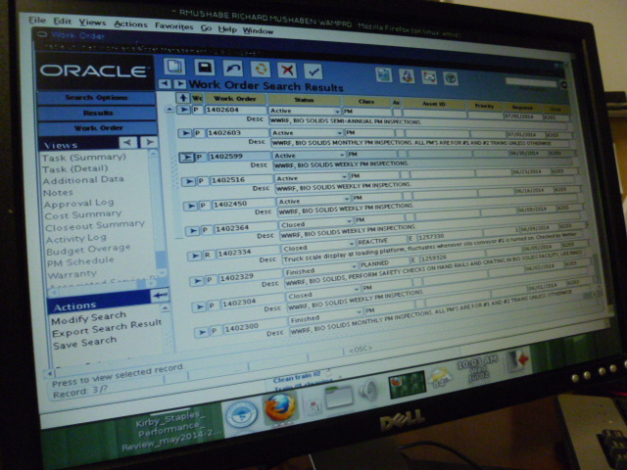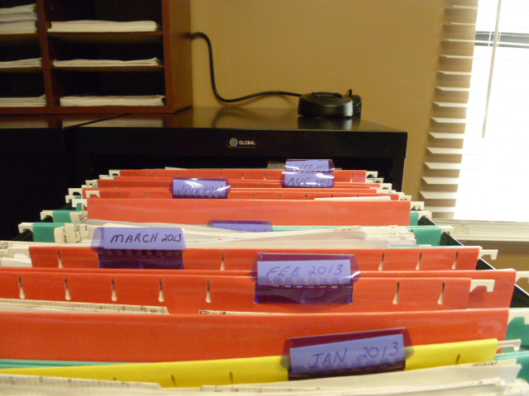
Project Id: 88669 Permit No: 1030060-008-AF Arms Number: 0060 001
Inspector: Shea Jackson Inspection Date / Time: 7/1/14 / _______
Source (EU): Two Sewage Sludge Drying Trains: Emissions are controlled by a Settling Chamber, Fisher-Klosterman, Inc. Model MS-520 Cyclonic Separator, Venturi Scrubber, Huntington Energy System, Inc., Model 65 Regenerative Thermal Oxidizer AC allows new scrub/cyclone

Description: [The records are maintained hard copy and in the Oracle application on PC.]
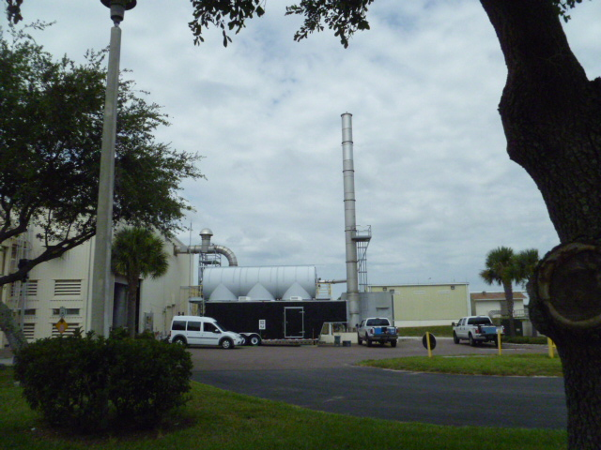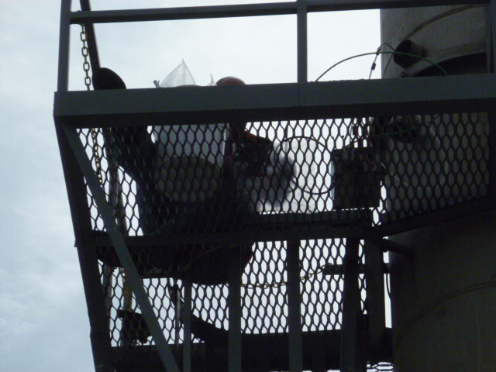
Project Id: 88669 Permit No: 1030060-008-AF Arms Number: 0060 001
Inspector: Shea Jackson Inspection Date / Time: 7/1/14 / _______
Source (EU): Two Sewage Sludge Drying Trains: Emissions are controlled by a Settling Chamber, Fisher-Klosterman, Inc. Model MS-520 Cyclonic Separator, Venturi Scrubber, Huntington Energy System, Inc., Model 65 Regenerative Thermal Oxidizer AC allows new scrub/cyclone

Description: [The stack was no visible emissions and the test consultant performing Odor control sample collection]

Largo Wastewater Reclamation Facility
5100 150th Avenue North, Clearwater

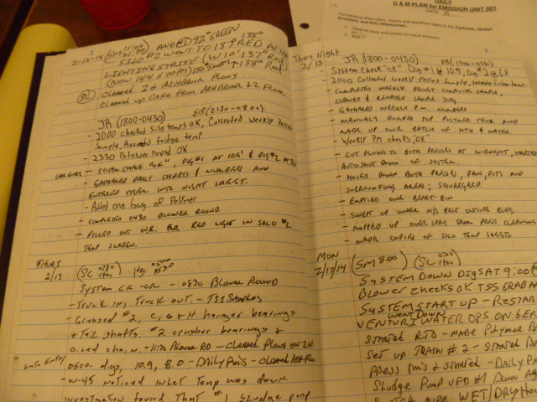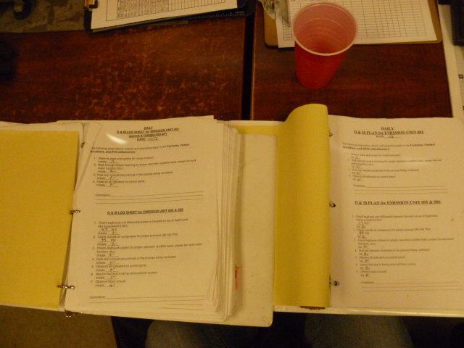

Project Id: 88669 Permit No: 1030060-008-AF Arms Number: 0060 001
Inspector: Shea Jackson Inspection Date / Time: 7/1/14 / _______
Source (EU): Two Sewage Sludge Drying Trains: Emissions are controlled by a Settling Chamber, Fisher-Klosterman, Inc. Model MS-520 Cyclonic Separator, Venturi Scrubber, Huntington Energy System, Inc., Model 65 Regenerative Thermal Oxidizer AC allows new scrub/cyclone

Description: [The facility daily log of all activities performed by employees is recorded in facility log as performed. The O & M operators check off forms are maintained in hard copy binders in the operator’s office. ]

