1030026 88763
FACILITY: Ajax Paving Industries of Florida, LLC |  |  |  |  |  |  |  |  |  |  |  |  |  |  |  |  |  |  |  | PERMIT ID: 1
Largo Facility - Plant 7 |  |  |  |  |  |  |  |  |  |  |  |  |  |  |  |  |  |  |  | DISTRICT: Southwest
ADDRESS: 1550 Starkey Road |  |  |  |  |  |  |  |  |  |  |  |  |  |  |  |  |  |  |  | CONTACT PHONE:
Largo, FL |  |  |  |  |  |  |  |  |  |  |  |  |  |  |  |  |  |  |  | 727-584-3329
ARMS NO:  1030026 001 |  |  |  |  |  |  |  | PERMIT NO: |  |  |  |  |  |  |  |  |  |  |  | Expiration Date: 4/27/16  Renewal Date: 2/27/16
 |  |  |  |  |  |  |  | 1030026-009-AO
 |  |  |  |  |  |  |  |  |  |  |  |  |  |  |  |  |  |  |  | Test Due Date: 1/22/00
EMISSION UNIT DESCRIPTION : 250 Ton/hour Asphalt Plant: Gencor Industries, Inc., Model 400 Ultra Drum Mix Asphalt Plant (85MMBtu/hr) Controlled by a Gencor Industries Inc. Primary Collection System (knockout box) and a Caterpillar, Autopulse II, Model No. APL-720 Baghouse.
CMS INSPECTION DATE: |  |  |  |  |  |  | ARMS INSPECTION TYPE: |  |  |  |  |  |  |  |  |  |  |  |  |  |  | COMPLIANCE STATUS:
 | April 23, 2014 |  |  |  |  |  |  |  |  | INS1 |  | ✓ | INS2 |  |  | INS3 |  |  | FUI |  |  |  | ✓ |  | IN |  |  | MNC |  |  |  |  | SNC
INSPECTION TYPE: |  |  |  | ✓ | Initial |  |  |  |  |  | Re-inspection |  |  |  | ✓ |  | Complaint |  |  |  |  |  |  | Drive-by |  |  |  |  |  | Quarterly
✓ |  |  | A. General Review:
1. |  | Permit File Review |  |  |  |  |  |  |  |  |  |  |  |  |  |  |  |  |  |  |  |  |  |  |  |  |  |  | Yes |  |  |  |  | No
 |  | Comments:
2. |  | Introduction and Entry |  |  |  |  |  |  |  |  |  |  |  |  |  |  |  |  |  |  |  |  |  |  |  |  |  |  | Yes |  |  |  |  | No
 |  | Comments: I met on site with Kyle Holmes
3. |  | Is the Responsible Official/Authorized Representative still: Vince L. Hafeli? |  |  |  |  |  |  |  |  |  |  |  |  |  |  |  |  |  |  |  |  |  |  |  |  |  |  | Yes |  |  |  |  | No
Comments: yes, still RO
The Responsible Official/Authorized Representative’s e-mail is: vhafeli@ajaxpaving.com
4. |  | Is the facility contact still: Vince L. Hafeli or Klye Holmes? |  |  |  |  |  |  |  |  |  |  |  |  |  |  |  |  |  |  |  |  |  |  |  |  |  |  | Yes |  |  |  |  | No
Comments: These are the correct contacts
The facility contact’s e-mail is: vhafeli@ajaxpaving.com?
IN | MNC | SNC | B. Specific Conditions:
ü  ü  ü  ü  ü  ü  ü  ü  ü  ü  ü  ü  ü  ü  ü  ü  ü  ü  ü  ü  ü  ü  ü  ü  ü  ü  ü  ü  ü  ü  ü  ü  ü  ü  ü  ü  ✓  ü |  |  | Inspection note: These permits became effective on 4/26/11. Operation Permit 1030026-009-AO renews air operation permit 1030026-008-AO. Construction Permit 1030026-010-AC removes the maximum hourly throughput limit for the on-site Reclaimed Asphalt Pavement (RAP) Crushing System (EU 003) and adds a Portable RAP Crushing System (EU 004).  General Conditions [62-4.160, F.A.C.]  8. If, for any reason, the permittee does not comply with or will be unable to comply with any condition or limitation specified in this permit, the permittee shall immediately provide the Department with the following information:  a. A description of and cause of noncompliance; and  b. The period of noncompliance, including dates and times; or, if not corrected, the anticipated time the noncompliance is expected to continue, and steps being taken to reduce, eliminate, and prevent recurrence of the noncompliance. The permittee shall be responsible for any and all damages which may result and may be subject to enforcement action by the Department for penalties or for revocation of this permit.  Comments: The facility has not had or reported any non compliance issues at this time. There were none observed during the inspection of the facility.  12. This permit or a copy thereof shall be kept at the work site of the permitted activity.  Comments: A copy of the permit was was not kept at the worksite. Mr. Holmes showed his copy of the permit in the plant office .  Common Conditions [Rule 62-296.320(4)(c), F.A.C.]  Unless otherwise specified in the permit, the following conditions apply to all emissions units and activities at the facility.  Emissions and Controls  2. Circumvention: The permittee shall not circumvent the air pollution control equipment or allow the emission of air pollutants without this equipment operating properly. [Rule 62-210.650, F.A.C.]  Comments: There was no observation of circumvention or evidence of any changes to the control device.  6. VOC or OS Emissions: No person shall store, pump, handle, process, load, unload or use in any process or installation, volatile organic compounds (VOC) or organic solvents (OS) without applying known and existing vapor emission control devices or systems deemed necessary and ordered by the Department. [Rule 62-296.320(1), F.A.C.]  Comments: The facility is not using any VOC or OS solvent compounds for operations at this site, without operation of control device  9. Unconfined Particulate Emissions:  a. No person shall cause, let, permit, suffer or allow the emissions of unconfined particulate matter from any activity, including vehicular movement; transportation of materials; construction, alteration, demolition or wrecking; or industrially related activities such as loading, unloading, storing or handling; without taking reasonable precautions to prevent such emissions.  b. Any permit issued to a facility with emissions of unconfined particulate matter shall specify the reasonable precautions to be taken by that facility to control the emissions of unconfined particulate matter.  c. Reasonable precautions include the following:  (1) Paving and maintenance of roads, parking areas and yards.  (2) Application of water or chemicals to control emissions from such activities as demolition of buildings, grading roads, construction, and land clearing.  (3) Application of asphalt, water, oil, chemicals or other dust suppressants to unpaved roads, yards, open stock piles and similar activities.  (4) Removal of particulate matter from roads and other paved areas under the control of the owner or operator of the facility to prevent reentrainment, and from buildings or work areas to prevent particulate from becoming airborne.  (5) Landscaping or planting of vegetation.  (6) Use of hoods, fans, filters, and similar equipment to contain, capture and/or vent particulate matter.  (7) Confining abrasive blasting where possible.  (8) Enclosure or covering of conveyor systems.  Comments: The facility is using reasonable precautions to control unconfined emissions.  1. The east side of facility around buildings is paved.  2. There is no construction, road grading, land clearing or demolition occurring at this facility.  3. The application of water with a water truck is performed at least 3 times a day to control unconfined yard emissions.  4.The facility is swept weekly  5. The dirt berm is maintained with existing native vegetation to reduce the unconfined emissions off the north side of the property 30’ vegetation is also along west and part of south property lines. Mr. Holmes stated, the activities for the asphalt process are going to be confined to the area around the asphalt plant. This is to reduce impact to properties bordering the site. This is to reduce impact to properties bordering the site. Additional berms surround the plant and crusher area to buffer properties adjacent to the plant operations.  6. The fan and filters are only associated with the baghouse.  7. There are no abrasive blasting activities performed at this facility.  8. The facility has installed a new covered conveyor escalator to the storage silos. This helps reduce emissions. The asphalt processing temperature has been reduced and the conveyor maintains heat, so when truck loading occurred there were less emissions observed, and thus reduction of asphalt odors.  Permit Administrative Requirements  7. General Standards: Objectionable Odor - No person shall cause, suffer, allow or permit the discharge of air pollutants, which cause or contribute to an objectionable odor. An objectionable odor is any odor present in the outdoor atmosphere, which by itself or in combination with other odors, is or may be harmful or injurious to human health or welfare, which unreasonably interferes with the comfortable use and enjoyment of life or property, or which creates a nuisance. If the Department and/or Pinellas County Air Quality Division (PCAQD) receives a valid odor complaint, the Department and/or PCAQD reserves the right to require that odor control measures/work practices be implemented.  [Rules 62-4.070(3), 62-210.200 (“Objectionable Odor”) and 62-296.320(2), F.A.C.; Pinellas County Code, Section 58-178]  Comments: An upwind/downwind survey of the facility was conducted. The observed parameters were:  Downwind odor level detected- 0; Wind direction – North west ~ 4 mph Upwind odor level detected- There were intermittent mild asphalt odors detected on the property during the observations of the plant operations a brief occurrence noted when 2 trucks were loading from storage silos..  8. Annual Operating Report - On or before April 1 of each year, the permittee shall submit a completed DEP Form 62-210.900(5), "Annual Operating Report for Air Pollutant Emitting Facility" (AOR) for the preceding calendar year. The report may be submitted electronically in accordance with the instructions received with the AOR package sent by the Department, or a hardcopy may be sent to the Compliance Authority. The sulfur dioxide emissions from using fuel oil when producing asphalt product shall be determined using the US EPA’s document AP-42, Table 1.3-1 and a reduction of 50% of the fuel bound sulfur, up to a maximum (as SO₂) of 0.1 lb of sulfur dioxide for each ton of asphalt product produced. (Note: one pound of sulfur produces two pounds of SO₂.) [Rules 62-4.070(3) and 62-210.370(3), F.A.C.]  Comments: The 2013 AOR was received by FDEP 1/20/14, and PCAQ review completed on 4/24/14.  9 Operation Permit Renewal Application: A completed application for renewal of the operation permit shall be submitted to the Permitting Authority with a copy to PCDEM (Compliance Authority) no later than 60 days prior to the expiration date of the operation permit.  [Rules 62-4.030, 62-4.050, 62-4.070(3), 62-4.090, 62-210.300(2), and 62-210.900, F.A.C.]  Comments: The permit expires on 4/27/16. An application is required to be submitted no later than 2/27/16.  Permit Facility Wide Conditions  1. Facility-Wide Fuel Usage - Facility-wide fuel oil consumption, including exempt sources, shall not exceed 2.87 million gallons in any consecutive 12-month period.  [Rule 62-210.200 (“Potential to Emit”), F.A.C.]  Comments: The highest consecutive 12 month total for 2014 was 3019 gallon. The facility changed the asphalt plant and oil heater operation from fuel oil to natural gas, as of December 2013, and the records for usage showed the permit limitation had not been exceeded. (See plant energy info record and 12 month totals)  2. Facility-Wide Fuel Usage Records - In order to demonstrate compliance with Specific Condition No. 1., the permittee shall monthly record the type of fuel oil (i.e., No. 2 fuel oil and on-specification reclaimed fuel oil) and quantity, in gallons, of each type of fuel oil used at the facility. The permittee shall monthly calculate and record the most recent consecutive 12-month period total amount of fuel oil in gallons for each fuel oil type and the total (combined from all sources, which includes exempt emission activities that burn fuel oil) amount of fuel oil in gallons. [Rule 62-4.070(3), F.A.C.]  Comments: Mr. Holmes sends the purchase invoices, and daily records on plant operation forward to the corporation office for summery by Mr. Vince Hafeli. I contacted Mr. Hafeli for the records and he submitted through email. The facility is no longer using on spec reclaimed fuel oil for the operation of the asphalt plant burner or the oil heater, and emission units were using natural gas. The records show zero usage of fuel oil for the plant and oil heater records. (See attached records)  3. Fuel Oil Sulfur Content Limitation - The sulfur content for all fuel oils shall not exceed 0.5% by weight. [Rule 62-4.070(3) F.A.C.]  Comments: There is no sulfur content regulated for natural gas. The facility no longer uses fuel oil for the operation of the asphalt plant burner or the oil heater, these emission units were using natural gas during the stack test performance. The sulfur content limitation is not applicable at this time.  4. Fuel Sulfur Content Record - In order to document continuing compliance with the sulfur content limitation in Specific Condition No. 3., in % by weight of the fuel oil, the permittee shall keep records on either vendor provided as-shipped analysis or on analysis of as-received samples taken at the plant. The analysis shall be determined by appropriate ASTM methods.  [Rule 62-4.070(3), F.A.C.]  Comments: These limitations do not apply for the plant usage now that use is only natural gas. The facility not using fuel oil for the operation of the asphalt plant burner or the oil heater, these emission units are using natural gas. These fuel oil specifications and limitations are not applicable at this time.  5. Reclaimed Fuel Oil Specifications – The permittee shall not burn off-specification reclaimed fuel oil. For each delivery of on-specification reclaimed fuel oil, the vendor shall provide an analysis documenting the fuel oil meets the following requirements of 40 CFR 761.20(e)(2) and (3) and 40 CFR 279.11 (July 1, 2004):  [Rules 62-4.070(3), and 62-710.210, F.A.C.]  Comments: These fuel oil limitations do not apply for the asphalt plant burner and the oil heater are operating with the use of natural gas.  6. Asbestos Containing Materials – This facility shall not process Asbestos Containing Materials (ACM), whether regulated asbestos containing material (RACM), category I or category II, and whether friable or non-friable when received at the facility.  a. "Asbestos" means the asbestiform varieties of serpentinite (chrysotile), riebeckite (crocidolite), cummingtonite-grunerite, anthophyllite, and actinolite-tremolite and includes trade acronyms products such as amosite.  b. "Asbestos-containing materials", ACM, means any materials which contain more than one percent asbestos as determined by Polarized Light Microscopy based on a representative composite sample.  c. "Asbestos removal project" means renovation or demolition operation in a facility that involves the removal of a threshold amount of regulated asbestos-containing material.  d. "Category I Nonfriable Asbestos-Containing Material (ACM)" means asbestos-containing packings, gaskets, resilient floor covering, and asphalt roofing products containing more than 1 percent asbestos as determined using the method specified in Appendix A, Subpart F, 40 CFR Part 763, Section 1, Polarized Light Microscopy.  e. "Category II Non-friable ACM" means any material, excluding Category I Nonfriable ACM, containing more than 1 percent asbestos as determined using the methods specified in Appendix A, Subpart F, 40 CFR Part 763, Section 1, Polarized Light Microscopy, that, when dry, cannot be crumbled, pulverized, or reduced to powder by hand pressure.  [40 CFR 61, Subpart M; Chapter 62-257, F.A.C.; and Rules 62-730.300 and 62-701.520, F.A.C.]  Comments: the facility does not receive demolition or construction debris, only asphalt road base for recycle. There is not any material observed on site, which would contain regulated asbestos. There was not any construction material observed as at this site. These above listed materials were not observed at this facility site. The recycled asphalt is main material on site, which is brought in by individual road construction trucking companies.  7. General Standards: Objectionable Odor - No person shall cause, suffer, allow or permit the discharge of air pollutants, which cause or contribute to an objectionable odor. An objectionable odor is any odor present in the outdoor atmosphere, which by itself or in combination with other odors, is or may be harmful or injurious to human health or welfare, which unreasonably interferes with the comfortable use and enjoyment of life or property, or which creates a nuisance. If the Department and/or Pinellas County Air Quality Division (PCAQD) receives a valid odor complaint, the Department and/or PCAQD reserves the right to require that odor control measures/work practices be implemented. [Rules 62-4.070(3), 62-210.200 (“Objectionable Odor”) and 62-296.320(2), F.A.C.; Pinellas County Code, Section 58-178]  Comments: No objectionable odors were going off property during observation of the site.  8. Unconfined Emissions of Particulate Matter - See Appendix C., Condition 9. Additional reasonable precautions include:  a. Paved parking and trafficked areas shall be maintained and kept free of particulate matter build-up.  b. Sprinkling with water shall be used as necessary on paved areas, unpaved areas, stockpiles and during loading/unloading operations.  c. Removal of particulate matter from roads and other paved areas under the control of the owner or operator of the facility to prevent re-entrainment, and from building and work areas to prevent particulate from being airborne.  d. Landscaping or planting of vegetation.  e. All aggregate brought into the facility arrives and is dumped in a damp matter.  f. Posting and enforcing a 5 MPH speed limit in all traffic areas.  [Rules 62-4.070(3) and 62-296.320(4)(c), F.A.C.]  Comments: a. The facility is maintains the paved areas in the front and around office buildings. The employees routinely sweep up particulate that fall beneath the conveyer lines, screeners and other equipments parts.  b. The facility water truck had watered the paved and gravel traffic areas. The employees operate truck approximately 3 times a day. The aggregates are not wetted on site but come in by truck load wet. The plant operation does not wet aggregates that are processed, wet materials can’t be used in asphalt production.  c. The facility keeps paved areas clean to reduce unconfined emissions.  d. There is vegetation is allowed to stay on ~30’ height berm along the north property lines, to help assist in dust control.  e. Aggregate and sand are delivered wet, but the sand tends to dry out and additional sprinklers are use to wet. There were no unconfined emissions observed coming from the stock piles during the inspection. Noticed the piles are being maintained at much lower heights and flat level on top to reduce unconfined emissions.  f. The facility is posted for speed restriction, 3 mph and the traffic on site was light and slow.  9. Fugitive Emissions Opacity Standard - In order to provide reasonable assurance that the precautions and practices taken at the facility are adequate, all sources of unconfined particulate matter not subject to 40 CFR 60, Subpart OOO, (see Emission Unit Nos. 003 and 004 limitations), should not exceed 10% opacity. Exceedance of this limit shall not be considered a violation in and of itself, but an indication that additional control precautions and/or practices beyond those outlined in Specific Condition No. 8 may be necessary. [Rule 62-4.070(3), F.A.C.]  Comments: The facility Emission unit EU 004 is for relocatable crusher. The crusher was on site and in operation during the facility inspection. The observations of pay loader and crane operation for the crusher unit, did not observe any unconfined emissions (See photo) The yard was wetted and no emissions from the crusher activity were observed.  10. Records Retention – All daily records shall be completed within three (3) business days and all monthly records shall be completed by the end of the following month. All recordkeeping information, supporting documentation, monitoring data, and all compliance test information required by this permit shall be maintained on-site or electronically for at least three (3) years and be made available to the Department and Pinellas County Air Quality Division for inspection upon request. [Rules 62-4.070(3), F.A.C.]  Comments: The AJAX industries took over the record keeping July 2012 after purchase of R.E. Purcell. The responsible official, Mr. Vince L. Hafeli, maintains the material usage records at the corporation office. (see records attached)  A.1. Federal Regulatory Requirements - This emission unit is subject to the requirements of 40 CFR 60, Subpart I – Standards of Performance for Hot Mix Asphalt Facilities and the attached general provisions of 40 CFR 60, Subpart A (see Appendix E.), where applicable, which are adopted by reference in Rule 62-204.800(8), F.A.C. [Rule 62-204.800(8), F.A.C.; 40 CFR 60, Subparts A and I]  § 60.92 Standard for particulate matter.  (a) On and after the date on which the performance test required to be conducted by § 60.8 is completed, no owner or operator subject to the provisions of this subpart shall discharge or cause the discharge into the atmosphere from any affected facility any gases which:  (1) Contain particulate matter in excess of 90 mg/dscm (0.04 gr/dscf).  (2) Exhibit 20 percent opacity, or greater. [39 FR 9314, Mar. 8, 1974, as amended at 40 FR 46259, Oct. 6, 1975]  Comments: The stack test performed on 3/11/14 result was 0.004 gr/dscf. This particulate matter result was below the 0.04 gr/dscf limitation standard and in compliance with limitation.  § 60.93 Test methods and procedures.  (a) In conducting the performance tests required in § 60.8, the owner or operator shall use as reference  methods and procedures the test methods in appendix A of this part or other methods and procedures as specified in this section, except as provided in § 60.8(b).  (b) The owner or operator shall determine compliance with the particulate matter standards in  § 60.92 as follows:  (1) Method 5 shall be used to determine the particulate matter concentration. The sampling time and sample volume for each run shall be at least 60 minutes and 0.90 dscm (31.8 dscf).  (2) Method 9 and the procedures in § 60.11 shall be used to determine opacity.  [54 FR 6667, Feb. 14, 1989]  Comments: The Southern Environmental Science, Inc. consultant’s team performed the Method 5 and 9 tests for the stack test. The asphalt plant runs resulted in average of 242.66 and was within +- 90-100% of the maximum capacity of 250 tph. The testing information showed the sample runs were performed per the methods requirements, for 60 minutes and the consultants were following the procedures of the methods and Appendix A requirements. (See 3/11/14 test audit notes)  A.2. Permitted Capacity - This emission unit is limited to the following operating parameters:  [Rule 62-210.200 (“Potential to Emit”) F.A.C.]  Comments: The AJAX facility has operated at lower production levels during the economic downturn and permitted modifications to the asphalt production equipment after the purchased from R.E. Purcell. The hours of operations for the consecutive 12 month period was 795 hours for July 2013. The highest daily tons /hour was on 3/31/14 at 249.09 TPH. The maximum production of asphalt for the consecutive 12 month period as of August 2013 was 150,473 tons. These rates do not exceed the above limitations stated in the table. (See record copies)  A.3. Authorized Fuel - The following fuels are allowed as ranked from the cleanest fuel (top) to the dirtiest fuel (bottom) for particulate matter and visible emissions testing purposes:  a. Natural gas;  a. No. 2 fuel oil; and  b. On-specification reclaimed fuel oil.  [Rule 62-210.200 (“Potential to Emit”), F.A.C.]  Comments: The facility asphalt plant and oil heater operate with natural gas only at this time. The emission units cannot be switched easily back to allow for fuel oil usage, without time consuming equipment and pipeline modifications and permit modification request.  A.4. Fuel Temperature – The fuel temperature at the burner manifold shall be maintained between 137º F and 140º F. Permitting Note: This temperature was recommended by General Combustion Corporation in a letter dated 1/10/2011.)  [Rule 62-4.070(3), F.A.C.]  Comments: This condition was only applicable to burner when rotary drum operated with fuel oil, to reduce odors and emissions. The fuel oil was disconnected from the asphalt plant operations in 2012.  A.5. Ground Tire Rubber (GTR) – When processing GTR into the asphalt mix, the temperature of the mix should always be less than 375º F.  [Rule 62-4.070(3), F.A.C.; DARM-PER-37, Guidance on Using Ground Tire Rubber in Asphalt]  Comments: The GTR nor polymer mixes were not being processed during the inspection. Mr. Holmes stated the AJAX facility has not used this in their asphalt mix this year. The GTR mix is typically for special DOT highway and commercial projects. The AJAX facility was not using this in the asphalt mix, and at this time, there is no future projects schedules at this time that require GTR mix. The rotary drum temperature chart observed during operation and record charts reviewed from 4/2013 to day of inspection were observed to be operating asphalt plant at less than 400 degrees.  A.6. Burner Cleaning – In order to keep the burner operating properly, the burner head shall be cleaned weekly, if necessary. Permitting Note: This practice was recommended by General Combustion Corporation in a letter dated 1/10/2011.)  [Rule 62-4.070(3), F.A.C.]  Comments: This condition is only applicable to the fuel oil operation, which accumulates a carbon build up that resulted in reduction in combustion efficiency and possible higher emissions. The natural gas is now used for the operation of the asphalt plant and oil heater, and thus cleaner operations with natural gas usage does not require weekly burner cleaning.  A.7. Visible Emission (VE) Limit - Visible emissions from the asphalt concrete plant’s baghouse shall not be equal to or greater than 20% opacity.  [40 CFR 60 Subpart I, 60.92(a) (2) and adopted by reference in Rule 62-204.800(8)(b), F.A.C.]  Comments: AQ staff did not performed a VE test. The control device baghouse stack vent was observed during the inspection. There was no visible emissions observed 0% opacity. (see photos)  A.8. Particulate Matter (PM) Limitation - Particulate emissions from the asphalt concrete plant’s baghouse, shall not exceed 0.04 grains per dry standard cubic foot averaged over a three (3) hour period. (Permitting Note: Based on a design airflow rate of 43,883 dscfm and 4,000 hours/year of operation, the equivalent PM emissions are 15.05 lbs./hour and 30.09 tons/year)  [40 CFR 60 Subpart I, 60.92(a)(1) and adopted by reference in Rule 62-204.800(8)(b), F.A.C.]  Comments: The stack test performed previous five years meet with the 0.04 during stack test performances. This year’s tests results reviewed by AQ staff after submitted for determining if emission unit is still operating within the limitation. The result was 0.004 gr/dscf and met conditions  A.9. Visible Emission (VE) Testing - In order to document compliance with Specific Condition A.7., the permittee shall test for visible emissions from the asphalt concrete plant’s baghouse annually during each federal fiscal year (October 1 – September 30). [Rule 62-297.310(7)(a), F.A.C.]  Comments: The VE test was performed last year on 3/11/14, to meet the above required time period for annual testing.  A.10. Particulate Matter (PM) Testing - In order to document compliance with Specific Condition No. A.8., the permittee shall test for particulate matter emissions from the baghouse of the asphalt concrete plant annually during each federal fiscal year (October 1 – September 30).  [Rule 62-297.310(7)(a), F.A.C.]  Comments: The PM method 5 test was also performed on 3/11/14, and review showed it met the above annual requirement.  A.11. Test Requirements - Tests shall be conducted in accordance with the applicable requirements specified in Appendix D (Common Testing Requirements) of this permit.  [Rule 62-297.310(7)(a)9., F.A.C.]  Comments: The test was performed as required under this Appendix D for methods required for this emission unit type, and records will be submitted with the test reports.  A.12. Test Requirement-Fuel Type - The facility shall comply with the following:  a. A compliance test submitted when the dryer is fired with natural gas will allow the dryer to be fired with natural gas and up to 400 hours of firing No. 2 fuel oil and/or on-specification reclaimed fuel oil. Within thirty (30) days of exceeding the 400th hour of firing the dryer with No. 2 fuel oil and/or on-specification reclaimed fuel oil, a new compliance test shall be conducted with the dryer being fired with the worst cast fuel oil that was used during the 400-hour period.  b. A compliance test submitted when the dryer is fired with No. 2 fuel oil will allow the dryer to be fired with natural gas, No. 2 fuel oil and up to 400 hours of on-specification reclaimed fuel oil. Within thirty (30) days of exceeding the 400th hour of firing the dryer with on-specification reclaimed fuel oil, a new compliance test shall be conducted with the dryer being fired with on-specification reclaimed fuel oil.  c. A compliance test submitted when the dryer is fired with of on-specification reclaimed fuel oil will allow the dryer to be fired with natural gas, No. 2 fuel oil, on-specification reclaimed fuel oil.  [Rules 62-4.070(3) and 62-297.310(7), F.A.C.]  Comments: The facility is operating with natural gas only, and testing with natural gas. If the facility converted back to fuel oil usage a. would apply b &-c are not applicable.  A.13. Test Requirement -Asphalt Concrete Type - If the last emissions compliance test was conducted when the asphalt plant was processing RAP, it shall limit the plant to only processing RAP. Once the plant is so limited, within thirty (30) days of processing virgin material, new compliance tests for particulates and visible emissions for the asphalt plant’s baghouse shall be conducted using only virgin materials. A compliance test submitted when processing only virgin materials shall also allow the plant to process RAP. [Rule 62-4.070(3), F.A.C.]  Comments: The test runs were performed while processing virgin asphalt at ~ 242.66 TPH.  A.14. Test Method(s) - Required tests shall be performed in accordance with the following reference method(s).  The above method(s) are described in Appendix A of 40 CFR 60 and are adopted by reference in Rule 62-204.800, F.A.C. No other method(s) may be used unless prior written approval is received from the Department.  [Rules 62-204.800 and 62-297.401, F.A.C.; Appendix A of 40 CFR 60]  Comments: The annual tests were performed using Method 1-4, 5 and 9, in accordance with Appendix A -4. (See test file)  A.15. Test Notification - The permittee shall notify the Compliance Authority in writing at least 15 days prior to any required tests. The notification must include the following information: the date, time, and location of each test; the name and telephone number of the facility’s contact person who will be responsible for coordinating the test; and the name, company, and the telephone number of the person conducting the test. Permitting Note: The notification should also include the relevant emission unit ID No(s)., test method(s) to be used, and pollutants to be tested.  [Rules 62-4.070(3) and 62-297.310(7)(a)9., F.A.C.]  Comments: The test notification was received on 1/20/14 more than 15 days in advance of test date 3/11/14. This is acceptable time for receipt.  A.16. Test Reports - The permittee shall prepare and submit reports for all required tests in accordance with the requirements specified in Appendix D (Common Testing Requirements) of this permit. Include the following for the test period in the test report submittal*:  a. facility name, facility ID, and Emission Unit number;  b. date;  c. production rate of hot mix asphalt concrete in tons/hour and whether RAP is used in the mix or not;  d. type and usage (gallons or cubic feet) of fuel burned;  e. fuel oil analysis of the sulfur content of the fuel oil used;  f. on-specification reclaimed fuel oil analysis to document compliance with the on-specification reclaimed fuel oil limits (if applicable);  g. a copy of the log for the day the test was conducted and the monthly log for the month the test was conducted (as required by Specific Condition A.17.); and  h. a visible emission test report for each portable RAP crushing system (EU 004) that used an off-site VE test to comply with Specific Condition C.7., since the previous asphalt plant emissions test (see Specific Condition No. C.15.). *Failure to submit this information may invalidate the test. [Rules 62-4.070(3) and 62-297.310(8), F.A.C.]  Comments: The above listed items are to be submitted with the test report, and reviewed by the PC Air Quality division, in same manner as they have been for previous years. The test report results were reviewed for acceptability at that time.  A.17. Operation Records - In order to document continuing compliance with Specific Condition No. A.2., the following records shall be kept:  Daily:  a. facility name, facility ID No., emission unit ID No., and description (i.e., R.E. Purcell Construction Co., Inc., Inc., 1030026, EU 001, drum mix asphalt plant);  b. date;  c. total virgin asphalt concrete production (tons);  d. total asphalt concrete containing RAP production (tons);  e. total of both types (c. and d. above) of asphalt concrete production combined (tons);  f. total hours of operation while producing asphalt concrete (virgin asphalt and asphalt containing RAP);  g. calculation of the daily average (tons/hour) production rate of asphalt concrete based on e. and f. above;  Monthly:  h. facility name, facility ID No., emission unit ID No., and description (i.e., R.E. Purcell Construction Co., Inc., 1030026, EU 001, drum mix asphalt plant);  i. total tons of both types of asphalt concrete produced for the month (tons/month);  j. most recent consecutive 12-month rolling total of asphalt concrete production based on i. above (tons/consecutive 12-month period);  k. most recent consecutive 12-month rolling total of hours of operation (hours/consecutive 12-month period);  l. type and quantity (gallons/month) of fuel oil burned in the dryer; and  m. most recent consecutive 12-month rolling total of all fuel oil consumed (gallons/consecutive 12-month period).  [Rule 62-4.070(3), F.A.C.]  Comments: The records reviewed pages 1-14 contained all the required information for (a-m), (See the records copies attached).  A.18. Burner Operation Records – In order to determine compliance with Specific Condition Nos. A.4., A.5. and A.6., the following records shall be kept:  Continuously  a. Continuous temperature chart of the asphalt mixture temperature in the dryer;  Once each day the plant is operating:  b. Temperature of the fuel at the burner manifold and date/time of record; and  Weekly:  c. date of the burner head cleaning. If it was determined that no cleaning was required, log the date the burner head was inspected.  [Rule 62-4.070(3), F.A.C.]  Comments: The rotary drum dryer burner is monitored with a continuous temperature chart for asphalt temperatures in the plant operations office. The rotary drum charts are kept on file in the plant office back to 2001 by Mr. Holmes. The burner head is checked as c. for burner head cleaning is not performed as often due natural gas operation does not cause build up on burner, in the same manner as when the facility was using fuel oil.  A.19. Additional Fuel Oil Usage Recordkeeping - In order to determine compliance with Specific Condition No. A.12. the following records shall be kept:  a. If the last compliance test was conducted while the dryer was fired with natural gas, the permittee shall keep a daily record of dryer operating hours while firing No. 2 fuel oil and/or on-specification reclaimed fuel oil, along with a cumulative total of No. 2 fuel oil and/or on-specification reclaimed fuel oil dryer operating hours since the last dryer compliance test*.  (*Permitting Note: When No. 2 fuel oil and/or on-specification reclaimed fuel oil dryer operating hours since the last compliance test exceed 400 hours, then additional compliance testing is required. (see Specific Condition No. A.12.))  b. If the last compliance test was conducted while the dryer was fired with No. 2 fuel oil, the permittee shall keep a daily record of dryer operating hours while firing on-specification reclaimed fuel oil along with a cumulative total of on-specification reclaimed fuel oil dryer operating hours since the last dryer compliance test*.  (*Permitting Note: When on-specification reclaimed fuel oil dryer operating hours since the last compliance test exceeds 400 hours, then additional compliance testing is required (see Specific Condition No. A.12.))  [Rule 62-4.070(3), F.A.C.]  Comments: The 2013 compliance test was performed with the use of natural gas. The emission unit is using natural gas only. (See records) The connection to natural gas does not allow conversion back and forth to fuel oil for the drum dryer or oil heater. These emission units operate only with natural gas. There is no additional record keeping requirement.  A.20. Baghouse Operation and Maintenance (O & M) Plan - The Caterpillar, Autopulse II, Model APL-720 baghouse system shall be operated and maintained in accordance with the Operation & Maintenance (O&M) Plan that was submitted as part of the permit renewal application received on 06/14/2010, or a revised plan approved by the Pinellas County Air Quality Division. The O&M documentation logs shall be maintained for a minimum of the most recent two years and be made available for inspection upon request. The Operation & Maintenance Plan shall include, but not be limited to the following:  a. Operating parameters of the pollution control device;  b. Time table for the routine maintenance of the pollution control device as specified by the manufacturer;  c. Time table for routine periodic observations of the pollution control device sufficient to ensure proper operation;  d. A list of the type and quantity of the required spare parts for the pollution control device which are stored on the premises of the permit applicant;  e. A record log which will indicate, at a minimum:  1. when maintenance and observations were performed;  2. what maintenance and observations were performed;  3. who performed said maintenance and observations; and  4. acceptable parameter ranges for each operational check.  [Pinellas County Code, Section 58-128]  Comments: Mr. Holmes performs the baghouse maintenance and record keeping. (See records) The records reviewed showed maintenance performed as required; the record entries checks were up to date. The facility is following the O& M according to the reviewed records kept on site back to April 2013. The records were still headed with R.E. Purcell. I contacted Mr. Hafeli and requested he correct record heading for AJAX. He did and sent email of change 5/29/14 (See Record photos)
  Constituent/Property | Allowable Level
  Arsenic | 5 ppm maximum
  Cadmium | 2 ppm maximum
  Chromium | 10 ppm maximum
  Lead | 100 ppm maximum
  Total Halogens | 1000 ppm maximum
  Flash Point | 100 degrees F minimum
  PCB’s | Shall be less than 2 ppm
  Hours of Operation | Daily Average Maximum Production Rate of Hot Mix Asphalt Concrete (tons/hour) | Maximum Production of Hot Mix Asphalt Concrete  (tons/consecutive 12-month period)
  4,000 | 250 | 1,000,000
  Method(s) | Description of Method and Comments
  1-4 | Traverse Points, Velocity and Flow Rate, Gas Analysis, and Moisture Content
  5 or 5A | Determination of Particulate Matter Emissions from Stationary Sources
  9 | Visual Determination of the Opacity of Emissions from Stationary Sources
✓ |  |  | Valid Permit [Rule 62-210.300]
✓ |  |  | Changes to Facility/emission unit [Rule 62-210.300]  Does the emission unit description above match what the facility is operating (Number of emission units or points, model number and serial number, etc.) Yes No  Comments: No changes

✓ |  | C. Other:
Pollution Prevention Activities
- P2 Handouts Provided: P2 Brochure; P2 Manual; P2 Checklist
- Have any emissions reductions occurred Yes / No
Chemical Substitution; Equipment Changes; Process Changes
Chemical/Material Reuse; On-site Recycling; Other:
Comments: Asphalt recycled back into mix.

Closing Conference: I informed Mr. Holmes the facility appeared to be operating in compliance at this inspection and I would be contacting Mr. Hafeli for the rest of the records.

Inspector(s): Shea Jackson, Pinellas County, Air Quality Division
Signature(s): Date: |  |  |  |  |  |  | Date: May 29, 2014
 | ACCESS? |  | ✓ | ARMS? | ✓

AIRS ID  1030026 | OWNER  Ajax Paving Industries of Florida, LLC |  | FACILITY NAME  Largo Facility - Plant 7
TITLE V |  | SYNTHETIC MINOR | DATE OF THIS FCE  5/29/14
TITLE V MEGA-SITE* |  | OTHER | DATE OF LAST FCE  9/15/12
*Facility with a large number of complex emissions units. It is more reasonable to evaluate a Title V Mega-Site once every 3 years instead of once every 2 years.

Review of All Required Reports

PERIODIC REPORTS |  | COMMENTS
DONE N/A | Annual operating report | The 2013 AOR was received by FDEP 1/20/14, and PCAQ review completed on 4/24/14
DONE N/A | Statement of compliance
DONE N/A | Annual
DONE N/A | Semi-annual
DONE N/A | Quarterly
DONE N/A | Other :

CONTINUOUS EMISSION MONITOR REPORTS |  | COMMENTS
DONE N/A | Quarterly excess emissions
DONE N/A | Semi-annual
DONE N/A | RATA
DONE N/A | CGA
DONE N/A | Other :
DONE N/A | Other :

Assessment of Control Device and Process Operating Conditions

OFF-SITE ASSESSMENT |  | (Describe the off-site assessment in comments)
ON-SITE ASSESSMENT |  | (Document the on-site inspection below)
DATE OF INSPECTION | DATE OF INSPECTION REPORT |  | My office maintains the inspection report...
DATE OF INSPECTION |  |  | ...in the ARMS database through EASIIR. | ...with the paper or electronic compliance files | ...in another location (specify).
4/23/14 | 5/28/14 |  |  |  | access data base
COMMENTS

Review of Tests and Records
TESTS, OBSERVATIONS AND RECORDS |  | COMMENTS
DONE N/A | Visible emission observation(s) | 0% passed 4/23/14
DONE N/A | Review of facility records and logs | Reviewed 4/1/2013 – 4/23/14
DONE N/A | Assessment of process parameters (feed rates, process rates, raw material compositions, etc.) | Within 250 tons/ hour etc
DONE N/A | Assessment of control equipment performance parameters  (water flow rates, pressure drops, temperatures, ESP power levels, etc.) | Baghouse collection system operating correctly
DONE N/A | Stack test(s) | Performed 3/11/2014
DONE N/A | Other :
DONE N/A | Other :

Compliance Monitoring (CM) Information
CM ELEMENT | My office maintains this information...
CM ELEMENT | ...electronically, in the ARMS database. | ...in the permit. | ...in the inspection report. | ...in another location (specify).
Facility information |  |  |  | access data base
Applicable requirements |  |  |  | access data base
Inventory of emission units |  |  |  | access data base
Enforcement history |  |  |  | access data base
Compliance activities |  |  |  | access data base
Findings and recommendations |  |  |  | access data base
COMMENTS
The facility was in compliance with its permit conditions for this period

Other Comments

Prepared by: Shea Jackson Date: 9/15/14

Reviewed by: Date:

1. Complete the form as much as possible during for inspection; 2. The remainder of checklist, for activities in the FY, are filled in no later than 9/15; 3. Between 9/15 and 9/30, complete the FCE by closing out the FCS project in ARMS. The INSP > FCS record only accepts a completion date and a comment; it does not accept information on the lower portion of the form. If an FCS project already exists for the fiscal year in question, enter a completion date and comment in the existing record, do not create a duplicate FCS record.

Ajax Paving Industries of Florida, LLC Largo Facility - Plant 7
1550 Starkey Road, Largo

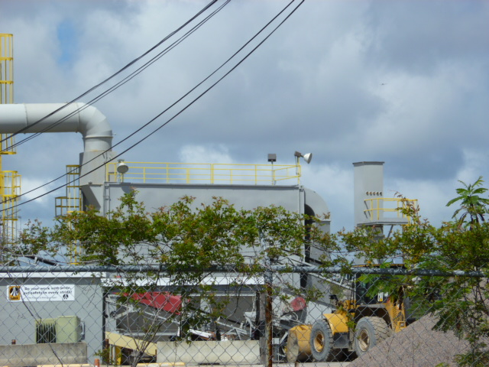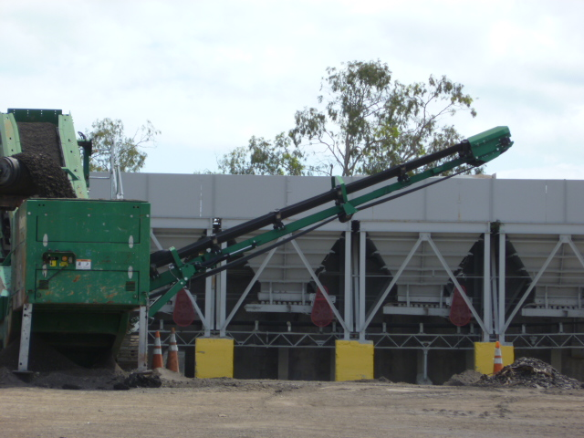

Project Id: 88763 Permit No: 1030026-009-AO Arms Number: 0026 001
Inspector: Shea Jackson Inspection Date / Time: 4/23/14 / _______
Source (EU): 250 Ton/hour Asphalt Plant: Gencor Industries, Inc., Model 400 Ultra Drum Mix Asphalt Plant (85MMBtu/hr) Controlled by a Gencor Industries Inc. Primary Collection System (knockout box) and a Caterpillar, Autopulse II, Model No. APL-720 Baghouse.

Description: [No emissions visible from stack at this time, observation of aggregate loading bins]

Ajax Paving Industries of Florida, LLC Largo Facility - Plant 7
1550 Starkey Road, Largo

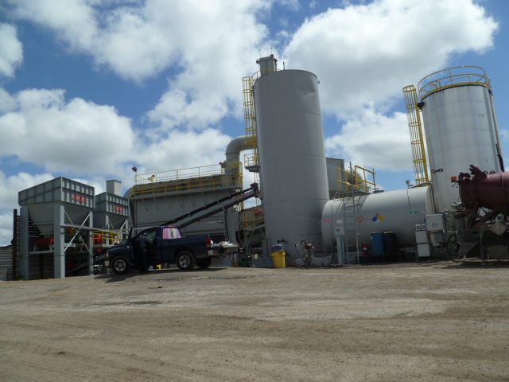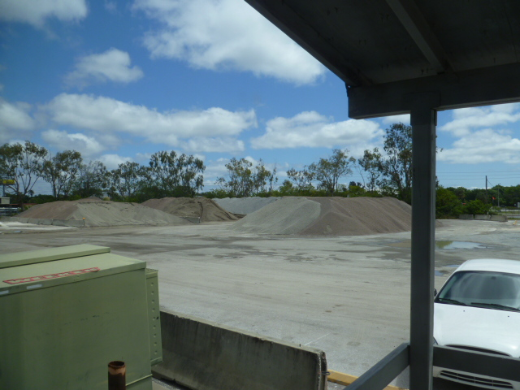

Project Id: 88763 Permit No: 1030026-009-AO Arms Number: 0026 001
Inspector: Shea Jackson Inspection Date / Time: 4/23/14 / _______
Source (EU): 250 Ton/hour Asphalt Plant: Gencor Industries, Inc., Model 400 Ultra Drum Mix Asphalt Plant (85MMBtu/hr) Controlled by a Gencor Industries Inc. Primary Collection System (knockout box) and a Caterpillar, Autopulse II, Model No. APL-720 Baghouse.

Description: [No visible emissions observed from baghouse vent, yard in good conditions recently water. The aggregate stock piles were wet and maintained at lower levels to prevent unconfined emissions. ]

Ajax Paving Industries of Florida, LLC Largo Facility - Plant 7
1550 Starkey Road, Largo

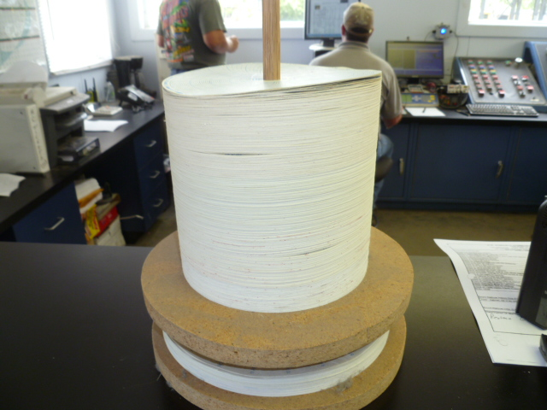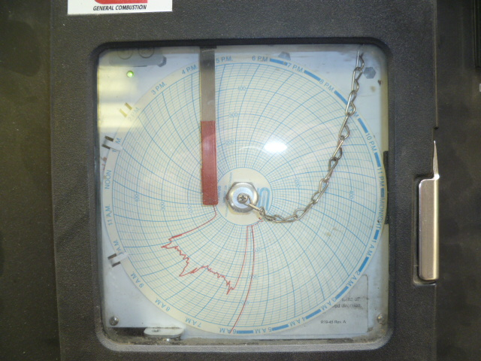

Project Id: 88763 Permit No: 1030026-009-AO Arms Number: 0026 001
Inspector: Shea Jackson Inspection Date / Time: 4/23/14 / _______
Source (EU): 250 Ton/hour Asphalt Plant: Gencor Industries, Inc., Model 400 Ultra Drum Mix Asphalt Plant (85MMBtu/hr) Controlled by a Gencor Industries Inc. Primary Collection System (knockout box) and a Caterpillar, Autopulse II, Model No. APL-720 Baghouse.

Description: [The rotary drum chart runs continuously during plant operations to maintain temperatures below 400 degree. The facility maintains the past 5 years charts on site]

