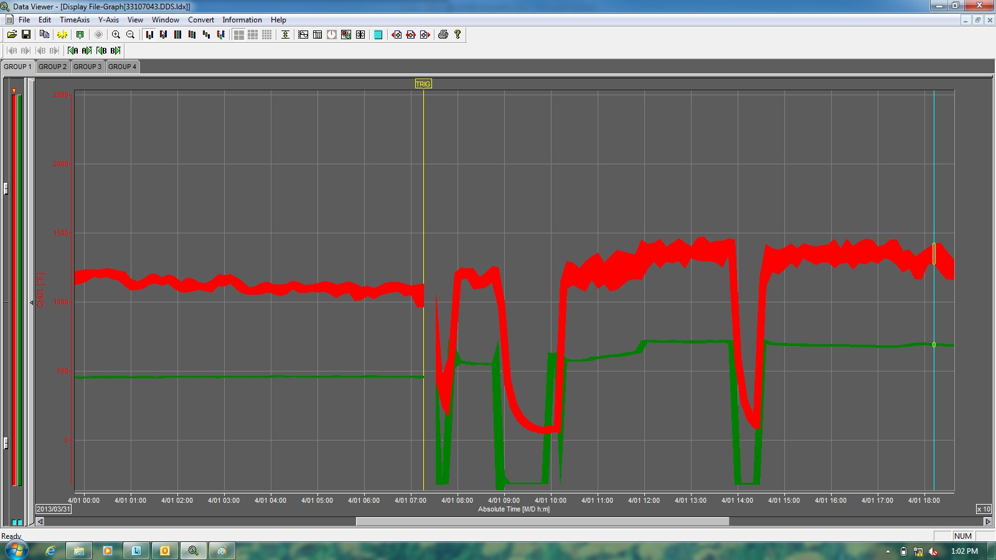
Martin Co./Palm City II Landfill Flare Downtime Chart 4/1/2013

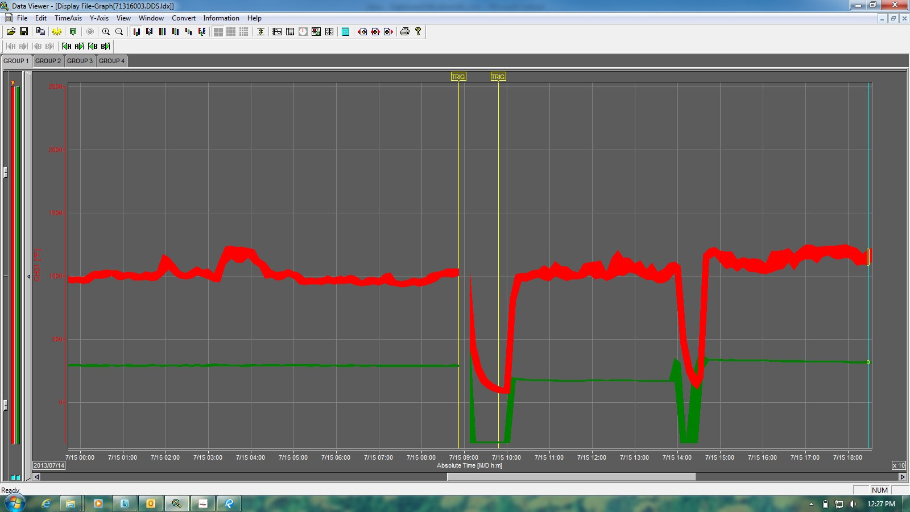
Martin Co./Palm City II Landfill Flare Downtime Chart 7/16/2013
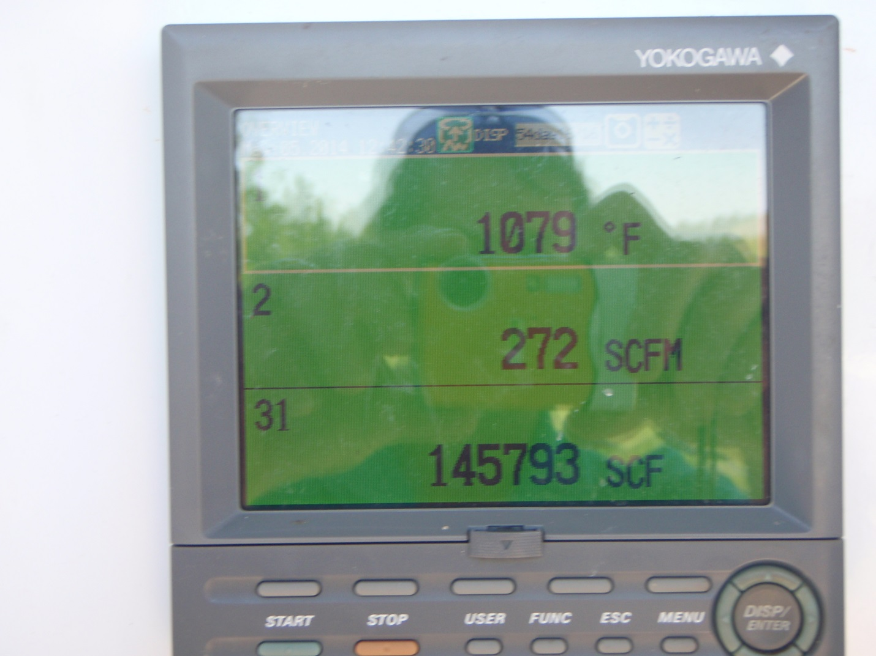
Martin Co./Palm City II Landfill Flare Display 5/5/2014

