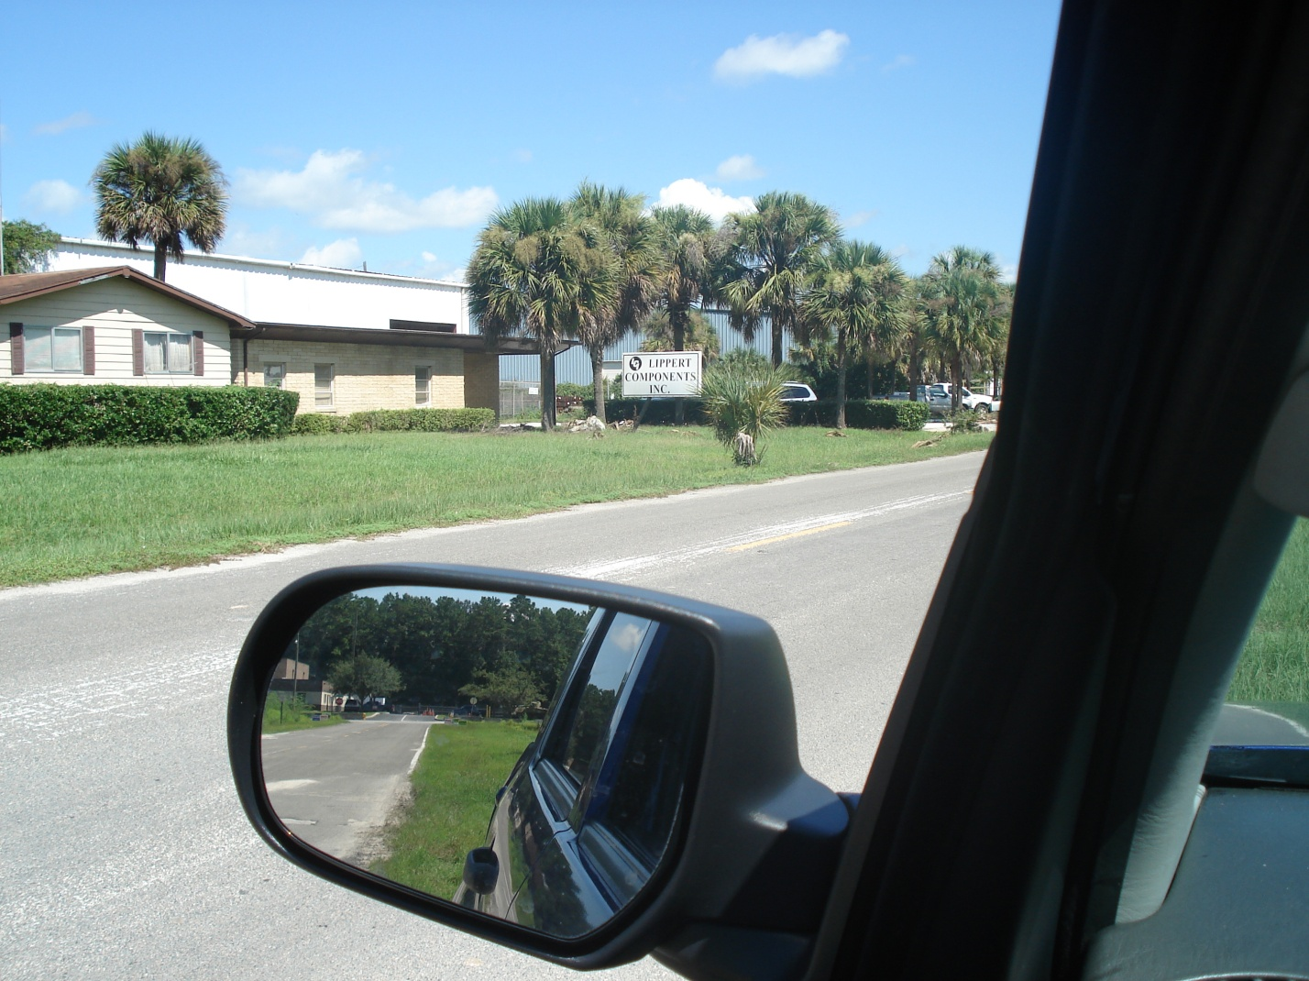
Lippert Components, Ocala. Photo taken August 26, 2008 by Garry Kuberski. Inspection conducted August 26, 2008.

