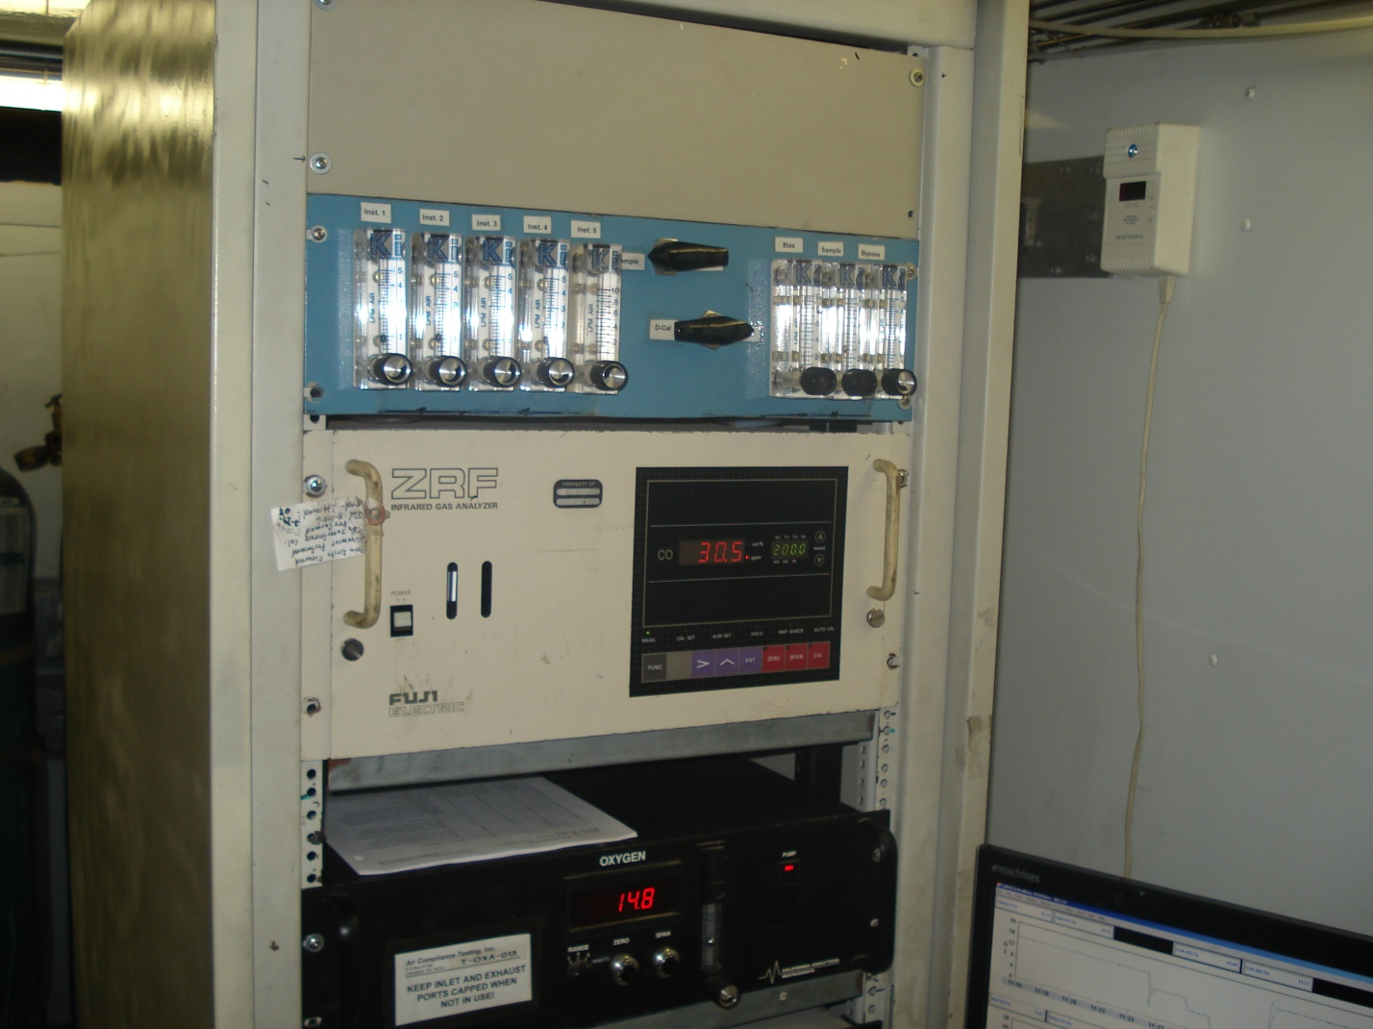
Lake Cogen inspection conducted December 9, 2008. Stack test was being conducted.
Taken by G. Kuberski
Photo 3

