FLORIDA DEPARTMENT OF ENVIRONMENTAL PROTECTION
INSPECTION REPORT FORM
AIR POLLUTANT EMISSION SOURCES

FACILITY: Rex Lumber | DISTRICT: Northwest | COUNTY: Jackson
ADDRESS: 5299 Alabama Avenue  Graceville | PHONE: (850) 263-4465 | CONTACT: Randy Cummings
CONTACT OR FACILITY EMAIL ADDRESS: rcummings@rexnfl.com
ARMS I.D. #: 0630011 | 0630011-009-AV | EXPIRES: 08/03/2008
RENEWAL APPLICATION/NOTIFICATION DUE DATE: 02/05/2008
SOURCE DESCRIPTION: Lumber Mill
INSPECTED BY: Richard Brookins  INSPECTION DATE: 03/29/2007 | AUDIT TYPE: Ins2 | COMPLIANCE STATUS:  Out of Compliance

INSPECTION COMMENTS

I arrived at the facility and was greeted by Mr. Mike Warrington and Mr. Steve Boyd, Production Area Managers. Mr. Warrington informed me that Mr. Randy Cummings is the new plant manager and would be the normal environmental contact. He was however, off-site at the beginning of the inspection. Both Mr. Warrington and Mr. Boyd accompanied me during my inspection of the facility. We were later joined by Mr. Randy Cummings who provided copies of requested records. Only Kiln #2 was in operation during the inspection.

There were no objectionable odors noticed during the inspection. [Facility-wide Condition 2]

There were fugitive emissions greater than 20% opacity noticed during the inspection. These emissions were coming from both the general yard area and vehicular traffic at the facility. [Facility-wide Condition 3 – Excessive visible emissions]

The facility does not have a Risk Management Plan, nor is it required to have one. [Facility-Wide Condition 4]

VOC control appeared adequate. No open containers were noticed that were not in actual use. [Facility-Wide Condition 7]

Reasonable Assurances continue to need improvement at this facility. Excessive fugitive emissions were noticed being directly and indirectly caused by forklift and other vehicular traffic at the facility. Even allowing for the onsite construction activities, the hard surfaced roadways and yard areas of the facility were dirty and did not appear to have been cleaned in quite some time. The waste wood truck drivers continue to be allowed to load their own trailers while at the facility. This results in material spilling over the sides of the trailer onto the ground, with the resulting potential for unconfined particulate emissions. Also the facility is required to wet down the unpaved roads to limit fugitive emissions but has no means to do so. On April 2, 2007 a phone call was received from Mr. Randy Cummings stating that the facility has located a tank to build a water trailer with. [Facility-wide Condition 8 – Lack of Reasonable Assurances]

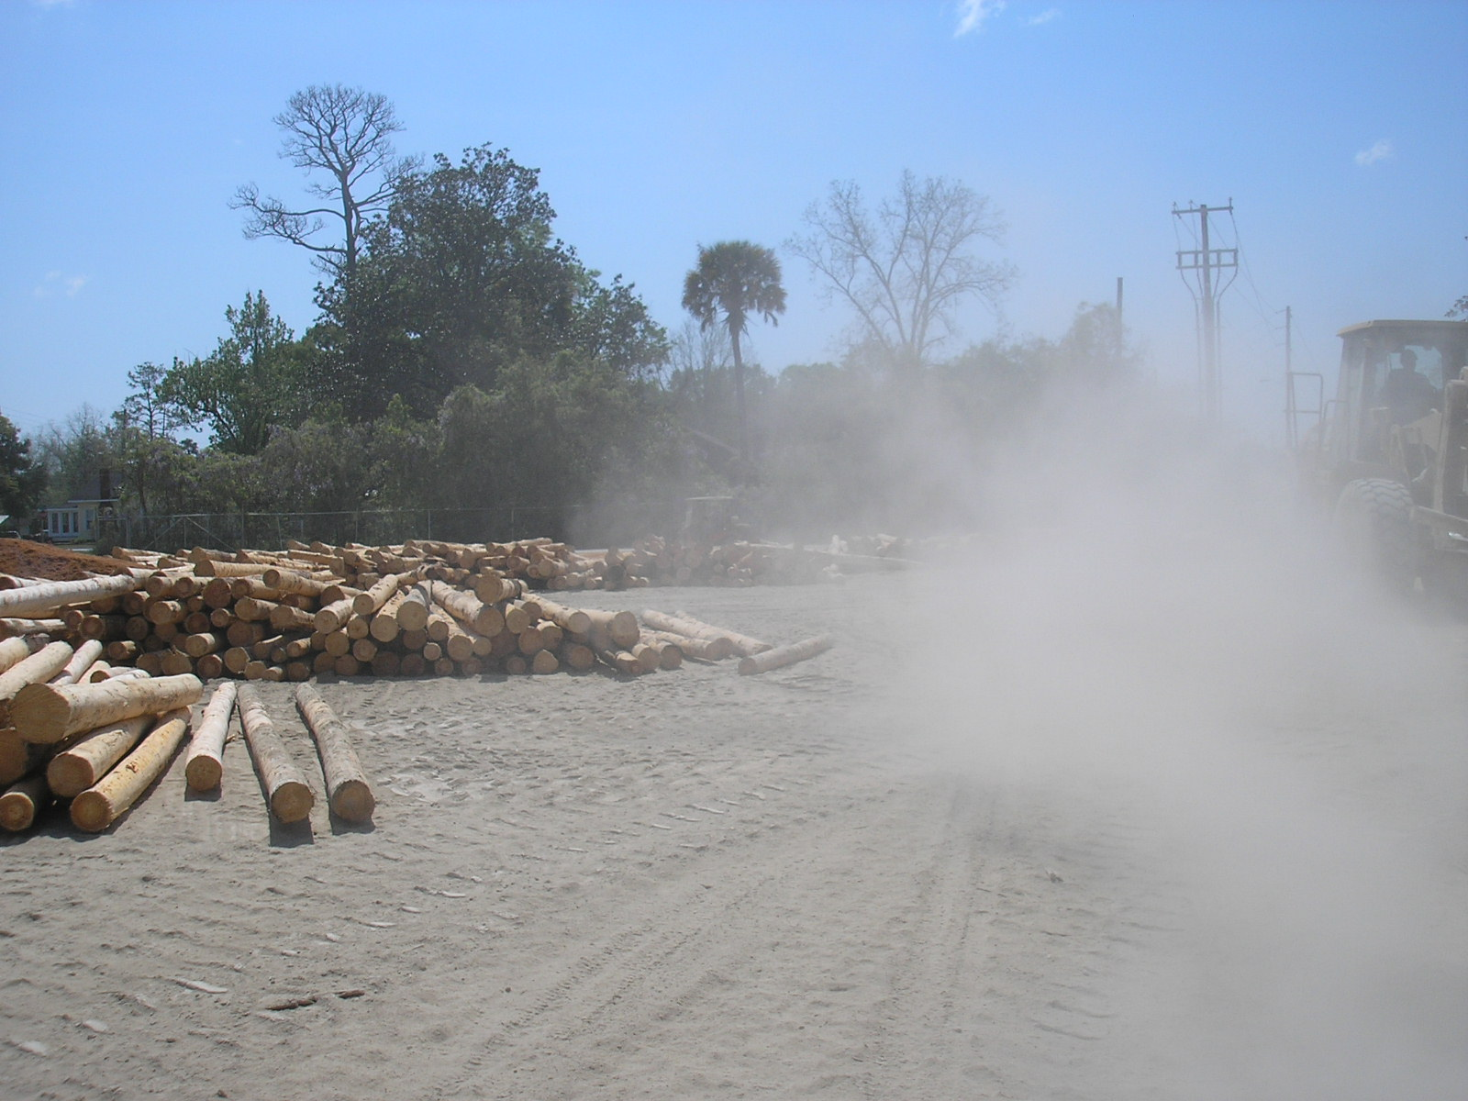
Fugitive emissions on unpaved roadways

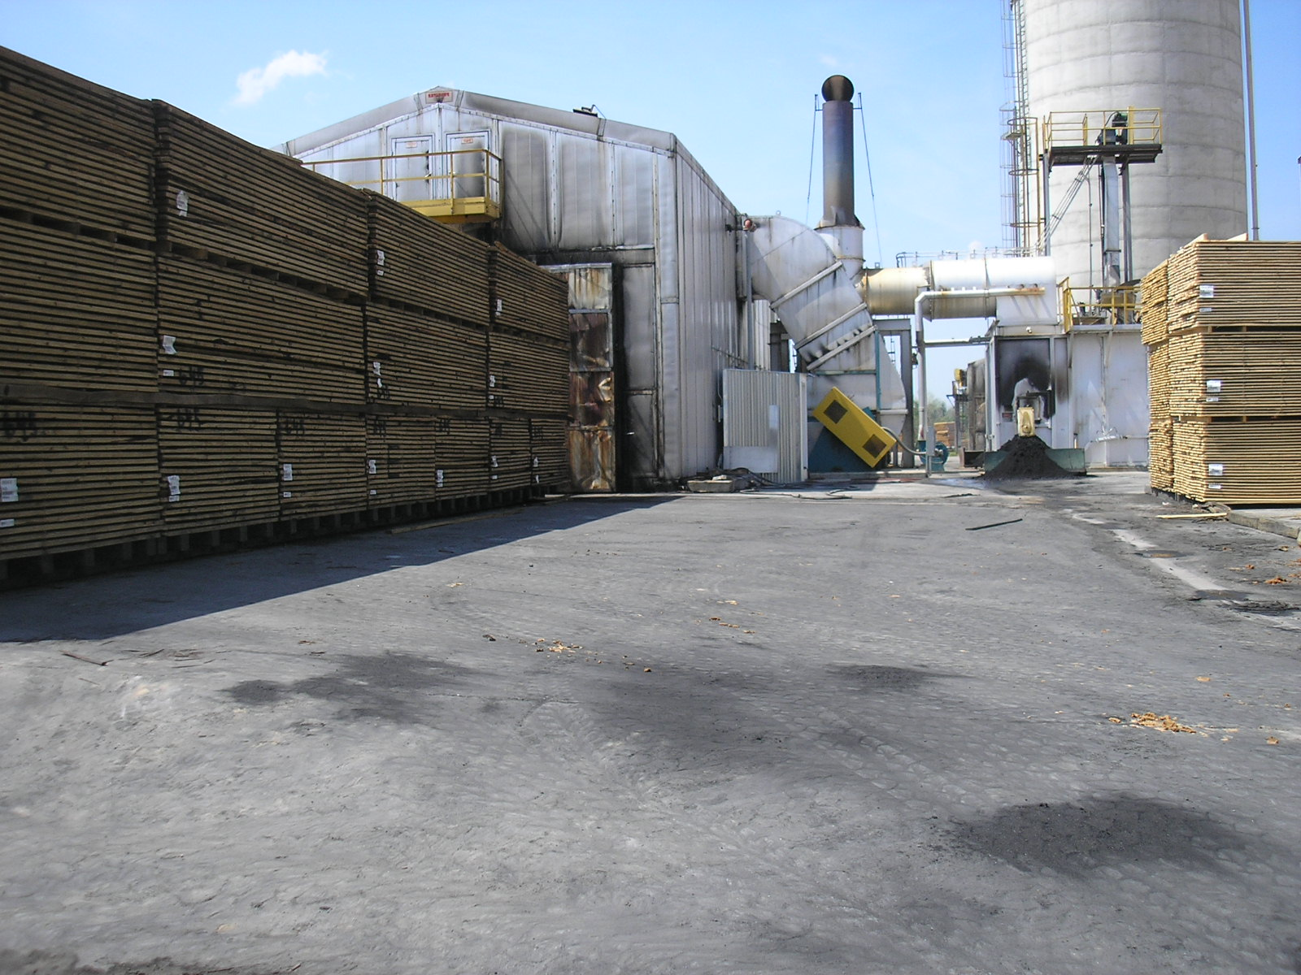
Area around Kiln #3

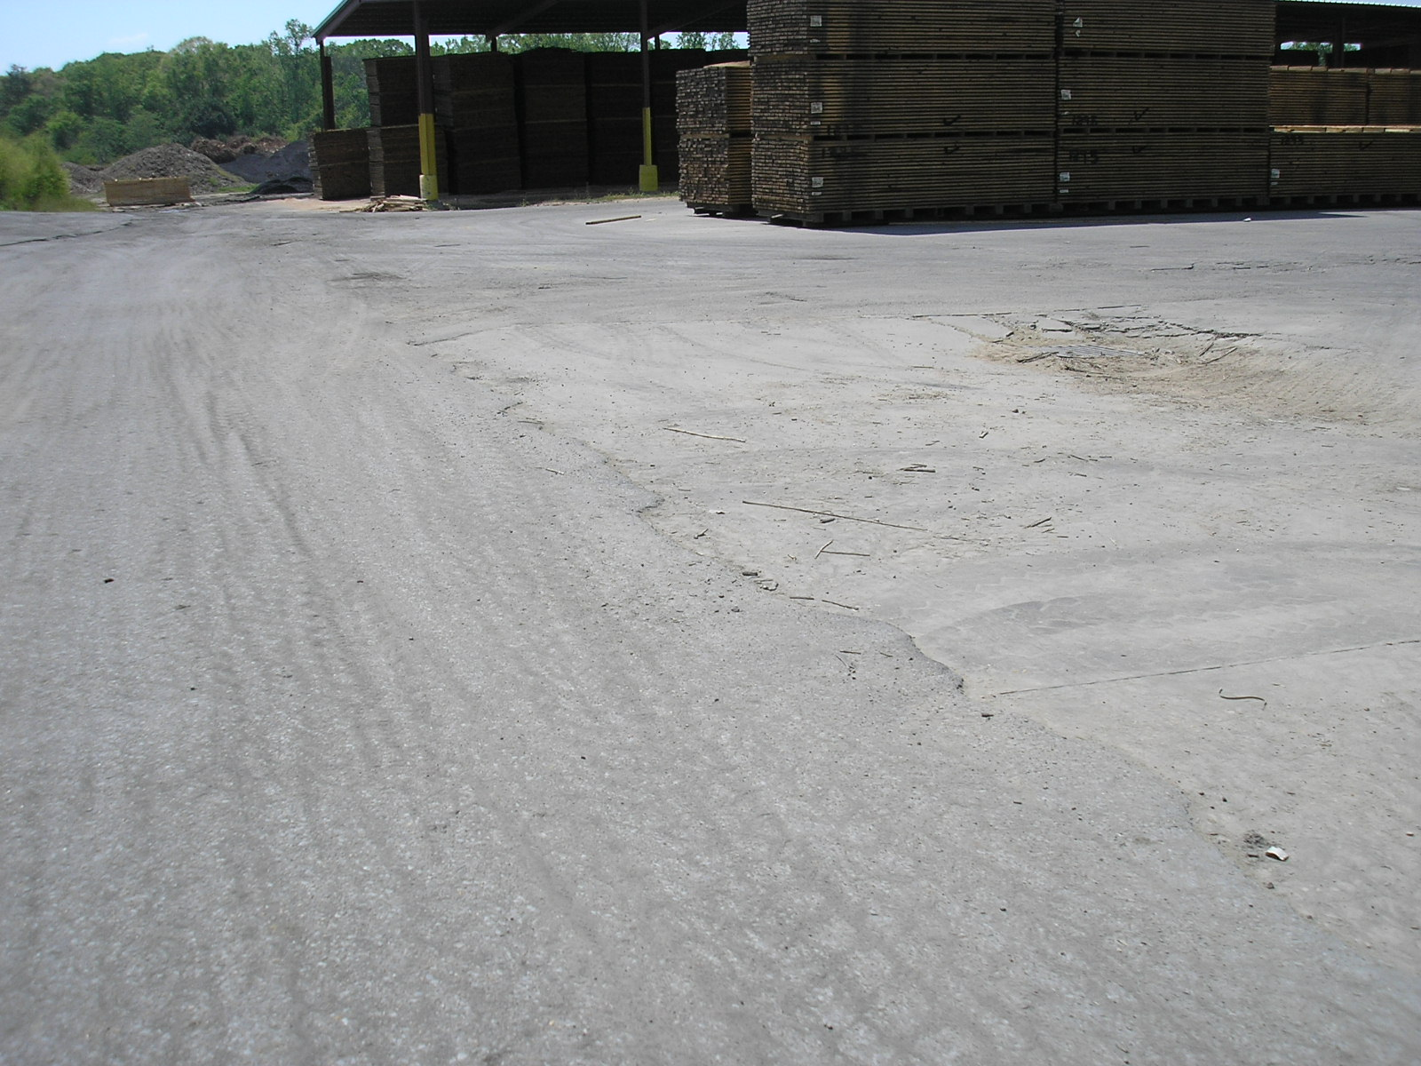
Wood storage areas – note buildup of material on roadway

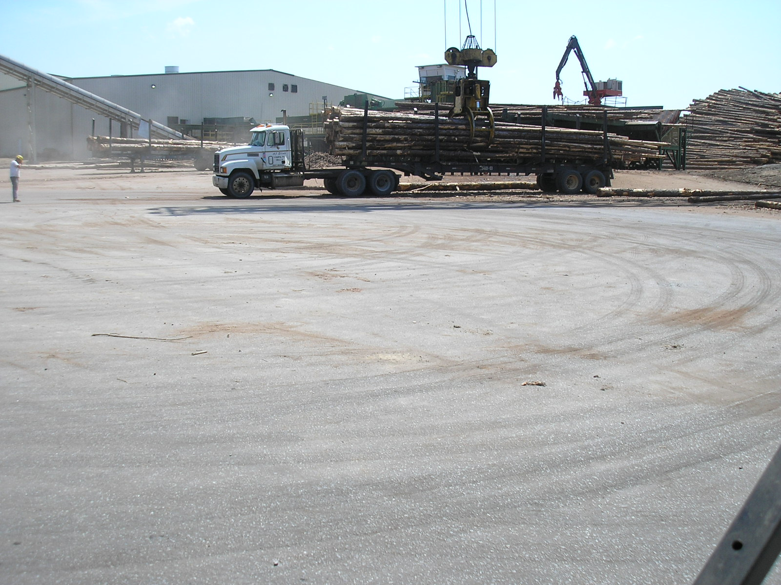
Log unloading area, note fugitive emissions in background

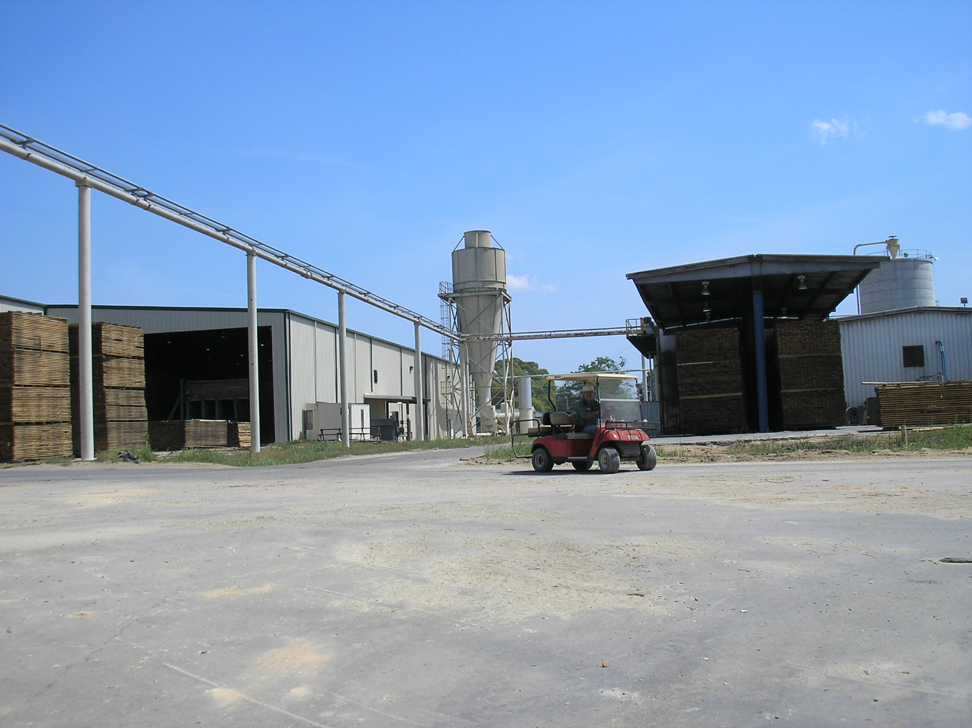
Additional hard surface roadways

EU022 Direct Fired Drying Kilns #1 and #2

According to records provided during the inspection, the facility has processed 7,521,134 board feet of lumber in Dry Kiln #1 and 7,616,360 board feet in Dry Kiln #2 during the current Y-T-D. This is within the facility’s has a maximum production rate of 40,150,000 board feet of lumber per year in each kiln. Weekly production records for 2006 were requested and reviewed as part of this inspection. For the calendar year 2006 Kiln #1 produced 33,842,437 board feet of lumber while Kiln #2 produced 31,785,151 board feet. [Specific Condition A.1]

The maximum permitted heat input for each kiln is now limited to a maximum of 22 MMBtu/Hr heat input based on a 24-hour average. This equates to 66,000 pounds of wood waste per day (or 2,750 Lb/Hr) per kiln assuming a HHV of 16,000,000 BTU/Ton. Records of heat input for both kilns for 2006 and this current Y-T-D were requested and reviewed as part of this inspection. The record review showed that Kiln #1 exceeded the new maximum allowable heat input (110% of testing rate) 26 times this current Y-T-D. Kiln #2 exceeded its new maximum allowable heat input 39 times this current Y-T-D. See the discussion of Specific Condition A.5 for additional information. [Specific Condition A.2 – Excessive Heat Input]

Visible emissions for Kiln #1 were estimated at 0% opacity (down) while Kiln #2 was estimated at 15% opacity during the inspection. [Specific Condition A.4]

Visible emission testing for both kilns was last performed on November 29, 2006. Heat input during this test was mistakenly recorded as 25 MMBtu/hr. An investigation during the annual inspection revealed that Kiln #1 was actually operating at 12,514,223 Btu/hr heat input while Kiln #2 was operating at 10,869,956 Btu/hr. Since the emission units are limited to a maximum of 110% of the actual operating rate during testing the new maximum operating rates for Kiln #1 is 13,765,645 Btu/hr while Kiln #2 is limited to a maximum of 11,956,951 Btu/hr. [Specific Condition A.5]

EU039 Planer Mill Shavings Cyclone, Shavings Bin Cyclone, and Fuel Storage Bin Cyclone

There were no visible emissions in excess of 20% opacity coming from the Shavings Bin, Fuel Storage Cyclones and/or the Planer Mill Shavings Cyclone.

EU041 #3 Direct Fired Dry Kiln

According to records provided, the facility has processed 7,875,411 board feet of lumber during the current Y-T-D in Dry Kiln #3. This is within the maximum permitted production rate of 44,860,000 board feet of lumber per year in each of the new kilns. Weekly production records for 2006 were requested and reviewed as part of this inspection. For the calendar year 2006 Kiln #3 produced 35,666,918 board feet of lumber. [Specific Condition B.1]

The maximum permitted heat input for this kiln is limited to 25 MMBtu/Hr heat input based on a 24-hour average. This equates to 150,000 pounds of wood waste per day (or 6250 Lb/Hr) per kiln assuming a HHV of 8,000,000 BTU/Ton. Records of heat input for Kiln #3 for calendar year 2006 and this current Y-T-D were requested and reviewed as part of this inspection. The record review showed that the facility exceeded its new maximum allowable heat input 2 times this current Y-T-D. See the discussion of Specific Condition B.5 for additional information. [Specific Condition B.2 – Excessive Heat Input]

Visible emissions for Kiln #3 were estimated at 0% opacity (down) during the inspection. [Specific Condition B.4]

Visible emission testing for this kiln was last performed on November 29, 2006. Heat input during this test was mistakenly recorded as 25 MMBtu/hr. An investigation during the annual inspection revealed that Kiln #3 was actually operating at 15,254,844 Btu/hr heat input. Since this emission unit is limited to a maximum of 110% of the actual operating rate during testing the new maximum operating rates for Kiln #3 is 16,780,328 Btu/hr. [Specific Condition B.5]

RECOMMENDATIONS:

Ensure the kiln operators are aware of the new heat input limitations.

Clean the facility roadways and hard surface yard areas.

Fabricate the water truck and use it as necessary to reduce fugitive emissions in the non-hard surface yard areas.

Review heat input records and find and correct the cause of the spurious excessive heat input readings.

