FACILITY ADDRESS:  6211 North 56th St , Tampa, FL 33610 |  |  |  |  |  |  |  |  | FACILITY PHONE:  813 914-0557  813 621-2065
INSPECTION DATE:  6/2/2009 |  | TIME IN: |  |  | TIME OUT: |  | INSPECTION TYPE  INS2 |  |  | STATUS:  IN
Permit No.  0570136-003-AO | Expiration Date:  September 20, 2009 |  |  | Overdue Tests  NA |  | P2 Action: NA
Warning Notice: Warning 2006-3768A 12/11/2006  Failure to cover dumpster, resulting in particulate matter/ vermiculite emissions creating a public nuisance.  Sent to enforcement. |  |  |  |  |  | Citizen Complaints: Complaint 2006-1965A 12/8/2006  Vermiculite dust eminating from the facility is causing breathing problems and eye irritation.  WN issued.
Correspondence File Review: Yes
SOURCE DESCRIPTION:
Vermiculite Expansion Furnaces

CONTACT(S): Tim Brothers, G.R. Schmelzer
Inspection:
I went to the facility for an un-announced FCE inspection. The facility has shutdown and has a for-sale sign in front of the parking lot. I took several pictures and left the facility at 2:30 PM.

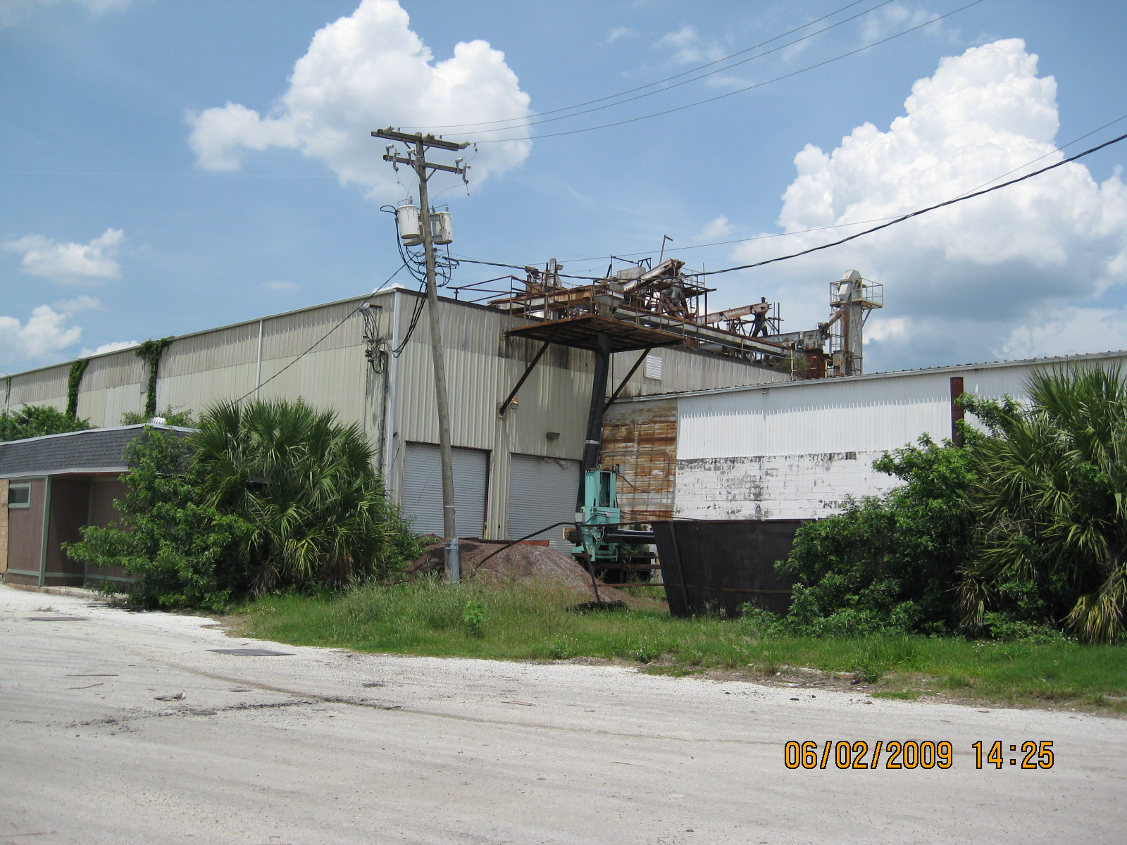
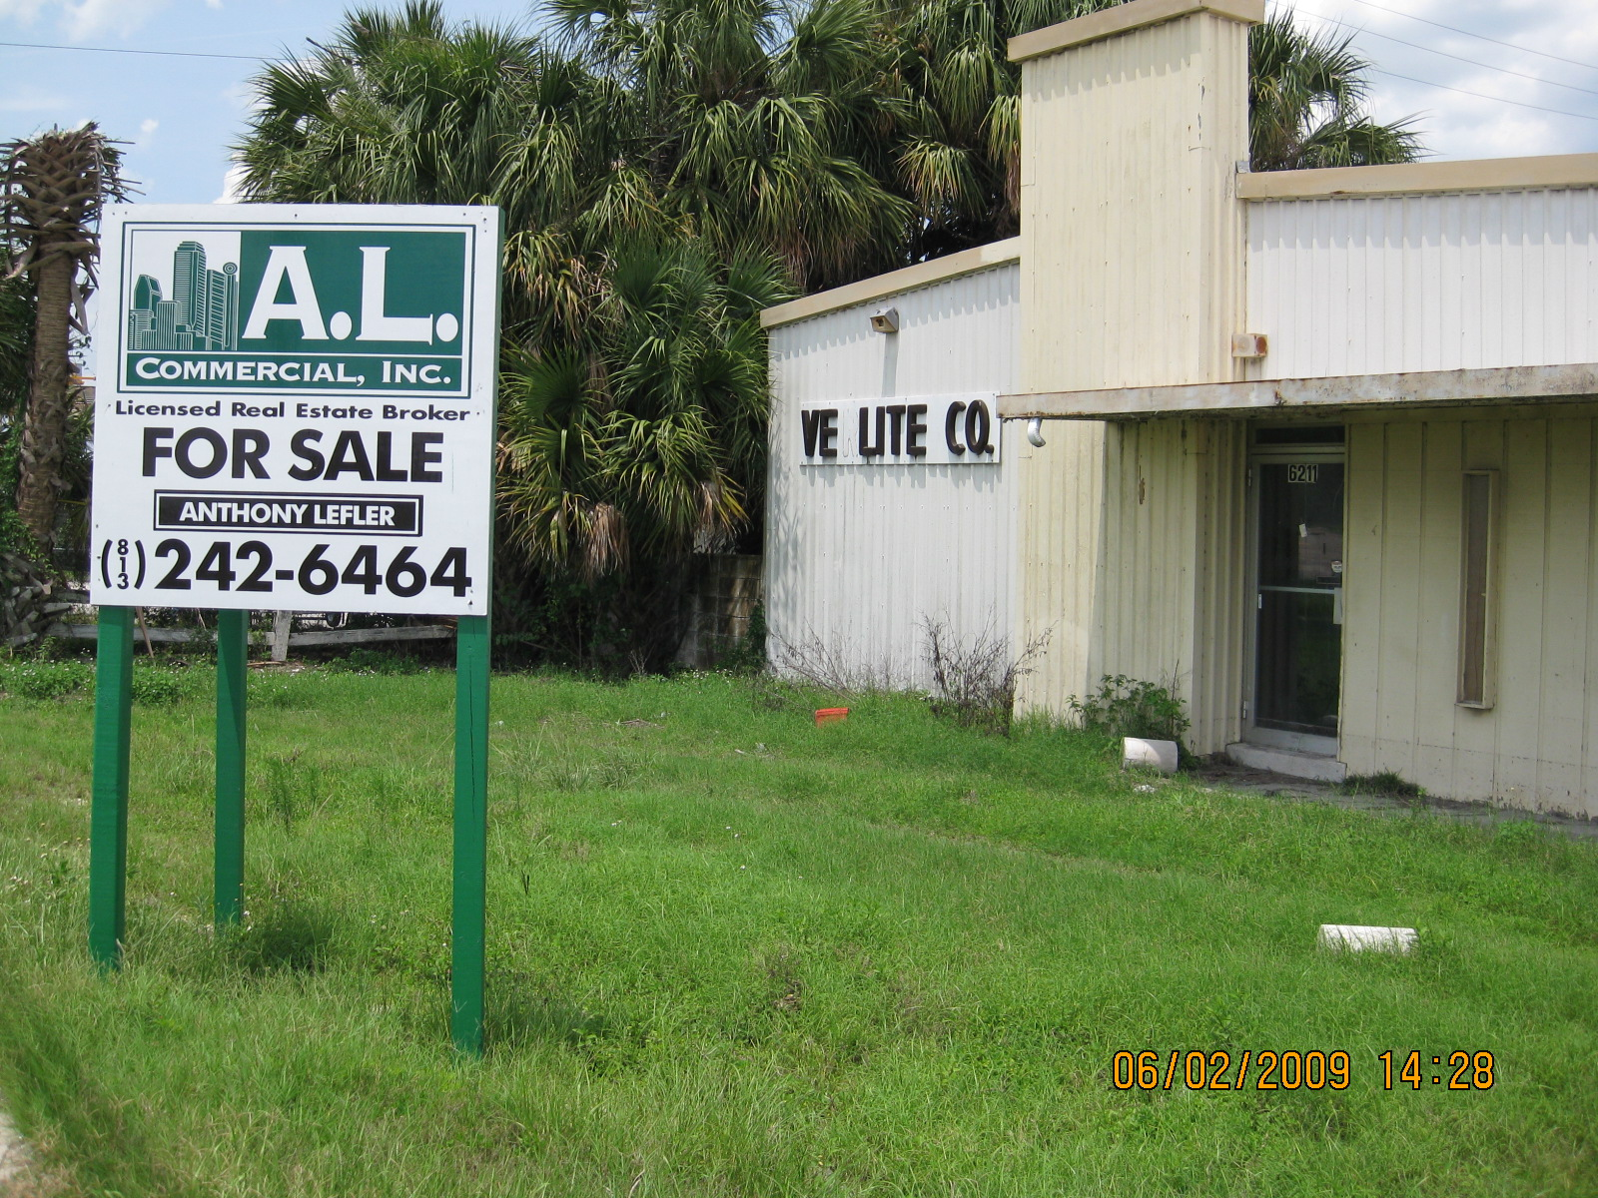

I called the facility on 6/4/2009 and the phone numbers were not working. I called the realtor and left message for them to call me back.

