INSPECTION REPORT FORM
ENVIRONMENTAL PROTECTION COMMISSION OF HILLSBOROUGH COUNTY
FACILITY: Tampa Electric Company - Hookers Point Station |  |  |  | PAGE 1 OF 1
FACILITY ADDRESS: |  |  | CITY:  Tampa
MAILING ADDRESS:  1700 Hemlock Street |  | CITY:  Tampa |  |  | ST:  FL | ZIP:  33605
INSPECTION DATE:  8/1/05 | TIME IN:  12:00 PM | TIME OUT:  1:00 PM |  | INSPECTION TYPE:  INS I |  | STATUS:  IN
NEDS NO.: 0570038
SOURCE DESCRIPTION: Power Plant
CONTACT(S): Laurie Pence
The purpose of this inspection was to verify the removal and shut down of all activities at the Tampa Electric Company (TECO) Hooker’s Point facility. Upon arrival I noticed a number of large TECO work trucks. I asked one of the workmen what they were doing. He explained that they were removing some of the poles and power cables because Gulf Marine had purchased the property and needed those items removed. The workman did not know when Gulf Marine had purchased the property, but stated they had been there working for a couple of weeks. I asked if any other activities were going on at the site such as sand blasting or anything else to which he replied “no”. I took the following photos of the facility and saw no evidence of any operational practices. I called Laurie Pence to inquire about the property sale on 8/1/05, and am awaiting her return phone call.

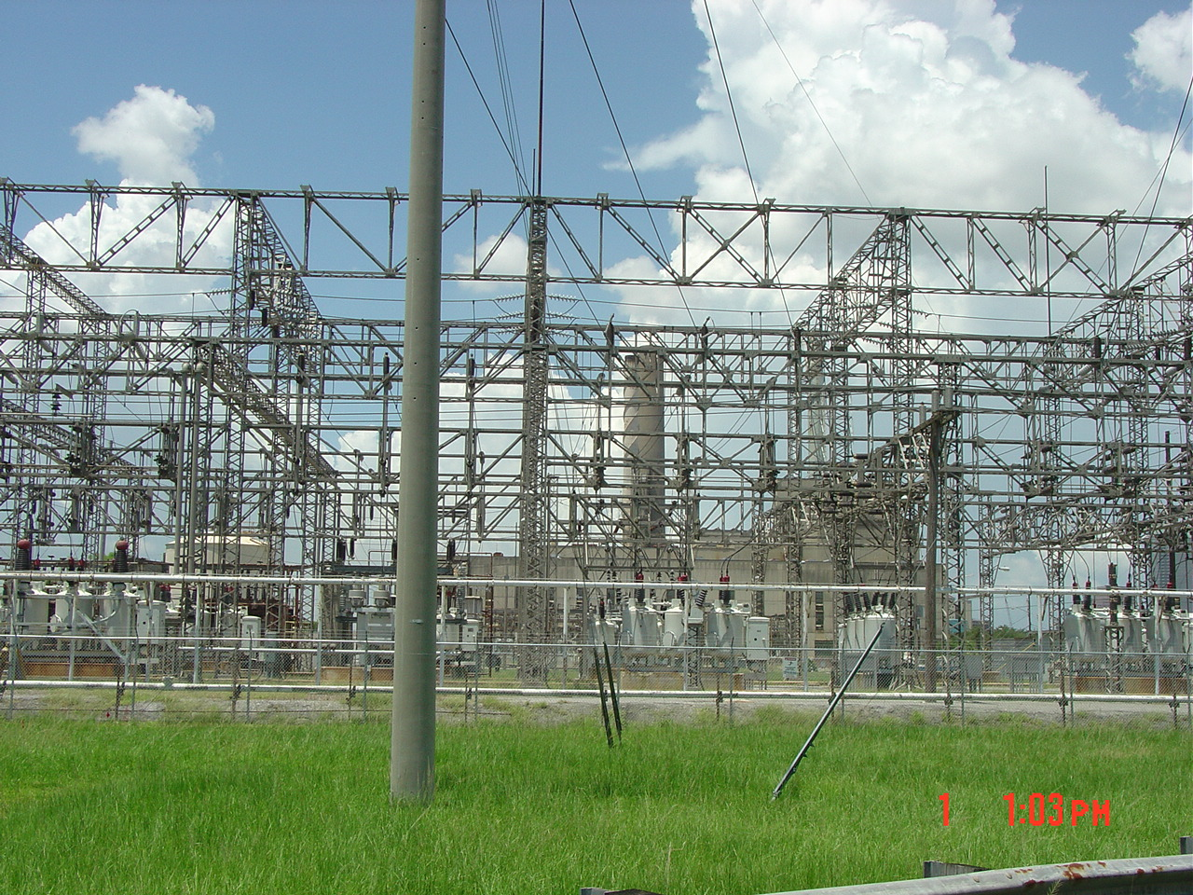
Teco Plant

INSPECTOR(S): Joshua Ellwein |  |  |  | REPORT DATE: 8/1/05

ENVIRONMENTAL PROTECTION COMMISSION CONTINUATION SHEET PAGE 2 OF 2
FACILITY: TECO – Hooker’s Point Station |  | REPORT NUMBER
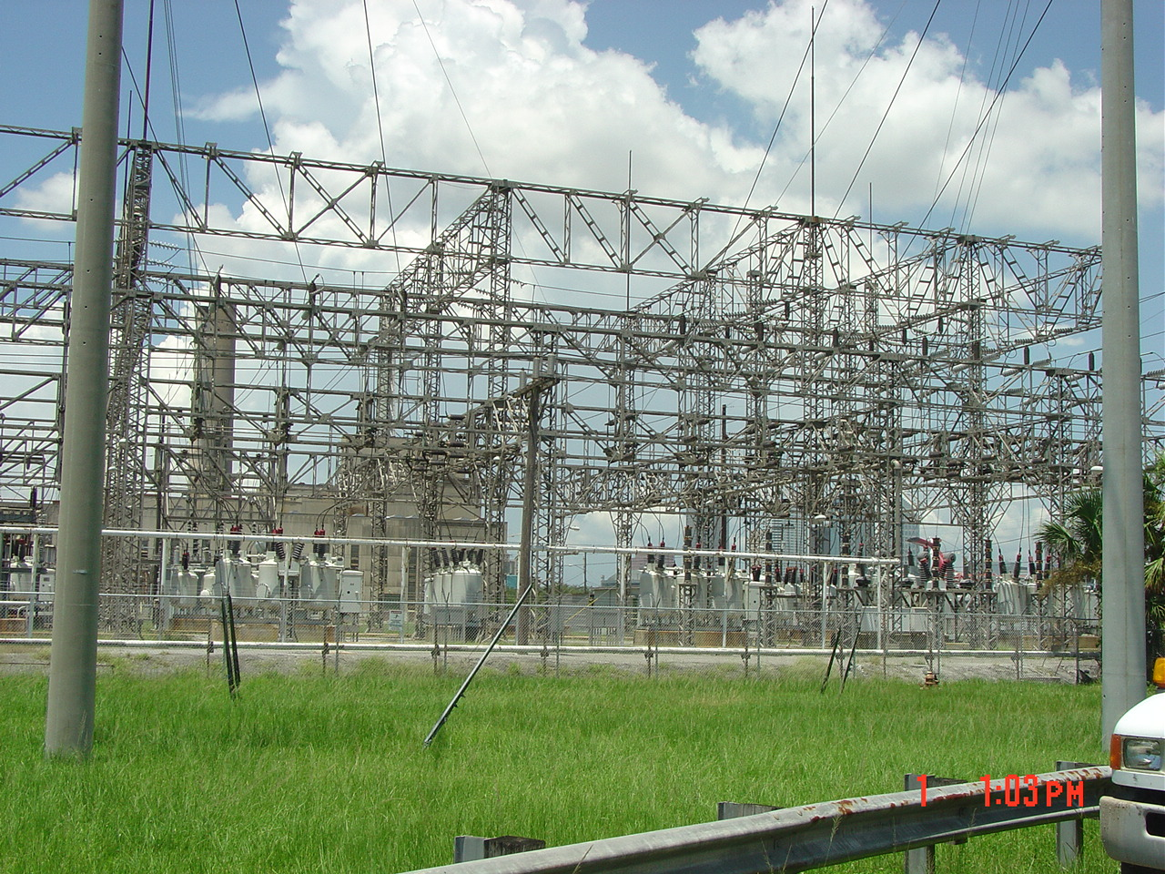
Teco Transformers

8/2/2005
I received a phone call today from Laurie Pence at Tampa Electric. She confirmed the sale of the old Hooker’s Point facility property to Gulf Marine; the contracts were signed 3/31/2005.

INSPECTOR(S): Joshua Ellwein | REPORT DATE: 8/1/05

