Tarmac (0250647) Site Plan Submitted 8/22/02 with GP Notification

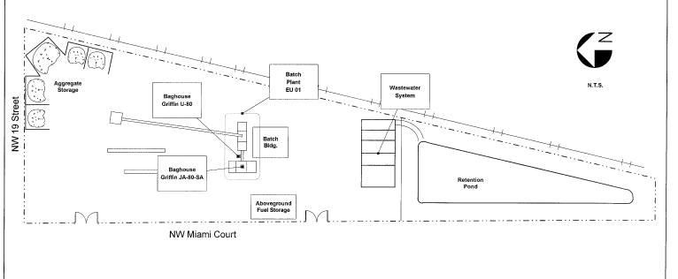

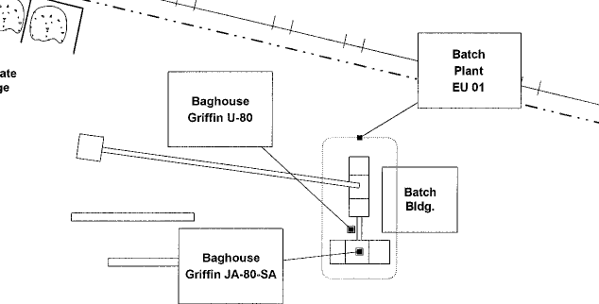
New Silo and Baghouse (Not included in GP Notification Site Plan).

