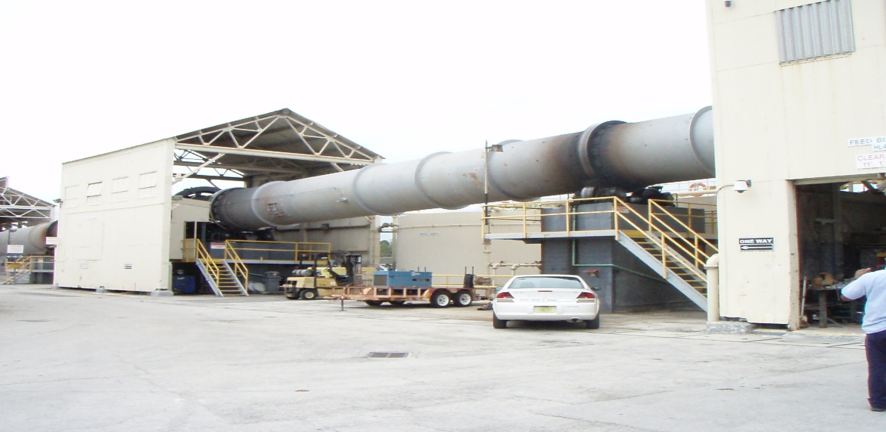

Hialeah Lime Kiln

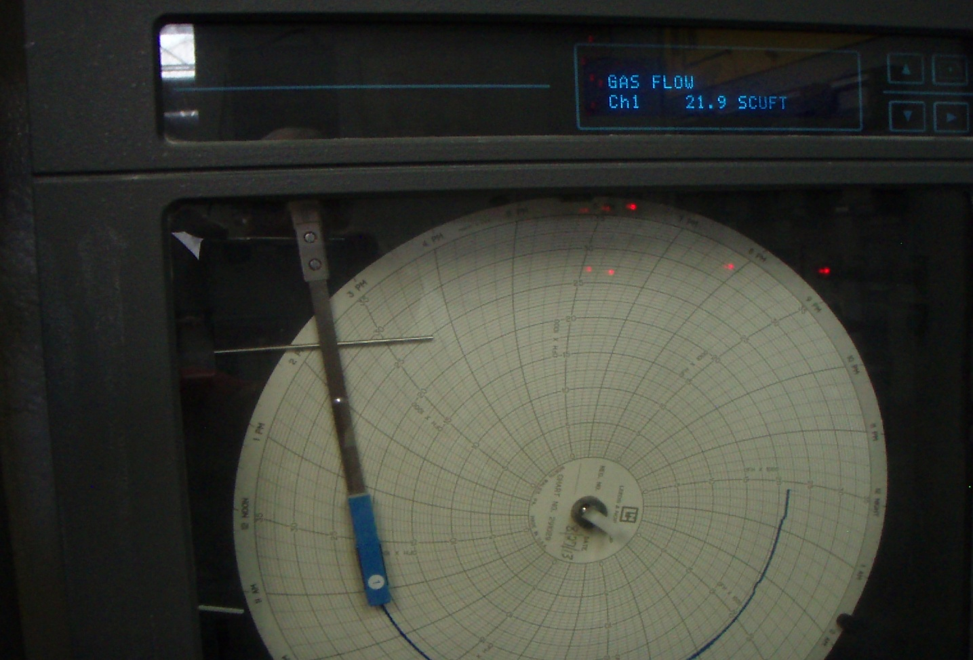

Hialeah Fuel Use Strip Chart

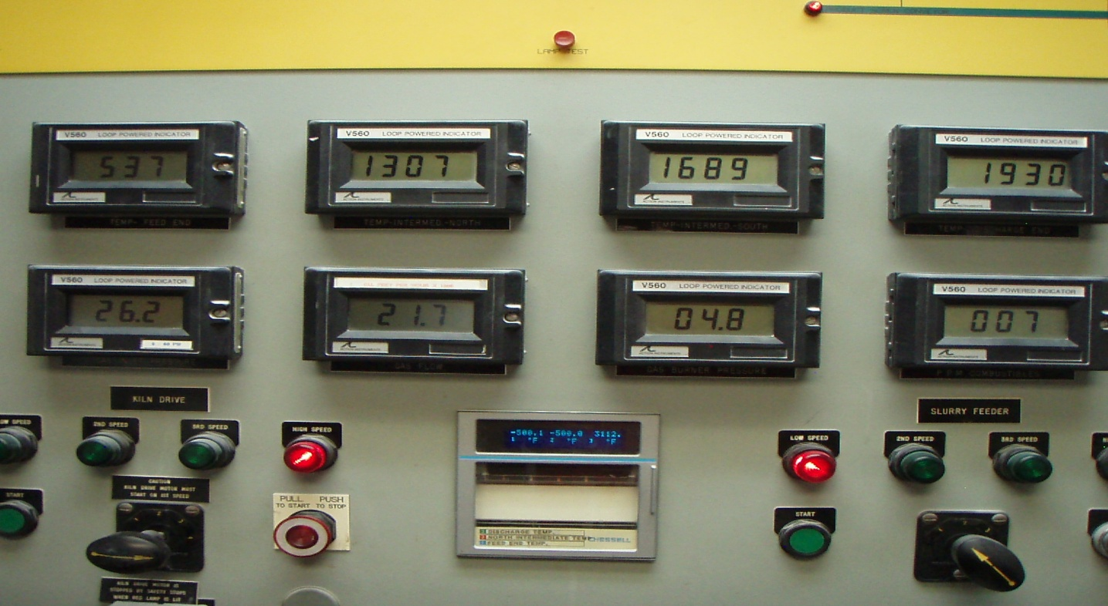

Hialeah Kiln Controller (Note Kiln Temps)

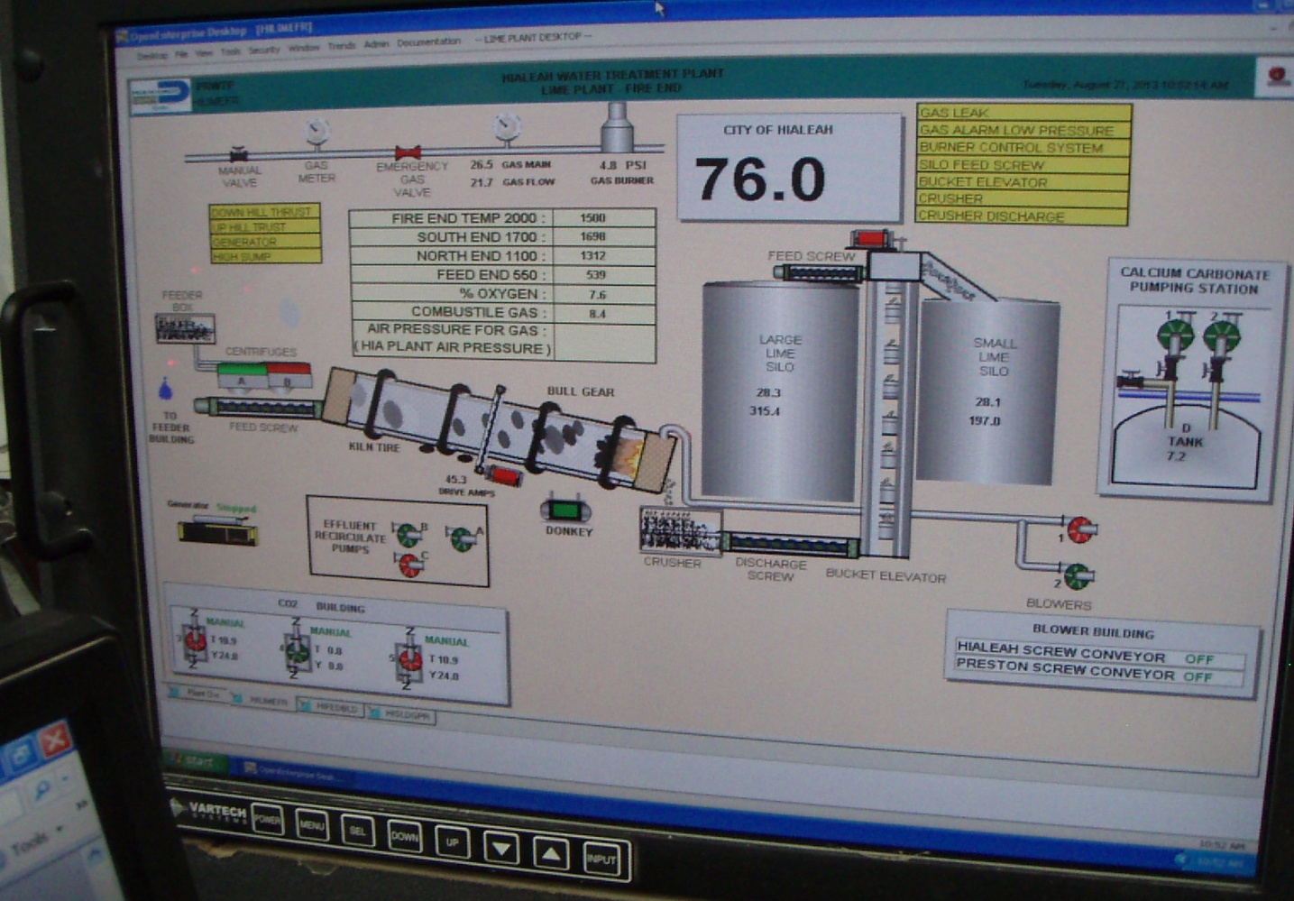

Hialeah Kiln LCD Monitor

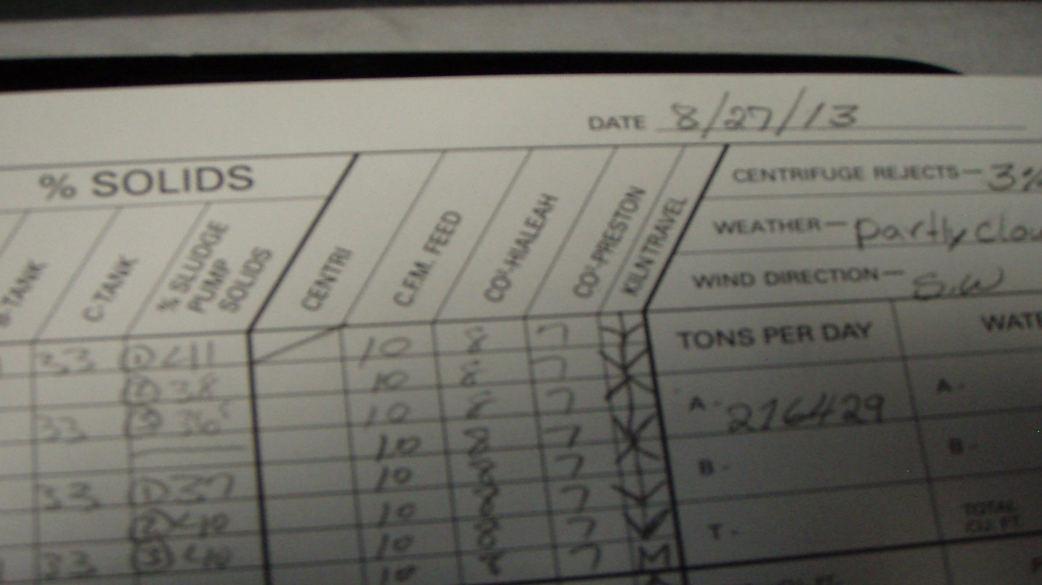

Hialeah Kiln Daily Log

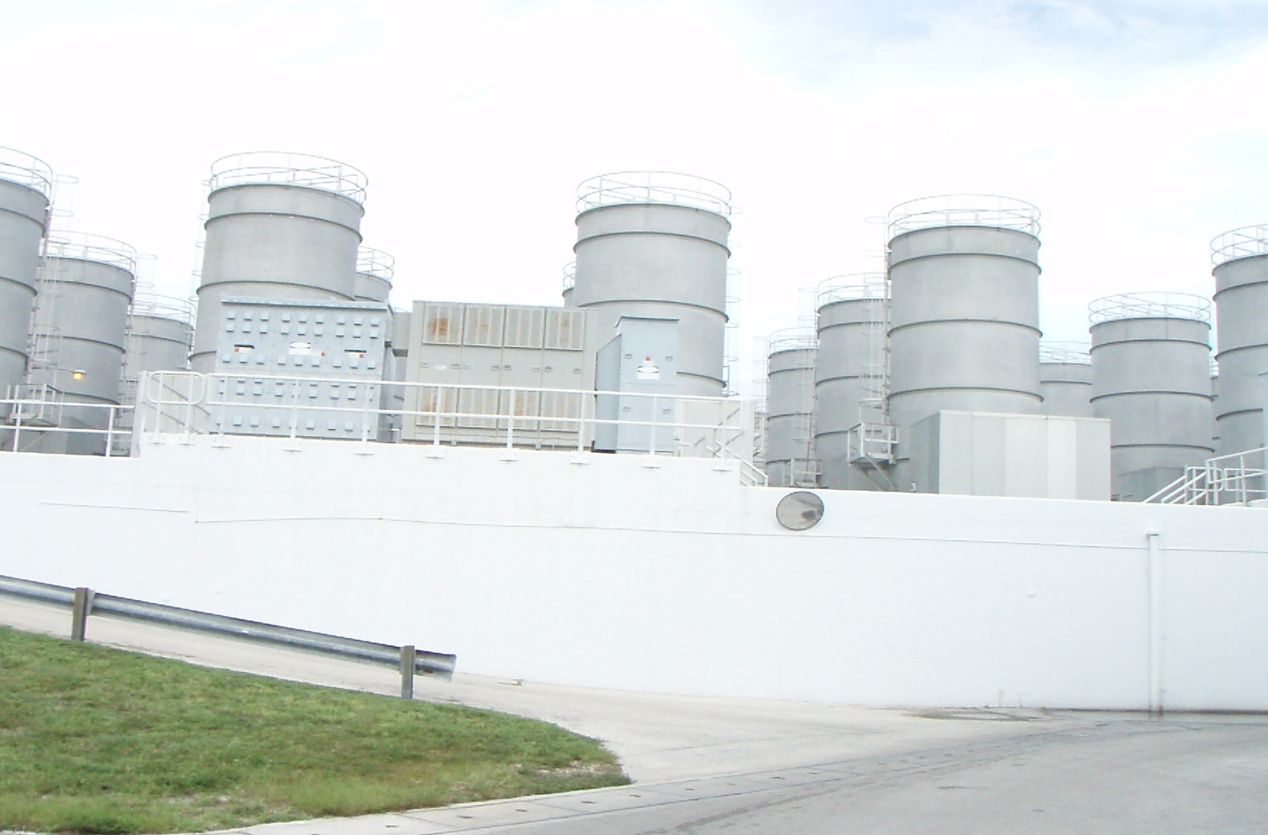

Preston Air Strippers

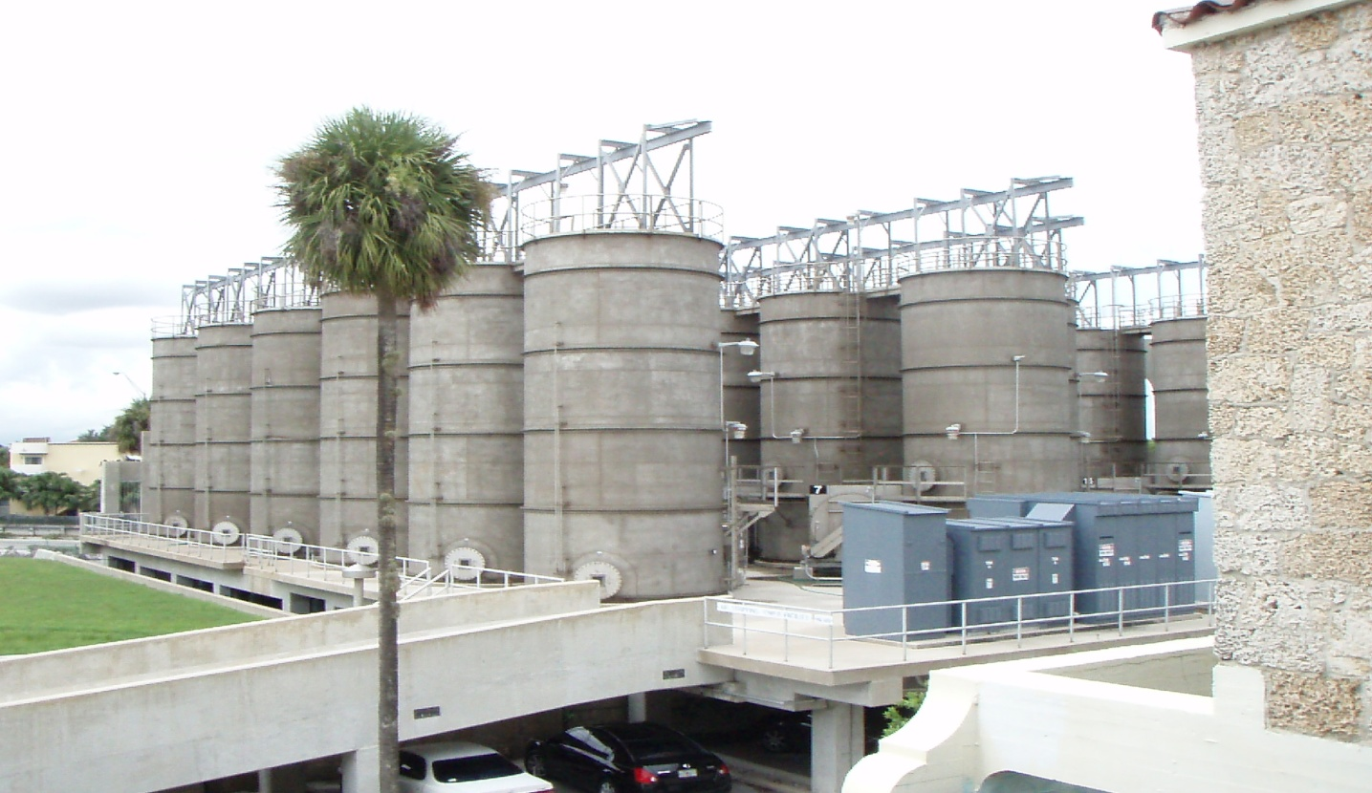

Hialeah Air Strippers

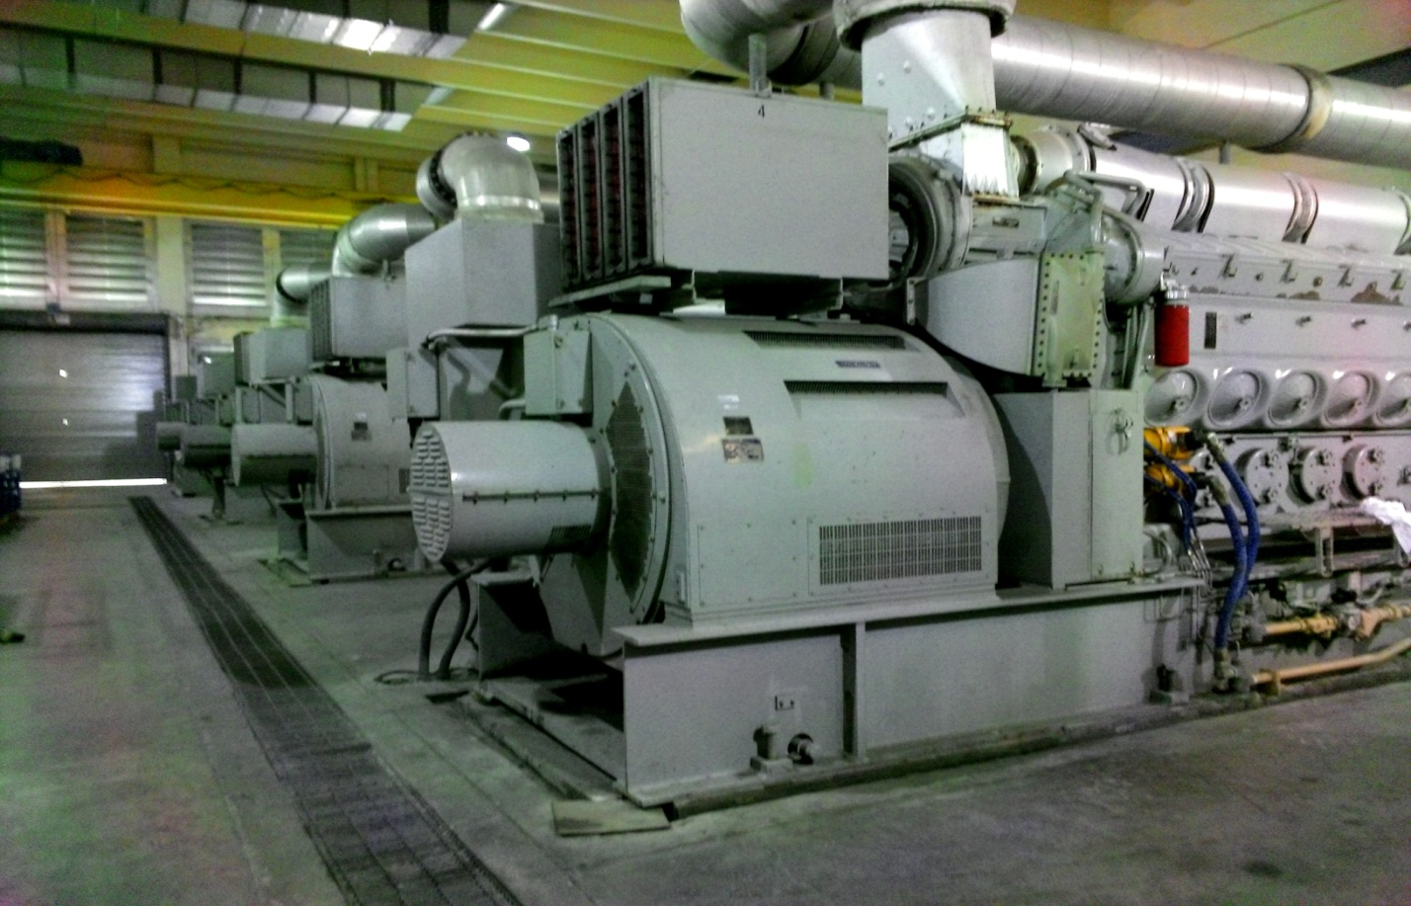

Hialeah Generators 1-4