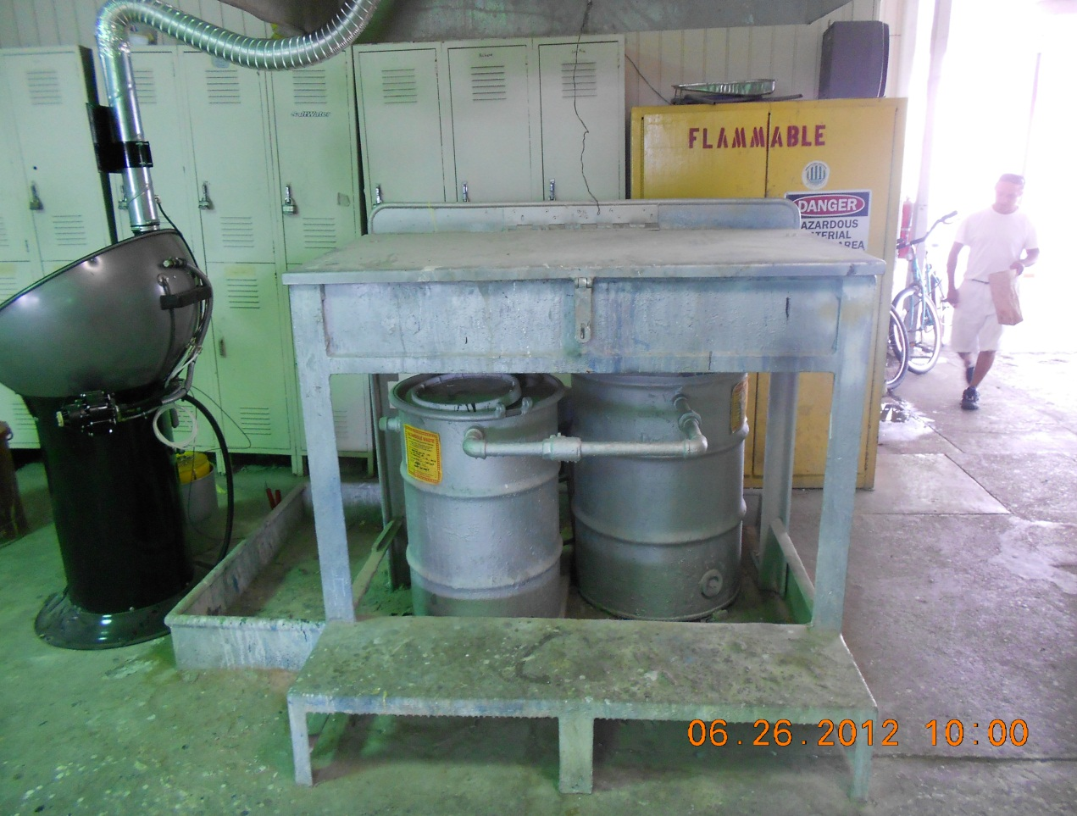
Photograph of lacquer thinner spray wash recyclable area. Taken By: E.Susky, NRS II
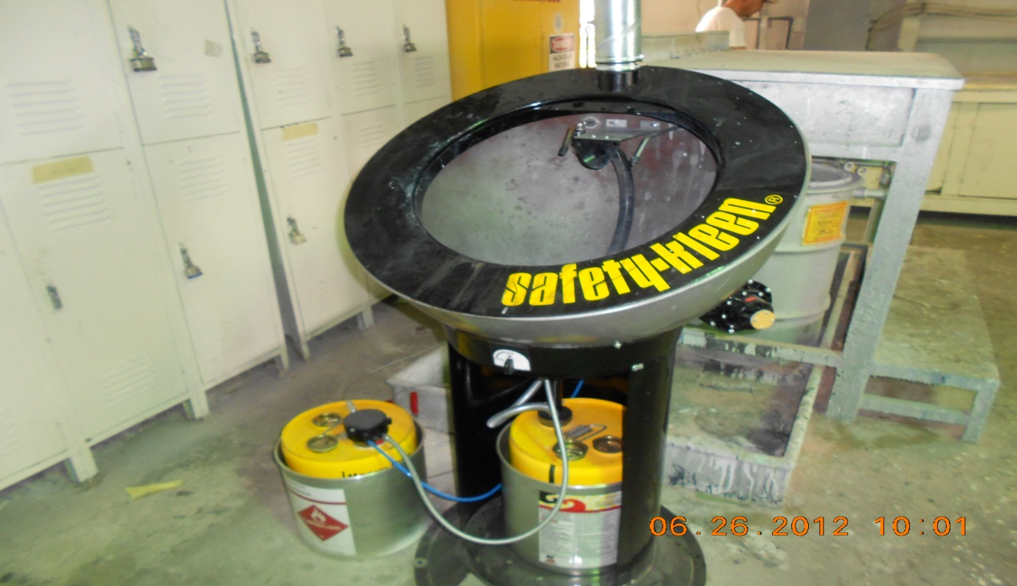
New Safety Kleen lacquer thinner recyclable system. Taken By: E.Susky, NRS II

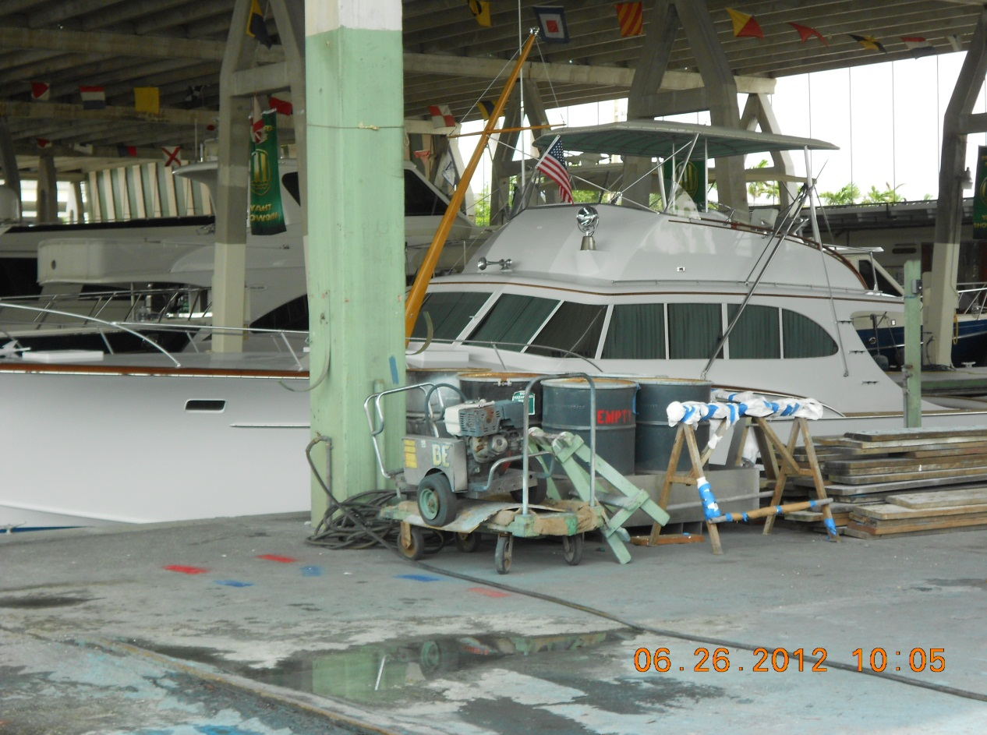
Secondary Containment movable containment for drums of hazardous waste removed off vessels. Taken By: E. Susky, NRS II

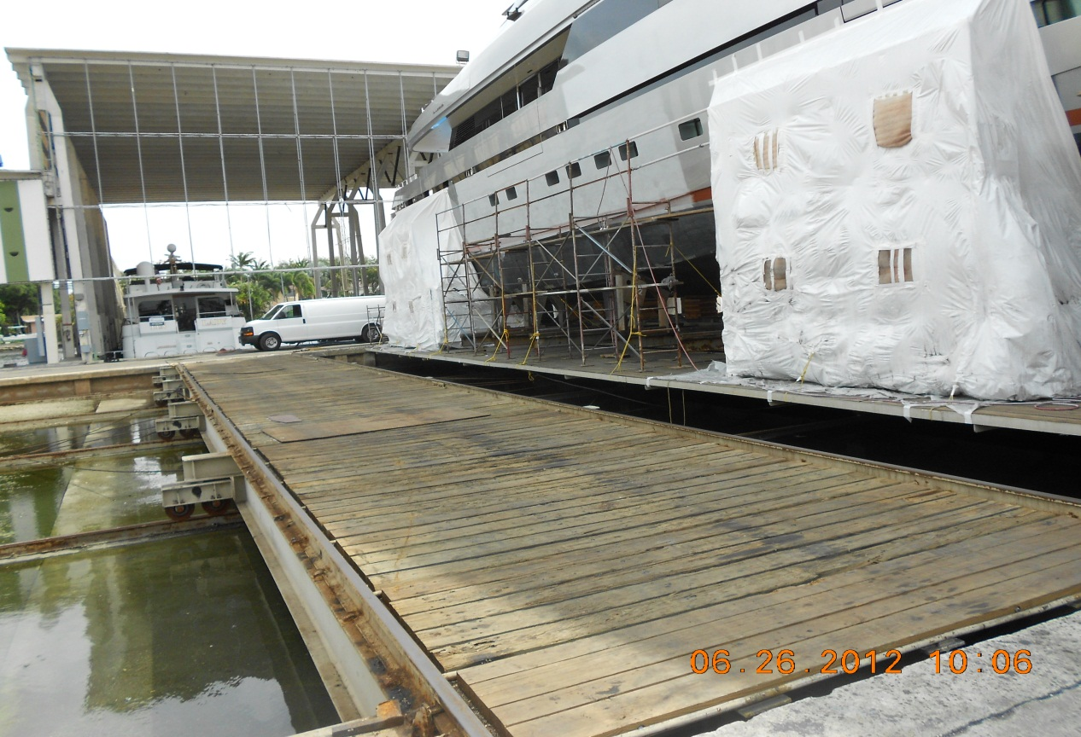
Properly encapsulated vessel observed while painting was conducted. Taken By: E. Susky, NRS II
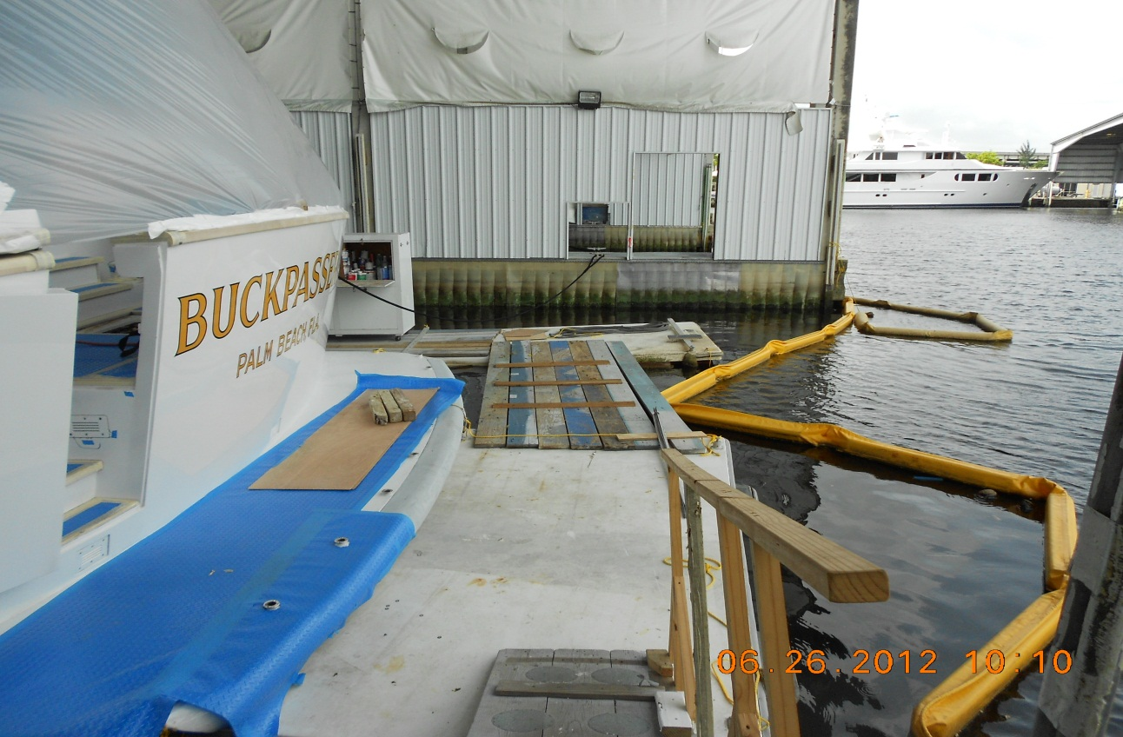
Properly boomed and rafted vessel observed after paint work was completed. Taken By: E.Susky, NRS II

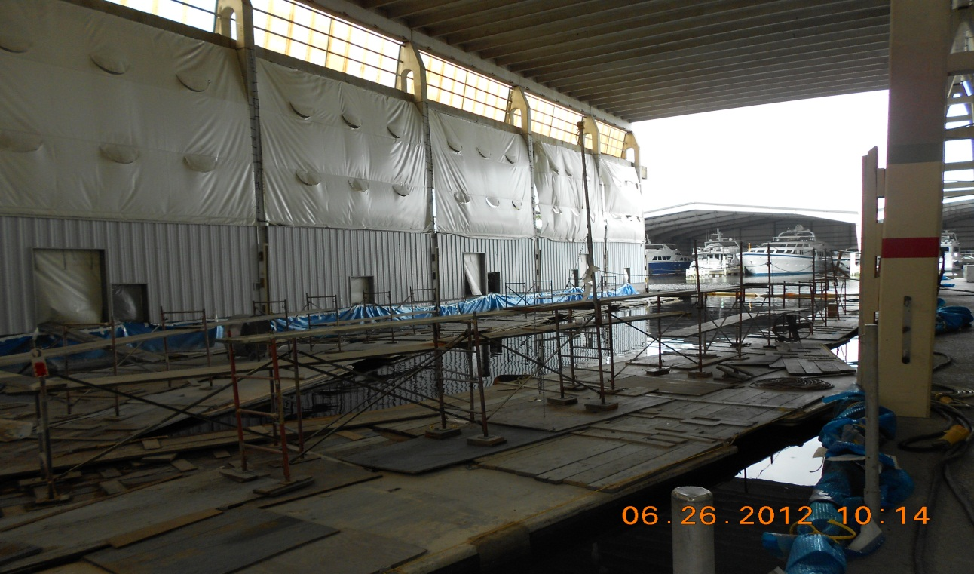
Proper scaffolding, rafting and boomed on-water bay before painting begins. Taken By: E.Susky, NRS II

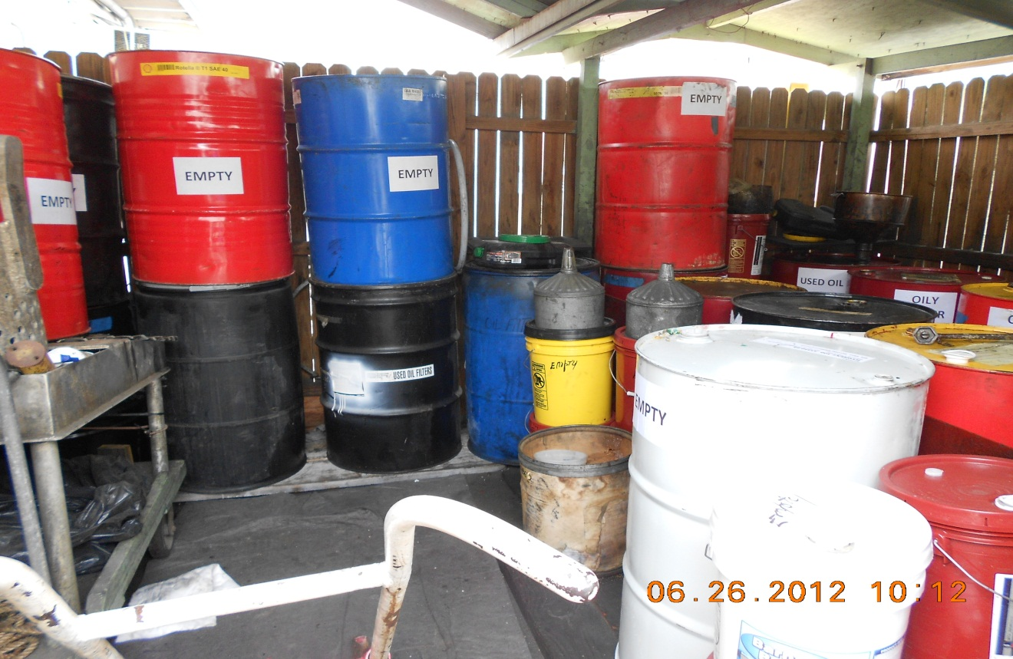
Secondary containment area for Bradford Marine. Taken By: E.Susky, NRS II

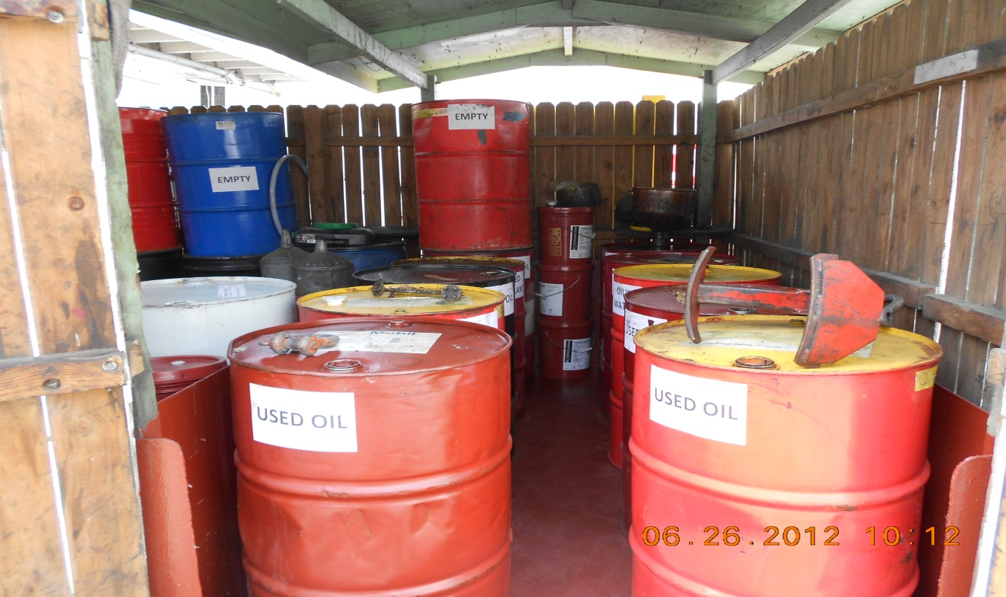
Secondary Containment area observed with proper labeling and berm. Taken By: E. Susky, NRS II

