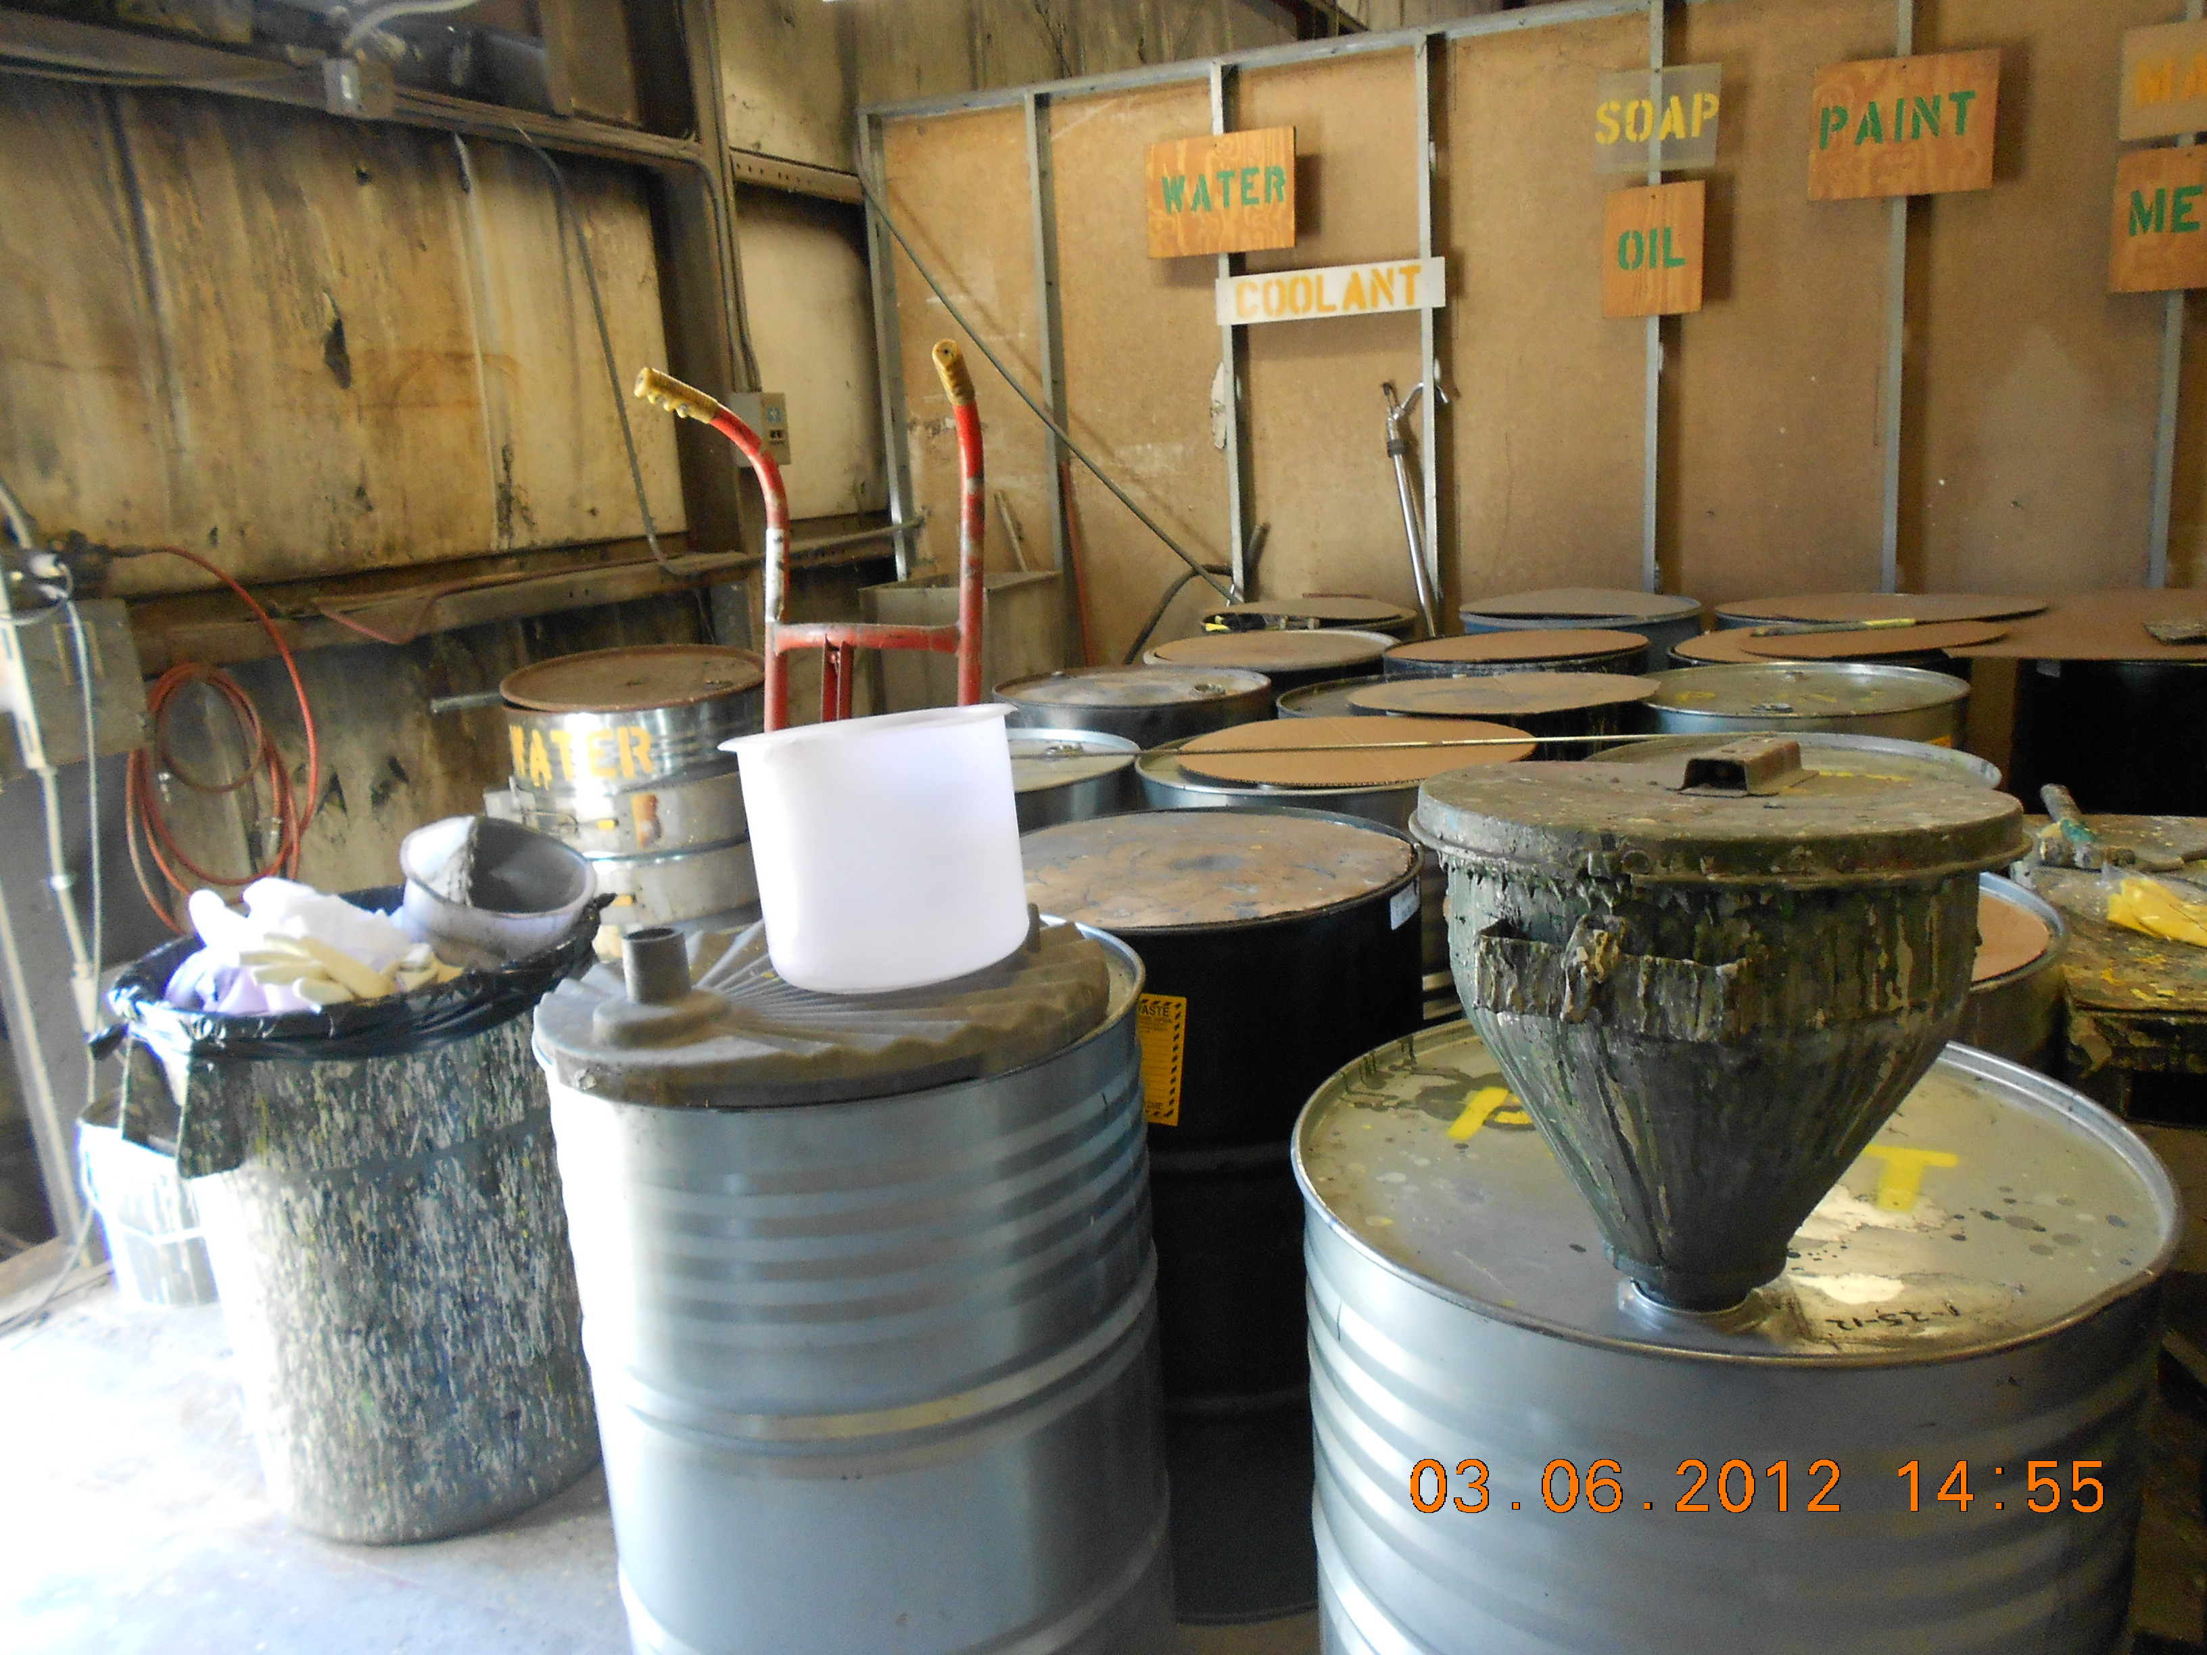
Hazardous storage area. Taken By: E. Susky, NRS II
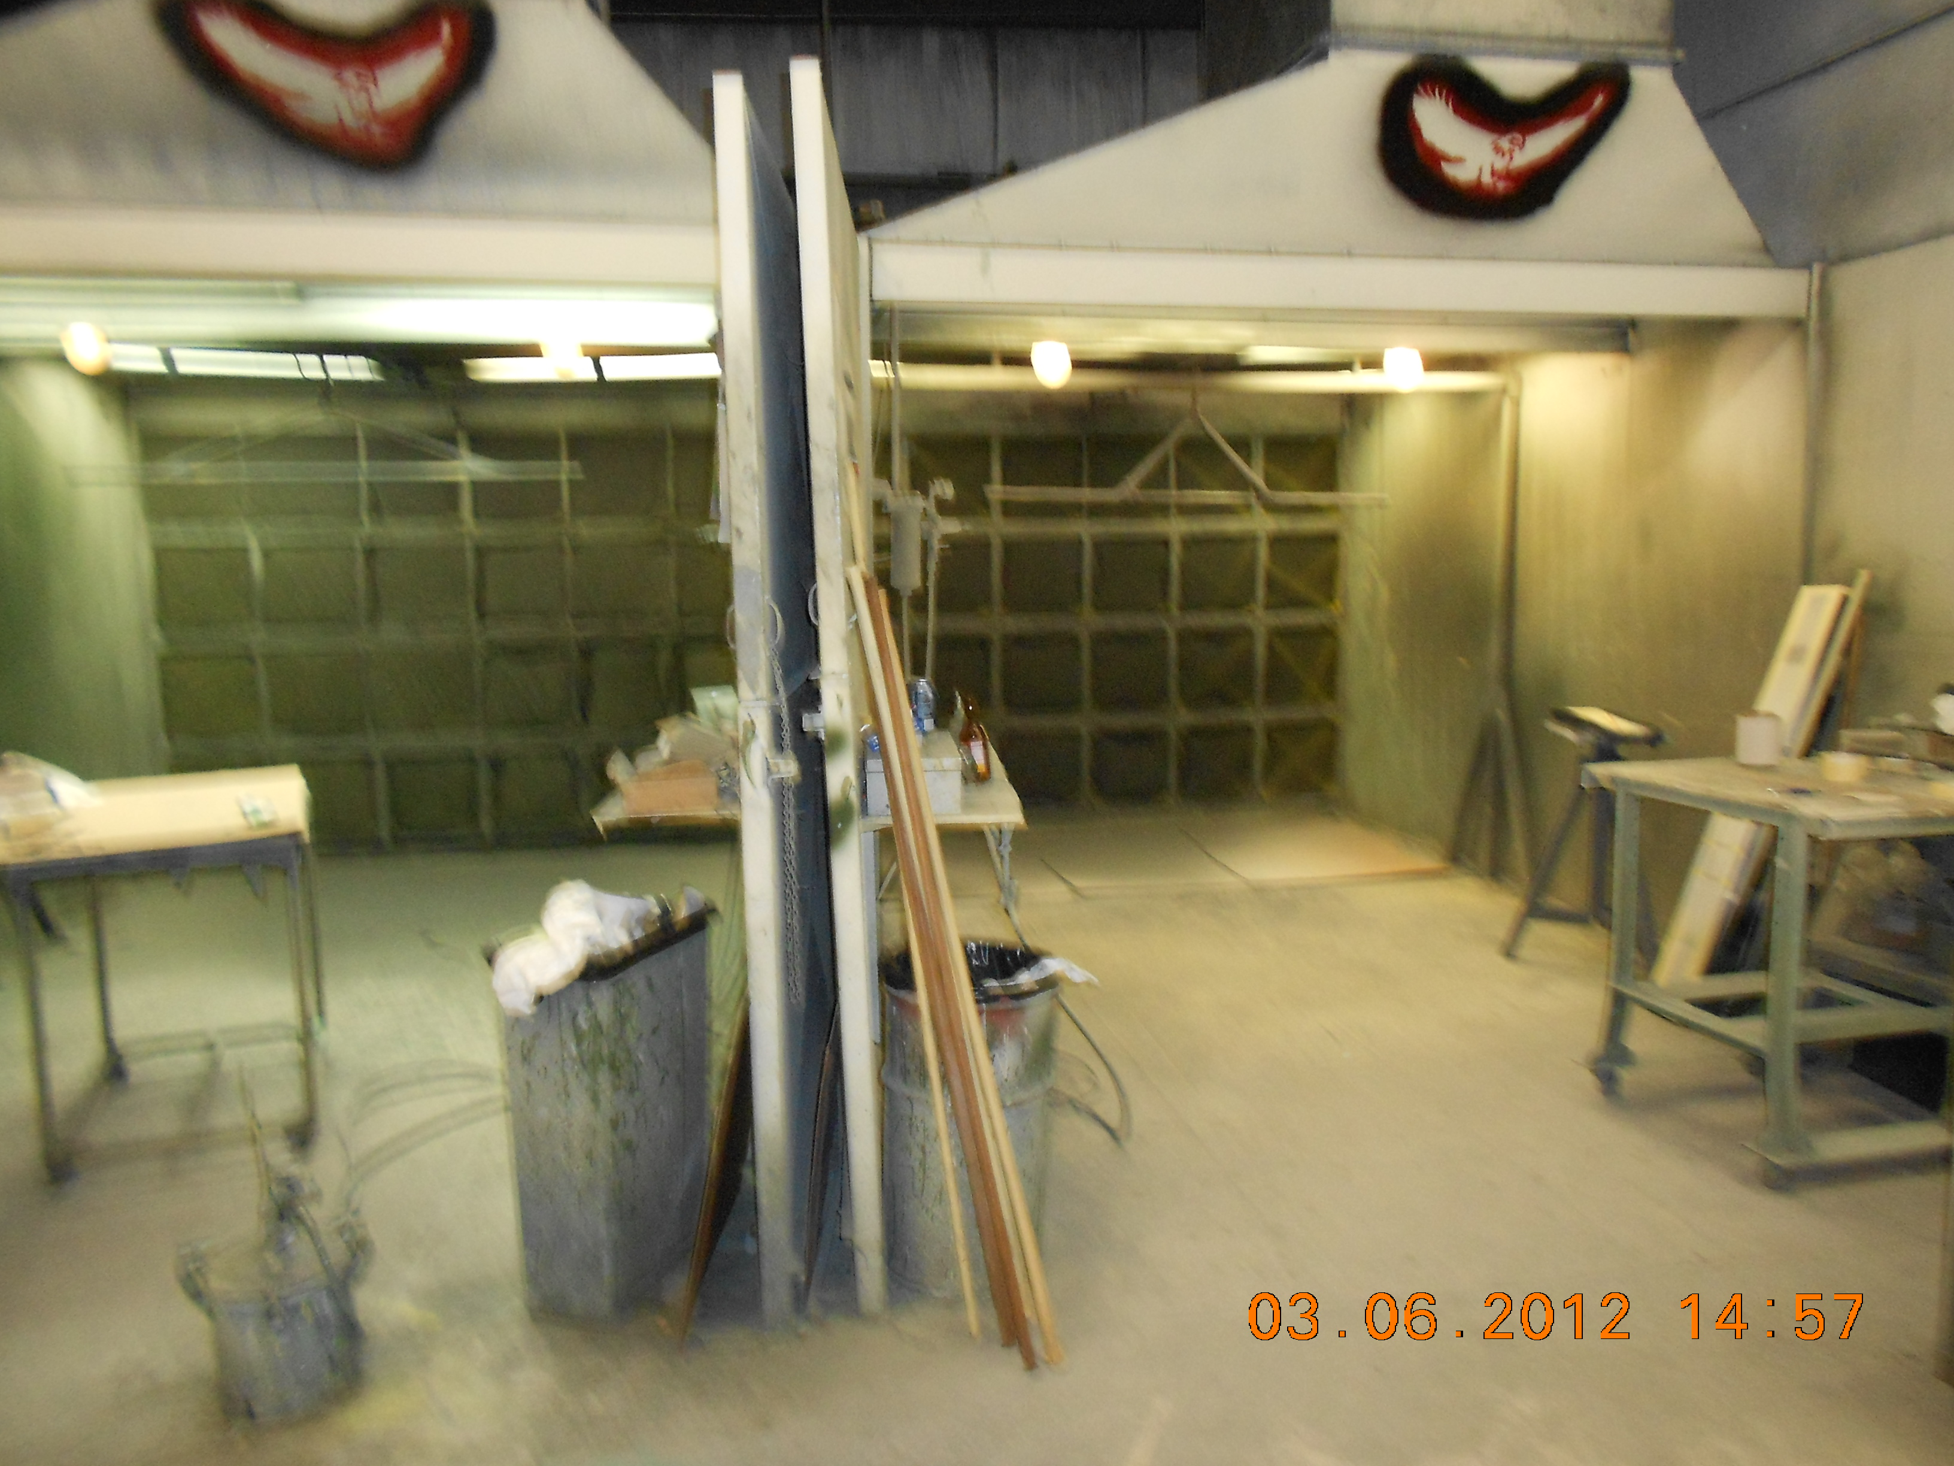

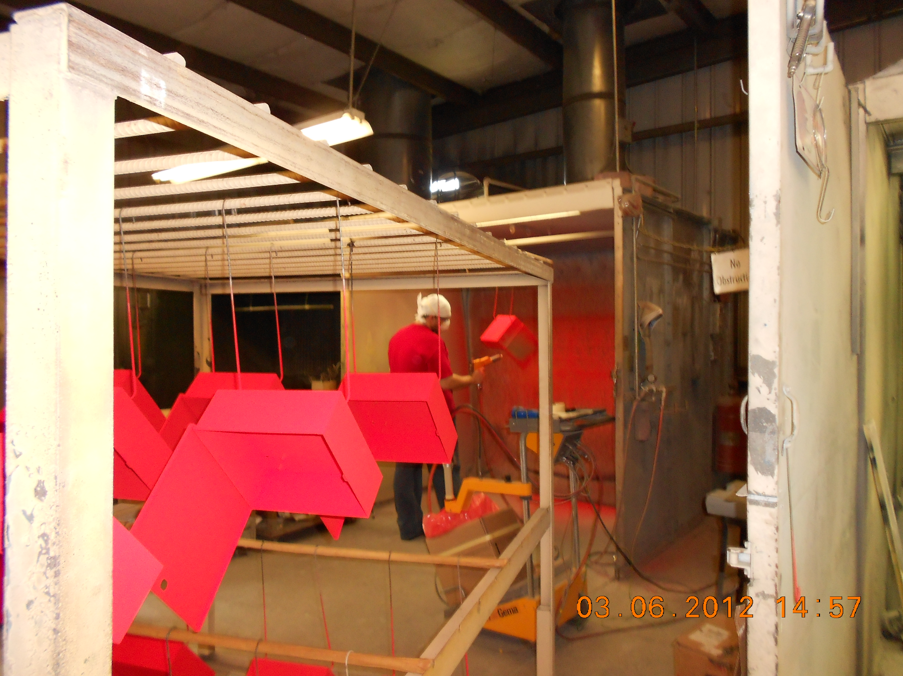
Paint Spray Booth and Drying area. Taken By: E.Susky, NRS II

