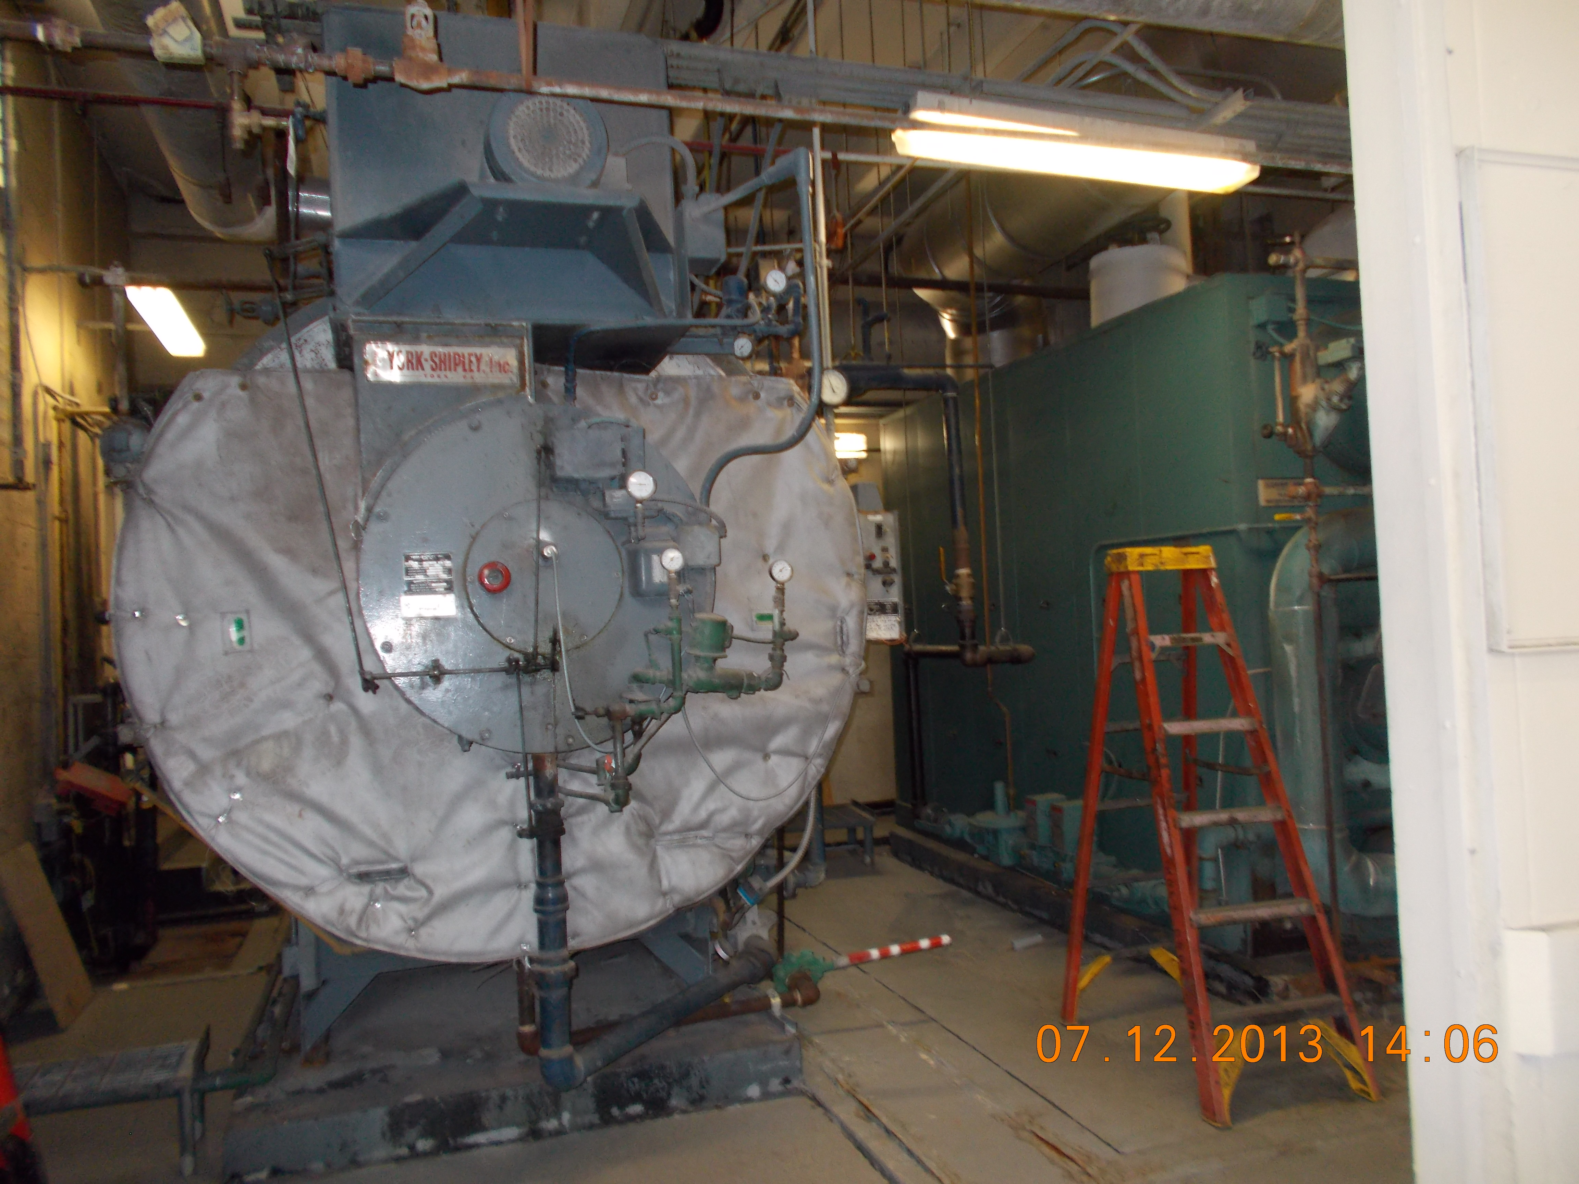
Photograph of Boiler at Holy Cross Hospital. Taken By: E. Susky, NRS II

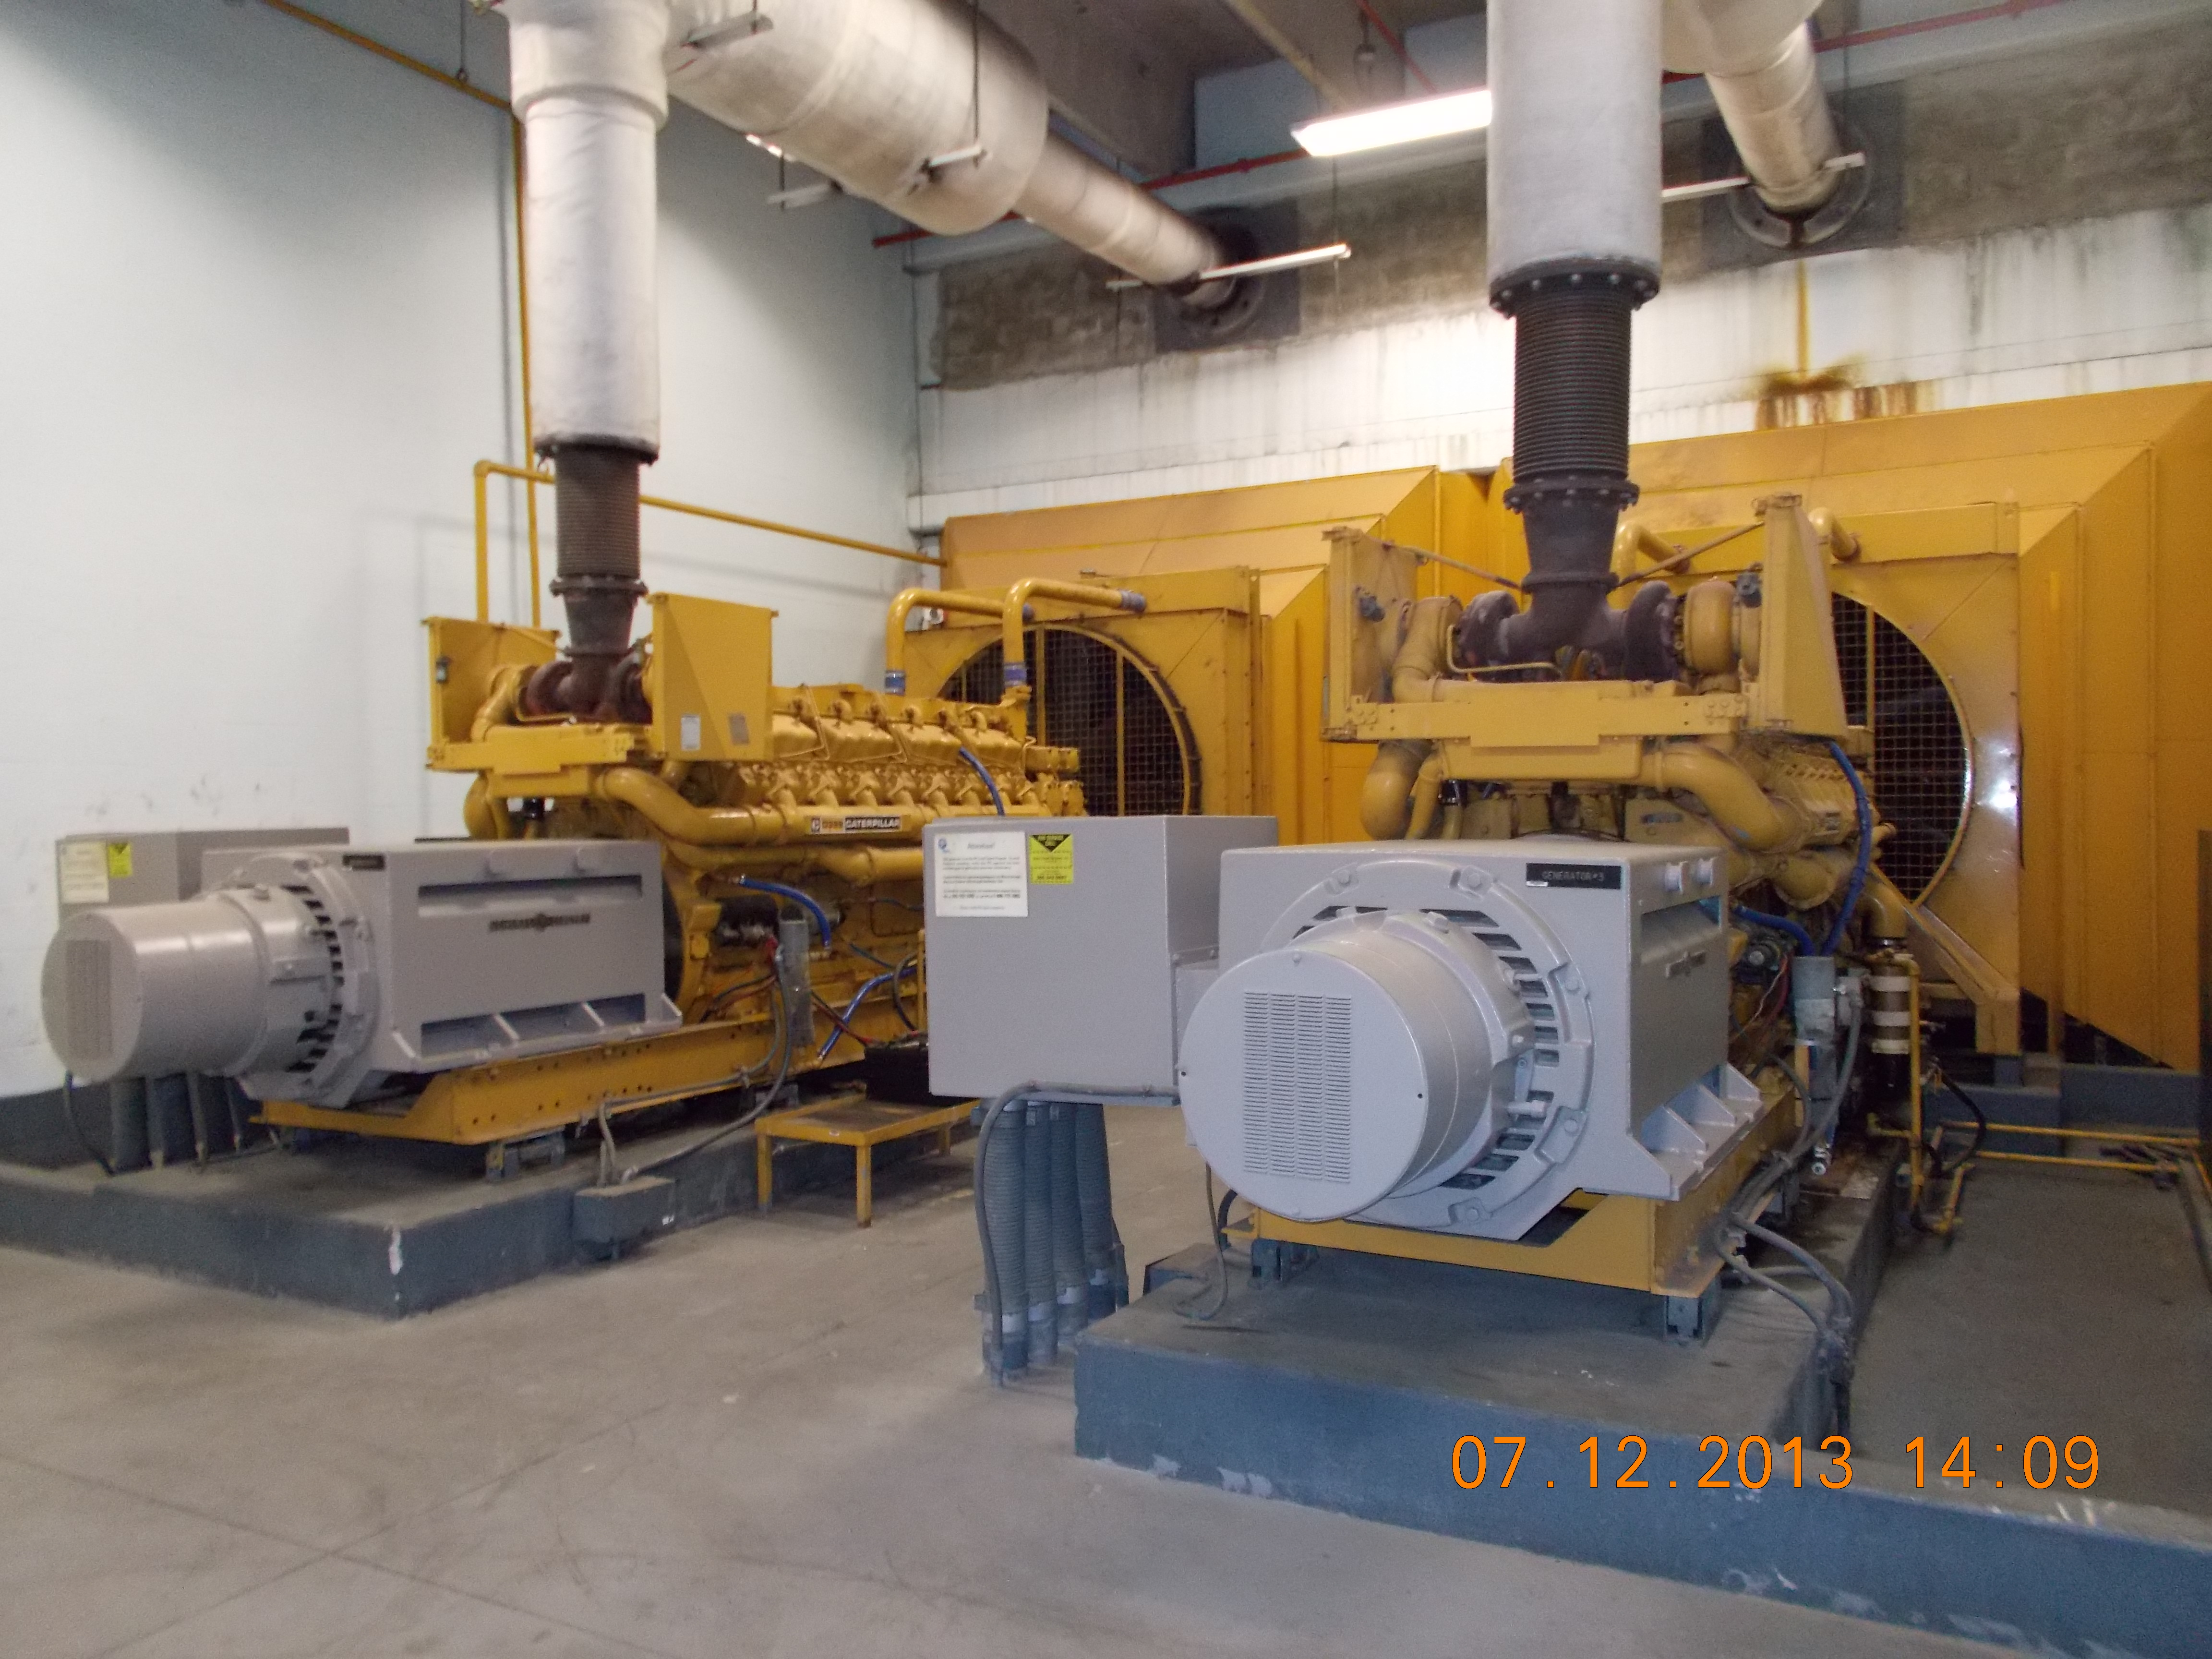
Photograph of back-up generator. Taken By: E. Susky, NRS II

