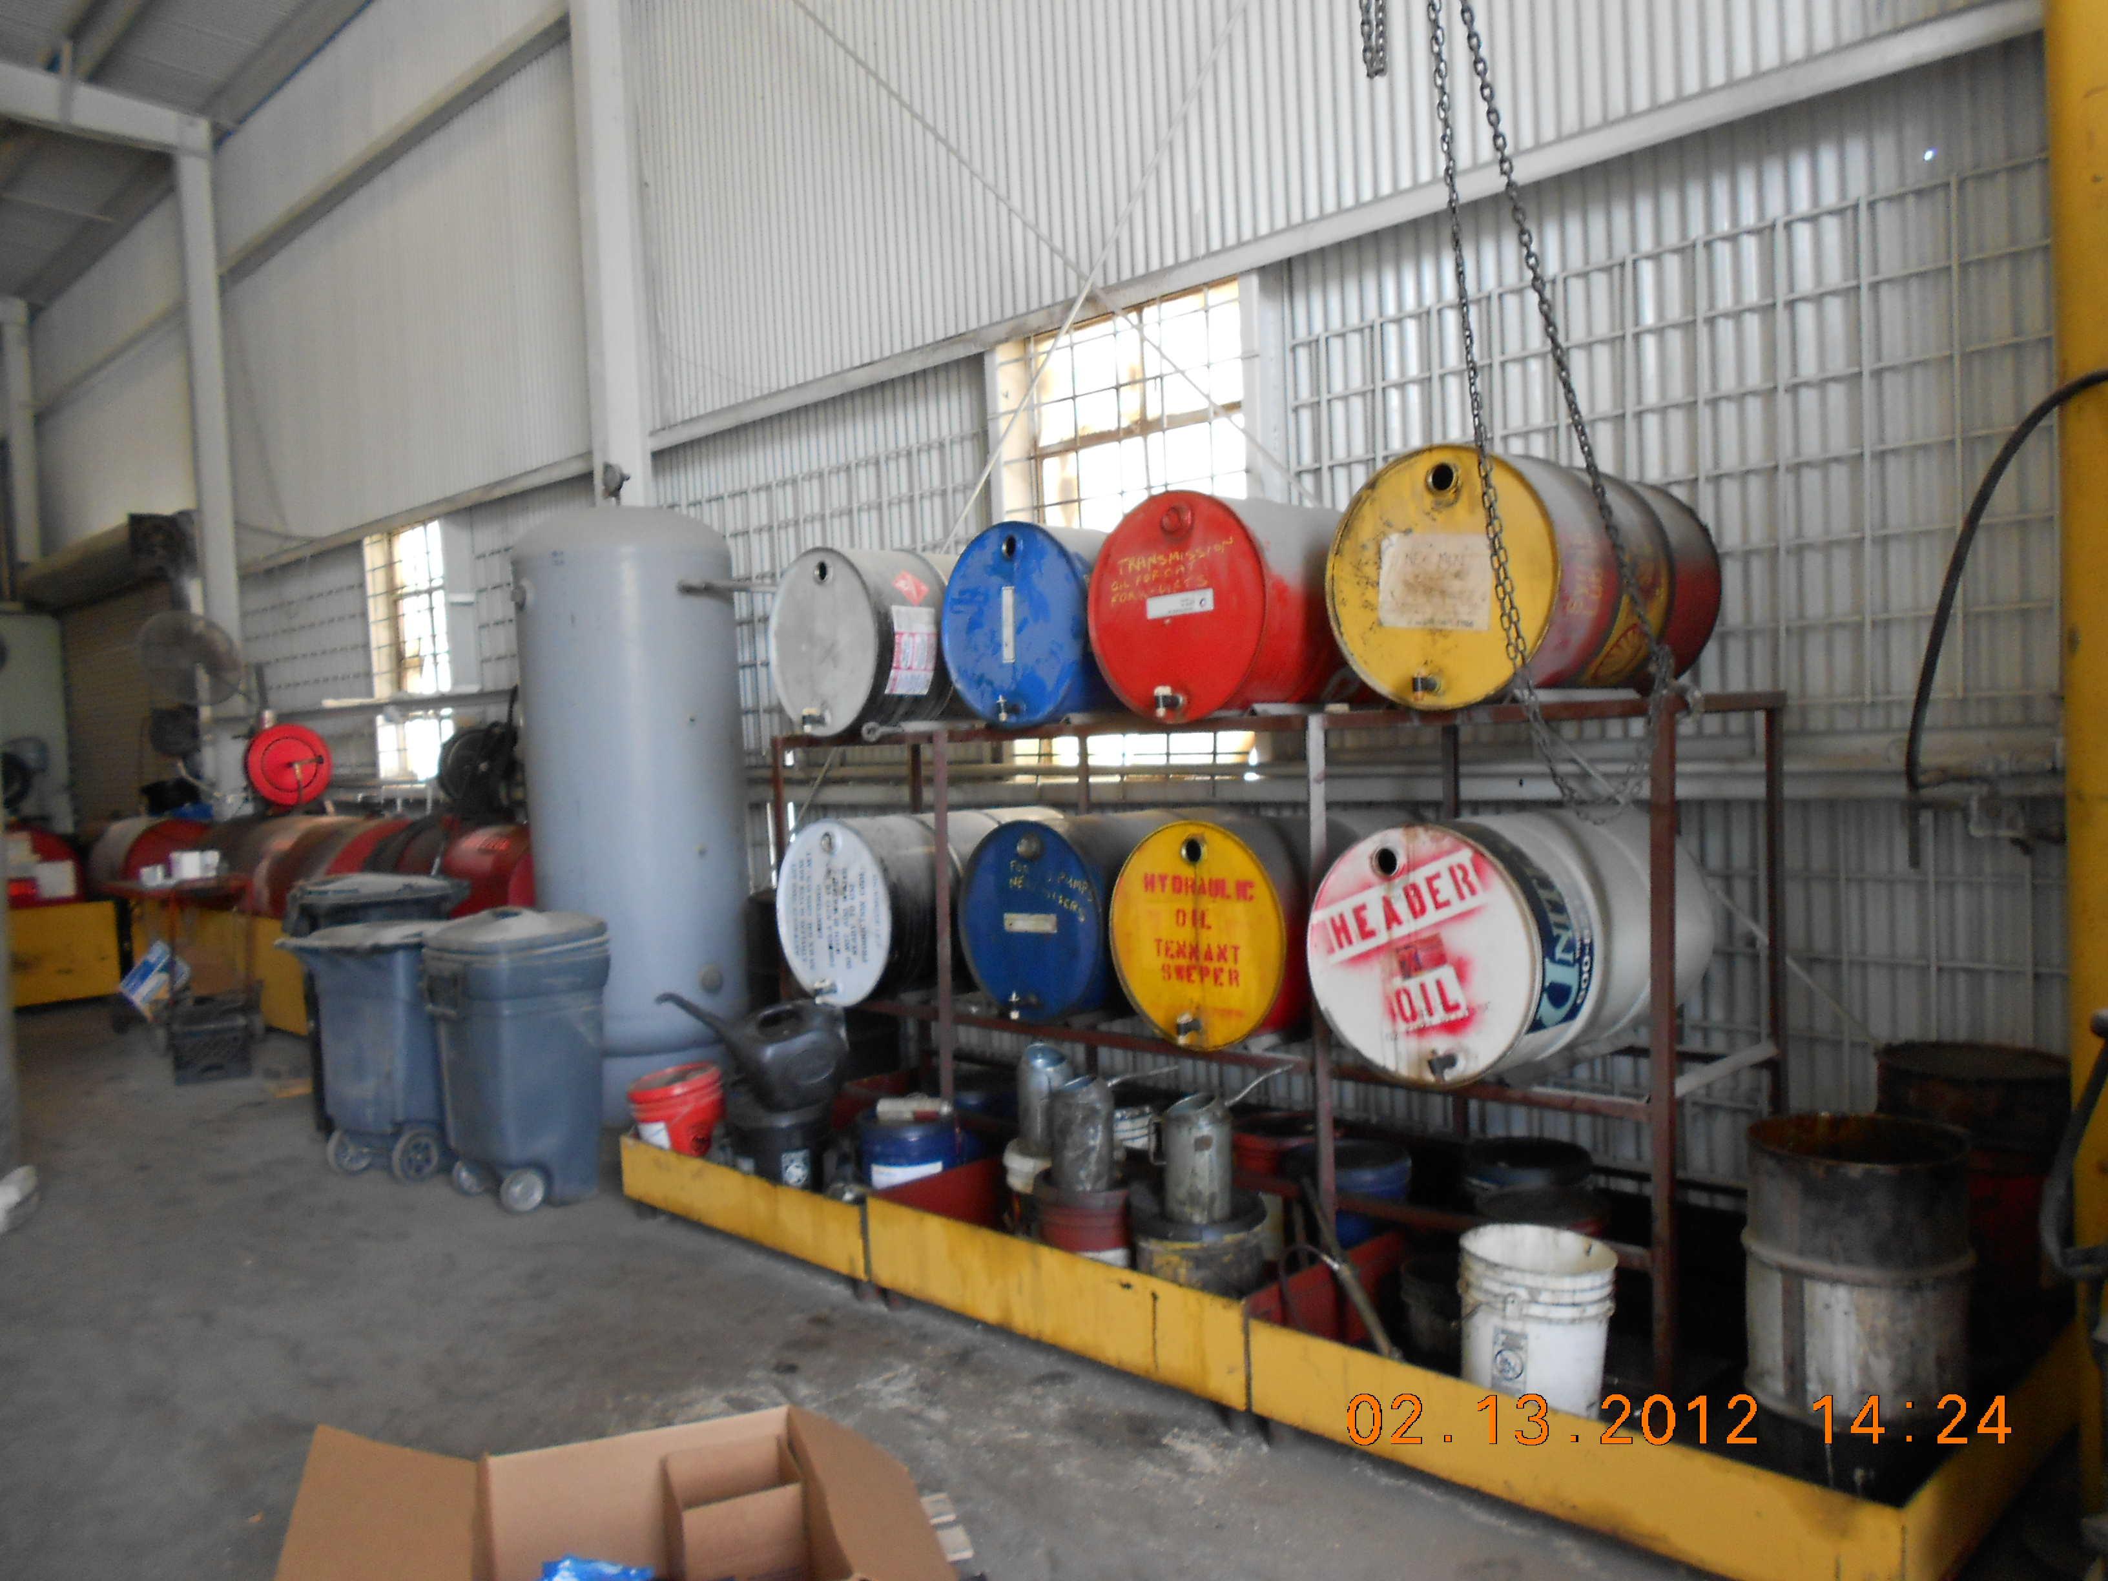
Hazardous Material Storage Area, Taken By: E.Susky, NRS II

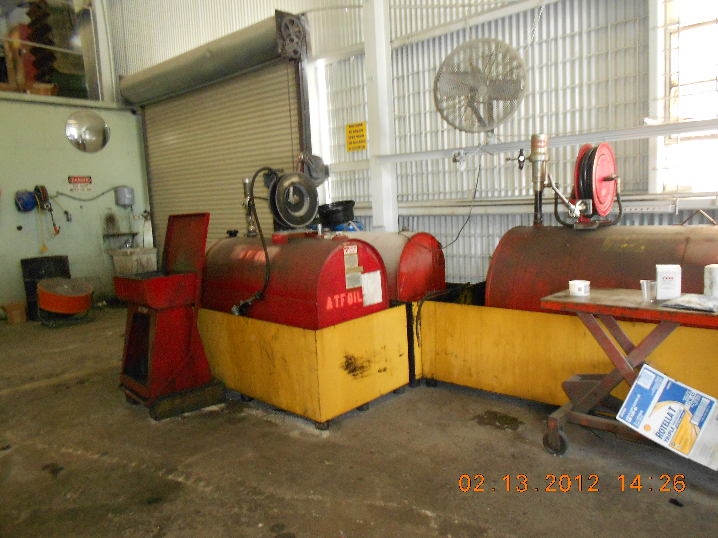
Tank Storage Area, Taken By: E.Susky, NRS II

