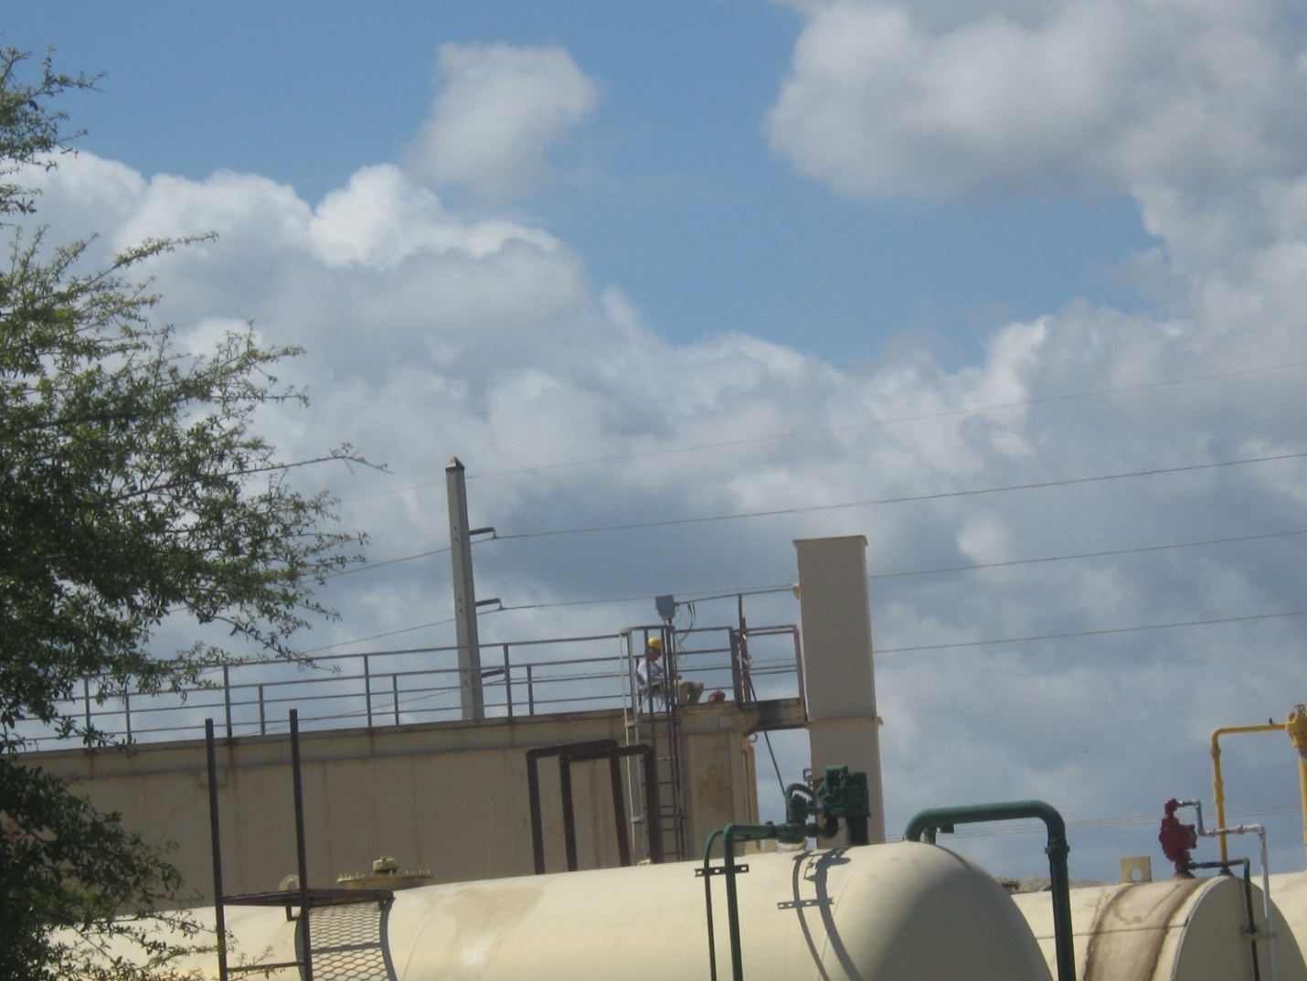
AIRS ID 0090122 Ranger Construction Valkaria. Taken by G. Kuberski 03/18/09. VE on stack was zero. Stack test person is operating the stack test train.

