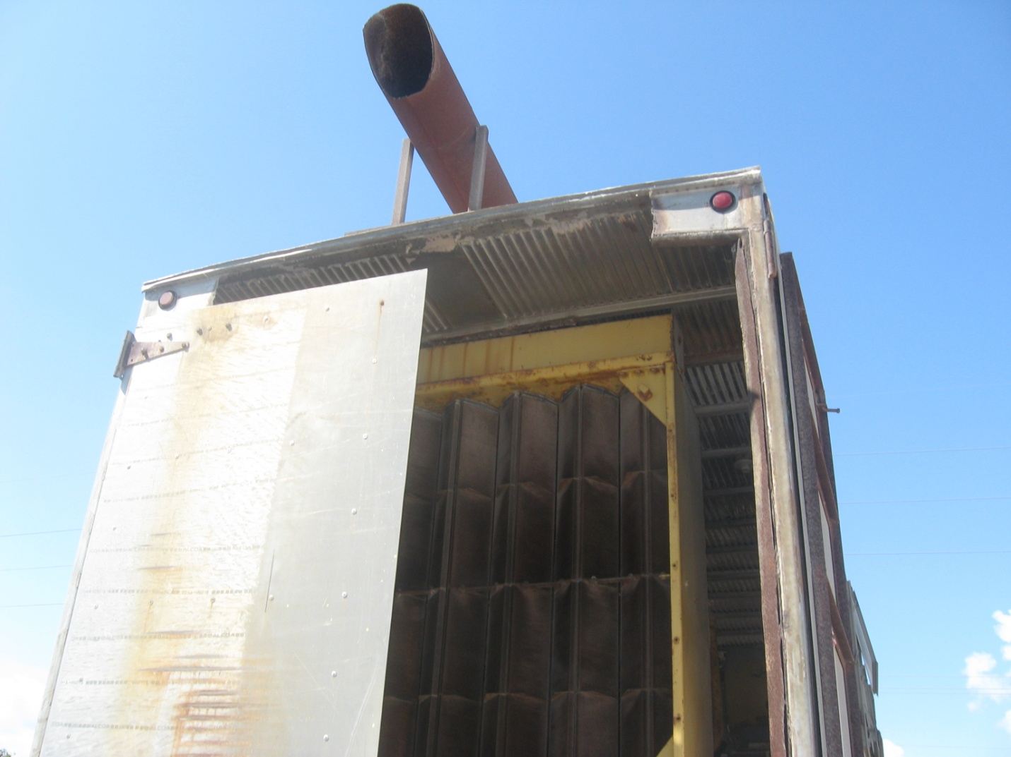
AIRS ID 0090122 Ranger Construction Valkaria. Taken by G. Kuberski 03/18/09. This generator is not in use and does not appear to have been operated for some time.

