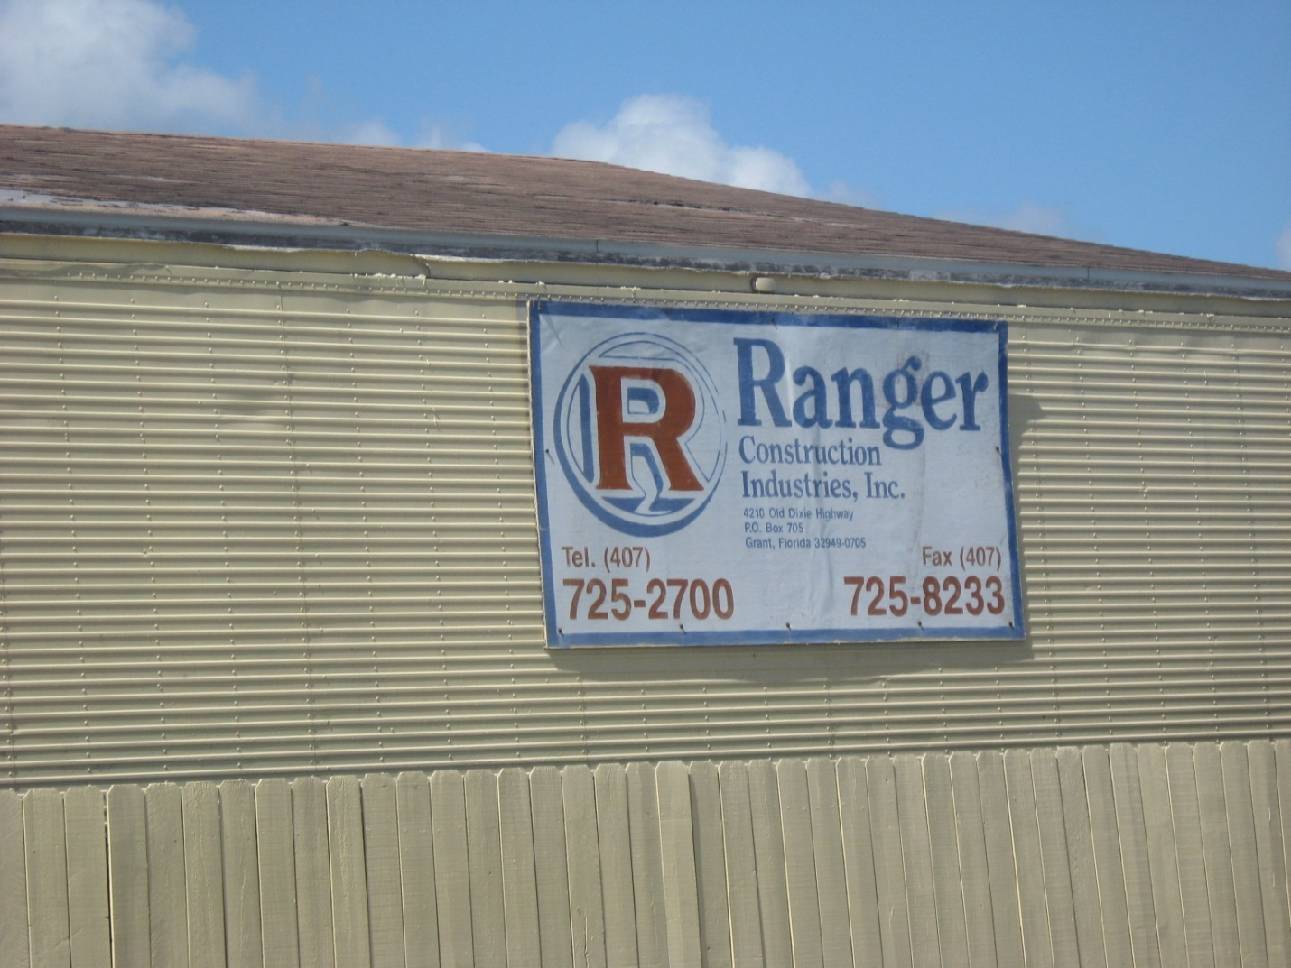
AIRS ID 0090122 Ranger Construction Valkaria. Taken by G. Kuberski 03/18/09

