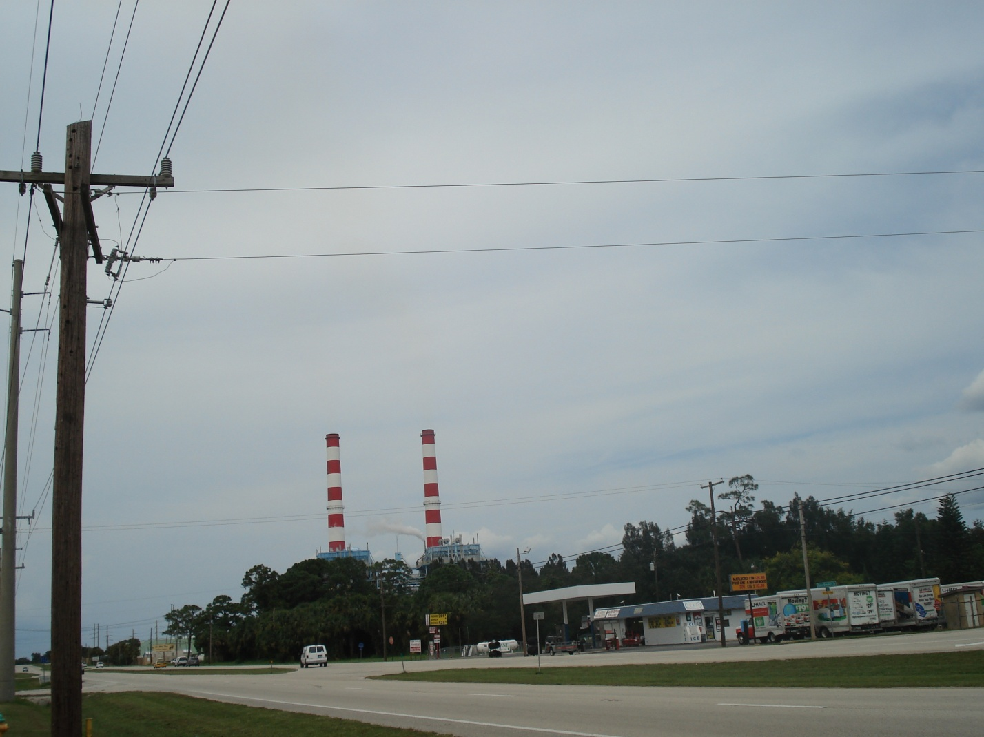
Florida Power and Light Cape Canaveral Plant. September 16, 2008, approx. 2:00 PM. Unit 1 (stack on the right) is burning oil and being stack tested for PM. Heat input is 3601 MMBTU/hour. Opacity from COM is 6%. Sky is overcast and grey. Observer read highest 6 min average opacity at 0%.
Photo taken by Garry Kuberski

