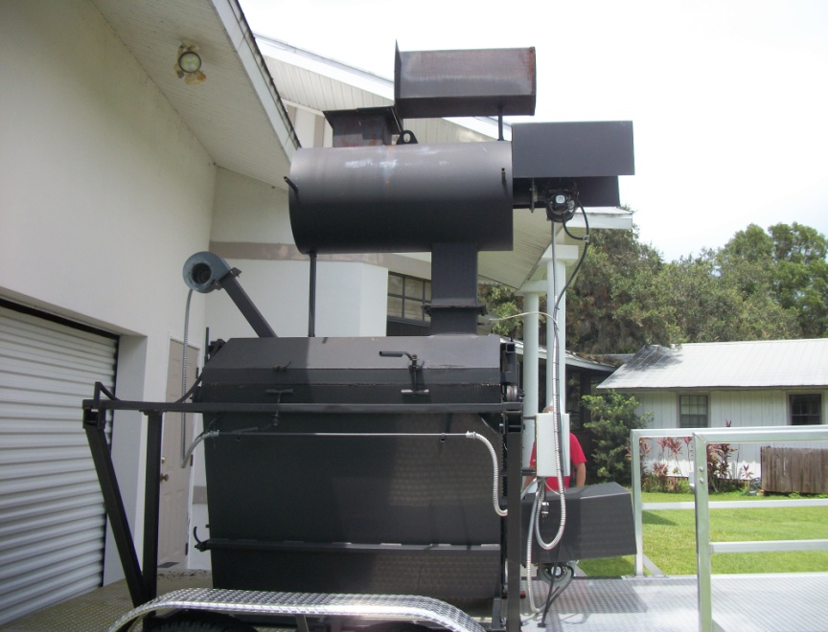  1. Portable Animal Crematory unit, Super Nova SN500, located at 17341 Frank Road, Ft. Myers, FL., looking at side view. Unit has not yet been in operation at this time. | 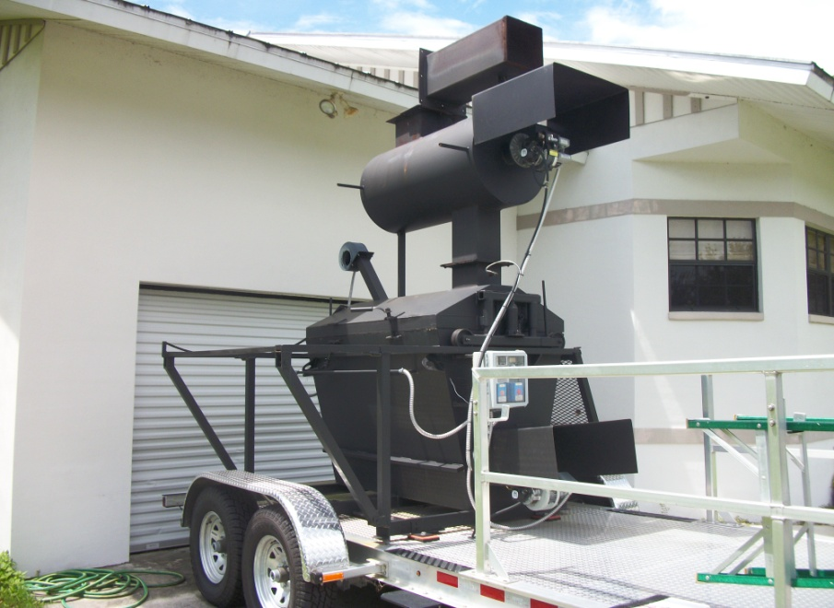
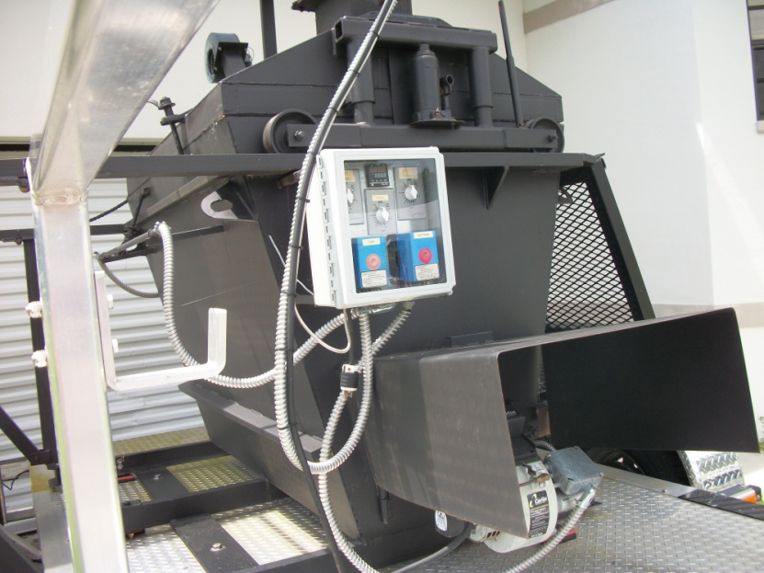
3. View of burner controls on the crematory unit.

