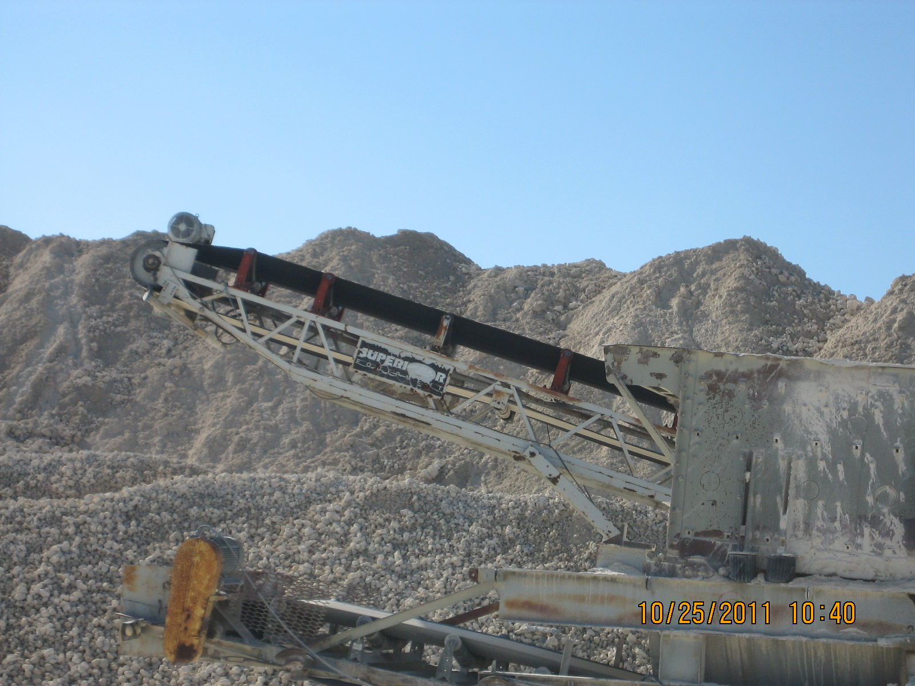
Superior Stacker Belt
Screener--#2818

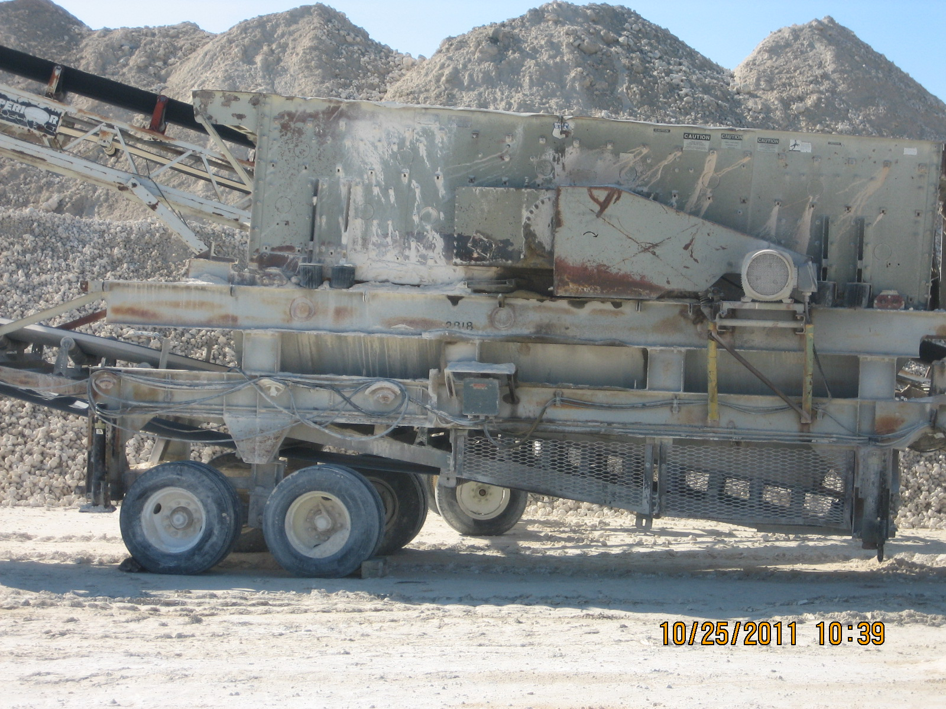
Screener--#2818

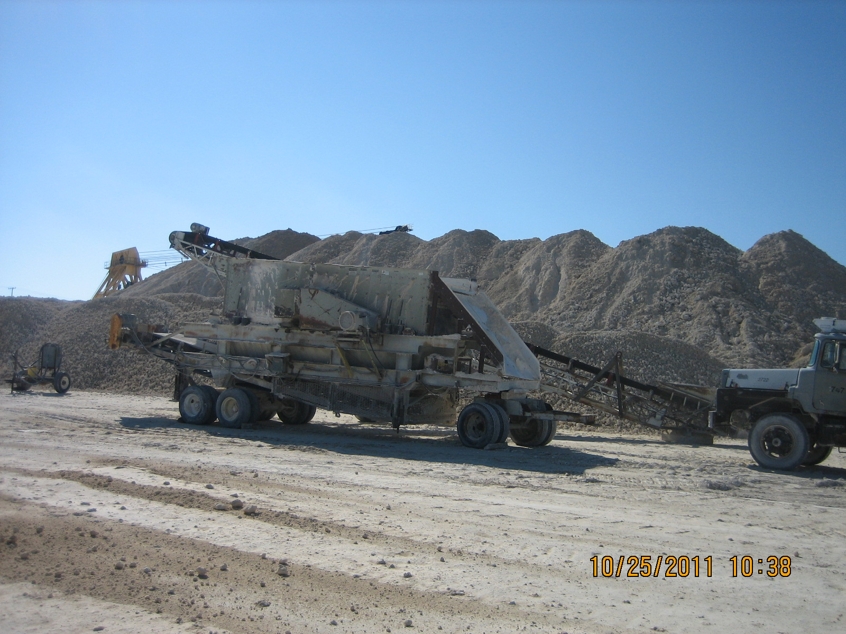
Screener-#2818 and Superior Stacker Belt

