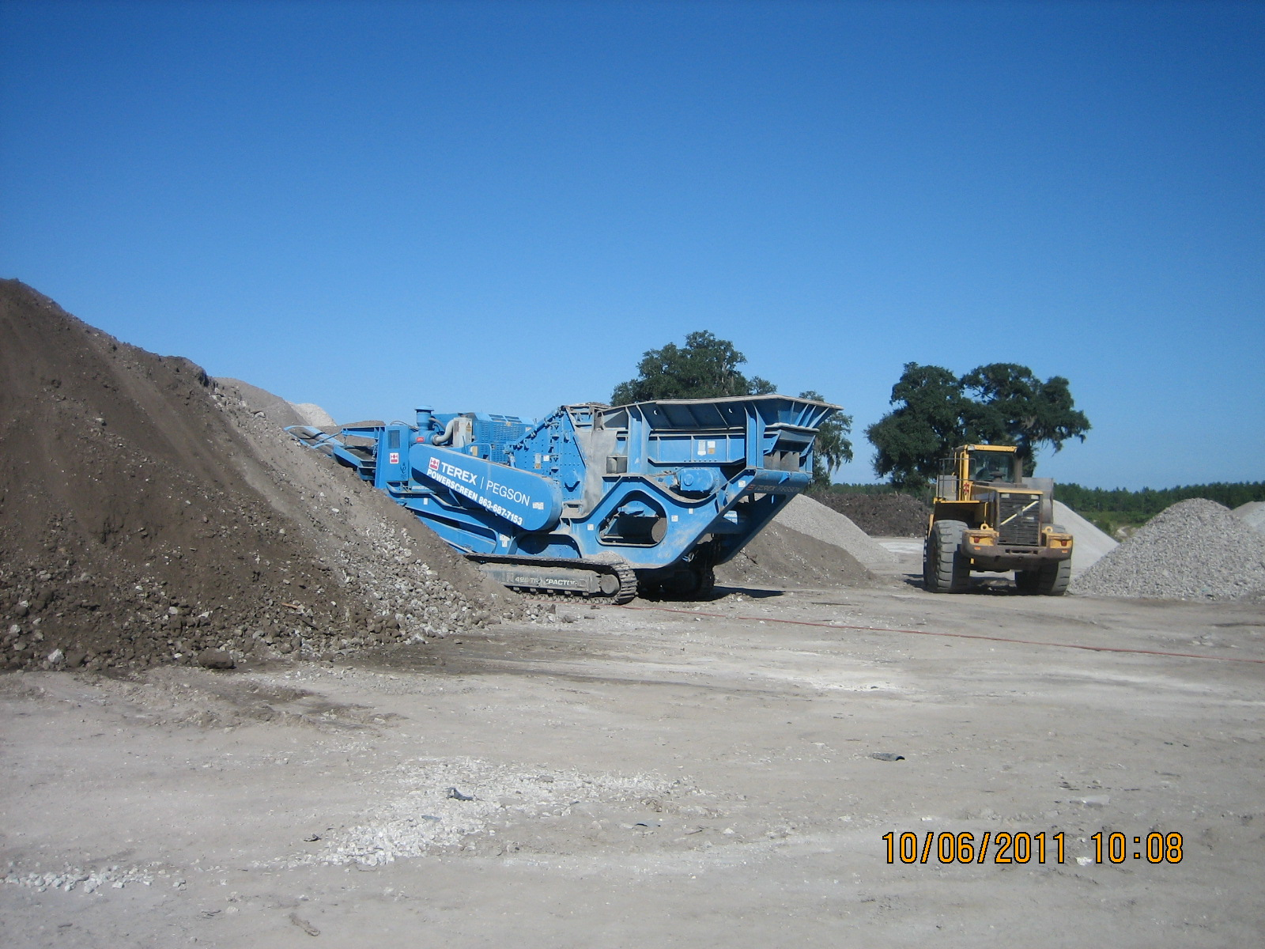
Pegson
Model: 428 Trackpactor
Manufactured: March 2009
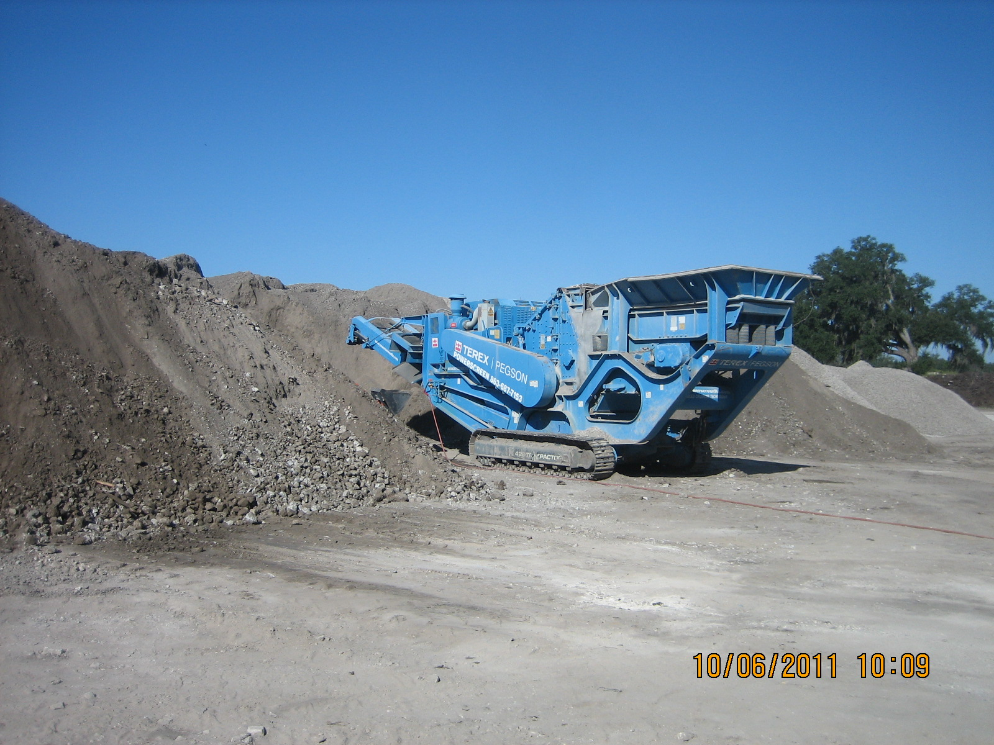
This standalone unit has only one emission point, the crusher exit.

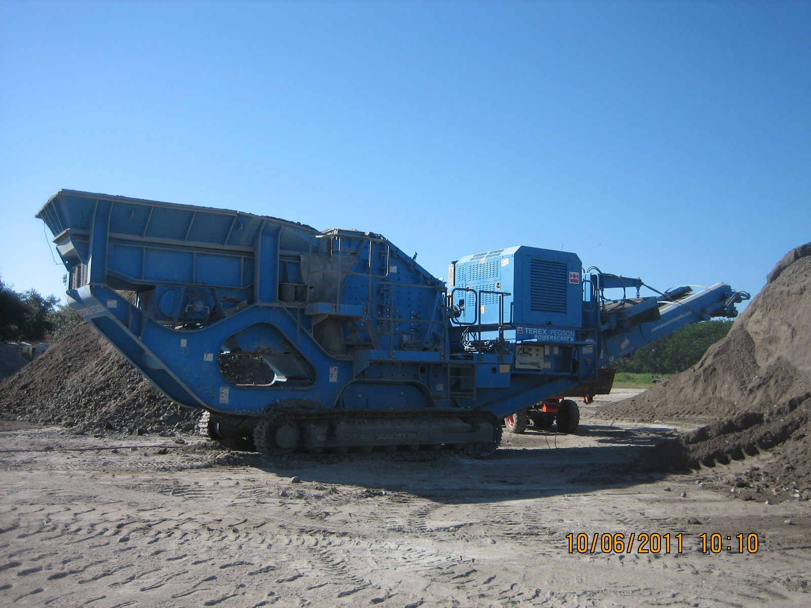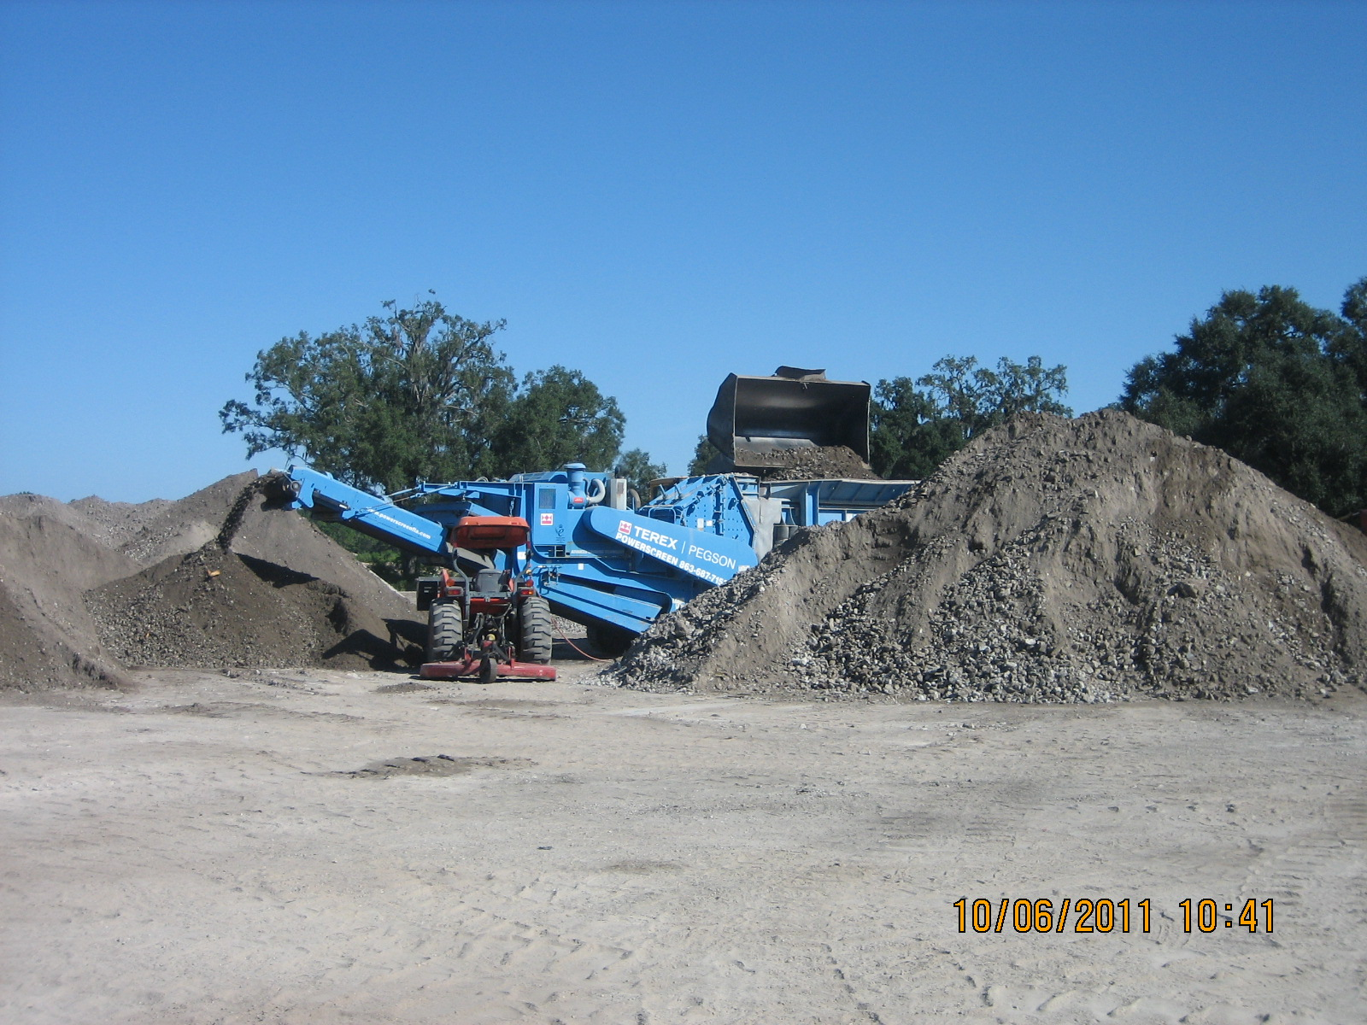
This unit has no Oversize Return Conveyor or Fines Belt.

View of unit during operation and VE Testing.

