Prestige Gunite

Facility Id#7775529
INS2 by Wendy D. Simmons on 05/18/2009

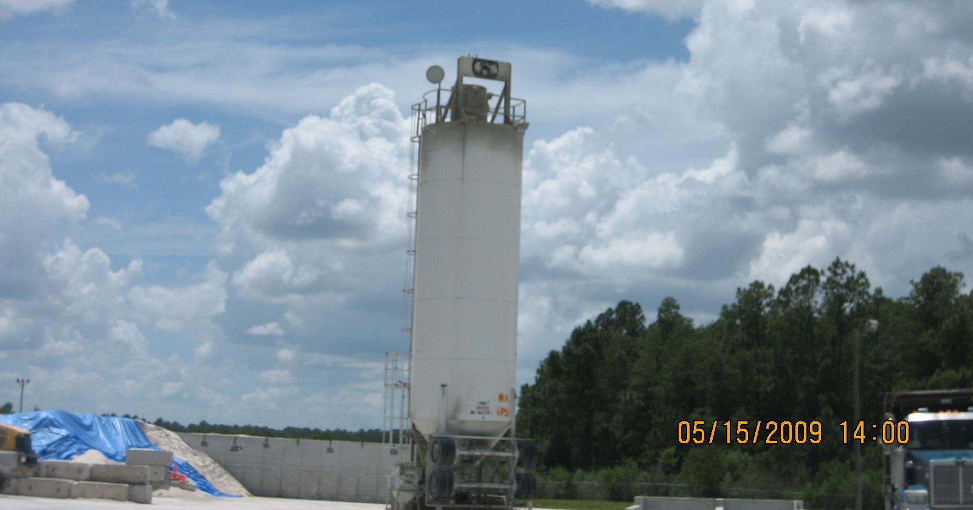
#1-Above picture depicts relocatable Belgrade 550 Barrel silo with silo top dust collector.

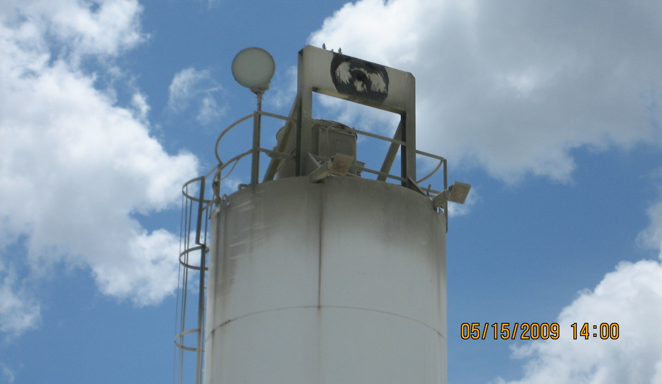

#2- Above picture depicts close-up of the Belgrade silo’s baghouse…baghouse vent is located at
the base of the baghouse. Vent opening is not visible in this photo.

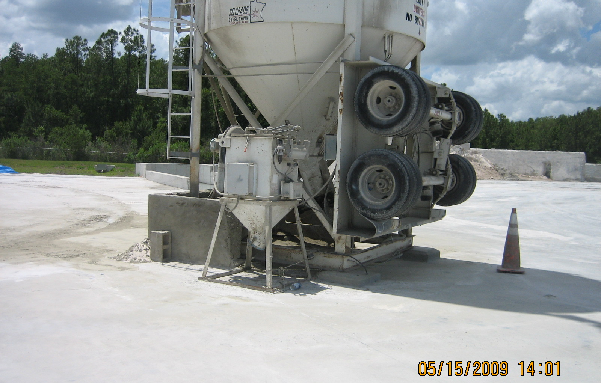
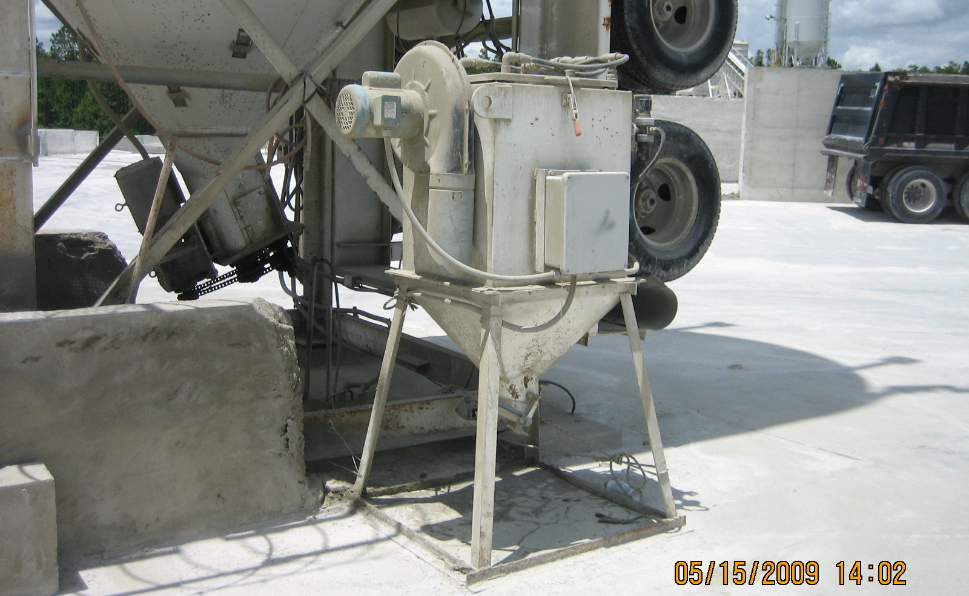
#3 & #4- Above pictures depict small dust vacuum system that controls emissions from the
loading of gunite batch trucks.

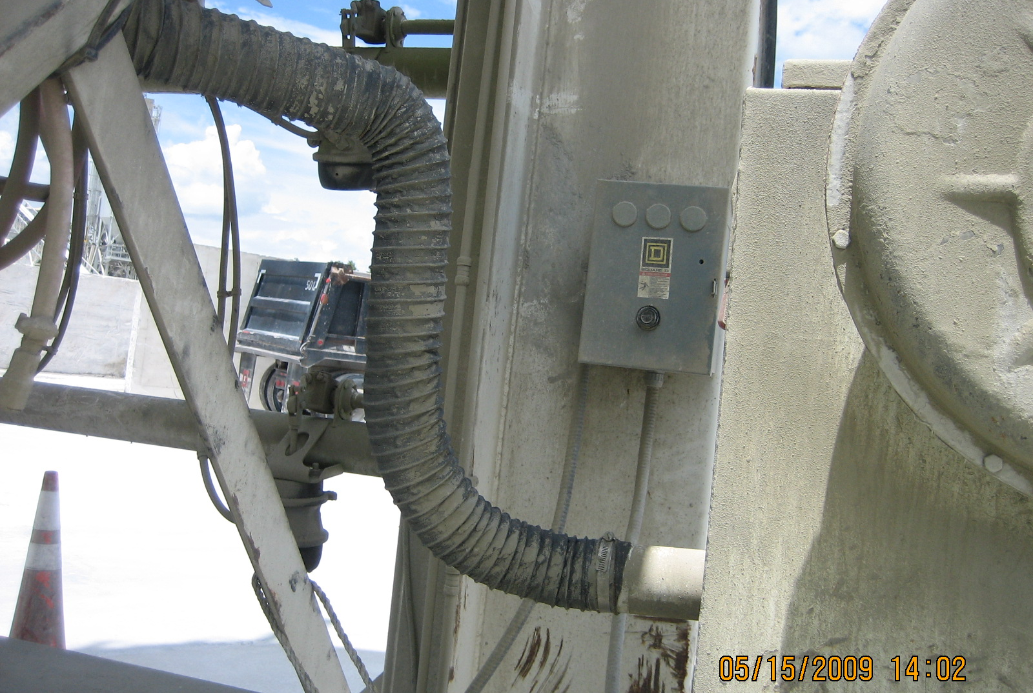

#5 Photo depicts vent hose that leads into dust vacuum system from truck loading plate.

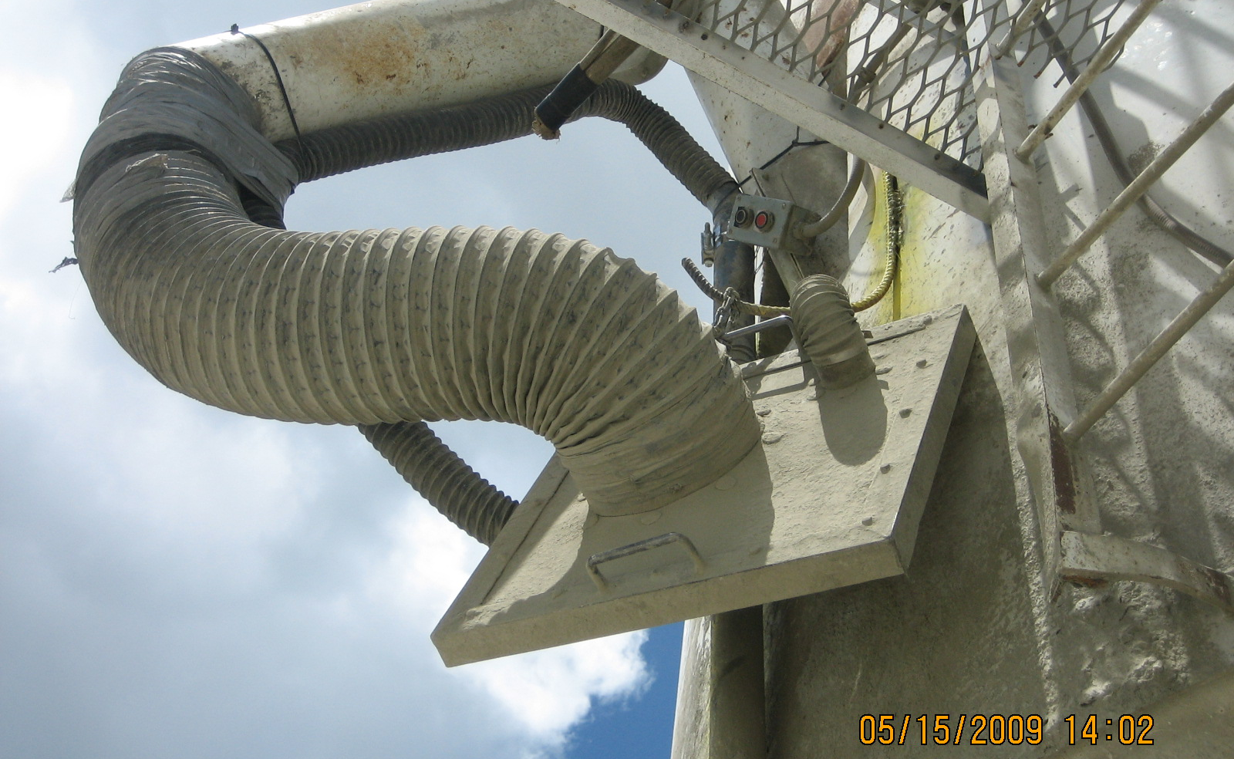

#6 The above photo depicts a close-up view of truck load out cover plate that includes loading
hose and dust vacuum system pick-up point.
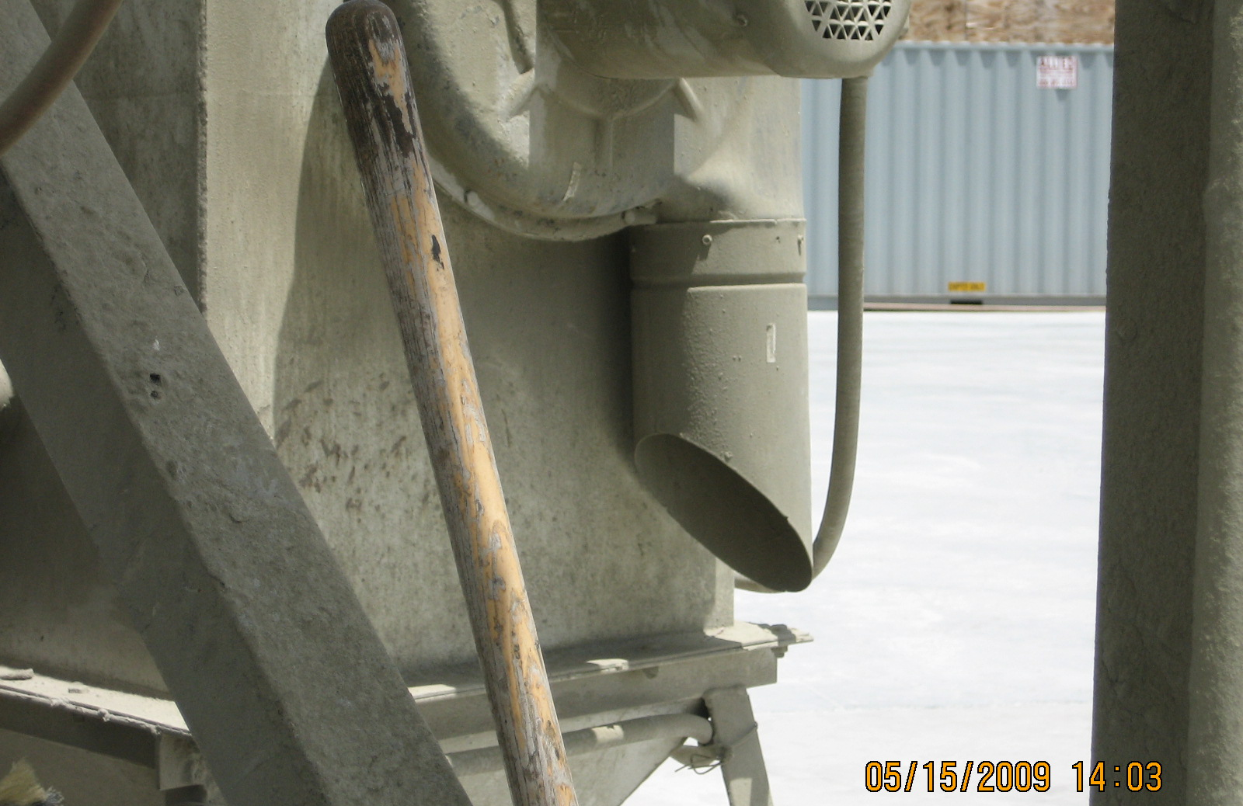

#7 Close-up picture of the dust vacuum system’s exhaust point or potential exhaust point.

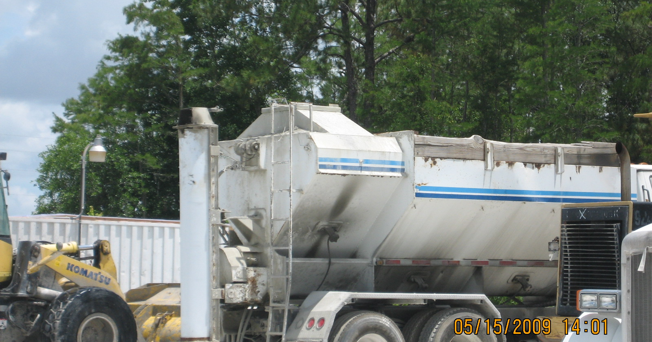

#8 Photo depicts gunite batch truck that is used to transport gunite mixture to pool construction
sites. Top back portion of truck is where port for loading is located.

Additional photos were taken at this site, but were not necessary for inclusion in this photo log.

